**Solar Off-Limb visualization**

**Aim: To develop an automated method to view solar off limb features.**

**Methodology**

* The sun center information for the desired data has to be fetched from ‘CRPIX1’, ‘CRPIX2’ and ‘R_SUN’ parameters in the fits header.
* A mask is generated around the Sun disk based on the sun-center information.
* All counts outside the sun disk are multiplied by 10 to increase the intensity of off limb features to make them similar to that for the Solar disk.
* An off axis mask is also generated at a user defined radial distance from the Solar limb to cover any regions beyond that.

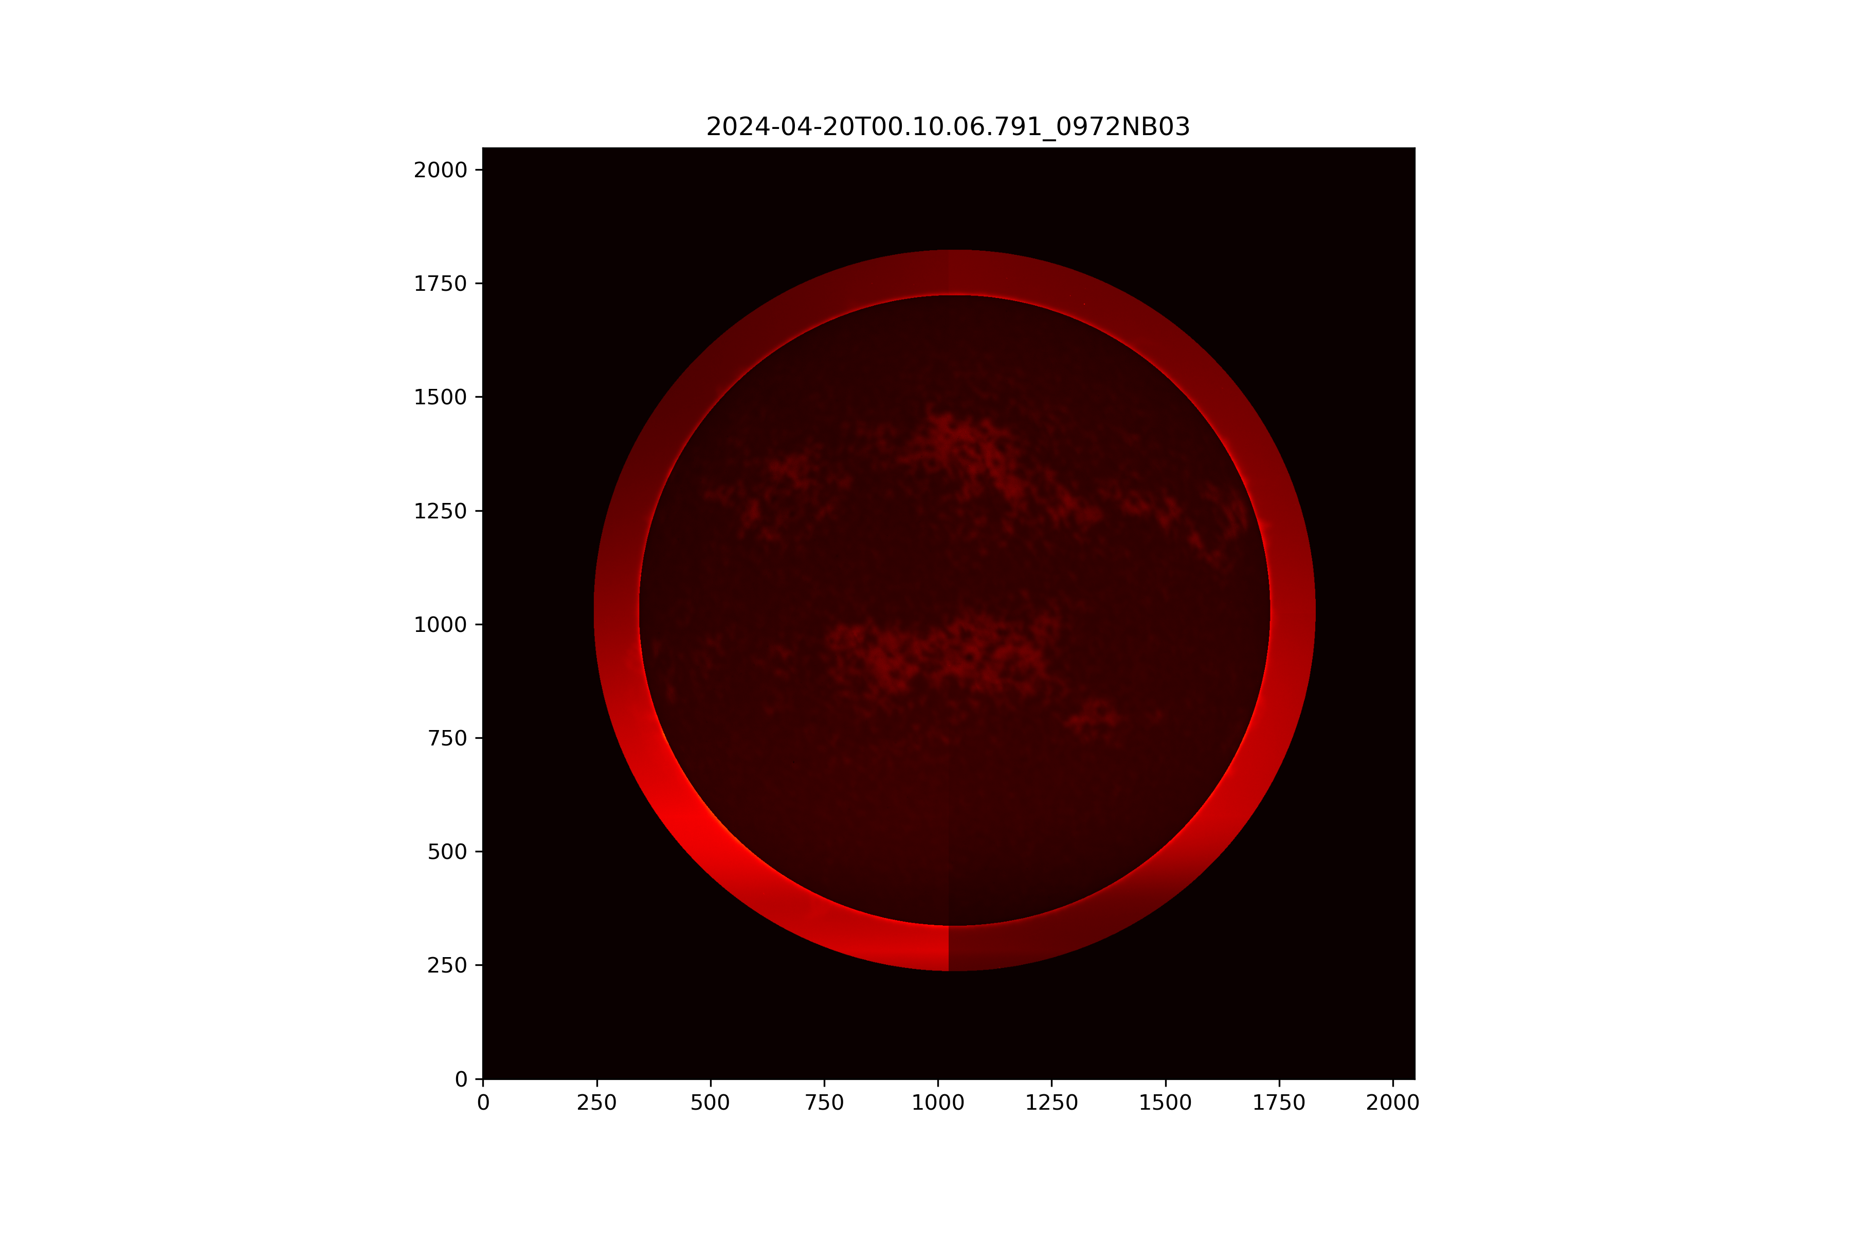

Figure 1 Example of Solar Off Limb feature visualization code.

**Conclusion**

* The project saves limb enhanced .png files in the $PROJECT/products directory.
* This script has been tested with SUIT 2k X 2k images taken over multiple days and with data at various field points. It has performed as desired at all times.
* This code can be easily used with 4k images and science filters other than Mg, if the sun center and sun radius information is accurately available for the same.

-x-