Hidden Magnitudes and Circular Codes
  - BlueDot Technical AI Safety Puzzle 1
7 September 2026

Summary
The unusual feature is country. At the specified hidden layer (h2), a linear probe is at chance (0.471) while a nonlinear probe reaches 0.966. The simplest high-performing geometric account is a one-dimensional interval code on the model’s food direction: the sign carries food, while the magnitude largely carries country. A raw signed projection predicts country at 0.502, whereas its absolute value and square both reach 0.946.
For Task 3, I trained a two-dimensional, unit-norm circular bottleneck on MNIST. Digit classes occupy successive angles, so even and odd digits alternate around the circle. After freezing the architecture, hyperparameters, split, and five seeds using validation data only, I evaluated once on the additional 50,000 QMNIST test examples. The mean even/odd accuracy was 0.537 for a linear probe and 0.958 for a nonlinear probe. This is a robust nonlinear advantage, though not perfect linear-probe immunity in every seed.

Task 1: Finding the unusual feature
I cached activations at the sentence embedding, each post-ReLU hidden layer, and the logits. For every feature and layer I trained:
- a logistic-regression probe; and
- a one-hidden-layer MLP probe.
Both probes were fit on the supplied training examples and scored on the supplied held-out examples. country is the only feature with a large linear/nonlinear gap at h2.
Feature | Linear probe | Nonlinear probe | Gap
country | 0.471 | 0.966 | 0.495
question | 1.000 | 1.000 | 0.000
food | 0.984 | 0.984 | 0.000
person | 0.999 | 0.999 | 0.000
body_part | 0.981 | 0.981 | 0.000
sentiment | 0.981 | 0.981 | -0.001
color | 0.973 | 0.972 | -0.001
number | 0.975 | 0.974 | -0.001
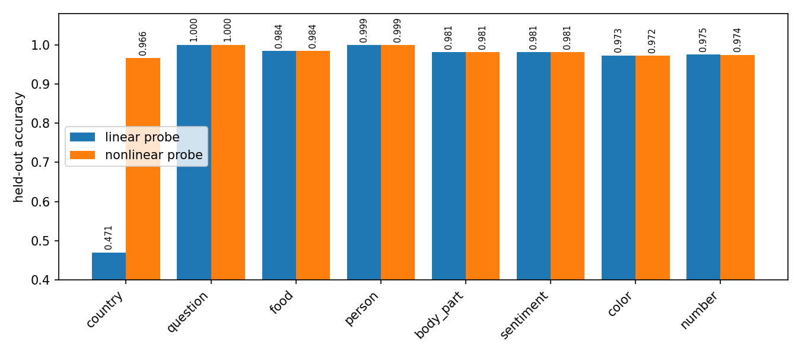
Figure 1. Held-out linear and nonlinear probe accuracy at h2. The country linear-probe bar is shown rather than clipped.
The layer trace localizes the phenomenon. Country is linearly decodable before h2, nonlinear only at h2, and linearly decodable again at h3 and the logits.
Tap | Linear | Nonlinear
embedding | 0.993 | 0.991
h0 | 0.989 | 0.991
h1 | 0.993 | 0.991
h2 | 0.471 | 0.966
h3 | 0.964 | 0.970
logits | 0.963 | 0.965
Three checks make a template artifact unlikely. Leave-one-template-out scoring gives 0.486 linear versus 0.995 nonlinear; a whitened-PCA control gives 0.503 versus 0.971; and shuffled country labels return to chance. These are probe results, not by themselves proof that the model causally uses every measured feature [1]. Here the supplied classifier’s own country output also reaches 0.964, showing that the information is behaviorally available.

Task 2: Geometry of country at h2

A magnitude code on the food direction
Let z be the standardized h2 activation and let w_food be a logistic regression direction fit to predict food on training data. I measured the scalar projection
$$p=w_{food}^{T}z.$$
The sign of p tracks food. Country changes the magnitude: country-positive examples lie nearer zero, while country-negative examples lie farther out on either side. The direction’s sign is arbitrary; the symmetric magnitude pattern is the relevant fact.
Country | Food | Mean held-out projection
0 | 0 | -21.8
0 | 1 | +18.9
1 | 0 | -5.0
1 | 1 | +4.4
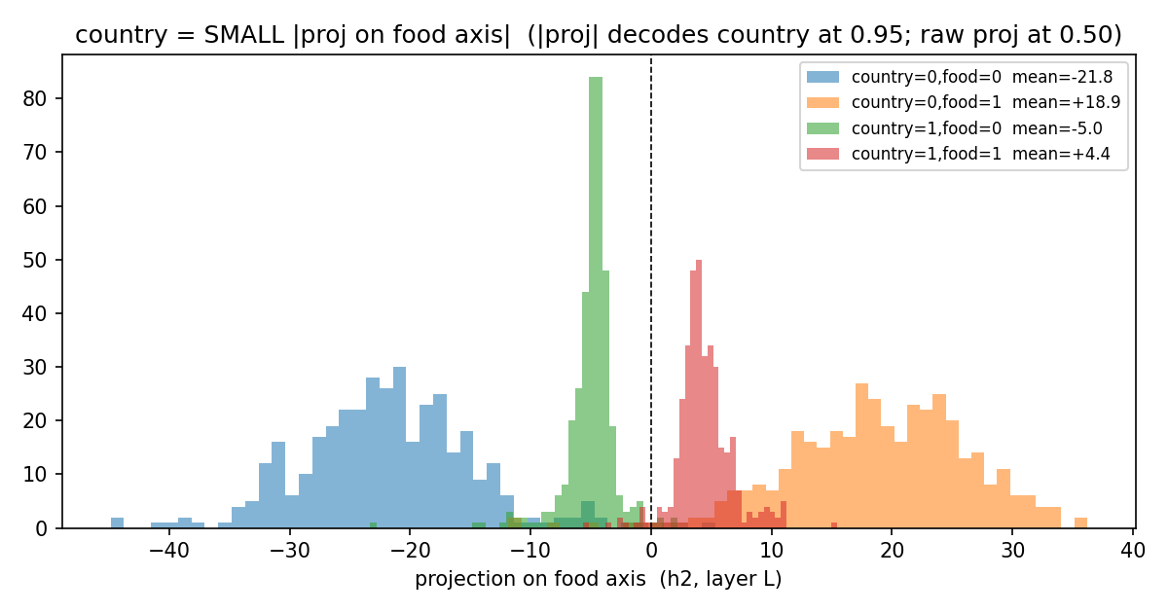
Figure 2. Measured held-out projections, not a synthetic reconstruction. Country changes distance from zero while food changes sign.
A one-dimensional decoder isolates the symmetry:
Input to logistic decoder | Country accuracy
$p$ | 0.502
$|p|$ | 0.946
$p^{2}$ | 0.946
Country directions fit separately within food=0 and food=1 have cosine similarity -0.985. Thus the country direction reverses when food changes, as expected if food supplies sign and country supplies magnitude. I therefore summarize the geometry as a primarily one-dimensional, sign-symmetric interval code aligned with the food direction. The word “primarily” matters: 0.946 is strong but not exact, and this analysis does not prove that a single scalar accounts for every country-relevant computation.
This resembles the absolute-value computation studied in toy models of superposition, where opposite ReLU branches can recover a sign-symmetric quantity [2]. It does not establish why this classifier learned the code. In particular, eight binary labels in 64 dimensions do not by themselves establish capacity pressure, so I make no capacity-causation claim.

What the next layer does, and does not show
The nonlinear code does not persist to the output: country is linearly decodable at h3 (0.964) and at the logits (0.963). Two h3 neurons have large, opposite input-weight alignment with the food direction. A newly fit logistic probe on those two activations scores 0.895, but that is correlational. Using the trained model’s actual country-output weights, those two neurons alone score only 0.517. Replacing them with their training means leaves accuracy at 0.967, compared with 0.964 unablated. They carry country-correlated information, but they are neither sufficient under the trained readout nor shown to be necessary. I therefore do not call them a two-neuron decoder.
I also discard an earlier “exact rank-1 bilinear” claim. Squaring one selected projection constructs an outer-product matrix of rank one by definition. With the separately fit unstandardized direction, that decoder reaches only 0.727; it is a rank-1 quadratic approximation, not an exact account of the classifier.

Task 3: An interleaved circular representation

Construction
A small CNN maps each MNIST image to a two-dimensional bottleneck b, normalized so that ${\left\|b\right\|}_{2}=1$. For digit class $k$, a geometry loss targets angle
$$θ_{k}=\frac{2πk}{10}$$
A linear ten-class head predicts the digit [4]. The derived binary feature is parity: even digits are classes 0, 2, 4, 6, 8, and odd digits are 1, 3, 5, 7, 9. They alternate around the unit circle, so parity occupies five disjoint angular regions rather than one half-space. Unit normalization is essential because it prevents radius from becoming a linear shortcut.

Frozen evaluation protocol
The original exploratory run repeatedly inspected a random split of all 70,000 MNIST examples. Because that split included canonical MNIST test images, I treat all results from it as contaminated and do not report them as held-out evidence.
The corrected protocol was fixed before the confirmatory audit:
- canonical MNIST training partition only;
- stratified 50,000/10,000 train/validation split, split seed 17291;
- training seeds 11, 29, 47, 71, 101;
- 30 epochs, Adam learning rate 0.001, batch size 256;
- geometry-loss weight 1.0;
- fixed epoch count, with no checkpoint or seed selection on audit outcomes; and
- a single confirmatory evaluation on QMNIST test50k, the 50,000 additional reconstructed test digits that do not duplicate the standard MNIST test set [3].
Training code never loads QMNIST. The audit script refuses to run if its result CSV already exists. Its first invocation stopped before predictions or metrics because raw QMNIST targets expose eight metadata columns; class-column extraction was unit-tested, then the unchanged frozen checkpoints were evaluated once. Checkpoint SHA-256 hashes and the event are recorded in the audit artifacts.

Confirmatory results
Metric on QMNIST test50k | Mean | SD | 95% CI
Direct ten-class head | 0.860 | 0.059 | [0.786, 0.934]
Refit linear ten-class probe | 0.949 | 0.026 | [0.916, 0.981]
Even/odd linear probe | 0.537 | 0.042 | [0.485, 0.590]
Even/odd nonlinear probe | 0.958 | 0.023 | [0.930, 0.986]
Even/odd majority baseline | 0.506 | 0.000 | [0.506, 0.506]
The intervals summarize variation across five training seeds as $\overset{‾}{x}±t_{0.975,4}s/\sqrt{5}$ with $t_{0.975,4}=2.776$; they are not per-example binomial intervals.
Seed | Validation digit | Audit digit | Audit parity linear | Audit parity nonlinear
11 | 0.811 | 0.810 | 0.495 | 0.925
29 | 0.798 | 0.795 | 0.510 | 0.965
47 | 0.878 | 0.876 | 0.525 | 0.979
71 | 0.945 | 0.943 | 0.601 | 0.976
101 | 0.881 | 0.877 | 0.555 | 0.945
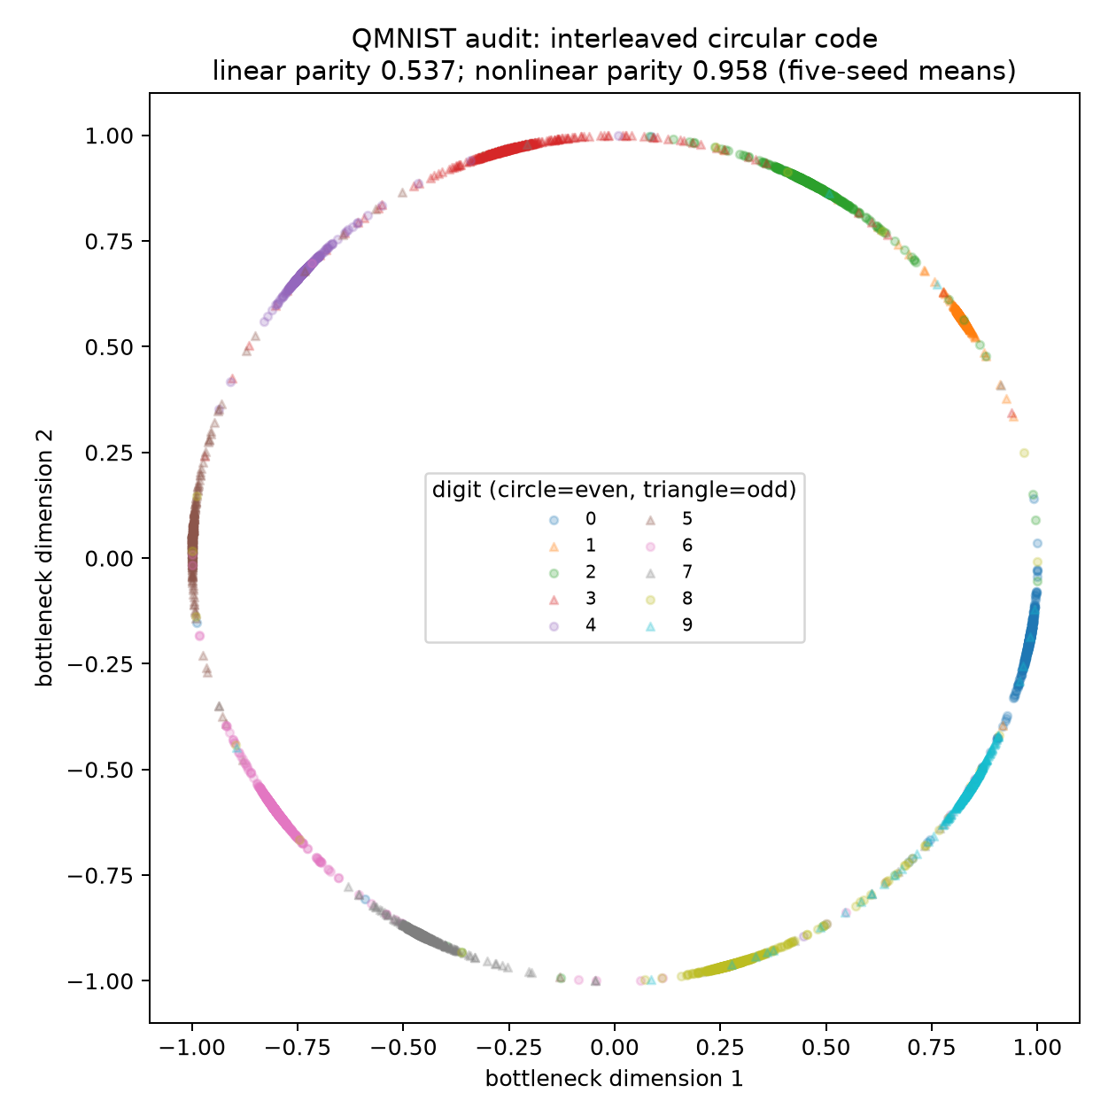
Figure 3. QMNIST audit geometry for seed 71, selected before audit because it had the highest validation digit accuracy. The title reports five-seed means.
The mean nonlinear-minus-linear parity gap is 0.421; every seed has a gap of at least 0.374. The nonlinear result is consistently high. The linear result is near the majority baseline on average, but seed 71 reaches 0.601, so the defensible claim is strong and repeatable nonlinear advantage from circular interleaving, not universal chance-level linear probing. Direct-head digit accuracy is also seed-sensitive (0.795 to 0.943), while a refit linear digit probe averages 0.949; this is a limitation of optimization in the frozen run, not something removed after seeing audit data.

Two failures that motivated the final design
Binary rotation. I first targeted two angles for binary country. The intended phase separation appeared, but a linear probe reached 0.989: two angular clusters are still separable by a line. This motivated interleaving more than two classes around the circle.
Nominal linked rings. I also tried to place country classes on two linked rings, using binary food as within-ring phase. That loss supplies only $ϕ∈\{0,π\}$, hence two target points per nominal ring. Post-hoc inspection finds only 4/12 angular bins containing at least 1% of either class and coordinate standard deviations [1.106, 0.139, 0.142]; the cloud is mostly one-dimensional. Its exploratory linear/nonlinear probe gap (0.533 versus 0.940) is real but test-contaminated. Ordering one cloud by an assumed ring angle and counting a disc crossing is not a topological invariant. This attempt failed to demonstrate linked rings, and no linking-number claim is retained.

Conclusion
Tasks 1 and 2 identify a localized nonlinear representation: country is hidden from linear readout at h2 by a sign-symmetric magnitude code tied to the food direction, then relinearized at h3. The causal evidence does not support a specific two-neuron decoder, an exact rank-1 mechanism, or a capacity-based origin story.
Task 3 shows a more elaborate binary representation by embedding a ten-class variable on a unit circle and reading parity from alternating arcs. On an additional QMNIST audit set and across five frozen seeds, nonlinear parity probes consistently outperform linear probes by a large margin. The seed variation is part of the result: the construction is strongly probe-resistant on average, but not perfectly immune to linear leakage.

Reproducibility
The clean setup uses Python 3.11, Torch 2.2, and torchvision 0.17:
./setup.sh
conda activate bluedot-impact-puzzle-1-py311
pytest -q
Task 3’s frozen training entry point is scripts/18_train_mnist_circular.py. The guarded confirmatory entry point is scripts/19_analyze_mnist_circular.py. Protocol metadata, validation metrics, checkpoint hashes, per-seed audit results, and aggregate uncertainty are under artifacts/results/18_mnist_* and artifacts/results/19_mnist_*.

References
- Alain, G., and Bengio, Y. (2016, revised 2018). “Understanding intermediate layers using linear classifier probes.” arXiv:1610.01644. https://arxiv.org/abs/1610.01644
- Elhage, N., et al. (2022). “Toy Models of Superposition.” Transformer Circuits Thread. https://transformer-circuits.pub/2022/toy_model/index.html
- Yadav, C., and Bottou, L. (2019). “Cold Case: The Lost MNIST Digits.” Advances in Neural Information Processing Systems 32. https://proceedings.neurips.cc/paper/2019/hash/51c68dc084cb0b8467eafad1330bce66-Abstract.html
- LeCun, Y., Bottou, L., Bengio, Y., and Haffner, P. (1998). “Gradient-Based Learning Applied to Document Recognition.” Proceedings of the IEEE, 86(11), 2278-2324. https://doi.org/10.1109/5.726791

