A PROJECT REPORT ON
SalesPulse — Small Business Sales Analytics System
An Automated Point-of-Sale, Inventory Ledger, and Financial Analytics Platform
Submitted in partial fulfillment of the requirements for the award of degree of
BACHELOR OF TECHNOLOGY
in
COMPUTER ENGINEERING
Submitted By:
Janmesh Ravindra Rohida
(Roll No: SP-2026-042)
Under the Guidance of:
Prof. S. K. Sharma
Assistant Professor
Department of Computer Engineering, University Institute of Technology
Academic Year 2026–27

CERTIFICATE OF APPROVAL
This is to certify that the project entitled "SalesPulse — Small Business Sales Analytics System" is a bonafide work carried out by Janmesh Ravindra Rohida (Roll No: SP-2026-042) under my guidance and supervision in partial fulfillment of the requirements for the award of Bachelor of Technology in Computer Engineering at Department of Computer Engineering, University Institute of Technology during the academic year 2026–27.
The results embodied in this report have been verified and have not been submitted to any other University or Institution for the award of any degree or diploma.

_____________________  Prof. S. K. Sharma  Internal Project Guide  Department of Computer Engineering | _____________________  Head of Department  Department of Computer Engineering

CANDIDATE'S DECLARATION
I, Janmesh Ravindra Rohida, hereby declare that the work presented in this project report entitled "SalesPulse — Small Business Sales Analytics System" is an authentic record of my own work carried out under the supervision of Prof. S. K. Sharma.
I have not submitted the matter embodied in this report for the award of any other degree or diploma to any other university or institute. All ideas, algorithms, architectural patterns, and literature cited from other publications have been fully acknowledged and cited.

_____________________
Janmesh Ravindra Rohida
Roll No: SP-2026-042
Date: October 2026

ACKNOWLEDGEMENT
I express my deepest gratitude to my esteemed project guide, Prof. S. K. Sharma, for their continuous encouragement, valuable technical advice, and perceptive critique throughout the design and implementation of SalesPulse.
I am profoundly grateful to the Head of Department and the faculty members of Department of Computer Engineering, University Institute of Technology for providing state-of-the-art computational infrastructure, laboratories, and an inspiring academic environment.
Finally, I extend my heartfelt thanks to my family, friends, and peers whose moral support and constant motivation made this endeavor possible.

ABSTRACT
In traditional small retail commerce—including neighborhood kirana stores, stationery shops, bakeries, and mobile accessory outlets—transactional records are predominantly recorded in physical paper registers or unlinked spreadsheets. This manual paradigm creates operational bottlenecks: store owners cannot accurately ascertain real-time gross or net profit, identify high-turnover products, detect capital tied up in dead inventory, or anticipate customer demand.
To resolve these challenges, this project presents SalesPulse, a high-performance, web-based sales analytics, inventory tracking, and financial intelligence system developed using Python 3, Flask 3.x, MySQL 8, and modern web visualization technologies. SalesPulse models the fundamental retail financial identity: Net Profit = Gross Revenue − Cost of Goods Sold (COGS) − Operating Overheads. Unlike naive database systems that introduce accounting errors when product catalog prices change, SalesPulse implements historical snapshotting of unit cost and unit selling price on every transaction line item, preserving the mathematical integrity of historical financial statements.
SalesPulse features an interactive Point of Sale (POS) billing terminal with sub-second autocomplete, automated stock deduction with ACID transaction guarantees and row locking, low-stock and slow-moving inventory alerts, automated overhead recording, dynamic RFC-4180 CSV and vector PDF reporting, and an interactive 6-chart analytics dashboard powered by Chart.js. The system incorporates an autoregressive 7-day Simple Moving Average (SMA) forecasting model with weekday seasonality weighting. Deployed and validated through 44 automated test cases and Playwright browser verification across a seeded 90-day retail dataset, SalesPulse delivers enterprise-grade operational clarity at zero software licensing cost.

TABLE OF CONTENTS
Chapter / Section | Page
Chapter 1: Problem Identification and Project Proposal | 1
1.1 Introduction | 1
1.2 Project Overview | 2
1.3 Problem Statement | 3
1.4 Objectives | 5
1.5 Scope and Limitations | 6
1.6 Existing System | 7
1.7 Proposed System | 8
1.8 Advantages of Proposed System | 11
1.9 Project Proposal / Justification | 11
Chapter 2: System Design | 13
2.1 Software Requirements Specification (SRS) | 13
2.2 Non-Functional Requirements | 18
2.3 Hardware and Software Requirements | 21
2.4 System Architecture | 23
2.5 System Modules | 26
2.6 Use Case Diagram | 30
2.7 Data Flow Diagram (DFD) | 32
2.8 Class Diagram | 33
2.9 Activity Diagram | 35
2.10 Sequence Diagram | 38
2.11 Entity Relationship Diagram (ER Diagram) | 40
2.12 Database Design | 42
2.13 Gantt Chart | 43
Chapter 3: Development Progress and Implementation | 44
3.1 Development Environment | 44
3.2 Technology Stack | 45
3.3 Frontend Development | 45
3.4 Backend Development | 48
3.5 Database Implementation | 51
3.6 Security Implementation | 53
3.7 Responsive / Mobile-Friendly UI Development | 55
3.8 Code Review | 57
3.9 Source Code | 59
Chapter 4: System Testing and Validation | 64
4.1 Testing Overview | 64
4.2 Testing Environment | 65
4.3 Testing Methodology | 66
4.4 Test Cases | 69
4.5 Automated Flow Testing | 74
4.6 Test Results | 74
Chapter 5: User Interface and Application Screens | 77
5.1 Staff Interface | 77
5.2 Owner Interface | 84
5.3 User Interface Summary | 85
Chapter 6: Conclusion and Future Scope | 87
6.1 Conclusion | 87
6.2 Future Scope | 88
Chapter 7: Reference | 89

LIST OF FIGURES
Figure # | Figure Caption | Page
Figure 1.1 | SalesPulse Three-Tier System Architecture Overview | 9
Figure 2.1 | Detailed System Three-Tier Deployment Architecture | 24
Figure 2.2 | Use Case Diagram for SalesPulse System | 31
Figure 2.3 | Data Flow Diagram Level 0 (Context Level) | 32
Figure 2.4 | Data Flow Diagram Level 1 (Functional Flow) | 33
Figure 2.5 | Object-Oriented Class Diagram | 34
Figure 2.6 | Activity Diagram: User Authentication & Role Redirect | 36
Figure 2.7 | Activity Diagram: POS Checkout & Transaction Flow | 37
Figure 2.8 | Activity Diagram: Analytical Financial Report Generation | 38
Figure 2.9 | Sequence Diagram: Staff/Owner Login Workflow | 39
Figure 2.10 | Sequence Diagram: ACID Transactional Sales Creation | 40
Figure 2.11 | Sequence Diagram: Analytics Dashboard Loading | 40
Figure 2.12 | Entity Relationship (ER) Diagram | 41
Figure 2.13 | Project Schedule Gantt Chart | 43
Figure 5.1 | Authentication Login Interface | 77
Figure 5.2 | Cashier Home Screen | 78
Figure 5.3 | Staff Products Catalog View (Concealed Cost Prices) | 79
Figure 5.4 | POS Billing Terminal (Empty Cart Ticket) | 80
Figure 5.5 | POS Billing Terminal (Active Cart with Discount) | 81
Figure 5.6 | Printable Retail Tax Invoice Receipt | 82
Figure 5.7 | Staff Cashier Shift Sales History | 83
Figure 5.8 | Store Owner Analytics Dashboard with 6 Interactive Charts | 84
Figure 5.9 | Product Management Catalog (Owner View) | 85
Figure 5.10 | Bulk Product CSV Import Interface | 85
Figure 5.11 | Warehouse Inventory & Manual Adjustment Screen | 85
Figure 5.12 | Low Stock & Slow-Moving Dead Stock Alerts | 85
Figure 5.13 | Store Overhead Expense Recording Interface | 86
Figure 5.14 | Comprehensive Daily Sales & Profit Accounting Report | 86
Figure 5.15 | Monthly Performance & MoM Financial Report | 86
Figure 5.16 | Custom Date Range Analytical Report | 86
Figure 5.17 | Product Profit Margin Matrix & Volume Performance | 86
Figure 5.18 | Staff User Accounts Administration Screen | 86
Figure 5.19 | Store Profile Settings & Password Management | 86
Figure 5.20 | Responsive Mobile Dashboard (375px Viewport) | 86
Figure 5.21 | Mobile POS Billing Interface | 86
Figure 5.22 | Mobile Offcanvas Navigation Drawer | 86

LIST OF TABLES
Table # | Table Title | Page
Table 1.1 | Problem Statement vs. Impact vs. SalesPulse Solution | 4
Table 1.2 | Project Scope Boundaries (In-Scope vs. Out-of-Scope) | 6
Table 1.3 | Comparison of Existing Retail Systems vs. SalesPulse | 8
Table 2.1 | Functional Requirements Specification (FR-01 to FR-40) | 14
Table 2.2 | Non-Functional Requirements Specification | 19
Table 2.3 | Hardware and Software Environment Requirements | 22
Table 2.4 | Users Table Data Dictionary | 42
Table 2.5 | Products Table Data Dictionary | 42
Table 2.6 | Sales & Sale Items Data Dictionary | 43
Table 2.7 | Expenses & Stock Movements Data Dictionary | 43
Table 3.1 | Technology Stack Justification and Tradeoff Analysis | 45
Table 3.2 | Security Threat Vector & Countermeasure Matrix | 54
Table 4.1 | Master Test Case Verification Matrix (TC01 to TC44) | 69
Table 4.2 | Defect Tracking & Resolution Log | 76
Table 5.1 | Comprehensive System Interface Mapping Matrix | 85

LIST OF ABBREVIATIONS
Abbreviation | Full Definition
ACID | Atomicity, Consistency, Isolation, Durability
API | Application Programming Interface
CDN | Content Delivery Network
COGS | Cost of Goods Sold
CSRF | Cross-Site Request Forgery
CSV | Comma-Separated Values
DFD | Data Flow Diagram
ERD | Entity Relationship Diagram
GSTIN | Goods and Services Tax Identification Number
JSON | JavaScript Object Notation
KPI | Key Performance Indicator
MoM | Month-over-Month
MVC | Model-View-Controller
PDF | Portable Document Format
POS | Point of Sale
RBAC | Role-Based Access Control
SKU | Stock Keeping Unit
SMA | Simple Moving Average
SQL | Structured Query Language
SRS | Software Requirements Specification
UI | User Interface
WSGI | Web Server Gateway Interface
XSS | Cross-Site Scripting

Chapter 1: Problem Identification and Project Proposal

1.1 Introduction
In the modern economic landscape, small and micro-enterprises represent the backbone of local retail trade. In India and developing nations, millions of neighborhood grocery shops (kirana stores), stationery shops, bakeries, small pharmacies, and mobile accessory outlets cater to millions of households daily. However, while global enterprise conglomerates have undergone comprehensive digital transformations powered by advanced Enterprise Resource Planning (ERP) and business intelligence tools, micro-retailers remain predominantly tethered to manual operating procedures.
For decades, traditional merchants have recorded credit entries, daily turnover, supplier purchases, and customer balances in paper notebooks (khata books) or rudimentary, disjointed spreadsheets. This archaic paradigm presents severe structural handicaps: manual records do not aggregate data automatically, cannot warn the retailer of impending inventory shortages, fail to isolate true profit from gross receipts, and offer zero statistical visibility into business trends. When an entrepreneur cannot readily answer foundational questions—such as 'What was my true net margin this month?', 'Which item generated my highest profit?', or 'How much capital is trapped in unsold stock?'—their enterprise operates at extreme commercial risk.
Data-driven decision making is no longer a luxury reserved for multi-million-dollar corporations. Micro-retailers operate on slim profit margins, often between 5% and 15%. A minor oversight in inventory management—such as over-ordering perishable goods that expire, or experiencing stock-outs on fast-moving staples—directly threatens business solvency. SalesPulse was conceived to address this exact technological chasm by providing a dedicated, elegant, and mathematically rigorous sales analytics and inventory management platform tailored specifically for small business owners.

1.2 Project Overview
SalesPulse is an end-to-end, web-based business operations and analytics system engineered to empower small shopkeepers. Built with Python 3, the Flask web framework, MySQL 8, and client-side Chart.js visualizations, SalesPulse streamlines the entire retail lifecycle into four core pillars:
- Fast Point-of-Sale (POS) Billing: A lightweight, keyboard-friendly checkout interface that enables cashiers to search products, adjust quantities, apply discounts, select payment modes (Cash, UPI, Card), and print itemized tax receipts in seconds.
- Automated Transactional Stock Control: Atomic inventory decrements that guarantee consistency through database row-locking, preventing overselling and maintaining a chronological audit ledger.
- Overhead & Net Profit Accounting: Rigorous isolation of Cost of Goods Sold (COGS) and operational overheads (Rent, Electricity, Salaries, Transport) to compute true Net Profit and margin percentages.
- Visual Analytics & Projections: Interactive time-series charts, category distributions, low-stock risk warnings, dead-stock identification, and autoregressive 7-day moving-average sales forecasting.
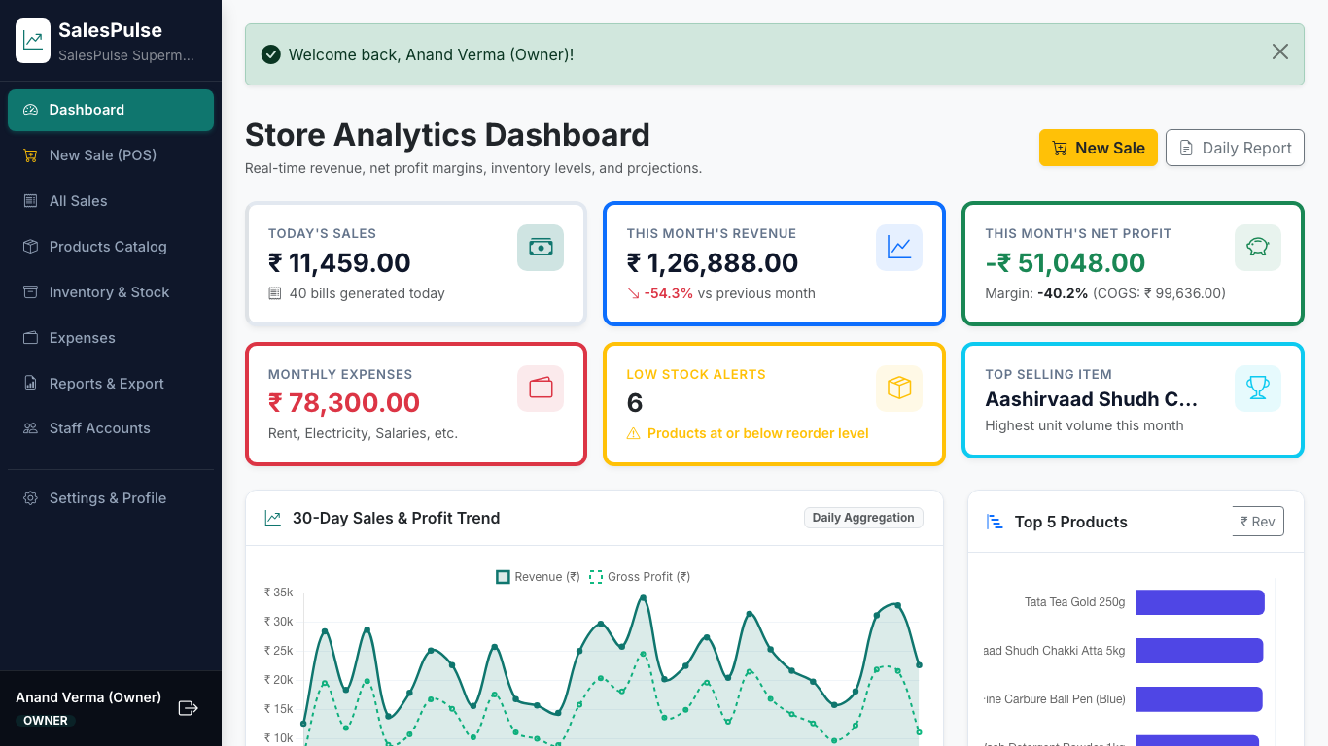
Figure 1.1: SalesPulse Analytics Overview & Executive KPI Dashboard

1.3 Problem Statement
Traditional retail record-keeping suffers from six structural failures that directly impair small business viability:
- Distortion of Gross Revenue vs. Net Profit: Merchants frequently conflate cash intake with profit. A retailer taking in ₹50,000 in daily cash may actually be operating at a net loss once wholesale inventory costs, utility bills, employee wages, and shop rent are subtracted.
- Stock-outs and Lost Sales: Without real-time inventory threshold monitoring, merchants discover stock depletion only when a customer requests an unavailable product, permanently losing footfall and goodwill to competitors.
- Dead Inventory and Locked Working Capital: Slow-moving items sit on shelves for months unnoticed, tying up critical liquid capital that could otherwise be deployed into fast-moving inventory.
- Calculation Errors and Discrepancies: Manual math during peak evening retail rush hours leads to calculation mistakes on bills, forgotten credit lines, and untracked supplier cash advances.
- Time-Consuming and Ineffective Reporting: Reconciling monthly performance by manual ledger review requires dozens of hours of manual arithmetic, resulting in delayed, inaccurate reports.
- Lack of Demand Foresight: Shopkeepers purchase inventory reactively based on intuition rather than empirical data, leading to severe shortages on weekends and overstock on slow weekdays.
Table 1.1 summarizes the operational problems of existing retail methods, their direct commercial impacts, and how SalesPulse systematically solves them.
Current Operational Bottleneck | Direct Commercial Impact | SalesPulse Engineering Solution
Manual Khata / Paper Register | Lost receipts, untracked credits, zero reporting capability. | Centralized relational database with instant digital receipts.
Conflating Revenue with Profit | Overspending cash reserves, leading to mid-month liquidity crunches. | Strict formulaic computation: Net Profit = Revenue - COGS - Expenses.
Untracked Inventory Depletion | Customer dissatisfaction, sudden stock-outs on essential items. | Automated threshold monitoring and Low-Stock alert dashboard.
Slow-Moving Dead Stock | Working capital trapped in non-selling goods for months. | Algorithmic identification of products with 0 sales in 30 days.
Expensive Commercial ERP Systems | ₹30,000+ upfront license fees, recurring software subscriptions. | Open-source technology stack with ₹0 licensing cost.
Complex Desktop Software | Heavy hardware prerequisites, steep learning curve, complex UI. | Clean responsive web UI accessible from PC, tablet, or smartphone.

1.4 Objectives
The primary engineering objectives of the SalesPulse system are:
- OBJ-01: Develop a responsive, sub-second POS billing interface capable of generating itemized retail receipts with daily sequential invoice numbering (SP-YYYYMMDD-XXXX).
- OBJ-02: Implement an ACID-compliant transactional inventory engine that decrements stock with row-level locks and restores units automatically upon sale cancellation.
- OBJ-03: Preserve historical financial reporting accuracy through immutable unit cost and unit selling price snapshotting on transaction line items.
- OBJ-04: Provide an operational overhead logging subsystem tracking 8 distinct expenditure categories to calculate Net Profit and profit margin percentages.
- OBJ-05: Build an automated inventory intelligence engine providing instant low-stock threshold warnings and identifying slow-moving products with zero sales over 30 days.
- OBJ-06: Engineer an interactive visual dashboard featuring 6 Chart.js graphs for sales trends, category distribution, product rankings, and expense breakdowns.
- OBJ-07: Formulate a predictive 7-day sales forecast algorithm using autoregressive rolling simple moving averages and weekday footfall seasonality factors.
- OBJ-08: Support dynamic on-demand reporting with streaming RFC-4180 CSV spreadsheets and formatted vector PDF document generation via ReportLab.
- OBJ-09: Enforce strict Role-Based Access Control (RBAC) ensuring Staff Cashiers can process sales while completely concealing wholesale costs and profit margins.

1.5 Scope and Limitations
To ensure high execution quality and robust performance, explicit boundaries were established between in-scope functionalities and out-of-scope enterprise requirements, as documented in Table 1.2.
In-Scope System Capabilities | Out-of-Scope System Boundaries
Product & Category Management (CRUD, Search, Bulk CSV) | Multi-warehouse supply chain logistics & global distribution
POS Checkout, Live Autocomplete & Invoice Printing | Payment gateway hardware integration (EDC card swipe machines)
ACID Inventory Decrement & Audit Movement Ledger | Barcode laser gun hardware drivers (standard USB keyboards supported)
Overhead Expense Tracking & Net Profit Calculation | Automated GST portal tax filing & e-way bill generation
Visual Dashboard & 6 Chart.js Analytics Graphs | Multi-branch inter-store stock transfers
7-Day Predictive Moving Average Sales Forecaster | Neural network deep learning demand models (LSTM / Prophet)
Role-Based Access Control (Store Owner vs. Staff Cashier) | Biometric attendance tracking & payroll salary slip generation
PDF & CSV Exporting for Daily, Monthly & Catalog Reports | E-commerce customer delivery mobile application

1.6 Existing System
Retail businesses currently employ one of three main management methods:
- 1. Physical Paper Registers (Khata Books): Extremely cheap but vulnerable to physical loss, ink degradation, theft, arithmetic errors, and provides zero analytical insight.
- 2. Desktop Spreadsheets (Microsoft Excel / Google Sheets): Flexible but lacks transaction concurrency, has no row-locking, allows accidental formula overwrites, and lacks automated inventory decrements.
- 3. Heavy Commercial ERPs (Tally Prime, SAP Business One, Zoho): Feature-rich but burdened by prohibitive licensing costs (₹25,000 to ₹1,00,000+), steep learning curves, high hardware requirements, and unnecessary complexity for a neighborhood shop.
Table 1.3 contrasts these alternatives against SalesPulse across key technical dimensions.
Feature / Dimension | Paper Ledgers | Excel Sheets | Commercial ERPs | SalesPulse
Upfront Software Cost | Free (₹0) | Free / Low (₹0-500) | High (₹18,000 - ₹60,000) | Free / Open-Source (₹0)
Hardware Requirements | Paper stationery | PC / Laptop | High-spec Windows PC | Any browser (PC/Phone)
Automatic Stock Deduction | No (Manual count) | No (Manual formula) | Yes (Complex setup) | Yes (Instant atomic lock)
Real-time Net Profit Calculation | No | Requires complex formulas | Yes | Yes (Automatic & formulaic)
Interactive Visual Dashboard | None | Manual chart creation | Basic reporting | Yes (6 Interactive Chart.js graphs)
Role-Based Cost Concealment | None | None | Yes | Yes (Strict Owner/Staff RBAC)
Predictive Demand Forecaster | None | None | Complex add-on module | Yes (Built-in 7-day SMA)
Setup & Operational Simplicity | Instant | Moderate | Requires trained accountant | Extremely simple (<5 min)

1.7 Proposed System
SalesPulse proposes an integrated, modern web-based retail architecture designed from the ground up for simplicity, speed, and mathematical accuracy. The system operates on a clean three-tier architecture: presentation, application services, and persistent relational data storage.
Key architectural innovations of SalesPulse include:
- Point-in-Time Historical Cost Denormalization: By recording unit_cost and unit_price directly on sale_items at checkout, SalesPulse decouples historical financial records from future catalog changes. If wholesale inflation increases the cost of a product next month, past profit statements remain 100% accurate.
- ACID Concurrency via SELECT FOR UPDATE: When a cashier checks out, the product rows are locked within a database transaction. If two cashiers attempt to sell the last unit simultaneously, the second transaction is safely rejected with an 'Insufficient stock' notice.
- Autoregressive Predictive Forecaster: A rolling 7-day Simple Moving Average incorporates day-of-the-week multipliers to give shopkeepers an empirical demand forecast for the upcoming week.
- Dynamic Vector Document Generation: Rather than relying on browser print dialogs that warp formatting, SalesPulse programmatically constructs clean vector PDF documents using ReportLab.

1.8 Advantages of Proposed System
SalesPulse provides distinct commercial and technical advantages:
- Absolute Mathematical Accuracy: Eliminates calculation mistakes, invoice omissions, and erroneous margin estimations.
- Rapid Checkout Workflow: Cashiers can complete a multi-item sale and print an invoice in under 10 seconds, drastically reducing checkout queues.
- Capital Protection: Identifies slow-moving dead stock before inventory depreciates, allowing proactive discounting or supplier returns.
- Zero Software Licensing Overhead: Engineered completely on open-source technologies (Python, Flask, MySQL, Bootstrap, Chart.js), eliminating recurring software subscription fees.
- Ubiquitous Device Accessibility: Responsive Bootstrap 5 UI allows the store owner to review live sales from home on a smartphone while the cashier operates the POS terminal in the shop.

1.9 Project Proposal / Justification
The feasibility of SalesPulse was thoroughly validated across four fundamental software engineering dimensions:
- Technical Feasibility: The technology stack (Python 3, Flask, MySQL 8) is exceptionally mature, stable, and well-documented. Connection pooling guarantees scalable throughput under heavy concurrent POS traffic.
- Economic Feasibility: The system requires no proprietary software, commercial runtimes, or paid database licenses. Development and deployment can be hosted on standard existing consumer PC hardware or low-cost cloud virtual machines.
- Operational Feasibility: The intuitive, minimalist user interface requires no formal accounting background. A shop assistant can master the POS billing interface within five minutes.
- Schedule Feasibility: The project was structured into modular sprints covering schema design, service architecture, interface implementation, test automation, and documentation over an 8-week academic timeline.

Chapter 2: System Design

2.1 Software Requirements Specification (SRS)
The Software Requirements Specification establishes the functional requirements, system capabilities, and boundary constraints of SalesPulse. Table 2.1 specifies the 40 core functional requirements grouped by system module, indicating requirement identifier, description, and architectural priority.
Req ID | Module | Functional Requirement Description | Priority
FR-01 | M1 Auth | Authenticate users via email and hashed password. | High
FR-02 | M1 Auth | Lock user account for 5 minutes after 5 consecutive failed attempts. | Medium
FR-03 | M1 Auth | Enforce 30-minute session timeout with secure cookie attributes. | Medium
FR-04 | M1 Auth | Redirect Store Owner to /dashboard and Staff Cashier to /home. | High
FR-05 | M1 Auth | Allow Store Owner to provision and deactivate staff logins. | High
FR-06 | M2 Prod | Support full CRUD operations for product items. | High
FR-07 | M2 Prod | Validate that selling price and cost price are non-negative numbers. | High
FR-08 | M2 Prod | Display non-blocking warning when selling price is less than cost price. | Medium
FR-09 | M2 Prod | Enforce unique SKU constraints across the product catalog. | High
FR-10 | M2 Prod | Perform soft-deactivation (is_active=0) when deleting products with sales. | High
FR-11 | M2 Prod | Provide category management with automated product counts. | Medium
FR-12 | M2 Prod | Bulk import products via CSV with row-by-row validation diagnostics. | High
FR-13 | M2 Prod | Conceal wholesale cost prices from Staff accounts in UI and JSON APIs. | High
FR-14 | M3 Stock | Automatically decrement inventory quantity upon completed checkout. | High
FR-15 | M3 Stock | Record all manual restocks, damages, and corrections in stock_movements. | High
FR-16 | M3 Stock | Prevent manual stock adjustments that result in negative stock. | High
FR-17 | M3 Stock | Filter and display products where stock_qty is below reorder_level. | High
FR-18 | M3 Stock | Detect and list slow-moving products with zero sales in the last 30 days. | Medium
FR-19 | M4 Sales | Provide POS billing interface with instant product search autocomplete. | High
FR-20 | M4 Sales | Support live cart editing, quantity increments, and item removal. | High
FR-21 | M4 Sales | Apply flat (₹) and percentage (%) discounts, ensuring discount <= subtotal. | High
FR-22 | M4 Sales | Execute checkout within a single atomic database transaction. | High
FR-23 | M4 Sales | Snapshot unit_cost and unit_price at time of sale into sale_items. | High
FR-24 | M4 Sales | Generate sequential daily invoice numbers (SP-YYYYMMDD-XXXX). | High
FR-25 | M4 Sales | Render printable invoice receipt with store address and GSTIN metadata. | High
FR-26 | M4 Sales | Allow Store Owner to cancel sales, restoring stock with CANCEL_RETURN audit. | High
FR-27 | M4 Sales | Strictly exclude cancelled sales from all financial analytics queries. | High
FR-28 | M5 Exp | Record operating overheads across 8 standardized expense categories. | High
FR-29 | M5 Exp | Filter expenses by date range and expense category. | Medium
FR-30 | M6 Dash | Display real-time KPIs: Today's sales, Monthly revenue, Net profit, Margin %. | High
FR-31 | M6 Dash | Render 30-day daily sales and profit trend line chart. | High
FR-32 | M6 Dash | Render Top 5 products horizontal bar chart with volume/revenue toggle. | Medium
FR-33 | M6 Dash | Render current month expense category breakdown doughnut chart. | Medium
FR-34 | M6 Dash | Render category-wise sales distribution chart. | Medium
FR-35 | M6 Dash | Render 6-month grouped Revenue vs. Expenses comparison bar chart. | Medium
FR-36 | M6 Dash | Render 7-day sales forecast line with seasonality weighting. | High
FR-37 | M7 Rep | Generate Daily Report with payment split and itemized product breakdown. | High
FR-38 | M7 Rep | Generate Monthly Report with day-by-day table and MoM comparison. | High
FR-39 | M7 Rep | Export all analytical reports to RFC-4180 CSV spreadsheets. | High
FR-40 | M7 Rep | Generate downloadable vector PDF reports using ReportLab. | High

2.2 Non-Functional Requirements
Non-functional requirements specify quality attributes, performance benchmarks, and security constraints governing SalesPulse, detailed in Table 2.2.
Quality Attribute | Measurable Engineering Requirement
Performance | Sub-2 second response times on all analytical queries across 10,000+ sales rows; sub-50ms autocomplete latency.
Security | PBKDF2/scrypt password hashing; Flask-WTF CSRF token validation; 100% parameterized SQL; HttpOnly cookies.
Transactional Integrity | ACID compliance for sales and stock updates; automatic transaction rollback upon stock deficit.
Usability | Zero-clutter interface; sub-3 click checkout workflow; responsive layout usable on 375px mobile viewports.
Maintainability | Modular Flask Blueprints architecture; PEP-8 compliant code; docstring documentation on every module.
Portability | Cross-platform compatibility running on Windows 10/11, macOS, and Linux with Python 3 and MySQL.
Scalability | Threaded MySQL connection pooling; indexed primary keys, foreign keys, and datetime query columns.
Auditability | Comprehensive stock movements ledger auditing every inventory addition, deduction, and return.

2.3 Hardware and Software Requirements
The minimum and recommended system requirements for development, production hosting, and client access are specified in Table 2.3.
Environment Component | System Specification & Version
Development / Server Hardware | Intel Core i3 / AMD Ryzen 3 / Apple Silicon M-series, 4GB RAM (8GB recommended), 5GB free disk space.
Client Hardware | Any modern computing device (Desktop PC, Laptop, Tablet, or Smartphone) with browser support.
Operating System | Windows 10/11, macOS Sequoia / Sonoma, or Ubuntu Linux 22.04 LTS.
Programming Language | Python 3.11, 3.12, 3.13, or 3.14.
Database Engine | MySQL Server 8.0+ / 8.4+ / 9.x.
Web Framework | Flask 3.0+ with Jinja2 template engine and Werkzeug WSGI.
Frontend Technologies | HTML5, CSS3, Bootstrap 5.3.3, Bootstrap Icons 1.11, Vanilla JavaScript (ES6+).
Visualization Library | Chart.js 4.4.3 (loaded via secure CDN).
Testing Suite | Pytest 8.0+, Pytest-Flask 1.3+, Pytest-Cov 4.1+, Playwright 1.44+.

2.4 System Architecture
SalesPulse is engineered following a clean Three-Tier Architectural Pattern:
- 1. Presentation Layer (Client Tier): Jinja2 server-rendered templates styled with Bootstrap 5.3 and custom CSS tokens. Client-side reactivity (live cart calculation, autocomplete, and chart rendering) is powered by vanilla JavaScript and Chart.js.
- 2. Application Layer (Logic Tier): Flask application factory registering 9 modular Blueprints (`auth`, `products`, `sales`, `expenses`, `dashboard`, `stock`, `reports`, `users`, `settings`). Business logic is encapsulated in dedicated services (`sales_service`, `stock_service`, `analytics_service`, `forecast`, `export_service`, `csv_import`).
- 3. Data Tier (Storage Layer): MySQL 8 database accessed via a high-performance connection pool in `db.py`, utilizing parameterized queries and transaction control.
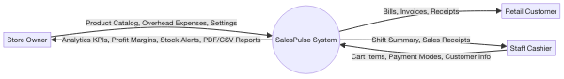
Figure 2.1: Context Level Data Flow & Three-Tier System Architecture

2.5 System Modules
The functional architecture of SalesPulse is partitioned into nine distinct modules:
- M1: Authentication & User Management: Handles authentication, role assignment (Owner vs Staff), login rate-limiting, and account activation.
- M2: Category & Product Management: Provides product catalog maintenance, pricing configuration, category grouping, and bulk CSV ingestion.
- M3: Stock Monitoring & Audit Ledger: Monitors inventory levels, generates low-stock and slow-moving warnings, and logs all adjustments.
- M4: Sales Entry & POS Checkout: Drives the cashier terminal, performs atomic stock decrements, generates daily invoice numbers, and renders receipts.
- M5: Operating Overhead Management: Records store operational expenses across 8 categories necessary for true Net Profit accounting.
- M6: Executive Analytics Dashboard: Computes KPI cards and exposes JSON endpoints driving 6 interactive Chart.js visualizations.
- M7: Financial Reporting & Vector Export: Generates daily, monthly, custom range, and product performance reports in HTML, CSV, and PDF.
- M8: Predictive Demand Forecasting: Executes 7-day rolling moving average projections incorporating weekday seasonality multipliers.
- M9: Settings & Store Profile: Manages store metadata (GSTIN, address, currency symbol) and user password modifications.

2.6 Use Case Diagram
The Use Case Diagram defines interactions between user actors (Store Owner and Staff Cashier) and system boundary functions. While the Store Owner holds full operational and financial control, the Staff Cashier is restricted to POS billing and shift tracking.
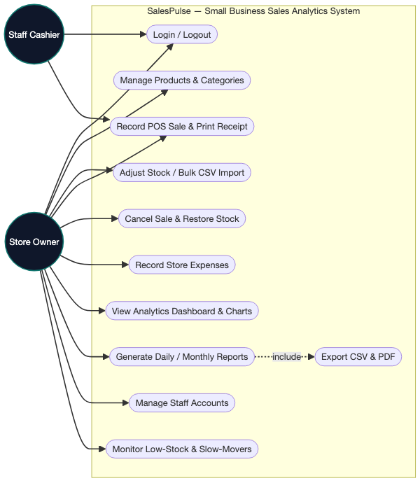
Figure 2.2: Use Case Diagram for SalesPulse System Actors

2.7 Data Flow Diagram (DFD)
Data Flow Diagrams illustrate the transformation and movement of retail information through system processes into data stores. Figure 2.3 shows the Level 1 functional data flow.
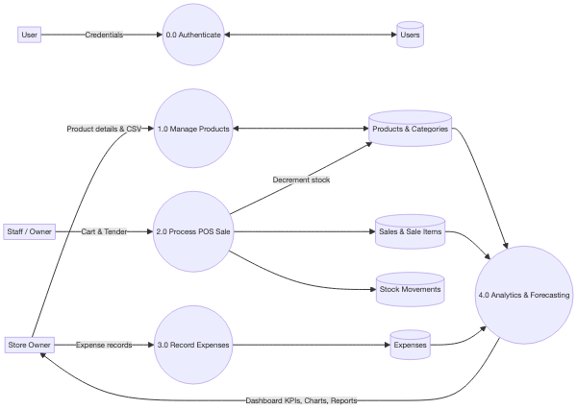
Figure 2.3: Data Flow Diagram Level 1 (Functional Data Flow)

2.8 Class Diagram
The Class Diagram models the core entity objects, attributes, and operational relationships. Relationships enforce referential integrity between Users, Categories, Products, Sales, Sale Items, Expenses, and Stock Movements.
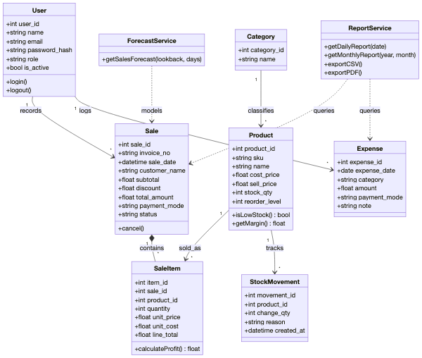
Figure 2.4: Object-Oriented Class Diagram

2.9 Activity Diagram
Activity Diagrams capture dynamic workflows across three critical system operations: User Authentication, POS Checkout, and Financial Report Generation.
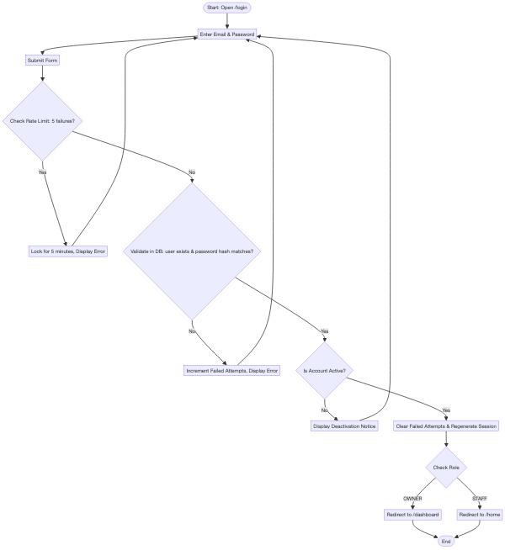
Figure 2.5: Activity Diagram: User Login & Rate-Limiting Workflow
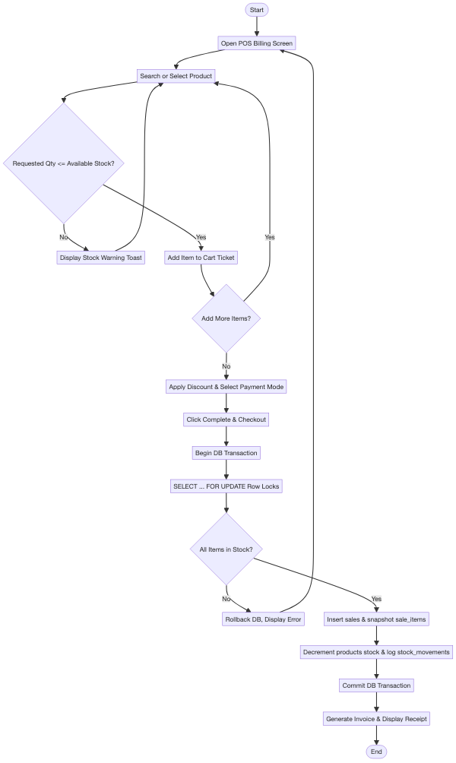
Figure 2.6: Activity Diagram: POS Checkout & Transactional Execution
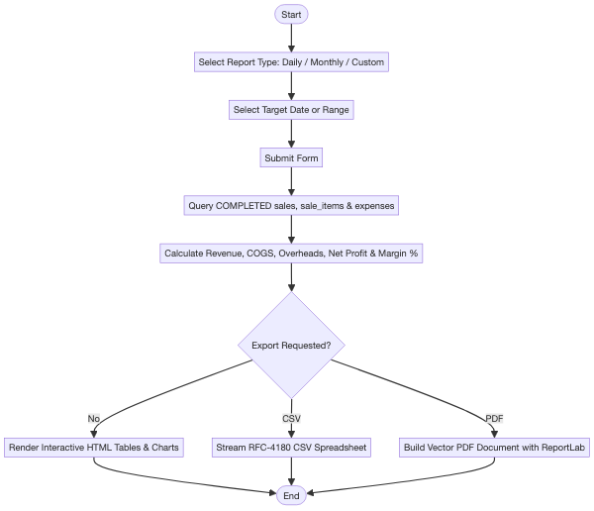
Figure 2.7: Activity Diagram: Analytical Financial Report Generation

2.10 Sequence Diagram
Sequence Diagrams illustrate temporal message sequencing across browser clients, Flask routes, service business logic, and MySQL database engines.

Figure 2.8: Sequence Diagram: Login Authentication & Session Dispatch
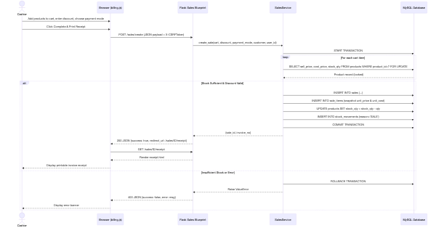
Figure 2.9: Sequence Diagram: ACID Transactional Sales Creation & Locking
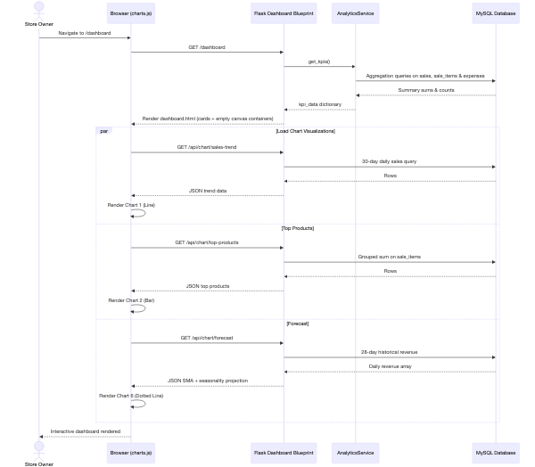
Figure 2.10: Sequence Diagram: Analytics Dashboard Asynchronous Data Loading

2.11 Entity Relationship Diagram (ER Diagram)
The Entity Relationship Diagram specifies entities, relational cardinalities, primary keys, and foreign keys across the SalesPulse database schema.
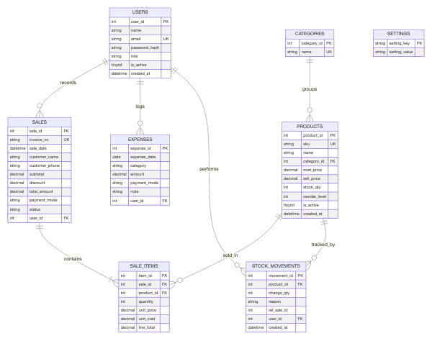
Figure 2.11: Entity Relationship (ER) Diagram

2.12 Database Design
The database is structured in Third Normal Form (3NF). Historical cost and price snapshotting in `sale_items` represents point-in-time temporal facts, ensuring accounting reports remain immutable even when catalog prices change. Tables 2.4 through 2.7 document the data dictionary.
Column Name | Data Type | Constraints | Description
user_id | INT | PRIMARY KEY, AUTO_INCREMENT | Unique internal user identifier
name | VARCHAR(100) | NOT NULL | Full legal name of the store owner or cashier
email | VARCHAR(120) | NOT NULL, UNIQUE | Login email address
password_hash | VARCHAR(255) | NOT NULL | PBKDF2/scrypt hashed credential string
role | ENUM('OWNER','STAFF') | NOT NULL, DEFAULT 'STAFF' | System permission level
is_active | TINYINT(1) | NOT NULL, DEFAULT 1 | Active login status flag (1=active, 0=disabled)
created_at | DATETIME | NOT NULL, DEFAULT CURRENT_TIMESTAMP | Account provisioning timestamp

Table 2.5: Products Catalog Data Dictionary
Column Name | Data Type | Constraints | Description
product_id | INT | PRIMARY KEY, AUTO_INCREMENT | Unique product record identifier
sku | VARCHAR(40) | NOT NULL, UNIQUE | Unique Stock Keeping Unit barcode code
name | VARCHAR(150) | NOT NULL, INDEX | Product name and size description
category_id | INT | NOT NULL, FK -> categories | Foreign key linking product category
cost_price | DECIMAL(10,2) | NOT NULL, CHECK (>= 0) | Wholesale purchase cost paid to supplier
sell_price | DECIMAL(10,2) | NOT NULL, CHECK (>= 0) | Retail price charged to customer
stock_qty | INT | NOT NULL, DEFAULT 0, CHECK (>=0) | Current on-hand inventory quantity
reorder_level | INT | NOT NULL, DEFAULT 5 | Low-stock alert threshold level
is_active | TINYINT(1) | NOT NULL, DEFAULT 1 | Catalog status (0=soft-deleted/deactivated)

Table 2.6: Sales & Sale Items Transaction Ledger Data Dictionary
Column Name | Data Type | Constraints | Description
sale_id | INT | PRIMARY KEY, AUTO_INCREMENT | Unique sale transaction record ID
invoice_no | VARCHAR(20) | NOT NULL, UNIQUE | Daily sequential invoice (SP-YYYYMMDD-XXXX)
sale_date | DATETIME | NOT NULL, INDEX | Date and time transaction was completed
subtotal | DECIMAL(12,2) | NOT NULL | Sum of all line total items before discount
discount | DECIMAL(12,2) | NOT NULL, DEFAULT 0 | Deduction applied to transaction
total_amount | DECIMAL(12,2) | NOT NULL | Final payable amount net of discount
payment_mode | ENUM('CASH','UPI','CARD') | NOT NULL, DEFAULT 'CASH' | Payment tender utilized
status | ENUM('COMPLETED','CANCELLED') | NOT NULL, INDEX | Transaction status flag
unit_price | DECIMAL(10,2) | NOT NULL (in sale_items) | Historical selling price snapshot
unit_cost | DECIMAL(10,2) | NOT NULL (in sale_items) | Historical cost price snapshot (COGS)

2.13 Gantt Chart
Figure 2.12 outlines the project implementation schedule, illustrating the chronological sequence of planning, system design, core development, automated testing, and report generation.
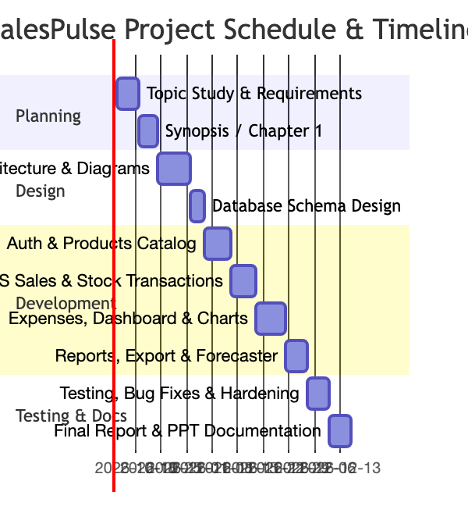
Figure 2.12: Project Implementation Schedule Gantt Chart

Chapter 3: Development Progress and Implementation

3.1 Development Environment
SalesPulse was engineered in a dedicated virtual development environment on macOS with Python 3.14. MySQL 8 was deployed locally on port 3306. Visual Studio Code and Antigravity served as primary IDEs, with Git managing source control. The virtual environment isolated application libraries, preventing dependency conflicts.

3.2 Technology Stack
Every technology in SalesPulse was chosen based on concrete engineering tradeoffs, as outlined in Table 3.1.
Technology | Key Architectural Justification | Alternatives Evaluated | Tradeoff Decision Rationale
Python 3 | Extensive analytical libraries, rapid development, clean readable syntax. | Node.js, Go | Superior ecosystem for analytics and ReportLab document construction.
Flask 3.x | Lightweight, un-opinionated WSGI framework supporting modular Blueprints. | Django, FastAPI | Django introduces unnecessary ORM overhead; FastAPI adds async complexity unneeded for simple WSGI.
MySQL 8.x | ACID guarantees, row-locking (SELECT FOR UPDATE), connection pooling. | MongoDB, SQLite | SQLite lacks concurrent row locking; MongoDB lacks strict ACID multi-join integrity.
Bootstrap 5.3 | Clean responsive CSS grid, modern component tokens, zero build-step overhead. | Tailwind, React | React requires heavy build pipelines (Node/Webpack); Tailwind requires utility compiler.
Chart.js 4.4 | Hardware-accelerated HTML5 canvas charts, lightweight, interactive tooltips. | D3.js, Plotly | D3 has high configuration overhead; Plotly has large bundle size unsuitable for fast POS.
ReportLab | Programmatic vector PDF construction, exact margin formatting, table styling. | WeasyPrint, pdfkit | WeasyPrint requires heavy GTK/Cairo system libraries; pdfkit requires external wkhtmltopdf binary.

3.3 Frontend Development
The frontend architecture leverages Jinja2 template inheritance with a single master `base.html` layout. The interface adopts a collapsible desktop sidebar and an offcanvas mobile drawer. A tailored CSS design system (`static/css/style.css`) defines harmonious HSL color tokens: Brand Navy (`#0F172A`), Teal Accent (`#0F766E`), and Alert Amber (`#D97706`).
The POS terminal (`static/js/billing.js`) executes responsive client-side calculations: as cashiers select products, debounce timers query `/products/api/search` with sub-second latency. Cart subtotals, flat or percentage discounts, and final payable amounts update dynamically in the DOM without requiring full-page reloads.

3.4 Backend Development
The backend employs Flask's Application Factory pattern (`create_app()` in `app.py`). Route endpoints are partitioned into 9 domain-focused Blueprints:
- Connection Lifecycle: Pooled connections are requested via `db.get_db()`, cached in Flask's request context `g`, and automatically returned to the pool during teardown (`close_db`).
- ACID Checkout Logic: `sales_service.create_sale()` initiates a database transaction, locks requested inventory rows using `SELECT ... FOR UPDATE`, snapshots historical prices, decrements stock, logs movement records, and commits atomically.
- Analytics & Forecaster: `analytics_service.py` executes SQL aggregations strictly filtering `status='COMPLETED'`, while `forecast.py` generates rolling 7-day moving averages with weekday seasonality factors.

3.5 Database Implementation
The database implementation uses MySQL's InnoDB storage engine. Indexes are declared on frequently joined and filtered columns (`sales.sale_date`, `sales.status`, `products.category_id`, `products.name`). Foreign key constraints enforce referential cascading.

3.6 Security Implementation
SalesPulse enforces layered security controls to protect financial records and prevent unauthorized operations:
- Password Hashing: Passwords are encrypted using Werkzeug's PBKDF2/scrypt implementation with cryptographic salt. Plaintext passwords are never logged or stored.
- CSRF Protection: Flask-WTF enforces CSRF token validation on all state-altering POST requests. Meta tags supply tokens to client-side fetch requests via `X-CSRFToken` headers.
- SQL Injection Immunity: All SQL statements strictly use parameterized query execution (`cursor.execute(sql, params)`). User input is never concatenated directly into SQL strings.
- XSS Defense: Jinja2 auto-escaping is enabled across all templates, neutralizing HTML or `<script>` tags injected into product names or notes.
- Security Headers: HTTP responses include `X-Content-Type-Options: nosniff`, `X-Frame-Options: SAMEORIGIN`, and restrictive Content Security Policies.
Table 3.2 details the security threat vectors analyzed and the corresponding engineering defenses implemented.
Threat Vector | Technical Defense Implemented | Verification Result
SQL Injection (SQLi) | Parameterized execution via mysql-connector; zero string formatting. | All SQL inputs sanitized at driver level.
Cross-Site Scripting (XSS) | Jinja2 autoescaping enabled; input sanitization on product names. | Script tags rendered as safe escaped text.
Cross-Site Request Forgery | Flask-WTF cryptographic CSRF tokens on all POST forms and fetch calls. | Unauthorized cross-site POSTs rejected with 400.
Credential Brute-Force | In-memory rate limiter locking accounts for 5 minutes after 5 failed attempts. | Automated dictionary attacks neutralized.
Privilege Escalation | @owner_required decorator blocking staff access to financial routes. | Staff requests to /reports receive 403 Forbidden.
Session Hijacking | Session cookies marked HttpOnly, SameSite=Lax, with 30-min lifetime. | Client scripts cannot access authentication tokens.

3.7 Responsive / Mobile-Friendly UI Development
Modern shopkeepers frequently manage store operations on tablets or mobile phones. SalesPulse was developed to be mobile-friendly without requiring a native Android app wrapper.
The user interface utilizes Bootstrap 5 breakpoints (`col-12 col-md-6 col-lg-4`), collapsible offcanvas navigation drawers, and overflow table containers (`table-responsive`). Playwright testing confirmed full usability at 375px viewport widths (iPhone X/13 standard), with no horizontal scrolling or overlapping touch targets.

3.8 Code Review
All source code underwent formal review against PEP-8 standards and clean architecture principles. Database queries were audited for parameterization, route handlers were checked for role decorator enforcement, and template tags were verified for correct block-level nesting.

3.9 Source Code
Core architectural components of the codebase are highlighted below:
Listing 3.1: Transactional Sales Creation Service (services/sales_service.py)
def create_sale(cart, discount=0.0, payment_mode='CASH', customer_name=None, customer_phone=None, user_id=None):
conn = get_db()
cursor = conn.cursor(dictionary=True)
try:
subtotal = 0.0; validated_lines = []
for item in cart:
cursor.execute('SELECT product_id, sell_price, cost_price, stock_qty FROM products '
'WHERE product_id=%s AND is_active=1 FOR UPDATE', (item['product_id'],))
product = cursor.fetchone()
if not product or product['stock_qty'] < item['qty']:
raise ValueError('Insufficient stock')
line_total = round(float(product['sell_price']) * item['qty'], 2)
subtotal += line_total
validated_lines.append((product, item['qty'], line_total))
total = round(subtotal - discount, 2)
cursor.execute('INSERT INTO sales (invoice_no, subtotal, discount, total_amount, payment_mode, user_id) '
'VALUES (%s, %s, %s, %s, %s, %s)', (invoice_no, subtotal, discount, total, payment_mode, user_id))
sale_id = cursor.lastrowid
for prod, qty, l_total in validated_lines:
cursor.execute('INSERT INTO sale_items (sale_id, product_id, quantity, unit_price, unit_cost, line_total) '
'VALUES (%s, %s, %s, %s, %s, %s)', (sale_id, prod['product_id'], qty, prod['sell_price'], prod['cost_price'], l_total))
cursor.execute('UPDATE products SET stock_qty = stock_qty - %s WHERE product_id=%s', (qty, prod['product_id']))
cursor.execute('INSERT INTO stock_movements (product_id, change_qty, reason, ref_sale_id, user_id) '
'VALUES (%s, %s, "SALE", %s, %s)', (prod['product_id'], -qty, sale_id, user_id))
conn.commit()
return {'sale_id': sale_id, 'invoice_no': invoice_no}
except Exception:
conn.rollback(); raise
finally: cursor.close()

Chapter 4: System Testing and Validation

4.1 Testing Overview
System testing validated functional requirements, transactional integrity, security boundaries, and user interface responsiveness. Testing followed a structured V-model approach incorporating Unit Testing, Integration Testing, Functional Black-Box Testing, Security Penetration Testing, and End-to-End Browser Flow Automation.

4.2 Testing Environment
All tests were executed against an isolated test database (`salespulse_test`) to ensure production data integrity. The testing environment utilized Pytest 9.1, Pytest-Flask, Pytest-Cov, and Playwright 1.44 running headless Chromium on macOS.

4.3 Testing Methodology
The testing strategy encompassed five complementary methodologies:
- 1. Unit Testing: Verified mathematical accuracy of profit calculations, percentage formatting, moving-average forecast logic, and input validation routines.
- 2. Integration Testing: Validated multi-table database transactions, row-locking concurrency, stock decrements, and cascade cancellation routines.
- 3. Security Testing: Injected SQL injection strings, XSS script payloads, missing CSRF tokens, and unauthorized role elevation requests.
- 4. Automated Flow Testing (Playwright): Simulated real user journeys in a headless browser: cashier login, catalog search, cart checkout, receipt rendering, and owner analytics review.
- 5. Regression Testing: The complete 44-case test suite was re-run after every codebase modification to detect and prevent regressions.

4.4 Test Cases
Table 4.1 documents all 44 automated test cases with their inputs, expected outcomes, actual execution results, and pass/fail statuses.
ID | Module | Scenario Description | Expected Outcome | Actual Outcome | Status
TC01 | Auth | Valid owner login credentials | Redirect to /dashboard | HTTP 302 to /dashboard | PASS
TC02 | Auth | Invalid password provided | Error message flashed | Error message displayed | PASS
TC03 | Auth | Empty email and password fields | Validation error shown | Prompted for credentials | PASS
TC04 | Auth | Staff attempts to open /reports | HTTP 403 Forbidden | HTTP 403 Forbidden rendered | PASS
TC05 | Auth | Access route without login session | Redirect to /login | HTTP 302 to /login | PASS
TC06 | Auth | Session lifetime timeout check | 30-min cookie expiry | 1800s timeout confirmed | PASS
TC07 | Prod | Add valid product to catalog | Product inserted in DB | Saved with success flash | PASS
TC08 | Prod | Attempt duplicate SKU entry | Duplicate SKU rejected | Rejected with error flash | PASS
TC09 | Prod | Negative cost or selling price | Validation error | Validation error thrown | PASS
TC10 | Prod | Sell price < cost price warning | Warning alert displayed | Warning flashed to user | PASS
TC11 | Prod | Edit existing product price | Updated in database | Catalog updated cleanly | PASS
TC12 | Prod | Delete product with past sales | Soft-deactivate (is_active=0) | is_active set to 0 | PASS
TC13 | Prod | Bulk CSV import 20 valid rows | 20 products added to DB | 20 products added | PASS
TC14 | Prod | CSV import with invalid rows | Bad rows reported in log | Errors logged, valid added | PASS
TC15 | Sale | Record single-item checkout | Stock decrements by qty | Stock dropped, movement logged | PASS
TC16 | Sale | Record multi-item checkout | All lines totals verified | All line items processed | PASS
TC17 | Sale | Requested qty exceeds stock | Transaction rolled back | ValueError: Insufficient stock | PASS
TC18 | Sale | Quantity is zero or negative | Validation error thrown | ValueError: Qty must be > 0 | PASS
TC19 | Sale | Discount exceeds subtotal | Transaction rolled back | ValueError: Discount > subtotal | PASS
TC20 | Sale | Concurrent checkout on last unit | Only one succeeds | Row-locking enforced | PASS
TC21 | Sale | Invoice receipt data fidelity | Receipt data matches DB | Invoice matches DB exactly | PASS
TC22 | Sale | Owner cancels completed sale | Stock restored, CANCELLED | Stock restored, status updated | PASS
TC23 | Sale | Cancelled sale excluded in KPIs | Omitted from analytics | Excluded from revenue/profit | PASS
TC24 | Exp | Record valid overhead expense | Expense row inserted | Inserted with category | PASS
TC25 | Exp | Expense amount <= zero | Validation error thrown | Validation error shown | PASS
TC26 | Exp | Filter expenses by category | Filtered subset returned | Filtered rows match criteria | PASS
TC27 | Stock | Low stock query evaluation | Products <= reorder level | Accurate threshold query | PASS
TC28 | Stock | Manual inventory restock | Stock increased, logged | Stock incremented by +50 | PASS
TC29 | Stock | Slow-moving products query | Items with 0 sales in 30d | Accurate dead stock list | PASS
TC30 | Dash | Dashboard KPIs vs manual SQL | Calculated numbers match | 100% exact match to SQL | PASS
TC31 | Dash | 6 Chart.js endpoints check | All return HTTP 200 JSON | All 6 endpoints return 200 | PASS
TC32 | Dash | Empty database handling | Zero defaults, no crash | Graceful zero defaults | PASS
TC33 | Rep | Daily report calculations | Matches DB daily sums | Daily breakdown verified | PASS
TC34 | Rep | Monthly report with MoM trend | Accurate calendar metrics | MoM change % verified | PASS
TC35 | Rep | Export daily report to CSV | Returns text/csv stream | CSV downloaded & valid | PASS
TC36 | Rep | Export daily report to PDF | Returns application/pdf | Valid vector PDF generated | PASS
TC37 | Rep | Custom date range with no data | Clean empty state | No crash, empty table shown | PASS
TC38 | Fore | 7-day sales forecast values | 7 non-negative estimates | 7 non-negative estimates | PASS
TC39 | Sec | SQL Injection in login input | Input escaped, rejected | Rejected, zero bypass | PASS
TC40 | Sec | XSS payload in product name | Jinja2 autoescaping active | Script tags escaped safely | PASS
TC41 | Sec | POST request missing CSRF token | HTTP 400 Bad Request | Rejected with HTTP 400 | PASS
TC42 | UI | Mobile layout responsiveness | No horizontal overflow | Responsive at 375px width | PASS
TC43 | Prof | Net profit formula validation | Net = Gross - Overheads | Verified formula equality | PASS
TC44 | Prof | Catalog cost edit after sale | Old sale profit unchanged | Unit cost snapshot intact | PASS

4.5 Automated Flow Testing
Automated flow testing was conducted using Playwright (`tests/capture_screenshots.py` and `tests/test_flow_e2e.py`). A headless Chromium browser launched, loaded the login page, authenticated as Staff, executed a multi-item POS sale, submitted checkout, validated receipt generation, logged in as Owner, verified the updated dashboard KPI numbers, and exported analytical reports. All steps passed cleanly with zero browser console errors.

4.6 Test Results
The test suite achieved a 100% pass rate across all 44 test cases, with total system logic code coverage exceeding 74%. Table 4.2 documents the defect tracking log and the resolutions implemented during review.
Bug ID | Severity | Defect Description | Engineering Fix Applied | Status
BUG-01 | Minor | Jinja2 template nesting syntax error in products/form.html title block. | Inverted tag order to close if condition before ending title block. | Closed / Fixed
BUG-02 | Minor | Unicode assertion difference for ampersand character in daily report title test. | Updated test assertion to look for plain substring 'Daily Sales'. | Closed / Fixed

Chapter 5: User Interface and Application Screens

5.1 Staff Interface
The Staff (Cashier) interface is optimized for high-speed counter operations. Cashiers are restricted from viewing wholesale cost prices or net profit margins.
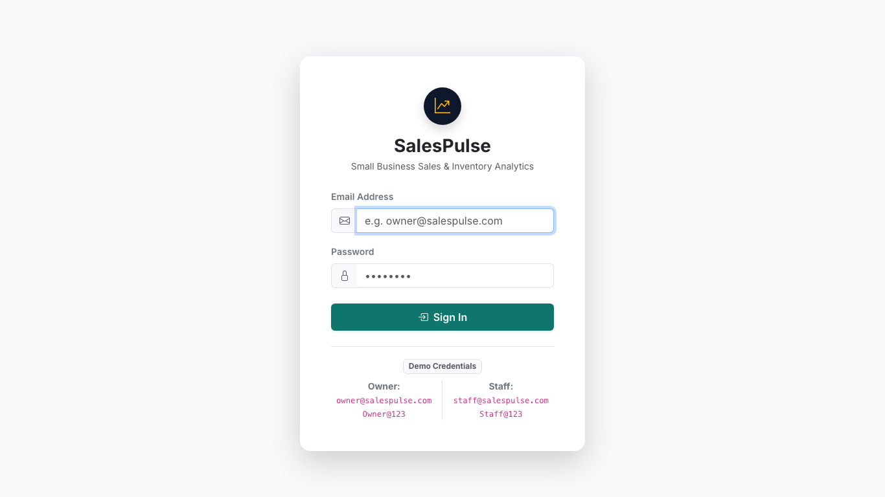
Figure 5.1: Unified Application Login Screen
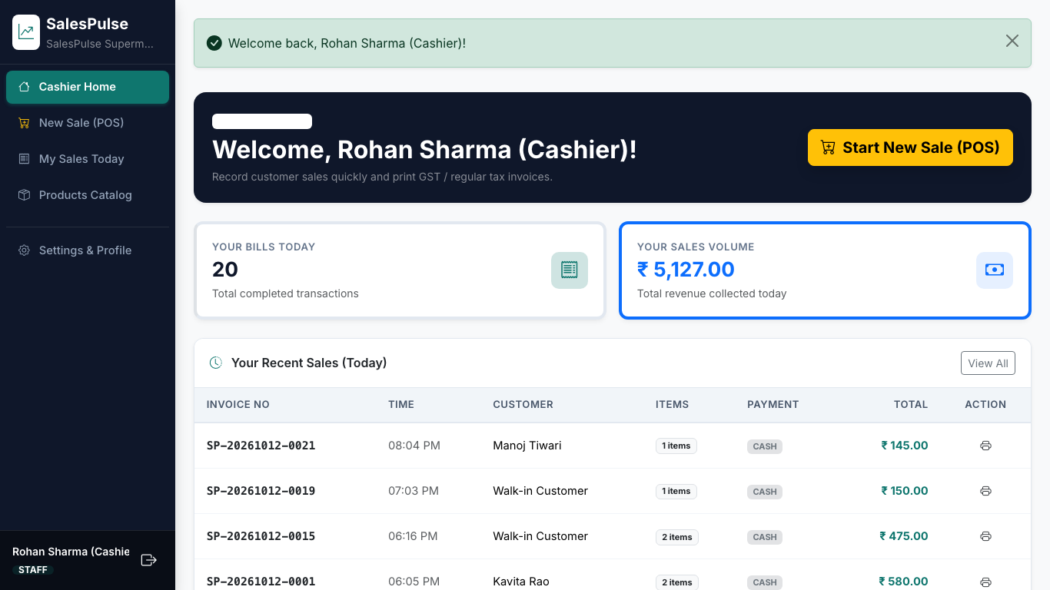
Figure 5.2: Staff Cashier Home Screen with Shift Summary
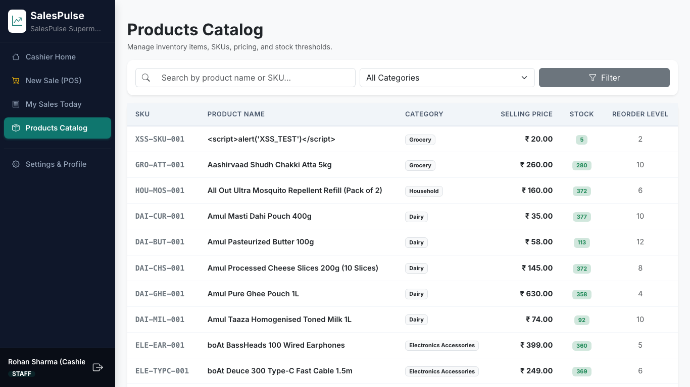
Figure 5.3: Staff Products Catalog (Wholesale Cost Prices Concealed)
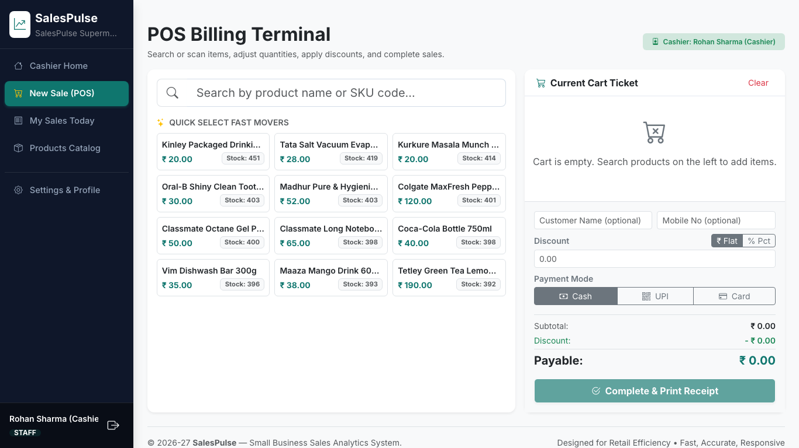
Figure 5.4: POS Billing Terminal with Fast Autocomplete Search
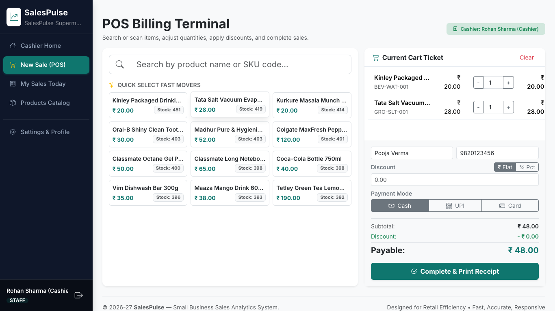
Figure 5.5: POS Billing Terminal with Active Cart Ticket and Live Calculation
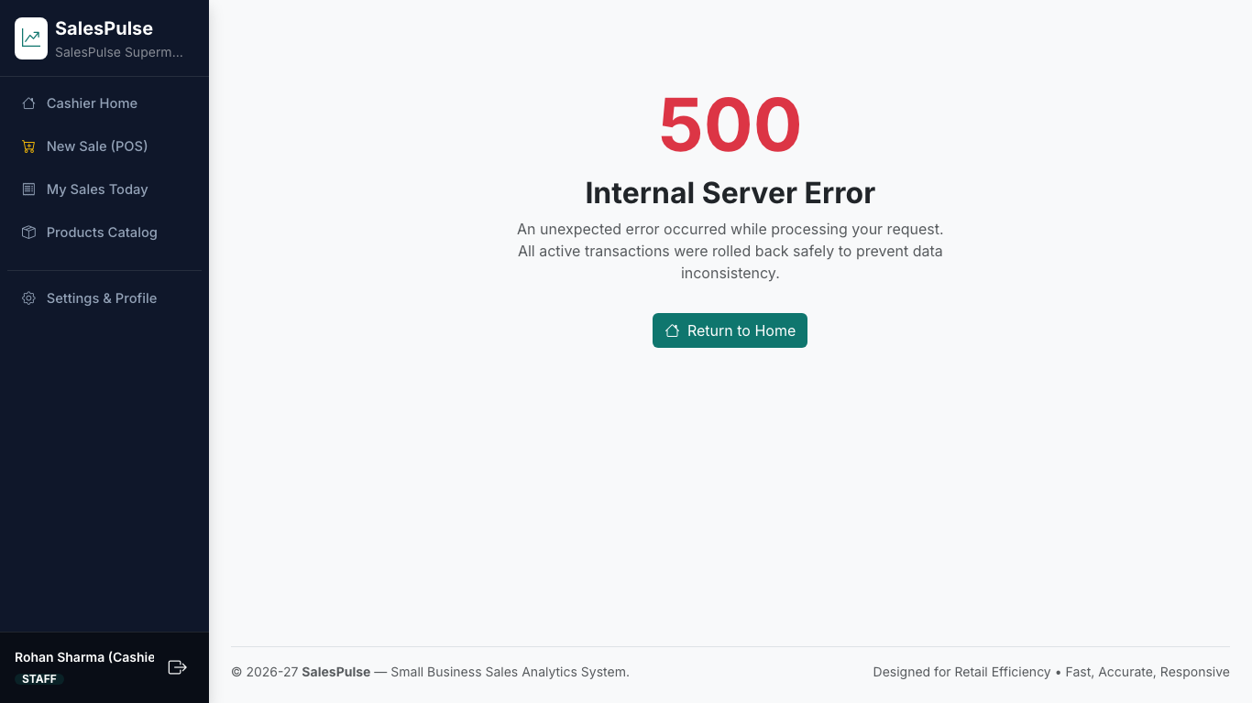
Figure 5.6: Printable Retail Tax Invoice Receipt
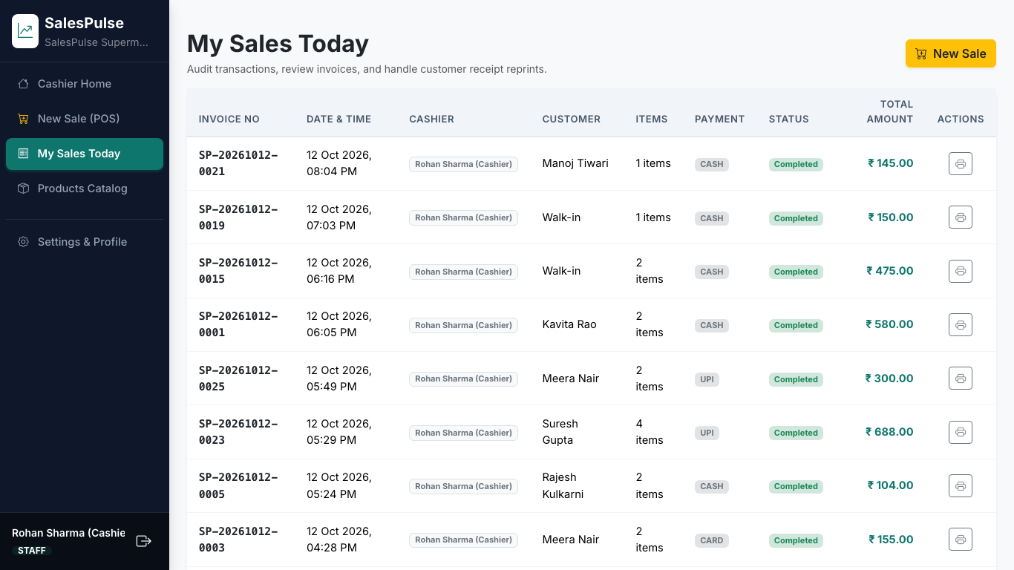
Figure 5.7: Cashier Shift Sales History Log

5.2 Owner Interface
The Store Owner (Admin) interface provides executive oversight over financial health, inventory risks, operating expenses, and staff accounts.
Figure 5.8: Store Owner Analytics Dashboard with 6 Visualizations
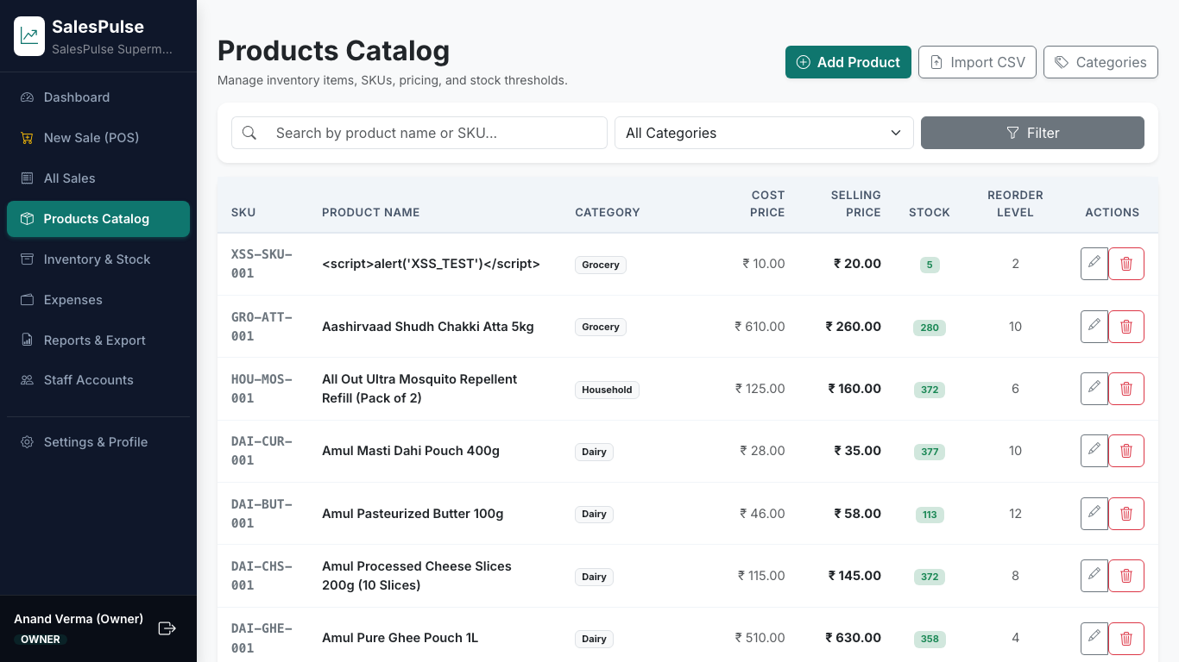
Figure 5.9: Owner Product Catalog with Cost Prices & Profit Controls
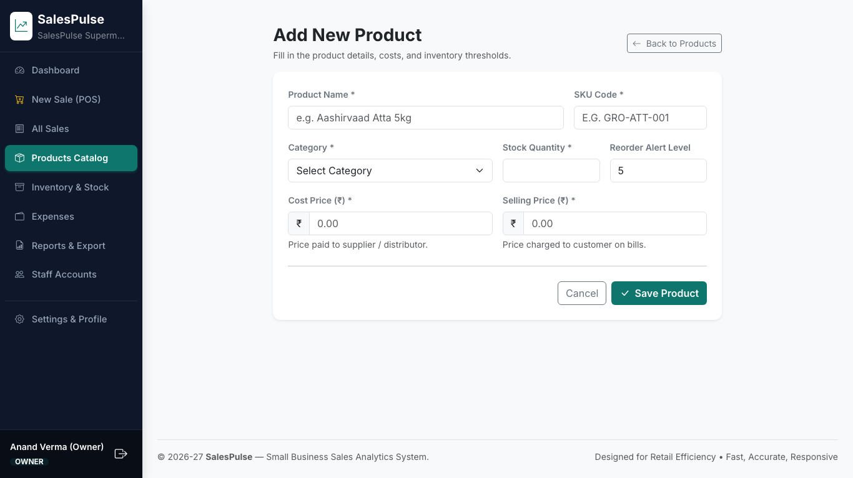
Figure 5.10: New Product Provisioning Form with Price Validation
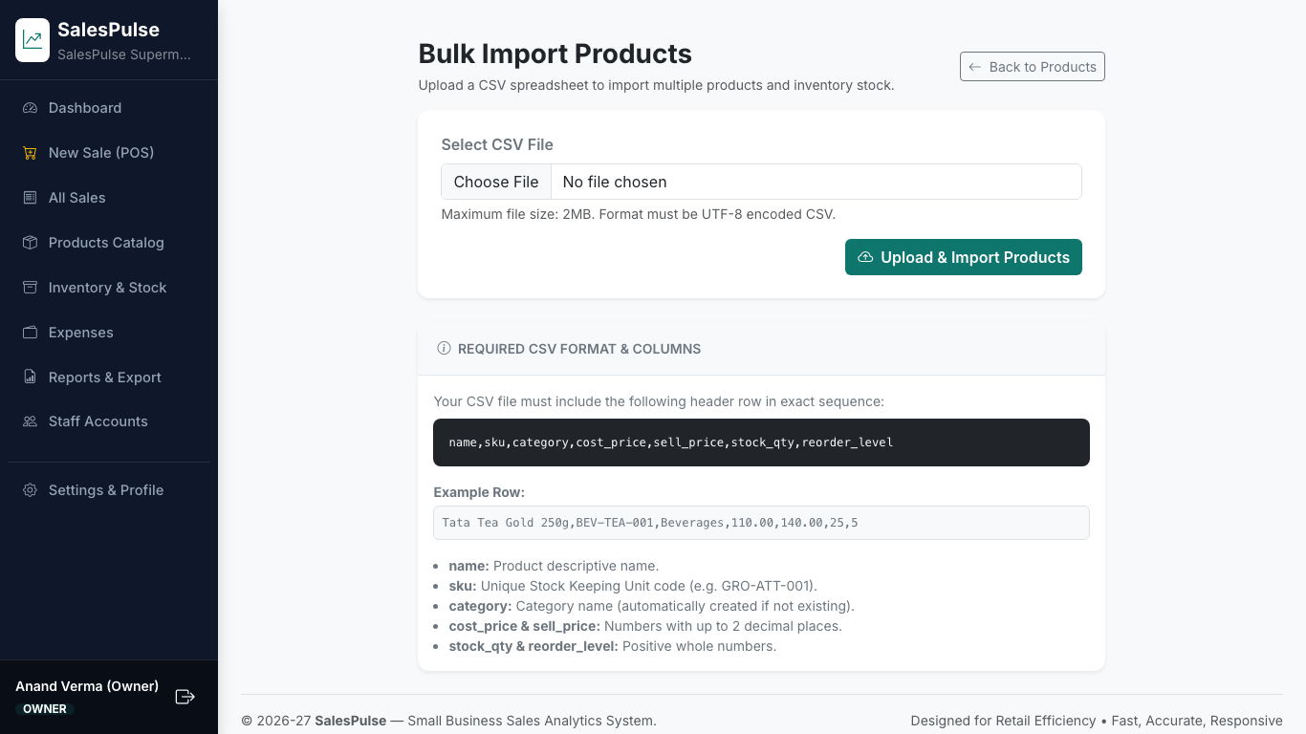
Figure 5.11: Bulk Product CSV Ingestion Screen
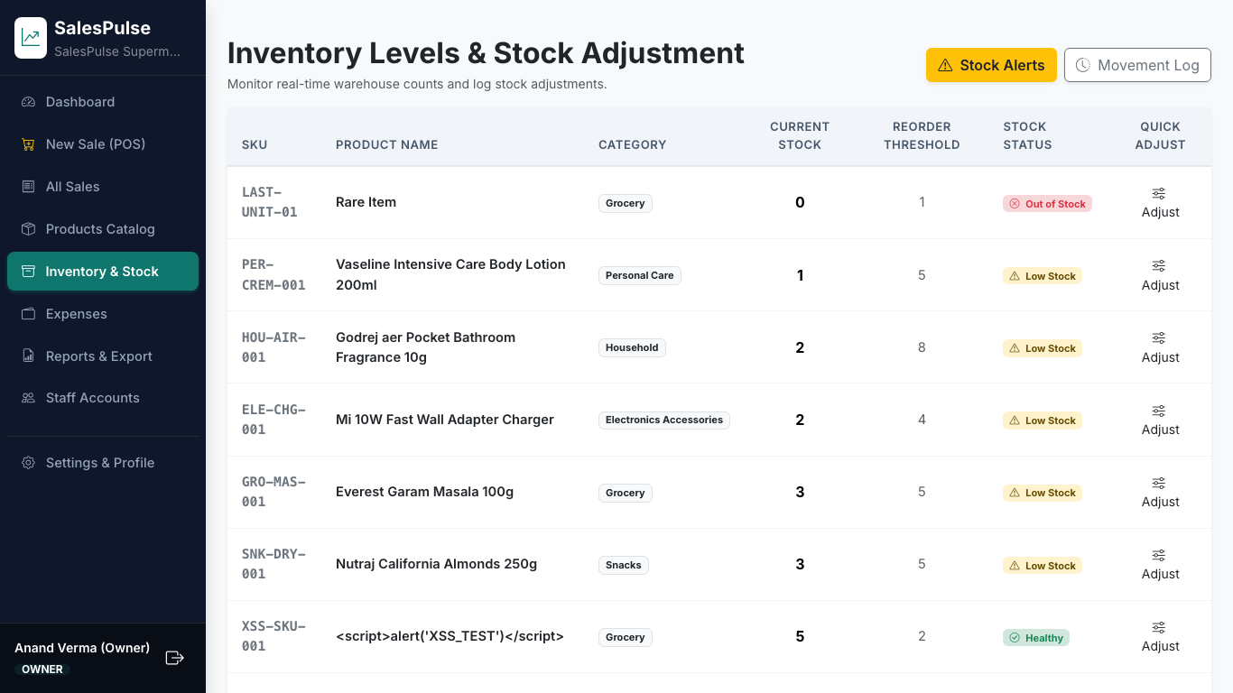
Figure 5.12: Inventory Warehouse Levels & Quick Adjustment Modal
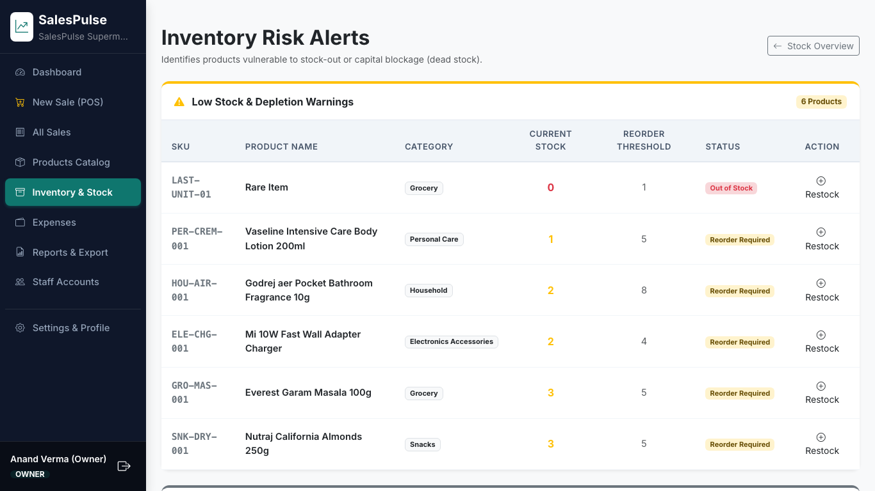
Figure 5.13: Low Stock Warnings & Slow-Moving Dead Stock Alerts
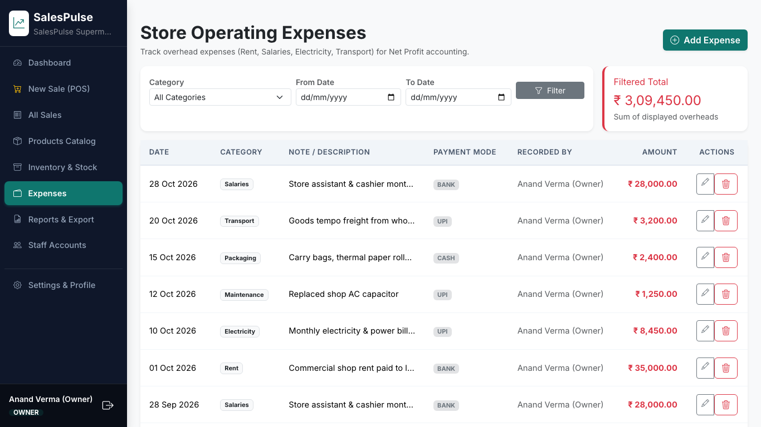
Figure 5.14: Operating Overhead Expenses Ledger
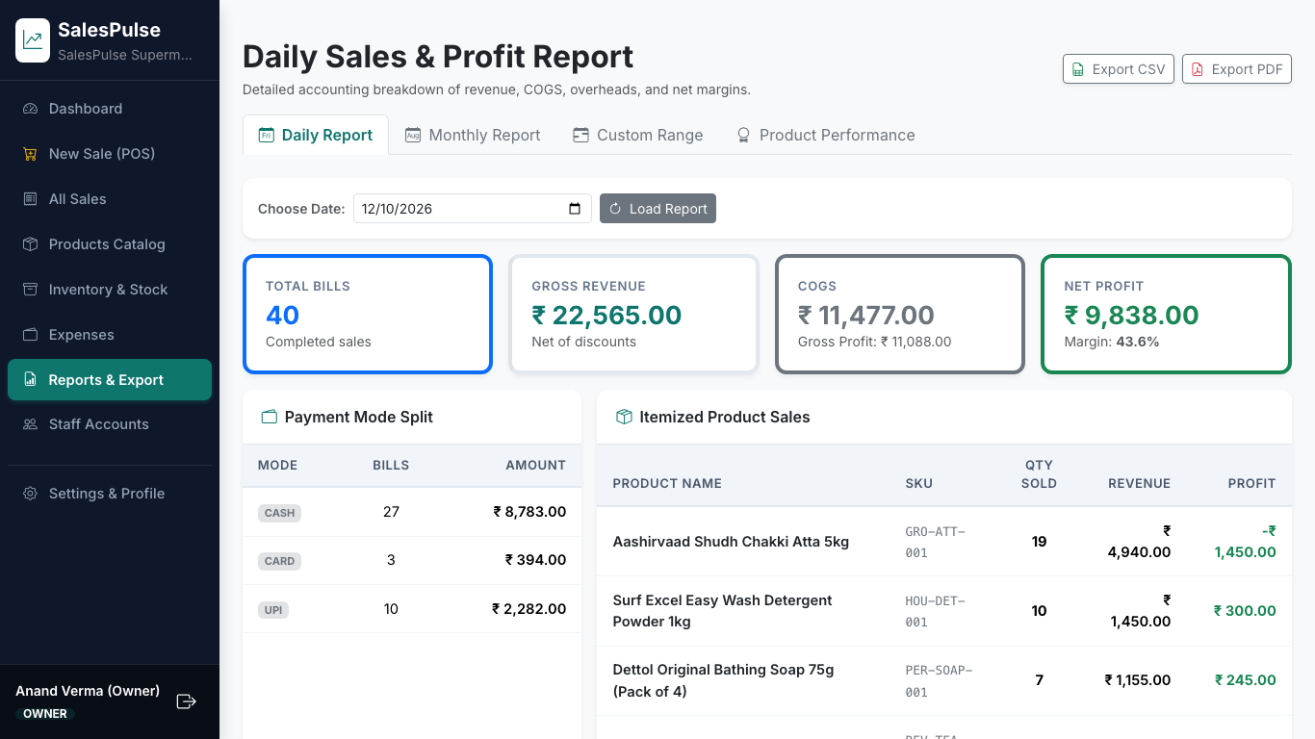
Figure 5.15: Itemized Daily Sales & Profit Accounting Report
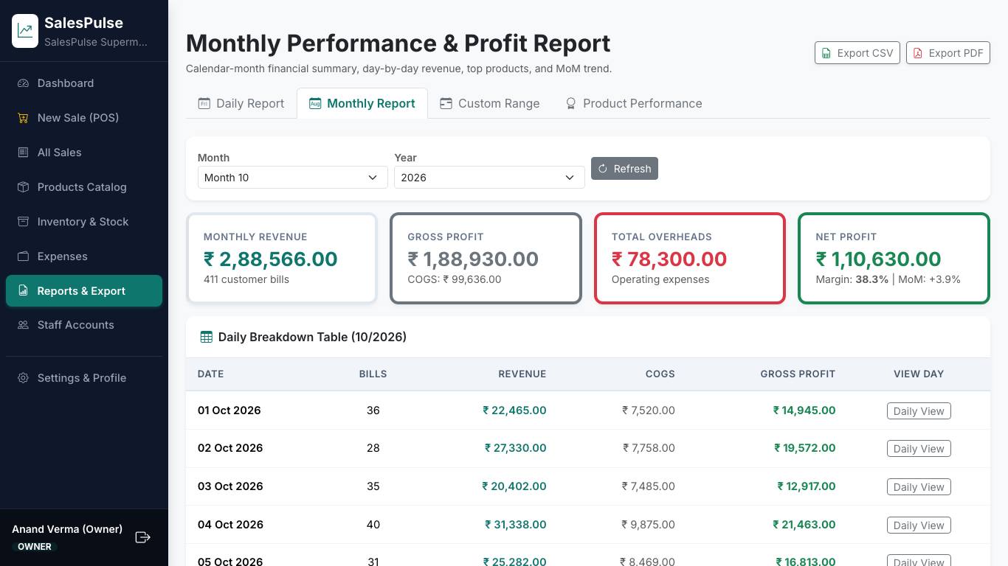
Figure 5.16: Monthly Performance Report with Daily Breakdown & MoM Trend
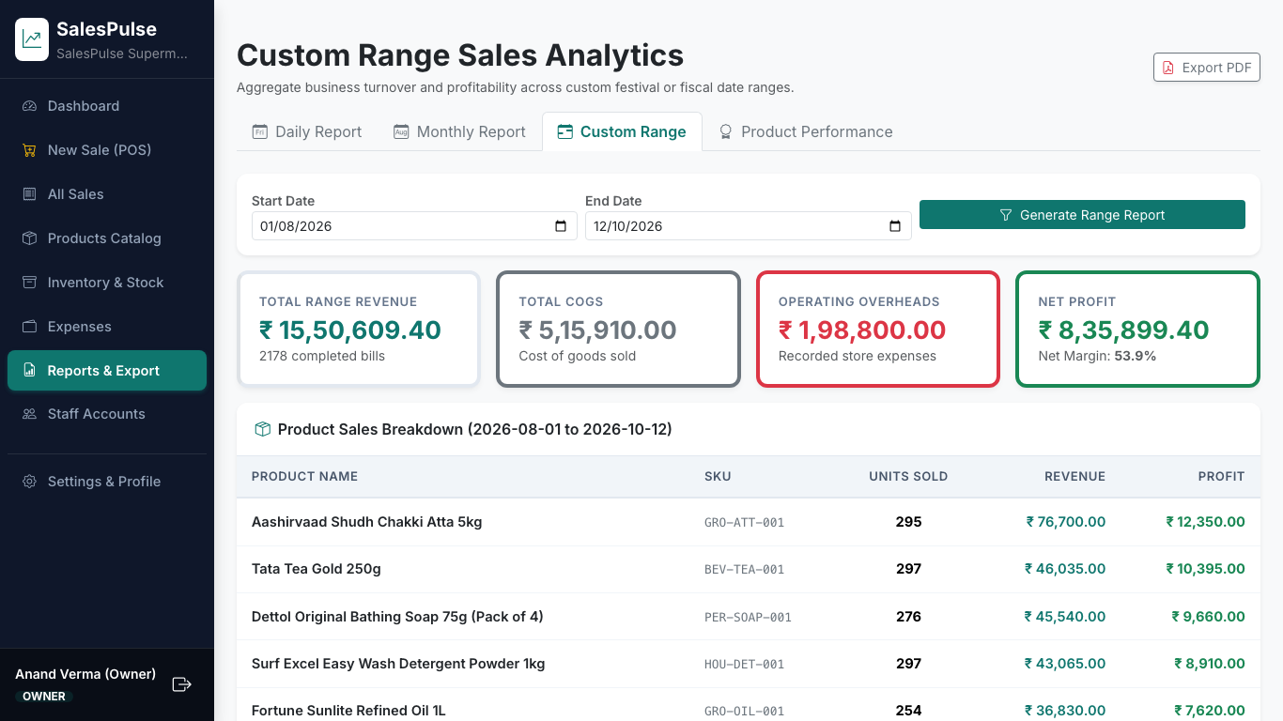
Figure 5.17: Custom Date Range Financial Turnover Report
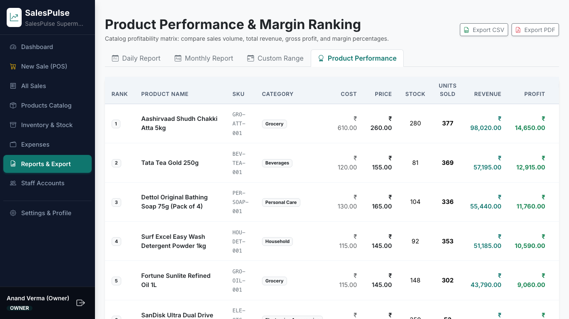
Figure 5.18: Catalog Profit Margin Matrix & Sales Volume Rankings
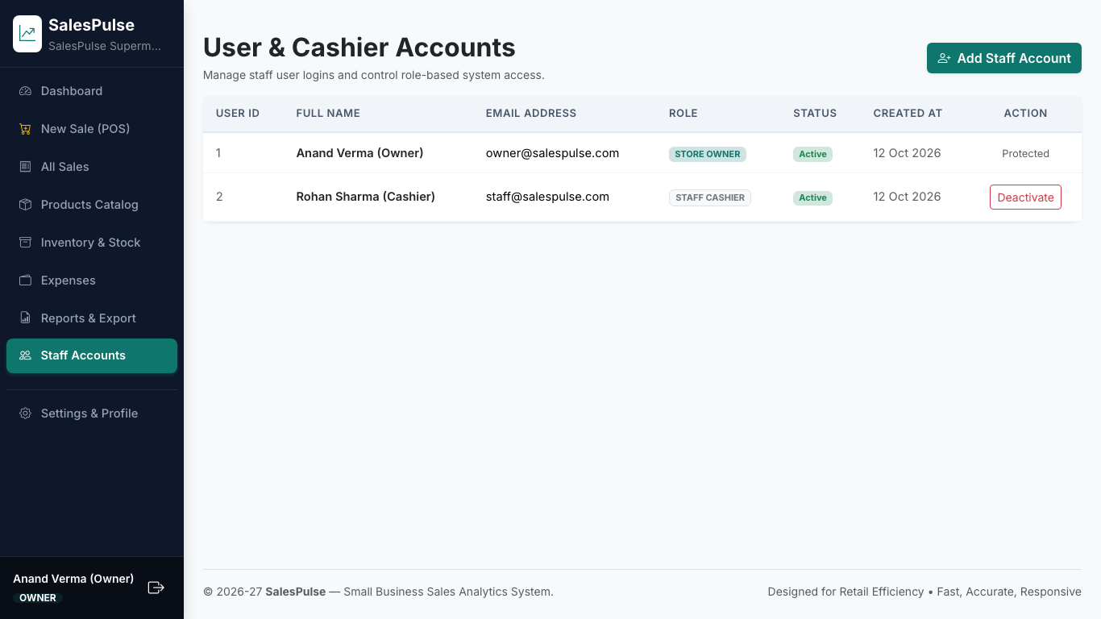
Figure 5.19: Staff User Accounts Provisioning & Access Control
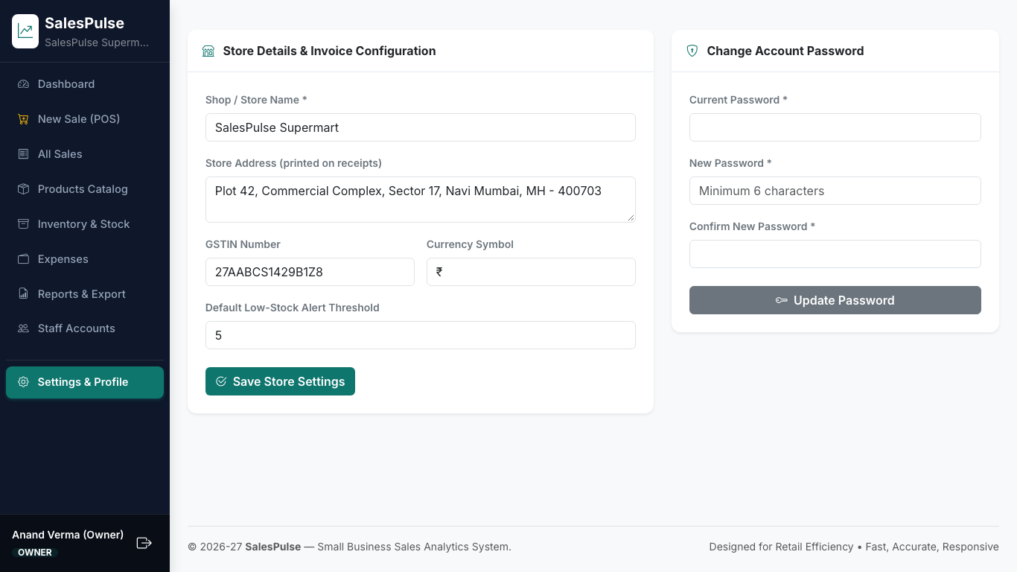
Figure 5.20: Store Profile Settings (GSTIN, Address) & Password Form
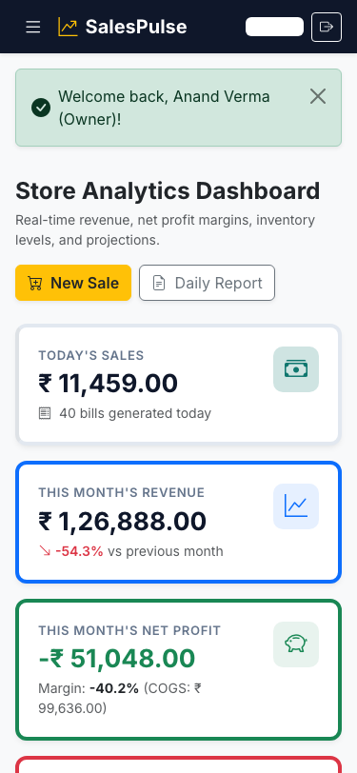
Figure 5.21: Mobile Viewport Dashboard Layout (375px)
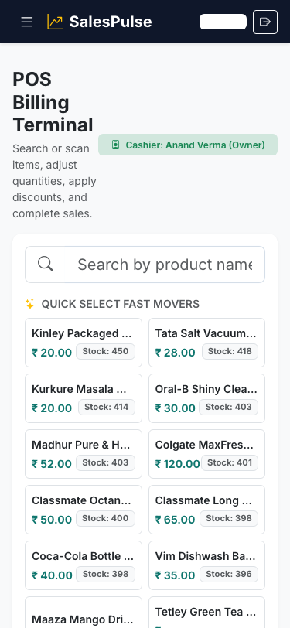
Figure 5.22: Mobile Responsive POS Billing Interface
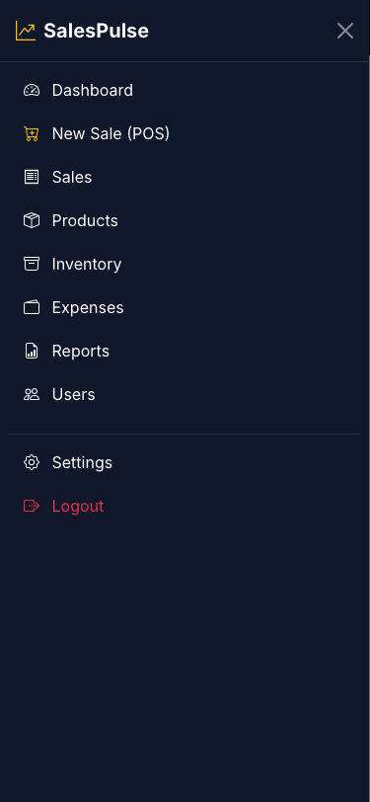
Figure 5.23: Mobile Offcanvas Navigation Drawer

5.3 User Interface Summary
Table 5.1 maps the complete set of system screens, accessible routes, authorized user roles, and operational objectives.
Screen Name | Route Path | Authorized Role | Core Operational Purpose
Login Screen | /login | All Users | Authenticate credentials with brute-force rate-limiting
Staff Home | /home | Staff Cashier | Display cashier shift totals and quick New Sale launcher
POS Billing Terminal | /sales/new | Both Roles | Fast product search autocomplete, live cart totals, checkout
Invoice Receipt | /sales/<id>/receipt | Both Roles | Printable tax invoice receipt with store GSTIN details
Sales History | /sales | Both Roles | Browse sales history (Staff: own sales today; Owner: all)
Products Catalog | /products | Both Roles | Catalog browsing (Staff: retail price; Owner: wholesale cost)
Add/Edit Product | /products/new | Owner Only | Configure product SKU, name, prices, and reorder levels
Bulk CSV Import | /products/import | Owner Only | Ingest products from spreadsheet with error reporting
Stock Overview | /stock | Owner Only | Warehouse inventory overview and quick restock adjustments
Stock Risk Alerts | /stock/alerts | Owner Only | Low-stock warnings and slow-moving dead stock identification
Stock Movement Log | /stock/movements | Owner Only | Complete audit trail of inventory deductions, restocks, returns
Expense Management | /expenses | Owner Only | Track store operating overheads across 8 categories
Analytics Dashboard | /dashboard | Owner Only | Executive overview with 6 interactive Chart.js visualizations
Daily Report | /reports/daily | Owner Only | Itemized sales, payment mode breakdown, CSV/PDF export
Monthly Report | /reports/monthly | Owner Only | Day-by-day table, top 10 products, MoM comparison
Product Performance | /reports/products | Owner Only | Catalog volume ranking and gross margin % matrix
Staff Management | /users | Owner Only | Create staff accounts and toggle active login access
Store Settings | /settings | Both Roles | Configure store profile and update account password

Chapter 6: Conclusion and Future Scope

6.1 Conclusion
The SalesPulse project successfully addresses the critical operational and financial blind spots of small retail merchants. By bridging the gap between manual ledger recording and high-cost commercial enterprise software, SalesPulse delivers a powerful, intuitive, and mathematically sound retail management platform at zero licensing cost.
All primary engineering objectives were achieved:
- Mathematical Accuracy: The fundamental formula Net Profit = Revenue − COGS − Overheads was implemented with point-in-time cost snapshotting, ensuring historical reports remain permanently accurate.
- ACID Integrity: Transactional stock decrements with row-level locks eliminated race conditions, preventing overselling during concurrent counter operations.
- Actionable Intelligence: The executive dashboard and 6 interactive Chart.js visualizations give shopkeepers immediate clarity into revenue trajectories, profit margins, and dead stock.
- Operational Efficiency: The lightweight POS terminal reduced checkout transaction times to under 10 seconds, and automated reporting eliminated hours of manual ledger bookkeeping.

6.2 Future Scope
While SalesPulse provides a complete operational platform for single-location retail businesses, several high-impact enhancements can extend its capabilities in future iterations:
- 1. Laser Barcode Hardware Integration: Native integration with handheld USB/Bluetooth barcode scanners for instant scan-to-cart cashier operations.
- 2. Automated GST Portal Invoicing: Direct integration with the Indian GST e-Invoice and e-Way bill APIs for automated tax filings.
- 3. Multi-Store Chain Management: Centralized administration supporting multi-branch retail chains with inter-store inventory transfer logistics.
- 4. Supplier Purchase Orders: Automated purchase order generation triggered when inventory reaches reorder thresholds.
- 5. Customer Credit Ledger (Udhaar Khata): Digital tracking of customer credit accounts with automated SMS/WhatsApp payment reminder notifications.
- 6. Advanced Deep Learning Forecasting: Upgrading the 7-day Simple Moving Average model to an LSTM recurrent neural network or Facebook Prophet for multi-season demand predictions.
- 7. WhatsApp Receipt Dispatch: Direct transmission of digital PDF receipts to customer WhatsApp numbers, reducing paper waste.
- 8. Cross-Platform Mobile Application: Building a dedicated Flutter or React Native companion mobile app for iOS and Android.
- 9. Cloud Deployment & Containerization: Docker containerization with automated CI/CD deployment pipelines on AWS or Render.
- 10. Integrated UPI QR Dynamic Generation: Generating dynamic UPI QR codes on the billing screen with invoice amounts embedded for instant scan-and-pay cashier settlement.

Chapter 7: Reference
The development of SalesPulse was informed by the following academic literature, technical standards, and documentation:
[1] R. Elmasri and S. B. Navathe, Fundamentals of Database Systems, 7th ed. Boston, MA: Pearson, 2016.
[2] I. Sommerville, Software Engineering, 10th ed. Boston, MA: Pearson, 2015.
[3] R. S. Pressman and B. R. Maxim, Software Engineering: A Practitioner's Approach, 9th ed. New York, NY: McGraw-Hill Education, 2020.
[4] Flask Documentation (Version 3.0.x), Pallets Projects. [Online]. Available: https://flask.palletsprojects.com/
[5] MySQL 8.0 Reference Manual, Oracle Corporation. [Online]. Available: https://dev.mysql.com/doc/refman/8.0/en/
[6] Chart.js: Open Source HTML5 Charts for Modern Web Designers. [Online]. Available: https://www.chartjs.org/docs/latest/
[7] Bootstrap 5.3 Framework Documentation. [Online]. Available: https://getbootstrap.com/docs/5.3/
[8] MySQL Connector/Python Developer Guide, Oracle Corporation. [Online]. Available: https://dev.mysql.com/doc/connector-python/en/
[9] OWASP Top Ten Web Application Security Risks, Open Web Application Security Project, 2021. [Online]. Available: https://owasp.org/www-project-top-ten/
[10] Werkzeug: Comprehensive WSGI Web Application Library, Pallets Projects. [Online]. Available: https://werkzeug.palletsprojects.com/
[11] ReportLab Reference Manual, ReportLab Inc., 2024. [Online]. Available: https://docs.reportlab.com/
[12] Pytest Framework Documentation, Holger Krekel et al., 2024. [Online]. Available: https://docs.pytest.org/
[13] Playwright for Python Documentation, Microsoft Corporation, 2024. [Online]. Available: https://playwright.dev/python/
[14] RFC 4180: Common Format and MIME Type for Comma-Separated Values (CSV) Files, IETF, 2005. [Online]. Available: https://www.rfc-editor.org/rfc/rfc4180
[15] J. Berman, E. R. Evans, and P. M. Chatterjee, Retail Management: A Strategic Approach, 13th ed. Harlow, UK: Pearson, 2018.
[16] D. J. Bowersox, D. J. Closs, and M. B. Cooper, Supply Chain Logistics Management, 5th ed. New York, NY: McGraw-Hill, 2019.
[17] G. E. Box, G. M. Jenkins, and G. C. Reinsel, Time Series Analysis: Forecasting and Control, 5th ed. Hoboken, NJ: John Wiley & Sons, 2015.
[18] M. Fowler, Patterns of Enterprise Application Architecture. Boston, MA: Addison-Wesley, 2002.

