Enhancing Motorbike Rental Safety Using an IoT-Enabled Smart Helmet with Alcohol Detection, Crash Alerts, and Ignition Lock Mechanism

GROUP CODE

GROUP MEMBERS
Antonio, Mackenzie
Del Rosario, Jan Miguel
Galura, Lanz
Maniago, Joshvy
Tayag, Sean John
Tulio, Willy

ADVISER
Anicia L. Ferrer

INTRODUCTION

In this modern world we cannot deny that motorcycle is still one of the fastest ways to travel especially on congested roads mainly caused by traffic, most people these days often use motorcycle pooling apps or sometimes opt for motorcycle rentals. According to Waluyo et al. (2022), Although the use of motorcycles is unsafe [1-3], motorcycles are a space-efficient travel mode because of their size and mobility. Due to the constant rising of the motorcycle users all over the world, the number of road related accidents also rises, especially the ones where alcohol is involved. Maheswari et al. (2020) states that the presence of alcohol in human blood has become the major reason of lung concerned diseases to the urban dwellers due to preserved exposure. Road accidents which result in death usually consist of drunk drivers disobeying the law. According to Lu et al. (2022), Alcohol intoxication is under human behaviour when a road user consumes alcohol prior to driving or while on the road. Alcohol decreases alertness of cognitive function of the brain leading to poor decision making, slower reaction rate and depressed thinking. Wearing traditional helmets doesn’t always do the trick, especially when alcohol is present, but due to advancements in IoT technologies can heavily transform on how we interact with daily objects. Besides the role of traditional helmet, we can upgrade it by equipping it with advanced features like alcohol detection and accident alert system we can improve its use besides as head protection.
The integration of alcohol detection technology within the helmet can serve as a proactive approach to prevent drunk driving and other road incidents, where alcohol is a main factor. This study explores the use of IoT integration on the traditional helmet which serves as a proactive approach to somewhat prevent drunk driving. It also comes with an accident alert system that will notify and ensure immediate help by sending alerts to designated emergency contacts. To further enhance the response to accidents, a GPS module will be integrated with the system to fetch the real-time location upon crash detection. The location will be sent via SMS as a clickable Google Maps link, enabling emergency responders or contacts to quickly locate the accident scene.

Purpose and Description
The purpose of this study is to develop alcohol detection, ignition lock mechanism, sudden impact detection and integrate it into an IOT- enabled smart helmet. With the current increase of alcohol related incidents the country is facing, the harm posed by driving under the influence of alcohol have been showing significant increase in the past few years. This also adds worries to the hearts of daily commuters because you never know when accident is going to occur. This project aims to prevent that type of accident not just for the driver but for everyone on the road. Also, it provides ease of mind for the motorcycle lessor by making sure the lessee doesn’t drive under alcohol influence.
This study will include conceptualization of an IOT-Enabled smart helmet to deeply understand and study the positive and negative impacts of it can provide. Upon the completion of the concept, the production and testing will be the next phase if this project to determine the safety and laudability of this project.

Capabilities of the Project:
Blood Alcohol Concentration (BAC) Monitoring:
- Estimates the BAC in a person’s breath.
- Enhances the credibility of the test results.
Impact Monitoring:
- Calculate the deceleration of the vehicle based on how quickly the vehicle slows down,
- Detects direct physical force or impact on the helmet using a Force Sensing Resistor (FSR) placed at key contact points.
- Enhances crash detection accuracy by combining motion data (MPU-6050) with pressure data (FSR).
Notification Automation:
- Automatically sends an alert whenever the vehicle suddenly decelerates indicating that there is a crash.
- Includes GPS coordinates in the alert for accurate location tracking.
- Reduces false positives by validating crashes with both motion (MPU-6050) and force (FSR) data.
Ignition Lock:
- Prevents the vehicle from starting whenever the BAC test fails.
Customization
- Designs can be customized based on personalized settings.

OBJECTIVES OF THE STUDY

The general objective of this study is to develop an IoT-enabled smart helmet system
aimed at enhancing the operational safety and reliability of motorcycle rental and fleet
businesses by preventing drunk driving, ensuring helmet usage, and enabling rapid response
during accidents.
Specifically, the study aims to:
- Design and develop an alcohol detection system that prevents the motorcycle from
starting if the rider's breath alcohol content exceeds a safe threshold, helping
business owners ensure their vehicles are used responsibly.
- Integrate a helmet detection feature that ensures the motorcycle cannot be started
unless the rider is wearing the smart helmet, promoting proper safety gear usage
and protecting business assets.
- Implement an accident-detection mechanism that automatically sends emergency
alerts with GPS location via SMS to preselected contacts, allowing business
owners to respond quickly to incidents involving their rented units.
- Evaluate the effectiveness and reliability of the smart helmet in detecting
alcohol consumption, accident impacts, and helmet usage under real-world
conditions, especially in rental or fleet scenarios.
- Investigate user acceptance and feasibility for the smart helmet in real-world
motorcycle operation.

Significance of the Study
This study aims to aims to examine and develop an IOT – Enabled Smart Helmet
to enhance the safety of the rider and the rented vehicle through the usage of three main features: alcohol detection, SMS crash alert, and an ignition lock mechanism. The significance of the study revolves around the potential to act for these safety issues commonly connected to road accidents particularly driving under influence (DUI), lack of helmet usage and delayed response time of authorities on emergencies.
In many regions in the world, especially in cities with high population and considered as tourist spots motorcycle rental is one of the common modes of transportation, However the rental company usually have little to no control over the rider drives under alcohol influence or doesn’t wear helmet. This lack of control can amass a high number of accidents that can be prevented including injuries and fatalities. This proposed smart helmet aims to lessen the risk by making sure that the rider can only operate once he passed the built-in breath analyzer.
For rental companies, this provides a useful and practical highly automated approach to improve the customer experience and safety while minimizing and even preventing the damage to rental property.
For riders, especially those who are unaware of the traffic laws the system encourages them to obey and comply with the safety protocols.
For emergency responders, the crash alert feature helps and enables them to respond faster to the accidents and have better incident report.
Furthermore, this study aims to help the field of technology-driven safety innovations showing how an IOT-Enabled device can be used for real world applications. It can also be a stepping stone for future innovations that can greatly improve and benefit the community.
SCOPE AND LIMITATION

The study portrays the design of an IoT-based smart helmet having alcohol detection and accident alerting mechanisms. The purpose is to provide safety for the roads by preventing intoxicated persons from riding motorcycles and providing an immediate response to accidents. The helmet is designed to detect the levels of alcohol in the rider's breath, preventing the ignition of the motorcycle if intoxication is detected. The system also has an accident-detection feature which automatically alerts emergency contacts upon occurrence of the crash. This feature includes GPS integration that retrieves the current location during the incident and sends it via SMS as a Google Maps link to assist in fast location tracking.
Though this study intends to enhance rider safety, some limitations exist. The breath analysis may not produce full-proof results for the alcohol detection system since other factors may also interfere, for instance, alcohol fumes from the environment. The accuracy of detection plays an important role, along with network connectivity. Any hindrance in real-time transmission of alerts due to poor signal coverage may affect the performance of the accident detection feature. Moreover, GPS accuracy can be limited in enclosed spaces or dense urban environments. Additionally, all road-accident causes have not been captured in this study, concentrating essentially on those concerns linked to alcohol and the detection of a crash. System performance in natural settings highly hinges on user adherence and hardware reliability, although other factors may also apply. Nevertheless, the project proposes a very feasible and creative approach to lessening the risks of drunk driving and the complacent emergency response.

CONCEPTUAL FRAMEWORK
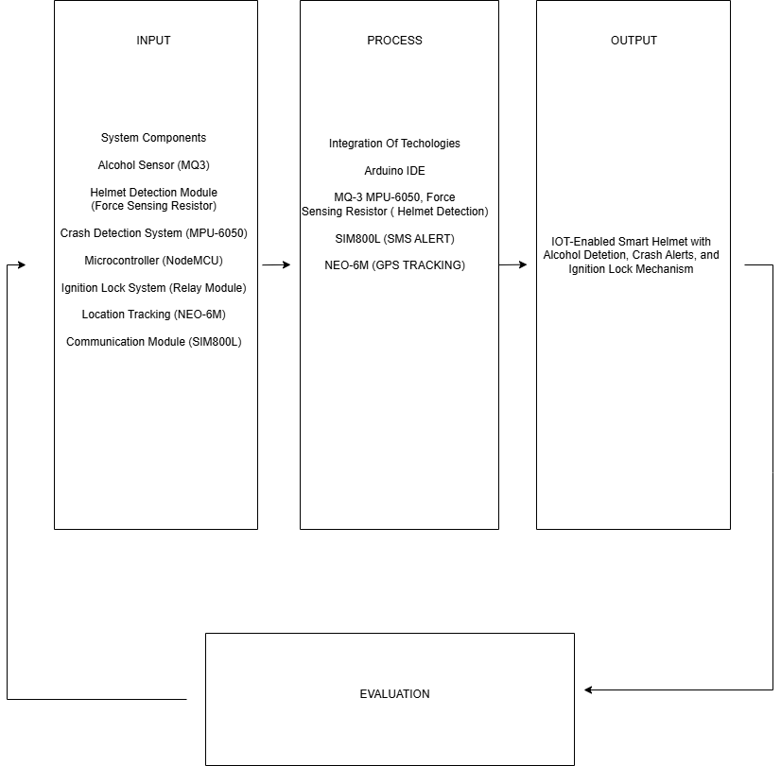
Figure 1: Conceptual Diagram
As stated in the diagram shown above, the components shown inside the box are the things necessarily needed for developing the IOT-Enabled Smart Helmet: The researchers will use hardware IOT components for the model, while for the process phase, waterfall methodology will be followed by the researchers. By maximizing the inputs in the process, the IOT-Enabled Smart Helmet will be developed. The helmet will encounter testing to ensure safety and functionality.

DEFINITION OF TERMS
To provide help in clarifying the terms used in this study, the following will be defined according to their use in the study.

Internet of Things (IOT) – group or network of physical devices such as sensors and machines that are connected to the internet. They can collect and share information or data. Theses devices can be controlled remotely and operated individually.

Driving under influence (DUI) – driving a vehicle after consuming alcohol. This is considered as a criminal offense and can cause great risk in the street.

Blood Alcohol Concentration (BAC) – It refers to testing the amount of alcohol in a person's blood. It is mostly used for determining the legal intoxication level suitable for driving.

Short Messaging System (SMS) – Also known as text messaging is a service that allows an exchange of messages between two users, typically via the use of cellular network.

Chapter II
Related Literature and Studies
This chapter provides reviews about relevant studies that helps in the development of an IOT-Enabled smart helmet with alcohol detection, SMS alert, and ignition lock mechanism, With the increasing number of alcohol related accidents caused by driving under influence and lack of helmet usage, the incorporation of these features in a wearable gear will play a crucial part for safety technologies.

Integration of IOT in our daily lives
As a transformative force, IoT is redefining how we interact with the world by connecting everyday objects to the internet, enabling seamless data collection, exchange, and processing. This technology is making environments smarter and more efficient, from smart homes that automatically adjust lighting and temperature based on user behavior to wearable health devices that monitor vital signs in real time (Rajini et al., 2025), this study illustrates how IOT drastically helped improve our daily lives by transforming devices into making them efficient. The increasing use of IOT-Enabled devices in industrial or commercial applications shows it’s potential to help improve the automation of data analysis and collection. For example, in healthcare devices that are wearable can alert doctors and patients when there is an abnormality in health indicators. On the other hand, in transportation, IOT-Enabled systems are used to track vehicles, monitor drivers and even send alerts whenever there is an accident happening. These advanced technologies can such as automated response and real-time monitoring can be integrated into a personal protective gear. Applying IOT into gears such as helmets can provide aid such as monitoring the behavior of the rider and preventing accidents, thus making the integration of IOT one of the vital elements of modern technology.

Impact of Alcohol Consumption on Road Safety
Every year driving under the influence of alcohol remains as one of the if not the leading cause of road traffic accidents in the world. Alcohol poses risks in the human body in the long term if there is an excessive intake, but this is only one of the risks it possesses. On the other hand, alcohol can also hinder a person from doing something due to intoxication. Specifically, for driving, it has been reported that alcohol could cause a delay in receiving perceptual information (perception), such as perceiving traffic signs or pedestrians, which then impairs cognition such as speed estimation, and action, such as maintaining a consistent speed (Yadav & Velaga, 2020). Despite legal sanctions in place, people continue to drive after drinking alcohol; in fact, it was reported that drivers impaired by alcohol were responsible for 147 million instances of driving under the influence in 2018 (Centers for Disease Control and Prevention, 2020). Laws have been passed on every country to prevent riders from driving under the influence of alcohol but every year it seems like nothing is working, that’s why some checkpoints provide law enforcement officers with the necessary tools to perform sobriety tests on the drivers.
Summary
The reviewed literatures emphasize and show the importance of IOT Integration on our daily lives and shows the risks of alcohol consumption, while some studies have explored each of these topics individually, there is still a lack of systematic approach that provides a solution for this long existing dilemma. This study fills the void by proposing a smart helmet that implements helmet use, detects alcohol consumption, and sends an SMS alerts to designated contacts for faster response. The development of such a wearable safety device that serves as an approach to help mitigate the alcohol-related traffic incidents and enhance the safety rider’s safety.

System Technical Background
The project focuses on developing an IOT-Enabled smart helmet with alcohol detection, SMS alert, and Ignition lock mechanism. This project aims to provide a way to improve road safety by preventing driving under the influence of alcohol, detecting accidents and sending SMS alerts for faster response and automatically disabling the ignition system to prevent drunk drivers from starting the vehicle. By incorporating Internet of Things (IOT) technology, the system establishes a smooth connection between the smart helmet, alcohol detector, SMS alert system, and vehicle ignition, providing an effective approach for the safety of the rider and provide and faster emergency response.

The Internet of Things (IOT) enables the device connected to gather, process and trade data over a network, creating a system that can respond to real-time conditions in the real world. The IOT components play a crucial role in assessing and tracking the rider’s environment and data. As accidents involving riders continues to rise, especially those alcohol related or delayed response from the authorities, this system proposes an innovative solution for a timely problem.

The smart helmet is equipped with multiple sensors with different use to fulfill its main functions. A sensor like MQ-3 is used to detect the presence of alcohol in the breath, Once the rider wears the helmet, the sensor then collects the data and sends it into a microcontroller for data processing. If alcohol level exceeds the safe threshold, the system immediately alerts the system and activates the ignition lock, preventing the start-up mechanism of the vehicle to prevent them from driving under the influence of alcohol.

To address scenarios where in accident happens, the helmet incorporates an MPU 6050 sensor, which combines a gyroscope sensor with an accelerometer to analyze and detect sudden impacts or unusual movement by the vehicle, when a crash is determined, the system triggers and sends an emergency alert notifying the registered contacts to send immediate help. The alert may also include a real time location through the help of GPS module, allowing for emergency respondents to get to the location quickly.

A relay module serves as an ignition lock mechanism, managing the power flow of the connected vehicle’s ignition system. The relay is managed by an ESP8266 microcontroller, which translates the sensors data and executes the command. The ESP8266 is handpicked due to its powerful capabilities and its features such as built-in WI-FI connectivity that allows it to serve as the main system’s central hub.

In summary, this helmet combines built in systems and IOT technology to make an intelligent solution and safety gear for riders, it not only prevents riders from drunk driving but also improves the emergency response due to its automated alert system. This smart helmet is expected to decrease the number of alcohol related accidents on the road and promotes responsible driving which can help save lives on the road.

Chapter III
Research Methodology
The main purpose of this study is to create an IOT-Enabled Smart Helmet that has features like Alcohol detection, Crash Sensor, SMS Alert System and Ignition Lock Mechanism. With the current surging number of alcohol-related accidents the risk posed by driving under influence has skyrocketed, to attain this, the researchers used developmental research method which focuses on the creation and improvement of the product and the development of a functional prototype to identify the possible lapses and analyze the needed information for the creation of the smart helmet.

This research used quantitative research in data gathering, it is used in gathering the measurable data from the sensors such as the BAC level to see the overall effectiveness of the helmet to further improve it for the future users.

Software Development Methodology
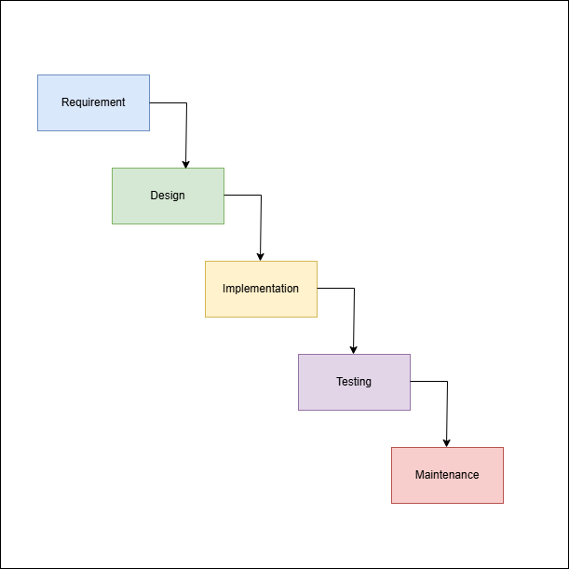
Figure 2: Waterfall Methodology
The researchers used the waterfall methodology in the development of the smart helmet. In this model the researchers continuously test the helmet to make sure it meets the requirements in consideration and ensure that its quality is up to standards. The researchers used the processes of Requirement, Design, Implementation, Testing and Maintenance.
Requirements – The requirements is one of the main phases in the development of the smart helmet, it involves the gathering of all the necessary materials. This also includes the identification of the required hardware needs such as alcohol sensors, crash sensors, microcontrollers, crash modules, and ignition control systems.

Design – this phase involves the creation of the system architecture and the hardware-software integration. This includes the data flow design, and the overall logic on how the helmet’s specific features will work based on given circumstance.
Implementation – This phase is where the actual buildout of the hardware and software unit is executed, this includes the assembly of the smart helmet, the development of the SMS alert system.
Testing – This is the phase where the functionality of the system is tested, each feature ranging from alcohol detection to the ignition lock mechanism is tested under controlled circumstances to ensure safe and precise performance of the smart helmet. This phase ensures that the smart helmet meets the specifications that is established during the first phase.
Maintenance – this phase focus on the post development activities like managing the SMS alert system and other improvements on the hardware of the helmet takes place. This phase makes sure that the features of the smart helmet remains fully functional and can be used for long-term operation, particularly in the motorcycle renting business where durability and performance is required.

Requirements Analysis and Documentation
Functional Requirements
Alcohol Detection – The helmet should detect the presence of alcohol through the breath sensor that is in the helmet. If the amount of alcohol present exceeds the threshold, then the motorcycle ignition should be locked preventing them from driving.
Crash Detection and Alert System – The helmet includes MPU 6050 that includes a built-in accelerometer and gyroscope which will be used to detect accidents. Upon detection, the helmet will send SMS alerts to the assigned emergency contact for faster emergency response.
Ignition Lock Mechanism – The motorcycle would only start and run if the smart helmet is worn and the sobriety test was passed.
Non-Functional Requirements
Reliability – The helmet’s features must work accurately and continuously under any disturbance or circumstance.
Scalability – The helmet should be able to handle the process of each of its features.
System Requirements
Helmet
Alcohol sensor (e.g., MQ-3)
Accelerometer/Gyroscope (e.g., MPU6050)
Microcontroller (e.g., ESP32)
Relay module for ignition lock
Rechargeable battery pack

WORKPLAN
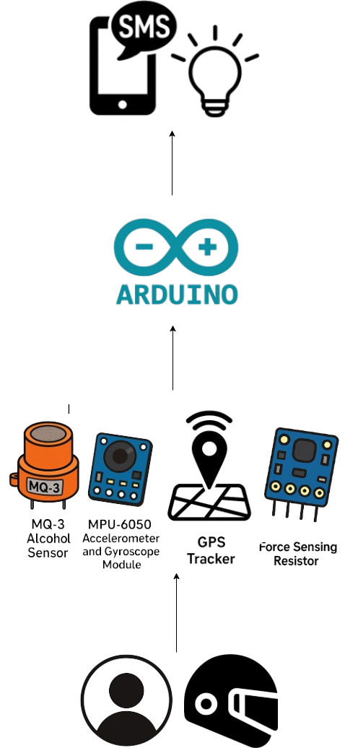

FLOWCHART

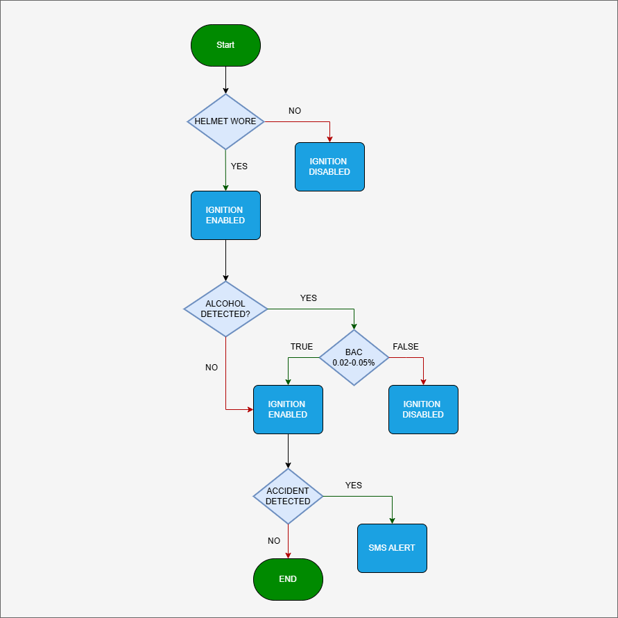
Figure 4: System Flowchart Design

Figure 4 illustrates the flow of the system. The process starts with a system initialization to verify whether the rider is wearing the helmet or not. If the helmet is not detected, then it immediately disables the vehicle’s ignition making it impossible to start. If the helmet was detected, then the helmet conducts alcohol detection using the sensors. If the BAC exceeds the acceptable threshold, then it will automatically triggers the vehicle ignition to be disabled to prevent drunk driving, but if no alcohol is detected then the ignition will be enabled. Once the vehicle is in use the sensors will continuously check and monitors the rider and the vehicle for possible accidents through the help of the accelerometer and gyroscope. If an accident is detected then it will automatically send SMS alerts to pre-defined emergency contacts, but if there are no accidents happened then the cycle ends without further actions. This cycle makes sure that the rider will only operate under safe conditions prioritizing its safety and avoiding any accidents.

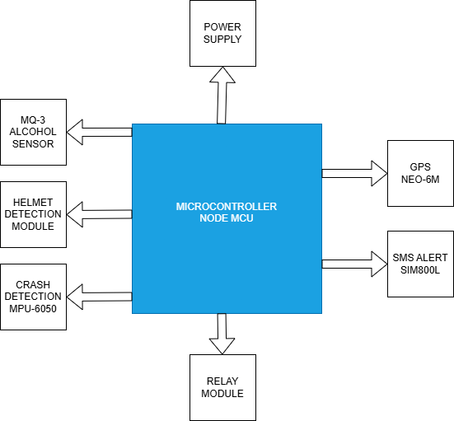
System Architecture

Figure 5: System Architecture

Research Tools and Instruments
Interview
In order to rally information and the required data,
Purposive Sampling
The type of sampling method that will be utilized in this study is purposive sampling, The chosen participants by the researchers are those who own a motorbike rental company and motorcycle riders. By employing this sampling, the data that will be collected will be used to analyze and showcase the result in methodological approach.
Survey Questionnaires
The researcher conducted a survey in which the prepared questionnaires are carried out via google forms and face to face approach. The questionnaire was created to gather feedback based on ISO25010 software quality characteristics, the gathered data will be used to enhance the proposed system and widen the knowledge of the researchers to provide a seamless creation of the output.

References
[1]Waluyo, T. A., Irawan, M. Z., & Dewanti, N. (2022). Adopting Electric Motorcycles for Ride-Hailing Services: Influential Factors from Driver’s Perspective. Sustainability, 14(19), 11891.
Retrieved from: https://doi.org/10.3390/su141911891
[2]Lu, J. L., Herbosa, T. J., & Lu, S. F. (2022). The effect of suspected alcohol intoxication on fatality and injuries of road users in Metro Manila — 2005-2020. Acta Medica Philippina, 56(19).
Retrieved from https://doi.org/10.47895/amp.v56i19.6277
[3]Maheswari, K., Madhumitha, U., Madhusurya, S., & Divya, T. (2020). Alcohol consumption detection using smart Helmet system. International Journal of Scientific Research in Science Engineering and Technology, 167–173.
Retrieved from https://doi.org/10.32628/ijsrset207244
[4] Rajini et al., (2025), IoT DEVICES AND THEIR INTEGRATION INTO DAILY LIFE
Retrieved from https://www.researchgate.net/profile/Joyanto-Roychoudhary/publication/389660477_Emerging_Research_Trends_in_Computer_Science_and_Information_Technology_ISBN_978-93-48620-71-2/links/67cbc88bcc055043ce6f45eb/Emerging-Research-Trends-in-Computer-Science-and-Information-Technology-ISBN-978-93-48620-71-2.pdf#page=22
[5] Yadav & Velaga (2020), Alcohol-impaired driving in rural and urban road environments: Effect on speeding behaviour and crash probabilities
Retrieved from https://www.researchgate.net/publication/340266079_Alcohol-impaired_driving_in_rural_and_urban_road_environments_Effect_on_speeding_behaviour_and_crash_probabilities
[6] Centers for Disease Control and Prevention (2020), Sobering facts: Alcohol-Impaired Driving State fact sheets | Transportation Safety | Injury Center |
Retrieved from https://cdctransportation.org/www.cdc.gov/transportationsafety/impaired_driving/states.html

