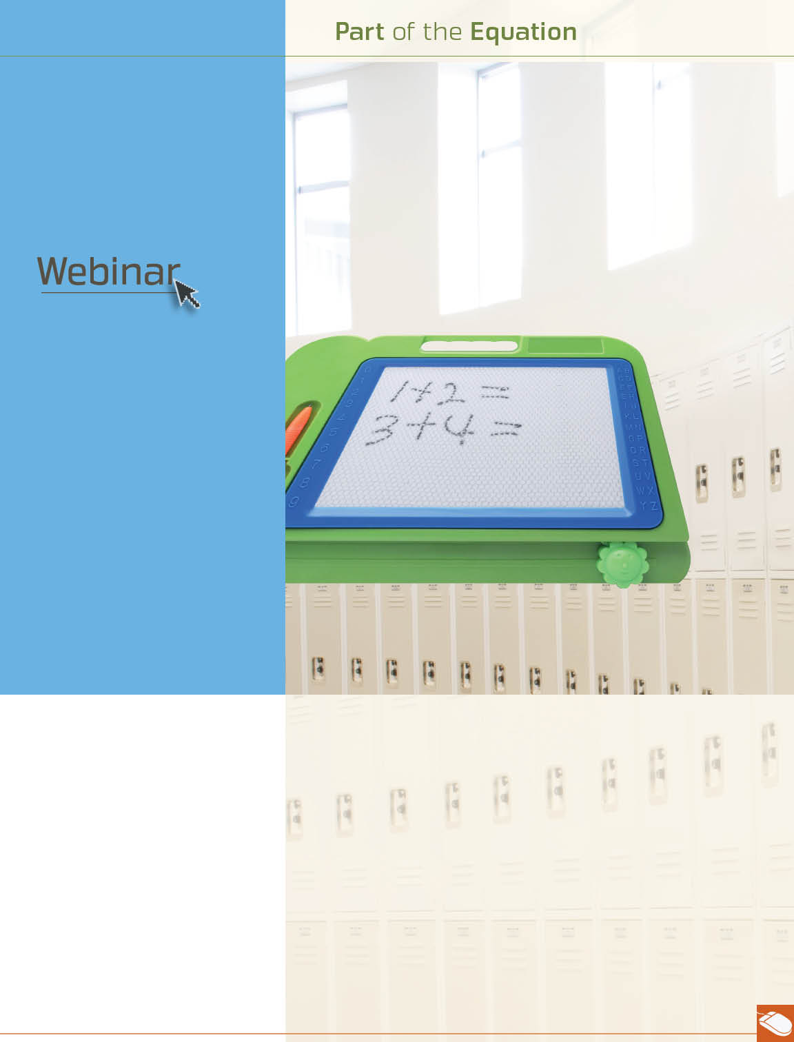


August

parents taking action*
August 16th at 12 pm, 2 pm, and 4 pm EST
Parents play a crucial role in helping children succeed in school. Explore the factors that contribute to school achievement and develop strategies to help children become responsible and engaged learners.

Parental involvement is key to a child’s academic success. Creating a home environment that supports learning, setting high academic expectations, and maintaining good communication with your child’s teachers, are all important. Your Work-Life/EAP service can help with information and resources to support your school-aged child. Want your child to succeed in school? You do the math. Call or log on to get started.

* Also available in Spanish
También disponible en Español
TOLL-FREE: 800-451-1834
WEBSITE: www.allonehealtheap.com
USERNAME: Wellesley

PASSWORD: Employee
Available anytime, any day, your Work-Life/EAP service is a free, confidential program to help you balance your work, family, and personal life.

