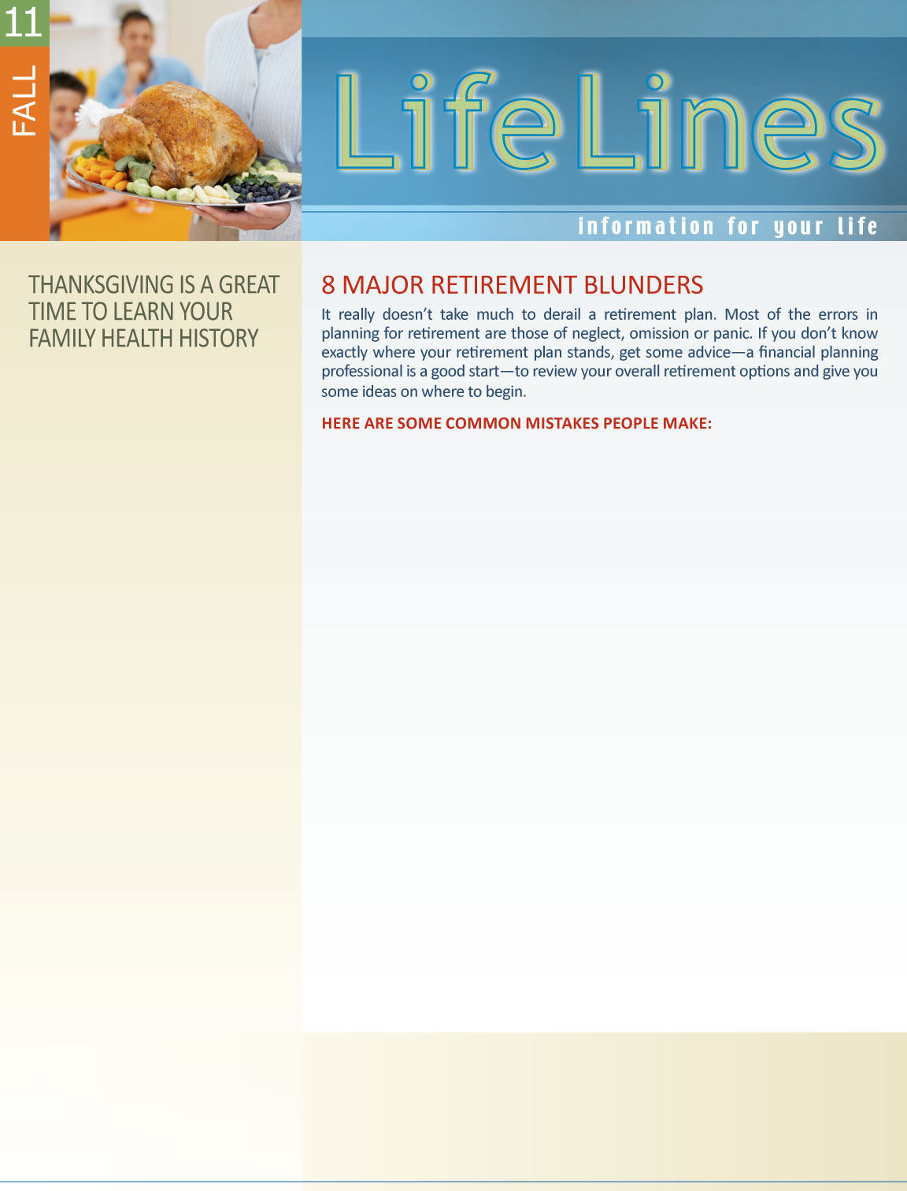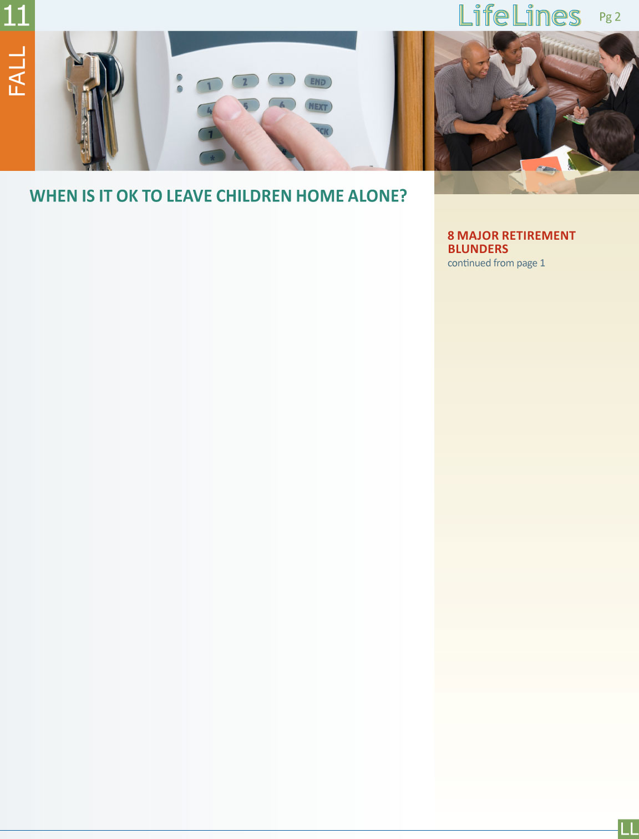
Assessing Your Child’s Readiness
•Is your child physically capable of handling himself around the house without getting injured?
•Can your child handle keys and door locks to avoid being locked inside or outside your home?
•Can your child operate small appliances safely in your absence?
•Will your child be able to be home alone without feeling scared or lonely?
•Is your child free of withdrawn, hostile or self-destructive behavior?
•Is your child able to handle the unexpected without getting upset?
•Is your child able to follow rules?
•Can your child understand and follow verbal or written instructions?
•Will your child be able to work out solutions to basic problems without help?
•Can your child read and write?
•Will your child be able to find something to do when alone?
•Is your child able to ask for help from friends, neighbors, and police when needed?
•Does your child understand the role of police, firefighters, and rescue squads?
•Does your child get along well with other children in your family as well as neighborhood kids and adults?
•Will your child be able to reach you in your absence?
•Will you be available in an emergency? Have you designated another trustworthy adult that is close by who will be available in an emergency?

•Do you and your child both feel your community is reasonably safe?
If you answered yes to all of the questions above and have determined that your child is ready to be home alone, be sure to take the proper precautions.
Preparing Your Child for Self-Care
•Provide your child with the telephone number of a trustworthy adult nearby and make sure he or she will be available.
•Provide your child with a number where you can be reached.
•Provide him or her with emergency telephone numbers and practice making these calls together.
•Walk through your home with your child and point out smoke alarms, door locks, exit routes, and first aid kits, discussing the importance of each item.
•Decide together on rules for preparing snacks, talking on the telephone, leaving the house, having friends over, watching TV or movies, using the Internet, and doing chores or homework.
•Keep your door locked and inform your child not to let anyone in the house.
•Inform your child about how to handle severe weather situations or blackouts.
To access your county’s guidelines, contact the Child Welfare Information Gateway at 1-800-394-3366. Most experts agree that a mature 11 or 12 year-old child is probably capable of being on his or her own for at least 2 hours.
Source: www.childwelfare.gov/pubs/factsheets/
homealone.cfm

continued on page 3
Your family Thanksgiving get-together is more than just a chance to catch up with family and overeat; it’s also a great time to learn about your family medical history. The U.S. Surgeon General has declared Thanksgiving to be National Family History Day, encouraging Americans to share a meal and talk about family health. This information can help your doctor decide which tests and screenings are recommended to help you know your health risks.
Knowing your family medical history is important. Chronic diseases can be hereditary and shared genetics, behaviors, lifestyles, and environment can all contribute to disease. Americans know that family history is important to their health. One survey found that 96 percent of Americans believe that knowing their family history is important. Yet, the same survey found that only one-third of Americans have ever tried to gather and write down their family’s health history. Are you ready to collect your family health history but don’t know where to start?
The updated Surgeon General’s My Family Health Portrait (https://family
history.hhs.gov/fhh-web/home.action) is an online tool to help you and your family collect and organize health history and easily share it with your doctor.
continued on page 3


1. Failing to start: It is amazing how many people find excuses to never start retirement savings. But no matter how daunting debt or other spending priorities seem, you have to save for retirement on a regular basis, even if it’s only a cursory amount. Over time, those small assets will grow to something considerably larger.
2. Failing to look at both your work and personal retirement portfolios: One of the critical problems in retirement planning comes from failing to treat the investments you make at work versus the ones you make independently as a unified whole. Working with a financial planner can help you look at every place you’re putting your money and finding out if you’re implementing those assets in the right way.
3. Failing to evaluate a prospective employer’s retirement options: Benefits can be worth as much as a nice paycheck. It’s possible you might be working for a company that still offers a traditional defined pension benefit plan in addition to a 401(k) plan. If you think you’re going to get an offer, it’s wise to interview prospective employers on the benefits side of what they’re offering you—particularly the timeframes on when those various benefits kick in. Above all, company matching of any assets you place in your retirement funds is key, as well as the vesting period for making those assets your own.
4. Failing to consider both kinds of Individual Retirement Accounts (IRAs):
The biggest difference between a traditional IRA and a Roth IRA is the way Uncle Sam treats taxes on both types of IRA investments. If you put money in a traditional IRA, you’ll be able to deduct that contribution on your income taxes. In a Roth IRA, you don’t receive the tax deduction for those contributions, but when it’s time to take the money out, you won’t have to pay taxes on it. If you and your spouse are not covered in your employer plans, you may be able to fund fully deductible IRAs.
5. Failing to update your beneficiaries: Starting in 2007, a direct transfer from a deceased employee’s IRA, qualified pension, profit-sharing or stock bonus
plan, annuity plan, tax-sheltered annuity, 403(b) plan or a governmental deferred compensation plan to any qualified IRA
can be treated as an eligible rollover distribution if the beneficiary is not the deceased’s spouse. That means your kids
or any other designated recipient can
continued on page 2

Contact Us


toll-Free: 800-451-1834

www.allonehealtheap.com 
user name: Wellesley
password: Employee

inherit your IRAs without negative tax consequences at that time. Non-spouse beneficiaries need to check with a financial planning expert when they must begin distributions from an inherited IRA. Of course, no matter what the investment, make sure your beneficiaries are always current.
6. Failing to reinvest your tax refunds: Did you know you could deposit your tax refund directly into your IRA? It works for a health or education savings account as well. While many people use their tax refund as a bonus to buy a treat or pay off bills, consider filing your taxes a bit early and arrange to e-file a direct deposit to your IRA.
7. Withdrawing money early from an IRA or blowing a rollover: Money taken out of an IRA is subject to income taxes and a penalty if you are under 59 ½ years of age and do not put it back into an IRA within 60 days. When moving assets, most of the time a trustee-to-trustee transfer can be more efficient and with less margin for error. If the IRA distribution check is made payable to you, there is a greater chance you’ll miss the 60-day deadline and you’ll face taxes and penalties.
8. Failing to contribute the maximum: Not every employee can afford to contribute the maximum allowed by their respective work retirement plans or individual retirement investments, but it should be a goal.
Financial Planning Association (FPA). 2009. Reprinted with permission.

With the school year starting, many working parents with older children ask the question: At what age can parents leave their children home alone? There are a few states which have laws that govern this, but most counties have developed guidelines through their Child and Protective Service Agencies that can help parents make informed decisions about leaving their children on their own. These guidelines generally take into consideration things such as maturity of the child; accessibility of an adult; how well the child is prepared to be on his or her own; safety of home environment; length of time alone; and child’s comfort level.

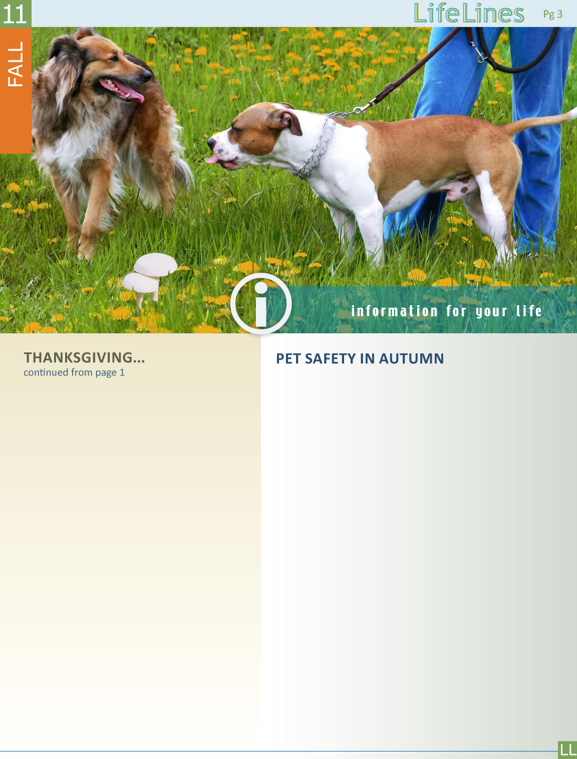
Here are some ways to start the conversation:
Talk to Your Family
Write down the names of blood relatives you need to include in your history.
• The most important relatives to talk to for your family health history are your parents, brothers and sisters, and your children. Then expand your conversation to the rest of the family members.
Ask Questions
Among the questions to ask are:
• Do you have any chronic diseases such as heart disease, or health conditions such as high blood pressure, cholesterol or diabetes?
• Have you had any other serious diseases such as cancer or stroke?
• How old were you when you developed these diseases?
Also ask questions about other relatives, both living and deceased, such as:
• What is our family’s ancestry—what country did they come from?
• What diseases did your deceased relatives have?
• How old were they when they died?
• What caused their deaths?
Adapted from Gather and Share Your Family Health History. Center for Disease Control (CDC). 2010. www.cdc.gov

The dog days of summer are over but autumn brings with it some dangers to your household pets. Remember these tips when you and your pet are enjoying the cooler weather:
• The use of rodenticides increases in the fall as rodents seek shelter
from the cooler temperatures by attempting to move indoors. Rodenticides are highly toxic to pets—if ingested, the results could be fatal. If you must use these products, do so with extreme caution and put them in places inaccessible to your pets.
• Back to school supplies can be tempting for pets to chew on and ingest. These are rarely toxic but can cause gastrointestinal distress or possible blockages.
• Wild mushrooms are common in the fall. Most are harmless but
some are very toxic. Keep pets away from areas where any mushrooms are growing. Contact your veterinarian or the Animal Poison Control Center at (888) 426-4435 immediately if you witness your pet eating a wild mushroom.
• In order to generate body heat, pets who exercise heavily outdoors, or who live outdoors, should be given more food during colder seasons. Make sure horses and other outdoor animals have access to clean, fresh water that is not frozen.
• Snakebites are common in the fall when these reptiles are getting ready to hibernate. Keep pets away from areas where snakes are present.
• Flushing radiators is common in the fall and dogs and cats are attracted to the sweet taste of ethylene glycol-based coolants. Just a small amount can kill your pets. Spills should be cleaned up immediately. Consider switching to propylene glycol-based coolants—though they aren’t completely nontoxic, they are much less toxic than other engine coolants.
Adapted from Autumn Safety Tips. Atlanta Humane Society. www.atlantahumane.org

