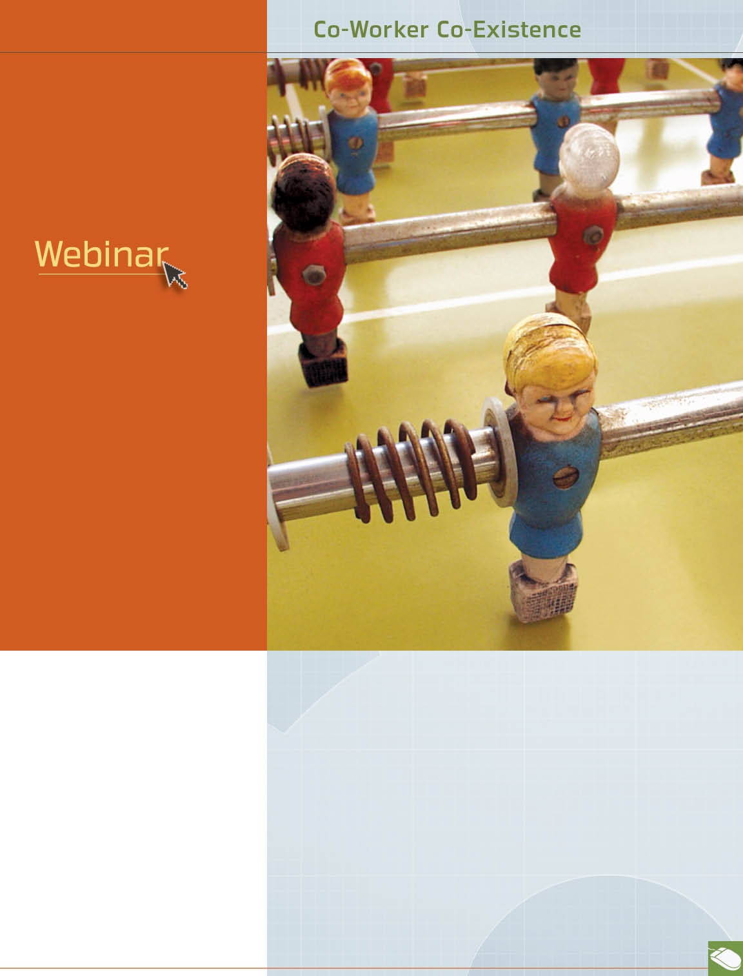


October

the ABCs of working with the XYZs*
October 18th at 12 pm,
2 pm, and 4 pm EST
Today’s workforce is comprised of generations with different values and priorities. Learn to identify the characteristics and key motivational factors of each generation to foster successful work groups.

Getting along with co-workers is necessary for on-the-job success. But how can you be part of the team if disagreements or distrust with others get in the way?
Your Work-Life/EAP service can help with strategies to create workplace harmony. Learn tips on workplace communication. Find out how to get beyond differences of opinion. Call or log on to get started.
* Also available in Spanish
También disponible en Español
Available anytime, any day, your Work-Life/EAP service is a free, confidential program to help you balance your work, family, and personal life.


TOLL-FREE: 800-451-1834
WEBSITE: www.allonehealtheap.com
USERNAME: Wellesley

PASSWORD: Employee

