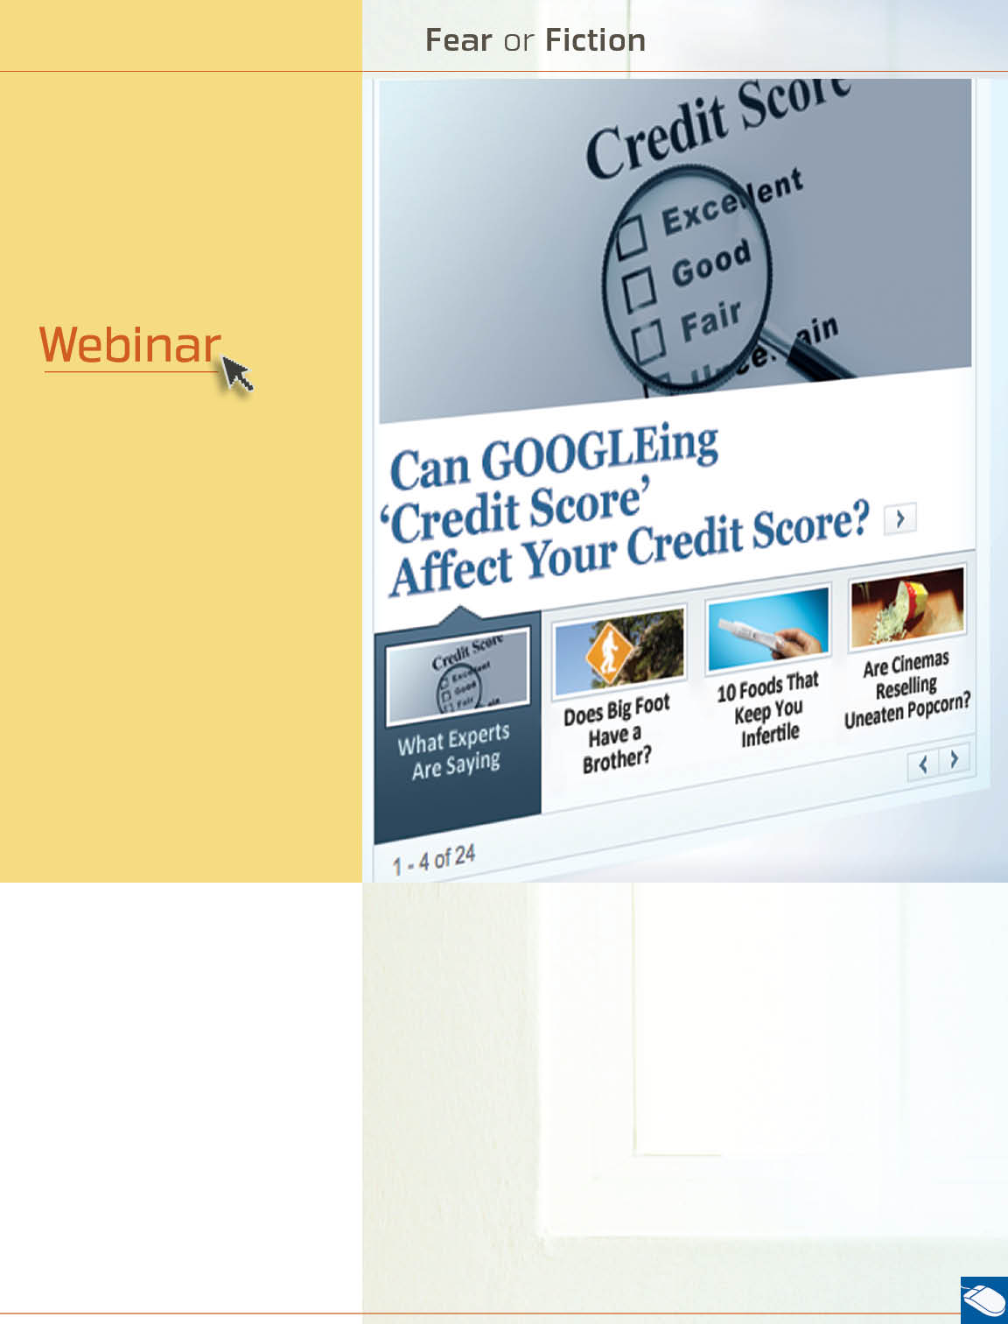


September

information overload:
Navigating through the Chaos
September 20th at 12 pm,
2 pm, and 4 pm EST
Information is everywhere. How do you sift through it all and pay attention to the important stuff? Learn how to achieve greater control of the information you receive to reduce the noise and increase your understanding.

“It’s true! I saw it online!” News about food scares, political scandals, or medical breakthroughs travels so fast that it is almost impossible to know what is real. And sometimes the wrong information can cause you anxiety and distress. Your Work-Life/EAP service can help with tips on searching and locating trustworthy sites to help separate the fear from the fiction. Call or log on to get started.

Available anytime, any day, your Work-Life/EAP service is a free, confidential program to help you balance your work, family, and personal life.



TOLL-FREE: 800-451-1834
WEBSITE: www.allonehealtheap.com
USERNAME: Wellesley

PASSWORD: Employee

