

Working @ Wellesley

Office of Human Resources
& Equal Employment Opportunity

Hiring Procedures
for
Faculty Staff
Table of Contents

Table of Contents | 2

Preparation for the Search
An Important Message for Hiring Chairs | 3
Guidelines for Recruitment of Tenure-Track Faculty | 4-6
Limited Search Process | 6
Search Process Checklist | 7-8
Faculty Search Plan | 9-12
Responsibilities of the Chair | 13-14
Role of Academic Administrative Assistant | 15
Role of the Search Committee | 16
Role of Diversity Liaison | 17
Role of Human Resources in the Search Process | 18
Outreach and Recruiting a More Racially/Ethnically Diverse Faculty | 19
Recruitment Activities Checklist | 20
Search Committee Pre-Meeting Agenda | 21

Candidate Selection and Assessment
Reviewing Resumes | 22-23
Bringing Candidates to Campus | 24
Sample On-Campus Interview Schedule | 25
Budget Process | 26
Welcome Packet Suggestions | 27
Interviewing Techniques | 28
Legal Issues to Consider | 29-30
Candidate Assessment Form | 31

Appendices
Appendix A: Outreach Resources | 32-43
Appendix B: MRHR Document: Maximizing the Opportunity to Diversify the Faculty | 44-55
Appendix C: Online Application System – PeopleAdmin | 56-68

An Important Message for All Wellesley College Hiring Chairs

Dear Wellesley College Hiring Chairs:

One of the most important and potentially long-lasting decisions made at the college is whom we hire as faculty. We are committed to hiring the very best candidates for tenure-track lines, judiciously selected from a wide and diverse pool of candidates. The Provost’s Office is working in close partnership with the Office of Human Resources to ensure that the hiring process is carried out in the most efficient and effective manner possible. We hope that the information provided here will help guide you through this exciting but complex process. Please know that your department dean is available and willing to answer questions about hiring procedures and to assist you throughout the search process.

We look forward to working with you in the upcoming year.

Sincerely,

Andrew Shennan, Richard French, and Kathryn Lynch

Search Process Contacts (Dean’s Office):
Andrew Shennan, Provost and Dean of the College | x3583 | ashennan
Richard French, Dean of Academic Affairs | x3583 | rfrench
Kathryn Lynch, Dean of Faculty Affairs | x3583 | klynch
Elizabeth Lieberman, Special Advisor to the Provost | x3587 | elieberm
Mary Pat Navins, Assistant Provost/Academic, Budget & Planning | x3228 | mnavins
Ruth Frommer, Faculty Appointment Coordinator & Clerk of the CFA | x3229 | rfrommer
Kathy Sanger, Office Manager | x3583 | ksanger2

Human Resource/Equal Employment Opportunity Office Contacts:
Eloise See McGaw, Assistant Vice President and Director of Human Resources & Equal Employment Opportunity | x2890 | emcgaw
Carolyn Slaboden, Associate Director of Human Resources  & Equal Employment Opportunity | x2216 | slabode
Kathi Krajewski, Compensation Manager | x2447 | kkrajews
Laura Andrews, Employment Coordinator | x3303 | landrews

Guidelines for Recruitment of Tenure-Track Faculty
I. Preliminaries
A. Requests for tenure-track faculty positions are submitted to the Office of the Provost in the spring preceding the recruitment period. The president and Provost/Deans notify departments of their decisions on these requests on or about July 1.
B. Normally new faculty members are hired at the rank of first-level assistant professor, or, in the absence of the Ph.D., at the instructor level. If the department wishes to hire at a higher rank, the chair must consult with the Provost/Deans before recruitment begins in order to obtain the Provost/Dean’s consent. Please remember that appointments at the ranks of associate professor and professor require the approval of the Committee on Faculty Appointments and that tenure decisions for faculty initially appointed at those ranks normally occur in the spring of the second year. If the department wants to consider hiring a faculty member with tenure, please consult your department dean for additional information and deadlines. Please consult Articles of Government, Book I, Article IX. Faculty Appointment Policies, for more information.
C. The Faculty Search Plan Part I must be submitted to Human Resources and your department dean in advance of the start of advertising for the position. The departmental search committee should be composed of members from a variety of ethnic and racial groups, if possible, and conform to Articles of Government, Book I, Article VIII, Section 1.C.1. The department should also select a senior member to serve as diversity liaison (DL).
II. Initial Appointment (Please consult Articles of Government, Book I, Article IX.)
A. Length of term. Initial appointments normally carry a four-year term. New faculty members who are receiving credit for previous experience will have a shorter initial appointment. The four-year term of a faculty member appointed to a convertible contract (see below) will include the time spent as instructor, before completion of the Ph.D.
B. Rank.
- Assistant Professor. A candidate who has the Ph.D. is appointed as an assistant professor.
Dean’s office notified of completion of the Ph.D. by: | Conversion to Assistant Professor:
October 1 of year of appointment | Retroactive to beginning of appointment
January 31 of first year of appointment | Effective as of spring semester of first year of appointment
Not completed by end of first year of appointment | Contract automatically renewed for a second one-year term as instructor
October 1 of the second year of appointment | Retroactive to beginning of second year of appointment
Not completed by October 1 of second year of appointment | Contract terminated at end of second year of appointment

- Instructor/convertible to Assistant Professor. A candidate who does not hold the Ph.D. degree (in fields in which the Ph.D. is the terminal degree) is appointed as an instructor. Such an appointment is normally for one year, with a provision for conversion of the contract to a four-year term as assistant professor. The Office of the Dean of the College must receive official notice that the work for the Ph.D. has been completed, according to the schedule described below:

3. See Articles of government concerning appointments at higher than the assistant professor levels, and the required Committee on Faculty Appointment approvals required.

III. Campus interviewing. Part II of the Search plan must be submitted to the department dean and HR before candidates can be brought to campus.
A. Approvals. Candidates for on-campus interviews must be approved by your department dean to ensure that candidates reflect a qualified and diverse pool. Please set up an appointment with your department dean and provide information to the dean about each candidate on your short list.
B. Schedule. Candidates for a tenure-track position normally are interviewed by the department dean. Prior to the interview with the dean, copies of a candidate's credentials—the cover letter from the candidate, a current c.v., and letters of recommendation—should be sent to the Office of the Provost. Publications need not be included. Original materials should be retained by the department. The dean will communicate his/her evaluation of the candidates to the chair when all candidates have been interviewed.
Chairs should give all members of their departments and related departments and programs opportunities to meet with the candidate. During the on-campus visit, candidates should give at least one seminar, lecture, or other presentation. Students should also be invited to meet the candidates and to offer their reactions to the search committee.
C. During the interview process, the chair should furnish each candidate with a general description of procedures and prospects concerning reappointment, promotion, and tenure in the department.
D. The Search Budget. Contact Mary Pat Navins, Assistant Provost to determine the budget for your search. This budget will cover search-related expenses including: travel, accommodations, and meals for the candidates and department members. [Note: The candidate should be housed at the Wellesley College Club or at the Babson Executive Center if the Club is full. Additionally, for all expenses incurred at the College Club, please send receipts to Mary Pat Navins.]
IV. Travel to interview candidates. Departments often travel to interview candidates at their professional meetings. The Provost’s Office will pay reasonable expenses for up to two faculty members after plans have been cleared (in advance) with the department dean. Transportation, meals and accommodations will be paid by the recruiting budget. Efforts should be made to minimize these expenses whenever possible.

  - A. Transportation. The interviewer(s) will be reimbursed for travel expenses on the usual carriers. Every effort should be made to find the lowest fares. Car travel will be reimbursed at the current mileage rate only when no other less expensive means of transportation is available.
  - B. Meals. Interviewers' meals will be reimbursed to a maximum of $50 per day. Meals for candidates will not normally be reimbursed.
  - C. Accommodations. The full cost of hotel accommodations will be paid. If the professional association requires the use of a suite for interviewing, the full cost of the suite will be paid.

V. Making an Offer

A. An offer must be approved by the department dean before a verbal or written offer can be made to the candidate. Any special circumstances, e.g. shorted length of initial contract, start-up funds, must be approved by the department dean in advance of the offer to the candidate.
B. All appointments at the associate or full professor level must be approved by the Committee on Faculty Appointments before an offer can be made.
VI. Contracts. As soon as an offer has been made and accepted, the department chair should contact the appropriate dean. A green copy of Form B and a copy of the candidate’s CV should be sent to the Office of the Provost. Part III of the Faculty Search Plan must be completed and submitted to HR.
A. Form B. Form B, signed by the Provost or Deans of the College, will initiate the writing of the contract. Note that no contract can be written until the Provost’s office has received a final signed copy of the Faculty Search Plan from HR. The Provost’s Office will send a draft of the contract to the department chair for approval; as soon as the chair has approved the contract, it will be sent to the candidate.
B. Non United States citizens/Permanent Residents. If you wish to hire someone who is not a U.S. citizen, you must notify the Advisor to International Students and Scholars Karen Pabon who handles visa matters for the College. She would appreciate knowing as soon as possible when someone who will need assistance in this area is being offered a position. Serious problems may arise when non-U.S. citizens enter the U.S. without the appropriate visa.
C. Moving Expenses and Research Account. Normally, a new tenure-track faculty member is allowed reimbursement of moving expenses up to a maximum of $4,000. In addition, s/he will receive a $3,000 reimbursable research account for the first academic year.

Limited or Expedited Search Procedure
Limited and expedited searches are exceptions to our normal and usual hiring procedures. Because they are exceptions, approval of a limited or expedited search must be obtained from your departmental dean and the provost before a job may be advertised. The College’s hiring procedures are in place to assure a fair and open process, and to encourage broad outreach so that our searches will attract a vibrant and diverse pool of candidates. Because limited and expedited searches limit the college’s ability to reach a diverse pool of applicants, permission to perform limited and expedited searches will be granted only under extraordinary circumstances. The department and/or department dean should provide specific and concrete information concerning why a limited search should be conducted.
Search Process Checklist

A tenure track search is an important process subject to state and federal employment laws, as well as College policy. Please use the following checklist to help you navigate the major steps in this process. Also note that hiring guidelines and relevant documents are available on-line (http://www.wellesley.edu/DeanCollege) or through the human resources website under hiring resources for Manager/Chair. Check with your department dean if you have questions or concerns about this process.

Once you have received authorization for the search from the deans and provost:

- Obtain a copy of the Faculty Search Plan (see pp. 10-14 or the link mentioned above)

- Compose the search committee and select a diversity liaison (DL).

- Complete Search Plan Part 1 and submit to department dean and Carolyn Slaboden, Assoc. Director HR, x2216 (cslabode@wellesley.edu). Part 1 includes the ad text, composition of the search committee and outreach. (See Appendix A, pp. 40-51 or the link mentioned above). HR can also be of assistance in exploring additional outreach sources. Hr will contact the Chair to demonstrate the online applicant tracking system.

- Once Part 1 is approved by department dean, Human Resources will submit job ads as identified in Search Plan.

When applications begin to arrive:

- All applications are now submitted and tracked online. In most cases applications will be received electronically. Applicants will be acknowledged automatically. Applicants will have the opportunity to voluntarily complete electronic EEO information. Aggregate diversity data will be shared with the department. HR will work closely with the Chair and academic administrator throughout the search process.

- Submit search plan Part II to HR, after ad closing date.

- Select short list and propose candidates for campus interviews. Meet with department dean to secure authorization for on-campus interviews.

- Human Resources will provide department chair and department dean with aggregate data on the diversity of the total pool and short list based on voluntary responses.

- Schedule interviews between candidates and department dean by contacting, Office Manager, x3583 (email: Dean College)

- The Department administrative assistant will handle all payments and reimbursements related to search. Contact Mary Pat Navins, Assistant Provost of the College, x3228 (mnavins@wellesley.edu) for budget information. (see attached Budget Process, p. 32)

When the department has voted and wishes to make an offer to a candidate:

- Contact the department dean for approval to offer the position and to discuss any special terms associated with the appointment (e.g. salary step, length of initial contract, previous experience, start-up costs). Departments are not authorized to make verbal offers without approval of the department dean.

- Submit search plan Part III to HR.

When a candidate has accepted the offer:

- Notify the department dean.

- Submit a green form and CV to Elizabeth Lieberman, Special Advisor to the Provost, x3587 (elieberm@wellesley.edu) to initiate the formal appointment process.

Wellesley College
Faculty Search Plan
Prepared by

The Office of the Provost

Wellesley College complies with its internal policy on equal employment opportunity and with state and federal law, which prohibit discrimination against candidates for employment on the basis of race, color, religion, age, sex, sexual orientation, pregnancy, national origin, ethnicity, physical or mental disability, genetic information, veteran's status or membership in uniformed armed services, or any other classes protected by law.
Wellesley College and the Office of the Provost also require that all departments conducting tenure-track searches complete Parts I and II before candidates can be brought to campus for interviews, and complete Part III before a contract can be issued.

Date: _______________________________________
Department: _________________________________
Position: ____________________________________
Department chair: _____________________________
Date review of applications begins (if different from deadline): __________________
Deadline for acceptance of applications: ___________

PART I. OUTREACH PLAN
Please complete Part I and send a copy to both the Office of Human Resources (Carolyn Slaboden, Assoc. Director of HR) and the Office of the Dean of the College (your department dean) BEFORE initial advertisements are placed. Outreach plans may be revised and updated throughout the search, and should be discussed with your department dean before outreach plans are finalized.
All ads should have integrated into the text the following language: "Wellesley College is an Affirmative Action/Equal Opportunity Employer, and we are committed to increasing the diversity of the college community and the curriculum. Candidates who believe they can contribute to that goal are encouraged to apply."
A. The job ad: Please place a copy of your proposed job ad here.
B. Newspapers, journals, and online advertisements:
Where do you intend to place ads? What audiences are likely to be reached?
 | Name of Publication | Date ad is placed | Target Audience
1
2
3
4
5

C. Please summarize below your outreach plans to professional and disciplinary associations, to graduate departments, and to colleagues.
 | Name of Contact Person | Title | Professional Association/Graduate Department/Colleagues | Contacted By | Date
1
2
3
4
5
6

D. Please summarize below your outreach plans to minority professional associations and caucuses (including minority online networks and list serves.)
 | Association Name | Contact Name | Date of Call | Date of Written Notice
1
2
3
4
5

E. Please list the names of the search committee members. Please identify which member of the search committee is the diversity liaison (DL). The departmental search committee should be composed of members from a variety of ethnic and racial groups, if possible, and conform to Articles of Government, Book I, Article VIII, Section 1.C.1.
- ________________________________
- ________________________________
- ________________________________
- ________________________________
- ________________________________
- ________________________________
- ________________________________
- ________________________________
- ________________________________
- ________________________________

PART II. CANDIDATE POOL

Candidates applying for a tenure-track position will receive an electronic confirmation of their application which will ask him/her to voluntarily self-identify for affirmative action/federal recordkeeping purposes. Information on the pool, in aggregate form is available to share with the Chair and Office of the Provost.
You should discuss your pool of candidates with your department dean before finalizing invitations for on-campus interviews.

Department: __________________________ Position: ______________________________

A. Total number of resumes received
____________ (males) ___________ (females)

B. Names of Applicants to be interviewed Off-Campus (If Applicable) (to be completed by hiring department)
1._____________________________
2._____________________________
3._____________________________
4. _____________________________
5._____________________________
6. ____________________________
7._____________________________
8._____________________________
9._____________________________
10._______________________________
11._______________________________
12._______________________________
C. Names of applicants on short list proposed for on-campus interviews. You should meet with your department
dean to received authorization for your list of on-campus interviewees.
1.___________________________________
2. __________________________________ 3.___________________________________
4.___________________________________
5.___________________________________
6.___________________________________

PART III. PROPOSED HIRE
Please present Faculty Search Plan Part III to the Office of Human Resources when the Department has voted to make an offer for the job. An offer must be approved, by the department dean, in advance of being made to a candidate. A formal contract letter will be generated only when a completed copy of Part III is received by the Office of the Provost.
Department: _____________________________________
Chair: __________________________________________
Name of Proposed Hire: _____________________________________
HR Officer Signature: _______________________________________
Date: ____________________________________________________
The signature above certifies that this search has been conducted in accordance with the college’s policies on recruitment and hiring. The college makes it hiring decisions based upon the merits, qualifications and abilities of the applicant and it does not discriminate in its hiring practices (or the terms or conditions of employment) based on any classification protected by law. Those protected classifications include race, color, religion, age, sex, sexual orientation, pregnancy, national origin, ethnicity, physical or mental disability, genetic information, veteran's status or membership in uniformed armed services, or any other classes protected by law.

Responsibilities of the Chair

The Chair of the Faculty Search Committee performs an essential role in the Search process. It is critical for the Search to be completed in a timely manner in order to attract and maintain the interest of the highest quality candidates. The responsibilities of the Chair of the Search Committee are divided into three steps:

Step I: Preparation for the Search
Step II: Candidate Assessment
Step III: Finalist Selection Process

The following describes in detail each step in the search process. In addition, we have provided a Search Process Checklist as a tool to utilize throughout the search process. (see Search Process Checklist, pp. 8-9) and (Guidelines for Recruitment of Tenure-Track Faculty, pp. 4-6)

Step I: Preparation for the Search

- Submit request for tenure track position to Provost’s Office in the spring before the recruitment period. Generally, authorization from the Deans, Provost, and the President are made in the summer.

- Complete part I of the Search Plan (see Faculty Search Plan, pp. 10-14) giving thoughtful attention to the diversity of the search committee and possible outreach. (see Appendix A, pp. 40-51 ) Human Resources can be helpful in developing additional outreach sources. Develop an ad which ties the job description into the College’s mission. When creating the Search Committee, consider the following guidelines:

- The membership of the Search Committee should reflect the diversity of the institution; it may be composed of faculty from the hiring department as well as faculty from other areas of the College who have cross-disciplinary knowledge of the needs of the department.

- Select a Diversity Liaison to serve on the search committee. The liaison will help in developing and implementing department-specific recruitment strategies.

- Committee members should possess the following qualities: be open to change, have vision; see participation on the committee as a learning opportunity, exercise good judgment, and understand the larger institutional goals and how recruiting faculty members with a wide range of experiences will advance those goals.

3. Submit part I of the search plan to the department dean and Carolyn Slaboden, Associate Director of Human Resources and Equal Opportunity, x 2216 (cslabode@wellesley.edu).

4. Once the search plan has been approved, Human Resources will place advertisements.

5. HR will train the Chair on the electronic applicant tracking system. While resumes are being received, the Chair should develop a clear picture of the position to share with the committee: include essential qualities and identify skills that are required and preferred.

6. Consider scheduling a pre-meeting of the Committee. (See Search Committee Pre-Meeting Agenda, p. 23)

7. Conduct Pre-Meeting of the Search Committee.

- Distribute the Role of the Search Committee (see Role of the Search Committee, p. 18) to committee members.

Step II: Candidate Assessment

- Review Resumes (see Reviewing Resumes, pp. 24-25 )

- Sort the Pool.

- The first screening should eliminate all candidates who do not meet the minimum requirements specified in the ad. Candidates who do not meet the advertised minimum requirements should not be interviewed or hired.

- The second screening focuses on evaluating the totality of each person’s background and experiences. Consider how well each applicant’s experience and commitment to diversity can contribute to the College’s diversity goals.

- Submit part II of the search plan to department dean and Human Resources before bringing candidates to campus. Review aggregate diversity data provided by Human Resources.

- Conduct first round off campus interviews with potential candidates.

- Conduct on-campus interviews

- When on-campus interviews will involve meeting with many people, the search committee should send candidates a schedule of events in advance. (See Sample On-Campus Interview Schedule, p. 31)

- The schedule that is mailed to the candidate is frequently accompanied by a welcome packet. (see Welcome Packet Suggestions, p. 33 )

- Travel arrangements and accommodations should be coordinated within the search budget. (see Budget Process, p. 32 )

- The Chair should furnish each candidate with a general description of procedures and prospects concerning reappointment, promotion and tenure in the department.

- Interview candidates (see Interviewing Techniques, p. 34 ) Allow time for wrap up following the interview (see Candidate Assessment Form, p. 37)

Step III: Finalist Selection Process

- Committee identifies final candidate.

- Part III of the search plan must be completed and sent to the departmental dean and Human Resources for approval prior to making a verbal or written offer.

- As soon as an offer has been made and accepted, the department chair should contact the department dean.

Role of Academic Administrative Assistant

The Academic Administrative Assistant plays an important support role in the faculty recruitment process. The actual responsibilities may vary from department to department, but the following list describes the general responsibilities.

- While most applicants will be successfully submitted electronically, at times supplemental documents may be sent in hard copy. The administrative assistant should work closely with Human Resources to scan all possible documentation into electronic form.

- Schedule on-campus interviews with the search committee members.

- When on-campus interviews will involve meeting with many people, the search committee should send candidates a schedule of events in advance. (See Sample On-Campus Interview Schedule p. 31 )

- The schedule that is mailed to the candidate is often times accompanied by a welcome packet (see Welcome Packet Suggestions, p. 33 )

- If the on-campus interview involves a presentation or lecture, a candidate should be made aware of the kind of presentation they will be expected to make and the audience for it.

- Travel arrangements and accommodations should be coordinated within the search budget. (see Budget Process, p. 32 )

Role of the Search Committee

Membership on a Search Committee is an important responsibility and provides an essential service to the College community.

- Understand the tasks and role of the committee in the search process.

- Have an understanding of the larger institutional goals and how recruiting
faculty members with a wide range of experiences will advance those goals.

- Cultivate a variety of contacts even before faculty openings occur.

- See participation on the committee as a learning opportunity.

- One of the most important responsibilities of the search committee is the development of a diverse pool of applicants. These outreach activities are integral for recruitment activities.

- As a member of the committee, develop a network of contacts with colleagues and field related associations.

- Working as part of a team, identify key questions, which all candidates will be asked.

- Following each interview, assess each candidate’s strengths and concerns.

- Discuss assessments with committee and make recommendations.

Role of Diversity Liaison

The Diversity Liaisons (DL) are a resource for faculty search committees and a partner in the faculty recruitment process. The Diversity Liaisons help implement and monitor the established search procedures to ensure broad outreach and equitable impact. The Diversity Liaisons have a clear understanding of all aspects of the faculty search process in order to provide support throughout the search process.

- Assist with the creation of a diverse search committee and the development of minority outreach on the search plan.

- Encourage the committee to consider the totality of each person’s background and experiences.

- Consider how well each applicant’s experience and commitment to diversity can contribute to the College’s diversity goal.

- Follow-up with newly hired candidates to help ease the transition.
Role of Human Resources in the Search Process

The Employment Staff in the Human Resources Office is prepared to support the search process whenever needed. Some of the areas include:

- Review and approve part I of the faculty search plan.

- Identify additional diverse outreach sources.

- Submit job announcements to appropriate outreach sources.

- Train departments on applicant tracking software.

- Support applicants throughout search process.

- Work closely with the administrative assistant during each stop of the search process.

- Review and approve part II of the faculty search plan.

- Provide Chair and department dean with aggregate diversity data on the total applicant pool and the short list of candidates.

- Review and approve part III of the faculty search plan.

Outreach and Recruiting a More Racially/Ethnically Diverse Faculty
The recruitment of a racially and ethnically diverse faculty continues to provide challenges to every college and university. Nevertheless, at institutions such as Wellesley College there is a commitment to diversity as a key element in the College’s excellent educational environment. Running a professional fair-minded search with broad outreach is an essential starting point for recruiting a diverse faculty. The faculty search plan is designed to aid you in carrying out a fair search with broad outreach. The Provost’s office and the committee on minority recruitment hiring and retention have also developed on-line resources to aid in carrying out a broad search. In addition, the department is requested to appoint an internal Diversity Liaison to aid in the search. Information related to the Diversity Liaison position can be found in the materials referred to below.
Please use the resources at the faculty diversity website http://www.wellesley.edu/DeanCollege/Diversity/Homepage/homepage.html . On this website you will find:
- A document from MRHR on maximizing the opportunity to diversity the faculty
http://www.wellesley.edu/DeanCollege/Diversity/Recruit/doc.html .

- Recent data about doctorates earned by academic subfield and race and ethnicity can be viewed at:
http://www.nsf.gov/statistics/nsf10309/

- On-line recruitment resources and helpful links to minority databases
http://www.wellesley.edu/DeanCollege/Diversity/Recruit/helpful_links.html or
http://www.wellesley.edu/HR/HiringResources/faculty.html .

In addition, your search committee should be as racially and ethnically diverse as possible. Finally, selecting a diversity liaison for each search is an important part of ensuring that attention is paid to the diversity of the applicant pool.

Recruitment Activities Checklist

Publications:
- Local, regional and national publications and corresponding websites
- Newspapers and journals of associations serving professionals in targeted field
- Minority publications read by professionals in targeted field
- Electronic sources

Position Announcements:
- Send to broad group of universities with programs in targeted field
- Post at conferences of professionals in targeted field
- Mail to targeted populations (e.g. alums)

Other:
- Personal contacts with colleagues
- Searchable databases
- Network with existing staff for possible contacts
- Contact colleagues to inquire about promising graduate students or new scholars from underrepresented groups

Search Committee Pre-Meeting Agenda

- Review the position and discuss the requirements.

- Consider reviewing job descriptions from other institutions that have been successful in diversifying their faculty.

- Consider including as a positive factor for consideration the demonstrated ability to work with diverse students and colleagues, or experience with a variety of teaching methods or curricular perspectives.

- Discuss challenges and priorities of the position.

- Discuss time commitment involved.

- Reinforce emphasis on diversity and discuss the role of Diversity Liaison.

- Develop time line for the process.

- Develop a network of contacts with colleagues and field related associations.

- Develop a process for search committee members to make personal contacts with potential candidates at professional meetings and conferences.

- Ask faculty to contact their colleagues to inquire about promising graduate students or new scholars from underrepresented groups.

- Establish guidelines for the review of resumes.

- Determine whether the committee shall see all resumes or whether the Chair or subcommittee will do preliminary screening.

- Establish guidelines for interviewing candidates.

- Determine whether to interview initially by subcommittee before bringing to full
committee.

- The committee determines the key questions to ask all candidates.

- Key questions are to be documented in order to maintain consistency throughout the interview process.
Reviewing Resumes

- Review the resume information to determine if the applicant meets the minimum requirements as outlined on the position description and has provided the requisite information, including a cover letter. Identify gaps in information and be sure to address these areas during the interview process.

- Cover letter should:

- Always accompany a resume.
- Be free of errors.
- Personalize the candidate to you.
- Be neat in appearance.
- Express genuine interest in the position.
- Describe how past experience would be transferable to the position.

- Characteristics of Resume Formats

Chronological
- Highlights positions and employers.
- Focuses on job progression, stability and growth.
- Hides
  - range of skills
  - abilities
  - accomplishments

Functional
    - Highlights specific skills, capabilities and accomplishments rather then positions.
    - Hides
      - lack of career progress and continuity
      - job hopping
      - lengthy or frequent unemployment
      - lack of required experience
      - lack of required education

Combination
        - Advantages of both formats are combined.
        - Hides little.
        - Offers better scope of abilities, skills, interests and accomplishments.

2. Review the resume form to determine how the strengths and weaknesses compare to the position requirements.

- Strengths

- Specific skills and abilities
- Scope of responsibilities, capabilities and accomplishments
- Education, continued learning and special training
- Direct, related and transferable experience
- Care given to growth and progression
- Continuity of employment and career
- Writing skills
- Job stability

- Weaknesses

- Lacking in related experience
- Job hopping
- Employment gaps
- Lack of career progress
- Lack of education and continued learning
- Lack of specific accomplishments

- What information can you not get from a resume?

- Ability to think on feet
- Need for direction
- Verbal communication skills
- Maturity level
- Initiative
- Flexibility
- Reason for looking for new position
- Attitude toward achievement, work and people
- Basic work values
- Career goals and ambitions

Bringing Candidates to Campus

Part II of the search plan must be submitted to the department dean and HR before candidates can be brought to campus.

Candidates for on-campus interviews must be approved by your department dean to ensure that candidates reflect a qualified and diverse pool. Please set up an appointment with your department dean and provide information to the dean about each candidate on your short list.

Candidates for a tenure-track position normally are interviewed by the department dean. Prior to the interview with the dean, copies of a candidate’s credentials – the cover letter from the candidate, a current c.v., and letters of recommendation-should be sent to the Office of the Dean of the College. Publications need not be included. Original materials should be retained by the department. The dean will communicate his/her evaluation of the candidates to the chair when all candidates have been interviewed.

Chairs should give all members of their departments and related departments and programs opportunities to meet with the candidate. During the on-campus visit, candidates should give at least one seminar, lecture, or other presentation. Students should also be invited to meet the candidates and to offer their reactions to the search committee.

During the interview process, the chair should furnish each candidate with a general description of procedures and prospects concerning reappointment, promotion and tenure in the department.

Sample On-Campus Interview Schedule

Candidate’s Name
Position Title
Date

8:30 a.m. – 9:30 a.m.
Meet with Search Committee member or other host

9:45 a.m. – 11.00 a.m.
Department Faculty/ Search Committee

11:15 a.m. – 11:45 a.m.
Meet with Dean

12:00 p.m. – 1:30 p.m.
Lunch with students/faculty

1:45 p.m. – 2:15 p.m.
Meet with Dean

2:45 p.m. – 5:15 p.m.
Lecture/presentation (if applicable)

5:30 p.m. – 6:30 p.m.
Department Open House

7:00 p.m.
Dinner

Budget Process

The Search Budget
Contact Mary Pat Navins, Assistant Provost, to determine the budget for your search. All recruiting expenses should be charged to this budget. The department is responsible for keeping its expenses within the authorized budget. Allowable expenses are summarized below.

Advertising
Job ads should be approved by the department dean before submission to vendors. Ad expenses are included in the department’s budget. Contact Carolyn Slaboden in Human Resources for additional information about the advertising process.

Travel to interview candidates
- Departments often travel to interview candidates at their professional meetings. This should be cleared (in advance) with the department dean.
- Transportation, meals and accommodations will be paid by the department’s recruiting budget. Efforts should be made to minimize these expenses whenever possible. If the professional association requires the use of a suite for interviewing, the full cost of the suite will be paid by the Provost’s Office. Interviewers' meals will be reimbursed to a maximum of $50 per day. Meals for candidates will not normally be reimbursed.

Campus Interviewing
- Transportation. The College will cover transportation costs incurred by the candidates on the usual carriers: trains, planes, buses and taxis. The candidate will be reimbursed for car travel at the current mileage rate when no other less expensive means of transportation is available. Every effort should be made to obtain the lowest possible airfare for candidates visiting campus. The department dean must approve airfares over $500.
- Accommodations. The candidate should be housed at the Wellesley College Club or the Babson Executive Center if the Club is full. Meals should be arranged at the College Club.

Search Committee meals with candidates
- The recruiting budget can be used to pay for up to three members of the search committee to have lunch with a candidate.
- Informal lunches with the candidate may be ordered in the department and paid for by the recruiting budget.
- Dinners should be held at the Wellesley College Club whenever possible. The candidate's meal and meals for up to three members of the search committee will be paid by the departmental recruiting budget. If it is necessary to schedule a dinner off-campus, meals should not be over a maximum of $50 per person.

Welcome Packet Suggestions

- College catalog or marketing materials

- Department brochure if available

- Organizational Chart

- Annual Reports

- Information from local Chamber of Commerce

- Campus Map

- Benefits synopsis

- Position Description

- Interview Schedule

- Summary of Benefits for Faculty Employees
http://www.wellesley.edu/HR/benefit/2010FacultyBenefitsSummary.pdf

Interviewing Techniques

Preparing for the Interview

An interview should be as structured as possible, yet tailored to each particular applicant. As the interviewer, you should evaluate the same general criteria for each applicant. An interview that follows a general standard outline will produce more reliable and valid information for selection than an unstructured interview.

- Review the position description and specifications.
- Write questions: questions should be formulated to help reveal those areas of knowledge, skills, and abilities (competencies required)
- Review the resume and application - this should be done ahead of time so that this information will not have to be referred to during the interview.
- Be prepared - many prospective employees are very prepared for the interview, so you should be too.

Conducting the Interview

- Establish rapport. The interview setting should be conducive to good communication.
- Rapport between the interviewer and the applicant contributes substantially to the effectiveness of the interview.

- Explain the purpose; set agenda.
This will help relax the applicant by letting him or her know what is about to occur.

- Gather information.
- The keys to control of the interview are careful listening combined with good use of questions.
- You should talk no more than 25% of the time. Your job is to listen and evaluate.
- You should avoid asking questions that require only a “yes” or “no” answer. Instead, ask open-ended questions that encourage the applicant to express ideas and information.
- Avoid asking leading questions which tempt the applicant to slant the answers to suit you.
- Don’t be overly apprehensive about silences. Sometimes applicants bridge silence with additional information that turns out to be quite significant.

4. Describe the role and the organization.
- Provide facts about the position, the department, etc. in a straightforward manner so that the applicant can make an intelligent decision on the acceptability of the position.

- Answer questions and allow the applicant to add information.

- Conclude the interview.
- Thank the applicant for his or her time and outline what will happen next.

Please note: Questions related to sex, age, color, race, religion, sexual orientation, national origin, marital status, children or disability are inappropriate when interviewing candidates for positions.

- Ask the same general questions and require the same standards for all applicants.
- Treat all applicants with fairness, equality, and consistency.
- Follow a structured interview plan that will help achieve fairness in interviewing.
- Ask questions that are relevant to the job itself.
Legal Issues to Consider

TOPIC | EMPLOYERS MAY ASK | EMPLOYERS MAY NOT ASK
Age | Generally, the only proper question is, “Are you  under 18, yes or no?” | Inquiry into the date of birth or age of an applicant.
Disability /  Handicap | Can you perform any and all job functions with or without reasonable accommodation? Can you describe how you would perform (any or) all job functions? These are the attendance requirements, can you meet them? If you ask these questions, they should be asked of all candidates. | Inquiry into whether the applicant has a physical or mental disability/handicap or about the nature or severity of the disability/handicap.
National Origin /Ancestry /  Citizenship | “Are you legally authorized to work in the United  States?” | Inquiry into the birthplace of an applicant or the birthplace of his or her parents(s), spouse and/or other close relatives. Inquiry into the national origin, ancestry or ethnicity of an applicant. Inquiry into whether an applicant for employment or an  applicant’s parent(s), and/or spouse are naturalized or native-born citizens of the U.S.
Medical  Examinations | Once an offer of employment has been made, an  employer may condition that offer on the results of  a medical examination conducted solely for the  purpose of determining whether the employee, with  or without reasonable accommodation, is capable  of performing the essential functions of the job. | Inquiry into whether an applicant has AIDS.
Race/Color | No questions. | Inquiry into the race or color of an applicant.
Photograph | No questions. | An employer cannot ask for a photograph to  accompany an application.
Religious Creed | No questions. | Inquiry into the religious denomination or practices of an applicant, his or her religious  obligations, or what religious holidays s/he observes.
Sex (Gender) | Generally, no questions. | Inquiry into an applicant’s maiden name or any question that pertains to only one sex (for example inquiries into marital status only asked  of women). Inquiries into whether applicant has children, plans to have children, or has child care arrangements.
Sexual  Orientation | No questions. | Inquiry into applicant’s sexuality (gay, bisexual, lesbian, heterosexual.)

TOPIC | EMPLOYERS MAY ASK | EMPLOYERS MAY NOT ASK
Criminal Record | Employers may ask the following: 1. Have you ever been convicted of a felony? Yes or No? 2. Have you  been convicted of a misdemeanor within the past five years (other than a first conviction for any of the  following misdemeanors: drunkenness, simple assault,  speeding, minor traffic violations, affray or disturbance of the peace)? Yes or No? 3. Have you completed a period of incarceration within the past five years for any misdemeanor (other than a first conviction for any of the following misdemeanors: drunkenness, simple assault, speeding, minor traffic violations, affray of disturbance of the peace)? Yes or No? 4. If the answer to question number 3 above is “yes,” please state whether you were convicted more than five years ago for any offense (other than a first time conviction for any of the following misdemeanors: drunkenness, simple assault, speeding, minor traffic violations, affray or disturbance of the peace)? Yes or No? | It is unlawful for an employer to make any inquiry of an applicant or employee regarding: 1.An arrest, detention or disposition regarding any  violation of law in which no conviction resulted. 2. First convictions for the misdemeanors of  drunkenness, simple assault, speeding, minor traffic violations, affrays or disturbance of the peace. For the purposes of 804 CMR 3.02 minor  traffic violations include any moving traffic violation other than reckless driving, driving to endanger and motor vehicle homicide. 3. Any conviction of a misdemeanor where the date of  the conviction or the completion of any period of incarceration resulting therefrom, whichever date is later, occurred five or more years prior to  the date of such inquiry, unless such person has been convicted of any offense within five years immediately preceding the date of inquiry. 4. No  person shall be held under any provision of any law to be guilty of perjury or of otherwise giving a false statement by reason of his failure to recite or acknowledge such information as he has a right to withhold by 804 CMR 3.02.
Education/  Experience/  References/  Organizations | Inquiry into the academic, vocational or professional  education of an applicant for employment. Inquiry into the work experience shall also contain a statement that the applicant may include in such history any verified work performed on a volunteer basis. Inquiry into references. | Questions about education designed to  determine how old the applicant is. Inquiry into the organizations of which the applicant for employment is a member, the nature, name or character of which would likely disclose the applicant’s protected class status.
Lie Detector Test | No questions. | It is unlawful to require or administer a lie  detector test as a condition of employment  or continued employment.
Sample Candidate Assessment Form

This form may be completed by the search chair or the interview team as a group at the end of each candidate's interview.

1. Candidate:

2. Date of Interview:

3. Strengths

- Concerns

- Numerical Assessment

SAMPLE
Candidate’s Name:

Not Suitable 1
2
Average 3
4
Outstanding 5
Totals

Average Score:________

MEANING OF RANKINGS FOR INTERVIEWS

- Applicant is inappropriate for this position.

- Person and position are poorly matched. Although there may be some positive correlation, applicant would not fulfill position expectations.

- Person and position match in an average way. There is some potential for success in the position, but the applicant may not fulfill job expectations.

- Applicant has a good chance of success in the position and matches position expectations in an above average way.

- Applicant would be outstanding in this particular role and would fulfill position expectations.

Appendix A: Department-Specific Outreach Resources

Sites that HR will automatically post positions

Searchable Databases:

The Southern Regional Education Board (SREB)
http://home.sreb.org/dsp/directory/Login.aspx

Login: Username: ANDREWS
Password: SUB0142
The scholar directory is a database that showcases more than 1.000 accomplished doctoral scholars and successful Ph.D. recipients who are committed to pursuing careers in the professoriate. It consists of scholars from these participating organizations and programs: the Southern Regional Education Board (SREB), the New England Board of Higher Education (NEBHE), the National Institutes of Health (Bridges to the Professoriate NIGMS-MARC), the National Science Foundation Alliances for Graduate Education and the Professoriate (AGEP), the National Science Foundation Postdoctoral Fellows Program and the Alfred P. Sloan Foundation (SLOAN) .

Minority and Women Doctoral Directory (MWDD)
The scholar directory is a database that showcases more than 1.000 accomplished doctoral scholars and successful Ph.D. recipients who are committed to pursuing careers in the professoriate. It consists of scholars from these participating organizations and programs: the Southern Regional Education Board (SREB), the New England Board of Higher Education (NEBHE), the National Institutes of Health (Bridges to the Professoriate NIGMS-MARC), the National Science Foundation Alliances for Graduate Education and the Professoriate (AGEP), the National Science Foundation Postdoctoral Fellows Program and the Alfred P. Sloan Foundation (SLOAN) .

Hard copy directory is received in Human Resources. Please contact Laura Andrews at 781-283-3303 for more information.

Committee on Institutional Cooperation (CIC)
(http://www.cic.uiuc.edu)

The site provides information on conferences and graduate students in research. Also serves as a resource for contact information for minority candidates. The website provides 2001/2002 directories for minorities, women and underrepresented groups.

Faculty for the Future
(http://www.engr.psu.edu/fff)

Dedicated to linking a diverse pool of women and under-represented minority candidates from engineering, science, and business with faculty and research positions at universities across the country.
Login: Username: wellesleycollege
Password: faculty

Future Black Faculty Database (FBF)
(http://bgess.berkeley.edu/cgi-bin/dbomni?op=udepts&db=f)

The Future Black Faculty Database contains records of doctoral candidates, recent graduates, and professionals of African descent seeking tenure-track university faculty positions. The Black Faculty Database contains contact information for faculty of African descent who support the exchange of resources among future and current faculty members.
To search: scroll to visitors and click on Future Black Faculty Database

IMDiversity.com
(http://www.imdiversity.com)

Provides career and self-development information for minority candidates. It includes a database of available jobs and candidate resumes and offers information on workplace diversity.

National Directory of Doctoral Scholars
(http://www.nebhe.org/doctoral.html)

Provides information on networking events locally and out of state.
The Registry (formerly National Minority Faculty Identification Program (NMFI))
(http://www.theregistry.ttu.edu/Default.aspx)

The Registry is a tool designed to help connect minority faculty with institutions of higher education.
The website has a posting site to post positions as well as the ability to search for candidates.(Human Resources will post requested position to this site for you)
Login: Username: Wellesley
Password: wellesley3202

Posting Outreach Sources by Discipline:

Africana Studies

Association for the Study of the Worldwide African Diaspora
http://www.aswadiaspora.org/

African Studies Association
http://www.africanstudies.org/

Association of Black Women Historians
http://www.abwh.org/

Association of African Women for Research and Development
http://www.afard.org/

American Studies

American Studies Crossroads Project (Checked out site and does not have a place to post/search jobs. Have emailed them directly to find out. Affiliated with American Studies Assocation (ASA) where they do post jobs.)
http://www.georgetown.edu/crossroads/roadsigntemp.html

Anthropology and Archaeology

American Anthropological Association
http://www.aaanet.org/profdev/index.cfm

American Association of Physical Anthropologists
http://www.physanth.org/discus/messages/1/1.html

American Philological Association
http://www.apaclassics.org/Administration/Placement/Placement.html

Earthworks
http://www.earthworks-jobs.com

Postdoctoral Opportunities in Anthropology
http://www.public.asu.edu/~acstone/postdoc/post-doc.htm

Primate-jobs
http://www.primate.wisc.edu/pin/jobs/index.html

Society for American Archaeology
http://www.saa.org/Careers/index.html

Society for Historical Archaeology
http://www.sha.org/students_jobs/default.htm

Art and Art History
About Art history
http://arthistory.about.com/library/info/bl_ahjintern.htm

Association for Art History
http://mypage.iu.edu/~aah/jobslink.html

College Art Association
http://www.collegeart.org/careers/

MERC Museum and Cultural Resource Jobs
http://www.museum-employment.com/

Resources in Art History for Graduate Students
http://www.efn.org/~acd/resources.html

Astronomy
American Astronomical Society
http://www.aas.org
American Institute of Physics
http://www.aip.org/careersvc/

Earthworks
http://www.earthworks-jobs.com

Nature Jobs
http://www.nature.com/naturejobs/

Physlink.com Job Board
http://www.physlink.com/Community/JobBoard.cfm

Science Careers
http://sciencecareers.sciencemag.org/

Biology
American Association of Anatomists
http://www.anatomy.org/Resources/positions_available.htm

American Association of Immunologists
http://www.aai.org/resources/default.htm

American Society for Cell Biology
http://www.ascb.org/index.php?option=com_content&view=article&id=29&Itemid=36

American Society for Microbiology
http://www.asm.org/

Experimental Medicine Job Listing
http://www.medicine.mcgill.ca/expmed/emjl/

Federation of American Societies for Experimental Biology
www.faseb.org

National Association of Biology Teachers
http://www.nabt.org/websites/institution/index.php?p=55

Nature Jobs
http://www.nature.com/naturejobs/

New Scientist Jobs
http://www.newscientistjobs.com/

Postdoc Jobs
http://www.postdocjobs.com/jobs/

Science Careers
http://aaas.org/

Society for Developmental Biology
www.sdbonline.org

Chemistry
AACC Job Center
www.aacc.org

Cen-chemjobs.org
http://cen-chemjobs.org/

ChemSoc: Chemistry World
http://jobs.rsc.org/careers/jobsearch

Nature Jobs
http://www.nature.com/naturejobs/

New Scientist Jobs
http://www.newscientistjobs.com/

Postdoc Jobs
http://www.postdocjobs.com/jobs/

Science Careers
http://aaas.org

Chinese & Chinese Studies

American Oriental Society
http://www.umich.edu/%7Eaos/jobs.html

Association for Asian Studies
http://www.aasianst.org/

Chinese Language Teachers Association
http://clta.osu.edu/employ.htm

European Association for Chinese Studies
http://www.soas.ac.uk/eacs/jobs.htm

Cinema and Media Studies
Association for Educational Communications and Technology
http://www.aect.org/

Broadcast Education Association
http://www.beaweb.org/AM/Template.cfm?Section=Industry_Job_Board&Template=/TaggedPage/TaggedPageDisplay.cfm&TPLID=4&ContentID=1526

Society for Cinema & Media Studies
http://www.cmstudies.org/

University Film & Video Association
http://www.ufva.org/

Classical Studies & Civilizations (Greek & Latin)

The American Classical League
http://www.aclclassics.org/tr_jobs.html

American Philological Association
http://www.apaclassics.org/

The Classical Association
http://www.apaclassics.org/Administration/Placement/jobscurrent.html

Classical Association of the Atlantic States
http://www.caas-cw.org/advertis.html

Cognitive and Linguistic Sciences

Canadian Linguistic Association
http://www.chass.utoronto.ca/~cla-acl/

Chartered Institute of Linguists
http://www.iol.org.uk/jobs/default.asp?r=XTEMOEJGAL

Linguistic Society of America
http://www.lsadc.org/info/jobs-index.cfm

Cognitive Science Society
http://cognitivesciencesociety.org/employment_overview.html

Comparative Literature

Modern Language Association
http://www.mla.org/jil

National Council of Teachers of English
http://www.ncte.org/

Computer Science
Association for Computing Machinery
http://campus.acm.org/crc/

Computing Research Association
http://www.cra.org/home.html

East Asian Languages and Literature

Association for Asian Studies
http://www.aasianst.org/jobs/index.htm

Chinese Language Teachers Association
http://clta.osu.edu/employ.htm

Economics
Economics Research Network
http://www.ssrn.com/update/ern/ernjob/ern_job.html

JOE (Job Openings For Economists)
http://www.aeaweb.org/joe/

Inomics: The Internet Site for Economics
http://www.inomics.com/cgi/show

Education
AACTE Position Vacancies
http://careers.aacte.org/home/index.cfm?site_id=370

American Counseling Association
http://www.counseling.org/AM/Template.cfm?Section=CAREER_CENTER

American Educational Research Association
http://careers.aera.net/home/index.cfm?site_id=557

Ed Jobs U Seek
http://education.umn.edu/jobs/

University Council for Educational Administration
http://www.ucea.org/

English

Modern Language Association
http://www.mla.org/jil

National Council of Teachers of English
http://www.ncte.org/

Environmental Sciences

Earthworks
http://www.earthworks-jobs.com

Ecological Society of America
http://www.esa.org/opportunities/

EE-Link
http://eelink.net/eejobsdatabase.html

Entomological Society of America
http://www.entsoc.org/employment/index.htm

EnvironmentalCareer.com
http://www.environmentalcareer.info/index.asp

Environmental Career Opportunities
http://www.ecojobs.com/

Environmental Jobs and Careers
http://www.ejobs.org/

Job Opportunities in Entomology
http://www.colostate.edu/Depts/Entomology/

Society of American Foresters
http://www.safnet.org/careercenter/classifieds.cfm

Texas A&M's Wildlife and Fisheries Sciences Department
http://www.wfsc.tamu.edu/jobboard/index.htm

French & French Cultural Studies

Alliance Française USA
http://www.utm.edu/staff/globeg/afusa.shtml
American Association of Teachers of French
http://www.frenchteachers.org
Geography and Geology
Association for Women Geoscientists
http://www.awg.org/eas/jobweb.html

Earthworks
http://www.earthworks-jobs.com

Geological Association of Canada
http://www.gac.ca/outreach/jobs.php

Geological Society of America
http://www.geosociety.org/classiads/classads.htm

Earth Classified Ads (formally Geotimes)
http://www.earthmagazine.com/earth/section/classifieds

Association of American Geographers – Careers in Georgraphy
https://communicate.aag.org/eseries/scriptcontent/custom/giwis/cguide/

German & German Studies

German Studies Association
http://www.thegsa.org/

Association for Modern German Studies
http://www.amgs.org.uk/

American Association of Teachers of German
http://www.aatg.org/

German Academic Exchange Service
http://www.daad.org/

History
History of Science Society
http://www.hssonline.org/profession/support/profession_jobs.lasso

OAH Jobs Online
http://www.oah.org/announce/jobs.html

International Relations

British International Studies Association
http://www.bisa.ac.uk/

Italian Studies

American Association of Teachers of Italian
http://www.aati-online.org/

American Council on the Teaching of Foreign Languages
http://www.actfl.org/i4a/pages/Index.cfm?pageID=4255

Japanese & Japanese Studies

Association of Teachers of Japanese
http://www.colorado.edu/ealld/atj/job.html

National Council of Japanese Language Teachers
http://www.ncjlt.org/
Jewish Studies

Association for Jewish Studies
http://www.ajsnet.org/positions.htm

National Association of Professors of Hebrew
http://polyglot.lss.wisc.edu/naph/employment.html

European Association for Jewish Studies
http://www.eurojewishstudies.org/display.php?sectionid=3

World Union of Jewish Studies
http://www.jewish-studies.org/Default.asp?LangCode=Eng

Latin American Studies
Latin American Studies Association
http://lasa.international.pitt.edu/employment.htm

Linguistics
The Linguist List
http://cf.linguistlist.org/

Mathematics
ASA JobWeb
http://www.amstat.org/jobweb/index.cfm

American Mathematical Society
http://www.ams.org/employment

Canadian Mathematical Society
http://camel.math.ca/Employment/

European Mathematical Society
http://www.euro-math-soc.eu/jobs.html

Math-jobs.com
http://www.math-jobs.com/

National Council of Teachers of Mathematics
http://www.jobtarget.com/home/index.cfm?site_id=4366

OR/MS Today
http://lionhrtpub.com/orms/classifieds/ORMS-classifieds.html

Ph.Ds.Org.: Science, Math, and Engineering Career Site
http://www.phds.org/

Purdue University Mathematics Department
http://www.math.purdue.edu/

University of Washington Statistics Department
http://www.stat.washington.edu/www/jobs/

Media Arts & Sciences

International Digital Media & Arts Association
http://www.idmaa.org/index.php?option=com_content&task=view&id=35&Itemid=68

Art & Science Collaborations, Inc.
http://www.asci.org/artikel535.html

Association for Educational Communications and Technology
http://www.siggraph.org/jobs/

Broadcast Education Association
http://www.beaweb.org/AM/Template.cfm?Section=Industry_Job_Board&Template=/TaggedPage/TaggedPageDisplay.cfm&TPLID=4&ContentID=1526

Society for Cinema & Media Studies
http://www.cmstudies.org/index.php?option=com_content&task=view&id=82&Itemid=94

University Film & Video Association
http://www.ufva.org/?pageid=1&error=10

Medieval/Renaissance Studies

Society for Medieval and Renaissance Philosophy
http://www.smrphil.org/society.html

Middle Eastern Studies

The Middle East Forum
http://www.meforum.org/experts.php

Middle East Studies Association
http://mesa.wns.ccit.arizona.edu/publications/employment.htm

Music
Musicology-Announce
http://launch.groups.yahoo.com/group/musicology-announce/
Music Educators National Conference
http://www.menc.org/industry/job/joblist.html

Neuroscience

Society for Neuroscience
http://www.jobtarget.com/home/index.cfm?site_id=397

International Behavioral Neuroscience Society
http://www.ibnshomepage.org/employment.htm

Federation of European Neuroscience Societies
http://fens.mdc-berlin.de/jobs/

British Neuroscience Association
http://www.bna.org.uk/currentlisting.html

Canadian Association for Neuroscience
http://www.ucalgary.ca/UofC/Others/CAN/

American Neurological Association
http://www.aneuroa.org/index.php?submenu=NeuroResources&src=directory&view=ANA_Jobs&category=Jobs

Association for Research in Otolaryngology
http://www.aro.org/positions/positions.html

Cognitive Science Society
http://cognitivesciencesociety.org/employment_overview.html

National Institute of Neurological Disorders and Stroke
http://www.ninds.nih.gov/

Oceanography
American Meteorological Society
http://www.ametsoc.org/careercenter/index.html

American Society of Limnology and Oceanography
http://www.aslo.org/jobs.html

Earthworks
http://www.earthworks-jobs.com

Peace and Justice Studies

Peace and Justice Studies Association
http://www.peacejusticestudies.org/

Idealist.org
http://www.idealist.org/

Philosophy
American Philosophical Association
http://www.apaonline.org/publications/jfp/advertise.aspx

PhilNet: Jobs in Philosophy
http://www.sozialwiss.uni-hamburg.de/phil/ag/jobs/main_english.html

Physics
American Association of Physics Teachers
http://www.aapt.org/

American Institute of Physics
http://www.aip.org/careersvc/

American Physical Society
http://careers.aps.org/

Physicsweb Jobs
http://physicsweb.org/jobs

Physlink.com Job Board
http://www.physlink.com/Community/JobBoard.cfm

TIPTOP Jobs On-Line
http://tiptop.iop.org/

Physical Education
National Association for Sport and Physical Education (NASPE)
http://www.aahperd.org/Naspe/

Athleticlink
http://wwwathleticlink.com

National Association of Collegiate Athletic Administrators (NACWAA)
http://www.nacwaa.org/jobs/jobs_find.php

Black Coaches Association (BCA)
http://www.bcasports.com

Diverse Issues in Higher Education
http://www.diverseeducation.com/

National College Athletic Association (NCAA)
http://www.ncaa.org/wps/ncaa?ContentID=139

Women’s Sports Foundation
http://www.womenssportsfoundation.org/Issues-And-Research.aspx

Political Science
American Political Science Association
http://www.apsanet.org/section_74.cfm

Canadian Political Science Association
http://www.cpsa-acsp.ca/template_e.cfm?folder=opport&page_name=positions.htm
Psychology
PsycCAREERS (APA Online)
http://jobs.psyccareers.com/search.cfm

American Psychological Society
http://www.psychologicalscience.org/jobs/

Psychwatch.com
http://www.psychwatch.com/job_page.htm

Society for Industrial and Organizational Psychology
https://www.siop.org/JobNet/

Quantitative Reasoning

The Mathematical Association of America
http://www.mathclassifieds.org/home/index.cfm?site_id=1925

ASA JobWeb
http://www.amstat.org/jobweb/index.cfm

American Mathematical Society
http://www.ams.org/employment

Canadian Mathematical Society
http://camel.math.ca/Employment/

European Mathematical Society
http://www.maths.lth.se/nordic/Euro-Math-Job.html

Math-jobs.com
http://www.math-jobs.com/

National Council of Teachers of Mathematics
http://www.jobtarget.com/home/index.cfm?site_id=4366

Religion
AAR – American Academy of Relgion
http://www.aarweb.org/Programs/Career_Services/default.asp

SBL – Society of Biblical Literature
http://www.sbl-site.org/careercenter/jobs.aspx

Canadian Corporation for Studies in Religion
http://www.ccsr.ca/openings.htm

Council for Christian Colleges & Universities
http://www.cccu.org/careers

Russian & Russian Area Studies

The American Association of Teachers of Slavic and East European Languages
http://aatseel.org/jobs/job-index.asp

American Association for the Advancement of Slavic Studies.
http://www.fas.harvard.edu/~aaass/

Sociology
American Sociological Association
http://www.asanet.org/index.ww

Rural Sociological Society
http://ruralsociology.org/profop/employ.html

Spanish

The American Association of Teachers of Spanish and Portuguese
https://www.aatsp.org/scriptcontent/custom/members/04_jobs/joblistings.cfm

Theatre Studies

American Association of Theatre Educators
http://www.aate.com/
American Society for Theatre Research
http://www.astr.umd.edu/
Association for Theatre in Higher Education
http://www.athe.org/
National Communications Association
http://www.natcom.org/

Women's Studies
Women in Higher Education
http://www.wihe.com

Writing Program

Association for Writers and Writing Programs
http://www.awpwriter.org/careers/index.htm
National Writers Union
http://www.nwu.org/nwu/index.php?cmd=showPage&page_id=1.3.14

Society for Technical Communication
http://jobs.stc.org/home/index.cfm?site_id=360
Writers Guild of America
http://www.wga.org/

National Association of Women Writers
http://www.naww.org/
Asian American Journalists Association
http://www.aaja.org/membership/career_listings/
International Women's Writing Guild
http://www.iwwg.com/
Appendix B: MRHR Document: Maximizing the Opportunity to Diversify the Faculty

TO: Academic departments with tenure track searches
FROM: Committee on Minority Recruitment, Hiring and Retention
(MRHR) and the Office of the Dean of the College
RE: Maximizing the opportunity to diversify the faculty

TABLE OF CONTENTS

I. INTRODUCTION........................................................................................................................................2

II. OVERVIEW: STEPS IN THE TENURE TRACK HIRING PROCESS...................................................3

III. THE SEARCH PROCESS........................................................................................................................4
A. SEARCH COMMITTEES: SIZE, COMPOSITION AND PROCEDURE..................................4
B. DEVELOPING THE POSITION, AND WRITING THE JOB AD ............................................6
C. CONTACT WITH POTENTIAL CANDIDATES ......................................................................6
D. SELECTION OF CANDIDATES FROM THE POOL................................................................7
E. EVALUATING THE JOB TALK.................................................................................................7
F. EVALUATING INTERVIEWS ...................................................................................................8
G. DINNER WITH CANDIDATES..................................................................................................8
H. COMPARING & CONTRASTING THE CANDIDATES .........................................................8

IV. INFORMAL NETWORKS......................................................................................................................8

V. THE ROLE OF DIVERSITY LIAISONS...............................................................................................10
A. INFORMATION FOR THE DIVERSITY LIAISONS..............................................................10
B. SCHEDULE OF TASKS FOR DIVERSITY LIAISONS..........................................................10
C. RESPONSIBILITIES FOR DIVERSITY LIAISONS ...............................................................11
D. CHECKLIST 1............................................................................................................................11
E. CHECKLIST 2.............................................................................................................................11

VI. LEGAL CONSIDERATIONS WHEN INTERVIEWING.....................................................................13

VII. UNCONSCIOUS BIASES....................................................................................................................15

VIII. CONCLUSIONS..................................................................................................................................16

I. INTRODUCTION
One of the most important and potentially long-lasting decisions made at the College is who we hire as faculty. We are all committed to hiring the very best candidates for tenure track lines, judiciously selected from a wide and varied pool of candidates. Recent data from the 28 COFHE institutions suggest that despite our good intentions and good will, the attempts to increase faculty of African and Hispanic/Latino descent have fallen below efforts at some of our peer institutions. Our internal data reveal that between 1990 and 1995, 22% of the faculty hired was of Asian descent. In the subsequent 8-year period, between 1995 and 2003, only 14% of the faculty hired was of Asian descent. These and other data suggest that the College has not been as successful as some other institutions at attracting and hiring faculty of color over the last 10 years. There is considerable evidence to suggest that increasing faculty of color can improve the racial and ethnic climate on campus and improve learning outcomes for students in a variety of disciplines. It is, therefore, critical to reverse the current trend of declining recruitment and hiring of faculty of color.

The procedures suggested in this draft document are designed to convert our good will into improved measurable outcomes. The draft outlines suggestions for and additions to the recruitment process so that a greater number of faculty of color may be considered in this pool. In our tenure track searches in 2004-5, only 1.5% and 3.5% of the applications received (from a total of 1217) were from individuals identified as of African or Hispanic/Latino descent, respectively. This small applicant pool resulted in no tenure track hires from these racial/ethnic groups. More encouragingly, 15.7% of the applicant pool was of Asian descent and 27% of tenure track hires were from this racial/ethnic group. These data from the most recent searches make it clear that increased outreach efforts will be necessary to expand the diversity of our applicant pool, particularly for faculty of African and Hispanic/Latino descent.

To improve recruitment of faculty of color, we recommend implementing a collegewide Faculty Diversity Liaison Program, a program that has been extremely successful in the hiring of Wellesley College staff. A diversity liaison (DL) should be a tenured member of the faculty (preferably a full professor) within the hiring department who, during a tenure-track search, will help in developing and implementing department-specific recruitment and
strategies. By using senior faculty from within the hiring department, the Diversity Liaison Program takes into account the department’s individualized needs and culture, which in turn should lead to more successful outcomes.

The DL is intended to be an aid to the tenure-track search process and a conduit for information. If you do not believe that a DL is the most effective way to broaden the applicant pool, please contact your department dean to suggest an alternative for your department. It is important that departments provide MRHR and the Dean’s Office with input so that the DL’s position can be crafted to meet the particular needs of each department.
Please consider the following questions as you read further:

In your department, what kind of help could the Diversity Liaison provide?
Are there particular areas (e.g., outreach, informal networking, interviewing, etc.) where the Diversity
Liaison could be especially valuable?

Many departments are already engaged in the recruitment efforts that we suggest here; others can avail themselves of these suggestions to transform or enhance the procedures they use commonly. The guidelines here should help you to conduct searches that are both broad in outreach and that meet federal and state employment requirements.

II. OVERVIEW: STEPS IN THE TENURE TRACK HIRING PROCESS

Although most departments will have internal protocols regarding tenure-track hiring, the recruiting of Wellesley’s tenure track faculty is defined by the College’s legislation and by institutional policies. The hiring of tenure-track faculty also must conform to federal and state employment and equal opportunity laws. The following is a broad outline of the required steps in each department’s tenure-track search:

(1) Requests for tenure track positions are submitted to the Dean’s Office in the spring preceding the recruitment period. Authorization from the Deans and President are made generally in the summer.

(2) Before an ad may be placed for a tenure track position, Part I of the Search Plan must be submitted to HR and the department dean. The department dean reviews the substance of the job ad. HR reviews the ad and Search Plan to ensure that it a) includes the College’s standard EEO language (see pg. 6), and b) is written in a manner that will
encourage a broad pool of applicants, to the extent possible given the needs of the department.

(3) The department should designate a DL and notify the department dean.

(4) Either before or at the time a department receives approval for its ad, it should submit Part I of its tenure track search plan to the departmental dean and HR. Part I of the search plan lists periodicals, professional associations, and hiring contacts that a department will use during the search.

(5) The department should send postcards (provided by the Dean’s Office) to all applicants, which provide applicants the opportunity to self-identify race/ethnicity. These cards are returned to HR, which will then summarize the data and consult with the Dean’s Office to ensure that the search has been broad and inclusive.

(6) The department must submit Part II of the search plan to department dean and
discuss candidates before candidates are invited for on-campus interviews.

(7) When the department has voted to make a job offer to a candidate, the chair of
the Search Committee must contact the department dean for approval before making an offer
to a candidate.

(8) The department must submit Part III of the search plan to HR
when it makes an offer to a candidate. Part III of the search plan states that
the search has been conducted in accordance with the college’s own procedures, and cannot
be signed if Parts I & II are outstanding.

III. THE SEARCH PROCESS

A. SEARCH COMMITTEES: SIZE, COMPOSITION AND PROCEDURE

The first step in the hiring process for all departments is defining who is eligible to serve on the Search Committee. This should be a fairly straightforward step, as the composition is defined by College legislation:

“The Search Committee should consist of the members of the Reappointments and Promotions Committee and one or more nontenured members of the Departmental Committee, if there be any, such nontenured members to be elected by the Departmental Committee in such manner as it may determine.” (Articles of
Government, Book I: Article VIII,
Section 1, C-1).

Nontenured members of the Search Committee could include assistant professors, laboratory instructors, and continuing part-time faculty (if the latter are members of the Departmental Committee, as described in Article VIII, Section 1, A-1).

However, the composition of the Search Committee becomes more complicated when we focus on the actual "who does what" aspect of the job. Departments across the College have defined the composition of the Search Committee differently depending on what aspect of the search work is being conducted. Here are two variations that currently exist at the College:

(1) The Search Committee is composed of all R&P members and a minimum of one nontenured member. Let us say (hypothetically) that this numbers ten faculty members. The entire group of 10 reads all of the applications, deliberates together, and votes on which candidates make the "short list" (i.e. to be invited to campus for interviews) or alternatively, determines a "longer list" (i.e. to be interviewed informally at a national meeting).

(2) The Search Committee has the same composition as above (and hypothetically, the same number of members: ten). However, only a subgroup of these ten (e.g., 3 or 4 members) reads all the applications. The subgroup chooses a "shorter list" of candidates and presents this list to the rest of the Search Committee, who then reads these applications. All members of the Committee (i.e., all 10) vote on whom to interview. (Note that some departments follow this process when there is only one job search. In comparison, some departments follow this process, breaking into subgroups only when they have two or more job searches in the same year.)

Thus, we can see that the size of the Committee can vary greatly at the applicationreading stage, depending on which of the strategies (above) the department employs. Which is best? Let's look at the costs and benefits of each:
(1) The first type of composition--involving everyone on the Search Committee at the initial, application reading stage--has definite benefits, namely, the multiplicity of viewpoints that are brought to the judgment process. While we've all noted a great deal of agreement amongst ourselves when we assess job candidates' folders, it is also the case that some of us find particular candidates very attractive, while our colleagues do not. Thus, with a larger (rather than smaller) group of readers, a given candidate may be more likely to find a champion(s) who sees the merit of his/her application and argues for his/her case. A second benefit of this approach is that all members of the Search Committee are fully informed about the applicant pool and are fully responsible for each stage of decision-making. Thus, each has an equal voice in the process and each is responsible for the outcome. However, there are costs as well. This is a very time-consuming and work-intensive process, when you consider "faculty hours" spent on the applications, especially if there is a large number of applicants. In addition, not all members of the Search
Committee may feel equally qualified to make judgments about applicants in a certain subfield of their discipline. They may not feel they have enough expertise in the subfield to winnow the very large number of applicants to a smaller number.

(2) The second type of composition--involving a subgroup of the Search Committee at the initial, application reading stage--deals with the above costs. Some (even many) of the Committee members do not engage in the effortful, time consuming job of reading all the applications. Thus, they rely on this subgroup of their colleagues to make the first, large cut for them. The costs are again, the flip side of the benefits of the other approach. A small group of people can be risky for the chances of any given candidate. The small group may all think very similarly--perhaps, too similarly--about what to look for in a job candidate, in which case, different views will never be heard. Candidates passed over at this stage (who do not make a "shorter list") will most likely never have another chance. Second, whenever a larger group relies on a smaller one to make important decisions for them, members of the larger group lose the ability, and power, to affect the outcome (which may, or may not, be a
problem for them).

What to do? We expect that most departments have evolved their preferred current approach. However, we would like to ask you to consider a change if you currently rely on the "subgroup" model. Is it possible to increase the size of your subgroup (i.e., those that read all the applications)? For example, if you typically have three members, can you increase the size to 4 or 5? This may be a reasonable compromise between the two approaches, especially
in cases where there are large applicant pools.

Questions to consider:

For any given search, how does your department determine who is on the Search Committee? Does everyone who is eligible know that he/she is eligible? Are there situations where someone is eligible (by College legislation) but is not allowed to serve on the Search Committee?

If a subgroup of the Search Committee reads the applications, how do you determine who is a member of this subgroup? Are there situations where someone wishes to serve on the subgroup committee but does not get to?

In general, how has your department constituted Search Committees in the past, in terms of size and composition? Given the costs and benefits listed for the two basic approaches (above), how do you evaluate your department's approach? If you have a small number of readers at the application stage, is it possible for you to enlarge that committee especially when there is only one search?

Finally, we've taken as a given that departments that rely on the "subgroup" approach have all members of the Search Committee read a "winnowed" or smaller number of applications, later in the process. Is this the case in your department? If not, does the subgroup choose the applicants who will come to campus to be interviewed?

B. DEVELOPING THE POSITION, AND WRITING THE JOB AD

Anecdotal evidence suggests that faculty positions that are designed broadly have a higher likelihood of attracting faculty of color than very narrowly focused ads. Broad training is also likely to be advantageous in the ever-changing disciplinary landscape of a liberal arts college. In addition, it is possible that a job advertised as open to
those beyond entry-level assistant professor will attract more faculty of color and increase the quality of the pool.

Does your department want to consider (when requesting authorization from the Dean’s Office) hiring at a level more advanced than that of entry-level assistant professor? Is it possible for your department to broaden the description of the current job position?

How does your department generate the wording of an ad?

Who is responsible for determining that a consensus has been reached about the content of the job ad?

Who is responsible for deciding where the ad will be placed?

Your job ad should include the College's standard Equal Opportunity statement, which has been changed from prior years. The current language is:

“Wellesley College is an EO/AA educational institution and employer. The College is committed to increasing the diversity of the college community and the curriculum. Candidates who believe they will contribute to that goal are encouraged to apply.”

C. SELECTION OF CANDIDATES FROM THE POOL

The department should develop criteria to be used to identify a strong list of candidates. All members of the Search Committee should know what the criteria are and should use them to make their decisions. Any disagreements among Search Committee members as to the content or relative importance of criteria should be discussed and resolved before evaluating candidates.

- What are the top criteria used by the Search Committee to identify a strong list of candidates?
- How are these criteria generated and by whom? Are these criteria ranked by level of importance?
- If there is disagreement in selecting a final pool of candidates, is there a process in place to resolve the disagreement?

D. EVALUATING THE JOB TALK

Using guidelines and having written summaries to evaluate the job talks increases the chances that all candidates are considered fairly and judged on the same criteria.

Are faculty and students given standardized guidelines or a checklist of items to assist them in their evaluation of the candidates (see Section VI)?

If your department encourages the use of faculty and student checklists, is there a mechanism in place to tally the results of these checklists?

If checklists are not used, do faculty and students submit any written evaluation of candidates?

Do faculty and students have the opportunity to discuss their evaluations of candidates? If so, does this take place in a private search committee meeting, or in a department meeting?

E. EVALUATING INTERVIEWS

Do most candidate interviews take place on an individual or group basis? Especially if interviews are done on an individual basis, each faculty member (and student) should be aware of HR interviewing guidelines (pg.13)?

When interviews are done by a group, does the group typically meet prior to the interview to discuss key questions? Are candidates formally interviewed by students? If so, how does the information they obtain from a candidate get transmitted back to the search committee and/or the department as a whole?

F. DINNER WITH CANDIDATES

Although dinner is considered to be an opportunity to get to know candidates informally, there is much that can occur over a dinner conversation that can affect the final evaluation. For example, some candidates may be more candid than others about their concerns or other job possibilities (e.g., " Boston housing is way too expensive"; "I'm also applying to large research universities.") Consequently, dinner with a candidate is often a continuation of the
more formal interview, and should be considered as such.

Who should attend dinners with candidates? (Reminder: The Dean’s Office will pay for 3 faculty members, and the candidate @ $50 each.)

Should there be some kind of debriefing among faculty within 48 hours of the dinner?

How is information communicated to faculty who did not attend dinner?

G. COMPARING & CONTRASTING THE CANDIDATES

Departments should examine their own hiring practices over the last 10 years to determine if most candidates are drawn from a restricted pool of universities. Although particular disciplinary programs may be strong, restricting candidates to a few selected programs virtually guarantees a less diverse pool.

Who made the top of the list and why?

What criteria and process does your department use in the event of a tie?

IV. INFORMAL NETWORKS

Hiring departments should use their informal networks as a means to help find, identify and recruit desirable candidates of color. There is also some anecdotal data to suggest that many desirable candidates of color consider most seriously those positions that they have learned about through informal networks. The strategies listed below have often been successful in:
a) publicizing a department’s serious commitment to obtaining a diverse candidate pool and
b) identifying interested candidates of color. Departments should tailor and augment these strategies to suit the particular needs of their field, discipline or interdisciplinary nexus.

The Search Committee may wish to consider the following:

(1) Contact faculty as well as alumnae of color you know and tell them that you are interested in having a diverse applicant pool for your open position. Ask them if they know of possible candidates of color, and/or departments, and/or dissertation advisers who have produced candidates of color in the past.

(2) Look at web sites in the field to see if there are any organizations that may have information on pools of candidates of color, may have information on organizations pertinent to the search where you might be able to find candidates of color, and may have information about faculty you might want to contact to locate suitable candidates. Recent data about doctorates earned by academic subfield and race and ethnicity are available on-line
[http://www.wellesley.edu/DeanCollege/Diversity/Recruit/avail_data.html]. Additionally, on-line recruitment resources and helpful links to minority databases
[http://www.wellesley.edu/DeanCollege/Diversity/Recruit/helpful_links.html].

(3) Post the job ad on the appropriate sites. Put a job ad on any list serves to which you belong, indicating that you wish to be contacted by candidates who believe they will contribute to the College’s goal of diversifying the community and the curriculum. Include in your ad the College’s standard Equal Opportunity statement (pg.6).

(4) Target graduate programs at universities with a high percentage of graduate students of color (historically black colleges, tribal colleges, universities in Arizona, New Mexico, Colorado and Texas). Some information is available through on-line websites. Contact faculty and/or chairs in departments that oversee dissertations in the desired subject area, and tell them that you are interested in having a diverse applicant pool for your open position. Ask them if they have any candidates of color to recommend or whether they know of other departments that might have candidates of color.

(5) Locate any minority associations in your field, and contact them for information on candidates, faculty who have a history of overseeing candidates of color, and list serves on which ads can be posted.

(6) If there are conferences that draw large numbers of graduate students of color, send the job ad along with materials about Wellesley College with attendees, or with someone from the department, or with someone who represents the college.

Using these networks, gather lists of qualified minority candidates. Send any that fulfill your criteria a personalized letter describing the position and inviting them to apply, with a copy of the job ad attached. Departments that have followed this procedure have been very successful at generating applications from candidates of color. Point these candidates to the prospective faculty website and/or send copies of the prospective faculty brochure (under development). Also give them the name(s) of people to contact if they want to discuss the job further. Follow up, if possible, with an email or phone call or a letter. One strategy is to identify qualified candidates of color early, and send faculty to any association meetings held in the field before the applications are due to meet with qualified candidates of color whom they wish to encourage to apply for the job.

V. THE ROLE OF DIVERSITY LIASIONS
It is our recommendation that the Diversity Liaison (DL) be a senior faculty member, and preferably a full professor. DLs will meet with MRHR and the Dean’s Office to obtain information and training pertinent to their departments’ search process and the recruiting and hiring of faculty of color. The position of DL should be rotated among eligible senior faculty within the department; thus, multiple members of the department would serve in this role over the years. Finally, it is recommended that the member(s) of color of a given department should not become the default DL.

A. INFORMATION FOR THE DIVERSITY LIAISONS
(1) Copies of all forms and materials generated by the Dean’s Office, HR and MRHR relating to the search process, including each department’s hiring history should be provided by the department chair to the DL.

(2) An information sheet outlining the functions and deadlines will be provided to the DL by MRHR. The information sheet will outline DL’s main functions, especially that of maintaining open and timely channels of communication with MRHR and the Dean’s Office.

(3) Checklists 1 and 2, to be filled out later in the academic year.

B. SCHEDULE OF TASKS FOR DIVERSITY LIAISONS
(1) Once the information described above has been mailed out, the DL should schedule a meeting with the Search Committee to cover information provided above.

(2) The DL should attempt to maintain an open line of communication with the chair of MRHR. In turn, MRHR will remind the department search committees of available resources during the period of application review. MHRH and/or the Dean's Office are available to assist the DL and the Department should any problems arise.

(3) After the search has been concluded, a member of MRHR will meet with the DL to complete a report based on Checklist 2 (attached). This report will not only provide information about a specific department at a particular moment, but will help the college to develop a list of "best practices."

C. RESPONSIBILITIES FOR DIVERSITY LIAISONS
Checklist of responsibilities:
(1) Beginning of search cycle: Confirm to the department dean that a meeting has taken place to discuss the MRHR information packet. Pose any questions that were raised at the meeting.

(2) After job listing has been posted and deadline for submission reached, submit Checklist 1 (included in packet).

(3) After the Search has been completed, contact the chair of MRHR to set up a follow-up meeting. Checklist 2 will be completed during this discussion.

D. CHECKLIST 1
To be filled out by the DL upon the completion of the dossier selection.

(1) Attach job description.

(2) List institutions, publications, sites, listserves, etc. where the job ad was posted.

(3) List any informal networks that were employed to diversify the pool of candidates.

(4) Information about participants in dossier selection:
a. Who participated in the dossier selection?
b. How many people read the dossiers?
c. Who voted?

(5) Number of dossiers received.

E. CHECKLIST 2
To be completed as a verbal report, with a member(s) of MRHR, after the search has concluded.

(1) What were the top criteria used by the search committee to identify a strong list of candidates?

(2) How were these criteria generated and by whom? Were these criteria ranked by level of importance?

(3) If there was disagreement in selecting a final pool of candidates, was (is) there a process in place to resolve the disagreement?

(4) Describe the process by which the applications were reviewed (Whole committee? Subcommittee? One or two individuals? Face-to-face meetings or email? How many meetings?)

(5) Provide the schedules of the candidates during their on-campus interviews. Were the visits parallel across candidates?

(6) Describe each part of the candidate's day (if a lecture, who was invited and who attended? If a student meeting, how were student participants chosen, etc.)

(7) Was the interview process conducted by individual faculty over the course of 1-2 days, as a group, or a combination of the two?

(8) Were faculty, students, or staff from other parts of the college included in any components of the interview?

(9) How informative was the MRHR material? What would the DL suggest leaving out next time around? What additional information would have been helpful?

VI. LEGAL CONSIDERATIONS WHEN INTERVIEWING
(Adapted from United Educators Guidelines)

The most effective approach to interviewing is to:
1. Focus on questions that are relevant to the job itself.
2. Be consistent in your approach with each candidate.

TOPIC | EMPLOYERS MAY ASK | EMPLOYERS MAY NOT ASK
Age | Generally, the only proper question is, “Are you  under 18, yes or no?” | Inquiry into the date of birth or age of an applicant.
Disability /  Handicap | Can you perform any and all job functions with or without reasonable accommodation? Can you describe how you would perform (any or) all job functions? These are the attendance requirements, can you meet them? If you ask these questions, they should be asked of all candidates. | Inquiry into whether the applicant has a physical or mental disability/handicap or about the nature or severity of the disability/handicap.
National Origin /Ancestry /  Citizenship | “Are you legally authorized to work in the United  States?” | Inquiry into the birthplace of an applicant or the birthplace of his or her parents(s), spouse and/or other close relatives. Inquiry into the national origin, ancestry or ethnicity of an applicant. Inquiry into whether an applicant for employment or an  applicant’s parent(s), and/or spouse are naturalized or native-born citizens of the U.S.
Medical  Examinations | Once an offer of employment has been made, an  employer may condition that offer on the results of  a medical examination conducted solely for the  purpose of determining whether the employee, with  or without reasonable accommodation, is capable  of performing the essential functions of the job. | Inquiry into whether an applicant has AIDS.
Race/Color | No questions. | Inquiry into the race or color of an applicant.
Photograph | No questions. | An employer cannot ask for a photograph to  accompany an application.
Religious Creed | No questions. | Inquiry into the religious denomination or practices of an applicant, his or her religious  obligations, or what religious holidays s/he observes.
Sex (Gender) | Generally, no questions. | Inquiry into an applicant’s maiden name or any question that pertains to only one sex (for example inquiries into marital status only asked  of women). Inquiries into whether applicant has children, plans to have children, or has child care arrangements.
Sexual  Orientation | No questions. | Inquiry into applicant’s sexuality (gay, bisexual, lesbian, heterosexual.)
TOPIC | EMPLOYERS MAY ASK | EMPLOYERS MAY NOT ASK
Criminal Record | Employers may ask the following: 1. Have you ever been convicted of a felony? Yes or No? 2. Have you  been convicted of a misdemeanor within the past five years (other than a first conviction for any of the  following misdemeanors: drunkenness, simple assault,  speeding, minor traffic violations, affray or disturbance of the peace)? Yes or No? 3. Have you completed a period of incarceration within the past five years for any misdemeanor (other than a first conviction for any of the following misdemeanors: drunkenness, simple assault, speeding, minor traffic violations, affray of disturbance of the peace)? Yes or No? 4. If the answer to question number 3 above is “yes,” please state whether you were convicted more than five years ago for any offense (other than a first time conviction for any of the following misdemeanors: drunkenness, simple assault, speeding, minor traffic violations, affray or disturbance of the peace)? Yes or No? | It is unlawful for an employer to make any inquiry of an applicant or employee regarding: 1.An arrest, detention or disposition regarding any  violation of law in which no conviction resulted. 2. First convictions for the misdemeanors of  drunkenness, simple assault, speeding, minor traffic violations, affrays or disturbance of the peace. For the purposes of 804 CMR 3.02 minor  traffic violations include any moving traffic violation other than reckless driving, driving to endanger and motor vehicle homicide. 3. Any conviction of a misdemeanor where the date of  the conviction or the completion of any period of incarceration resulting therefrom, whichever date is later, occurred five or more years prior to  the date of such inquiry, unless such person has been convicted of any offense within five years immediately preceding the date of inquiry. 4. No  person shall be held under any provision of any law to be guilty of perjury or of otherwise giving a false statement by reason of his failure to recite or acknowledge such information as he has a right to withhold by 804 CMR 3.02.
Education/  Experience/  References/  Organizations | Inquiry into the academic, vocational or professional  education of an applicant for employment. Inquiry into  the work experience shall also contain a statement that  the applicant may include in such history any verified  work performed on a volunteer basis. Inquiry into  references. | Questions about education designed to  determine how old the applicant is. Inquiry into the organizations of which the applicant for employment is a member, the nature, name or character of which would likely disclose the applicant’s protected class status.
Lie Detector Test | No questions. | It is unlawful to require or administer a lie  detector test as a condition of employment  or continued employment.

It is also recommended that the following types of questions be avoided as they
may be construed as discriminatory:

1 No questions regarding marital status.
2 No questions regarding childcare arrangements, plans for the family, or the spouse’s occupation - – unless the candidate indicates a need for employment options for his/her spouse as a factor to be considered.
3 No comments about a candidate’s physical appearance.
4 Avoid expressing value judgments about College social life that could be expected to discourage unmarried candidates, women, gays and/or lesbians and/or candidates of color.
5 Avoid introducing, race, religion, national origin, sex and other such factors as
subjects.

VII. UNCONSCIOUS BIASES

We will send to each chair of a searching department J. Moody's book, Faculty Diversity (2004). In Chapter 4, the author discusses how unconscious biases on the part of academic hiring committees can have a disproportionately negative impact on applicants of color. This chapter also summarize best and worst practices in faculty recruitment.

Another resource is a website for the ADEPT (Awareness of Decisions in Evaluating Promotion and Tenure) project http://www.adept.gatech.edu/index.htm . ADEPT provides case studies and various forms of reference material relevant to promotion and tenure evaluations. One of the primary goals of the instrument is to assist users in identifying forms of bias in evaluation processes to achieve fair and objective evaluations. Although this website focuses on biases in evaluation of tenure and promotion cases, many of the issues are
also relevant at the time of hiring.

VIII. CONCLUSIONS

The Office of the Dean of the College, as well as members of MRHR are eager to work with departments to conduct searches with broad outreach that meet federal and state regulations. We also look forward to improving the effectiveness of our recruitment efforts. We remind everyone involved in the hiring process that the College makes it hiring decisions based upon the merits, qualifications and abilities of the applicant and it does not discriminate in its hiring practices (or the terms or conditions of employment) based on any classification
protected by law. Those protected classifications include race, color, religion, age, sex, sexual orientation, pregnancy, national origin, ethnicity, physical or mental disability, genetic information, veteran's status or membership in uniformed armed services, or any other classes protected by law.

Hiring Manager’s
User’s guide

Wellesley College
Hiring System



PeopleAdmin, Inc.
816 Congress Avenue
Suite 1800
Austin, TX 78701
512-997-2500

INTRODUCTION

Welcome to the Wellesley College Online Employment Application System. The Human Resources department has implemented this system in order to automate many of the paper-driven aspects of the employment application process.

You will use this system to:
- View your open jobs
- View Applicants to your Requisitions
- Notify HR of your decisions regarding the status of each applicant

The system is designed to benefit you by facilitating:
- Faster processing of employment information
- Up-to-date access to information regarding all of your Requisitions
- More detailed screening of Applicants’ qualifications – before they reach the interview stage

The HR department has provided these training materials to assist with your understanding and use of this system.

Your Web Browser
The Employment Application System is designed to run in a web browser over the Internet. The system supports browser versions of Netscape 4.7 and above and Internet Explorer 4.0 and above. However some of the older browser versions are less powerful than newer versions, so the appearance of certain screens and printed documents may be slightly askew. Please notify the system administrator of any significant issues that arise.

The site also requires you to have Adobe Acrobat Reader installed. This is a free download available at www.Adobe.com.

It is recommended that you do not use your browser's "Back", "Forward" or "Refresh" buttons to navigate the site, or open a new browser window from your existing window. This may cause unexpected results, including loss of data or being logged out of the system. Please use the navigational buttons within the site.

The site is best viewed in Internet Explorer 5.5 and above.

Security of Applicant Data
To ensure the security of the data provided by applicants, the system will automatically log you out after 60 minutes if it detects no activity. However, anytime you leave your computer we strongly recommend that you save any work in progress and Logout of the system by clicking on the logout link located on the bottom left side of your screen.

GETTING STARTED

After entering the URL, the “login screen” for the system will appear and should be similar to the following screen: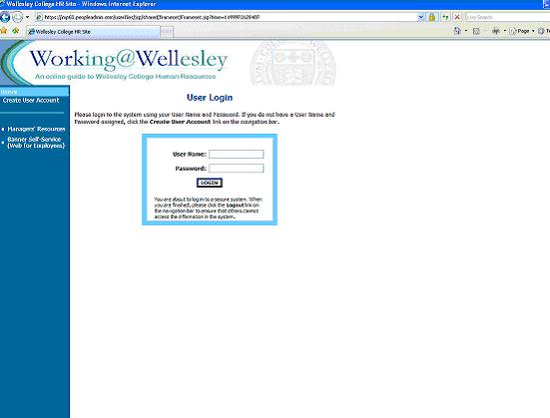

Before you may enter the site, you must obtain a user name and password from Human Resources. Once you log in you will be prompted to change your password.

VIEWING APPLICANTS TO YOUR REQUISITIONS

After logging in to the system, if you have a Requisition that is currently accepting applications, you will see a screen that looks similar to the following:

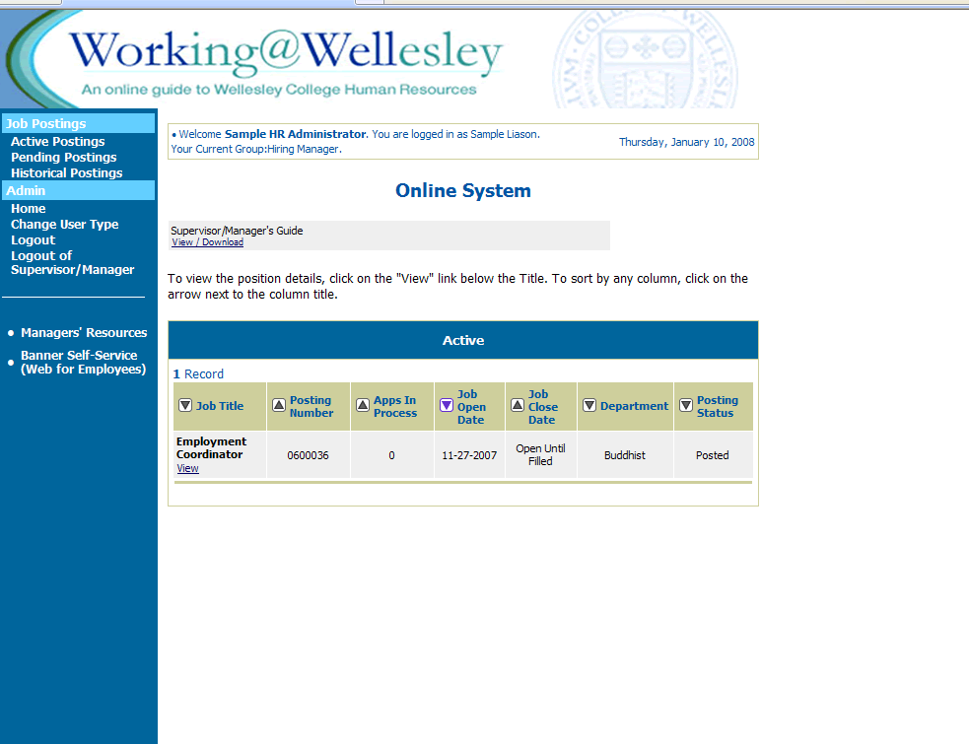

Underneath the Job Postings heading on the left navigation bar, you are presented with the option to View Active, Pending or Historical Requisitions.

View Active: Requisitions that are Active are either:
- currently posted on the applicant site, or
- no longer posted but contain applicants still under review

View Historical: Requisitions that are Historical are either:
- Filled and are no longer listed on the applicant website
- Cancelled and therefore not listed on the applicant website

To view the details of a specific Posting, including the description and the Applicants to that Posting, click on the word “View” below the relevant title. This will bring you to a screen similar to the following:

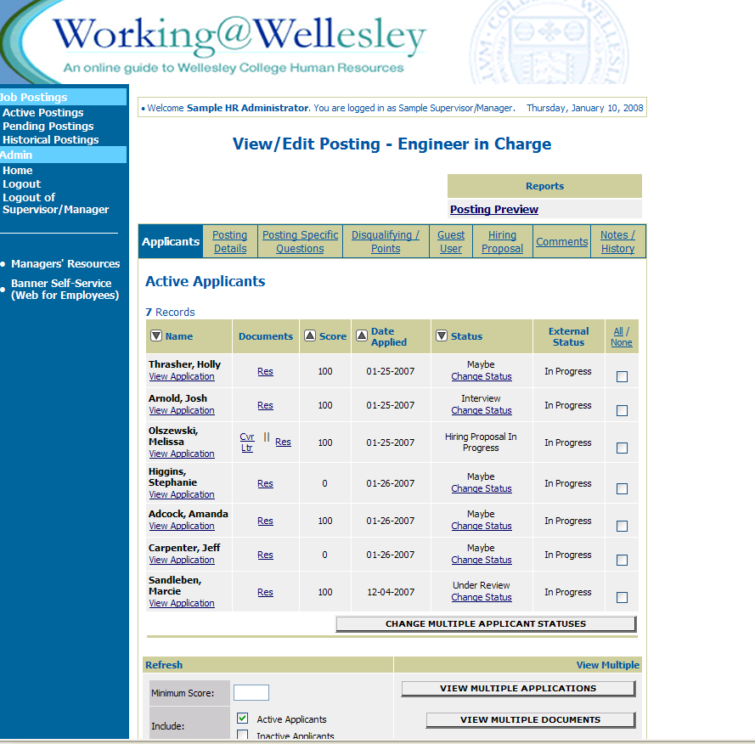

You will notice the posting data is divided into tabs, listed across the top, starting with “Applicants”. This first tab lists the Applicants who have applied to this Posting. Additional information is also provided on this screen, including their date applied, status, etc. You may click through the other tabs at the top of the screen to view more details about the Requisition, including Screening Questions and Points.

From the screen shown above you may perform a number of tasks, including:
- Sort and view applicants by different criteria
- Print applications and documents
- Change an applicant’s status

Sorting & Filtering Applicants by Different Criteria

To sort applicants by Name, Date Applied, etc., click the arrow at the top of the data column you wish to sort. The order in which applicants are displayed will change accordingly.

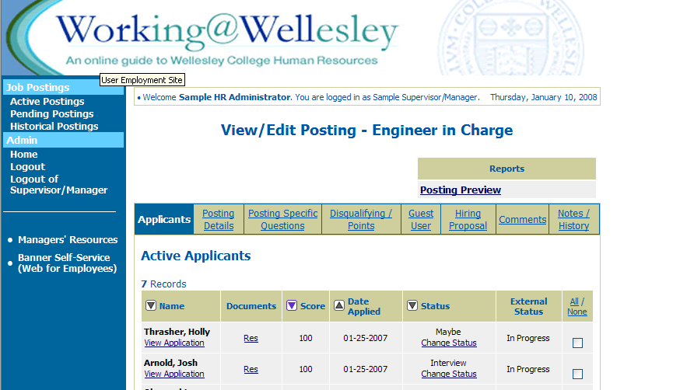

If applicable, to filter applicants by score, enter a numeric value in the Minimum Score box, and click Refresh. Only applicants meeting the score entered (and higher) will be included in your results.

You may also choose to show Active Applicants, Inactive Applicants, or both. This is performed by checking the boxes next to “Active Applicants” (active Applicants are those still under review) and “Inactive Applicants” (inactive Applicants are no longer under review). Click the Refresh button to refresh the screen.

Viewing and Printing Applications

To view and print a single application, click the link "View Application" under the applicant’s name from the "Active Applicants" screen (the screen shown on the previous page). After clicking on this link, a screen similar to the following will appear in a new browser window. It may take a few moments for the information to load into the new window.

Select File>Print from your browser’s menu to print the applications. There is a signature line at the bottom of the page for obtaining the applicant’s signature, if necessary.

To close the window, click the "Close Window" link, or click the X in the upper right-hand corner of the window (this will NOT log you out of the system – it will simply return you to the list of Applicants on the “View Applicants” screen).

To view and print multiple applications at the same time, perform the following steps:
- Check the boxes next to the corresponding Applicants whose applications you wish to print (or click the “All/None” link). These boxes are located on the right side of the page. (See top of next page.)
- Click the View Multiple Applications button.
- A new window will appear (it may take several moments to load). This window contains all the applications you selected to print.
- Select File > Print from your browser’s menu to print the application(s).
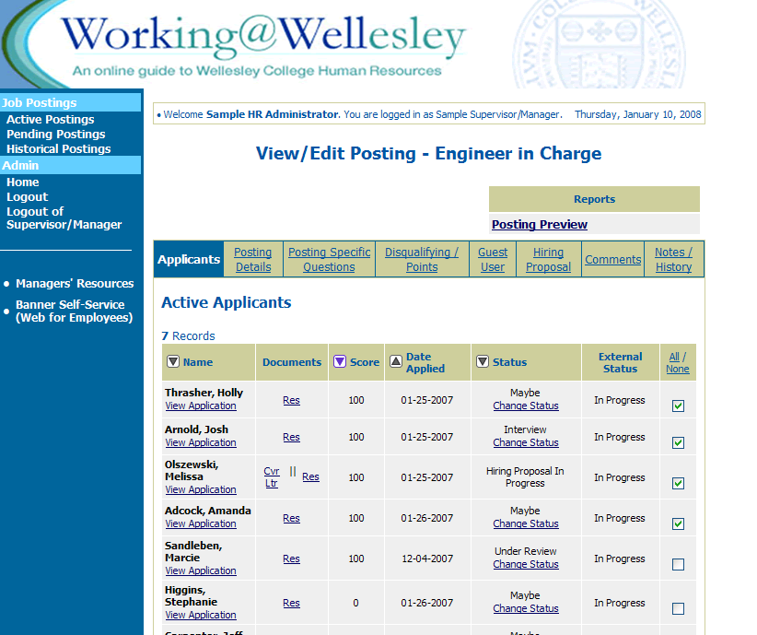

Viewing and Printing Documents

This process is very similar to printing applications, except the documents appear in the Adobe Acrobat Reader software. This is done to preserve the integrity of the documents’ formatting, and to assist in preventing viruses from entering the system via documents attached by Applicants.

To view and print a single document (such as a resume or cover letter) that the applicant attached when applying for the Posting, click the link of the document under the column labeled “Documents” from the "Active Applicants" screen.

After clicking the link, a new window will appear (it may take several moments to load) in Adobe Acrobat Reader. This window contains the document for the applicants you selected to print. Select File>Print from the Adobe Acrobat Reader menu to print the document. To close the window, click on the “X” in the upper right corner of the window (this will NOT log you out of the system – it will simply return you to the list of applicants on the “View Posting” screen).

To view and print multiple documents at the same time, perform the following steps:
- Check the boxes next to the corresponding applicants you wish to print (or click the “All/None” link). These boxes are located on the right side of the page.
- Click the View Multiple Documents button.
- Select File>Print from the Adobe Acrobat menu.

Changing the Status of Applicants

While in the Active Applicants display screen, you can change the status of Applicants as you review their applications.

To change the status of one applicant, click the “Change Status” link under the Status column in the row corresponding to the applicant (see following example).

To change the status of multiple applicants at the same time, check the box below the “All/None” column for each applicant that you wish to change (or click the “All/None” link), and then click the button labeled Change Multiple Applicant Statuses.

After clicking the Change Multiple Applicant Statuses button, a screen similar to the following will appear:

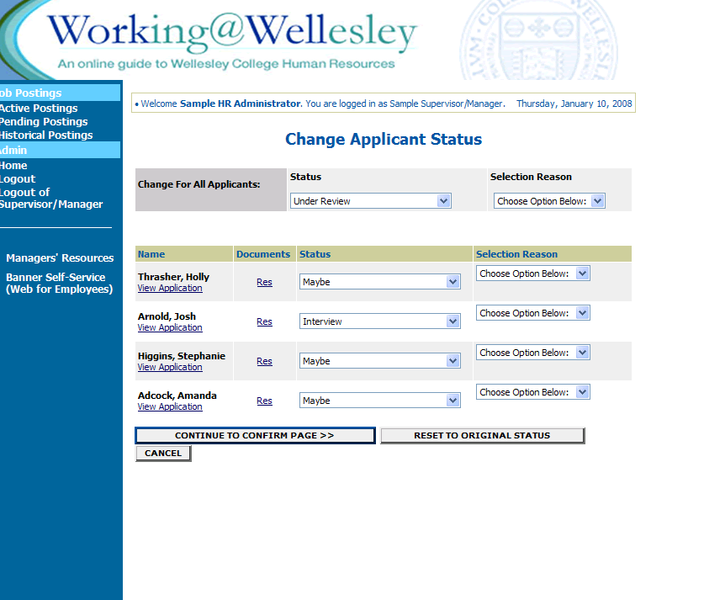

Under the “Status” column there is a drop down menu of the different statuses an applicant could be changed to. Select the new status for each applicant, and then click the Continue to Confirm Page button. To reset the statuses to their original values, click the Reset to Original Status button. To return to the previous screen, click Cancel.

After clicking the Continue to Confirm Page button, you will come to a confirmation page. Select the Save Status Changes button to complete the action. Select the Cancel button to return to the previous screen to edit your changes.

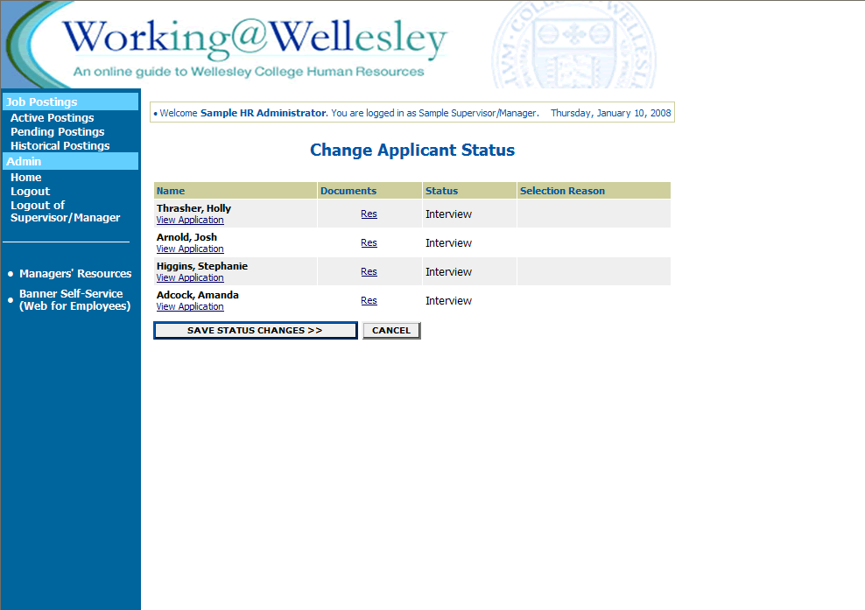

ADMINISTRATIVE FUNCTIONS

Changing Your Password

To change your password, click the “Change Password” link on the left navigation bar, and enter the required information. The change will be updated automatically.

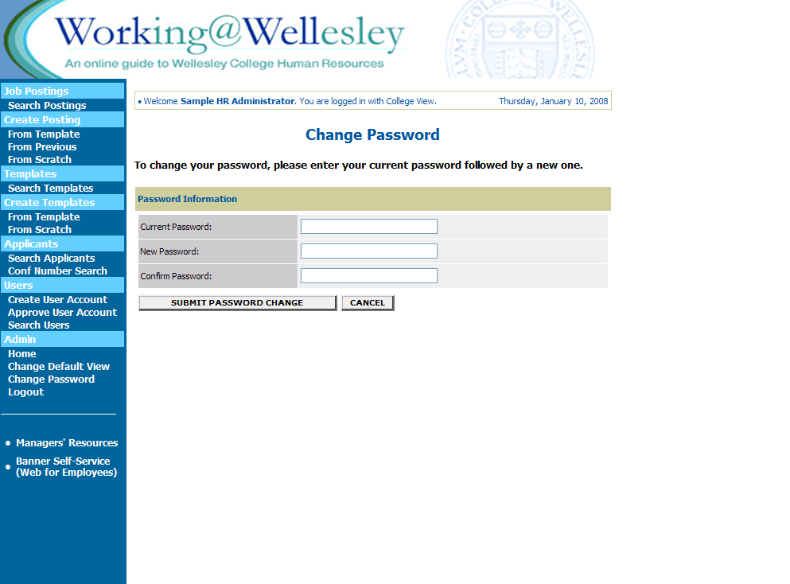

Logging Out

To ensure the security of the data provided by applicants, the system will automatically log you out after 60 minutes if it detects no activity. However, anytime you leave your computer we strongly recommend that you save any work in progress and Logout of the system by clicking on the logout link located on the bottom left side of your screen.

In 1992, Wellesley College ranked 2nd of the COFHE institutions in the number of faculty of African descent; while by 2002, the College dropped to 4th. Over the same period, Wellesley College continued to rank 14th of the COFHE institutions in the number of faculty of Hispanic/Latino descent.
While the College values diversity of all kinds in its faculty, for the purposes of this hiring initiative we are focusing on faculty of African, Asian, Hispanic/Latino, and Native American descent.

