The Five Steps for Setting Up Your Basic Course Site  
  
1) Add useful information to the course home page (“Site Information Display” section). This might be a welcome message, office hours, instructions to the students on how to use the site (e.g., "click on the Resources button, and then click the Word file named Syllabus.docx"), an image that represents the theme, etc.

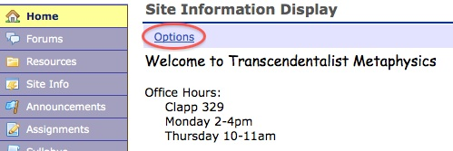

1. Click on **Options**.
2. Change the **Title** if need be.
3. Enter text and/or an image (using the  Insert Image button) in the web editor window.
4. Click **Update Options** at the bottom when finished, or just to preview it as you go along.

2) Select which Tools you want to initially employ in your site (e.g., choosing to keep only Resources and Forums). You can always add or remove tools later without loss of data.

1. Click on **Site Info**.
2. At the top, click **Edit Tools**.
3. Check the box for ones you want to try (such as, Search); un-check those you don’t wish to use at this time.
4. Click **Continue**, then **Finish**.

3) Rename the “General Discussion” Topic in Forums, or add a new one.

1. Click on the **Forums** tool.
2. Click on **Forum** or **Topic Settings** to change the title; click **Save** at the bottom.

4) Add your Syllabus or other course files (such as reserve reading material) to Resources.

1. Click the **Resources** tool.
2. Click on **Add** alongside a folder, and select **Upload Files**.
3. Choose the **Browse** button, find the file on your computer, and click **Open**.
4. Change the **Display Name** if needed, and then **Upload Files Now**.

5) When you have the course site ready for students to use, Publish your course.

1. Click the **Site Info** tool.
2. Choose **Manage Access** from the top.
3. Check the **Publish site** box, and click **Update**.

You can now communicate and share files with your students, and you can add other tools as your needs and interests later indicate.