# 1. Login

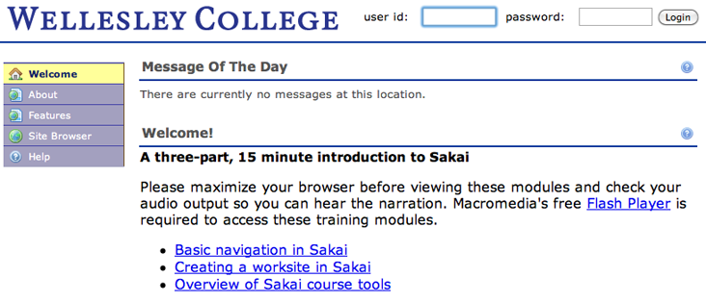Point your web browser to <https://sakai.wellesley.edu> Enter your domain username and password. Click **Login**.

If you’d like a review of Sakai’s basic features, you can follow the links on the login page to view videos.

2. Basic Navigation & major parts of Sakai  
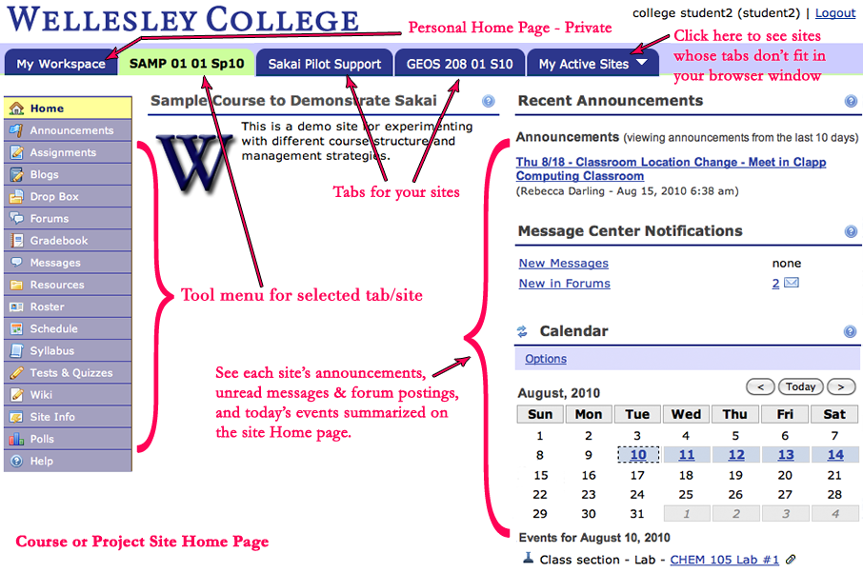There are three types of collaborative spaces in Sakai:

MyWorkspace – Personal home page. Contains your own Resources folder. You can choose to share files with sites, other users, or outside world.

Announcements, Calendar events, unread Messages, and unread Forum posts from all sites you belong to aggregate into your MyWorkspace, so you can see them when you log in. However, not all Sakai tools automatically inform you about changes. Some tools, like Resources, allow the person posting content to decide whether or not to notify site members via email when something new is available.

Course Sites - Created automatically for every course based on information from the registrar's office. Tied to academic calendar.

Project Sites – Collaborative spaces in Sakai. Roughly equivalent to FirstClass conferences. Project Sites are similar to course sites, but aren’t tied to academic calendar. As a faculty or staff member, you can create these yourself, upon getting departmental approval.

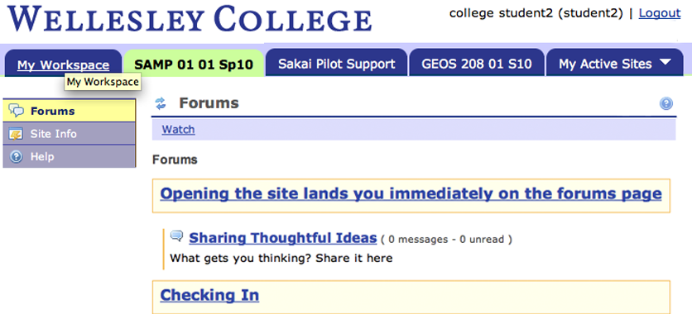Tools in Sakai sites are modular. You can use as many or as few as you like. You may have a site with many tools, as you see above, or your site may only include discussion forums 🡪

Using local navigation tools inside Sakai instead of the browser buttons is extremely important. If you use the browser buttons to navigate, you may lose content you’re working on in the site.

The Reset Button takes you back to the starting point for the tool you’re using, restoring its original state. This is helpful if you’re several levels in a task and would like to start over from the beginning.

*Be careful*: Unless you click Save before pressing the reset button, any information you’ve entered in the tool’s text boxes or lists will be lost.

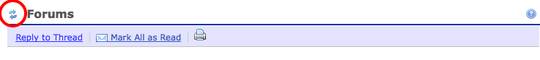

# 3. Adding Participants to your Site

Sakai’s sites are closed by default. Course sites will automatically include all registered students as participants. To allow other users (e.g., other Wellesley faculty, colleagues elsewhere, auditors) to access your site, you should add them as participants.

Click on **Site Info** in the left-hand menu. You will see a horizontal blue bar with more menu items. Select **Add Participants**.

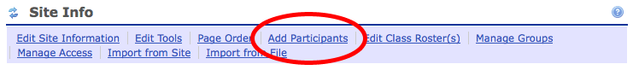

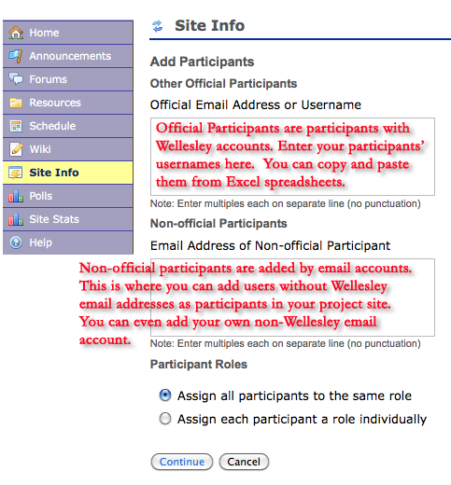

All site participants must be assigned a role. The role determines a user’s permissions and access to certain parts of the site. Search Participant roles in the help to see the default set of permissions for each role.

# 4. Adding Files to Resources

Content may be stored within many Sakai tools, but the primary repository for content is the Resources tool.

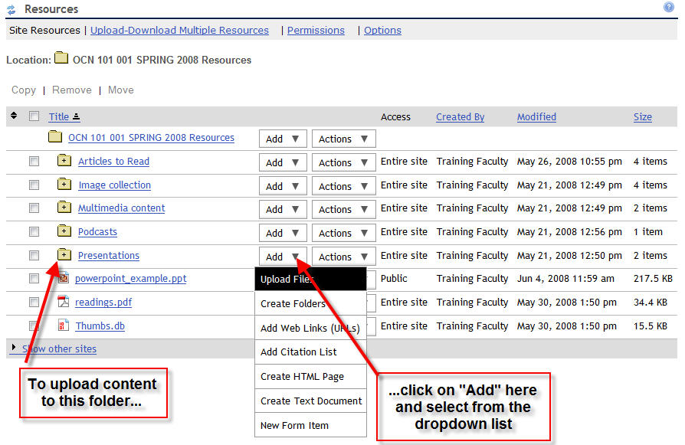Click on **Resources** in the left-hand menu. You will see a hierarchical display of folders:

You can also expand the folder views by clicking on the small “+” symbol (indicating a folder has content). Clicking on the item link itself will display the item. Clicking on the “Actions” drop down associated with a folder or item offers the opportunity to copy, move, remove, or reorder the items, edit the details of an item or change access permissions on the item.

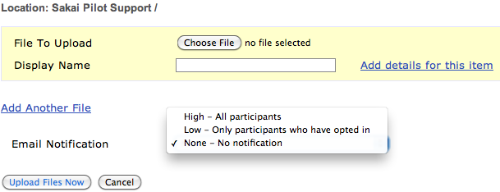You may want to notify site members about new content as you upload it. Select **Upload Files** from the “Add” drop down menu. After you choose the file(s), set the Email Notification level.

Remember to click **Upload Files Now** or your changes won’t be saved.

Do you have a large volume of content to upload into Sakai? Click on **Upload-Download Multiple Resources** in the Resources tool to set up WebDAV with a client such as CyberDuck or AnyClient for easier and more reliable uploading of many files.

# 5. Entering text directly in Sakai Tools

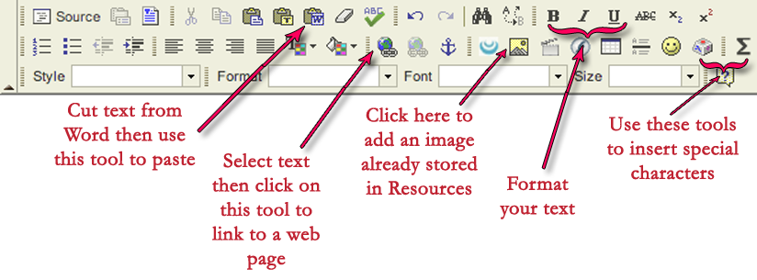Many of Sakai’s tools use a web editor to allow you to enter and format text directly in your web browser. The formatting options will look familiar, but here are a few particularly useful buttons.

# 6. Discussion Forums

The Forum tool provides a hierarchy of Forums, Topics, Threads and Messages to organize discussions. Your role on the site will determine which forum parts you can create and reply to.

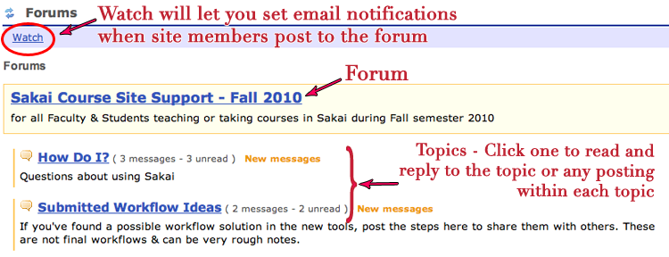Forums are containers at the top level. Each forum contains one or more Topics. Forums and Topics are usually created by the Instructor.

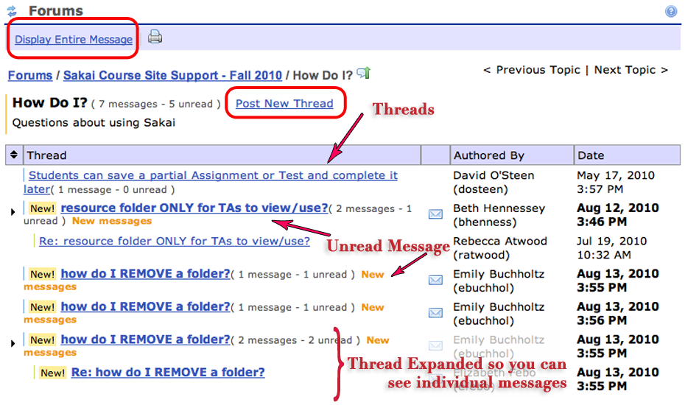Topics contain the individual threads and messages (postings). If you click on a topic, you will now be able to see the threads and messages. Threads are groups of messages, and appear with the oldest messages at the top of the list. In most cases, all site users will be able to create new message threads by clicking the **Post New Thread** link.

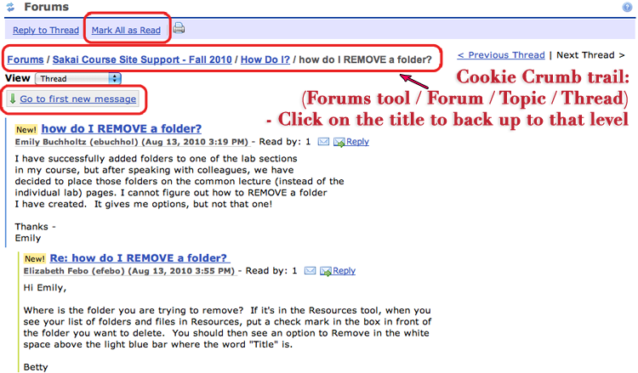Click on a message or thread to open it

In order for messages to be marked as read, you need to click the envelope icon next to each thread, or select **Mark All As Read** in each thread.

Sakai forums are organized with the oldest message at the top of the list. Click **Go to first new message** to jump down to the first unread message in the forum.

# 7. Tips

1. Save before clicking on a new Tool, a different web page, or another tab.
2. Compose longer text entries in a text editor (e.g., Notepad) or word processor (e.g., Word) and then copy/paste into the text entry area in Sakai.
3. If you are copying from Word, use the “Paste from Word” button in Sakai’s web editor, to remove extraneous formatting (see section 5 of this document for an image of the button).

# 8. Need Help?

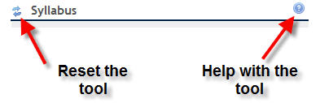Contextually-appropriate help is accessible within each Sakai tool by clicking on the question mark icon in the upper right of each tool window. You may also reset the tool by clicking on the arrows adjacent to the tool title. This restores the tool to its original state.

You can also find help using the **Help** tool in the Tools menu on the left-hand side of each Sakai screen or by asking questions in the **UC Pilot Support** forums.