Overview
This repository contains a fully orchestrated dbt + Airflow data pipeline designed to transform raw operational data into analytics-ready dimensional models. The solution includes:
- A modular dbt project (staging, marts, snapshots, tests)
- Airflow DAGs for orchestration, scheduling, and monitoring
- A complete Mermaid diagrams pack for documentation
- Configurable connections, variables, and environment overrides
The pipeline is built for reliability, transparency, and ease of deployment across local and cloud environments.
Setup Instructions
Local Development Setup
Prerequisites
- Python 3.10+
- Node.js (for Mermaid CLI)
- Docker (recommended for Airflow)
- dbt-core installed
- Airflow installed or running via Docker Compose
Clone the Repository
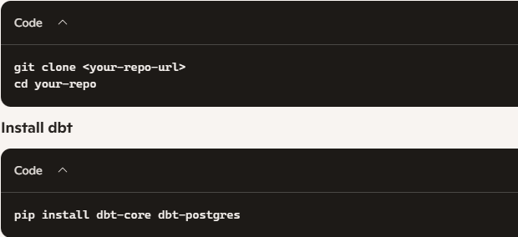
Start Airflow (Docker Compose)
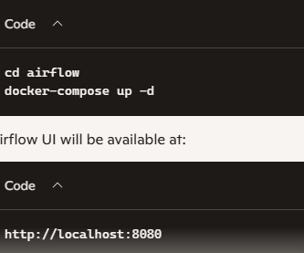
Run dbt Locally
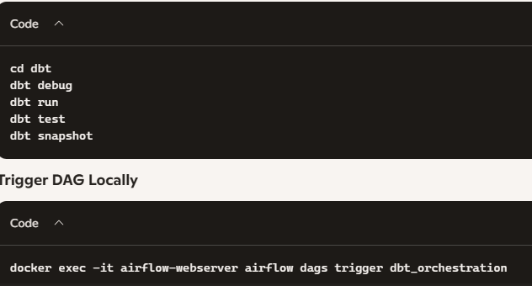
Cloud Deployment Setup
This project can be deployed to:
- AWS MWAA
- Astronomer
- Google Cloud Composer
- Azure Data Factory + dbt Cloud
General Cloud Steps
Cloud Deployment Setup
This project can be deployed to:
- AWS MWAA
- Astronomer
- Google Cloud Composer
- Azure Data Factory + dbt Cloud
General Cloud Steps
- Upload airflow/dags/ to your cloud Airflow environment
- Upload airflow/plugins/
- Configure Airflow Connections
- Configure Airflow Variables
- Deploy dbt project to dbt Cloud or a containerized environment
Cloud Storage Integration
- Raw data → S3 / GCS / Azure Blob
- Warehouse → Snowflake / BigQuery / Redshift / Postgres
- Logs → CloudWatch / Stackdriver / Azure Monitor

Rationale for Data Modeling Choices
Dimensional Modeling (Kimball-style)
The pipeline uses:
- Staging models to clean raw data
- Dimension tables (dim_customers, dim_products)
- Fact tables (fct_orders)
- Snapshots for SCD Type 2 history
This structure supports:
- Analytics use cases
- Fast BI queries
- Historical tracking
- Clear lineage
dbt Rationale
dbt provides:
- SQL-based transformations
- Built-in testing
- Automatic lineage
- Environment-aware configuration
- Version control + CI/CD compatibility
Airflow Rationale
Airflow provides:
- Mature orchestration
- DAG-based dependency management
- Retry logic, sensors, monitoring
- Plugin system for Slack alerts + custom operators
Assumptions
Data Assumptions
- Raw data exists in a warehouse
- Primary keys are stable
- Timestamps exist for snapshots
Pipeline Assumptions
- Airflow can access the dbt project directory
- Connections are configured (dbt_postgres, slack_conn)
- Scheduler runs continuously
Modeling Assumptions
- Customer, product, and order data follow relational structure
- Fact tables reference dimension tables
- Reporting models require aggregated metrics
4. Open Questions
- These items may require clarification before production deployment:
- Should snapshots track additional SCD attributes?
- Should reporting models be materialized as tables or views?
- Should Airflow trigger dbt Cloud jobs instead of local dbt runs?
- Should alerts go to Slack, email, or a monitoring platform?
- Should incremental models be added for large datasets?
- Should data freshness checks be added for raw sources?

Documentation & Diagrams
All diagrams are stored in:
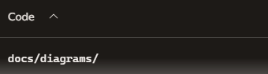
Regenerate diagrams using Mermaid CLI:
