CS 532 Requirements Analysis and Project Plan

Report Contents

1. Review Milestone: Requirements Review

Project: Graffiti Incident Tracking System

Team: Michael Jannain, Jimmy Doan, Julian Nunez, Jose Garcia

Date of Report: 2 - 15 - 2016

2. Project plan contents

a. **Michael - Project Manager, System Engineering Manager**

**Jimmy - Software Manager**

**Julian - Configuration Manager**

**Jose - Test Manager**

b. Development Environment (and Target Environment if different)

i. Platform/operating system:

-Windows

ii. Implementation language(s):

-Python

-C/Java (possible)

-Web Language (PHP, Javascript, or other)

iii. Database application:

-MySQL

iv. Rationale for selection:

- MySQL and Python are very compatible and offer many libraries for support

c. ICSM Common CaseID 5 (System of systems/enterprise-wide systems): GITS must be able to be “integrated together in a manner that allows them to interoperate and perform cross-cutting mission-specific capabilities”. Constant connection and communication between the Public Works City Crew and Law Enforcement is critical.

d. Methodologies/techniques: Architected Agile - Small group size and lack of experience in software development/required languages among team members warrants extra focus towards foundations/architectural issues in the initial iteration. Transition to agile afterwards is perfect for students who have other time commitments.

e. Basis of Development Estimate – Software Size

i. Provide software size estimates using the one of the three methods discussed in class: lines of code, function points, or object points

-Lines of Code: 50,000

-Web Portion: 25,000 lines of code (complexity: medium-high)

-Backend Python/Database: 25,000 lines of code (complexity: low)

-Compared With: previous database and web-application

ii. Estimates should be done by software “component” and identify the associated complexity of each.

* System/Performance - 13,000 (Med Complexity)
* GITS Framework - 14,300 (Med Complexity)
* Incident Entry - 14,300 (Med Complexity)
* Analysis - 3,900 (High Complexity)
* Reporting Capabilities - 3,900 (Low Complexity)

f. Schedule (OpenProj preferred, if available…. Otherwise, use a spreadsheet)

i. List of third level development tasks (based on life cycle model selected)

Build 1 - Development, Unit Test, Handover to Test (City Workers)

Build 2 - Development, Unit Test, Handover to Test (Law Enforcement)

Build 3 - Sync Crew and Law Enforcement

Build 1 Test for City Crew - Test Planning, Analysis, Execution, Completion

Build 2 Test for Law Enforcement - Test Planning, Analysis, Execution, Completion

ii. For each 3rd level task, identify planned start date, duration of task, and any predecessor tasks

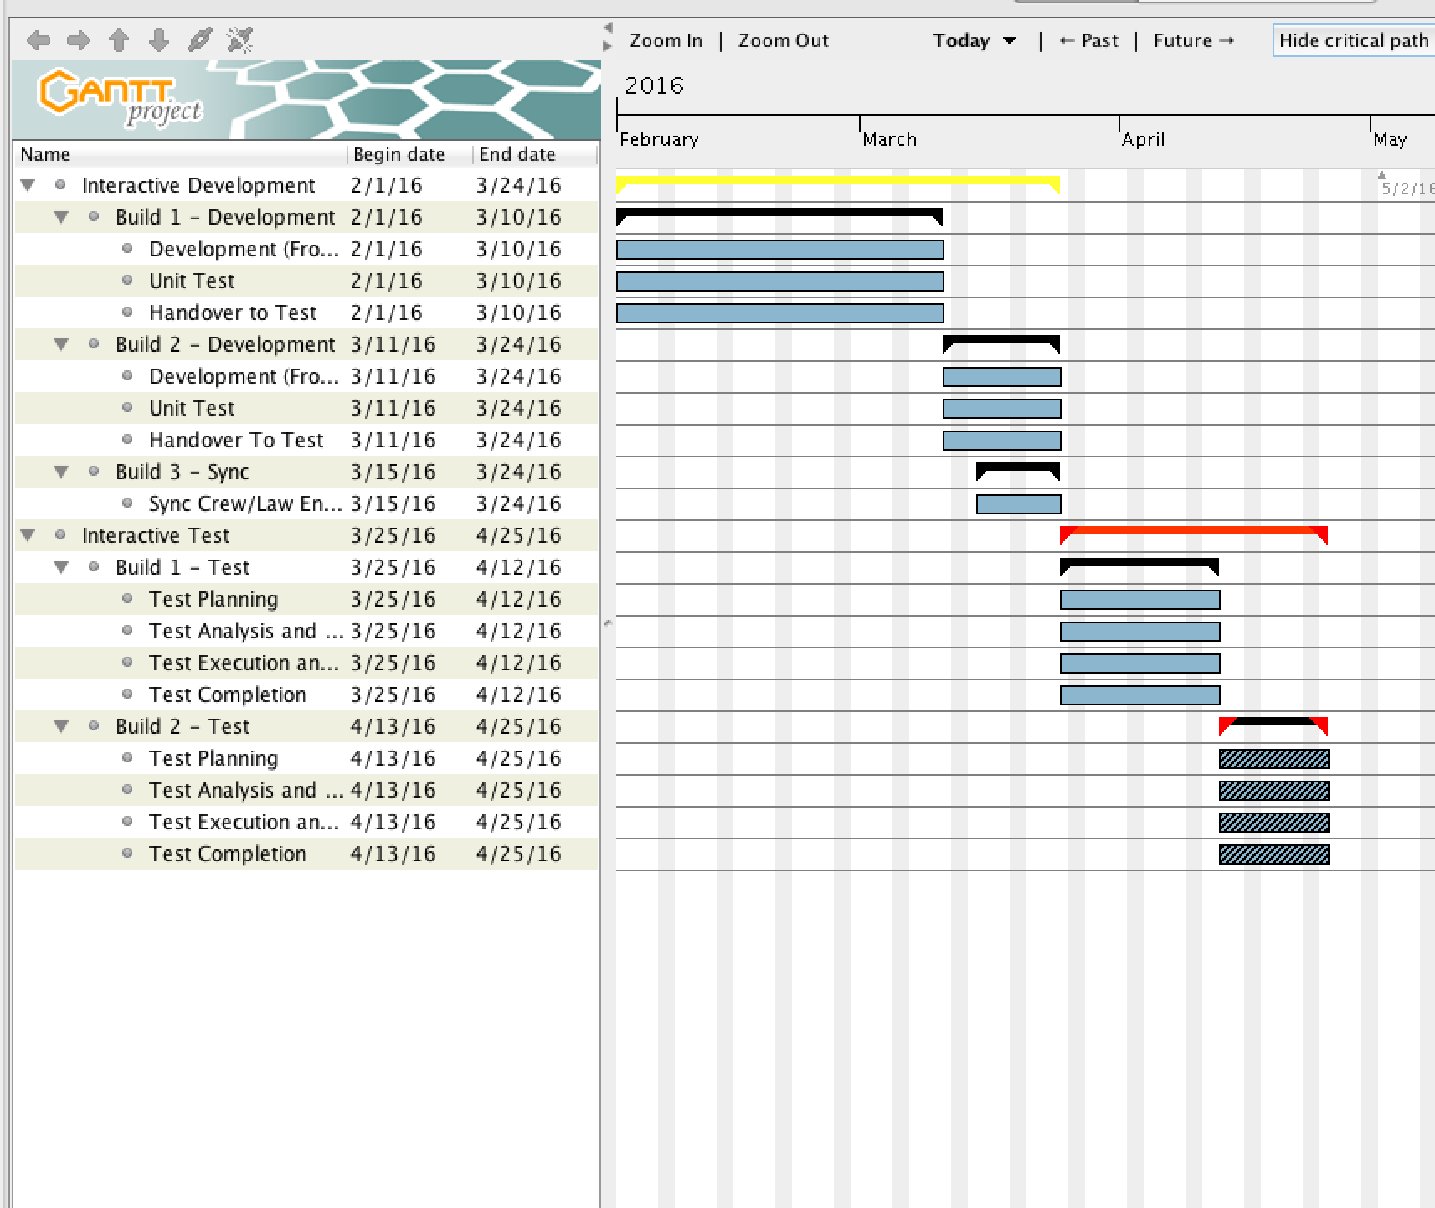

-Interactive Development (Start=2/1/16, End=3/24/16)

-Build 1 - Development (Start=2/1/16, End=3/10/16)

-Development (Start=2/1/16, End=3/10/16)

-Unit Test (Start=2/1/16, End=3/10/16)

-Handover to Test (Start=2/1/16, End=3/10/16)

-Build 2 - Development (Start=3/11/16, End=3/24/16)

-Development (Start=3/11/16, End=3/24/16)

-Unit Test (Start=3/11/16, End=3/24/16)

-Handover to Test (Start=3/11/16, End=3/24/16)

-Build 3 - Sync (Start=3/15/16, End=3/24/16)

-Sync City Workers/Law Enf. (Start=3/15/16, End=3/24/16)

-Interactive Development (Start=3/25/16, End=4/25/16)

-Build 1 - Test (Start=3/25/16, End=4/12/16)

-Test Planning (Start=3/25/16, End=4/12/16)

-Test Analysis (Start=3/25/16, End=4/12/16)

-Test Execution (Start=3/25/16, End=4/12/16)

-Test Completion (Start=3/25/16, End=4/12/16)

-Build 2 - Test (Start=3/11/16, End=3/24/16)

-Test Planning (Start=4/13/16, End=4/25/16)

-Test Analysis (Start=4/13/16, End=4/25/16)

-Test Execution (Start=4/13/16, End=4/25/16)

-Test Completion (Start=4/13/16, End=4/25/16)

iii. Identification of critical path

* Critical Path: 2 months, 25 days (= 85 days)
* Section of Schedule: Build 2 - Test

iv. Progress to date with respect to the planned schedule

* Phase: Build 1 - Development

g. Estimate of total number of labor hours to perform all tasks in the schedule

* 4 members x 85 days x 2 hrs. per day = 680 labor hours

3. Requirements

a. Statement of Scope of Effort/Understanding of Problem

i. GITS will allow Central City Public Works personnel to document graffiti on an Internet Portal and send the incident data to Law Enforcement Officials. Law Enforcement Officials will then have access to a user interface that allows them to view, edit, and update this incident data, photos of the damage, and identity of suspects. Law Enforcement Officials will also be able to use analysis capabilities to identify “hot spots”. Authorized staff will be allowed to request, view, or print reports from the database.

ii. GITS will have a menu driven, full graphical user interface with multiple, moveable, and resizable windows. 5 second response time when a user completes all required steps in a transaction and commits that transaction to the database. Support multiple users with password protected accounts that only allow access to assigned cases. Information will be retained after single entry to database. Customizable input validation and error messages indicating input requirements. Be able to correctly process hyphenated names in any name component, first, middle, and/or last and allow name searches using the standard wildcard characters. Online Help function that covers all screens, modules, inquiries, data entry fields, etc.

iii. Use Cases (UML diagram format)

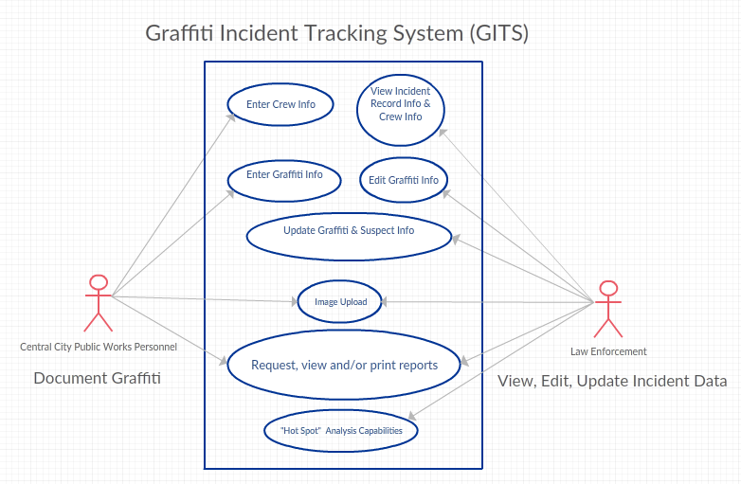

b. Discussion of requirements analysis (Note: complete details of requirements, requirements allocation, and mapping to increments expected to be in Project Notebook)

i.

|  |  |  |  |  |  |  |
| --- | --- | --- | --- | --- | --- | --- |
| Requirement # | Brief Requirement Description | Priority | Requirement Source | Functionality | GITS Subsection | Increment Implementation |
| 1 | System and Performance Requirements (UI Performance) | MED | General | System/Performance | UI/Portal | 3 |
| 2 | System and Performance Requirements (Operational Environment: Multiple Users) | MED | General | System/Performance | UI/Portal | 3 |
| 3 | System and Performance Requirements (Security Access) | HIGH | General | System/Performance | UI/Portal | 3 |
| 4 | System and Performance Requirements (Single Entry of Information) | MED | General | System/Performance | UI/Portal | 3 |
| 5 | System and Performance Requirements (Validation of Inputs) | MED | General | System/Performance | UI/Portal | 3 |
| 6 | System and Performance Requirements (Entry and Processing of Names) | LOW | General | System/Performance | UI/Portal | 3 |
| 7 | System and Performance Requirements (Online Help) | LOW | General | System/Performance | UI/Portal | 3 |
| 8 | System and Performance Requirements (Screens/UI) | LOW | General | System/Performance | UI/Portal | 3 |
| 9 | System and Performance Requirements (Prototype Design/Process) | MED | General | System/Performance | UI/Portal | 3 |
| 10 | System and Performance Requirements (Error Message) | LOW | General | System/Performance | UI/Portal | 3 |
| 11 | GITS Framework (Navigation Structure) | LOW | General | GITS Framework | UI/Portal | 3 |
| 12 | GITS Framework (User Login Management) | MED | General | GITS Framework | UI/Portal | 3 |
| 13 | GITS Framework (Authorized Users: Information Entry/Maintnence) | MED | General | GITS Framework | UI/Portal | 3 |
| 14 | GITS Framework (User Name) | LOW | General | GITS Framework | UI/Portal | 3 |
| 15 | GITS Framework (User Employee Number) | LOW | General | GITS Framework | UI/Portal | 3 |
| 16 | GITS Framework (User's Job Title) | LOW | General | GITS Framework | UI/Portal | 3 |
| 17 | GITS Framework (User Password) | MED | General | GITS Framework | UI/Portal | 3 |
| 18 | GITS Framework (Allowable Access Areas: Subsystem) | LOW | General | GITS Framework | UI/Portal | 3 |
| 19 | GITS Framework (System Admin Menu) | LOW | General | GITS Framework | UI/Portal | 3 |
| 20 | GITS Framework (Print Authorized User Report: Whole System/Subsystem) | LOW | General | GITS Framework | UI/Portal | 3 |
| 21 | GITS Framework (System Level Authorized Users: Password Reset/Initialization) | MED | General | GITS Framework | UI/Portal | 3 |
| 22 | Graffiti Incident Documentation (Crew Info) | HIGH | Central City Public Works | Incident Entry | Internet Portal | 1 |
| 23 | Graffiti Incident Documentation (Graffiti Info) | HIGH | Central City Public Works | Incident Entry | Internet Portal | 1 |
| 24 | Graffiti Incident Documentation (Image Upload) | HIGH | Central City Public Works | Incident Entry | Internet Portal | 1 |
| 25 | Graffiti Incident Documentation (Options) | HIGH | Central City Public Works | Incident Entry | Internet Portal | 1 |
| 26 | Ability to view Incident Record Info & Crew Info | HIGH | Law Enforcement | Incident Entry | User Interface | 2 |
| 27 | Ability to edit Graffiti Info | HIGH | Law Enforcement | Incident Entry | User Interface | 2 |
| 28 | Ability to update Graffiti Info | HIGH | Law Enforcement | Incident Entry | User Interface | 2 |
| 29 | Ability to update Suspect Info | HIGH | Law Enforcement | Incident Entry | User Interface | 2 |
| 30 | Add label to image | LOW | Law Enforcement | Incident Entry | User Interface | 2 |
| 31 | Graffiti Incident Documentation (Options) | HIGH | Law Enforcement | Incident Entry | User Interface | 2 |
| 32 | Image Upload | HIGH | Law Enforcement | Incident Entry | User Interface | 2 |
| 33 | Graffiti Analysis (GA) Requirements (Frequency of Incidents) | HIGH | Law Enforcement | Analysis | User Interface | 2 |
| 34 | Graffiti Analysis (GA) Requirements (Hot Spot: Calculation) | HIGH | Law Enforcement | Analysis | User Interface | 2 |
| 35 | Graffiti Analysis (GA) Requirements (Hot Spot: Reporting) | HIGH | Law Enforcement | Analysis | User Interface | 2 |
| 36 | Graffiti Reporting (GR) Requirements (Map of Incidents) | HIGH | Authorized Staff | Reporting Capabilities | Internet Portal | 2 |
| 37 | Graffiti Reporting (GR) Requirements (Sorted Record of Incidents) | HIGH | Authorized Staff | Reporting Capabilities | Internet Portal | 2 |
| 38 | Graffiti Reporting (GR) Requirements (Status Report) | HIGH | Authorized Staff | Reporting Capabilities | Internet Portal | 2 |

ii. Discussion of completeness, consistency, testability, etc. of requirements and any changes that were required to address these types of issues.

* Still in Build Phase 1. No Requirements changed or added yet. Test Phase after each design phase.

iii. Quantitative summary of requirements at end of requirements analysis

1. Total number from initial requirements document by functional area

* System/Performance = 10
* GITS Framework = 11
* Incident Entry = 11
* Analysis = 3
* Reporting Capabilities = 3

2. Number of requirements added, deleted, or changed during requirements analysis activities.

* No requirements added, deleted, or changed during this current process.

3. Total number of requirements going forward into top-level design

* 38

4. Risk status/Areas needing further analysis/questions still not answered and plans for getting risks/issues resolved.

* Lack of experience and knowledge of programming languages in database and web design might lead to time management issues and warrant extra time contribution.
* Resolution: Account for extra time needed to familiarize ourselves with new tools/languages.