Team Project Notebook Contents

1. Status Cover Sheet and signature page that contains the signature of all team members contributing to the project notebook

X _Jimmy Doan_________________________________________________________________

X__Julian Nunez________________________________________________________________

X_ Michael Jannain_____________________________________________________________

X_ Jose Garcia___________________________________________________________________

1. Team Plan: *This in NOT just your Report #1 plan information, but rather the backup data/information that supports your Report #1*
   1. Life cycle model: **Joint Application Design**. Customer explicitly states “All customization, modifications, or new development will be accomplished using JAD (Joint Application Design) methodology”.
   2. Estimates (updated at each phase): Size, labor hours, schedule
      1. Size: 4 developers
      2. Labor Hours: 4 members x 53 days x 2 hours = 424 hours
      3. Schedule:

-Interactive Development (Start=2/1/16, End=3/24/16)

* + - 1. Build 1 - Development (Start=2/1/16, End=3/10/16)
         1. -Development (Start=2/1/16, End=3/10/16)
         2. -Unit Test (Start=2/1/16, End=3/10/16)
         3. -Handover to Test (Start=2/1/16, End=3/10/16)
      2. Build 2 - Development (Start=3/11/16, End=3/24/16)
         1. -Development (Start=3/11/16, End=3/24/16)
         2. -Unit Test (Start=3/11/16, End=3/24/16)
         3. -Handover to Test (Start=3/11/16, End=3/24/16)
      3. Build 3 - Sync (Start=4/4/16, End=4/24/16)
         1. -Sync City Workers/Law Enf. (Start=4/4/16, End=4/24/16)
  1. Actual measures: Size, labor hours, schedule
     1. Software Size: 1,500 SLOC
  2. Schedule to include the following for each major activity: lead person, subtasks, relationships between subtasks (e.g., predecessors/successors), and critical path

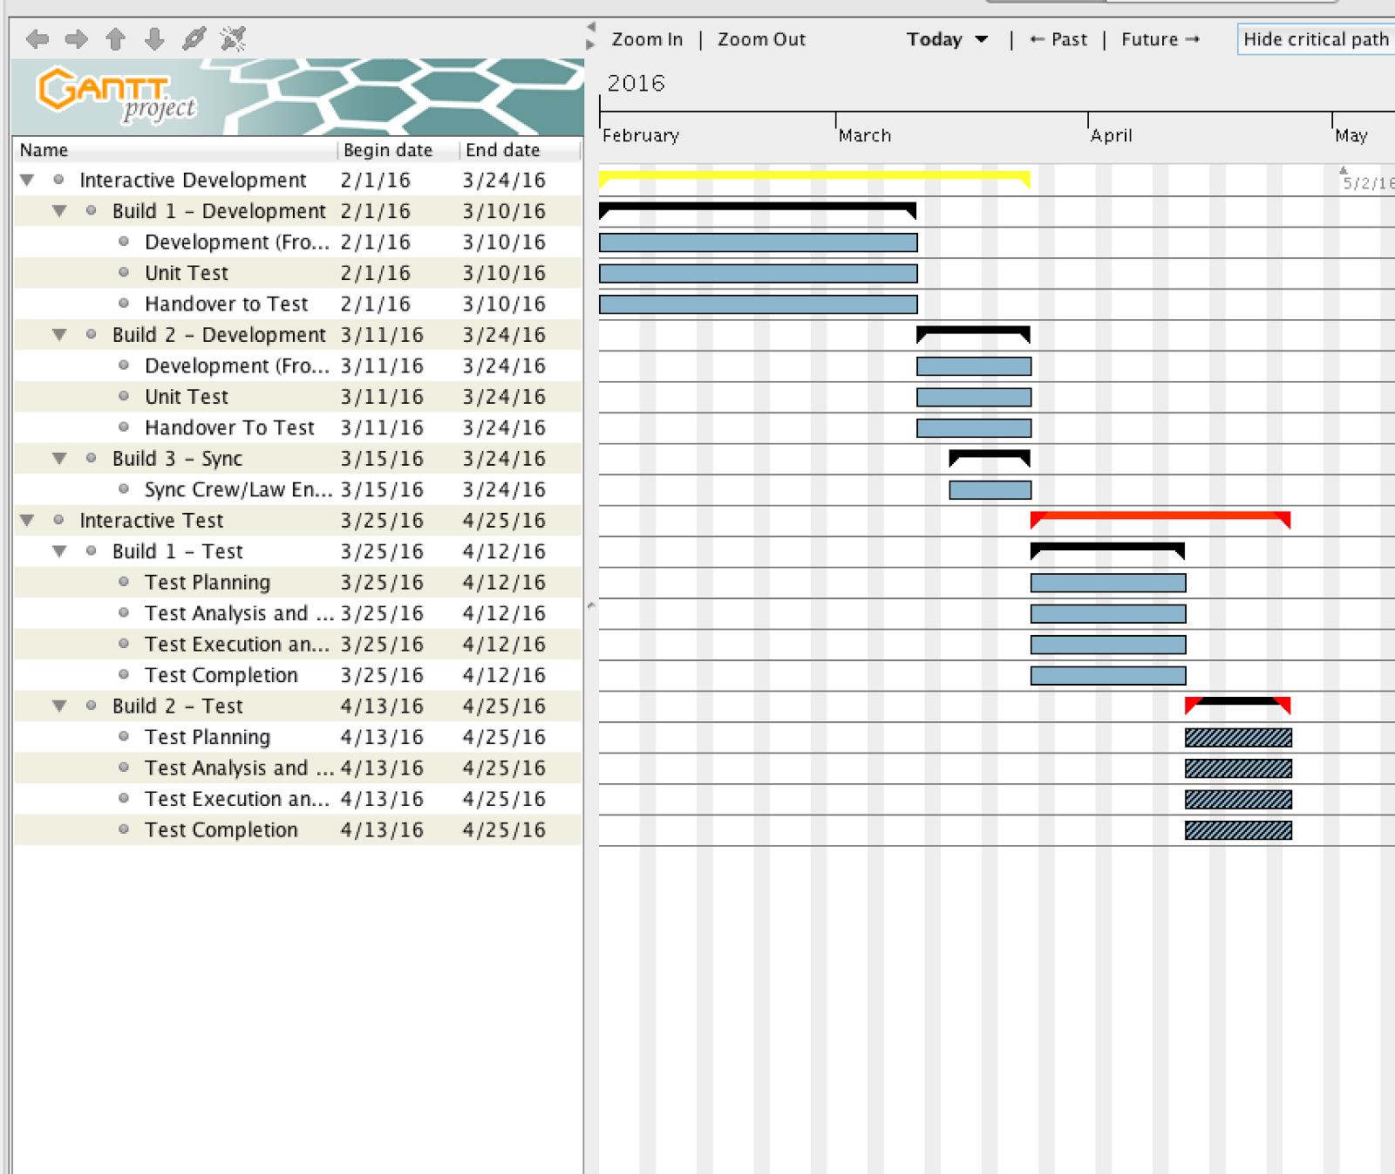

<https://docs.google.com/spreadsheets/d/1okDLT07rOzk8BJ7gpmj1Bzzrad5iaqobG1pHFYGOGuk/edit?usp=sharing>

1. Requirements: *This in NOT just your Report #1 requirements information, but rather the backup data/information that supports your reports (requirements updates are expected for each of your reports)*
   1. List of team requirements

|  |  |
| --- | --- |
| 1 | System and Performance Requirements (UI Performance) |
| 2 | System and Performance Requirements (Operational Environment: Multiple Users) |
| 3 | System and Performance Requirements (Security Access) |
| 4 | System and Performance Requirements (Single Entry of Information) |
| 5 | System and Performance Requirements (Validation of Inputs) |
| 6 | System and Performance Requirements (Entry and Processing of Names) |
| 7 | System and Performance Requirements (Online Help) |
| 8 | System and Performance Requirements (Screens/UI) |
| 9 | System and Performance Requirements (Prototype Design/Process) |
| 10 | System and Performance Requirements (Error Message) |
| 11 | GITS Framework (Navigation Structure) |
| 12 | GITS Framework (User Login Management) |
| 13 | GITS Framework (Authorized Users: Information Entry/Maintenance) |
| 14 | GITS Framework (User Name) |
| 15 | GITS Framework (User Employee Number) |
| 16 | GITS Framework (User's Job Title) |
| 17 | GITS Framework (User Password) |
| 18 | GITS Framework (Allowable Access Areas: Subsystem) |
| 19 | GITS Framework (System Admin Menu) |
| 20 | GITS Framework (Print Authorized User Report: Whole System/Subsystem) |
| 21 | GITS Framework (System Level Authorized Users: Password Reset/Initialization) |
| 22 | Graffiti Incident Documentation (Crew Info) |
| 23 | Graffiti Incident Documentation (Graffiti Info) |
| 24 | Graffiti Incident Documentation (Image Upload) |
| 25 | Graffiti Incident Documentation (Options) |
| 26 | Ability to view Incident Record Info & Crew Info |
| 27 | Ability to edit Graffiti Info |
| 28 | Ability to update Graffiti Info |
| 29 | Ability to update Suspect Info |
| 30 | Add label to image |
| 31 | Graffiti Incident Documentation (Options) |
| 32 | Image Upload |
| 33 | Graffiti Analysis (GA) Requirements (Frequency of Incidents) |
| 34 | Graffiti Analysis (GA) Requirements (Hot Spot: Calculation) |
| 35 | Graffiti Analysis (GA) Requirements (Hot Spot: Reporting) |
| 36 | Graffiti Reporting (GR) Requirements (Map of Incidents) |
| 37 | Graffiti Reporting (GR) Requirements (Sorted Record of Incidents) |
| 38 | Graffiti Reporting (GR) Requirements (Status Report) |

* 1. Requirements matrix mapping team requirements to design and tests

|  |  |  |  |
| --- | --- | --- | --- |
| PHASE: | PERSON RESPONSIBLE: | REQUIREMENT: | USER: |
| Interactive Development |  |  | CITY WORKERS |
| Build 1 - Development |  |  | CITY WORKERS |
| Development (Front/Back-End) |  |  | CITY WORKERS |
|  | Mike | Graffiti Incident Documentation (Crew Info) | CITY WORKERS |
|  | Jimmy | Graffiti Incident Documentation (Graffiti Info) | CITY WORKERS |
|  | Jose | Graffiti Incident Documentation (Image Upload) | CITY WORKERS |
|  | Julian | Graffiti Incident Documentation (Options) | CITY WORKERS |
| Unit Test |  |  | CITY WORKERS |
| Handover to Test |  |  | CITY WORKERS |
| Build 2 - Development |  |  | LAW ENFORCEMENT |
| Development (Front/Back-End) |  |  | LAW ENFORCEMENT |
|  | Mike | Ability to view Incident Record Info & Crew Info | LAW ENFORCEMENT |
|  | Jimmy | Ability to edit Graffiti Info | LAW ENFORCEMENT |
|  | Jose | Ability to update Graffiti Info | LAW ENFORCEMENT |
|  | Julian | Ability to update Suspect Info | LAW ENFORCEMENT |
|  | Mike | Add label to image | LAW ENFORCEMENT |
|  | Jimmy | Graffiti Incident Documentation (Options) | LAW ENFORCEMENT |
|  | Jose | Image Upload | LAW ENFORCEMENT |
|  | Julian | Graffiti Analysis (GA) Requirements (Frequency of Incidents) | LAW ENFORCEMENT |
|  | Jimmy | Graffiti Analysis (GA) Requirements (Hot Spot: Calculation) | LAW ENFORCEMENT |
|  | Mike | Graffiti Analysis (GA) Requirements (Hot Spot: Reporting) | LAW ENFORCEMENT |
| Unit Test |  |  | LAW ENFORCEMENT |
| Handover to Test |  |  | LAW ENFORCEMENT |
| Build 3 - Sync |  |  | BOTH |
| Sync Crew/Law Enforcement |  |  | BOTH |
|  | Julian | System and Performance Requirements (UI Performance) | BOTH |
|  | Julian | System and Performance Requirements (Operational Environment: Multiple Users) | BOTH |
|  | Julian | System and Performance Requirements (Security Access) | BOTH |
|  | Julian | System and Performance Requirements (Single Entry of Information) | BOTH |
|  | Jose | System and Performance Requirements (Validation of Inputs) | BOTH |
|  | Jose | System and Performance Requirements (Entry and Processing of Names) | BOTH |
|  | Jose | System and Performance Requirements (Online Help) | BOTH |
|  | Jose | System and Performance Requirements (Screens/UI) | BOTH |
|  | Jimmy | System and Performance Requirements (Prototype Design/Process) | BOTH |
|  | Jimmy | System and Performance Requirements (Error Message) | BOTH |
|  | Jimmy | GITS Framework (Navigation Structure) | BOTH |
|  | Jimmy | GITS Framework (User Login Management) | BOTH |
|  | Mike | GITS Framework (Authorized Users: Information Entry/Maintenance) | BOTH |
|  | Mike | GITS Framework (User Name) | BOTH |
|  | Mike | GITS Framework (User Employee Number) | BOTH |
|  | Mike | GITS Framework (User's Job Title) | BOTH |
|  | Mike | GITS Framework (User Password) | BOTH |
|  | Jimmy | GITS Framework (Allowable Access Areas: Subsystem) | BOTH |
|  | Jose | GITS Framework (System Admin Menu) | BOTH |
|  | Julian | GITS Framework (Print Authorized User Report: Whole System/Subsystem) | BOTH |
|  | Jimmy | GITS Framework (System Level Authorized Users: Password Reset/Initialization) | BOTH |
|  | Mike | Graffiti Reporting (GR) Requirements (Map of Incidents) | BOTH |
|  | Julian | Graffiti Reporting (GR) Requirements (Sorted Record of Incidents) | BOTH |
|  | Jose | Graffiti Reporting (GR) Requirements (Status Report) | BOTH |
| Interactive Test |  |  | CITY WORKERS |
| Build 1 - Test |  |  | CITY WORKERS |
| Test Planning |  |  | CITY WORKERS |
| Test Analysis and Design |  |  | CITY WORKERS |
| Test Execution and Recording |  |  | CITY WORKERS |
| Test Completion |  |  | CITY WORKERS |
| Build 2 - Test |  |  | LAW ENFORCEMENT |
| Test Planning |  |  | LAW ENFORCEMENT |
| Test Analysis and Design |  |  | LAW ENFORCEMENT |
| Test Execution and Recording |  |  | LAW ENFORCEMENT |
| Test Completion |  |  | LAW ENFORCEMENT |

* 1. List of approved requirement changes

-None (no changes made yet)

* 1. Context diagram at team level

-See responsibilities document

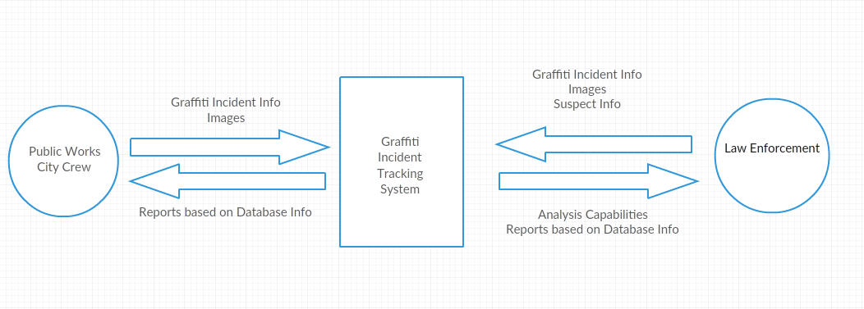

* 1. Use Case diagram

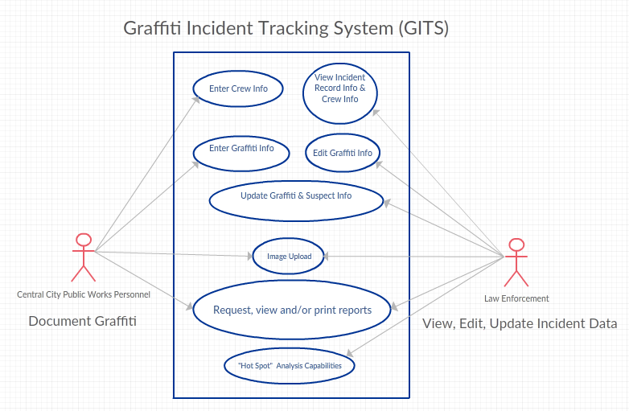

* 1. Informal notes related to requirements analysis activities

-Most of the requirements will have to cross over at one point or another due to the need for the database to sync in real time. Therefore we have decided that the web-facing portal for the city workers will be important and will focus on that first. This is because our team has less web development experience than other categories. Then, law enforcement’s back end database will become the focus. Finally in build three the data will be synchronized across the web-facing and offline databases.

* 1. Informal notes from customer or project manager clarifying or modifying requirements

-Requirements for Build #3 relate to system requirements or general categories that fit both Law Enforcement and City Worker groups.

-Requirements in Build #2 relate to Law Enforcement.

-Requirements in Build #1 relate to City Workers.

1. Design: *This in NOT just your Report #3 information, but rather the backup data/information that supports your reports. Note that Report #3 focuses on the architecture (top-level design), data model, and user interface prototype and the project notebook also includes information related to the detailed design.*
   1. Primary Key: incidentID (class Information)
   2. Foreign Key: userAccess (class UserAccess)
   3. Indices 1-7 onlin, 7-14 offline

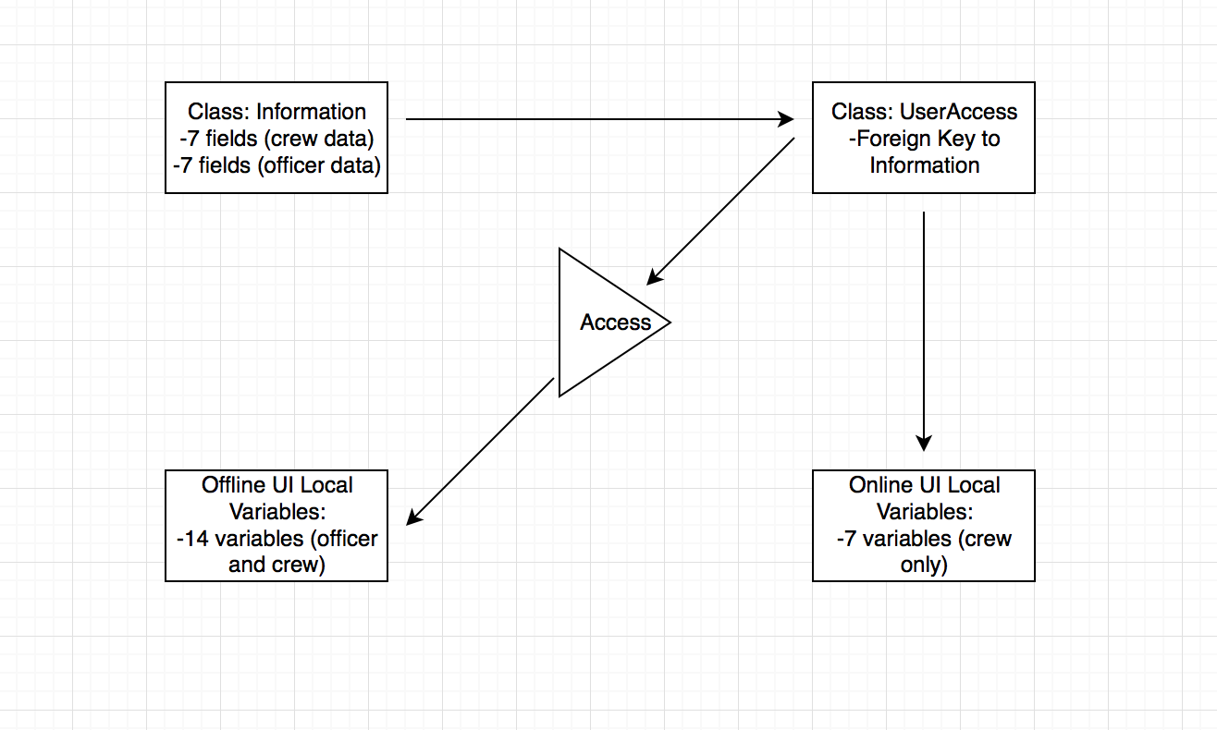

* 1. Top level architecture diagram
     1. Model:
        1. Class: Information
           1. incidentName: records the name of the incident
           2. Name: name of the crew member
           3. Supervisor: name of supervisor
           4. DateOnSite: date the cleanup occurred
           5. ScaleOfCleanup: scale
           6. DatePosted: date posted to site
           7. CrewID: id of the crew that cleaned up
           8. incidentID: incident id
        2. Class: OfflineInfo:
           1. OfficerID: officer’s id
           2. Name: name of officer
           3. Hotspot: is this location hot with crime
           4. AnalysisPriv: sets scope for how much the officer can view and or edit from the analysis of data
        3. Class: UserAccess (foreign key = Information)
           1. UserAccessLevel: this is the foreign key related to the Information class - it decides if the user has access to the information and which of the variables.
  2. Alternatives investigated and rationale for selection
     1. MYSQL vs SQLLite (mysql was more robust and offered the features needed for multiple connections)
  3. Database/data structure design
     1. Primary to foreign key relational database
     2. Online/Offline data filters
  4. User interface prototype
     1. 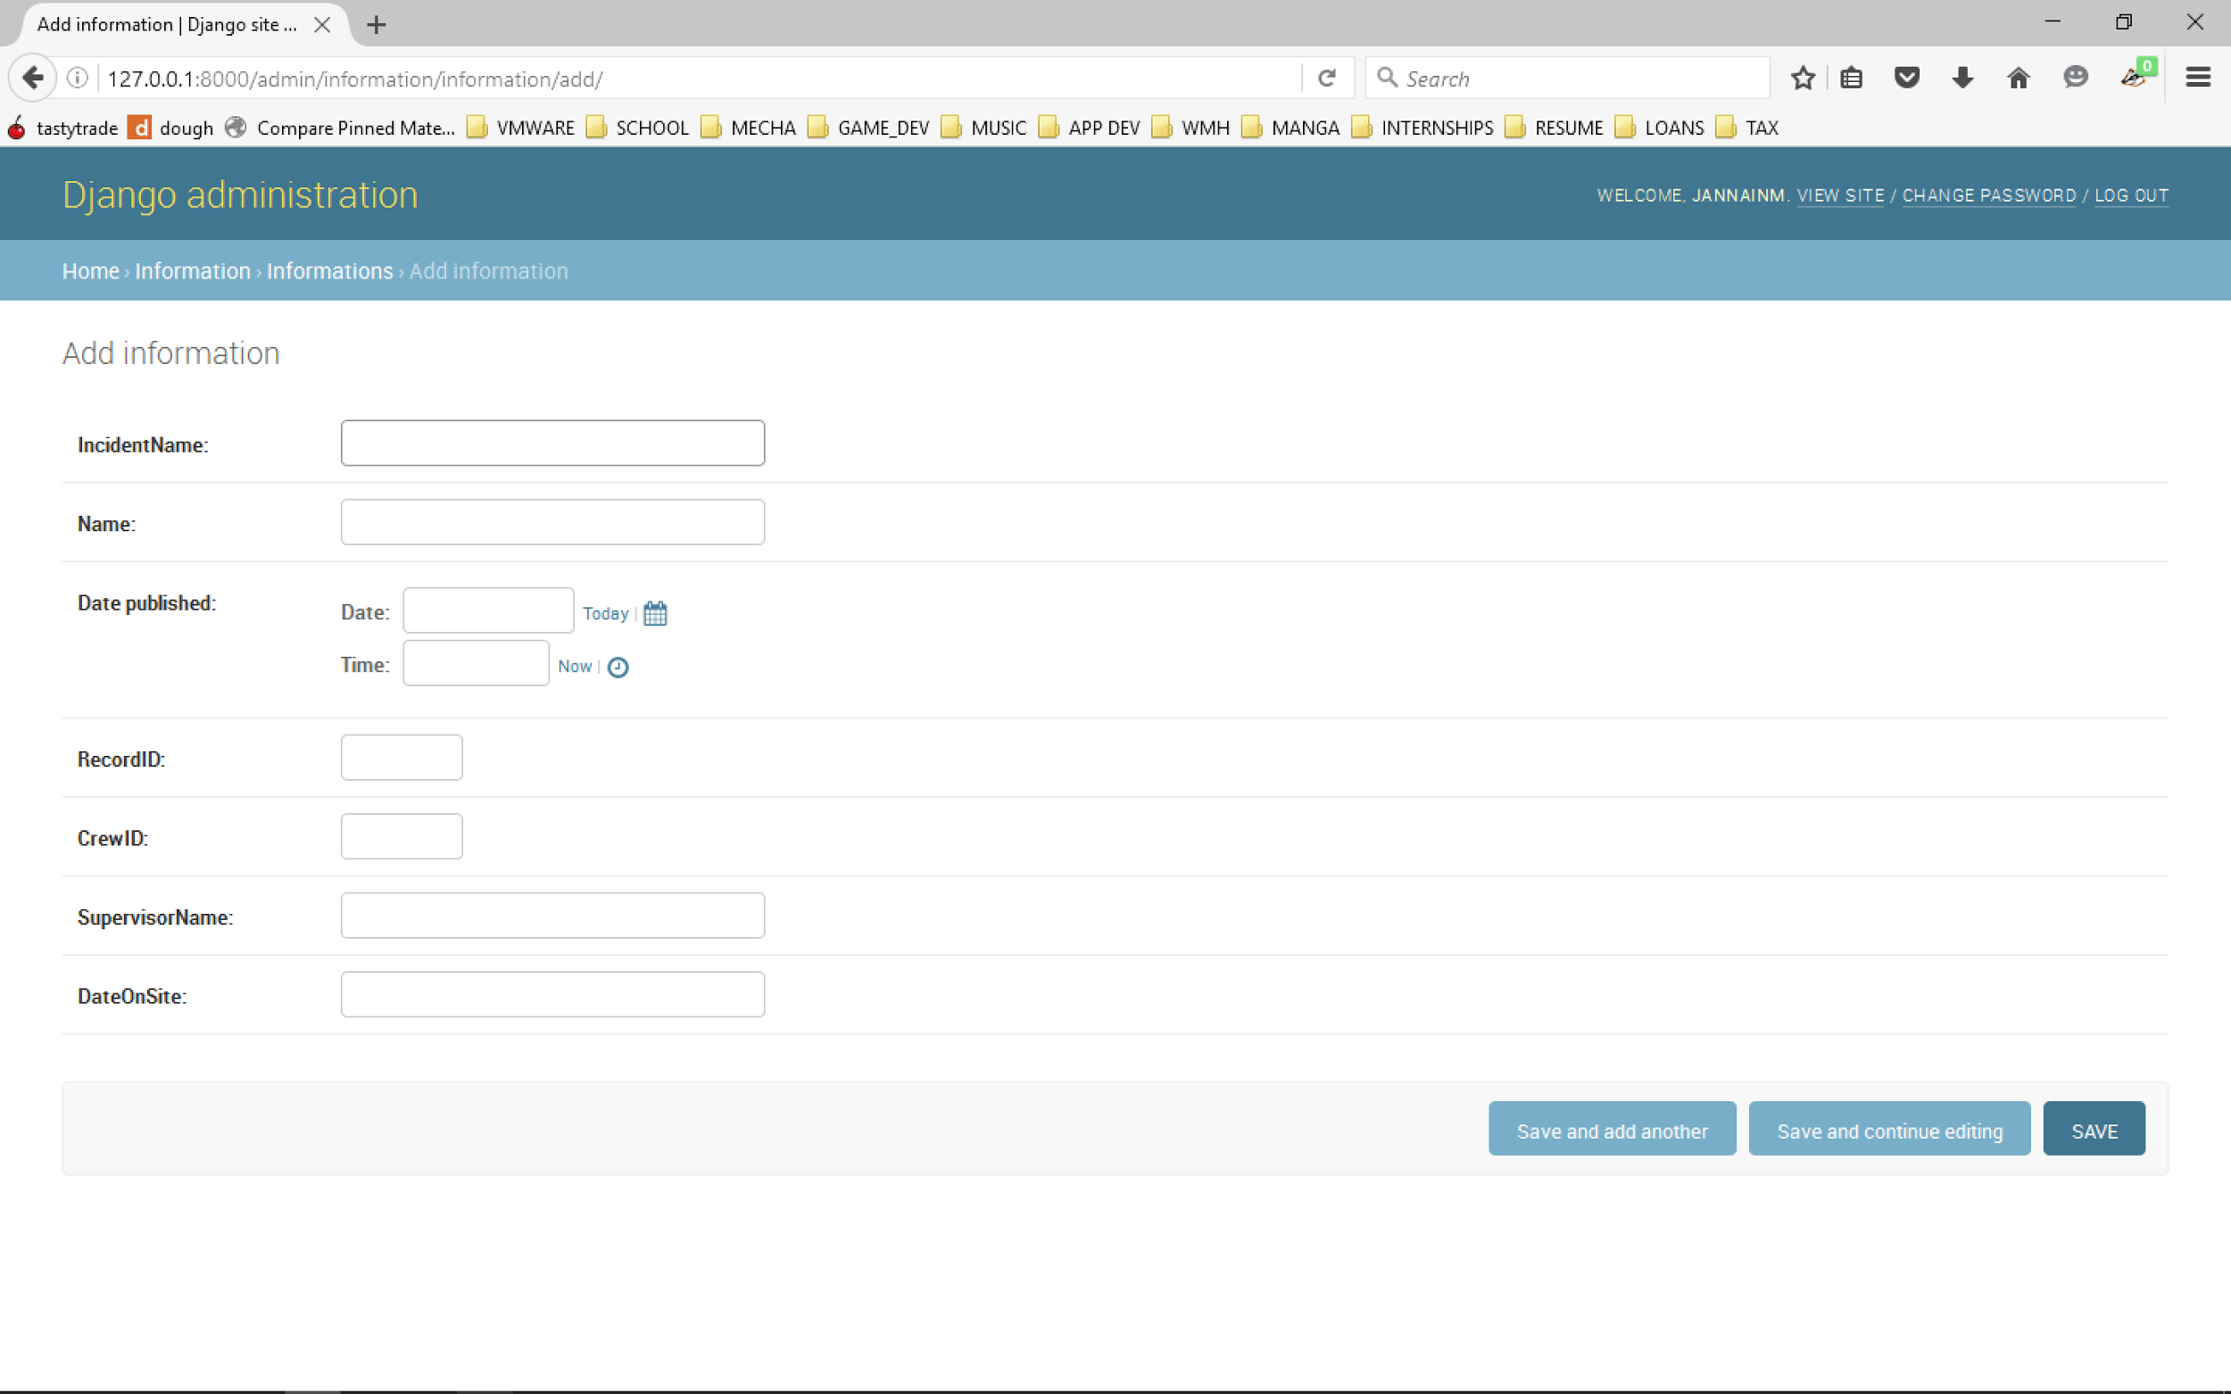
  5. Informal notes related to design activities
     1. The integration is the only part left the website and offline ui work by themselves and now the data will be stored in a mutual buffer to update edits made.
  6. Design review/inspection notes (top level and detailed-optional*)
     1. *See ERD above (section 4.g.i)*

1. Code and Test
   1. Code review/inspection notes (optional*)
   2. Unit test plan
   3. Unit test review/inspection notes (optional*)
   4. Unit test/retest results
   5. Integration test plan
   6. Integration test review/inspection notes (optional*)
   7. Integration test/retest results
2. Independent System Test: *This is NOT just your test plan report, but rather includes the backup data/information that supports your test plan report and any updates to your report as your first increment definition evolves*
   1. Test Plan/Strategy
      1. Plan for testing project requirements to include
         1. Test method for each requirement
         2. Test tools and data required for each test
      2. Informal notes related to test planning activities
      3. Test plan review/inspection notes (optional*)
   2. Test Procedures
      1. For each test procedure/case:
         1. Description of test procedure/case steps
         2. Requirements tested by each procedure/case
         3. Inputs for each test procedure/case
         4. Expected results
         5. Pass/fail criteria
      2. Test procedure review/inspection notes (optional*)
   3. Test Tool Development (if applicable)
      1. Test tool design
      2. Test tool design review/inspection notes (optional*)
      3. Test tool testing results
   4. Test Results Report
      1. List of tests executed and results
      2. Defect discovery profile
      3. Defect closure profile
3. Up-to-date timesheet for all team members
   1. Jimmy: 30 hours (avg. 7 hours per week)
   2. Michael: 30 hours (avg. 7 hours per week)
   3. Jose: 30 hours (avg. 7 hours per week)
   4. Julian: 30 hours (avg. 7 hours per week)