

**Abstract:**

Effective inventory management is crucial for businesses of all sizes to optimize their operations, reduce costs, and enhance customer satisfaction. An Inventory Management System (IMS) is a software solution designed to streamline and automate the management of inventory, from procurement to storage, tracking, and sales. The Inventory Management System allows organizations to maintain accurate records of their inventory levels, suppliers, and customer orders. It employs various tools and functionalities, such as barcode scanning, real-time tracking, and reporting, to facilitate efficient inventory control.

**Introduction:**

An inventory management system is a software application that helps businesses efficiently track, organize, and manage their inventory, ensuring optimal stock levels and streamlined operations. It plays a crucial role in minimizing costs, preventing stockouts, and maximizing overall productivity and profitability.

The aim of an Inventory Management System project is to efficiently track, control, and optimize the flow of goods and products within an organization. This system helps minimize carrying costs, prevent stockouts, improve order accuracy, and enhance overall inventory control. Ultimately, the goal is to ensure that the right quantity of the right items is available at the right time, reducing operational costs and maximizing customer satisfaction.

Inventory management involves overseeing the procurement, storage, and distribution of goods to ensure optimal levels are maintained. It aims to minimize carrying costs while meeting customer demand, ultimately enhancing efficiency and profitability for a business

**Objective:**

To effectively and efficiently control and track an organization's inventory, which includes raw materials, finished products, and other goods.

**Methodology**

This proposed inventing management synthon indo several panel of independent, →Admin panel

→Admin panel

→Employee panel

Admin panel:

→Can log into his profile

→Can see the log in logout activity

→Can delete conformation

→Can see employee information

→Can see the product details

Employee Panel:

→Can sign up to make a profile

→Can log in to see the order details.

→Can change password

→Can see the order details

**Database Design:**

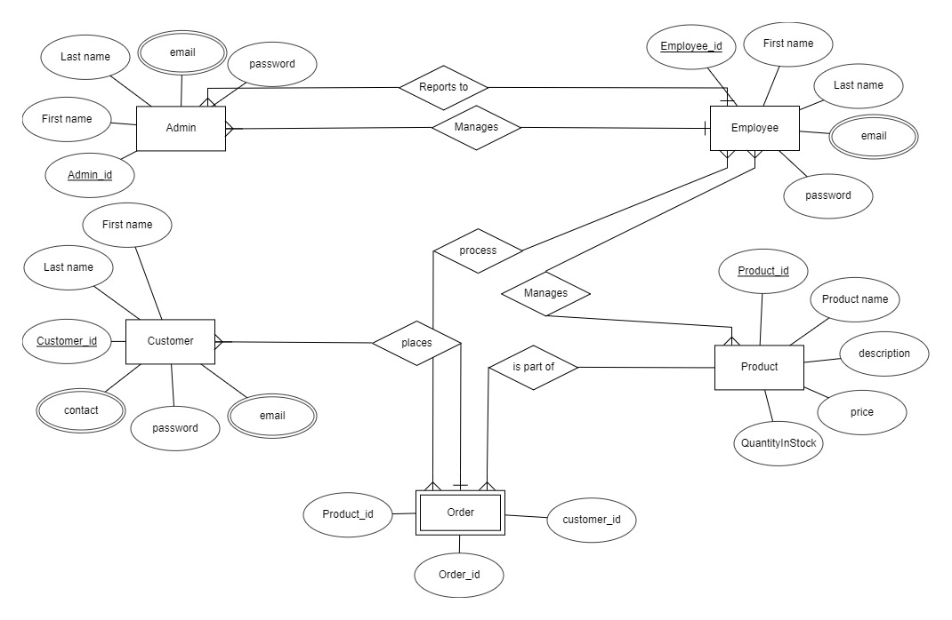

Admin: (Admin_ID, First Name Last Name, email, password)

Employee: (Employee_ID, First Name, Last Name, email, password)

Customer: (Customer_ID, First Name, Last Name, email, password, Contact)

Product: (Product_id, product name, description, price, QuantityInStock)

Order: (Order_ID, Customer_ID, product id)

**System outputs:**

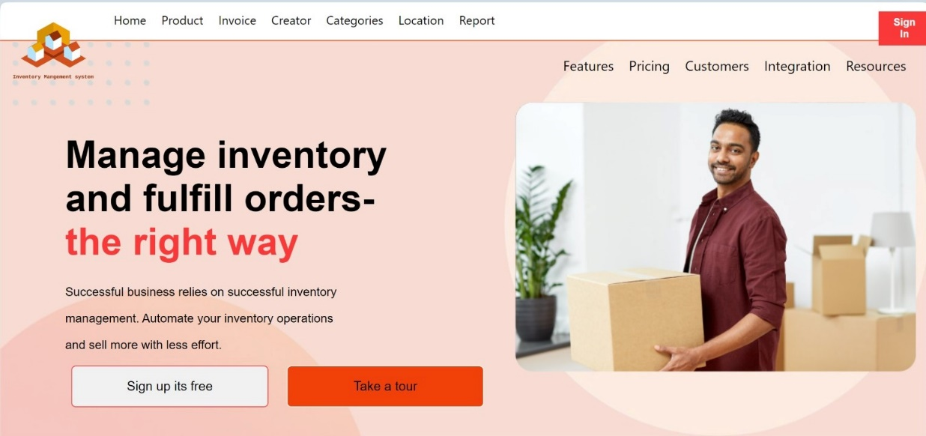

**Figure 1- It's a homepage for IMS.**

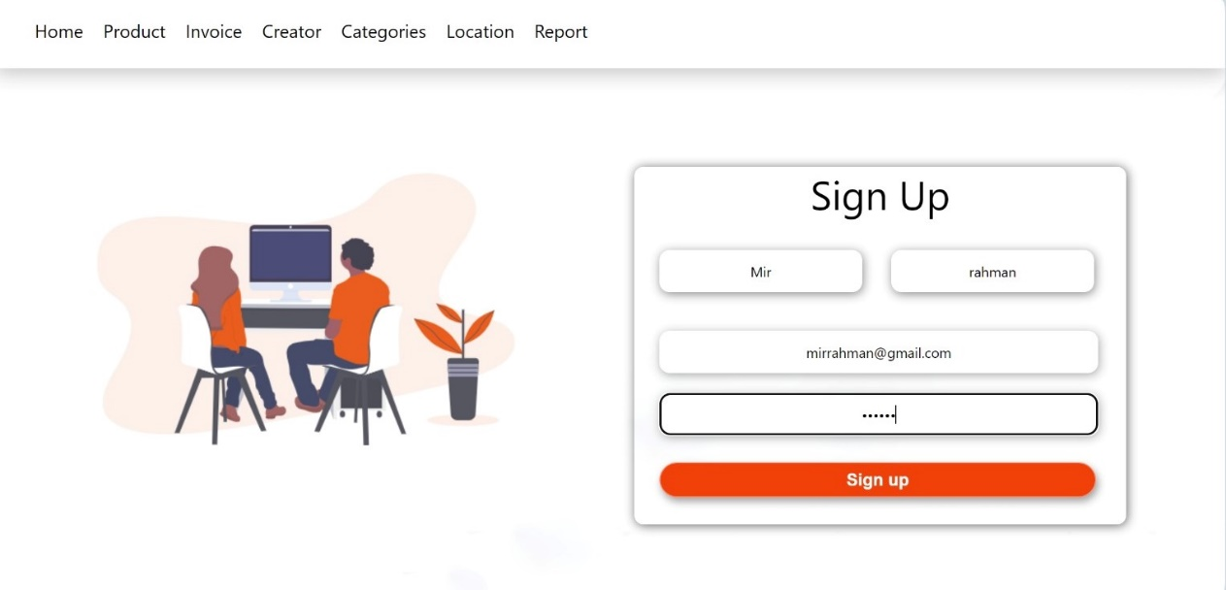

**Figure 2: A person can sign up for as an admin or an employee**

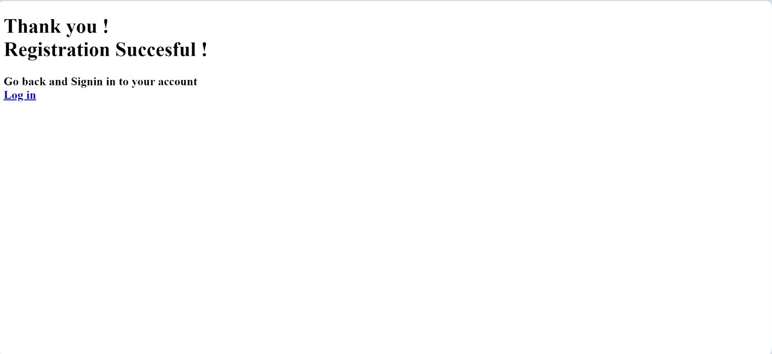

**Figure 3: If registration is successful the msg appears**

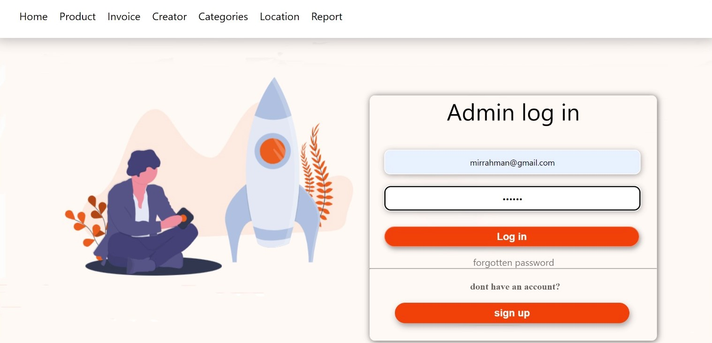

**Figure 4: admin can log in to this page**

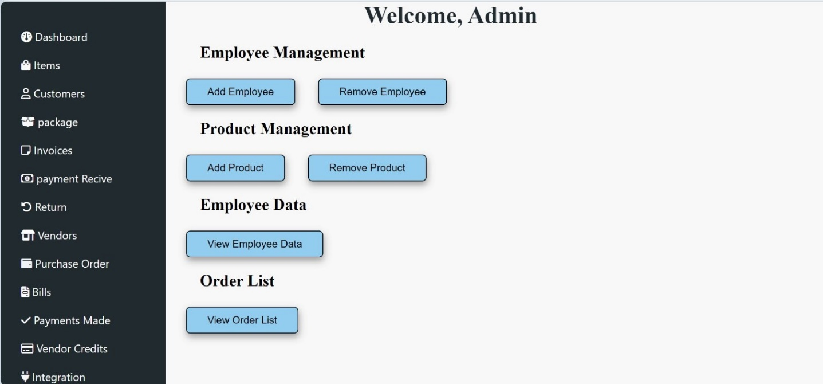

**Figure 5: After log in admin can see the details of employee, products and orders.**

**Conclusion :**

An inventory management system is a kind of website where employees can manages product. They can keep track of inventory. They can check if the inevntory is full or if the product is in stock or not. Employees can process order. In this system, admin manages employees. An admin can see the login logout history of an employee. Admin can update,delete and edit employees data. Also an Admin can see the order details and product details.