CSE302 (1): LAB EXAM on Oracle APEX

Report

Student ID:2020-2-60-005
Student Name: Jannatul Ferdous Salma
Section:02

Application URL:
https://apex.oracle.com/pls/apex/r/jannat_cse302/labexam-2020-2-60-005
Application ID:

Authentication Information
User name | Password
admin | admin123
Cse302 | Cse302123

Screenshots of the pages
Staff Form
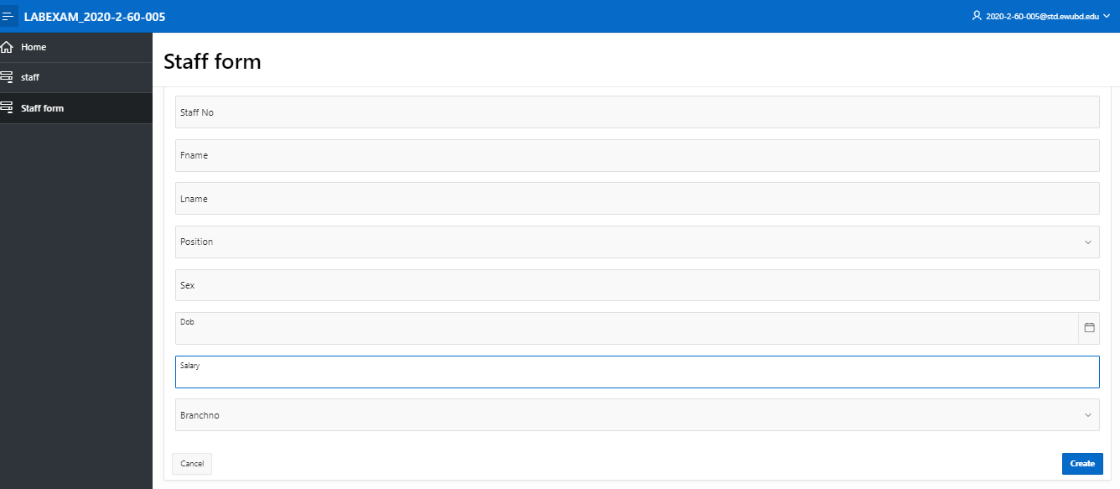

Propertyforrent form
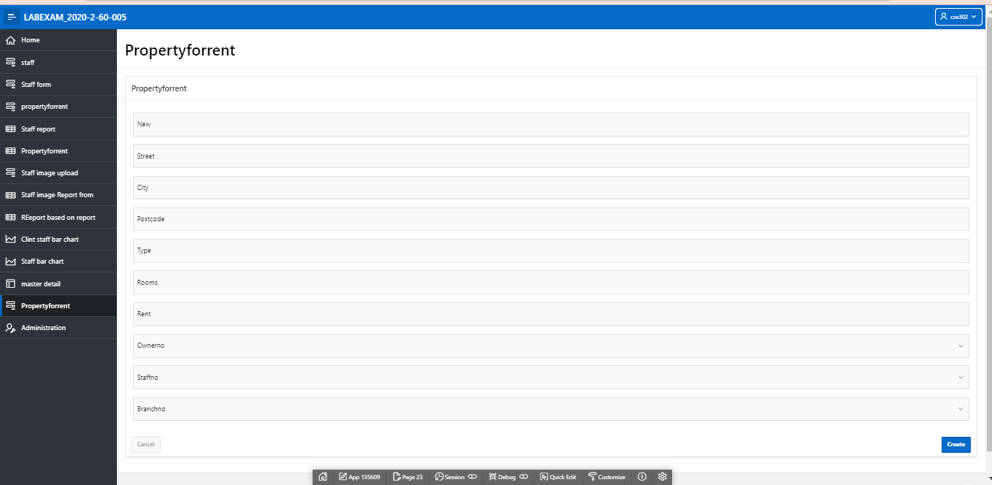

Report: Staff
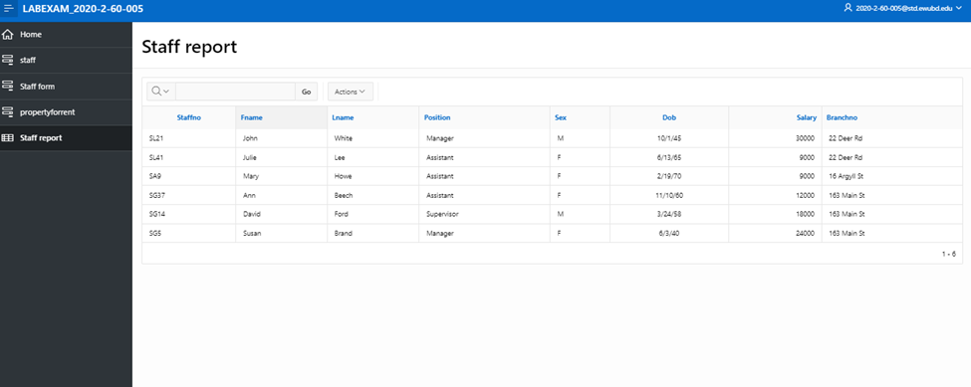

Report: propertyforrent
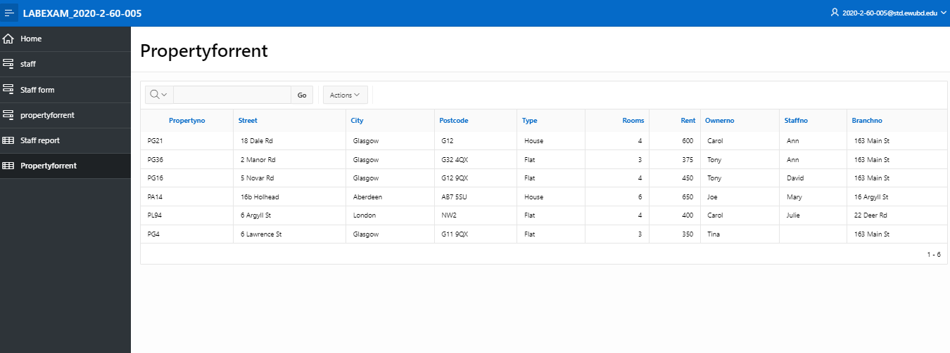
Master Detail Page
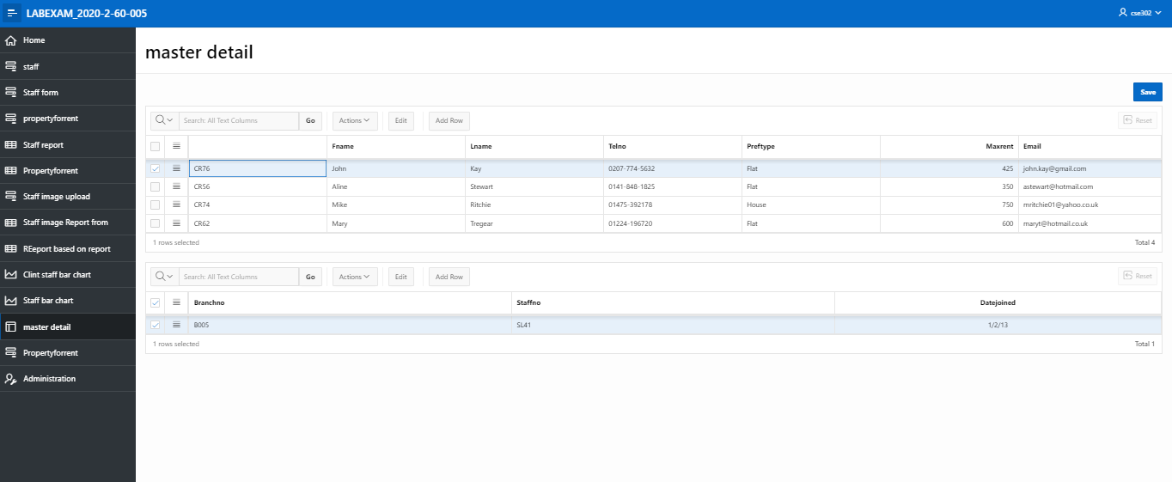

Staff Image Upload Form:
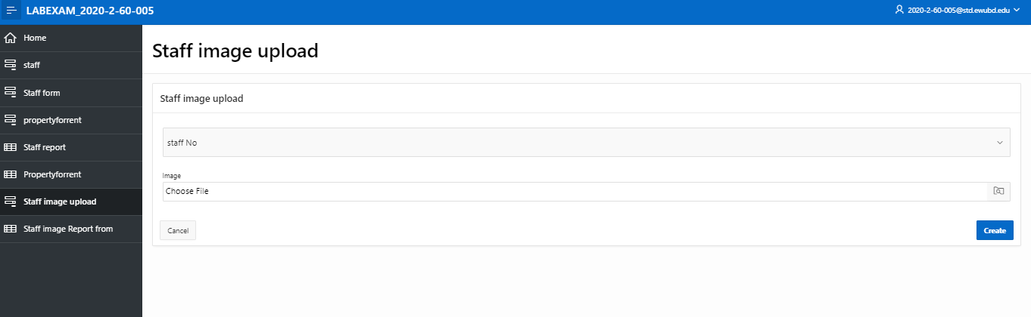

Staff Image Report Form:

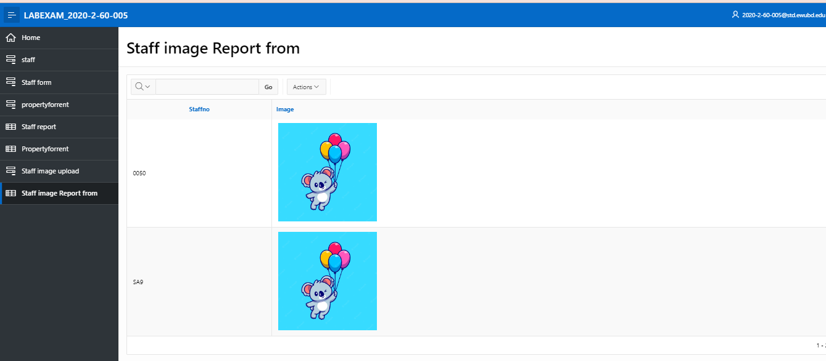
Report based on query
SELECT c.fname, c.lname, c.telno, p.street, p.city, p.postcode, p.rent, p.branchno, v.viewdate, v.comment
From client c, registration r, propertyforrent p, viewing v, officebranch o
WHERE c.clientno = r.clientno
AND r.branchno = o.branchno
AND p.propertyno = v.propertyno
AND c.clientno = v.clientno;

Screenshot:
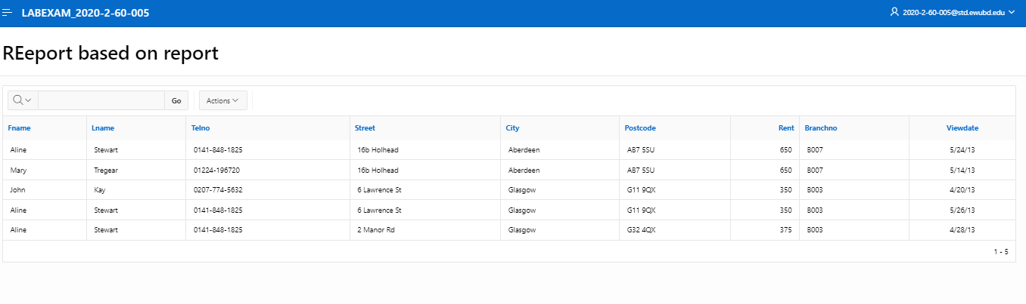

Chart:
Query:
select count(clientno) as Number_Of_Client, s.staffno
from staff s left join registration r on s.staffno = r.staffno
group by s.staffno;

Screenshot:
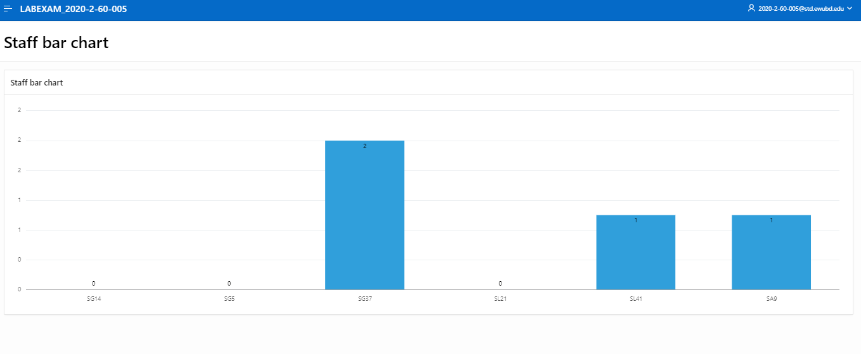

Authentication and Authorization
