

**Daffodil International University**

Software Requirements

Specification

Document Sharing

**Prepared by**

Fatema Tuj Jannat

181-35-2440

Sec: C

Department of Software Engineering

Table of Contents List of

1. Introduction...........................................................................................................................4

1.1 Purpose.............................................................................................................................4

1.2 Documentation Conventions...........................................................................................4

1.3 Product Scope .................................................................................................................4

1.4 Glossary ..........................................................................................................................5

1.5 Overview..........................................................................................................................5

# 1.6 References.......................................................................................................................5

2. User Classes & Characteristics.............................................................................................5

2.1 User..................................................................................................................................5

2.2 Admin ...............................................................................................................................6

3. Design & Implementation Constraints...................................................................................6

3.1 Operating Environment:....................................................................................................6

3.2 Software Language Used...................................................................................................6

3.3 Development Tools:.......................................................................................................... 6

3.4 Database Support: ............................................................................................................ 6

4. User Documentation ..............................................................................................................6

5. Assumptions & Dependencies............................................................................................... 6

5.1 SIS Protocol ..................................................................................................................... 7

5.2 Data Entry ........................................................................................................................ 7

5.3 Hardware Dependencies ..................................................................................................7

5.4 Browser Dependencies.................................................................................................... 7

6. Functional Requirements...................................................................................................... 7

6.1 Use Case:..........................................................................................................................8

6.2 Use Case Description:......................................................................................................9

7. External Interface Requirements...........................................................................................10

7.1 User Interface...................................................................................................................10

7.2 Hardware Interface...........................................................................................................10

7.3 Software Interface............................................................................................................10

7.4 Communication Interface.................................................................................................10

8. Requirement Engineering Process........................................................................................10

8.1 Feasibility Study ..............................................................................................................10

8.1.1 Economic Feasibility ....................................................................................................10

8.1.2 Technical Feasibility......................................................................................................11

8.1.3 Behavioral Feasibility ...................................................................................................11

8.2 Requirement Validation....................................................................................................11

9. Non-Functional Requirements...............................................................................................12

9.1 Performance Requirements...............................................................................................12

9.2 Safety Requirements.........................................................................................................12

9.3 Security Requirements......................................................................................................12

9.4 Maintainability Requirements...........................................................................................12

**1. Introduction**

**1.1 Purpose**

The introduction of the Software Requirements Specification (SRS) provides an overview of the entire SRS with purpose, scope, definitions, acronyms, abbreviations, references and overview of the SRS. The aim of this document is to gather and analyze and give an in-depth insight of the complete Document Sharing by defining the problem statement in detail. Nevertheless, it also concentrates on the capabilities required by stakeholders and their needs while defining high-level product features. The detailed requirements of the Document Sharing are provided in this document.

**1.2 Documentation Conventions**

This SRS is divided up into sections detailing an overall description, the external interface requirements, system features, and other non-functional requirements. As this is the final draft, any future modifications of this document would involve adapting the product to changing systems and uses. We hope to have the product evolve to changing times as to ensure continued use and success. The Document and Specification team have prepared the overall information in this document to the best of their ability. Once read, it is evident that each section is important to the overall SRS and significant to the project in its own right.

**1.3 Product Scope**

This document sharing site will be a notebook, which will help the people to storing any important document for further uses and sharing. People can delete their previous notes, edit their existing notes also. After accessing this site they log out from this site and also by logging they can uses this site in next time.

If we have a site for sharing all important document that will be very useful for our further uses. This site helps users to upload, download and manage notes of their. Sometimes we want to separate an important file, research paper or job circular from another document. So that we can find this file without any delay. If we stored this file in a site, it will help us to access this document by searching the file name, which is easy.

The document sharing site will used for any people and will provide various facilities.

Here one can create their own notes. Admin have to approve this notes in this

Site. So that people can find their important documents any time. They can share their notes in this site for further uses

**1.4 Glossary**

This subsection contains definitions of all the terms, acronyms, and abbreviations used in the document. Terms and concepts from the application domain are defined.

DIU- Daffodil International University

SRS- System Requirement Specification

DS- Document Sharing

**1.5 Overview**

This Software Requirements Specification (SRS) specifies all the requirements for DS. In traditional system, we have no site for share any kind of document. We need to share information in our daily basis. For that we need a site in where we store our important document for further uses and sharing. This site allow users to create note which can be file, research paper, text, drawings, photographs, audio, or saved web content. Notes are stored in notebooks and can be uploaded, edited, viewed, deleted or searched and shared.

If we have a site for sharing all important document that will be very useful for our further uses. This site helps users to upload, download and manage notes of their.

Sometimes we want to separate an important file, research paper or job circular from another document. So that we can find this file without any delay. If we stored this file in a site, it will help us to access this document by searching the file name, which is easy.

**1.6 References**

**IEEE. IEEE STD 830-1998 IEEE Recommended Practice for Software Requirements Specifications. IEEE Computer Society, 1998.**

**2. User Classes & Characteristics**

**2.1 User**

In the DS the major and sensitive role is played by the User. Anybody will be able to User of this DS site. We need to share information in our daily basis. For that we need a site in where we store our important document for further uses and sharing. This site allow users to create note which can be file, research paper, text, drawings, photographs, audio, or saved web content. Notes are stored in notebooks and can be uploaded, edited, viewed, deleted or searched and shared.

If we have a site for sharing all important document that will be very useful for our further uses. This site helps users to upload, download and manage notes of their. Sometimes we want to separate an important file, research paper or job circular from another document. So that we can find this file without any delay. If we stored this file in a site, it will help us to access this document by searching the file name, which is easy.

**2.1 Admin**

The document sharing site will used for any people and will provide various facilities.

Here one can create their own notes. Admin have to approve this notes in this DS site. . And also recover user password request by user.

**3. Design & Implementation Constraints**

**3.1 Operating Environment:**

The DS will be a web based system. Thus anyone having a browser can hit the specific link and can get access to it. Thus it will ensure its best usage and will ease the means of getting access to the system. Moreover it will remove the complexities of running the system in multiple platforms as it will be deployed in a web server.

**3.2 Software Language Used:**

|  |
| --- |
| Or, 1. WordPress |

The application will be developed using

1. HTML

2. CSS

3. PHP/Python

**3.3 Development & Database Tools:**

For the development purpose

1. Microsoft Visual Studio
2. SQL Server Management.
3. Xampp

**4. User Documentation**

According to the schedule, after 4 months of the start of the project, I will hand-over the complete project. At the same time, the project will also provide a user manual, where all the how-tos will be put together. I also responsible to conduct training sessions for the Administrative task, where they will provide tutorials, notes along with the hands on training. On the other hand, the project should be launched as a pilot project for about 4 months to get more feedback from the end-users and responsible to change with newbie requirements.

**5. Assumptions & Dependencies**

**5.1 SIS Protocol**

In this system there is an option to access from the Internet along with Intranet and Ethernet. Here, the user can upload notes and can maintain profile (before it would be approved by the admin and frozen the editable option.

**5.2 Data Entry**

Though the data entry operation is out of the scope of this project, but for giving it a standard look our I added some meaningful data to check the compatibility of the system. To include, these information has collected from the requirement elicitation process from user. It will make arrangement to enter all the previous information related to the system to the database.

**5.3 Hardware Dependencies**

To operate the system the following hardware dependencies are needed:

• Runs on any x86-64 machine.

• Depending on the number of users it server, it’ll need a reasonably powerful machine to perform its tasks. The actual requirements will be profiled at a later phase.

• Every user must have internet connectivity devices to use the system.

**5.4 Browser Dependencies**

The system is based on web; therefore no custom tailored client is required to access it. However, SIS will be compatible with any JavaScript enabled open standard browsers, and it will also support Internet Explorer (IE), Mozilla Firefox (any latest version) and other compatible browsers.

**6. Functional Requirements**

Before identification of the requirements we needed the comprehensive engagement and lighting quick coordination with the stakeholders. This accelerates the entire requirements management process by orchestrating the flow of information and processes across different team members and stakeholders. Again this is combined with hybrid agile and waterfall development methodologies and tools. Flexible workflows and automatic notifications streamline communication, review, and approval of requirements across stakeholders, while common metrics and dashboards ensure everyone is on the same page. So, the listed requirements go with all the previous processes.

**6.1 Use Case:**

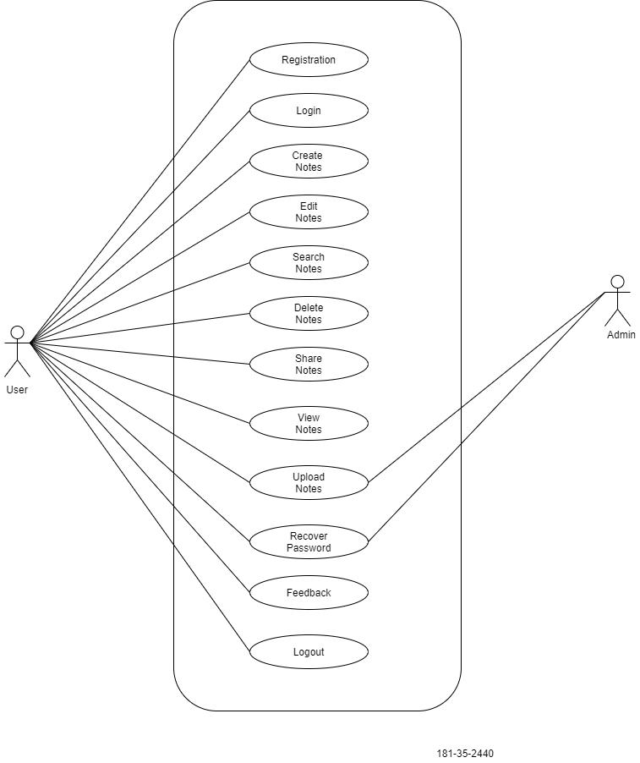Figure: Use case

**6.2 Description of this Use case**

|  |  |  |  |  |  |
| --- | --- | --- | --- | --- | --- |
| **RQ No** | **Title** | **Description** | **Type** | **Priority** | **Stack**  **holder** |
| **RQ No: 01** | **Registration** | Anybody will be able to login this Document Sharing (DS) site by create account. | FR | High | User |
| **RQ No: 02** | **Log in** | Anybody will be able to use this (DS) site by login after creating account. | FR | High | User |
| **RQ No: 03** | **Create  Notes** | People will be able to create notes after login DS site | FR | High | User |
| **RQ No: 05** | **Edit Notes** | People will be able to edit their existing notes. | NFR | Medium | User |
| **RQ No: 06** | **Search Notes** | People will be able to search their necessary documents in DS site | NFR | Medium | User |
| **RQ No: 07** | **Delete  Notes** | People will be able to delete their previous documents as needed. | NFR | Medium | User |
| **RQ No: 08** | **Share  Notes** | People will be able to share their document as needed. | FR | High | User |
| **RQ No: 09** | **View  Notes** | People will be able so view their note after saving and approved by admin. | FR | High | User |
| **RQ No: 10** | **Upload  Notes** | People will be able to upload necessary file in this site approve by admin. | FR | Medium | User,  Admin |
| **RQ No: 11** | **Recover Password** | People will be recover their password if they forget, sending recovery password to admin, admin will sending recovery password link to user. | NFR | Medium | User,  Admin |
| **RQ No: 12** | **Feedback** | People will be able to give feedback or any comments after sharing. | NFR | Medium | User |
| **RQ No: 13** | **Logout** | After logging in the system, user must be logged out after finished his work. | FR | High | User |

**7. External Interface Requirements**

**7.1 User Interface**

The user interface is a key to application usability. The application should include content presentation, application navigation, and user assistance. To illustrate, the admin has a lots of functionalities to be done. So, the functionalities are grouped and thus used in the navigation bar. The user: admin can expand or shrink the navigation bar. The UI for user should be very simple where there is only option to upload notes.

**7.2 Hardware Interface**

In the current version of the software, it will have no special hardware interface with other external systems. It will run in a general-purpose computer system with general-purpose hardware and software. Actually the assumption of the hardware is already given to the upper section 5.3 in page 7.

**7.3 Software Interface**

To the end-user there is no need of any extra software to be installed. It is to be mentioned that, the user need JavaScript enabled browsers to run the system. For OS, there has no boundary or strict rules, can run smoothly in any OS. However, through the channel the cryptography should be maintained through the whole system as the user can access it through internet also.

**7.4 Communication Interface**

All sorts of communications between server and client programs will be using Hyper Text Transmission Protocol (HTTP) and the messaging will be done by XML format. As a result, any user using standard communication protocols can communicate with the project without any protocol conversion or any other hassles.

**8. Requirement Engineering Process**

**8.1 Feasibility Study**

In this document of project, we are also providing some feasibility which will support the system and also give more litheness. ` For these we gave emphasize on the following topics.

**8.1.1 Economic Feasibility**

Economic analysis is most frequently used for evaluation of the effectiveness of the system. More commonly known as cost/benefit analysis the procedure is to determine the benefit and saving that are expected from a system and compare them with costs, decisions is made to design and implement the system. This part of feasibility study gives the top management the economic justification for the project.

**8.1.2 Technical Feasibility**

Technical feasibility centers on the existing manual system of the test management process and to what extent it can support the system. According to feasibility analysis procedure the technical feasibility of the system is analyses and the technical requirements such as software facilities, procedure, inputs are identified. It is also one of the important phases of the system development activities. The system offers greater levels of user friendliness combined with greater processing speed. Therefore, the cost of maintenance can be reduced. Since, processing speed is very high and the work is reduced in the maintenance point of view management convince that the project is operationally feasible

**8.1.3 Behavioral Feasibility**

People are inherently resistant to change and computer has been known to facilitate changes. An estimate should be made of how strong the user is likely to move towards the development of computerized system. These are various levels of users in order to ensure proper authentication and authorization and security of sensitive data of project.

**8.2 Requirement Validation**

Through the all process of Software Requirement Elicitation we endure different type and level of requirements. From these huge requirements we have already thrashed out the functional requirements. But there are some validations of these requirements like in the registration process of the user in the system. However, all these are not accepted and for that we have ensured these with the stakeholders throughout the elicitation process. As, the requirements validation is critical to successful system product development and implementation. Requirements are validated when it is certain that the subject set of requirements describes the input requirements and objectives such that the resulting system products can satisfy the requirements and objectives. The Requirements Validation Process helps ensure that the requirements are necessary and sufficient for creating design solutions appropriate to meeting the exit criteria of the applicable engineering life cycle phase and of the enterprise-based life cycle phase in which the reengineering efforts occur.

Key activities of requirements validation are:

• Conduct requirements reviews to validate that requirements are correct, unambiguous, complete, consistent, ranked for importance, verifiable (testable), modifiable, and traceable. Review teams should include end user representatives and customer representatives, in addition to the developer participants. Use quality checklists as an aid to the review process.

• Use prototyping to validate requirements. Prototypes demonstrate assumptions and actual understandings and can alert the team to mismatches between the written requirement and the interpretation carried forward in the prototype.

• Validate the conceptual models developed during analysis.

• Plan how each requirement will be verified establish acceptance tests.

Perform the validation of any requirements document provided by the acquirer at the time of contract award we can ensure that our requirements specifications have the following characteristics:

• Lack of ambiguity

• Conciseness – Minimal number of words used and presented in a distinct visual form

• Completeness – The specification contains all requirements known to date

• Consistency – There are no conflicting requirements

Traces to origins – The source/origin of each requirement are identified. It may have evolved from a more general requirement, result from a conversation with a user, result from adoption of a standard, or adhering to a new regulation.

**9. Non-Functional Requirements**

**9.1 Performance Requirements**

Server software does not require any special hardware other than the minimum hardware required for running enterprise OS. Extra disk storage will be required for archives and electronic documents. Increases of memory enables efficient query processing, which is required for quick bibliographic search. Two server grade processors with clock speed 3.0 GHz, at least 8GB RAM and 300 GB hard disk is recommended for the server. Client machine with recommended hardware required for desktop operating system and web browser (with open JavaScript enable).

**9.2 Safety Requirements**

As per IIT work place safety rules and the IIT server room where the server is supposed to be placed and the monitoring people.

**9.3 Security Requirements**

Each time there is a security violation, the log file will be updated with the login, date, and time. Again, high level cryptography and checking should be kept to make it more secured. However, while email or request from any unwanted client the request should drop and let that user know about the fault.

**9.4 Maintainability Requirements**

At least one backup server with same configuration as in main server is also recommended for fault tolerance and better performance. Separate storage (with backup) for database, electronic document, and manuscript is also recommended. Multiple computing nodes with the storage are required for high availability and to enhance the performance of the application. Again, after a certain period the preliminary manuscript files and other files related with that can be deleted manually from the database to increase the performance.