BHAGWAN PARSHURAM INSTITUTE OF TECHNOLOGY

MINOR PROJECT SYNOPSIS

SWACHH BUDDY: AN AI-ENABLED SMART WASTE MANAGEMENT PLATFORM FOR CITIZEN PARTICIPATION AND SUSTAINABLE WASTE MANAGEMENT

Synopsis submitted in partial fulfillment of the requirement for the Minor Project, VIIth semester



Under the supervision of

Dr. Charu Gupta

CSE Department [Assistant Professor]

Submitted by:

GROUP NO. 50

Jannat Garg (12420802723)

Simran Kapoor (06820802723)

August 2026
Table of Contents

- Introduction 3
- Need of the Project 3
- Problem Statement 4
- Proposed System / Project Overview 4
- Key Features of Swachh Buddy 10
- Hardware and Software Requirements 10
- Expected Outcome of the Project 11
- Conclusion and Future Scope 11
References
- Literature Review 6
  - Review of Selected Studies 6
  - Thematic and Theoretical Discussion 8
Research Gap 12

Introduction
Municipal solid waste generation has increased manifold around the world due to urbanization, population growth, and evolving consumption patterns. With most municipal solid waste being dumped irresponsibly without segregation, it leads to loss of resources, increased landfilling with adverse consequences on the environment and public health, and inefficiencies in recycling and recovery. Inadequate segregation at the source is a fundamental weakness in solid-waste management, making the recycling and recovery process nonviable both in terms of effort and cost.
The majority of contemporary techniques are focused on addressing only one aspect of the waste-management process, for example, analyzing wastes in images, optimizing collection-route generation, or offering citizen engagement platforms or awareness. This issue prompted the development of an integrated citizen-centric digital-waste management system, which connects waste generators, collectors, and managers in a unified digital ecosystem. This solution, named Swachh Buddy, is an AI-enabled end-to-end digital-waste management system that incorporates AI/ML-based waste identification and segregation engine, citizen education, incentivization and reporting, collection coordination, geo-tracking, and geo-fencing features, and an admin panel in one fully integrated platform.

Need of the Project
Conventional waste-management systems have various shortcomings. An integrated digital platform can address these issues by enabling source-segregation, providing citizens with the right information, and offering incentives. The issue of source segregation is complicated by the fact that many citizens are not aware of the proper segregation methods. Additionally, there is a lack of general awareness on recycling and segregation, and citizens have little incentive to sort their garbage. Secondly, garbage collection is not regular: bins tend to overflow since the collection schedule is unknown to citizens, and optimising the collection route is difficult for authorities. Finally, municipal authorities must have better oversight of collection operations to ensure that they are operating correctly and provide the necessary feedback to the citizens.
An integrated digital platform can resolve these issues in several ways. Firstly, the AI-based garbage identification system can help sort garbage at the source by educating and incentivising users to sort their garbage correctly. Secondly, gamification and an integrated reward system can be used to encourage desired behaviours, such as achieving certain numbers of correctly sorted trash bags. The platform can also utilise the geo-tagging system to report overflowing bins and illegal dumping.

Problem Statement
While existing research and practice attempt to address the issue of waste management, these solutions are largely individual-focused, addressing only one link in the management chain. Some works focus on automated waste classification using deep learning models, others propose smart bins or systems for sensing the level of waste in bins, while some address the issue from the citizens’ point of view, proposing reporting applications or even raising awareness. While these solutions might effectively target individual issues, they are not integrated, and a system that employs one method cannot be easily combined with another, for instance, a smart bin system might have no way of interacting with a citizen reporting application. Furthermore, while such solutions might address specific problems, they fail to provide an overarching perspective, which leaves the management authorities powerless over the chain of events.
The issue targeted by the current crowd-sourcing initiative is the lack of an integrated solution that would tie the various existing methods together, creating a system where waste identification and segregation, citizen involvement, collection coordination, location-based data acquisition, and analytical data would be integrated into a single platform. Such a platform is embodied in the proposed Swachh Buddy.

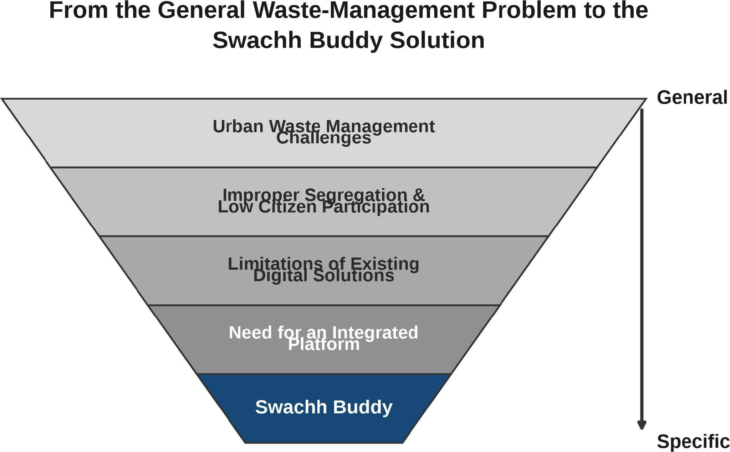

Figure 1: From the General Waste-Management Problem to the Swachh Buddy Solution

Proposed System / Project Overview
Swachh Buddy is conceived as an AI-enabled, citizen-centric digital waste-management platform with two complementary sides: a citizen side and a municipal or administrative side. The citizen side helps users identify and segregate waste correctly, learn about waste management, report problems, and earn rewards for responsible behaviour. The administrative side supports waste collectors and municipal authorities in coordinating collection, monitoring reported issues and collection-related information, visualizing locations on maps, and analysing operational data.
Waste collectors receive collection tasks based on reported data and locations, and the platform supports proposed location-based monitoring of collection activity and vehicles on maps. Data from these activities flow to an administrative dashboard, where authorities monitor the state of the waste-management system.
The principal actors and components of the proposed system are citizens, who will interact with the application’s interface in the form of identification, guidance, reporting, and incentives; waste collectors, who will receive the information about collection tasks and potentially be supervised; municipal authorities, who will supervise the work through a dashboard; AI/ML components and mapping and location tools, which will be utilized for classification and geo-targeting purposes; and a database and cloud backend with a dashboard, which will store data and serve monitoring needs. The suggested technology stack includes React and TypeScript as the frontend framework and the programming language, Firebase as the backend framework, Python as the scripting language, and computer vision and deep learning techniques as the core of AI/ML components. Additionally, a mapping and location API such as Google Maps will be integrated.
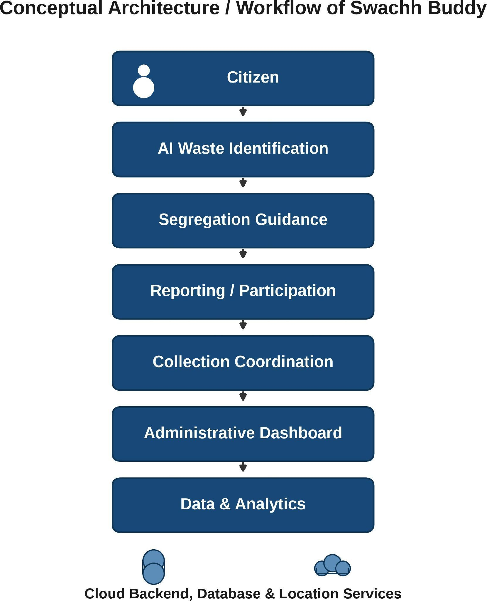

Figure 2: Conceptual Architecture / Workflow of Swachh Buddy

Key Features of Swachh Buddy
Table 1 summarizes the major features of the proposed platform.
Table 1: Major Features of Swachh Buddy

Feature | Description | User / Stakeholder | Expected Benefit
AI-based waste identification |  | Citizens | Correct disposal decisions at the source

Feature | Description | User / Stakeholder | Expected Benefit
 | Identifies the category of a waste item from an image using a deep-learning model
Waste segregation guidance | Suggests the correct bin or category for each waste item | Citizens | Better source segregation
Citizen education and awareness | Learning content on segregation, recycling and sustainability | Citizens | Improved awareness and behaviour
Gamification | Points, levels and challenges for responsible disposal | Citizens | Higher engagement and participation
Rewards and incentives | Recognition and rewards linked to participation | Citizens | Sustained responsible behaviour
Improper waste-disposal reporting | Channel to report littering, dumping or wrong-bin disposal | Citizens | Accountability and cleaner neighbourhoods
Geo-tagged reporting | Reports marked with location using maps and location services | Citizens, Authorities | Fast, locatable response
Map/location support | Map-based visualization of reports, bins and collection activity | Citizens, Authorities | Better spatial awareness
Collection coordination | Collection tasks based on reported data and locations | Collectors, Authorities | More responsive collection
Location-based monitoring | Proposed location-based monitoring of collection activity and vehicles on maps | Collectors, Authorities | Transparency and route verification
Administrative dashboard | Unified view of operations at ward and city level | Authorities | Centralized management and oversight
Notifications and alerts | Alerts for schedules, reports and collection updates | Citizens, Collectors | Timely information
Citizen-authority interaction | Two-way communication within the platform | Citizens, Authorities | Faster resolution of issues
Waste-management data and analytics | Trends and summaries over collected data | Authorities | Data-driven planning and policy
Sustainability awareness | Features promoting recycling, recovery and reduced landfill load | All stakeholders | Environmental benefit

Hardware and Software Requirements
The hardware and software requirements of the proposed system are summarized in Tables 3 and 4.
Table 3: Hardware Requirements

Hardware Requirement | Purpose / Remarks | Status
Computer / laptop | Development, testing and execution of the platform | Required
Smartphone / mobile device | Access to the citizen-facing application and geo-tagged reporting | Required
Camera / image-capture device | Capturing waste images for AI-based identification | Required
Internet connectivity | Accessing the platform and cloud services | Required

Table 4: Software Requirements

Software Requirement | Purpose / Remarks | Status
React and TypeScript | Frontend development of the web application | Required
Firebase | Backend services, authentication, database and cloud storage | Required
Python | Development of AI and machine-learning models | Required
AI/ML and deep-learning libraries | Training and inference for waste classification (e.g., TensorFlow or PyTorch) | Required
Computer vision libraries | Image processing for waste identification | Required
Google Maps / location APIs | Mapping, geo-tagged reporting and location-based monitoring | Required
Cloud database / storage services | Persistent storage of user, report and collection data | Required
Web browser | Accessing the platform | Required

Expected Outcome of the Project

Research Paper
A research paper is planned as a second outcome of the project. Its intended contribution concerns AI-assisted waste segregation, citizen participation, digital waste-management applications, integrated waste-management systems and sustainable waste management. The paper is expected to describe the design of Swachh Buddy, present the implementation of its core modules and discuss lessons learned. No claim of publication is made at this stage.

Conclusion and Future Scope
Swachh Buddy addresses the problems identified in this synopsis by integrating the individual components of waste management into a single platform that connects citizens, waste collectors and municipal authorities. AI-based identification and segregation guidance improve disposal at the source, reporting and incentives encourage citizen participation, collection coordination and location-based monitoring improve collection efficiency, and an administrative dashboard with analytics gives authorities the information needed for data-driven decisions. The reviewed literature supports the feasibility of each component, and the research-gap analysis shows that their integration is a genuine contribution.
Future scope of the project includes improved AI models trained on larger and more diverse datasets, real-world municipal deployment and evaluation, advanced route optimization for collection fleets, predictive analytics for waste generation, broader citizen participation, and integration with existing municipal systems. Future versions of Swachh Buddy may also incorporate IoT-enabled smart bins for automated fill-level monitoring, extending the platform with sensor-based infrastructure.

References
- Rapeepan Pitakaso, Thanatkij Srichok, Surajet Khonjun, Paulina Golinska-Dawson, Sarayut Gonwirat, Natthapong Nanthasamroeng, et al., “Artificial intelligence in enhancing sustainable practices for infectious municipal waste classification,” Waste Management, vol. 183, pp. 87-100, 2024, doi: 10.1016/j.wasman.2024.05.002.
- David B. Olawade, Oluwaseun Fapohunda, Ojima Z. Wada, Sunday O. Usman, Abimbola O. Ige, Olawale Ajisafe, et al., “Smart waste management: A paradigm shift enabled by artificial intelligence,” Waste Management Bulletin, vol. 2, no. 2, pp. 244-263, 2024, doi: 10.1016/j.wmb.2024.05.001.
- Biplov Paneru, Krishna Bikram Shah, Bishwash Paneru, Nawraj Bhattrai, Vikram Alexander, Hem Raj Pant, et al., “Sustainable waste management with AI: Waste classification using deep learning and IoT-based analysis of CH₄ production,” in Proc. 2024 Second International Conference on Emerging Trends in Information Technology and Engineering (ICETITE), 2024, pp. 1-6, doi: 10.1109/ic-etite58242.2024.10493623.
- Karan Belsare, Manwinder Singh, Anudeep Gandam, Praveen Kumar Malik, Ritu Agarwal, and Anita Gehlot, “An
integrated approach of IoT and WSN using wavelet transform and machine learning for the solid waste image classification in smart cities,” Transactions on Emerging Telecommunications Technologies, vol. 35, no. 4, art. e4857, 2023, doi: 10.1002/ett. 4857.
- Abhishek Kadalagere Lingaraju, M. Niranjanamurthy, Priyanka Bose, Biswaranjan Acharya, Vassilis C. Gerogiannis, Andreas Kanavos, et al., “IoT-based waste segregation with location tracking and air quality monitoring for smart cities,” Smart Cities, vol. 6, no. 3, pp. 1507-1522, 2023, doi: 10.3390/smartcities6030071.
- Mohammed Imran Basheer Ahmed, Raghad B. Alotaibi, Rahaf A. Al-Qahtani, Sara S. Al-Hetela, Khawla A. Al-Matar,
Noura K. Al-Saqer, et al., “Deep learning approach to recyclable products classification: Towards sustainable waste management,” Sustainability, vol. 15, no. 14, art. 11138, 2023, doi: 10.3390/su151411138.
- Bingbing Fang, Jiacheng Yu, Zhonghao Chen, Ahmed I. Osman, Mohamed Farghali, Ikko Ihara, et al., “Artificial
intelligence for waste management in smart cities: A review,” Environmental Chemistry Letters, vol. 21, no. 4, pp. 1959-1989, 2023, doi: 10.1007/s10311-023-01604-3.
- Megha Chhabra, Bhagwati Sharan, May ElBarachi, and Manoj Kumar, “Intelligent waste classification approach based on improved multi-layered convolutional neural network,” Multimedia Tools and Applications, vol. 83, no. 36, pp. 84095-84120, 2024, doi: 10.1007/s11042-024-18939-w.
- Md. Mosarrof Hossen, Azad Ashraf, Mazhar Hasan, Molla E. Majid, Mohammad Nashbat, Saad Bin Abul Kashem, et al., “GCDN-Net: Garbage classifier deep neural network for recyclable urban waste management,” Waste Management, vol. 174,
pp. 439-450, 2024, doi: 10.1016/j.wasman.2023.12.014.
- Mohammed M. Ahmed, Ehab E. Hassanien, and Aboul Ella Hassanien, “IoT-based intelligent waste management system,” Neural Computing and Applications, vol. 35, no. 32, pp. 23551-23579, 2023, doi: 10.1007/s00521-023-08970-7.
- Soumyabrata Saha and Rituparna Chaki, “IoT based smart waste management system in aspect of COVID-19,” Journal
of Open Innovation: Technology, Market, and Complexity, vol. 9, no. 2, art. 100048, 2023, doi: 10.1016/j.joitmc.2023.100048.
- Aya Idrissi, Rajaa Benabbou, Jamal Benhra, and Mounia El Haji, “Smart waste collection based on vehicle routing optimization: Case of Casablanca City,” Procedia Computer Science, vol. 236, pp. 194-201, 2024, doi: 10.1016/j.procs. 2024.05.021.
- Bakhtiar Ali, Muhammad Awais Javed, Abeer A. K. Alharbi, Salihah Alotaibi, and Mohammed Alkhathami, “Internet of Things-assisted vehicle route optimization for municipal solid waste collection,” Applied Sciences, vol. 14, no. 1, art. 287, 2024, doi: 10.3390/app14010287.
- B. Sinduja and Tarun Kumar, “An intelligent app-based system for waste segregation and collection,” Procedia Computer Science, vol. 235, pp. 2843-2856, 2024, doi: 10.1016/j.procs.2024.04.269.
- Hossein Nematollahi, Saeid Gitipour, and Nasser Mehrdadi, “Comparative life cycle assessment and route optimization modeling of smart versus conventional municipal waste collection: Environmental impact analysis in an urban context,” Results in Engineering, vol. 24, art. 103408, 2024, doi: 10.1016/j.rineng.2024.103408.

Literature Review

Review of Selected Studies
The literature search was conducted to evaluate the state of the art in smart waste management and identify the place of the product within this arena. In particular, 15 articles were found and analyzed to extract benefits and ideas for development. The research questions were related to AI-based waste classification, collection and route optimization, citizen engagement, and a general overview of AI in waste management.

Year | Authors | Title | Method | Limitations | Remarks | Synopsis
2024 | Pitakaso et | Artificial | Dual-ensemble deep- | Results depend on | Supports the AI- | Develops an AI system for
 | al. | intelligence in | learning framework | the datasets used; | based waste | classifying infectious municipal
 |  | enhancing | combining ensemble | integration with | classification module | waste using ensemble
 |  | sustainable | image segmentation and | municipal | of Swachh Buddy | segmentation, multiple CNN
 |  | practices for | multiple CNN models | infrastructure | with high-accuracy | models and a learning-based
 |  | infectious | with reinforcement | remains an open | hybrid ensembles | fusion strategy, achieving accuracy
 |  | municipal waste | learning-differential | need |  | above 96.54% on a new dataset
 |  | classification | evolution decision fusion |  |  | and 97.81% on an existing one.

Year | Authors | Title | Method | Limitations | Remarks | Synopsis
2024 | Olawade et | Smart waste | Comprehensive review | Review-level | Provides the broad | Reviews how AI is transforming
 | al. | management: A | (review paper) of AI | synthesis without | conceptual | waste collection, sorting, recycling
 |  | paradigm shift | applications in waste | original experiments; | justification for an | and monitoring, highlighting
 |  | enabled by | collection, sorting, | data quality, privacy, | integrated, AI-driven | smart-bin monitoring, route
 |  | artificial | recycling and monitoring | cost and ethics | platform such as | optimization, dynamic scheduling
 |  | intelligence |  | remain open | Swachh Buddy | and demand prediction while
 |  |  |  | challenges |  | noting data quality, privacy and
 |  |  |  |  |  | cost challenges.
2024 | Paneru et al. | Sustainable waste | CNN-based classification | Short monitoring | Demonstrates the | Presents a CNN that classifies
 |  | management with | of organic and inorganic | window (ten days); | potential of IoT- | decomposable and non-
 |  | AI: Waste | waste with cloud transfer | sensor-based | based monitoring; | decomposable waste with 96%
 |  | classification using | through the Blynk | methane tracking is | Swachh Buddy | accuracy and uses a cloud platform
 |  | deep learning and | platform; gas and | indicative rather than | currently focuses on | for real-time monitoring, with gas
 |  | IoT-based analysis | ultrasonic sensors for | a full deployment | AI and digital | and ultrasonic sensors tracking
 |  | of CH₄ production | methane monitoring over | study | application | methane over ten days.
 |  |  | ten days |  | functionality rather
 |  |  |  |  | than sensor-based
 |  |  |  |  | IoT infrastructure
2023 | Belsare et al. | An integrated | IoT-based waste | Classification | Shows how image- | Integrates IoT monitoring, WSN
 |  | approach of IoT | monitoring, wireless | limited to domestic, | based machine | communication and wavelet-
 |  | and WSN using | sensor network | e-waste and medical | learning can classify | transform image processing to
 |  | wavelet transform | communication, and | categories; | waste into useful | classify waste into domestic, e-
 |  | and machine | discrete wavelet | comparison made | categories for the | waste and medical categories; a
 |  | learning for the | transform with image | only against KNN | identification | CNN achieved better accuracy
 |  | solid waste image | processing and a CNN; |  | features | with shorter processing time than a
 |  | classification in | compared with a KNN |  |  | KNN classifier.
 |  | smart cities | classifier
2023 | Lingaraju et | IoT-based waste | IoT-based smart waste- | Focus on air-quality | Adds location | Presents a smart waste-
 | al. | segregation with | management system | and weight | tracking and | management system that classifies
 |  | location tracking | using machine learning | classification rather | environmental | waste as wet, dry or metallic and
 |  | and air quality | for air-quality | than fine-grained | awareness to | uses machine learning to classify
 |  | monitoring for | classification; waste | waste categorization; | segregation, aligning | air quality near dustbins, reporting
 |  | smart cities | categorized into wet, dry | deployment scope | with the location- | air-quality data to authorities.
 |  |  | and metallic types with | not fully detailed | based and reporting
 |  |  | location tracking |  | features of Swachh
 |  |  |  |  | Buddy
2023 | Ahmed et al. | Deep learning | CNN and pre-trained | Accuracy depends | A benchmark of | Evaluates a CNN and three pre-
 |  | approach to | transfer-learning models | on training data; pre- | deep models for | trained models for garbage
 |  | recyclable products | (DenseNet169, | trained models | recyclable | classification, with accuracies
 |  | classification: | MobileNetV2, | require substantial | classification that | from 88.52% for the CNN to
 |  | Towards | ResNet50V2) for | computational | can inform model | 98.95% for ResNet50V2; transfer
 |  | sustainable waste | automated garbage | resources | selection in the AI | learning significantly improved
 |  | management | classification |  | module | performance.
2023 | Fang et al. | Artificial | Broad review (review | Review-level | Provides quantitative | Broadly reviews AI across smart
 |  | intelligence for | paper) of AI across | synthesis; | evidence (up to | bins, sorting robots, waste-
 |  | waste management | waste-to-energy, smart | quantitative benefits | 36.8% transport- | generation models, logistics and
 |  | in smart cities: a | bins, sorting robots, | vary widely across | distance reduction, | illegal-dumping detection,
 |  | review | waste-generation models, | applications and | 72.8–99.95% | reporting up to 36.8% reduction in
 |  |  | logistics, illegal dumping | contexts | classification | transport distance and
 |  |  | and resource recovery |  | accuracy) for the AI | classification accuracy between
 |  |  |  |  | components of | 72.8% and 99.95%.
 |  |  |  |  | Swachh Buddy
2024 | Chhabra et | Intelligent waste | Improved deep CNN for | Two-class scope | High-accuracy | Proposes an improved deep CNN
 | al. | classification | separating organic from | (organic versus | automated | to separate organic from recyclable
 |  | approach based on | recyclable waste on a | recyclable); | segregation of | waste, achieving 93.28% accuracy
 |  | improved multi- | 25,077-image dataset; | performance is | organic and | on 25,077 images, benchmarked
 |  | layered | compared with five | dataset-specific | recyclable waste | against VGG16, VGG19,
 |  | convolutional | transfer-learning models |  | supports the | MobileNetV2, DenseNet121 and
 |  | neural network |  |  | segregation-guidance | EfficientNetB0.
 |  |  |  |  | feature
2024 | Hossen et al. | GCDN-Net: | Multi-stage deep-learning | Multi-label | A robust, explainable | Introduces GCDN-Net for single-
 |  | Garbage classifier | approach (GCDN-Net) | performance (mAP | classifier relevant to | label and multi-label garbage
 |  | deep neural | for single-label and | 0.69) is noticeably | both classification | classification on the GIGO dataset,
 |  | network for | multi-label classification | lower than single- | and citizen- | achieving 95.77% accuracy in
 |  | recyclable urban | on the GIGO dataset of | label; results are | education features | single-label classification and
 |  | waste management | 25,000 images, with | dataset-specific |  | using Score-CAM for
 |  |  | Score-CAM visualization |  |  | explainability.
2023 | Ahmed et al.

Year | Authors | Title | Method | Limitations | Remarks | Synopsis
 |  | IoT-based | IoT-based system with | Simulation-based | Addresses bin | Presents an IoT-based intelligent
 |  | intelligent waste | LEACH-based energy | evaluation; real- | energy efficiency, | waste-management system with
 |  | management | balancing for smart bins, | world deployment | data quality and | energy balancing for smart bins,
 |  | system | improved KNN with | not demonstrated | route planning | missing-value handling and
 |  |  | artificial hummingbird |  | together, relevant to | energy-efficient truck routing,
 |  |  | optimization for missing |  | collection | achieving 34% energy savings for
 |  |  | data, and energy-efficient |  | management | the smart-bin network.
 |  |  | truck routing
2023 | Saha and | IoT based smart | Integrative review and | Framework proposal | Highlights citizen- | Reviews urban waste-management
 | Chaki | waste management | proposed IoT-based | based on an | collector interaction | issues and proposes an IoT-based
 |  | system in aspect of | framework for urban | integrative review | and dynamic | framework with bin fill-level
 |  | COVID-19 | India covering bin fill- | rather than full field | scheduling, relevant | monitoring, dynamic scheduling
 |  |  | level monitoring, | deployment | to citizen | and route optimization,
 |  |  | dynamic scheduling and |  | participation and | emphasizing citizen-concessioner
 |  |  | route optimization |  | collection | interaction and health benefits.
2024 | Idrissi et al. | Smart waste | Smart-bin technology | Case-study scope | Directly relevant to | Combines smart-bin technology
 |  | collection based on | combined with a vehicle- | (Casablanca); | the route- | with a vehicle-routing-problem
 |  | vehicle routing | routing-problem tool, | outcomes tied to a | optimization and | tool for Casablanca, considering
 |  | optimization: Case | considering fill level, | specific city context | collection-planning | fill level, time windows, vehicle
 |  | of Casablanca City | time windows, vehicle |  | features of Swachh | capacity and tour constraints,
 |  |  | capacity and tour- |  | Buddy | aiming to reduce the cost and
 |  |  | completion constraints |  |  | environmental footprint of
 |  |  |  |  |  | collection.
2024 | Ali et al. | Internet of Things- | IoT sensors combined | Simulation-based | Multi-criteria route | Develops a TOPSIS-based
 |  | assisted vehicle | with TOPSIS multi- | comparative | optimization cutting | algorithm for waste-collection
 |  | route optimization | criteria decision analysis | evaluation against | collection distance | route selection using IoT sensor
 |  | for municipal solid | for route selection using | single-parameter | by 14% supports | data and criteria such as toxicity,
 |  | waste collection | toxicity, volume and | baselines | collection | volume and time, reducing total
 |  |  | time-duration metrics |  | coordination and | collection distance by 14%.
 |  |  | while minimizing |  | vehicle tracking
 |  |  | distance
2024 | Sinduja and | An intelligent app- | App-based framework | Detailed | Directly parallels the | Proposes an app-based system
 | Kumar | based system for | integrating municipal | implementation | citizen-facing | integrating municipal waste,
 |  | waste segregation | solid waste, human | results and large- | application and | human participation and
 |  | and collection | elements and technology; | scale evaluation are | source-segregation | technology, with a smart bin that
 |  |  | a smart bin classifies | not fully reported | goals of Swachh | classifies waste at the source and
 |  |  | waste at the source, and |  | Buddy | an application supporting
 |  |  | an application supports |  |  | communication, data collection
 |  |  | communication and data |  |  | and community participation.
 |  |  | collection
2024 | Nematollahi | Comparative life | Life cycle assessment | Medium-sized urban | Provides | Compares smart and conventional
 | et al. | cycle assessment | (IMPACT 2002+) and | case context; results | environmental- | collection systems over ten years
 |  | and route | simulation comparing | depend on life cycle | impact evidence for | using life cycle assessment and
 |  | optimization | smart and conventional | assessment | smart collection, | simulation, showing significant
 |  | modeling of smart | collection systems over | assumptions | supporting the | environmental advantages for the
 |  | versus | ten years, with route- |  | sustainability | smart system supported by route-
 |  | conventional | optimization modeling |  | rationale of Swachh | optimization modeling.
 |  | municipal waste |  |  | Buddy
 |  | collection
Table 2: Literature Review of Selected Studies (2023–2024)

Thematic and Theoretical Discussion

Thematic Synthesis

The fifteen selected articles can be clustered into five major themes. Theme 1: AI-Based Waste Classification: The articles by Pitakaso et al. (2024), Ahmed et al. (2023), Chhabra et al. (2024) and Hossen et al. (2024) develop and evaluate deep-learning models for classifying waste from images, illustrating how convolutional networks and transfer learning can identify classes of waste with high accuracy. This directly informs the proposed AI-based identification/categorization component of the Swachh Buddy application. Theme 2: Digital/App-Based Waste-Management: The articles by Paneru et al. (2024), Lingaraju et al. (2023) and Sinduja and Kumar (2024) describe digital and application-based systems for managing waste including integrated approaches that incorporate classification, supervision, and communication processes, thereby informing the app-based component of Swachh Buddy. Theme 3: Collection and Route Optimization: The articles by Idrissi et al. (2024), Ali et al. (2024), Nematollahi et al. (2024) and Ahmed et al. (2023) focus on managing waste collection including optimizing collection routes and planning to minimize distance and cost of collection as well as environmental impact. Theme 4: Citizen Participation and Reporting: The articles by Sinduja and Kumar (2024), Saha and Chaki (2023) and Lingaraju et al. (2023) emphasize the importance of citizens in waste management systems and discuss the relevance of communication, reporting, and incentives. This informs the citizen-based participation and reward aspects of the proposed system. Theme 5: Review Studies and Broader Frameworks: The articles by Olawade et al. (2024), Fang et al. (2023) and Saha and Chaki (2023) provide review-level discussions on the application of AI and IoT in waste management, thus contributing conceptual and quantitative evidence on the potential of AI-based waste management and citizen participation initiatives.

Theoretical Discussion
- Artificial Intelligence and Machine Learning. Artificial intelligence and machine learning techniques underpin the analytical components of many of the discussed articles, particularly those based on image-classification methods. Applied with convolutional networks and deep-learning models, AI helps identify objects and classify them into distinct categories such as organic, recyclable, e-waste, and medical waste. Additionally, the predictive abilities of AI may help estimate volumes of waste produced and forecast future demand while enabling optimal resource allocation.
- Computer Vision. Through computer vision, images can be analyzed to identify and segregate waste. Captured by cameras, images can be processed using computer vision algorithms based on deep-learning models to identify objects in the image and classify them based on certain criteria. Computer vision can be used at the disposal point to help identify whether an object is biodegradable, recyclable, or hazardous.
- Citizen Participation. Although technological methods dominate waste management discussions, citizen participation remains crucial to achieving sustainable waste management solutions. For instance, waste segregation takes place at the disposal point and largely depends on the knowledge and willingness of the citizens to participate in waste segregation activities. As such, citizen education, reporting, and general communication are important components of waste management and should be encouraged.
- Gamification. Gamification refers to the use of game mechanics to drive behaviors among target populations. It has been increasingly used in health and environment-related interventions to encourage desired behaviors such as exercising and proper waste segregation among citizens. Points, levels, rewards, and other gamified elements can be integrated into a mobile-based app to encourage citizens to report, segregate, and dispose of waste in designated places.
- Digital Reporting and Geolocation. Digital reporting can be used to collect information on various aspects of waste management, for instance, to report blocked drains or illegal dumping of waste. Additionally, geolocation technologies can be used to record the exact location of the reported issues, thus helping the municipal authorities locate and address the problems. The process also helps generate information on the status of waste management in different parts of the city.
- Collection and Monitoring. Information collected and shared digitally can be used to supervise, monitor, and control waste management activities. For instance, collection of information on illegal dumping, location of waste piles, and general status of drains can help the authorities deal with the issues effectively. Similarly, the information can be used to determine the most appropriate collection routes based on the situation of waste management in different parts of the city or town. Monitoring activities can also be carried out using digital information, for instance, to follow up on reported issues and ensure they have been addressed appropriately.
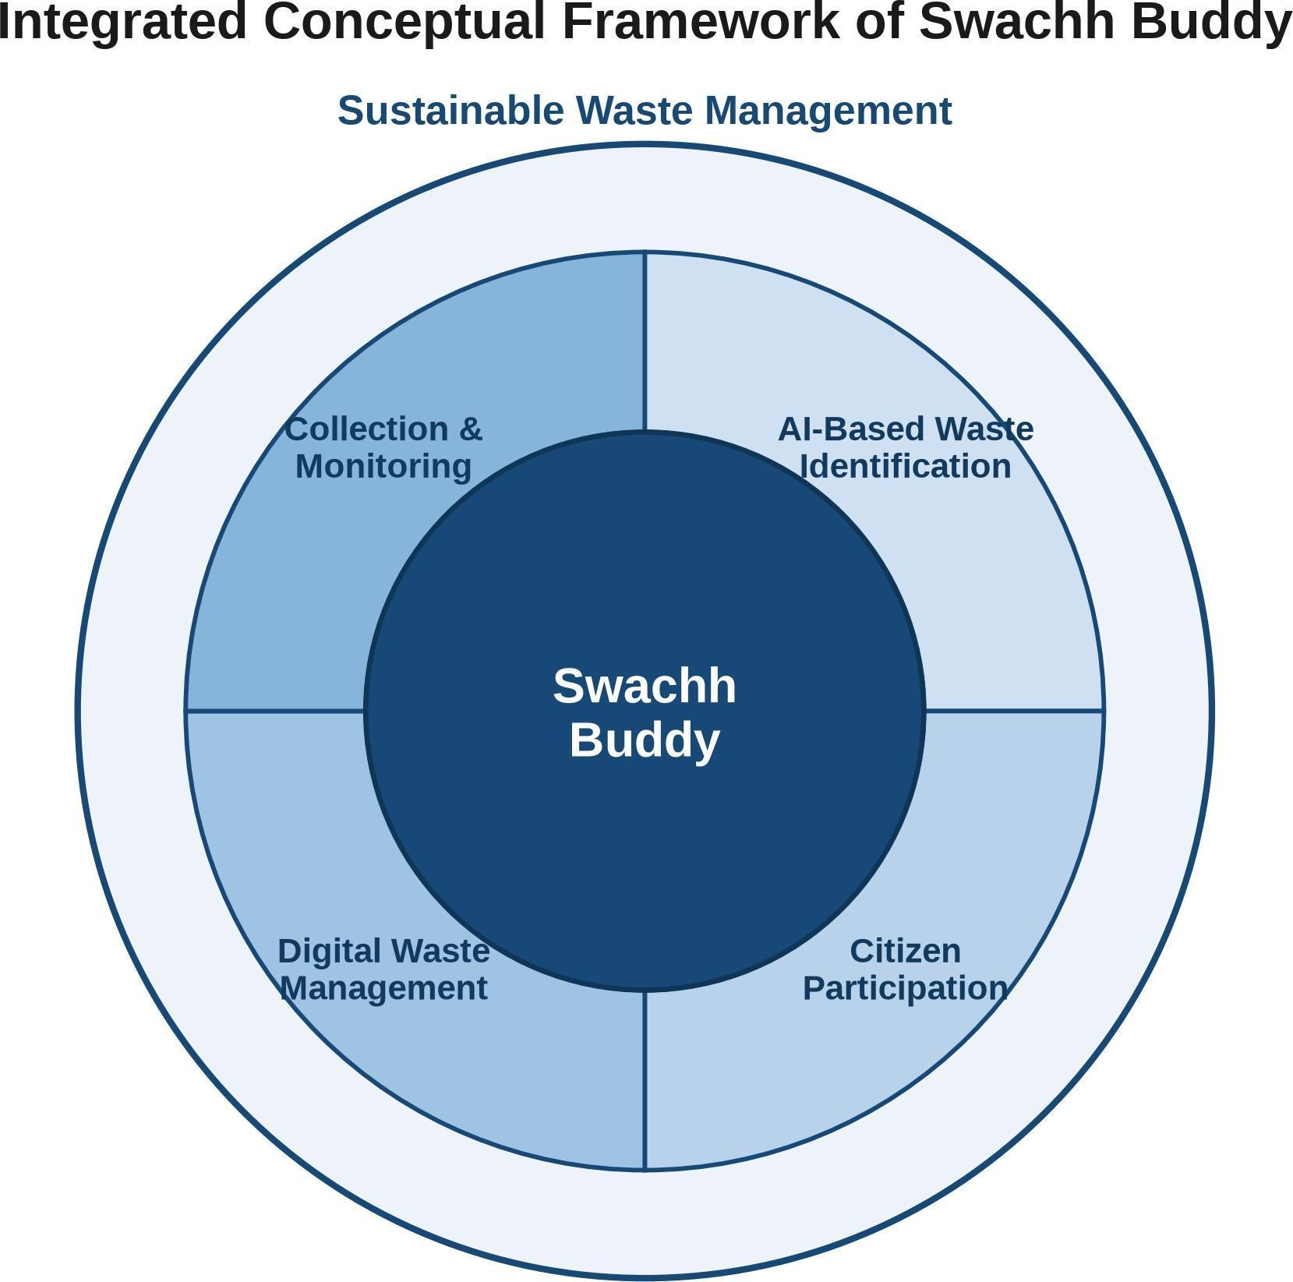

Figure 3: Integrated Conceptual Framework of Swachh Buddy

Research Gap
Examining the fifteen selected studies together reveals a clear pattern. Existing research provides valuable solutions for individual aspects of waste management, such as AI-based waste classification, collection and route optimization, smart monitoring, digital applications and citizen interaction. However, these approaches often focus on individual components rather than integrating AI-based segregation assistance, citizen engagement, reporting, location-based functionality and administrative monitoring into a single citizen-centric platform. The reviewed literature shows limited integration of these components within a single citizen-centric platform, indicating a need and an opportunity for greater integration across these dimensions.
Swachh Buddy attempts to address this integration opportunity by combining AI-based identification and segregation guidance, citizen education, incentives and reporting, collection coordination, location-based functionality and an administrative dashboard in one platform. The literature supports the feasibility of each individual component, and the identified gap lies in their integration, which is precisely the contribution this project proposes.

