Day 4 Internship Task
Prompt Engineering Fundamentals

1. What Is Prompt Engineering?
A prompt is the instruction or information given to an AI model to get a response. Prompt engineering is the skill of writing prompts so that the response is useful, accurate, well structured, and relevant. A good prompt does not only ask a question. It explains the task, the context, and the result that is expected.
A well-built prompt can include four parts, although not every prompt needs all of them:
- Instruction: what the model should do.
- Context: background information, such as who the reader is or what the situation is.
- Task requirements: limits and details, such as length, tone, or what to include.
- Expected output: the format of the answer, such as a table, a numbered list, or JSON.
Two other techniques also change the result. Giving the model a role, such as teacher or software engineer, changes the perspective and language of the answer. Stating the output format clearly makes the response easier to read and use.

2. Prompt Experiment: One Task, Three Prompts
Selected task: Create a study plan for learning Python.

Prompt 1: Simple
Make a study plan for Python.

Week 1: Revise Python basics, including variables, data types, operators, strings, lists, tuples, sets, dictionaries, loops, conditions, and functions.
Week 2: Learn intermediate Python concepts, including object-oriented programming, classes, inheritance, exception handling, file handling, modules, and packages.
Week 3: Practice problem-solving, debugging, working with APIs, handling JSON data, using virtual environments, and writing clean, reusable code.
Week 4: Apply Python to AI development by learning how to use LLM APIs, work with structured outputs, understand tool calling, explore FastAPI, and build a simple AI assistant.
Daily Routine: Study for 1–2 hours, revise concepts, write code, solve practice problems, and apply what you learn through small projects.

Prompt 2: Added context and requirements
I am a BSCS student and I already know basic programming. Make a 4-week study plan to learn Python for AI development. I can study two hours per day, and I want to practice with small projects.

Daily Study Time: 2 hours per day
Week 1: Python Fundamentals
- Day 1: Variables, data types, operators, and strings.
- Day 2: Lists, tuples, sets, and dictionaries.
- Day 3: Conditions, loops, and list comprehensions.
- Day 4: Functions, parameters, return values, and scope.
- Day 5: File handling and working with JSON.
- Day 6: Exception handling and debugging.
- Day 7: Mini-project: Build a student record management system.
Week 2: Intermediate Python
- Day 8: Object-oriented programming, classes, and objects.
- Day 9: Inheritance, encapsulation, and polymorphism.
- Day 10: Modules, packages, and virtual environments.
- Day 11: Iterators, generators, and decorators.
- Day 12: Type hints and clean code.
- Day 13: Working with APIs using the requests library.
- Day 14: Mini-project: Build a weather or currency information application using an API.
Week 3: Python for Data and AI
- Day 15: NumPy fundamentals and arrays.
- Day 16: Pandas for data manipulation.
- Day 17: Data cleaning and preprocessing.
- Day 18: Matplotlib for data visualization.
- Day 19: Introduction to machine learning with scikit-learn.
- Day 20: Train and evaluate a simple machine learning model.
- Day 21: Mini-project: Build a student performance prediction model.
Week 4: Python for Generative AI
- Day 22: Understand LLMs and connect Python to an LLM API.
- Day 23: Build a chatbot using an LLM API.
- Day 24: Learn prompt engineering and structured outputs.
- Day 25: Learn embeddings and vector databases.
- Day 26: Build a simple PDF question-answering application using RAG.
- Day 27: Learn tool calling and basic AI agent workflows.
- Day 28: Final project: Build an AI study assistant that answers questions and generates quizzes.
Daily Routine:
- 30 minutes: Learn a new concept.
- 45 minutes: Write code and solve exercises.
- 35 minutes: Work on a mini-project.
- 10 minutes: Review what you learned and document your progress.
Expected Outcome: By the end of four weeks, you should have stronger Python skills, practical experience with data analysis and machine learning, an introduction to Generative AI, and several small projects to showcase in your portfolio.

Prompt 3: Clear instructions, context, audience, and format
Act as a programming teacher. Create a 4-week Python study plan for a BSCS student who already knows basic programming and wants to move into AI development. The student can study two hours per day. Present the plan as a table with the columns Week, Topics, Daily Practice, and Mini Project. After the table, add three study tips. Use simple English and keep the whole answer under 250 words.

4-Week Python Study Plan for AI Development
Week | Topics | Daily Practice | Mini Project
Week 1 | Python data structures, functions, loops, file handling, exceptions | Solve 3–5 coding problems daily | Student Record Management System
Week 2 | OOP, modules, APIs, JSON, virtual environments | Write reusable functions and practice API requests | Weather Information App
Week 3 | NumPy, Pandas, data cleaning, visualization, basic machine learning | Analyze datasets and train simple models | Student Performance Prediction
Week 4 | LLM APIs, prompt engineering, embeddings, RAG, tool calling | Build small AI features and test their outputs | AI Study Assistant that answers questions and generates quizzes
Daily Schedule (2 Hours)
- 30 minutes: Learn a new concept.
- 45 minutes: Write code and solve problems.
- 35 minutes: Work on your mini project.
- 10 minutes: Review and revise.
Three Study Tips
- Practice daily: Write code yourself instead of only watching tutorials. Consistency helps you improve faster.
- Build while learning: Apply each new concept to a small project to understand how it works in real applications.
- Review and improve: Revisit difficult topics, debug your code, and upload completed projects to GitHub to build your portfolio.

3. Comparison of the Three Responses
Aspect | Prompt 1 (simple) | Prompt 2 (context) | Prompt 3 (full)
Clarity | General and unfocused | Clearer, matches my situation | Clear and easy to follow
Relevance | Not tailored to my level or goal | Tailored to my level and time | Tailored, with practical focus
Structure | Loose paragraphs or a basic list | Better organized by week | Follows the requested layout exactly
Completeness | Missing details such as projects and practice | Includes most details | Includes everything requested, plus tips
Formatting | No control over the format | Partly structured | Table, as requested

Most useful response: The response to Prompt 3 was the most useful for this task. It gave a ready-to-use plan in the exact layout I asked for, with practice and projects for every week. The first response was generic because the prompt gave the model nothing to work with. The second was more relevant because it knew my level and available time, but the model still chose the format and length on its own.
What changed: Each prompt added more information. Context made the answer relevant, the role and audience shaped the language, and the format instruction controlled the structure. The task stayed the same, so the difference in quality came from the prompt alone.
Note: Check this table against your own three responses and adjust any row where your chatbot behaved differently.

4. Improved Prompt
I took Prompt 3 and made it more precise by adding my goal, a restriction on resources, and instructions for what to avoid:
Act as a programming teacher. Create a 4-week Python study plan for a BSCS student who already knows basic programming and wants to build AI applications. The student can study two hours per day. Present the plan as a table with the columns Week, Topics, Daily Practice, Mini Project, and Free Resource. Choose topics that lead toward working with AI APIs, such as functions, data structures, file handling, working with JSON, and making API requests. After the table, add three study tips. Use simple English, keep the answer under 250 words, and do not include paid courses.

The improved version adds the end goal, so the topics point toward AI development. It also adds a resource column and an explicit limit on paid content, which removes two things the model would otherwise have to guess.

5. My Collection of Five Useful Prompts
Replace the text in square brackets with real content before testing each prompt.

Prompt 1: Learning
Explain what an API is to a BSCS student who is new to AI development. Start with a real-world analogy, then give a short example without code, and finish with three quiz questions and their answers.

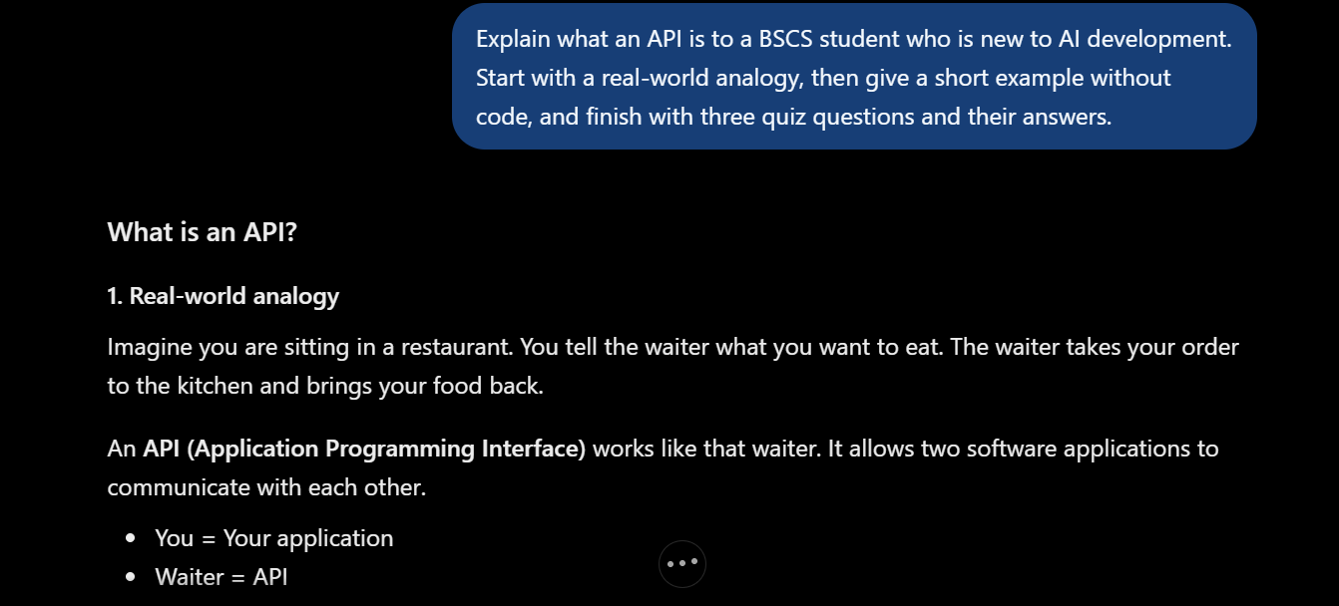

Prompt 2: Summarizing
Summarize the text below in five bullet points for a busy student, then add a one-sentence takeaway. Use simple English and do not add information that is not in the text.
Text: An API, or Application Programming Interface, is a set of rules and protocols that allows different software applications to communicate and exchange data with one another. Essentially, it acts as a digital messenger that takes a request from one system, delivers it to another system, and brings the response back

- API stands for Application Programming Interface.
- An API allows different software applications to communicate.
- It follows a set of rules and protocols.
- It helps applications exchange data with each other.
- An API acts as a digital messenger, sending requests and returning responses.
Takeaway: An API connects software applications by delivering requests and bringing back responses.

Prompt 3: Generating content
Write a LinkedIn post of about 120 words about completing the first week of my AI internship. Use a professional but friendly tone, mention one thing I learned about prompt engineering, end with a question for readers, and add three relevant hashtags.

[ Insert screenshot: Generating c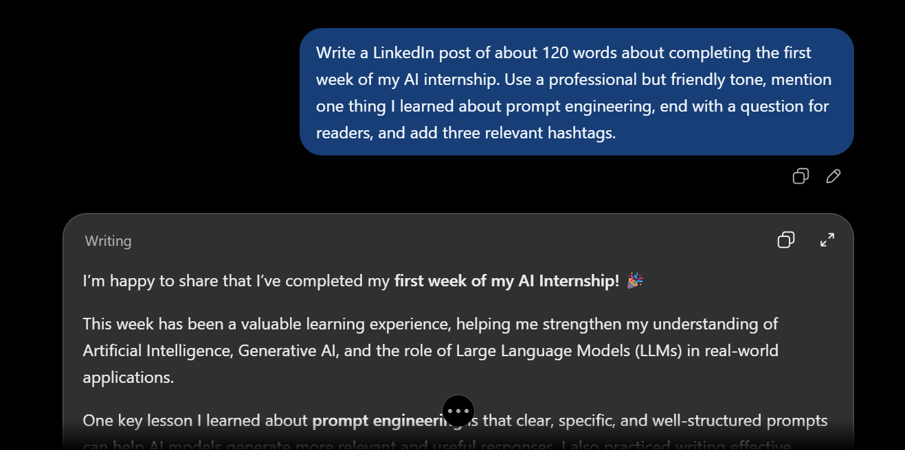ontent prompt tested in the chatbot ]

Prompt 4: Solving a technical problem
I get the following error when running my Python code. Explain the cause in simple terms, give the corrected code, and explain what you changed.
Error: NameError: name 'message' is not defined Code: print(message)

[ Insert screenshot: Solving a technica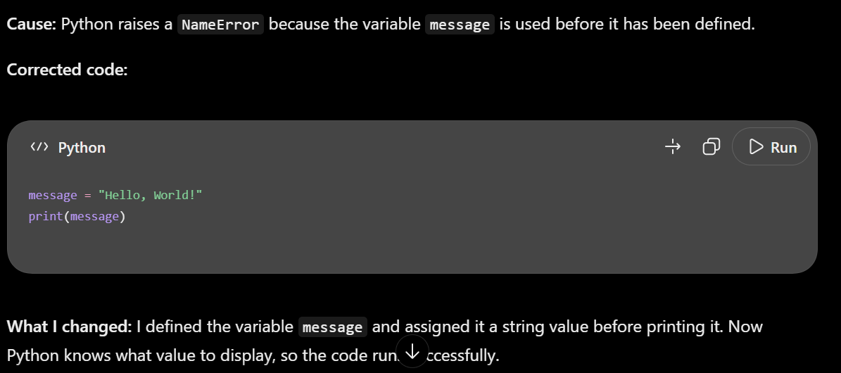l problem prompt tested in the chatbot ]

Prompt 5: Analyzing information
Analyze the customer feedback below. Identify the top three themes, the overall sentiment, and two suggested improvements. Present the results in a table with the columns Theme, Evidence, and Suggestion.
Feedback: “Fast, friendly, and professional. Clean location and excellent service."

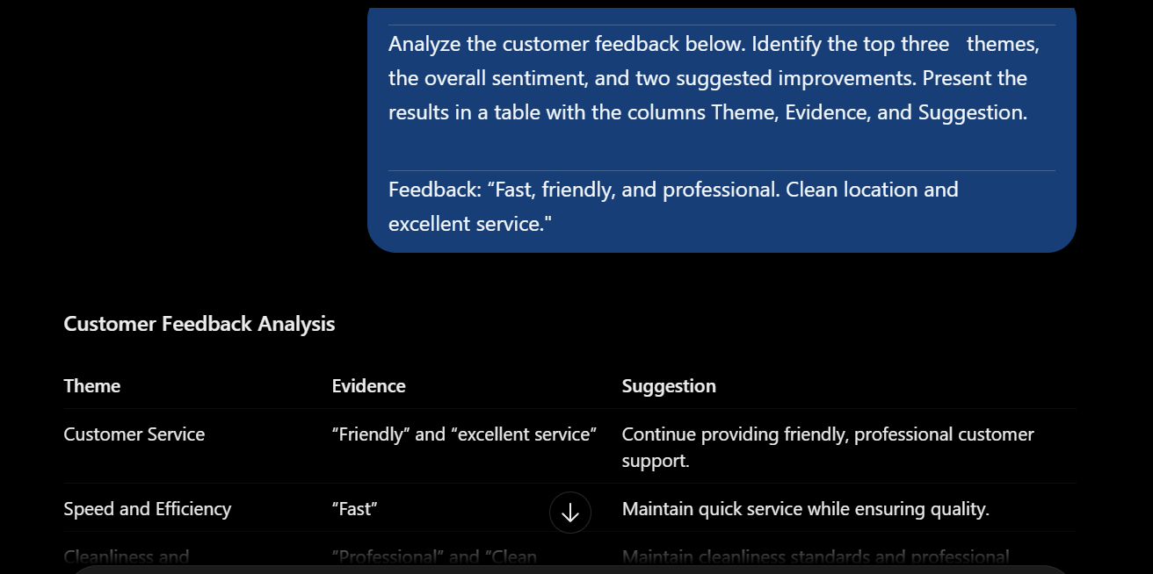

6. Learning Summary
Today I learned that the quality of an AI response depends heavily on the prompt. A good prompt states the task, gives context, defines the audience, and describes the expected format. Through the experiment, I saw that adding each of these elements made the response more relevant, better structured, and more complete. I also built a small collection of five prompts for learning, summarizing, content creation, technical problem solving, and analysis, which I can reuse in future projects.

7. Learning Resources
- OpenAI prompt engineering guide: https://platform.openai.com/docs/guides/prompt-engineering
- Google AI prompting guide: https://ai.google.dev/gemini-api/docs/prompting-strategies
- Anthropic prompt engineering overview: https://docs.anthropic.com/en/docs/build-with-claude/prompt-engineering/overview

