Day 5 Internship Task
Advanced Prompting and Structured Outputs

1. Key Concepts
- Zero-shot prompting: asking the model to do a task without giving it any examples.
- Few-shot prompting: including one or more examples in the prompt so the model can see how the task should be done.
- Separating instructions and context: an application tells the model what to do (instructions) and supplies the information to work with (context), such as a customer message. Keeping them in clearly labeled sections reduces confusion.
- Structured outputs: asking the model to return information in a fixed format, such as JSON with named fields, instead of a free-form paragraph.

2. Experiment: Zero-Shot vs Few-Shot Classification
I used five customer messages and asked the model to label each one as Positive, Negative, or Neutral.
Customer messages:
1. “The delivery was fast and the packaging was great!”
2. “I waited two weeks and nobody replied to my emails.”
3. “My order number is 8812.”
4. “It does what it says. Nothing special.”
5. “Thanks for the quick refund, I really appreciate it.”

Zero-shot prompt (no examples)
Classify each of the following customer messages as Positive, Negative, or Neutral.

1. “The delivery was fast and the packaging was great!”
2. “I waited two weeks and nobody replied to my emails.”
3. “My order number is 8812.”
4. “It does what it says. Nothing special.”
5. “Thanks for the quick refund, I really appreciate it.”

- Positive — The customer is happy with the fast delivery and great packaging.
- Negative — The customer is frustrated by the long wait and lack of email responses.
- Neutral — The customer is only providing an order number.
- Neutral — The customer says the product works but expresses no strong positive or negative feelings.
- Positive — The customer appreciates the quick refund.

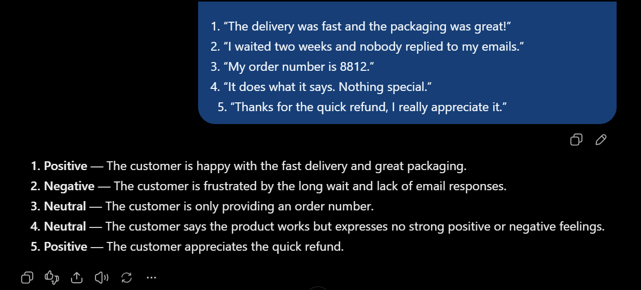

Few-shot prompt (three examples)
Classify each customer message as Positive, Negative, or Neutral. Follow the pattern in the examples.

Examples:
Message: “Love the new design, it works perfectly.” → Positive
Message: “The item arrived broken and support was rude.” → Negative
Message: “I want to know the store address.” → Neutral

Now classify these messages:
1. “The delivery was fast and the packaging was great!”
2. “I waited two weeks and nobody replied to my emails.”
3. “My order number is 8812.”
4. “It does what it says. Nothing special.”
5. “Thanks for the quick refund, I really appreciate it.”

- → Positive
- → Negative
- → Neutral
- → Neutral
- → Positive

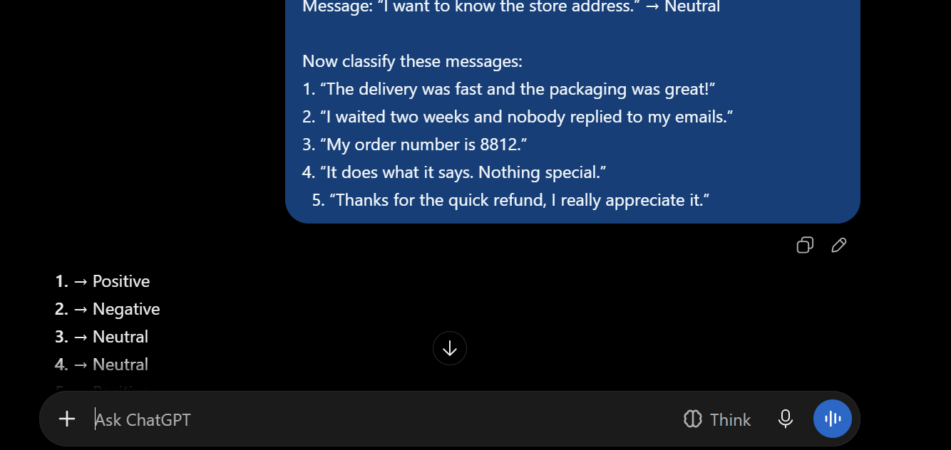

Comparison: The few-shot prompt gives the model a pattern to follow, so its labels and answer format tend to be more consistent, especially for messages that are not clearly positive or negative, such as messages 3 and 4. The zero-shot prompt relies only on the model’s general understanding and may add explanations or label borderline messages differently. Compare your own two responses and note any labels or formats that changed.

3. Customer Message Classifier
The classifier sorts a message into a category (Sales, Support, Complaint, or General), assigns a priority (Low, Medium, or High), and gives a short reason, returned as JSON.

Test messages
Message 1: “Hi, Thanks for swift delivery.”
Message 2: “Hello, do you offer bulk discounts if I order 50 wireless keyboards? My name is Ahmed Raza.”
Message 3: “I can’t log in to my account even after resetting my password. Can someone help me?”

Initial prompt
Classify this customer message into a category (Sales, Support, Complaint, or General), give the priority (Low, Medium, or High), and a short reason. Return the result in JSON.

Message: Thanks for swift delivery

Result for Message 1:
{ "category": "General", "priority": "Low", "reason": "The customer is expressing appreciation for fast delivery and does not require any action." }

Result for Message 2:
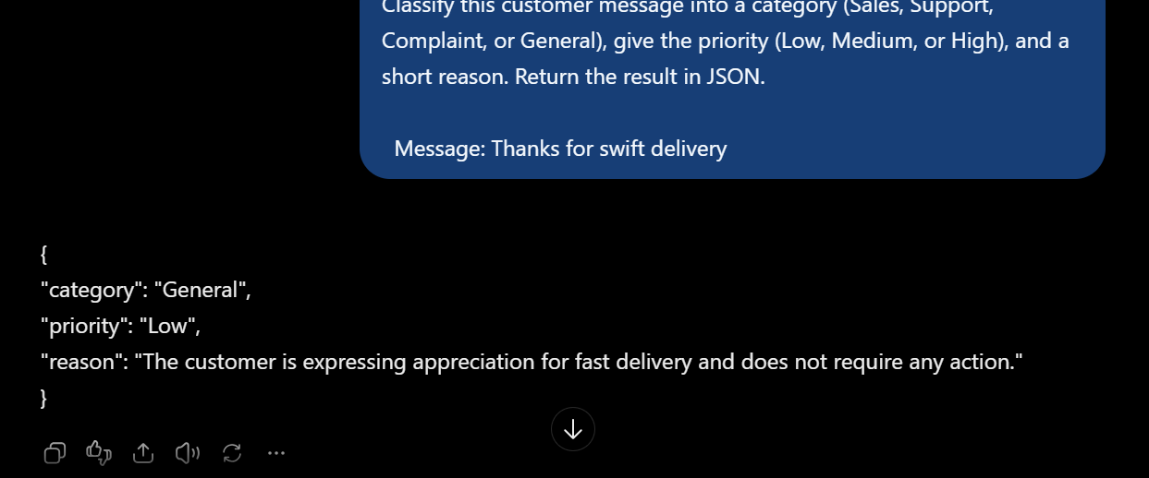

Result for Message 3:
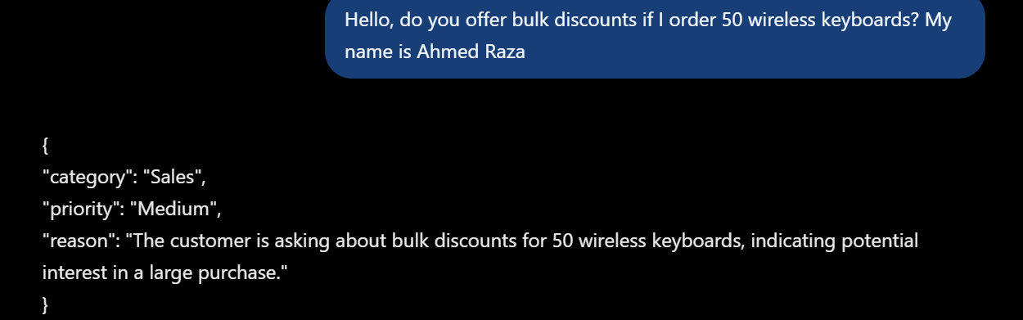

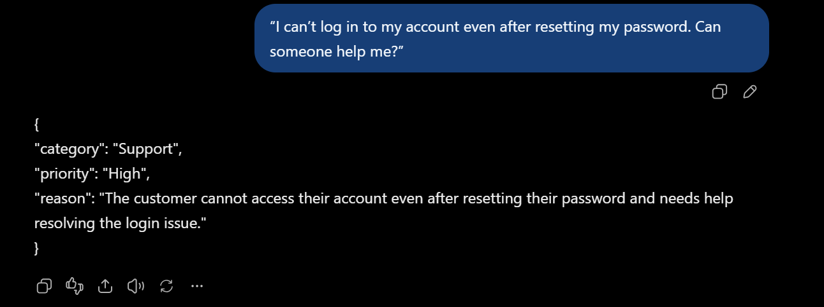

Observation: With only a loose instruction, the output can vary between messages. Typical problems are different field names, extra text around the JSON, wrapping the JSON in markdown code fences, or values outside the allowed list. Note which of these happened in your tests.

Improved prompt
To fix the inconsistency, I separated the instructions from the message, defined every field, listed the allowed values, and stated the exact output format.
INSTRUCTIONS
You are a customer message classifier. Read the customer message and return the result as JSON only. Do not add any explanation, text, or markdown outside the JSON.

ALLOWED VALUES
category: "Sales", "Support", "Complaint", or "General"
priority: "Low", "Medium", or "High"

PRIORITY RULES
High: the customer is upset, the problem has happened repeatedly, or money or an urgent deadline is involved.
Medium: the customer needs help or an answer within a few days.
Low: general questions with no urgency.

OUTPUT FORMAT
{
"customer_name": "string or null if not mentioned",
"category": "one allowed value",
"priority": "one allowed value",
"reason": "one short sentence"
}

CUSTOMER MESSAGE
[customer message]

Result for Message 1:
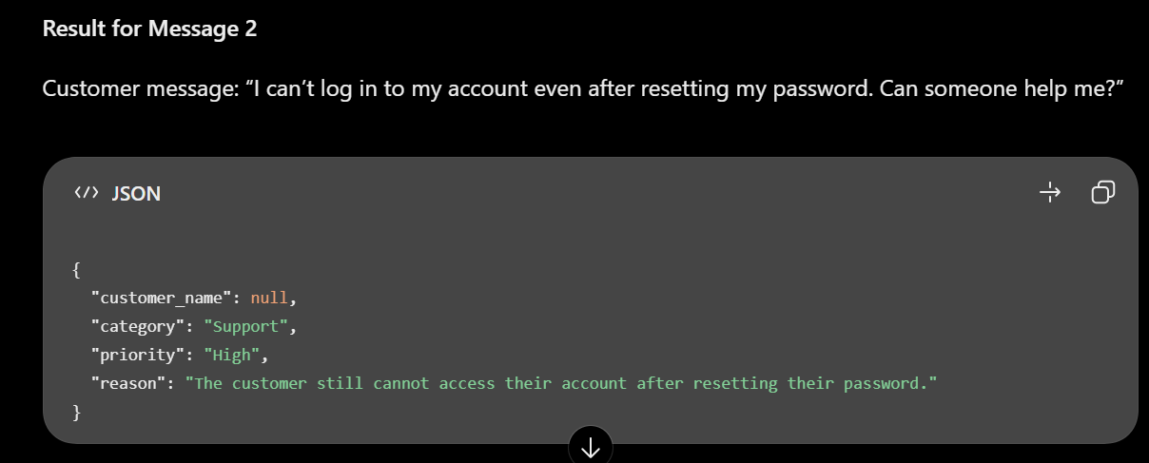

Result for Message 2:
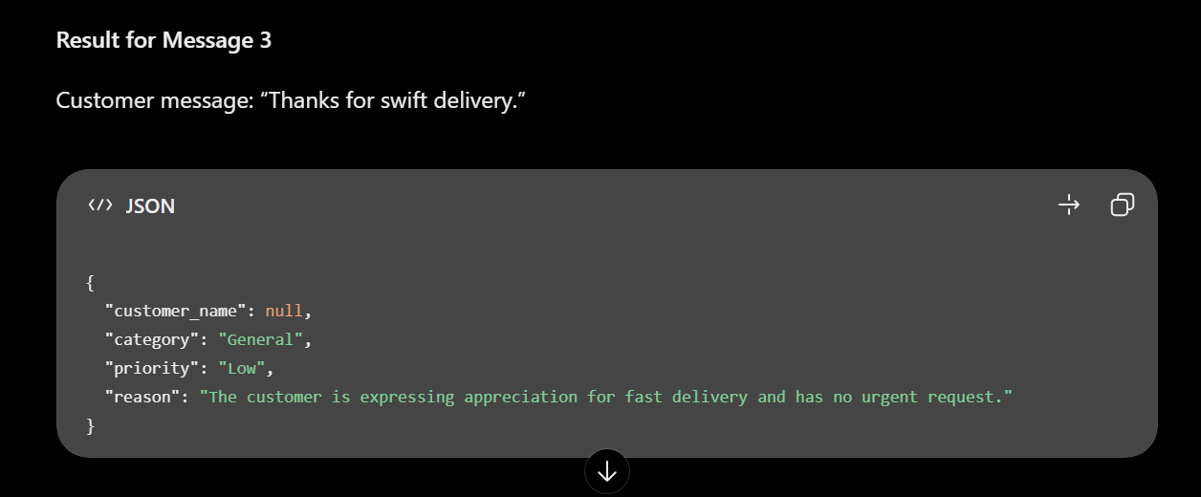

Result for Message 3:
Hello, do you offer bulk discounts if I order 50 wireless keyboards? My name is Ahmed Raza.”

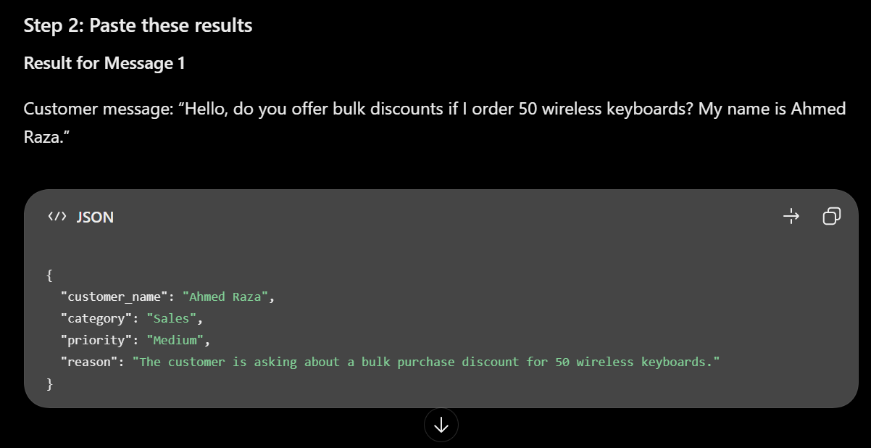

Result: With the improved prompt, every response should follow the same structure: the same four fields, values taken only from the allowed lists, and no text outside the JSON. Check that this is true for all three of your test messages.

4. Why Structured Output Matters for Software
A paragraph written for a human is easy to read but hard for a program to use. If an LLM sends a backend server a sentence such as “This seems like an urgent complaint from Sara,” the server would have to guess how to pull out the category, priority, and name. A JSON response gives each value its own named field, so the backend can read it directly, for example by checking whether priority equals “High” and then routing the ticket to a senior agent.
Predictable output also lets the application validate responses, store them in a database, and trigger automatic actions such as sending alerts or assigning tickets. It makes the system more reliable, because the same code can handle every response without being rewritten each time the wording changes.

5. Learning Summary
Today I learned the difference between zero-shot and few-shot prompting, how to separate instructions from context, and why structured outputs matter. I tested a customer message classifier, found that a loose prompt gives inconsistent results, and improved it by defining fields, allowed values, and priority rules. These techniques will be useful when I connect LLMs to backend systems through APIs.

6. Learning Resources
- OpenAI prompt engineering guide: https://platform.openai.com/docs/guides/prompt-engineering
- OpenAI structured outputs guide: https://platform.openai.com/docs/guides/structured-outputs
- Google AI prompting strategies: https://ai.google.dev/gemini-api/docs/prompting-strategies
- Anthropic prompt engineering overview: https://docs.anthropic.com/en/docs/build-with-claude/prompt-engineering/overview

