Day 8 Internship Task
Embeddings and Semantic Search

1. What Is an Embedding?
An embedding is a way of turning information, such as a sentence, into a list of numbers called a vector. Computers cannot compare meaning directly, but they can compare numbers. The embedding model is trained so that the numbers capture the meaning of the text. As a result, two pieces of text with similar meaning get vectors that sit close together in vector space, while unrelated text ends up far apart.
A simple way to picture it is a map. On a map, cities that are near each other have similar coordinates. In the same way, sentences about similar ideas get similar vectors, even if they use different words. The similarity between two vectors is usually measured with cosine similarity, where a score closer to 1 means the texts are more alike in meaning.

2. Keyword Search vs Semantic Search
Keyword search looks for the exact words from the query inside the text. Semantic search compares meaning, so it can find relevant information even when no words match.
For example, a document might say “Our company provides online programming courses.” A user searches for “Where can I learn software development online?” A keyword search may fail, because the sentences share only the word “online”. Semantic search can recognize that “programming courses” and “learn software development” describe a similar idea and return the document.

3. Experiment 1: Similar Meaning, Different Words
I wrote five sentences about different topics and generated an embedding for each. Then I wrote three new sentences that are related to some of the originals but use different words, and compared each one with all five originals.

Original sentences
# | Sentence
1 | I enjoy learning Python programming.
2 | Our school offers evening classes for adult learners.
3 | Pasta with tomato sauce is my favorite dinner.
4 | The football team won the championship last night.
5 | We are planning a trip to the mountains this summer.

New sentences and the original each should match
New sentence | Closest original (expected) | Similarity score
I like studying software development with Python. | Sentence 1 (programming) | [ add score ]
Spaghetti topped with a red sauce is what I love to eat for supper. | Sentence 3 (food) | [ add score ]
We will travel to the hills for a vacation soon. | Sentence 5 (travel) | [ add score ]

Observation: Each new sentence should score highest with the original that shares its topic, even though almost none of the words are the same. For example, “spaghetti with a red sauce” does not repeat any key word from “pasta with tomato sauce”, but the embeddings place them close together. Sentences about different topics, such as football and food, should have clearly lower scores.
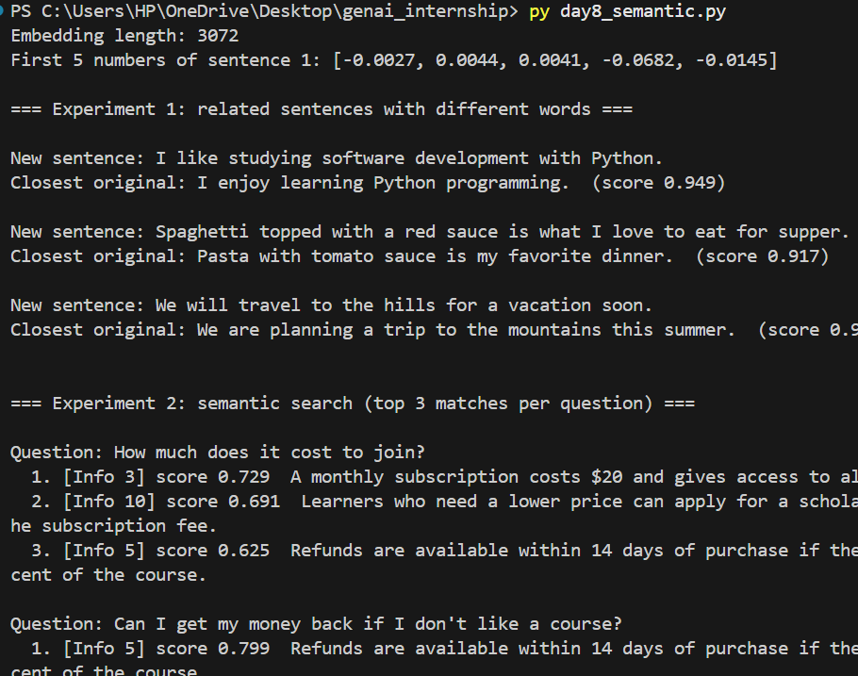

4. Experiment 2: Small Semantic Search
For the main experiment, I created ten short pieces of information about a fictional course platform called BrightPath Online Academy. I generated embeddings for all ten, then embedded six user questions and found which pieces of information were closest to each question.

Sample information
# | Information
1 | BrightPath Online Academy offers beginner to advanced programming courses in Python, JavaScript, and web development.
2 | Students can enroll in any course at any time, and lessons are available on demand around the clock.
3 | A monthly subscription costs $20 and gives access to all courses, with a 7-day free trial.
4 | Students who finish a course and pass the final project receive a verified certificate.
5 | Refunds are available within 14 days of purchase if the student has completed less than 20 percent of the course.
6 | The support team answers questions by email and live chat from 9 AM to 6 PM on weekdays.
7 | Each course includes quizzes, coding exercises, and a final project reviewed by an instructor.
8 | Students can download lesson videos to watch offline in the mobile app.
9 | Instructors are working software engineers with at least five years of industry experience.
10 | Learners who need a lower price can apply for a scholarship that covers up to 50 percent of the subscription fee.

Test questions and results
User question | Best match (expected) | Similarity score
How much does it cost to join? | Info 3 (subscription price) | [ add score ]
Can I get my money back if I don’t like a course? | Info 5 (refund policy) | [ add score ]
Will I get proof that I completed a course? | Info 4 (verified certificate) | [ add score ]
Can I study without an internet connection? | Info 8 (offline downloads) | [ add score ]
Who do I contact if I have a problem? | Info 6 (support team) | [ add score ]
Is there financial help for students who can’t afford it? | Info 10 (scholarship) | [ add score ]

Observation: The best matches were found by meaning rather than shared words. “Proof that I completed a course” matched “verified certificate”, “without an internet connection” matched “watch offline”, and “financial help” matched “scholarship”, even though these pairs have no important words in common. A keyword search would most likely have missed all three. The scores also show how confident the match is: a clearly correct match scores noticeably higher than the unrelated pieces of information.
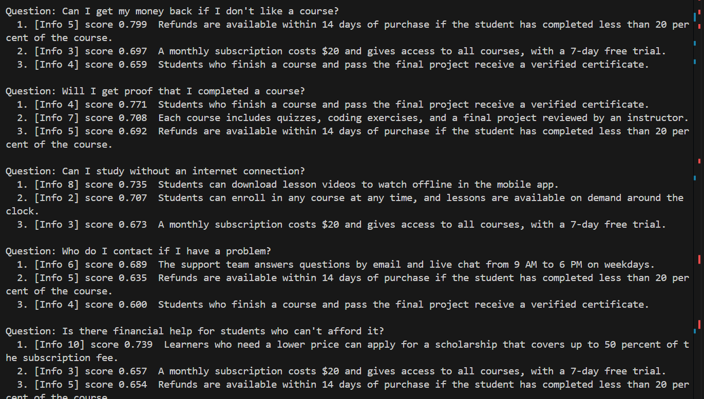

5. Source Code
I used the Gemini embeddings API (model: gemini-embedding-001) with Python. The API key is read from an environment variable, so it does not appear in the code.
import math
from google import genai
from google.genai import types

# The API key is read from the GEMINI_API_KEY environment variable.
# PowerShell: $env:GEMINI_API_KEY="your-key-here"
client = genai.Client()
MODEL = "gemini-embedding-001"

def embed(texts, task_type):
"""Send a list of texts to the embeddings API and return one vector per text."""
response = client.models.embed_content(
model=MODEL,
contents=texts,
config=types.EmbedContentConfig(task_type=task_type),
)
return [e.values for e in response.embeddings]

def cosine(a, b):
"""Cosine similarity: closer to 1 means more similar in meaning."""
dot = sum(x * y for x, y in zip(a, b))
return dot / (math.sqrt(sum(x * x for x in a)) * math.sqrt(sum(y * y for y in b)))

# ---------- Experiment 1: five sentences and three related rewrites ----------
originals = [
"I enjoy learning Python programming.",
"Our school offers evening classes for adult learners.",
"Pasta with tomato sauce is my favorite dinner.",
"The football team won the championship last night.",
"We are planning a trip to the mountains this summer.",
]
rewrites = [
"I like studying software development with Python.",
"Spaghetti topped with a red sauce is what I love to eat for supper.",
"We will travel to the hills for a vacation soon.",
]

orig_vecs = embed(originals, "SEMANTIC_SIMILARITY")
new_vecs = embed(rewrites, "SEMANTIC_SIMILARITY")

print("Embedding length:", len(orig_vecs[0]))
print("First 5 numbers of sentence 1:", [round(v, 4) for v in orig_vecs[0][:5]])

print("\n=== Experiment 1: related sentences with different words ===")
for text, vec in zip(rewrites, new_vecs):
scores = [cosine(vec, o) for o in orig_vecs]
best = max(range(len(scores)), key=lambda i: scores[i])
print(f"\nNew sentence: {text}")
print(f"Closest original: {originals[best]} (score {scores[best]:.3f})")

# ---------- Experiment 2: small semantic search ----------
documents = [
"BrightPath Online Academy offers beginner to advanced programming courses in Python, JavaScript, and web development.",
"Students can enroll in any course at any time, and lessons are available on demand around the clock.",
"A monthly subscription costs $20 and gives access to all courses, with a 7-day free trial.",
"Students who finish a course and pass the final project receive a verified certificate.",
"Refunds are available within 14 days of purchase if the student has completed less than 20 percent of the course.",
"The support team answers questions by email and live chat from 9 AM to 6 PM on weekdays.",
"Each course includes quizzes, coding exercises, and a final project reviewed by an instructor.",
"Students can download lesson videos to watch offline in the mobile app.",
"Instructors are working software engineers with at least five years of industry experience.",
"Learners who need a lower price can apply for a scholarship that covers up to 50 percent of the subscription fee.",
]
questions = [
"How much does it cost to join?",
"Can I get my money back if I don't like a course?",
"Will I get proof that I completed a course?",
"Can I study without an internet connection?",
"Who do I contact if I have a problem?",
"Is there financial help for students who can't afford it?",
]

doc_vecs = embed(documents, "RETRIEVAL_DOCUMENT")
q_vecs = embed(questions, "RETRIEVAL_QUERY")

print("\n\n=== Experiment 2: semantic search (top 3 matches per question) ===")
for q, qv in zip(questions, q_vecs):
ranked = sorted(
((cosine(qv, dv), i) for i, dv in enumerate(doc_vecs)), reverse=True
)[:3]
print(f"\nQuestion: {q}")
for rank, (score, i) in enumerate(ranked, start=1):
print(f" {rank}. [Info {i + 1}] score {score:.3f} {documents[i]}")

6. Why Embeddings Matter for RAG and Large Amounts of Information
When an application has a large amount of information, such as hundreds of policy documents, it cannot send everything to an LLM, because of the context window limit and the cost of tokens. It also cannot rely on exact keywords, since users phrase questions in many different ways. Embeddings solve both problems: they let the application quickly find the few pieces of information whose meaning is closest to the question, so only those pieces need to be sent to the LLM.
This is the basic flow of a RAG (Retrieval-Augmented Generation) system:
- The documents are split into small pieces and each piece is converted into an embedding.
- The user’s question is converted into an embedding with the same model.
- The system finds the document pieces whose embeddings are most similar to the question embedding.
- Those pieces are given to the LLM together with the question.
- The LLM writes an answer based on the retrieved information.
For example, a university assistant could turn its policies and course details into embeddings. When a student asks a question, the system retrieves the most relevant policy and the LLM uses it to answer.

7. Learning Summary
Today I learned that an embedding turns text into a vector that represents its meaning, and that similar meanings give vectors that are close together. I saw the difference between keyword search and semantic search, and I ran two small experiments showing that related sentences can be matched even when they use different words. I also learned why embeddings are important for RAG systems, which I will study further along with vector databases.

8. Learning Resources
- Gemini API embeddings documentation: https://ai.google.dev/gemini-api/docs/embeddings
- OpenAI embeddings guide: https://platform.openai.com/docs/guides/embeddings
- Hugging Face learning resources: https://huggingface.co/learn

