Day 9 Internship Task
Vector Databases and Storing Embeddings

1. What Is a Vector Database?
An embedding turns information into a vector, a long list of numbers that represents its meaning. A vector database is a database built to store these vectors and to quickly find the ones most similar to a given query vector. Comparing a question against every stored vector one by one would be slow with a large amount of information, so vector databases use specialized indexes to make similarity search fast. This makes them a key part of semantic search, recommendation systems, and RAG applications.

2. Traditional Database vs Vector Database
 | Traditional database | Vector database
Stores | Structured data such as names, emails, prices, and dates | Vectors (embeddings), together with the original text and metadata
Searches by | Exact values or conditions | Similarity in meaning
Example query | “Find all products where price is less than 5000” | “Find products similar in meaning to this description”
Typical use | Accounts, orders, inventory | Semantic search, knowledge bases, RAG

The two are often used together: a traditional database for exact facts, and a vector database for finding information by meaning.

3. Vector Search Workflow
The basic flow of a vector search system is:
- Information (text) is prepared.
- An embedding model converts each piece of text into a vector.
- The vectors are stored in the vector database.
- The user’s question is converted into a vector with the same embedding model.
- The database performs a similarity search and returns the closest records.
Summary: information → embedding model → vector → vector database → similarity search → relevant results.

4. Vector Records and Metadata
A record in a vector database usually contains four things:
- ID: a unique identifier for the record, such as faq4.
- Vector: the embedding that represents the meaning of the text.
- Document: the original text, so it can be shown or sent to an LLM.
- Metadata: extra information such as category, title, and source. Metadata can be used to filter results, for example searching only inside the “Admissions” category.

5. Selected Vector Database: Chroma
I chose Chroma because it is free, open source, and runs locally inside a Python program, so no account, server, or payment is needed. It is beginner-friendly: a few lines of code create a collection, store text with metadata, and run similarity searches. The data is saved in a local folder (chroma_db), so it persists between runs. Chroma also has a built-in embedding option, so it converts the text into vectors automatically when I store it and when I search. This keeps the project simple and lets me focus on how vector storage and similarity search work.

6. Sample Information Stored
I created ten fictional FAQs for a made-up institution, Crescent Valley University. Each record has a category, title, and source as metadata (the source for all records is “University FAQ Handbook”).
ID | Category | Title | Text
faq1 | Admissions | Admission Dates | Admission applications for the fall semester open on March 1 and close on June 30.
faq2 | Admissions | Eligibility | Applicants need at least 60 percent marks in their previous degree and must pass the university entry test.
faq3 | Fees | Fee Payment | The tuition fee is paid per semester, and students can choose to pay in two installments.
faq4 | Scholarships | Merit Scholarship | Students with a GPA above 3.5 can apply for a merit scholarship that reduces tuition by up to 50 percent.
faq5 | Hostel | Hostel Facilities | On-campus hostels are available for both male and female students, and rooms can be booked after admission is confirmed.
faq6 | Library | Library Hours | The library is open from 8 AM to 10 PM on weekdays and offers free access to online research journals.
faq7 | Transport | Shuttle Service | The university runs shuttle buses from major city areas to campus every 30 minutes in the morning.
faq8 | Exams | Make-up Exams | Students who miss a final exam because of illness can apply for a make-up exam within seven days with a medical certificate.
faq9 | Career | Career Services | The career services office organizes job fairs twice a year and helps students prepare resumes and interviews.
faq10 | IT | IT Resources | Students receive a university email account and free access to cloud software and Wi-Fi across campus.

7. Source Code
The full program is below. To run it: pip install chromadb, then run python day9_vector_search.py. No API key is needed. The first run downloads Chroma’s small built-in embedding model, so it may take a minute.
import chromadb

# 1. Create the vector database (saved in a local folder called chroma_db)
client = chromadb.PersistentClient(path="chroma_db")
collection = client.get_or_create_collection(name="university_faqs")

# 2. Our information: (id, category, title, text)
faqs = [
("faq1", "Admissions", "Admission Dates",
"Admission applications for the fall semester open on March 1 and close on June 30."),
("faq2", "Admissions", "Eligibility",
"Applicants need at least 60 percent marks in their previous degree and must pass the university entry test."),
("faq3", "Fees", "Fee Payment",
"The tuition fee is paid per semester, and students can choose to pay in two installments."),
("faq4", "Scholarships", "Merit Scholarship",
"Students with a GPA above 3.5 can apply for a merit scholarship that reduces tuition by up to 50 percent."),
("faq5", "Hostel", "Hostel Facilities",
"On-campus hostels are available for both male and female students, and rooms can be booked after admission is confirmed."),
("faq6", "Library", "Library Hours",
"The library is open from 8 AM to 10 PM on weekdays and offers free access to online research journals."),
("faq7", "Transport", "Shuttle Service",
"The university runs shuttle buses from major city areas to campus every 30 minutes in the morning."),
("faq8", "Exams", "Make-up Exams",
"Students who miss a final exam because of illness can apply for a make-up exam within seven days with a medical certificate."),
("faq9", "Career", "Career Services",
"The career services office organizes job fairs twice a year and helps students prepare resumes and interviews."),
("faq10", "IT", "IT Resources",
"Students receive a university email account and free access to cloud software and Wi-Fi across campus."),
]

# 3. Store each FAQ. Chroma turns the text into a vector automatically.
for faq_id, category, title, text in faqs:
collection.upsert(
ids=[faq_id],
documents=[text],
metadatas=[{"category": category, "title": title, "source": "University FAQ Handbook"}],
)
print("Stored", collection.count(), "records in the vector database.\n")

# 4. Search with a question and print the best matches
def search(question, category=None):
if category:
results = collection.query(query_texts=[question], n_results=3, where={"category": category})
else:
results = collection.query(query_texts=[question], n_results=3)

print("Question:", question)
for i in range(len(results["ids"][0])):
print(f" {i + 1}. {results['metadatas'][0][i]['title']} (distance: {results['distances'][0][i]:.3f})")
print(f" {results['documents'][0][i]}")
print()

search("How can I get financial help to pay for my studies?")
search("I was sick on the day of my test, what can I do?")
search("Where can I stay if I live in another city?")
search("How do I get help finding a job after graduation?")
search("When can I apply?", category="Admissions") # similarity search + metadata filter

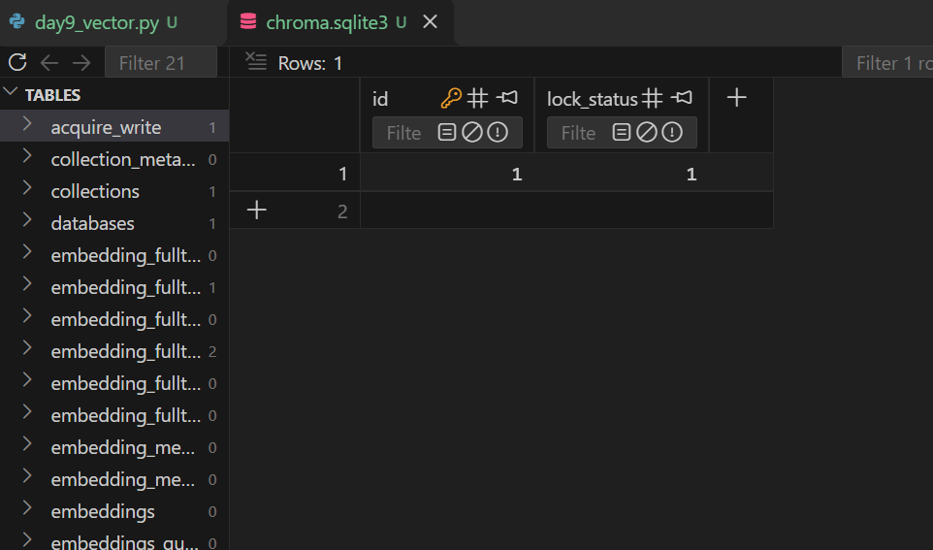

8. Search Queries and Results
I tested four questions that deliberately use different words from the stored text, plus one search that combines similarity with a metadata filter. The database returns a distance for each result, and a smaller distance means a closer match.
Question | Top result (expected) | Distance
How can I get financial help to pay for my studies? | faq4: Merit Scholarship | [ add score ]
I was sick on the day of my test, what can I do? | faq8: Make-up Exams | [ add score ]
Where can I stay if I live in another city? | faq5: Hostel Facilities | [ add score ]
How do I get help finding a job after graduation? | faq9: Career Services | [ add score ]
When can I apply? (filter: category = Admissions) | faq1: Admission Dates | [ add score ]

Observation: The questions use different words from the stored information. For example, “sick on the day of my test” does not contain the words “miss”, “exam”, or “illness”, yet it should retrieve the make-up exam record. In the same way, “stay if I live in another city” relates to hostels, and “financial help” relates to scholarships. The metadata filter limited the last search to the Admissions category, which shows how metadata and similarity search work together. 9. Reviewing the Results
Similarity search finds the closest records, but closest does not always mean correct. If no stored record really answers the question, the database still returns the nearest ones, so a low similarity score is a warning sign. A question may also be close to several records at once, such as a financial question that relates to both fees and scholarships. For this reason, a real application needs additional steps, such as setting a minimum similarity score, using metadata filters, splitting long documents into good chunks, and checking the retrieved text before the LLM uses it to answer.

10. Learning Summary
Today I learned that a vector database stores embeddings together with the original text and metadata, and that it finds relevant information by comparing meaning instead of exact words. I built a small semantic search system with Chroma and its built-in embeddings, stored ten FAQs, and tested it with questions phrased in different words. This is the retrieval step of a RAG system, and the next step is to pass the retrieved information to an LLM so it can write the final answer.

11. Learning Resources
- Chroma documentation: https://docs.trychroma.com/
- Pinecone: What is a vector database?: https://www.pinecone.io/learn/vector-database/

