***Objective:*** Study of Diode Transistor Logic NOR & NAND Gate

***Circuit Diagram:***

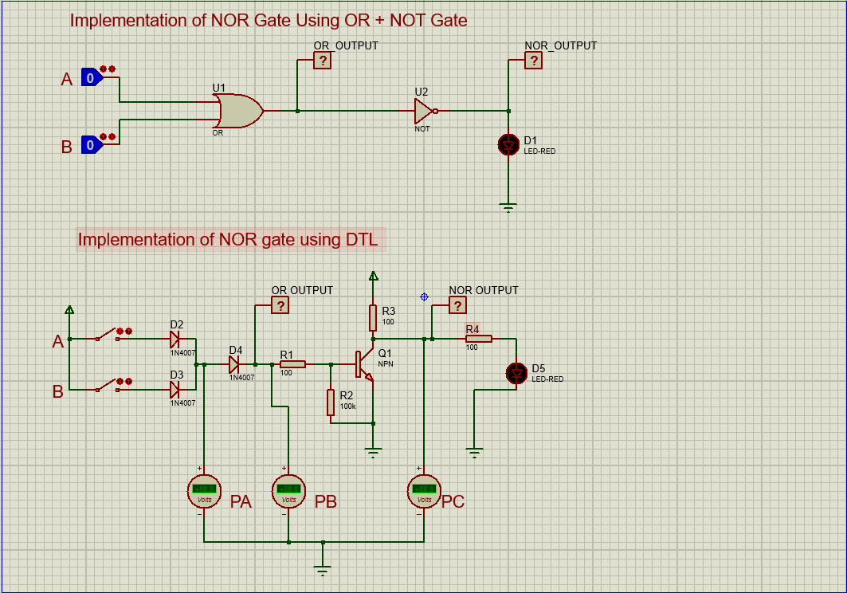

***Experimental Data:***

|  |  |  |  |  |
| --- | --- | --- | --- | --- |
| A | B | PA | PB | PC |
| 0 | 0 | 0.27 V | 0.00 V | 3.62 V |
| 0 | 1 | 4.26 V | 3.52 V | 0.03 V |
| 1 | 0 | 4.26 V | 3.52 V | 0.03 V |
| 1 | 1 | 4.29 V | 3.55 V | 0.03 V |

***Question Answeer***:

1. Explain the differences in voltage reading between PA,PB and PC. Hence explain why did we use the diode D1 and D2 in the circuit?

***Answer:*** In this circuit, we have implemented NOR Gate using DTL method in which DTL means Diode Transistor Logic. We have used 2 Diodes as it is DTL method and we can see the values from diode and the value of each diode is 0.7 V. The voltage readings in PA, PB and PC are 0.27 V,0.00 V and 3.62 V when they are both in OFF condition(A=0,B=0)

1. What would the outputs look like if we used negative logic instead of positive logic for both the circuits

***Answer***: If we used the negative logic instead of positive logic then the output would show different and it will act as OR gate.

1. Explain the role of NPN transistor in this circuit

***Answer:*** The role of NPN transistor are work like an ON/OFF condition.

4. Implement a NAND gate using the same technique DTL and state the results as per the table 1. You can use the following NAND gate circuit for the simulation

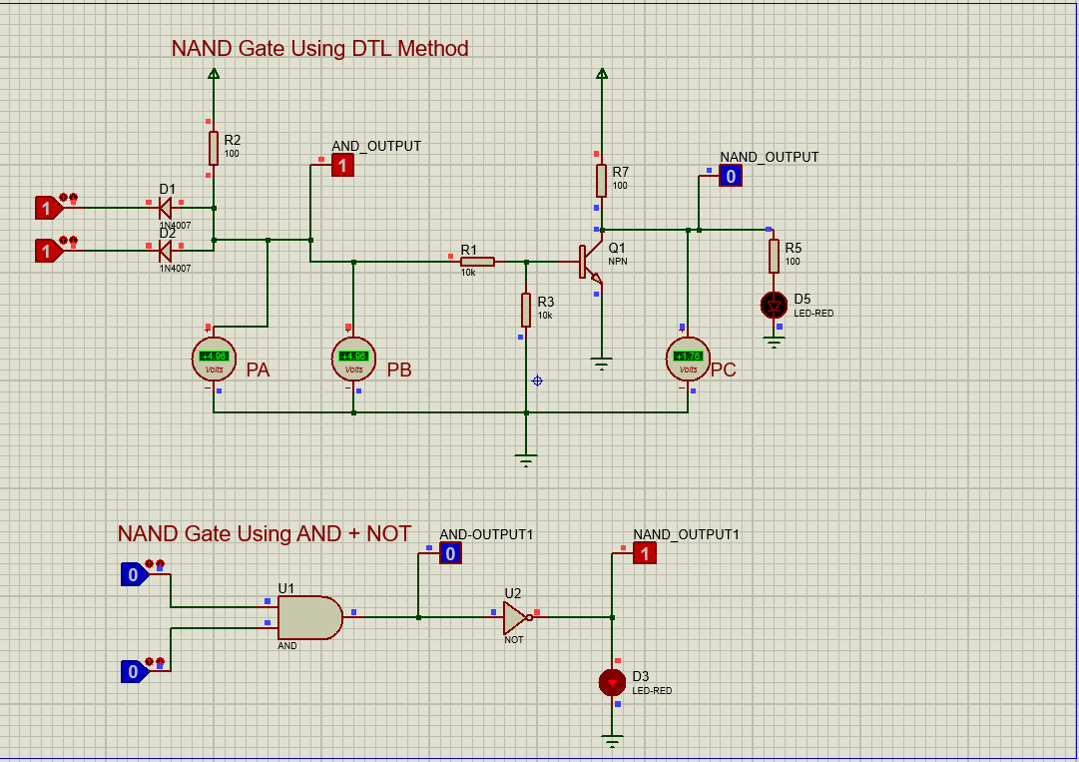

|  |  |  |  |  |
| --- | --- | --- | --- | --- |
| A | B | PA | PB | PC |
| 0 | 0 | 0.75 | 0.75 | 3.62 |
| 0 | 1 | 0.80 | 0.80 | 3.62 |
| 1 | 0 | 0.80 | 0.80 | 3.62 |
| 1 | 1 | 4.96 | 4.96 | 1.76 |