Security Testing Evidence Report
Cybersecurity Integrated Digital Leave Management System with Real-Time Intrusion Alerts
Local Government Unit of Alicia
Generated: 2026-10-26T22:14:25+08:00 · Automated suite: SecurityTestMatrixTest

Overall result: ALL SCENARIOS PASS
6 scenarios · 300 total trials · 300 passed · 0 failed

1. Overview and Methodology
This report documents the security testing conducted on the system. Six security test scenarios, drawn from the project test plan, were each executed 50 times by an automated test suite so that every result is a tally of 50 independent trials rather than a single run. In total, 300 trials were executed and all passed.
The suite exercises the system’s own live security controls — the application-layer Intrusion Detection Service, the login-security (brute-force / lockout) service, and the role-based access-control middleware. Each trial records its outcome and captures representative rows from the application’s own log tables (intrusion_logs, failed_logins) as evidence.

Test environment
Framework | Laravel 12 · PHP 8.3 · PHPUnit
Controls under test | IntrusionDetectionService · LoginSecurityService · PermissionMiddleware
Iterations | 50 per scenario (configurable via SECURITY_MATRIX_ITERATIONS)
Assessment type | Defensive self-assessment, in-process against the project’s own application
Evidence store | security-evidence.sqlite (database), runs.csv, report.html, PNG figures

2. Summary of Results
# | Scenario | Security control verified | Trials | Result
1 | Detected Vulnerabilities | Input validation · RBAC · Authentication · Secure config | 50/50 | PASS
2 | Unauthorized Access Attempt | OTP authentication · RBAC · Access logging | 50/50 | PASS
3 | Blocked Unauthorized Login Attempts | Login-attempt blocking · IP / source monitoring | 50/50 | PASS
4 | SQL Injection Attempt | Input validation · IDS signatures · Parameterized queries | 50/50 | PASS
5 | Brute Force Login Attempt | Login blocking · OTP authentication · Intrusion logging | 50/50 | PASS
6 | Intrusion Alerts Generated | Real-time intrusion alerts · Audit logging | 50/50 | PASS
Mean real-time alert latency (brute-force lockout → administrator notification queued): 19.32 ms across 50 trials.

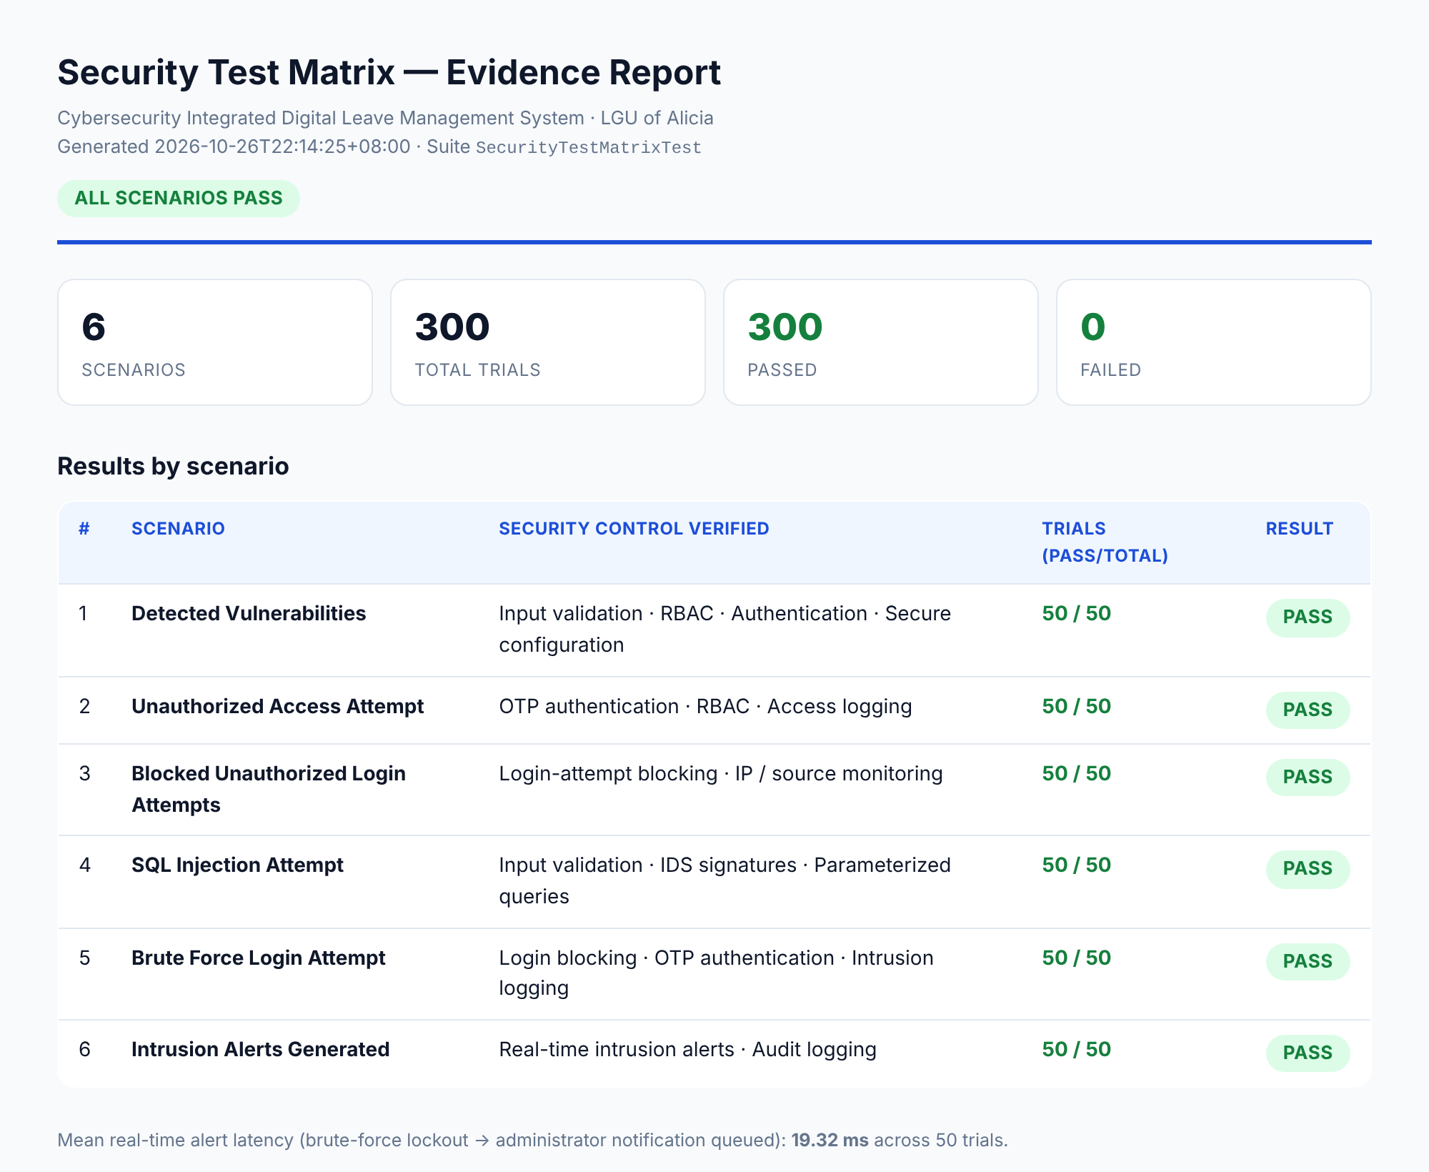
Figure 1. Automated evidence report — results by scenario.

3. Scenario Detail and Database Evidence

3.1 Detected Vulnerabilities (endpoint sweep)
Tool / method | Automated endpoint sweep (OWASP ZAP-equivalent access-control probe)
Attack scenario | Every role-restricted endpoint requested under both an unauthenticated session and an authenticated employee-role session.
Security control | Input validation · RBAC · Authentication · Secure configuration
Expected result | No finding of high or critical severity. A restricted page served, or a 5xx server error, counts as a finding.
Pass / fail criteria | PASS: no high/critical finding in any trial. FAIL: a restricted page is served or a server error occurs.
Result (50 trials) | PASS — 50 / 50 trials, 0 findings (5 endpoints × 2 sessions probed per trial).
Endpoints probed: /users, /roles, /security, /audit-logs, /settings. Anonymous access was redirected to the login screen (302); employee access was refused (403).

3.2 Unauthorized Access Attempt
Tool / method | Manual / automated login and direct-URL testing
Attack scenario | Direct URL access to five role-restricted endpoints by an authenticated employee-role account and by an unauthenticated session.
Security control | OTP authentication · RBAC · Access logging
Expected result | Unauthorized access attempts denied.
Pass / fail criteria | PASS: unauthorized users cannot reach restricted pages. FAIL: a protected area is reached.
Result (50 trials) | PASS — 50 / 50 trials. Employee hits returned 403 and were logged as privilege-escalation events; anonymous hits were redirected to login.
Evidence — rows captured from the application’s own tables during the run:
category | severity | route | method | matched_rule | ip | user_id
privilege | medium | users | GET | rbac_denied | 127.0.0.1 | 50
privilege | medium | roles | GET | rbac_denied | 127.0.0.1 | 50
privilege | medium | security | GET | rbac_denied | 127.0.0.1 | 50
privilege | medium | audit-logs | GET | rbac_denied | 127.0.0.1 | 50
privilege | medium | settings | GET | rbac_denied | 127.0.0.1 | 50
Table: privilege-escalation rows written to intrusion_logs (one per denied endpoint).

3.3 Blocked Unauthorized Login Attempts
Tool / method | Login monitoring / system logs
Attack scenario | Twenty consecutive failed authentications against one account from a single source address within a 60-second window.
Security control | Login-attempt blocking · IP / source monitoring
Expected result | Unauthorized login attempts automatically blocked after the threshold limit.
Pass / fail criteria | PASS: repeated failures are blocked after the defined limit. FAIL: excessive failures continue without restriction.
Result (50 trials) | PASS — 50 / 50 trials. The account was blocked once the 3-attempt threshold was crossed; every attempt was recorded; a correct password afterwards was still refused.
Evidence — rows captured from the application’s own tables during the run:
identifier | ip | reason | occurred_at
s3.victim50@alicia.gov.ph | 198.51.0.50 | invalid_password | 2026-10-26T14:14:20.000000Z
s3.victim50@alicia.gov.ph | 198.51.0.50 | invalid_password | 2026-10-26T14:14:20.000000Z
s3.victim50@alicia.gov.ph | 198.51.0.50 | invalid_password | 2026-10-26T14:14:20.000000Z
s3.victim50@alicia.gov.ph | 198.51.0.50 | blocked | 2026-10-26T14:14:20.000000Z
s3.victim50@alicia.gov.ph | 198.51.0.50 | blocked | 2026-10-26T14:14:20.000000Z
Table: failed_logins rows for one source address — invalid-password attempts followed by blocked attempts.

3.4 SQL Injection Attempt
Tool / method | SQLMap-equivalent payload set / manual injection testing
Attack scenario | Ten injection payloads (tautology, UNION, and time-delay families) across query and login input fields.
Security control | Input validation · IDS signatures · Parameterized queries
Expected result | SQL injection attempts fail; no unauthorized database access occurs.
Pass / fail criteria | PASS: injection attempts are blocked and no unauthorized database access occurs. FAIL: injection bypasses validation or reaches database information.
Result (50 trials) | PASS — 50 / 50 trials. The IDS blocked and logged the classic payload shapes; every payload was additionally run through a parameterized query and returned zero rows, proving it was treated as a literal string and never executed as SQL.
Evidence — rows captured from the application’s own tables during the run:
category | severity | matched_rule | payload_excerpt | ip
sqli | high | sqli_signature | -- | 198.51.0.50
sqli | high | sqli_signature | -- | 198.51.0.50
sqli | high | sqli_signature | UNION+SELECT+username,+password+FROM+users+-- x' UNION SELECT | 198.51.0.50
sqli | high | sqli_signature | UNION+SELECT+NULL,+version()+-- ' UNION SELECT | 198.51.0.50
sqli | high | sqli_signature | -- | 198.51.0.50
Table: sqli detections written to intrusion_logs (high severity, signature match).

3.5 Brute Force Login Attempt
Tool / method | Hydra-equivalent wordlist / manual brute-force testing
Attack scenario | Twenty login attempts using a password wordlist against a valid account name from a single source address.
Security control | Login blocking · IP monitoring · OTP authentication
Expected result | Brute-force attempts blocked.
Pass / fail criteria | PASS: repeated attempts are blocked after the allowed threshold. FAIL: brute-force attempts continue successfully.
Result (50 trials) | PASS — 50 / 50 trials. No wordlist entry ever produced a session; the account was blocked after the threshold and a high-severity auth_fail event was logged.
Evidence — rows captured from the application’s own tables during the run:
category | severity | matched_rule | payload_excerpt | ip
auth_fail | high | lockout_threshold | Account auto-blocked: s5.sample@alicia.gov.ph | 198.51.200.200
Table: the lockout event written to intrusion_logs when the threshold was crossed.

3.6 Intrusion Alerts Generated
Tool / method | Intrusion monitoring system
Attack scenario | Each attack family executed, with alert presence and audit record measured, and alert latency timed.
Security control | Real-time intrusion alerts · Audit logging
Expected result | Suspicious activities generate intrusion alerts.
Pass / fail criteria | PASS: suspicious or unauthorized activities generate real-time alerts. FAIL: intrusions occur without generating alerts.
Result (50 trials) | PASS — 50 / 50 trials. Brute-force lockouts produced an administrator lockout alert plus an audit record; SQL-injection bursts crossing the auto-block threshold produced an intrusion alert. Mean alert latency: 19.32 ms.

4. How to Reproduce
From the project root, run the three commands below. The first runs all 50 trials per scenario; the second builds the database, CSV and HTML report; the third renders the figures.
SECURITY_MATRIX_ITERATIONS=50 php artisan test --filter=SecurityTestMatrixTest
php scripts/security-evidence-report.php
node scripts/security-evidence-screenshots.cjs
Evidence files are in docs/security-evidence/: the queryable database (security-evidence.sqlite), the trial ledger (runs.csv), the HTML report and the PNG figures.

5. Where to Put This in the Manuscript
Chapter 3 — Methodology (Testing / Evaluation procedure)
Put the methodology paragraph and the test-environment table here. Describe the six scenarios, the 50-trial repetition, and that testing exercised the system’s live security controls. This establishes rigour and repeatability. Reference the summary table as a forward pointer to Chapter 4.
Chapter 4 — Results and Discussion
Put the Summary of Results table (Section 2) and Figure 1 here as the headline finding: 6 scenarios, 300 trials, 100% pass. Then discuss each scenario briefly, citing the pass/fail criteria. The mean alert-latency figure (19.32 ms) belongs here as a performance result for the real-time alerting objective.
Chapter 4 or Appendix — Scenario detail and database evidence
The per-scenario detail cards and the captured database rows (Section 3) are your proof. If your program allows a results chapter to carry tables, keep the detail cards in Chapter 4; otherwise move Section 3 to an appendix (e.g., “Appendix G — Security Testing Evidence”) and cite it from Chapter 4. The intrusion_logs and failed_logins tables are the concrete artifacts a panelist will look for.
Appendix — Raw artifacts and reproduction
Place the reproduction commands (Section 4) and screenshots of the SQLite database and HTML report in an appendix. Mention that the full ledger (runs.csv, 300 rows) and the database file are included in the submission package so the results can be independently verified.
Chapter 5 — Summary, Conclusion, Recommendation
Cite the 100% pass rate as evidence that the security objectives (intrusion detection, access control, brute-force protection, real-time alerting) were met. For recommendations, note that this is an in-process self-assessment and that an external network-level scan (OWASP ZAP / SQLMap against a running HTTPS instance) is recommended as future work — this shows maturity and pre-empts the obvious panel question.
ISO/IEC 25010 — Security characteristic
Use this evidence to support the “Security” characteristic (confidentiality, integrity, non-repudiation, accountability) in your ISO 25010 evaluation chapter, and cite the per-trial pass rate alongside the respondent survey scores.
Honesty note for your defense: this is a defensive self-assessment run in-process against the project’s own application, not an external penetration engagement. Where the test plan names an external tool (ZAP, SQLMap, Hydra), the suite reproduces the check that tool performs against the live controls. State this plainly in Chapter 3 so the scope is clear; it strengthens, rather than weakens, the work.

