A Cybersecurity Integrated Digital Leave Management System With Real-Time Intrusion Alerts For Local Government Unit Of Alicia

A Manuscript Presented to the Faculty of the College of Computing Studies,
Information and Communication Technology
Isabela State University - Echague Campus

In Partial Fulfillment of the Requirements for the Degree
Bachelor of Science in Information Technology

By:

Macarubbo , Noly J.,Jr.
Mendoza , Alexander John T.
Mendoza , Dj Robin O.

March 2026
CHAPTER I

INTRODUCTION

1.1. Project Context

The Local Government Unit (LGU) of Alicia currently manages employee leave records using a manual, paper-based system that has been in place since the 1990s. This process involves handwritten leave applications, multiple levels of approval through physical signatures, and manual updating and computation of leave credits. Although this method allows basic documentation of employee absences, it continues to present operational challenges such as delays in processing leave requests, difficulty in retrieving records, and potential errors in leave credit computation. As organizations increasingly adopt digital technologies, many institutions are transitioning to electronic leave management systems to improve efficiency and record management. Digital leave management platforms enable employees to submit leave requests electronically while allowing administrators to monitor leave balances and approval workflows through centralized systems, thereby improving organizational efficiency and administrative decision-making (Munawir et al., 2024).
Over time, the LGU has initiated the development and adoption of various digital systems to improve administrative operations. Several processes within different offices have already been computerized to enhance efficiency and data management. However, leave management remains one of the few processes that is still fully manual, creating inconsistency in the LGU’s overall digital transformation. With approximately 135 employees and an average of 5 to 25 leave applications per month, the manual system places a continuous workload on limited personnel responsible for processing and computing leave credits, resulting in delays, increased risk of human error, and difficulty in tracking employee records.
Leave management also involves different types of leave, including deductible and non-deductible leave categories. Manual classification and computation of these leave types increase the likelihood of inaccuracies in employee leave balances. In addition, reliance on physical documents increases the risk of data loss, duplication, and inconsistency, which further affects the reliability of records.
Given these conditions, there is a need to modernize the leave management process and align it with the LGU’s existing digital systems. Automation will improve efficiency, ensure accuracy, and enhance record management. At the same time, cybersecurity and network security principles must be applied to protect system access, communication, and data integrity. As systems become digital, records may become vulnerable to unauthorized access if proper controls are not implemented (Farayola et al., 2024). Furthermore, system connectivity may expose applications to risks such as unauthorized access and data manipulation, which can affect system operations (Al Mehairi, 2022).
To address these challenges, this study proposes the development of a Cybersecurity Integrated Digital Leave Management System With Real-Time Intrusion Alerts for the Local Government Unit of Alicia. The proposed system will automate leave processing, classification, and record management within a controlled Local Area Network (LAN) environment. The study will apply Network Security principles such as access control, secure communication, traffic validation, LAN isolation, and intrusion monitoring to strengthen the security of the system and protect sensitive employee records.
Basic security mechanisms will also be implemented, including authentication with One-Time Password (OTP), Role-Based Access Control (RBAC), IP monitoring, login attempt monitoring and blocking, input validation, audit logging, and real-time intrusion alerts. These mechanisms are intended to ensure controlled system access, detect suspicious activities, and protect employee information from unauthorized access and manipulation. To further validate these mechanisms, controlled penetration testing will be conducted to ensure that the implemented security features function correctly and can prevent common vulnerabilities.
The use of a Local Area Network (LAN) environment is an important security measure for the proposed system. Since the system will operate only within the internal network of the Local Government Unit (LGU) of Alicia, access to the system will be limited to authorized personnel inside the organization. This setup minimizes exposure to external cyber threats such as unauthorized remote access, internet-based attacks, and external data interception. In addition, LAN-based deployment allows centralized monitoring, controlled user access, traffic validation, and faster communication between client devices and the server, making it more suitable for handling sensitive employee records within the LGU environment.

1.1.1. Background of the Study

Human resource management plays a vital role in maintaining organizational productivity and operational efficiency within the Local Government Unit (LGU) of Alicia. One of its essential administrative functions is the management of employee leave records, which ensures that employee absences are properly documented and monitored in accordance with organizational policies. Effective leave monitoring enables the LGU to maintain workforce availability while promoting transparency and accountability in administrative processes.
In the LGU of Alicia, leave monitoring is currently performed through manual processes that rely heavily on paper-based forms, physical approval procedures, and manual computation of leave credits. Although these methods allow basic record keeping, they often lead to operational inefficiencies such as delays in approval processes, inaccurate leave credit calculations, and difficulties in retrieving historical records. These limitations affect administrative efficiency and decision-making, particularly as the number of employees and leave applications increases.
To address similar challenges, many organizations have adopted digital leave management systems that automate the monitoring and management of employee leave records. These systems allow employees to submit leave requests electronically and enable administrators to manage approvals, monitor leave balances, and generate reports through centralized platforms (Munawir et al.,2024). By reducing reliance on manual processes, digital systems improve administrative efficiency, enhance accuracy in leave computation, and increase accessibility of employee records. However, in the LGU of Alicia, leave management remains one of the few administrative processes that has not yet been computerized despite ongoing digitalization efforts in other offices.
Despite the advantages of digital systems, organizations must also consider the proper handling of digital information. As administrative processes become computerized, maintaining data integrity and protecting sensitive employee information become important considerations. Data integrity ensures that records remain accurate and consistent, while data protection mechanisms help prevent unauthorized access, modification, or loss of information (Farayola et al.,2024).
Furthermore, even within internal organizational networks, risks such as unauthorized internal access, improper modification of leave records, misuse of user privileges, and inconsistent data handling may still occur if system access is not properly controlled. In LAN-based government systems where multiple employees access shared resources, implementing controlled authentication, access restriction, and activity monitoring is necessary to maintain data integrity and accountability.
In this context, basic security mechanisms such as authentication, Role-Based Access Control (RBAC), input validation, and activity monitoring can be integrated to support system reliability and data protection. These mechanisms help ensure that only authorized users can access system functions while maintaining accountability through recorded system activities. When properly implemented, these features enhance the overall reliability of the system without overcomplicating its design (Manoharan, 2024).
Leave management is prioritized over other administrative systems because it directly affects employee benefits, compliance with government policies, and workforce availability. Unlike attendance systems, leave management involves complex classification of leave types such as sick leave, vacation leave, maternity leave, and special non-deductible leave. Manual computation of these categories increases the risk of miscalculation and policy violations. Ensuring accurate leave credit computation is critical, as errors may directly impact employee entitlements and organizational accountability.
Given the need to improve administrative efficiency in the LGU of Alicia while ensuring controlled system access and data reliability, this study proposes the development of a Cybersecurity Integrated Digital Leave Management System With Real-Time Intrusion Alerts For Local Government Unit Of Alicia. The proposed system integrates process automation with essential security mechanisms to support accurate, efficient, and well-managed leave record monitoring within a controlled environment.

1.1.2. Statement of the Problem

The Local Government Unit (LGU) of Alicia currently manages employee leave credits through manual documentation and paper-based processes. This approach often results in delays in leave processing, inaccuracies in leave credit computation, and difficulty in retrieving employee records. In addition, the reliance on manual record management increases the risk of data inconsistency, loss of records, and limited tracking of employee leave history.
With the increasing adoption of digital technologies in administrative operations, there is a need for a system that can automate leave monitoring, improve administrative efficiency, and ensure accurate and reliable record management. At the same time, basic security mechanisms must be incorporated to control system access and protect employee information within a digital environment.
Specifically, this study seeks to answer the following questions:
- What is the percentage reduction in leave processing time achieved by the proposed system, compared with a measured baseline of the existing manual process, in terms of (a) end-to-end request turnaround from filing to final approval and (b) the time required to complete a single leave application form?
- What is the improvement in the accuracy of leave credit computation, measured as the leave-credit error rate, that is, the proportion of processed applications whose computed leave balance deviates from the balance derived by the Civil Service Commission Omnibus Rules on Leave, under the existing manual process compared with the proposed system?
- How effective are the implemented security controls in containing simulated attacks, measured as the control effectiveness rate across the defined attack scenarios, and what residual findings remain after controlled penetration testing?
- What is the level of product quality of the proposed system as evaluated by end users and information technology experts using ISO/IEC 25010, in terms of functional suitability, usability, performance efficiency, and security?
- What is the timeliness and precision of the system's real-time intrusion alerting, measured as (a) the detection-to-notification latency for each simulated intrusion event and (b) alert precision, the proportion of generated alerts that correspond to genuine intrusion attempts?

1.2. Objectives of the Project

The primary objective of this study is to develop a Cybersecurity Integrated Digital Leave Management System With Real-Time Intrusion Alerts For Local Government Unit Of Alicia that improves the efficiency, accuracy, and security of employee leave credit monitoring. The proposed system aims to replace the existing manual leave monitoring process with a digital platform that enables efficient leave record management while ensuring the protection of sensitive employee information through the implementation of modern cybersecurity mechanisms.
Specifically, the study will undertake the following:
- To develop a Cybersecurity Integrated Digital Leave Management System With Real-Time Intrusion Alerts for the LGU of Alicia that automates leave application processing, leave classification and credit computation under the Civil Service Commission Omnibus Rules on Leave, record management, and report generation within a centralized platform accessible through authorized devices in the Local Area Network (LAN).
- To measure the percentage reduction in leave processing time achieved by the proposed system against a measured baseline of the existing manual process, covering both end-to-end request turnaround and the time required to complete a single leave application form.
- To determine the improvement in the accuracy of leave credit computation, using the Civil Service Commission Omnibus Rules on Leave as the reference standard, by comparing the leave-credit error rate of the existing manual process with that of the proposed system.
- To implement LAN-based security mechanisms, including authentication with One-Time Password (OTP), Role-Based Access Control (RBAC), input validation, audit logging, IP monitoring, login attempt blocking, and real-time intrusion alerts, and to determine their control effectiveness rate against defined attack scenarios while documenting any residual findings.
- To assess the product quality of the proposed system based on ISO/IEC 25010 in terms of functional suitability, usability, performance efficiency, and security, as evaluated by end users and information technology experts.
- To determine the timeliness and precision of the system's real-time intrusion alerting, measured as detection-to-notification latency and alert precision.

1.3. Scope and Limitations

This study focuses on the design, development, and implementation of a Cybersecurity Integrated Digital Leave Management System With Real-Time Intrusion Alerts For Local Government Unit Of Alicia. The proposed system will provide a centralized digital platform for managing employee leave applications, monitoring leave credits, and maintaining leave-related records within the organization’s internal network environment. The system is designed to support approximately 135 employees of the LGU, with an average of 5 to 25 leave applications processed per month, reflecting the current operational workload of the office.
The system will allow authorized personnel to record, update, and monitor leave credits, while enabling employees to submit leave applications and view their leave balances through a digital interface. Basic security mechanisms such as authentication with One-Time Password (OTP), Role-Based Access Control (RBAC), input validation, and audit logging will be implemented to ensure controlled system access and protection of employee records. These features are intended to support secure and reliable system usage within the LGU environment.
The proposed system is limited to deployment within the Local Area Network (LAN) of the LGU of Alicia and is not intended for public internet access. As a result, the system does not include external network protection mechanisms such as cloud-based security services, distributed denial-of-service (DDoS) mitigation, or external web application hosting security. In addition, the effectiveness of the system’s security mechanisms depends on the proper maintenance of the internal network infrastructure and user compliance with organizational security policies.
The scope of the system will be limited to permanent employees of the Local Government Unit of Alicia, specifically those who are eligible to file leave applications under existing policies. The system will focus on core leave management functions, including leave application processing, leave credit computation, record updating, and viewing of leave history. However, the system will not include other human resource management functions such as payroll processing, employee performance monitoring, recruitment management, or biometric attendance tracking. Furthermore, the system will not be integrated with external government databases, cloud-based platforms, or national human resource management systems.
1.4. Significance of the Study

The development of the Cybersecurity Integrated Digital Leave Management System With Real-Time Intrusion Alerts For Local Government Unit Of Alicia is expected to provide significant benefits to various stakeholders within the Local Government Unit of Alicia.
● Local Government Administration
The system will improve administrative efficiency by automating leave processing, reducing reliance on manual documentation, and minimizing delays in approval and record handling. It will also support more accurate leave credit computation and faster retrieval of employee records.
● Government Employees
Employees will benefit from a more efficient leave application process, quicker approval turnaround, and easier access to their leave balances and records, resulting in improved transparency and convenience.
● Information Technology Personnel
The system will demonstrate the practical implementation of a LAN-based administrative solution that integrates automation with essential security mechanisms. It will also provide a basis for managing and maintaining internal systems within a controlled network environment.
● Future Researchers
This study may serve as a reference for future research related to leave management systems in local government settings, particularly in developing systems that balance automation, usability, and controlled security implementation.

1.5 Conceptual Framework
The conceptual framework of this study follows the Input–Process–Output (IPO) model. It presents the resources and requirements that enter the study, the development and evaluation activities performed upon them, and the outputs produced, which correspond directly to the questions raised in the Statement of the Problem.

Figure 2
Conceptual Framework of the Study
INPUT | PROCESS | OUTPUT
Existing manual leave process: workflow, forms, measured turnaround, measured leave-credit error rate  Civil Service Commission Omnibus Rules on Leave and CSC Form No. 6 (Revised 2020)  LGU Alicia organizational structure: 17 offices, 135 plantilla employees, Department Head to HR to Mayor approval hierarchy  Security requirements: threat model, CIA objectives, Republic Act No. 10173 obligations  Technical resources: LAN infrastructure, server and client hardware, PHP, Laravel, and MySQL platform  ISO/IEC 25010 quality characteristics | Iterative and Incremental Development across eleven planned increments, each cycling through requirement analysis, system design, system development, and system testing against defined exit criteria  Integration of security controls: authentication with OTP, Role-Based Access Control, input validation, audit logging, intrusion detection, IP monitoring and blocking, real-time alerting  Evaluation activities: baseline measurement of the manual process, retrospective record audit, gold-standard case validation, task-based testing, role-differentiated ISO/IEC 25010 evaluation, and controlled penetration testing | Cybersecurity Integrated Digital Leave Management System With Real-Time Intrusion Alerts, deployed within the LAN of the LGU of Alicia  Percentage reduction in leave processing time (Question 1)  Improvement in leave credit computation accuracy (Question 2)  Control effectiveness rate and residual findings register (Question 3)  ISO/IEC 25010 product quality rating (Question 4)  Intrusion alert latency and precision (Question 5)

Note: Figure 2 presents the conceptual framework of the study. The Input column identifies the existing conditions, policy requirements, organizational structure, security requirements, and technical resources on which the study draws. The Process column identifies the development model followed and the evaluation activities conducted. The Output column identifies the developed system together with the five measured results that answer the research questions. A feedback relationship runs from the Process and Output stages back to the Process stage: findings obtained during testing and evaluation are returned to the development activity, where they are addressed in a subsequent increment. This feedback relationship is consistent with the Iterative and Incremental Development model described in Section 3.2.

1.5.1 Theoretical Grounding
The study is grounded on three established models rather than on a theory of technology adoption. First, the ISO/IEC 25010 systems and software product quality model supplies the characteristics against which the quality of the developed artifact is evaluated. Second, the Confidentiality, Integrity, and Availability (CIA) triad, together with the principle of defense in depth, governs the design of the security controls, which are layered so that no single mechanism is solely responsible for protecting employee records. Third, the Role-Based Access Control model formalized by Sandhu et al. (1996) and standardized as ANSI INCITS 359-2004 supplies the access control structure of the system, in which permissions are assigned to organizational roles and are acquired by users only through role membership.
These models are applied in the design and evaluation of the artifact rather than tested as theories. The study does not adopt a technology acceptance or behavioral intention model, because its instruments measure product quality characteristics, computational correctness, processing performance, and security control effectiveness, and do not measure perceived usefulness, perceived ease of use, or behavioral intention to use. Adopting such a model without measuring its constructs would not be supported by the data this study collects.

1.6 Definition of Terms
The following terms are defined operationally as they are used in this study.
Alert precision. The proportion of intrusion alerts generated by the system that correspond to genuine intrusion attempts, measured across a test period that includes ordinary administrative activity as well as simulated attacks.
Control effectiveness rate. The proportion of attack attempts contained by the implemented security controls out of the attempts made. An attempt is counted as contained only when the action does not succeed, the event is recorded in the audit or intrusion log, and any automated response defined for that scenario is triggered.
Deductible leave. A leave type whose approved days are subtracted from an employee’s accumulated leave credits under the Civil Service Commission Omnibus Rules on Leave, such as vacation leave and sick leave.
Detection-to-notification latency. The elapsed time between the moment the system records a suspicious event and the moment that event becomes visible to an administrator on the security dashboard or through a generated notification.
Increment. A planned, self-contained portion of the system that passes through its own cycle of requirement analysis, design, development, and testing, and that must satisfy defined exit criteria before the next increment begins.
Leave-credit error rate. The proportion of processed leave applications whose computed leave balance deviates from the balance derived independently from the Civil Service Commission Omnibus Rules on Leave.
Non-deductible leave. A leave type whose approved days are not subtracted from an employee’s accumulated leave credits, such as maternity leave, paternity leave, and special leave benefits for women.
Plantilla employee. An employee occupying an authorized regular position in the approved staffing pattern of the Local Government Unit, and who is therefore entitled to file leave applications under existing Civil Service rules.
Policy as configuration. A design approach in which leave policy rules, including leave types, day limits, credit sources, and documentary requirements, are stored as system data rather than written into program code, so that a change in Civil Service Commission issuances can be applied by reconfiguring the system rather than by modifying and redeploying it.
Real-time intrusion alert. A notification of a detected suspicious event that reaches an administrator within a defined interval of its detection. In this study the interval is bounded by the fifteen-second refresh cycle of the security dashboard, and high-severity events additionally generate an electronic mail notification.
Residual finding. Any security observation that is not fully contained during testing, or any weakness identified by automated scanning, that remains at the close of the testing period, recorded with its severity classification and its disposition as remediated, mitigated, or accepted.
Role-Based Access Control (RBAC). An access control model in which permissions are assigned to organizational roles rather than to individual user accounts, and users acquire permissions only through membership in a role.

CHAPTER II

REVIEW OF RELATED LITERATURE & STUDIES

2.1 Introduction

This chapter presents the review of related literature and studies that provide the theoretical and technological foundation for the development of the proposed system. The discussion focuses on digital human resource information systems, leave management systems, and supporting security mechanisms relevant to administrative system implementation.
Previous studies indicate that digital leave management systems improve administrative efficiency by replacing manual processes with automated platforms that enable electronic submission of leave requests, streamline approval workflows, and maintain centralized records of employee leave data (Munawir et al., 2024). These systems enhance transparency, reduce processing time, and minimize errors associated with manual leave tracking.
In addition, existing studies emphasize the importance of incorporating appropriate system controls such as authentication, access control, and monitoring to support proper system usage and protect sensitive employee information (Alade et al., 2022; Anda et al., 2022). In the Philippine context, digital systems have improved administrative operations in government institutions; however, challenges related to system implementation, record management, and accurate leave credit computation remain.
Based on these findings, there is a need for a system that not only automates leave management but also ensures accurate leave classification, controlled system access, and centralized record management. This study addresses these needs by proposing a Cybersecurity Integrated Digital Leave Management System With Real-Time Intrusion Alerts tailored to the operational requirements of the Local Government Unit (LGU) of Alicia.
2.2 Review of Related Literature
Foreign Literature
Digital Human Resource Information Systems
Digital transformation has significantly influenced the development of human resource information systems (HRIS) in modern organizations. HRIS platforms enable organizations to manage workforce data efficiently through centralized digital databases. Web-based leave management systems improve the efficiency of leave application processing and monitoring through automated workflows and centralized record management (Jadhav et al., 2023). These systems allow administrators to process employee records, monitor workforce activities, and generate analytical reports that support managerial decision-making (Maulana & Amelia, 2025).
Research indicates that automated HR systems improve administrative efficiency by reducing manual documentation and enabling real-time access to employee data (Munawir et al., 2024). Furthermore, digital platforms integrate various administrative functions such as employee records, attendance, payroll, and leave tracking into a unified system, improving workflow coordination, employee productivity, and organizational efficiency (Yona & Meilani, 2024)
However, despite these advantages, many HR systems focus on general administrative functions and do not provide specialized mechanisms for accurate leave classification and policy-based computation.
Leave Management Systems

Leave management systems allow organizations to track employee leave requests and maintain accurate leave balances. Manual systems rely on paper-based processes, which often result in inefficiencies, delays, and errors in record management (Adamu, 2020; Alade et al., 2023).
Digital leave management systems address these issues by automating leave submission, approval, and record updating. Employees can submit requests electronically, while administrators manage leave records through centralized databases. These systems improve efficiency, reduce paperwork, and enhance transparency (Munawir et al., 2024; Alade et al., 2022).
Studies such as Pagayonan (2022) and Choudhari et al. (2023) confirm that automated systems improve record accuracy and streamline workflows. More recent systems incorporate features such as real-time monitoring, notifications, and data visualization to support workforce management and decision-making (Salazar et al., 2025; Pagayonan, 2022).
However, most systems do not implement structured leave classification mechanisms. As a result, they may fail to distinguish between deductible and non-deductible leave types, leading to inaccurate leave credit computation.
Cybersecurity in Digital Information Systems

As organizations adopt digital systems for managing workforce data, cybersecurity has become an essential aspect of information system design. Cybersecurity strategies and information security frameworks provide guidelines for protecting digital systems from unauthorized access, data breaches, and cyber attacks. These strategies recommend implementing security measures such as encryption, authentication mechanisms, secure communication protocols, and monitoring tools to safeguard sensitive organizational information (Al Mehairi, 2022).
Human resource information systems often contain confidential employee data, including personal records and employment history. Protecting this data is critical to maintaining organizational integrity and ensuring compliance with data protection regulations. Implementing strong cybersecurity strategies and security governance practices helps prevent unauthorized access and ensures that sensitive information remains protected within digital platforms and organizational systems (Al Mehairi, 2022).

The study of Manoharan (2024) emphasized that human resource information systems store large volumes of sensitive employee data such as personal records and employment histories, making them potential targets for cyberattacks. Organizations must therefore implement strong cybersecurity frameworks that include encryption mechanisms, authentication protocols, and monitoring systems to protect HR databases from unauthorized access.
Similarly, the study of Farayola et al. (2024) highlighted that data privacy and information security are critical concerns in modern digital systems due to the increasing volume of sensitive data stored within organizational databases. Encryption technologies and access control mechanisms are essential components of information security frameworks because they ensure the confidentiality, integrity, and availability of digital information.
Research also emphasizes the importance of authentication mechanisms in securing digital systems. Authentication methods such as password hashing, secure login protocols, session validation, and secure authentication frameworks are commonly used to verify user identities before granting access to system resources. These mechanisms strengthen system security and reduce the risk of unauthorized access (Al-Husban & Al-Husban, 2025; Khan et al., 2023).
Role-Based Access Control in Information Systems
Access control mechanisms play a vital role in protecting digital information systems. Access control determines how users interact with system resources and ensures that only authorized individuals can access sensitive information. Among the various access control models used in modern systems, Role-Based Access Control (RBAC) is widely implemented in organizational environments.
RBAC assigns system permissions based on user roles rather than individual user accounts. Each role within the organization is associated with specific privileges that determine the actions users can perform within the system. By assigning users to predefined roles, organizations can regulate system access more efficiently and ensure that users only access information relevant to their responsibilities.
Research indicates that RBAC enhances system security by preventing unauthorized access to sensitive data. It also simplifies the management of user permissions by grouping access privileges according to organizational roles. This model is widely used in enterprise systems, government platforms, and human resource management applications where different users require varying levels of access to system resources.
Integrating RBAC with authentication mechanisms and encryption protocols further strengthens the security of information systems. These security measures ensure that digital platforms maintain the confidentiality, integrity, and reliability of organizational data.

ISO/IEC 25010 Software Quality Model

The ISO/IEC 25010 software quality model provides a standardized framework for evaluating the quality of software systems based on defined characteristics such as functional suitability, performance efficiency, usability, reliability, and security. This model is widely used in software engineering to assess whether a system meets user requirements and performs effectively under various conditions.
The model emphasizes that a high-quality system must not only function correctly but also provide a satisfactory user experience, efficient performance, and strong security mechanisms. These quality characteristics are essential in evaluating modern information systems, particularly those handling sensitive organizational data.
In this study, selected characteristics from the ISO/IEC 25010 model—specifically usability, functionality, performance efficiency, and security—are used as the basis for evaluating Cybersecurity Integrated Digital Leave Management System With Real-Time Intrusion Alerts for the Local Government Unit of Alicia. These criteria support the systematic assessment of the system’s effectiveness, reliability, and overall quality.
Local Literature

Information Systems in Philippine Local Government Units

Digital transformation has influenced the adoption of information systems within Philippine local government units. Government institutions manage large volumes of administrative data related to employee records, financial transactions, and public services.
The transition from manual record management to digital systems helps improve efficiency in government operations.
Research on digitalization in Philippine municipal governments highlights the role of digital platforms in improving governance and public service delivery. Digital systems enable government institutions to manage administrative records more efficiently, improve transparency in operations, and enhance accountability in public administration.
Studies also indicate that digital information systems improve the organization and accessibility of government records. Computerized databases allow administrators to retrieve information quickly and generate reports automatically, thereby reducing the administrative workload associated with manual record keeping (Moreno & Zabala, 2023).
Digital Leave Management Systems in Philippine Government Institutions

Several studies in the Philippines have explored the implementation of digital leave management systems in government institutions. A study in the City Government of Tagaytay developed a web-based system that automates leave monitoring and reduces administrative workload. The system enables electronic leave submission and automatic leave balance computation (Anda et al., 2022).
Pagayonan (2022) developed a Leave Management Information System that improves efficiency by automating leave monitoring and maintaining centralized records. The study highlights that manual processes often lead to delays and inaccurate leave balance computation. The system allows electronic submission of requests and improves record accuracy.
Similarly, Salazar et al. (2025) developed an online leave management system with data visualization features to support analysis of leave patterns and workforce availability. The study emphasizes that digital platforms enhance transparency, reporting, and decision- making. It also improves employee experience by allowing easy tracking of leave status and balances.
The findings of Anda et al. (2022) further show that digital leave monitoring systems improve efficiency, reduce processing time, and enhance record management. Employees can access leave information easily, while administrators can generate reports and monitor leave balances more effectively. These systems also support transparency and accountability by maintaining centralized digital records.
These studies demonstrate that digital leave monitoring systems are increasingly adopted in Philippine institutions to improve administrative efficiency and workforce management. However, most systems are implemented as internet-based applications rather than within secure internal networks. For government institutions handling sensitive employee data, operating within a controlled LAN environment is essential to ensure data security and prevent unauthorized access.
Digital Information Systems for Government Data Management

A recent study by Moreno & Zabala (2023) examined how digital Human Resource Management (HRM) and e-governance systems improve public service delivery and administrative operations in local government units. The study emphasized that many government offices in the Philippines still rely on manual and paper-based administrative processes, resulting in inefficient record management, delayed transactions, redundancy of records, and increased risks of data inconsistencies and information loss.
To address these operational challenges, the study proposed a contextualized framework for integrating digital HRM and e-governance technologies within local government environments. The framework highlighted the importance of digitizing administrative records, improving workflow coordination, and enhancing the management of government services through centralized and technology-driven systems. The implementation of digital platforms demonstrated improvements in administrative efficiency, organizational coordination, transparency, and service delivery within local government operations.
The study further emphasized that digital management systems contribute to better functional performance, usability, reliability, and organizational effectiveness by minimizing manual workloads and improving data accessibility. Through digitized administrative processes, local government personnel were able to perform tasks more efficiently while reducing delays associated with traditional paper-based operations.
In addition, the study discussed how digital systems improve public administration by enabling organized databases, efficient report generation, streamlined workflows, and improved monitoring of government activities. The integration of e-governance initiatives also supports transparency, accountability, and data-driven decision-making within local government institutions.
Overall, Moreno & Zabala (2023) demonstrated that digital HRM and e-governance systems significantly improve administrative efficiency, operational reliability, and public service delivery in local government units. These findings support the development of automated and centralized information systems that replace manual processes and strengthen data management practices within government institutions.

Information Security and Data Protection Standards

The study by Cofino et al. (2023) emphasizes the importance of implementing comprehensive information security management standards in organizations that rely on digital systems. The researchers highlighted that the increasing use of information and communication technology (ICT) in organizations exposes systems to various cybersecurity risks, including data breaches, unauthorized access, and internal security threats. These risks make it necessary for organizations to implement structured security frameworks that can effectively protect digital data and ensure the confidentiality, integrity, and availability of information systems.
The study proposed a security management framework that integrates the Plan–Do– Check–Act (PDCA) model, ISO/IEC 27001 information security standards, and the Data Privacy Act of 2012 (Republic Act 10173) to strengthen digital data protection practices. According to the study, the PDCA model supports continuous improvement in information security management by enabling organizations to plan security controls, implement protective measures, evaluate system performance, and improve security strategies over time. This structured process allows organizations to systematically monitor their ICT infrastructure and address potential vulnerabilities before they lead to security incidents.
Furthermore, the study emphasized that compliance with ISO/IEC 27001 provides a standardized framework for establishing and maintaining an Information Security Management System (ISMS). This framework integrates technological solutions, organizational policies, and employee awareness programs to ensure that sensitive information is adequately protected. In addition, the study highlighted the importance of adhering to the Data Privacy Act of 2012, which mandates organizations to implement security measures that protect personal data from unauthorized access, misuse, or disclosure.
Overall, the findings of the study demonstrate that implementing structured information security standards significantly strengthens the protection of digital systems and organizational data. By adopting integrated security frameworks that combine international standards and national data protection regulations, organizations can improve their cybersecurity posture, minimize security risks, and ensure the safe management of sensitive information. These insights highlight the critical role of security frameworks in the development and implementation of secure digital information systems.

2.3 Review of Related Studies

The reviewed foreign and local studies demonstrate that digital leave management systems significantly improve administrative efficiency, reduce processing time, and enhance record management compared to manual processes. Foreign studies generally emphasize advanced system capabilities, including automation, real-time monitoring, analytics, and reporting features (Munawir et al., 2024; Pagayonan, 2022). These systems provide comprehensive platforms that streamline leave application, approval workflows, and data analysis to support decision-making. In contrast, local studies primarily focus on improving administrative processes by automating leave submission, record management, and report generation within government institutions (Anda et al., 2022; Pagayonan, 2022). While both foreign and local implementations demonstrate improvements in efficiency and accuracy, local systems tend to prioritize operational functionality rather than advanced analytical features.
Despite these improvements, both foreign and local studies reveal common limitations. Most systems focus primarily on automating leave requests and approvals but lack structured mechanisms for leave classification, particularly in distinguishing between deductible and non-deductible leave types. This limitation may lead to inaccurate leave credit computation and inconsistencies in employee records. In addition, many systems are designed as web-based or cloud-based applications, making them dependent on external networks rather than operating within controlled internal environments, which may not be suitable for government offices that require restricted system access and localized data management.
Furthermore, while some systems incorporate security features such as authentication and access control, these are often implemented as additional components rather than structured and integrated mechanisms within the system design. As a result, access control policies and monitoring capabilities may not be consistently enforced. Another observed limitation is that most studies do not focus on systems specifically tailored to the operational requirements of local government units, such as handling moderate employee populations, structured approval workflows, and policy-based leave computation.
These limitations are particularly relevant in the context of the Local Government Unit of Alicia, where leave management remains manual and involves approximately 135 employees with regular leave transactions. The absence of automation, structured leave classification, and controlled system access increases the risk of inefficiencies, inaccuracies, and difficulty in record management.
Based on this comparison, there is a clear need for a system that integrates automation, accurate leave classification, structured access control, and deployment within a controlled Local Area Network (LAN) environment. In response, this study proposes a Cybersecurity Integrated Digital Leave Management System With Real-Time Intrusion Alerts tailored to the operational needs of the LGU of Alicia. The proposed system aims to address the identified gaps by improving processing efficiency, enhancing accuracy in leave computation, and ensuring reliable and well-managed employee records within a controlled environment.
2.4 Synthesis of the Reviewed Literature and Studies

The reviewed literature and studies highlight the importance of digital systems in improving administrative efficiency, accuracy, and record management in human resource operations. Digital leave management systems automate leave submission, approval, and record tracking, which significantly reduces manual workload and minimizes errors (Munawir et al., 2024; Alade et al., 2022). These systems demonstrate clear advantages over traditional manual processes, which are often associated with delays, inaccurate computations, and inefficient record handling (Adamu, 2020; Alade et al., 2023).
Studies in both foreign and local contexts confirm that digital systems improve transparency, accessibility, and administrative efficiency. In government institutions, digital platforms enhance record management and support better decision-making (Anda et al., 2022; Moreno & Zabala, 2023). Advanced systems also incorporate features such as analytics, reporting tools, and real-time monitoring to further improve workforce management (Salazar et al., 2025; Pagayonan, 2022).
Despite these advancements, several key gaps remain across the reviewed studies. First, most systems focus primarily on automation but lack structured mechanisms for leave classification. As a result, they may apply uniform leave deductions, leading to inaccurate leave credit computation, particularly for non-deductible leave types such as official travel and special absence. This limitation is significant in the context of the LGU of Alicia, where manual computation of leave credits for approximately 135 employees increases the likelihood of classification errors and inconsistencies in leave balances.
Second, many systems are implemented as web-based or cloud-based applications, making them dependent on external networks. This setup may not be suitable for government offices that require controlled access within internal environments. In the case of LGU Alicia, where administrative processes are handled within a local office setup, a system that operates within a Local Area Network (LAN) is more appropriate to ensure controlled access and system reliability.
Third, although some systems incorporate security features, these are often not clearly structured or integrated within the system design. This may result in inconsistent access control and limited monitoring of user activities. For LGU Alicia, where a limited number of personnel handle leave processing for multiple employees and process an average of 5 to 25 leave applications per month, the absence of structured access control and monitoring increases the risk of errors, unauthorized modifications, and lack of accountability.
Fourth, limited studies focus on systems specifically tailored for local government units with defined operational requirements, such as moderate employee populations, structured approval workflows, and policy-based leave computation. In LGU Alicia, the continued use of a manual system since the 1990s, despite the adoption of other digital systems, highlights the need for a solution that directly addresses its specific operational context and workload conditions.
These gaps indicate the need for a system that integrates automation, accurate leave classification, controlled access, and centralized record management within a secure and restricted environment.
In response, this study proposes the development of a Cybersecurity Integrated Digital Leave Management System With Real-Time Intrusion Alerts For Local Government Unit Of Alicia. The proposed system addresses these limitations by providing automated leave processing, accurate leave classification, structured access control, and centralized record management within a controlled Local Area Network (LAN) environment. By aligning system features with the actual operational conditions of the LGU, the study aims to improve processing efficiency, enhance accuracy in leave computation, and ensure reliable and well-managed employee records.
Table 1
Comparison of Related Studies
Author/Year | System/Study Focus | Key Features | Limitations Identified
Munawir et al. (2024) | Digital Leave Management System | Automated leave filing, centralized leave database, electronic approval workflow, leave tracking | Limited implementation of structured cybersecurity controls and leave classification mechanisms
Yona & Meilani (2024) | HRIS Usage and Organizational Productivity | HRIS integration, employee performance improvement, organizational efficiency, digital HR management | Did not focus on leave-specific workflows, LAN-based deployment, or cybersecurity integration
Pagayonan (2022) | Leave Management Information System | Electronic leave submission, automated leave monitoring, centralized leave records | No implementation of structured access control, intrusion detection, or LAN-based deployment
Anda et al. (2022) | Web-Based Leave Monitoring System | Automatic leave balance computation, report generation, electronic processing | Internet-dependent deployment with limited discussion on cybersecurity protection and access monitoring
Salazar et al. (2025) | Online Leave Management System | Data visualization, leave tracking, report generation, employee monitoring tools | Focused mainly on analytics and reporting without emphasizing controlled internal network security
Al Mehairi (2022) | Cyber Security Strategies for Organizational Information Systems | Authentication mechanisms, encryption strategies, secure communication, information security governance | Focused on general cybersecurity governance rather than leave management implementation
Al-Husban & Al-Husban (2025) | Secure Authentication and Web Application Readiness | Password protection, authentication methods, secure login protocols, session validation | Focused primarily on authentication readiness without integrated administrative workflow implementation
Cofino et al. (2023) | Information Security Management Framework | ISO/IEC 27001 implementation, PDCA model, Data Privacy Act compliance, security governance | Focused primarily on organizational security management policies rather than operational leave systems
Khan et al. (2023) | Secure Authentication and Access Protection in Information Systems | Password hashing, secure authentication methods, access verification, user identity protection | Focused mainly on authentication security without leave management integration

Note: Table 1 presents the comparison of related literature and studies relevant to the proposed Cybersecurity Integrated Digital Leave Management System With Real-Time Intrusion Alerts For Local Government Unit Of Alicia. The reviewed studies demonstrate that existing leave management systems, Human Resource Information Systems (HRIS), and digital governance platforms improve administrative efficiency, automate workflows, and strengthen organizational record management. However, several Note: Table 1 presents the comparison of related literature and studies relevant to the proposed system. The reviewed studies show that existing leave management systems improve administrative efficiency and automate organizational processes.
However, limitations such as weak cybersecurity integration, limited intrusion detection, lack of LAN-based deployment, and insufficient access control were identified.
These gaps highlight the need for a secure and centralized leave management system with Role-Based Access Control (RBAC), intrusion monitoring, audit logging, and real-time security alerts for the Local Government Unit (LGU) of Alicia.

CHAPTER III

RESEARCH METHODOLOGY

3.1 Research Design

This study will employ a developmental research design. This design is appropriate for studies whose principal output is a constructed artifact that is evaluated against defined objectives, rather than a test of an existing theory. The study is structured according to the Design Science Research process model of Peffers et al. (2007), whose activities, namely problem identification, definition of the objectives of a solution, design and development, demonstration, evaluation, and communication, correspond to the phases undertaken in this study.
The design and development component covers the systematic analysis, design, construction, and testing of the proposed system, and is elaborated in Section 3.2. The evaluation component establishes whether the developed artifact meets its stated objectives. It draws on three complementary types of evidence rather than on user perception alone.
The first is correctness evidence, obtained by comparing the leave credits computed by the system against results derived independently from the Civil Service Commission Omnibus Rules on Leave. The second is performance evidence, obtained from task-based testing and from system-generated activity and audit records that document the actual duration of leave transactions. The third is perception evidence, obtained through an ISO/IEC 25010 evaluation administered to respondents according to the system functions they actually use. Using three sources permits triangulation, so that a conclusion is supported by objective measurement as well as by respondent judgment.
Security validation will be conducted through controlled penetration testing within an isolated Local Area Network segment containing no live employee records. Its purpose is to determine whether the implemented security controls contain a defined set of attack scenarios, and to document any residual findings. Because the security controls of the system form part of its design rather than additions made after development, no unsecured version of the system exists. The evaluation therefore measures the containment of defined attacks and the risk that remains after containment, and does not claim a reduction in vulnerability count relative to an earlier insecure state.
This study does not adopt an experimental design. No treatment is randomly assigned, no control group is maintained, and no hypothesis is tested. The comparison between the existing manual process and the proposed system is an evaluation activity supported by a documented baseline and reported through descriptive statistics, and it is presented as such rather than as an experimental result.
This research design is appropriate because it allows structured system development while producing objective and verifiable evidence for each research question, and because it states plainly the limits of the evidence it produces.

3.1.1 Operational Definition of Variables
To ensure that each variable is measured consistently, the following operational definitions will govern data collection and analysis. Each variable is tied to a single measurement procedure and a single source of data.

Table 2
Operational Definition of Variables
Variable | Operational Definition | Measurement | Source of Data
Leave processing time | Elapsed working time from the submission of a leave application to the recording of the final approval decision | Difference between the submission timestamp and the decision timestamp, expressed in working hours | Manual baseline log; system audit records
Form completion time | Elapsed time required by one employee to complete and submit one leave application form | Stopwatch timing for the manual form; interval between the form-open and form-submit records for the system | Task-based testing; system activity log
Leave-credit error rate | Proportion of processed applications whose computed leave balance deviates from the balance derived from the CSC Omnibus Rules on Leave | Number of deviating records divided by the number of records examined, multiplied by 100 | Retrospective record audit; gold-standard case set
Control effectiveness rate | Proportion of attack attempts contained, where containment requires that the action fails, the event is logged, and any defined automated response is triggered | Number of contained attempts divided by the number of attempts made, multiplied by 100 | Controlled penetration testing
Residual finding | A security observation not fully contained, or a weakness identified by scanning, that remains open at the close of testing | Count by severity classification, with disposition recorded | Penetration test report
Product quality | Respondent rating of the system on the selected ISO/IEC 25010 characteristics | Mean of four-point Likert items per characteristic, interpreted using the scale in Section 3.6 | ISO/IEC 25010 evaluation questionnaire
Detection-to-notification latency | Elapsed time from the recording of a suspicious event to its appearance on the security dashboard or in a generated notification | Difference between the detection timestamp and the notification timestamp, in seconds | Intrusion log; dashboard observation
Alert precision | Proportion of generated alerts that correspond to genuine intrusion attempts | Number of true alerts divided by the total number of alerts raised during the test period, multiplied by 100 | Intrusion log; test activity record

Note: Table 2 presents the operational definitions used in this study. Variables are defined so that two researchers applying the same procedure to the same records would arrive at the same value. Tables appearing after this point in the manuscript are renumbered accordingly.
This research design is appropriate because it allows structured system development and objective evaluation using measurable criteria while ensuring that system security is validated in a realistic, practical, and controlled manner.

3.2 System Development Method

Figure 1

System Development Process Diagram
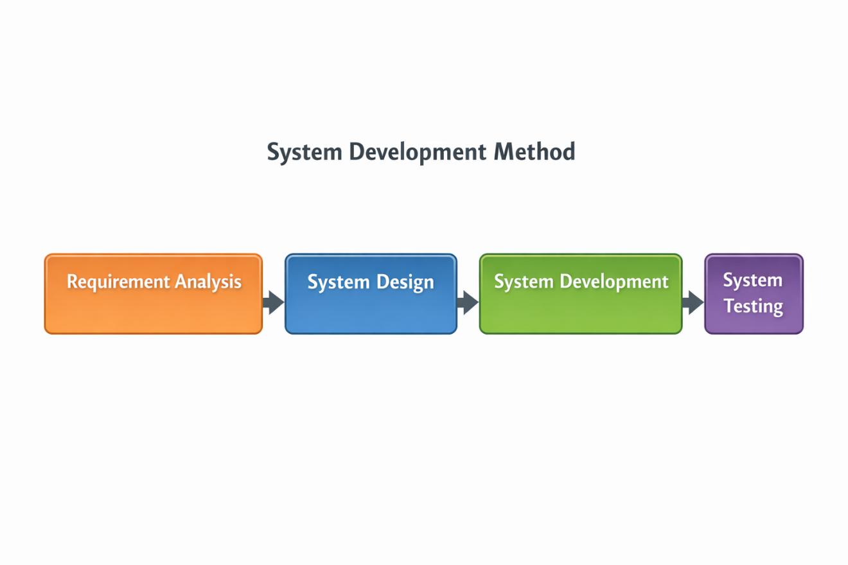
Note: Figure 1 illustrates the system development model that will be used in this study. The process is cyclical rather than strictly linear. Each increment passes through the same four activities, namely requirement analysis, system design, system development, and system testing, and the results of testing are returned to the analysis and design activities of the next increment.
This study will adopt the Iterative and Incremental Development (IID) model (Larman & Basili, 2003). Under this model the system is not delivered in a single pass. It is constructed as a series of planned increments, each of which passes through its own cycle of requirement analysis, system design, system development, and system testing, and each of which must satisfy defined exit criteria before the succeeding increment begins. Increments already delivered are revisited and refined when later increments reveal defects or opportunities for improvement.
This model was selected over a strictly sequential model for three reasons. First, the leave policy requirements of the system are fixed by the Civil Service Commission Omnibus Rules on Leave and can therefore be specified early, while the security, reporting, and user interface requirements were expected to be refined as the system took shape. Second, incremental delivery allows each functional module to be verified independently before dependent modules are built, which limits the accumulation of undetected defects. Third, the model provides a defined mechanism for incorporating corrective and refinement work, which a strictly sequential model does not.
The increments, their scope, and their exit criteria are presented in Table 3. Each increment concludes with automated testing of the functions it introduces, and the tests accumulated from earlier increments are re-executed so that previously delivered functions are confirmed to remain correct.

Table 3
Development Increments and Exit Criteria
Increment | Scope | Exit Criteria
1 and 2 | Project structure, offline vendor assets, architecture documentation, and architectural decision records | Development environment runs; architecture and design decisions are recorded
3 | Database schema, data models, and reference data covering CSC leave types, roles, permissions, holidays, and system settings | Schema migrates without error; reference data loads completely
4 and 5 | Authentication with email One-Time Password, account lockout, password reset and change, session timeout, authorized-device restriction, and Role-Based Access Control with role inheritance and per-user overrides | Authentication and access control tests pass
6 | CSC Form No. 6, fifteen CSC leave types with configurable policy rules, working-day computation, leave credit computation, and the Department Head to HR to Mayor approval workflow | Leave workflow and credit computation tests pass, including prevention of negative balances
7 and 8 | Audit and activity logging, intrusion detection, automatic blocking of offending addresses, security dashboard, and real-time intrusion alerts | Intrusion detection and logging tests pass
9 | Reports with export to PDF, Excel, and CSV, role-scoped dashboards, and the versioned application programming interface | Report and interface tests pass
10 | System-wide validation: full regression testing, controlled penetration testing, and ISO/IEC 25010 documentation | All accumulated tests pass; no high or critical security finding remains open
11 | Deployment artifacts: installation and configuration scripts, backup and restore procedures, and the installation guide | System installs and operates on the target LAN environment

Note: Table 3 presents the increments through which the system will be developed, together with the exit criteria that must be satisfied before the succeeding increment begins. Progress against these increments is recorded in the project phase plan and milestone log, and is independently traceable through the version control history of the project repository.
The four activities performed within each increment are described below.

- Requirement Analysis
This phase will focus on understanding the current manual leave monitoring system of the LGU of Alicia and identifying existing problems and system needs.
  - Examine the current manual leave process
  - Identify inefficiencies, delays, and errors in leave computation
  - Determine user requirements and system functionalities
  - Define system scope and operational needs

- System Design
This phase will involve planning the overall structure and functionality of the system based on the identified requirements.
  - Design the database structure for employee and leave records
  - Develop the user interface for employees, HR personnel, and administrators
  - Create workflow processes for leave application and approval
  - Define leave classification logic (deductible and non-deductible)
  - Establish access control and system structure
- System Development
This phase will involve the actual creation and implementation of the system based on the design specifications.
  - Develop the system using PHP, MySQL, HTML, CSS, and JavaScript
  - Implement authentication and access control mechanisms
  - Build modules for leave application, approval, and monitoring
  - Integrate leave credit computation and reporting features
  - Ensure system functionality aligns with defined requirements
- System Testing
This phase will ensure that the system performs correctly and meets the required standards.
  - Conduct functional testing to verify system features
  - Perform task-based testing to evaluate usability and performance
  - Apply controlled security validation to assess system protection
  - Identify and fix errors or system issues
  - Validate overall system performance and reliability
This incremental sequence provides a clear and systematic development process. Because each increment is verified before the next begins, defects are detected close to the point at which they are introduced, and the system that enters evaluation has already been confirmed to satisfy the exit criteria defined for every increment.

3.3 Participants/Respondents
The participants of this study will consist of employees and selected information technology experts involved in the evaluation of the proposed Cybersecurity Integrated Digital Leave Management System With Real-Time Intrusion Alerts for the Local Government Unit of Alicia.
The study population consists of approximately 135 plantilla employees of the LGU of Alicia who are eligible to file leave applications. These employees are distributed across different offices within the LGU, including the Office of the Municipal Mayor, Office of the Municipal Vice Mayor, Office of the Sangguniang Bayan, Office of the Secretary to the Sangguniang Bayan, Office of the Municipal Administrator, Office on Human Resource Management, Planning and Development Office, Office of the Civil Registry, Office on General Services, Budget Office, Accounting Office, Treasury Office, Assessor’s Office, Office on Health Services, Office on Social Welfare and Development Services, Office for Agricultural Services, and Engineering Office.
To ensure proper representation of employees from different offices, the study will use stratified random sampling. The population will be divided into strata based on office assignment, and respondents will be selected proportionally from each office. This approach ensures that employees involved in different administrative and leave management functions are adequately represented in the study.
A total of 35 respondents will participate in the study. 30 respondents will be selected from the LGU employees. These respondents will include regular employees, administrative staff, and personnel involved in filing, processing, approving, and monitoring leave applications. Since the LGU processes approximately 5 to 25 leave applications per month, these respondents are considered appropriate sources of information regarding the efficiency, usability, and functionality of the proposed system.
The 30 LGU respondents will be proportionally distributed across the different offices as follows: 5 respondents from the Office of the Municipal Mayor, 1 from the Office of the Municipal Vice Mayor, 3 from the Office of the Sangguniang Bayan, 1 from the Office of the Secretary to the Sangguniang Bayan, 4 from the Office of the Municipal Administrator, 1 from the Office on Human Resource Management, 1 from the Planning and Development Office, 1 from the Office of the Civil Registry, 1 from the Office on General Services, 1 from the Budget Office, 2 from the Accounting Office, 2 from the Treasury Office, 1 from the Assessor’s Office, 2 from the Office on Health Services, 2 from the Office on Social Welfare and Development Services, 1 from the Office for Agricultural Services, and 2 from the Engineering Office.
In addition, 5 external IT experts will be selected using purposive sampling. These experts will be chosen based on their professional knowledge and experience in system development, cybersecurity, database management, and software evaluation. Their participation is necessary to provide technical evaluation of the implemented security controls, validate the effectiveness of authentication and access restriction mechanisms, assess the reliability of network protection measures within the LAN environment, and interpret the results of controlled vulnerability testing.
The number of employee respondents was determined using Slovin’s formula at a five percent margin of error, applied to the population of 135 plantilla employees, and the resulting figure was rounded upward. The population size of each office will be obtained from the plantilla records of the Office on Human Resource Management and reported in Chapter IV, so that the proportional allocation across strata can be verified.
The allocation will be adjusted to ensure that the offices that exercise the widest range of system functions are adequately represented. Personnel of the Office on Human Resource Management and designated approving officers will be sampled at a higher rate than the general employee population, because they are the only respondents who perform leave certification, credit computation, and approval, and are therefore the only respondents able to evaluate those functions.
The five information technology experts will be selected on the basis of documented qualifications, namely at least three years of professional experience in system development, information security, or database administration, or a recognized certification in a related field. Because the number of experts is small, their ratings will be reported individually as well as in aggregate, and the range of their ratings will be presented alongside the mean so that the degree of agreement among them is visible.
3.4 Data Gathering Instruments
1. ISO/IEC 25010-based evaluation questionnaire
An ISO/IEC 25010-based evaluation questionnaire will serve as the primary instrument for assessing perceived product quality. This standard was selected because it provides a structured and widely accepted framework for evaluating software systems. The questionnaire will be subjected to expert validation by selected Information Technology faculty members and research experts to establish the clarity, relevance, and alignment of its items with the objectives of the study, and a content validity index will be computed from their ratings. A pilot test will be conducted with respondents who are not part of the final sample, and the internal consistency of the instrument will be reported using Cronbach’s alpha, with a coefficient of 0.70 or higher taken as acceptable.
A four-point Likert scale will be used to measure respondents’ level of agreement, defined as:
1 – Strongly Disagree
2 – Disagree
3 – Agree
4 – Strongly Agree
The four-point scale is used to require respondents to take a definite position rather than select a midpoint. The study acknowledges that a forced-choice scale removes the option of a genuinely neutral judgment, and this is recognized as a limitation of the instrument rather than as evidence of its superiority.
The questionnaire will be administered in three role-differentiated versions, so that each quality characteristic is rated only by respondents who actually exercise the functions concerned. Employees will rate the functions they use, namely leave filing, balance viewing, and status tracking. Personnel of the Office on Human Resource Management and approving officers will rate the approval workflow, leave certification, credit computation, and reporting functions. Information technology experts will rate security, maintainability, and portability. Results will be reported by characteristic together with the respondent group that supplied them.

- Task-Based Testing
Task-based testing will be conducted to evaluate system usability and performance. Participants will perform key tasks such as submitting leave requests, approving applications, and viewing records.
Metrics:
- Task completion rate
- Time on task
- Error rate
Success Criteria:
- ≥ 80% completion rate
- Time on task ≤ 120% of expert time
- ≤ 2 errors
- ≤ 10% performance gap

3.4.1 Baseline Measurement Protocol of the Manual Process
The baseline of the existing manual process will be measured before the proposed system is placed in use, because the measurement cannot be recovered afterwards. Two quantities will be recorded. The first is end-to-end processing time, obtained by tracking a minimum of twenty leave applications from the date and time of filing to the date and time of the final approval decision, using the dates recorded on the physical forms and the routing slips. The second is form completion time, obtained by timing a minimum of twenty employees as they complete a leave application form under ordinary office conditions. Measurements will be taken by the researchers using a common recording sheet that specifies the start and end points defined in Table 2, and the number of observations, the period covered, and the offices involved will be reported with the results.

3.4.2 Retrospective Record Audit
The accuracy of the existing manual process will be established through a retrospective audit of approved leave records. A sample of previously processed applications will be drawn from the records of the Office on Human Resource Management, and the leave credits recorded for each will be recomputed independently against the Civil Service Commission Omnibus Rules on Leave. Any deviation between the recorded balance and the recomputed balance will be counted as an error, and the leave-credit error rate of the manual process will be computed as defined in Table 2. Records will be handled in anonymized form, individual employees will not be identified in any output of the study, and the findings will be reported in aggregate as validation of the computation logic rather than as an assessment of the work of any office or person.

3.4.3 Gold-Standard Case Set
The accuracy of the proposed system will be established using a gold-standard case set. Between forty and sixty leave scenarios will be constructed to span all fifteen CSC leave types together with the conditions under which computation is most likely to fail, namely applications crossing a calendar year, applications spanning holidays and weekends, half-day applications, applications exceeding the available balance, monetization, and terminal leave. For each scenario the expected result will be determined by the Human Resource Management Officer, independently of the system, on the basis of the Civil Service Commission Omnibus Rules on Leave. The same scenarios will then be entered into the system, and the computed results compared with the expected results. The exact-match rate will be reported, and every mismatch will be examined and its cause described.

3.4.4 System-Generated Records
The system maintains audit and activity records that store, for every leave transaction, the identity of the acting user, the action performed, the record affected, and the time at which the action occurred. These records will serve as an unobtrusive measurement instrument for processing time under the proposed system. Because they are generated in the course of ordinary use, they permit processing time to be computed for every transaction in the observation period rather than only for observed sessions, and they allow the total processing time to be decomposed into the time spent at each stage of the approval workflow. Data extracted from these records will be anonymized before analysis.
The allowable time on task will be computed by first calculating the mean expert completion time, then multiplying it by 1.2 (120%) to establish the allowable threshold. The mean completion time of regular users will then be compared to this value. This approach will account for differences in user experience and learning curve, ensuring realistic performance expectations.
3.5 Evaluation Procedure
The evaluation of the system will be conducted using both the ISO/IEC 25010-based questionnaire and task-based testing to ensure a comprehensive assessment of system quality.
The ISO/IEC 25010 model will be used as the primary basis for evaluating system performance. Respondents will assess the system using a four-point Likert scale, allowing the researchers to quantify user perception and satisfaction.
The evaluation procedure will follow these steps:
- System Orientation
Participants will be introduced to the system and its functionalities.
- Task Execution
Participants will perform assigned tasks such as leave application, approval, and record viewing.
- Experimental Comparison Participants will perform selected tasks using both the manual process and the proposed system. The order will be counterbalanced: half of the participants will perform the manual task first and half will perform the system task first, with assignment to order determined at random. Counterbalancing is applied because a participant who performs the same task twice in a fixed order benefits from familiarity on the second attempt, which would otherwise be indistinguishable from an improvement produced by the system. Processing time, accuracy, and efficiency will be recorded and compared, and the order of presentation will be recorded with each observation.
- Questionnaire Completion
Participants will evaluate the system using the ISO/IEC 25010-based questionnaire.
- Supplementary Security Validation
Controlled security validation will be conducted to assess the effectiveness of authentication, access control, input validation, and login monitoring mechanisms against common threats such as unauthorized access attempts and malicious input attacks within the LAN environment.
- Data Recording and Consolidation
All collected data will be organized for analysis.

3.6 Data Analysis Techniques
The analysis of results will determine whether the system meets its objectives and addresses the identified problems. The collected data will be analyzed using the following methods:
1. Descriptive Analysis
Descriptive statistics such as mean, frequency, and percentage will be used to summarize the data collected from the ISO/IEC 25010-based questionnaire and task-based testing.
The mean will serve as the primary measure to determine the overall evaluation score of the system in terms of functionality, usability, performance, and security.
The computed mean for each criterion will be interpreted using the following scale:
3.25 – 4.00 → Strongly Agree (Very High)
2.50 – 3.24 → Agree (High)
1.75 – 2.49 → Disagree (Low)
1.00 – 1.74 → Strongly Disagree (Very Low)
A higher mean score will indicate better system performance and higher user satisfaction.
Frequency will be used to determine how many respondents selected each response category, while percentage will be used to express these results in proportion. These will support the interpretation of the mean by showing the distribution of responses and identifying patterns in user evaluation.
For task-based testing, interpretation will be based on the following criteria:
- Task Completion Rate
The percentage of users who successfully complete a task will be calculated. A result of 80% or higher will indicate that the system is usable and that tasks can be completed successfully by most users.
- Time on Task
The mean expert completion time will be computed and multiplied by 1.2 (120%) to determine the allowable threshold. The mean completion time of regular users will then be compared to this value. If the user time does not exceed the threshold, the system will be considered efficient.
- Error Rate
The number of errors encountered per task will be recorded. A maximum of 2 errors per task will be considered acceptable, indicating that the system is easy to use and minimizes user mistakes.

For processing time under the proposed system, the primary source of data will be the system-generated audit records described in Section 3.4.4 rather than observed sessions. The elapsed time between the submission of an application and the recording of the final approval decision will be computed for every application processed during the observation period, and the median will be reported alongside the mean because processing times are expected to be skewed by applications that wait over non-working days. Dwell time at each stage of the approval workflow will also be reported, so that the source of any reduction is identified rather than assumed.
2. Comparative Analysis
Comparative analysis will be conducted to evaluate differences between the existing manual leave monitoring process and the proposed system.
Based on the current process in the LGU of Alicia, manual leave processing will take an average of one (1) day due to multiple steps such as form submission, routing, and approval. In addition, filling out a leave application form manually will take approximately 10 minutes per employee, depending on the completeness of required information.
These baseline values will be used as a reference in comparing the performance of the proposed system.
The interpretation will be based on the following indicators:
- Processing Time The percentage reduction will be computed as the difference between the mean baseline processing time and the mean processing time under the proposed system, divided by the mean baseline processing time, multiplied by 100. The number of observations contributing to each mean will be reported. The term significant is not used in this study in its statistical sense, since no inferential test is performed; reductions are reported as measured differences with their observation counts.
- Accuracy The leave-credit error rate of the manual process, obtained from the retrospective record audit described in Section 3.4.2, will be compared with the leave-credit error rate of the proposed system, obtained from the gold-standard case set described in Section 3.4.3. A lower error rate under the proposed system indicates improved accuracy. Both rates will be reported with the number of records or cases examined.
- Efficiency
A reduction in the time required to complete leave application tasks, particularly from the manual average of 10 minutes per form, will indicate improved operational efficiency.
In addition, comparative analysis will be used to compare the performance of expert users and regular users. A performance gap of not more than 10% in terms of task completion, time on task, and error rate will indicate that the system is intuitive and has a low learning curve.
3. Security Evaluation Analysis
Security evaluation will be conducted through controlled penetration testing of the deployed system within an isolated Local Area Network segment containing no live employee data. Because the security controls of the system are integral to its design rather than additions made after development, no unsecured version of the system exists and a pre-implementation vulnerability count is not obtainable. The evaluation therefore measures how completely the implemented controls contain a defined set of attack scenarios, and what risk remains after they do. Three measures will be reported.
First, the control effectiveness rate. For each attack scenario a fixed number of attempts will be executed against the running system, and the control effectiveness rate will be computed as the proportion of attempts contained out of the attempts made. An attempt is counted as contained only when all three of the following hold: the action does not succeed, the event is recorded in the audit or intrusion log, and any automated response defined for that scenario is triggered. A scenario is regarded as passing at a control effectiveness rate of 100 percent, because a partial defense against a deterministic attack is a defect rather than a degree of success.
Second, the residual findings register. Every observation that is not fully contained, together with any weakness surfaced by automated scanning, will be recorded with its severity classification, the component affected, and its disposition as remediated, mitigated, or accepted with justification. The system is regarded as meeting its security objective when no finding of critical or high severity remains open at the close of testing. Findings of medium and low severity that remain open will be reported together with the reason for their acceptance rather than omitted.
Third, detection and alerting performance. For each scenario that should raise an alert, the elapsed time between detection and notification will be recorded, together with confirmation that the corresponding entry appears in the audit trail. Alert precision will also be reported, computed across the full test period including ordinary administrative activity as well as simulated attacks, so that the sensitivity of the alerting mechanism is not overstated by counting false positives as detections.
These three measures together answer the third and fifth research questions. The first establishes whether the controls hold, the second establishes what risk survives them, and the third establishes whether the monitoring mechanism makes an intrusion visible to an administrator within a usable interval.
To provide measurable and objective evaluation of the implemented security mechanisms, the following security evaluation metrics will be used:
Table 4
Security Evaluation Metrics
Test Scenario | Tool Used | Attack Scenario Definition | Security Control | Expected Result | Evidence to Collect | Pass/Fail Criteria
Detected Vulnerabilities | Penetration Testing Tools (e.g., OWASP ZAP, SQLMap) | Automated scan of all application endpoints using OWASP ZAP under both an unauthenticated session and an authenticated employee-role session | Input validation, RBAC, authentication, secure configuration | No finding of high or critical severity; any finding recorded in the residual findings register | Vulnerability scan reports, penetration testing results | Pass: no finding of high or critical severity remains open at the close of testing.  Fail: a finding of high or critical severity remains exploitable after testing.
Unauthorized Access Attempt | Manual penetration testing / login testing | Direct URL access to five role-restricted endpoints by an authenticated employee-role account and by an unauthenticated session | OTP authentication, RBAC, LAN isolation | Unauthorized access attempts denied | Access logs, failed login records, screenshots | Pass: Unauthorized users cannot access the system or restricted pages. Fail: Unauthorized users successfully access protected areas of the system.
Blocked Unauthorized Login Attempts | Login monitoring tools / system logs | Twenty consecutive failed authentications against one account from a single source address within a sixty-second window | Login attempt blocking, IP monitoring | Unauthorized login attempts automatically blocked after threshold limit | Audit logs, blocked IP records, login attempt reports | Pass: Repeated failed login attempts are automatically blocked after the defined limit.  Fail: Excessive failed login attempts are not blocked or continue without restriction.
Intrusion Alerts Generated | Intrusion monitoring system | Each scenario in this table executed once, with alert latency and the presence of the corresponding audit record measured | Real-time intrusion alerts, audit logging | Suspicious activities generate intrusion alerts | Alert notifications, audit trail records | Pass: Suspicious or unauthorized activities generate real-time intrusion alerts.  Fail: Intrusion attempts occur without generating alerts or notifications.
SQL Injection Attempt | SQLMap / manual SQL injection testing | Ten injection attempts across login and leave-form input fields using tautology, UNION, and time-delay payloads | Input validation, parameterized queries | SQL injection attempts fail | SQLMap results, database logs, screenshots | Pass: SQL injection attempts are blocked and no unauthorized database access occurs. Fail: SQL injection successfully bypasses validation or accesses database information.
Brute Force Login Attempt | Hydra / manual brute-force testing | Twenty consecutive login attempts using a wordlist against a valid account name from a single source address | Login blocking, IP monitoring, OTP authentication | Brute-force login attempts blocked | Login logs, blocked IP records, screenshots | Pass: Repeated login attempts are blocked after the allowed threshold. Fail: Brute-force attempts continue successfully without restriction.

Note: Table 4 presents the security evaluation metrics used to measure the effectiveness of the implemented cybersecurity and network security controls. For each test scenario the table states the attack scenario definition, the security control exercised, the expected result, the evidence to be collected, and the pass or fail criteria. The metrics do not compare the system against an earlier insecure state, because none exists; they measure the extent to which the implemented controls contain the defined attacks, and any finding that is not fully contained is carried into the residual findings register described in Section 3.6.
3.7 Ethical Considerations
This study will adhere to ethical standards in the conduct of research involving human participants. The following considerations will be observed to ensure the protection of respondents and the integrity of the study:
- Informed Consent
All participants will be informed about the purpose of the study, the procedures involved, and their role in the evaluation. Participation will be voluntary, and respondents will have the right to withdraw at any time without any consequences.
- Confidentiality
The identities of all participants will be kept confidential. Personal information and responses will not be disclosed to unauthorized individuals and will be used solely for research purposes.
- Data Privacy Compliance
The study will comply with the provisions of the Republic Act No. 10173, also known as the Data Privacy Act of 2012, ensuring that all collected data will be securely stored, properly handled, and protected from unauthorized access.
- Use of Data for Academic Purposes Only
All collected data will be used strictly for academic purposes and will not be used for commercial or non-related activities.
- Controlled Testing Environment
All security validation activities will be conducted strictly within a controlled Local Area Network (LAN) environment using a separate testing setup that does not contain actual sensitive employee information. The testing procedures will not affect real government systems, operational services, or production databases.
Authorization for Security Testing Before any security testing tool is executed, the researchers will secure written authorization from the Local Government Unit of Alicia. The authorization will identify the systems within scope, the period during which testing may be conducted, the tools to be used, and the officer granting the authorization. No scanning, injection testing, or authentication testing will be performed before this authorization has been obtained. This requirement is observed because unauthorized access to a computer system is an offense under Republic Act No. 10175, the Cybercrime Prevention Act of 2012, and written authorization establishes that the testing conducted in this study is lawful and sanctioned.
Ethics Review The study will be submitted for review under the research ethics process of Isabela State University before data collection begins, and the approval reference will be cited in the final manuscript.
Coordination on Personal Data The retrospective record audit described in Section 3.4.2 involves records that contain personal information. The researchers will coordinate with the officer designated by the Local Government Unit for data protection, records will be anonymized before analysis, no individual employee will be identified in any output of the study, and findings will be reported only in aggregate.
Data Retention and Disposal All research data will be stored in encrypted form on devices controlled by the researchers, will be accessible only to the researchers and the research adviser, and will be permanently deleted within one year after the final defense. Physical records used during the baseline measurement and the retrospective audit will be returned to the Office on Human Resource Management immediately after the data required by the study have been recorded.

CHAPTER IV

TECHNICAL BACKGROUND

4.1 Introduction

This chapter presents the technical background of the proposed Cybersecurity Integrated Digital Leave Management System With Real-Time Intrusion Alerts For Local Government Unit Of Alicia. It discusses the system architecture, application structure, core components, and security framework. The chapter also outlines the tools, technologies, and testing environment that will be used to ensure the system’s functionality, security, and reliability.
The purpose of this chapter is to provide a clear explanation of how the proposed system will be designed, developed, and implemented to address the limitations of the existing manual leave monitoring process. These limitations include delays in processing, manual computation of leave credits, difficulty in record management, and potential risks in handling sensitive employee data.
In alignment with the research design presented in Chapter III, this chapter will describe how the system components will be structured and integrated during the development process. It will also explain how technical solutions are applied to improve efficiency, accuracy, and data security within the organization.
Furthermore, this chapter will highlight the integration of security mechanisms within the system, including authentication, access control, data validation, and monitoring features. It will also describe the testing environment and validation methods that will be used to assess system performance and security.
Finally, this chapter will include system diagrams that will visually represent the architecture and structure of the proposed system. These diagrams will support the technical discussion and will provide a clearer understanding of how the system will operate within a controlled environment.
4.1.1 System Overview
The proposed Cybersecurity Integrated Digital Leave Management System With Real-Time Intrusion Alerts For Local Government Unit Of Alicia will follow a centralized LAN-based client-server architecture designed to support secure and efficient leave management operations within the Local Government Unit (LGU) of Alicia. All client devices will communicate with a centralized application and database server through the internal Local Area Network (LAN), allowing the organization to maintain controlled access and centralized monitoring of system activities.
The LAN-based deployment will minimize exposure to external cyber threats by restricting system accessibility to authorized devices connected within the internal government network. Security mechanisms such as authentication, Role-Based Access Control (RBAC), audit logging, IP monitoring, and intrusion alerting will work together as a layered security framework that protects employee records, validates user access, and monitors suspicious activities within the network environment.
Through centralized processing, automated leave computation, and integrated security controls, the system will improve administrative efficiency while maintaining confidentiality, integrity, and accountability of organizational data.
The system will automate the process of leave application, approval, and leave credit computation within the LGU of Alicia. It will operate entirely within the LAN environment to ensure controlled access, secure data management, and efficient processing of leave transactions.
At a high level, the system will support six user roles within the LGU organizational structure. Regular employees will submit leave applications through a web-based interface and monitor the status of their requests. Department heads will review and endorse or return the applications filed by personnel of their office. Personnel of the Office on Human Resource Management will certify leave credits, verify the classification of the leave applied for, and manage employee and leave records. The Municipal Mayor, or the officer authorized to act in that capacity, will render the final decision on each application. The system administrator will manage user accounts and system settings, and the Super Admin will oversee security monitoring, audit records, and system configuration. Approval therefore proceeds in three stages, from the department head to the Office on Human Resource Management and then to the Municipal Mayor, and the leave balance of the employee is deducted automatically only when the final decision is recorded.
The system will automatically process submitted leave applications by validating inputs, classifying the leave applied for, and computing leave credits according to predefined rules. The classification and computation rules implement fifteen leave types recognized under the Civil Service Commission Omnibus Rules on Leave, together with the corresponding entries of CSC Form No. 6 (Revised 2020). For each leave type the system stores its day limit, whether it is deductible or non-deductible, the credit source from which deductible leave is drawn, and the documentary requirements that apply. These rules are held as system configuration rather than as program code, so that a subsequent Civil Service Commission issuance can be accommodated by reconfiguring the system rather than by modifying and redeploying it. Once a leave request has been approved at the final stage, the system will update the leave balance of the employee and store the transaction in a centralized database accessible within the LAN environment.
Due to the implementation of automated computation and validation mechanisms, manual computation of leave credits will no longer be required. As a result, responsibilities related to leave computation will be streamlined and integrated into the HR personnel role, reducing redundancy and improving operational efficiency within the organization.
The system will consist of key components including the user interface, application logic, database, and integrated security mechanisms. Security features such as authentication with One-Time Password (OTP), Role-Based Access Control (RBAC), input validation, and audit logging will ensure that only authorized users can access and manage system data.
Overall, the system will provide a centralized, efficient, and secure platform that aligns with the operational workflow of the LGU of Alicia while improving leave management processes, maintaining data accuracy, and strengthening controlled access to organizational information.

4.2 Network Architecture

4.2.1 Overview of Network Architecture

The proposed Cybersecurity Integrated Digital Leave Management System With Real-Time Intrusion Alerts For Local Government Unit Of Alicia will utilize a client-server network architecture deployed within the internal network of the Local Government Unit (LGU) of Alicia. This architecture is selected to ensure centralized data management, controlled system access, and efficient communication between users and the system.
At the core of the network is a centralized server, which will host the web application and database. The server will be responsible for processing user requests, executing system logic, performing automatic leave credit computation, and storing all employee and transaction records. By centralizing these functions, the system ensures data consistency, integrity, and easier maintenance.
Connected to the server are multiple client devices, such as desktop computers and mobile phones used by employees, HR personnel, approving officers, and IT staff. These client devices will access the system through web browsers within the Local Area Network (LAN). Since all access is internal, the communication between clients and the server will be faster and more reliable compared to internet-based systems.
The connection between the server and client devices will be facilitated through a network switch or router, which will manage data transmission within the network. This network infrastructure ensures that all devices can communicate efficiently while maintaining organized data flow within the system.
The system workflow within the network begins when a client device sends a request to the server, such as submitting a leave application. The server processes the request, validates the input, performs automatic computation, and updates the database. The result is then sent back to the client device, allowing users to view updated information in real time. This continuous interaction between client and server ensures seamless system operation.
To strengthen security within the network, several mechanisms will be integrated. Authentication with One-Time Password (OTP) will be used to verify user identity during login. Role-Based Access Control (RBAC) will ensure that users can only access features appropriate to their roles. Additionally, IP monitoring and login attempt tracking will detect suspicious activities, and threshold-based blocking will prevent repeated unauthorized login attempts.
Since the system will operate entirely within a LAN environment, it will not depend on external internet connectivity. This design reduces exposure to external cyber threats and enhances data privacy. All data exchanges will occur within the internal network, ensuring that sensitive employee information remains protected.
Overall, the network architecture will provide a secure, efficient, and centralized environment that supports system functionality while maintaining strict access control, fast data processing, and reliable communication within the LGU.
4.2.2 Network Components
• Client Devices
These include desktop computers and mobile phones used by employees, HR personnel, approving officers, and IT staff to access the system through a web browser within the LAN. Users will perform tasks such as submitting leave applications, approving requests, and monitoring records.
• Network Infrastructure
The system will use a Local Area Network (LAN) with a network switch or router to enable communication between client devices and the centralized server. This will ensure fast and reliable data transmission within the organization.
• Centralized Server
The server will host the web application and database. It will handle system processing, user authentication, automatic leave computation, and data storage, ensuring centralized control and management of records.
• Database System
These databases will store employee information, leave records, transaction logs, and system activities. It will support efficient data retrieval, reporting, and record management.
• Security Components
These include authentication (username, password, OTP), Role-Based Access Control (RBAC), input validation, audit logging, and monitoring features such as IP tracking and login attempt blocking to protect the system from unauthorized access.

4.2.3 Network Architecture Diagram
Figure 2
Network Architecture of the Proposed Cybersecurity Integrated Digital Leave Management System With Real-Time Intrusion Alerts For Local Government Unit Of Alicia
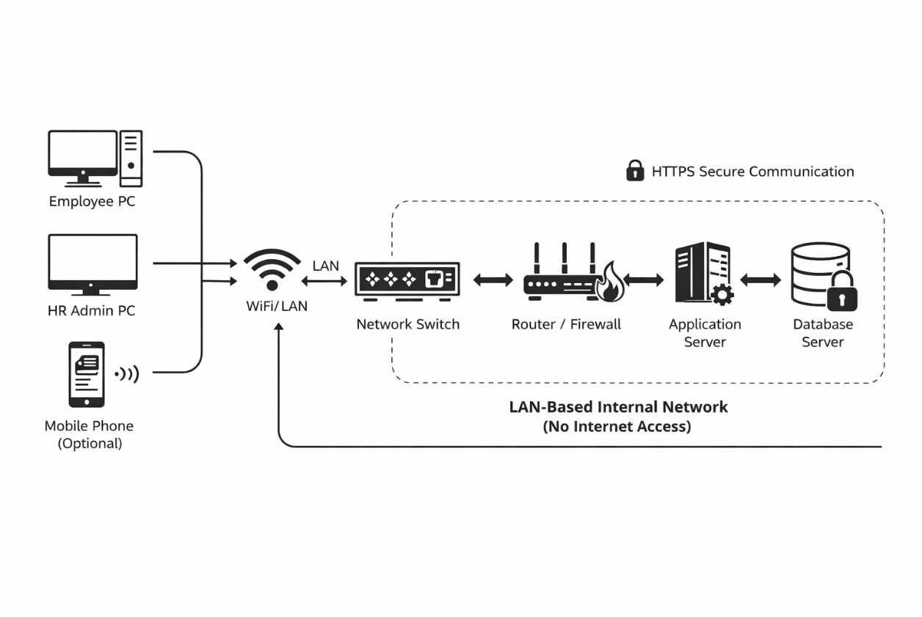 Note: Figure 2 illustrates the LAN-based client-server architecture of the proposed Cybersecurity Integrated Digital Leave Management System With Real-Time Intrusion Alerts For Local Government Unit Of Alicia, where employee PCs, HR workstations, and mobile devices connect through a Local Area Network to a centralized system server. User requests pass through the network switch and router/firewall, which regulate communication and enforce security controls before reaching the application server that processes leave transactions and automated computations, while the database server manages all records and logs. The architecture is intentionally confined within a LAN to ensure controlled access and minimize exposure to external threats, with HTTPS securing data transmission and the firewall filtering network traffic. This centralized and secured design enhances data protection, ensures consistent system control, and improves operational efficiency through faster communication, real-time processing, and reduced manual workload. The LAN-based architecture also reduces dependency on internet connectivity and limits the system’s exposure to external attack surfaces, making it more appropriate for internal government operations that require controlled access and localized data protection.
4.3 Application System Architecture
4.3.1 Application Overview
The application system will be a LAN-based web platform developed to manage and monitor employee leave transactions within the Local Government Unit (LGU) of Alicia. It serves as the interface between users and a centralized backend system, enabling real-time processing of requests within a secure and controlled internal network. The LAN-based deployment ensures stable connectivity, faster data transmission, and restricted access to authorized users, making it suitable for office-based operations.
The system will support core functions such as user authentication, leave request submission, approval workflow, leave monitoring, automatic leave credit computation, and report generation. Employees can submit leave applications and monitor their status, approving officers are responsible for evaluating and deciding on requests, HR personnel oversee records and system outputs, and the Super Admin manages access, logs, and security controls. The application will enforce Role-Based Access Control (RBAC) to ensure that each user can only access features relevant to their role. Through centralized processing and automated computation of leave credits, the system reduces manual workload, minimizes errors, and ensures data consistency. Overall, the design improves operational efficiency, accuracy, and transparency in leave management within the organization.
4.3.2 Application Components
The application consists of the following components:
• User Interface (UI) – Will provide the visual interface of the system, including dashboards, forms, and reports that allow users to submit leave requests, view balances, monitor status, and interact with system features based on their assigned access privileges. The interface communicates through HTTPS traffic protection to ensure that data transmitted over the network remains confidential and protected from interception, supporting the Confidentiality aspect of the CIA Triad.
• Leave Management and Workflow Module – Will handle the submission, routing, approval, and processing of leave requests, ensuring that all transactions follow the defined workflow and organizational policies. This module supports Integrity in the CIA Triad by ensuring that leave records are processed accurately and cannot be modified without authorization.
• Leave Computation Module – Will automatically calculate leave credits and update employee balances based on predefined rules, ensuring accuracy and eliminating manual computation errors. This contributes to Integrity and Availability within the CIA Triad by maintaining reliable and accessible leave information.
• Monitoring and Reporting Module – Will enable HR personnel to track leave records, monitor application status, and generate reports and dashboards for administrative use. This module also supports intrusion detection and IP monitoring by identifying suspicious login attempts, unusual activities, and abnormal system behavior within the network environment.
• Authentication and Access Control Module – Will secure system access using username, password, and One-Time Password (OTP). Passwords are stored using bcrypt hashing to ensure that user credentials are protected even in the event of database compromise. The module implements secure authentication and access control mechanisms to restrict unauthorized access based on user roles and permissions. Additionally, brute force blocking and IP-based login monitoring are implemented to detect and prevent repeated unauthorized login attempts.
• Audit and Activity Logging Module – Will record system activities, user actions, login attempts, and transaction logs to support monitoring, accountability, and security validation. This serves as an audit trail that helps administrators trace system events, investigate incidents, and detect possible malicious activities or policy violations.
• Database Component – Will store and manage all system data, including employee information, leave records, transaction history, and system logs, ensuring data consistency, integrity, and efficient retrieval. Database protection mechanisms help maintain the Confidentiality, Integrity, and Availability (CIA Triad) of organizational data.
• Network Security and Threat Detection Component – Will monitor network-based activities within the Local Area Network (LAN) to identify suspicious behavior, unauthorized access attempts, and possible cyber threats. This component supports LAN-based threat detection, intrusion detection, IP monitoring, and secure communication protocols to strengthen the overall cybersecurity posture of the leave management system.

4.3.3 Integrated Network Security Framework
The proposed system will apply a layered security framework that combines authentication, authorization, encryption, audit logging, and network monitoring mechanisms to protect organizational data and maintain controlled access within the Local Area Network (LAN) environment. Instead of relying on a single protection mechanism, the system will integrate multiple complementary security controls that work together to strengthen confidentiality, integrity, accountability, and threat monitoring.
Authentication mechanisms will verify user identities through username, password, and One-Time Password (OTP) validation, while Role-Based Access Control (RBAC) will restrict system functions according to assigned user responsibilities. HTTPS secure communication and bcrypt password hashing will protect sensitive credentials and transmitted information from unauthorized access and interception.
In addition, input validation and parameterized queries will help prevent unauthorized data modification and common injection attacks, while audit logging, IP monitoring, and intrusion alerts will provide monitoring, traceability, and accountability for suspicious activities occurring within the network environment.
Through this integrated framework, the system will maintain a balance between usability, administrative efficiency, and practical cybersecurity implementation suitable for a LAN-based government environment.

4.3.4 Security Control Mapping
Table 5
Security Control Mechanisms
Security Objective | Implemented Mechanism
Confidentiality | HTTPS, OTP Authentication, bcrypt hashing
Integrity | Input validation, audit logs, automated computation
Availability | LAN-based deployment, centralized server
Authentication | Username/password login with OTP
Authorization | Role-Based Access Control (RBAC)
Accountability | Audit trail and activity logs
Threat Detection | IP monitoring and intrusion alerts

Note: Table 5 presents the mapping of implemented cybersecurity controls based on the identified security objectives of the proposed system. The implemented mechanisms are integrated within the application architecture to support the Confidentiality, Integrity, and Availability (CIA) Triad while ensuring controlled access, accountability, and threat detection within the Local Area Network (LAN) environment of the Local Government Unit (LGU) of Alicia.
The implemented security controls are designed to protect sensitive employee information, prevent unauthorized access, ensure the accuracy of leave records, and support reliable system operation. Authentication and authorization mechanisms such as One-Time Password (OTP) verification and Role-Based Access Control (RBAC) ensure that only authorized users can access system resources based on assigned roles and permissions. Meanwhile, audit logging, activity monitoring, and real-time intrusion alerts strengthen system accountability and support the detection of suspicious activities and unauthorized access attempts.
Furthermore, the integration of HTTPS secure communication, bcrypt password hashing, input validation, and threshold-based login protection enhances the overall cybersecurity posture of the proposed system by minimizing common vulnerabilities such as credential compromise, brute-force attacks, unauthorized data modification, and insecure data transmission. These mechanisms collectively support the development of a secure, centralized, and reliable leave management platform suitable for government operations within a controlled LAN-based environment.

4.3.5 Application Architecture Diagram
Figure 3
Application Architecture of the Proposed Cybersecurity Integrated Digital Leave Management System With Real-Time Intrusion Alerts for the Local Government Unit of Alicia

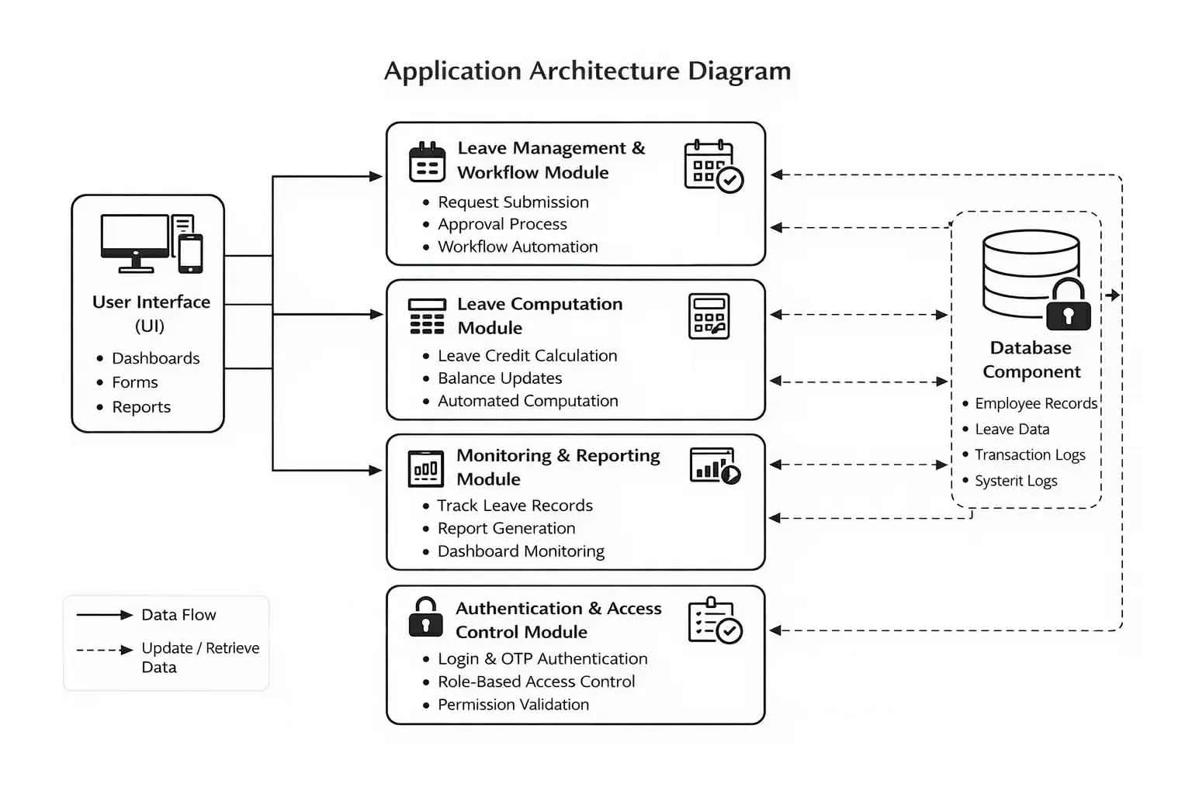 Note: Figure 3 presents the application architecture of the Cybersecurity Integrated Digital Leave Management System With Real-Time Intrusion Alerts For Local Government Unit Of Alicia, showing the interaction of its core modules within a centralized structure. The User Interface (UI) serves as the entry point, allowing users to submit requests and access system features, while inputs are processed through the Leave Management and Workflow Module, which handles routing and approval of leave transactions. The Leave Computation Module will automatically calculate leave credits and update balances. Ensuring accuracy, while the Monitoring and Reporting Module supports tracking and report generation for administrative use. System security is enforced through the Authentication and Access Control Module, which verifies users using credentials and One-Time Password (OTP) and applies Role-Based Access Control (RBAC), while the Audit and Activity Logging Module records system activities for accountability and monitoring. All modules interact with the centralized Database Component, which stores user data, leave records, and system logs, ensuring efficient processing, data integrity, and secure management of information.

4.4 Security Tools and Technologies

4.4.1 Network Monitoring and Analysis Tools
Wireshark will be used to capture and analyze network packets within the system to verify that all data transmissions are properly secured using HTTPS encryption. By inspecting live traffic, it allows the researchers to confirm that sensitive information such as login credentials and leave records are not transmitted in plain text. This approach is appropriate because it will provide direct, real-time visibility into actual network behavior, making it more reliable than relying solely on system configuration or code review. Compared to other tools, Wireshark is well-suited for academic environments due to its accessibility, detailed packet inspection capabilities, and effectiveness in validating encryption implementation without altering the system, thereby serving as a practical method for supplementary security validation.

4.4.2 Intrusion Detection and Prevention Mechanisms
The system will implement basic intrusion detection and prevention mechanisms at the application level to monitor and protect against unauthorized access attempts. These mechanisms are integrated with the Super Admin dashboard, which serves as the central monitoring interface of the system.
• Intrusion Detection – The system will monitor user activities such as login attempts and access patterns through system logs and audit trails. Suspicious activities, including repeated failed login attempts, will be identified and recorded. These events will be displayed in the Super Admin dashboard, allowing real-time monitoring of system behavior.
• Intrusion Prevention – The system will enforce preventive measures such as IP tracking and threshold-based login attempt blocking. When abnormal behavior is detected, the system will automatically restrict access from the identified source. Information such as blocked IP addresses and login attempt logs will be reflected in the Super Admin dashboard for administrative review.
These mechanisms enhance system security by combining automated protection with administrative monitoring, ensuring that potential threats are both prevented and visible to authorized personnel within the system.

4.4.3 Real-Time Intrusion Alert Workflow
The proposed Cybersecurity Integrated Digital Leave Management System With Real-Time Intrusion Alerts For Local Government Unit Of Alicia will implement a real-time intrusion alert workflow to monitor, detect, record, and respond to suspicious login activities within the Local Area Network (LAN) environment. This workflow is integrated into the system’s authentication and monitoring mechanisms to support controlled access, strengthen system security, and protect sensitive employee information from unauthorized access attempts.
The workflow begins when a user attempts to access the system by submitting login credentials consisting of a username, password, and One-Time Password (OTP). The Authentication and Access Control Module will validate the submitted credentials against the records stored in the centralized database while enforcing Role-Based Access Control (RBAC) policies to ensure that users can only access functions appropriate to their assigned roles.If invalid credentials are detected, the system will automatically record the failed login attempt together with relevant information such as the username used, associated IP address, device information, timestamp, and login status. These events will be stored in the audit and activity logs to support accountability, monitoring, and security validation within the organization.
To strengthen protection against unauthorized access and brute-force login attempts, the system will continuously monitor repeated failed authentication attempts originating from the same user account or IP address. Once the predefined threshold for failed login attempts is exceeded, the system will automatically trigger a real-time intrusion alert. The suspicious IP address or user session will be temporarily blocked to prevent further unauthorized access attempts within the network environment.
The detected event will also be reflected in the Super Admin dashboard. The dashboard requests unseen security events from the application at a fifteen-second interval, so that a detected event becomes visible to an administrator within fifteen seconds of its detection under normal network conditions; events of high severity additionally generate an electronic mail notification through the internal mail relay. The term real-time is used in this study in that bounded sense, and the detection-to-notification latency actually achieved will be measured and reported as specified in Section 3.6. The dashboard will display the affected username, the detected IP address, the timestamp of the incident, and the type of suspicious activity detected, enabling administrators to review, investigate, and respond to potential security incidents.
In addition, all intrusion-related events and blocked access attempts will remain recorded in the audit trail database for future analysis, monitoring, and reporting purposes. These records support system accountability and provide evidence that can assist administrators in identifying recurring security issues, monitoring abnormal access behavior, and validating the effectiveness of the implemented security controls.
Overall, the real-time intrusion alert workflow strengthens the confidentiality, integrity, and accountability of the proposed system by combining automated intrusion detection, threshold-based prevention mechanisms, centralized monitoring, and audit logging within a secure LAN-based environment. Through these integrated security processes, the system will support reliable leave management operations while minimizing the risk of unauthorized access, malicious activities, and misuse of sensitive employee records.

4.4.4 Threat Model and Security Risk Assessment
Table 6
Threat Model and Implemented Security Control
Threat | Possible Impact | Implemented Security Control
SQL Injection | Unauthorized database access | Input validation and parameterized queries
Brute-Force Login Attempts | Unauthorized account access | Login attempt blocking and IP monitoring
Unauthorized Access | Exposure of employee records | RBAC and OTP authentication
Session Hijacking | Account/session compromise | HTTPS secure communication
Data Tampering | Incorrect leave records | Audit logging and validation
Credential Theft | User account compromise | bcrypt password hashing
Insider Misuse | Unauthorized modification of records | Activity logs and access monitoring

Note: Table 6 presents the threat model and security risk assessment of the proposed Cybersecurity Integrated Digital Leave Management System With Real-Time Intrusion Alerts For Local Government Unit Of Alicia. The table identifies common attack scenarios and security threats that may affect the confidentiality, integrity, and availability of organizational data within the system environment.
The identified threats were analyzed based on their possible impact on employee records, leave transactions, authentication processes, and overall system operations. Corresponding cybersecurity controls were integrated into the application architecture to minimize vulnerabilities, prevent unauthorized activities, and strengthen system protection within the Local Area Network (LAN) environment.
The implementation of input validation, parameterized queries, authentication mechanisms, Role-Based Access Control (RBAC), HTTPS secure communication, audit logging, IP monitoring, and threshold-based intrusion prevention supports the system’s overall cybersecurity posture by reducing exposure to common web application and network-related threats. These mechanisms also improve accountability, monitoring, and controlled access to sensitive employee information handled by the Local Government Unit (LGU) of Alicia.
Furthermore, the threat model supports the study’s objective of integrating practical and structured cybersecurity mechanisms within the leave management platform. By identifying potential risks and corresponding preventive controls, the system ensures that security considerations are incorporated as part of the overall application and network architecture rather than being treated solely as additional features.

4.4.5 Programming or Scripting Languages
The system will use a combination of programming and scripting languages to support its frontend and backend operations within a LAN-based environment. These technologies are selected for their compatibility, efficiency, and suitability for web-based system development.
• PHP with the Laravel framework – will be used for backend processing, including leave request handling, workflow management, authentication, and automatic leave computation. Laravel was selected because its object relational mapper composes database statements as parameterized queries and its templating engine escapes output by default, so that the protection against SQL injection and cross-site scripting claimed in Section 4.4.4 rests on framework level mechanisms rather than on the discipline of individual developers. Password security is implemented using bcrypt hashing, which applies salting and a configurable computational cost factor, making stored credentials resistant to brute-force and rainbow table attacks. The framework is well suited to LAN-based deployment because it runs on a standard PHP and MySQL stack that can be installed and maintained on a single local server.
• JavaScript – will be used for client-side functionality such as form validation and dynamic user interface interaction. It improves system responsiveness by enabling real-time feedback without reloading pages.
• HTML – will be used to structure web pages, including forms, dashboards, and reports. It will provide a standard and reliable foundation for building web-based interfaces.
• CSS / Bootstrap– will be used to design and format the visual layout of the system, ensuring a consistent and user-friendly interface across different users.
4.4.6 Database or Log Storage
• MySQL/MariaDB Database – The system will use a MySQL/MariaDB database to store and manage all system data, including employee records, leave transactions, leave balances, and audit logs. This centralized database ensures organized, consistent, and efficient data storage and retrieval. It is well suited for the system due to its reliability, strong support for structured data, and compatibility with PHP-based applications in a LAN environment, making it practical for deployment and maintenance within the LGU.
• Audit Logs – The system will maintain audit logs to record activities such as login attempts, leave approvals and rejections, and system updates. These logs support monitoring, traceability, and accountability by providing a detailed record of system events. Audit logging is appropriate as it enhances transparency, enables detection of suspicious activities, and supports security validation without adding complexity to the system.

4.4.7 Penetration Testing Tools
• OWASP ZAP – Will be use to perform automated vulnerability scanning to identify common web application weaknesses such as cross-site scripting (XSS), SQL injection, and insecure configurations. It is chosen because it provides comprehensive and reliable scanning for web-based systems and is well suited for controlled academic testing environments.
• SQLMap – Will be use to automate SQL injection testing by sending crafted queries to evaluate database security and input validation. It is selected for its effectiveness in detecting database vulnerabilities and validating the robustness of input handling mechanisms.
• Hydra – Will be use to simulate brute-force login attempts to test authentication strength and login protection mechanisms such as account locking and blocking. It is chosen for its capability to assess authentication security in a controlled and measurable way.
The selected security testing tools are chosen for their reliability and ability to simulate common web application and network-based attack scenarios relevant to the proposed system. These tools are widely used in controlled academic penetration testing environments due to their accessibility, ease of use, and capability to demonstrate real-world vulnerabilities without requiring large-scale enterprise infrastructure. Each tool targets a specific security area, allowing the researchers to perform focused validation of practical security mechanisms such as authentication, access restriction, traffic protection, input validation, and monitoring within the LAN-based system environment.

4.5 Security Testing Environment
4.5.1 Test Network Setup
Security testing for the system will be conducted within a controlled Local Area Network (LAN) environment configured similarly to the actual LGU office setup. The network will simulate the internal office arrangement, where multiple workstations are connected to a centralized server through a router or switch. This setup ensures realistic system deployment while maintaining isolation from external networks, allowing safe evaluation of system functionality, data processing, and security mechanisms without disrupting actual operations.
4.5.2 Test Devices
The test devices will include:
• Desktop computers (employees, HR personnel, approving officers, and Super Admin)
• Mobile devices (for browser-based access within the LAN)
• Local server or computer system (hosting the application and database)
These devices will be used to conduct functional testing, performance testing, and security testing. Functional testing will verify system operations, performance testing will evaluate system responsiveness, and security testing will assess the effectiveness of implemented security controls.
4.5.3 Monitoring Setup
The monitoring setup will include tools such as:
• Wireshark – for packet analysis to capture and verify secure data transmission within the LAN
• OWASP ZAP – for vulnerability scanning to identify web application security weaknesses
• SQLMap and Hydra – for testing input validation and authentication security through controlled simulations
• System logs and monitoring features – for tracking login attempts, blocked IPs, and system activities through the Super Admin dashboard
These tools and mechanisms are configured to reflect realistic monitoring practices within an organizational environment, where both automated tools and system-generated logs are used to observe system behavior. Wireshark allows verification of actual data transmission within the LAN, ensuring that communication remains encrypted, while OWASP ZAP, SQLMap, and Hydra simulate common attack scenarios to test system defenses. In addition, system logs and dashboard monitoring will provide continuous visibility of user activities and security events, similar to how administrators oversee systems in actual office operations. This combined setup ensures that both real-time monitoring and controlled security validation are achieved without disrupting normal system functions.

4.6 Attack Simulation and Security Testing Methods
Table 7
Types of Attacks Simulated and Evaluation Criteria
Attack Type | Description | Objective | Test Procedure / Trials | Expected Output | Evidence to Collect | Pass/Fail Criteria
SQL Injection | Attempts to inject malicious SQL queries into input fields such as login and leave forms to access or manipulate database data | To evaluate input validation and database security mechanisms | A total of 10 SQL injection attempts will be conducted across login and form input fields using common payloads and SQL injection testing tools | The system rejects malicious inputs and prevents unauthorized query execution | Screenshots of blocked attempts, SQLMap/tool reports, system logs, database activity logs, and database state before and after testing | Pass: All 10 attempts are blocked; no unauthorized data access, query execution, or database modification occurs. Fail: Any SQL injection attempt successfully accesses, modifies, bypasses, or exposes database information.
Brute-Force Attack | Repeated login attempts using multiple password combinations to gain unauthorized access | To assess authentication strength and account protection mechanisms | A total of 20 consecutive login attempts will be executed using incorrect credentials within a short time frame | The system limits login attempts and triggers account lockout, blocking, or delay mechanism | Login attempt logs, blocked IP records, screenshots of lockout notifications, audit logs, and penetration testing reports | Pass: Account is locked or login attempts are blocked after the defined threshold (3–5 tries); no unauthorized access is granted. Fail: Unlimited login attempts are allowed or unauthorized access is successfully achieved.
Input Manipulation | Submission of invalid, unexpected, or malformed data to bypass validation or cause system errors | To test input validation and system robustness | A total of 15 invalid input tests will be performed, including empty fields, special characters, oversized inputs, invalid scripts, and incorrect data formats | The system validates inputs and prevents submission of invalid or malicious data | Validation error screenshots, application logs, audit logs, database records, and system behavior reports | Pass: All invalid or malicious inputs are rejected and the system remains stable without crashes or errors.  Fail: Invalid inputs are accepted, validation is bypassed, or system crashes/errors occur.

Note: Table 7 presents the simulated attack scenarios used to evaluate the security of the proposed system, including their corresponding objectives, test procedures, expected outputs, collected evidence, and pass/fail criteria. The table demonstrates how each attack scenario is used to assess key security mechanisms such as input validation, authentication, login protection, and system robustness. The evaluation focuses on verifying whether the implemented security controls effectively prevent unauthorized access, block malicious inputs and attacks, generate monitoring records or alerts, and maintain stable system performance during controlled security testing.

4.6.1 Security Testing Procedures
Figure 4
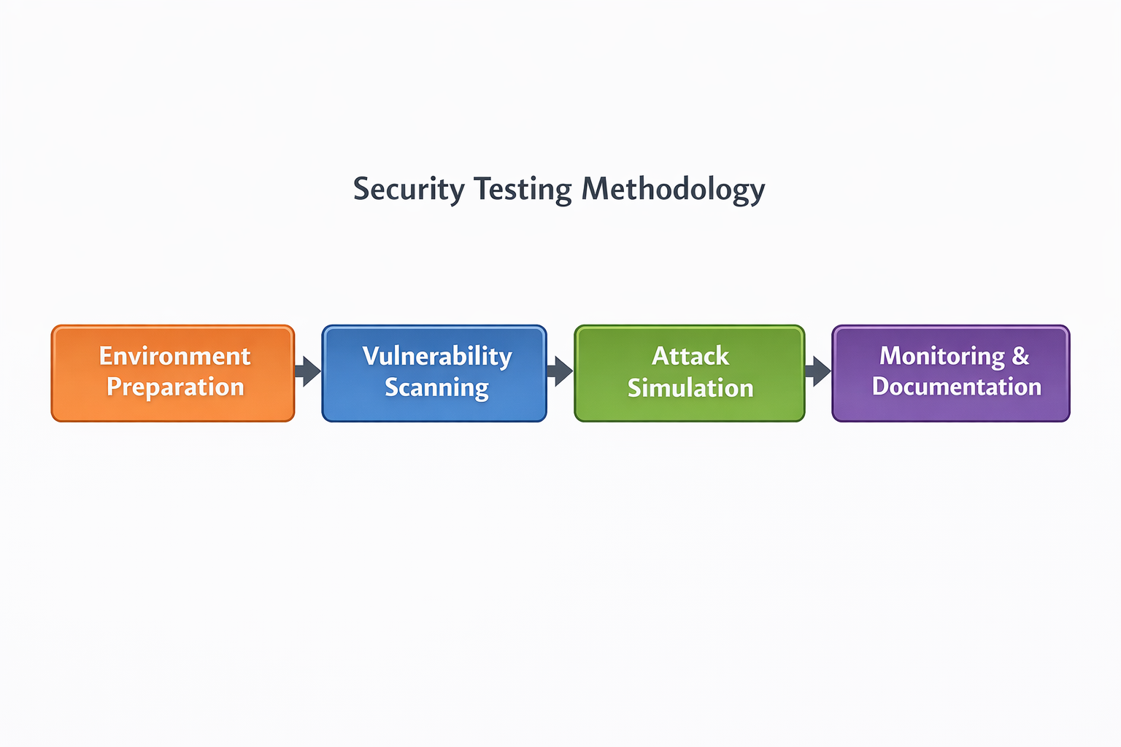
Security Testing Diagram
Note: Figure 4 The diagram presents the structured security testing procedures applied to evaluate the Cybersecurity Integrated Digital Leave Management System With Real-Time Intrusion Alerts For Local Government Unit Of Alicia. The process begins with Environment Preparation, where the system is deployed in a LAN-based setup, test devices are connected, HTTPS is enabled, and audit logging is activated to ensure a secure and realistic testing environment. This is followed by Baseline Functional Verification, where normal system operations such as login, leave submission, and approval are performed to confirm that the system and its security mechanisms are functioning correctly prior to testing.
The procedure then proceeds to Vulnerability Scanning using OWASP ZAP to identify potential weaknesses, followed by SQL Injection Testing with SQLMap to validate input and database security. In the Attack Simulation stage, brute-force attacks are conducted using Hydra, while Network Traffic Analysis using Wireshark verifies that data transmission is encrypted. Finally, Monitoring and Documentation involve reviewing system logs and recording all findings to assess the effectiveness of implemented security controls. This process ensures a systematic and measurable evaluation of the system’s security.
4.7 Security Design Considerations
Confidentiality
Employee information and leave records will be accessible only to authorized users through secure authentication, Role-Based Access Control (RBAC), and encrypted communication using HTTPS, ensuring that sensitive data is protected from unauthorized access.
Integrity
The system will maintain the accuracy and consistency of data by implementing input validation, controlled access permissions, and automated processing, preventing unauthorized modification of leave records and system data.
Availability
The system will be designed to remain accessible within the LAN environment, ensuring continuous operation and reliable access for authorized users during office hours.
Threat Detection and Response
The system will implement application-level threat detection and response mechanisms, including monitoring of login attempts, IP tracking, and threshold-based blocking of suspicious activities. Unauthorized access attempts will be automatically restricted, while system logs and the Super Admin dashboard will provide real-time visibility of security events. The system will generate real-time alerts when repeated failed login attempts, suspicious IP activity, or unauthorized access attempts are detected. These alerts will be displayed on the Super Admin dashboard and recorded in audit logs for review and response. These mechanisms ensure timely detection, monitoring, and response to potential security threats while strengthening the overall security and accountability of the system.
Non-Repudiation
Non-repudiation will be ensured through audit logging and activity tracking. The system will record all user actions, including login attempts, leave submissions, approvals, and updates. These logs, along with timestamps and user identifiers, will serve as verifiable records, ensuring accountability and preventing users from denying their actions.
Authentication
The system will implement secure authentication mechanisms using username and password combined with One-Time Password (OTP) verification. This multi-layered approach strengthens access control and ensures that only authorized users can access system functionalities.

4.8 System Limitations and Assumptions
1. System Limitations
• LAN Dependency – The proposed system is designed specifically for deployment within the Local Area Network (LAN) environment of the Local Government Unit (LGU) of Alicia. As such, the system is accessible only through authorized devices connected within the internal network and does not support public internet access or remote external connectivity. This design minimizes exposure to external cyber threats but limits accessibility outside the LGU environment.
• Scalability Constraints – The system is developed based on the operational requirements and transaction volume of the LGU of Alicia. Performance may be affected if deployed in larger organizations with significantly higher numbers of users or transactions without corresponding infrastructure upgrades.
• Device and Infrastructure Dependency – Access to the system depends on properly configured workstations, compatible web browsers, stable server operation, and reliable internal network infrastructure maintained by the organization.
• Security Scope Limitation – The study focuses only on practical and implementable cybersecurity mechanisms suitable for an academic capstone project. The system implements application-level security controls such as authentication, Role-Based Access Control (RBAC), audit logging, intrusion alerting, login monitoring, and input validation. However, it does not include advanced enterprise-level cybersecurity solutions such as cloud security orchestration, distributed intrusion prevention systems, large-scale threat intelligence integration, or enterprise Security Information and Event Management (SIEM) platforms.
• Data-at-Rest Encryption – The system encrypts data in transit using HTTPS and protects stored credentials using bcrypt hashing, but it does not encrypt the database files themselves at rest. Protection of stored data therefore depends on host access control, the restriction of database connections to the local host, and the physical security of the server. Transparent database encryption is identified as a recommendation for future work.
• Administrative Dependency – The effectiveness of the implemented security controls depends on proper network maintenance, secure user practices, and continuous monitoring and management by authorized administrators within the LGU environment.
2. Assumptions
• Users will have authorized access and valid credentials provided by the administration.
• The Local Area Network (LAN) environment will be properly maintained and secured by the organization.
• Users will possess basic knowledge of system usage and web-based navigation.
• The server, database, and network infrastructure will remain stable and operational during system use.

4.9 System Security Diagrams

4.9.1 Network Topology Diagram

Figure 5
Network Topology of the Cybersecurity Integrated Digital Leave Management System With Real-Time Intrusion Alerts For Local Government Unit Of Alicia


Note: Figure 5 illustrates a LAN-based client-server network topology designed for the Cybersecurity Integrated Digital Leave Management System With Real-Time Intrusion Alerts For Local Government Unit Of Alicia, where employee PCs, HR workstations, and mobile devices connect through a WiFi/LAN to a network switch, which routes traffic through a router/firewall before reaching the application and database servers. This topology implies a centralized and internally controlled architecture, where all system operations and data processing are handled within a secured local network rather than relying on external internet infrastructure. The design is intentionally confined within a LAN environment to ensure controlled access, reduced exposure to external threats, and stable system performance. By routing all communications through a firewall and using HTTPS for data transmission, the system enforces strict security controls, preventing unauthorized access and protecting sensitive data from interception. Centralizing the application and database servers also improves data accuracy and consistency, as all transactions are processed in a single source of truth, minimizing errors and synchronization issues. Overall, this topology enhances both security and reliability by combining network isolation, controlled access, and efficient data management within the organization.
4.9.2 Data Flow Diagram

Figure 6
Data Flow of the Proposed Cybersecurity Integrated Digital Leave Management System With Real-Time Intrusion Alerts For Local Government Unit Of Alicia 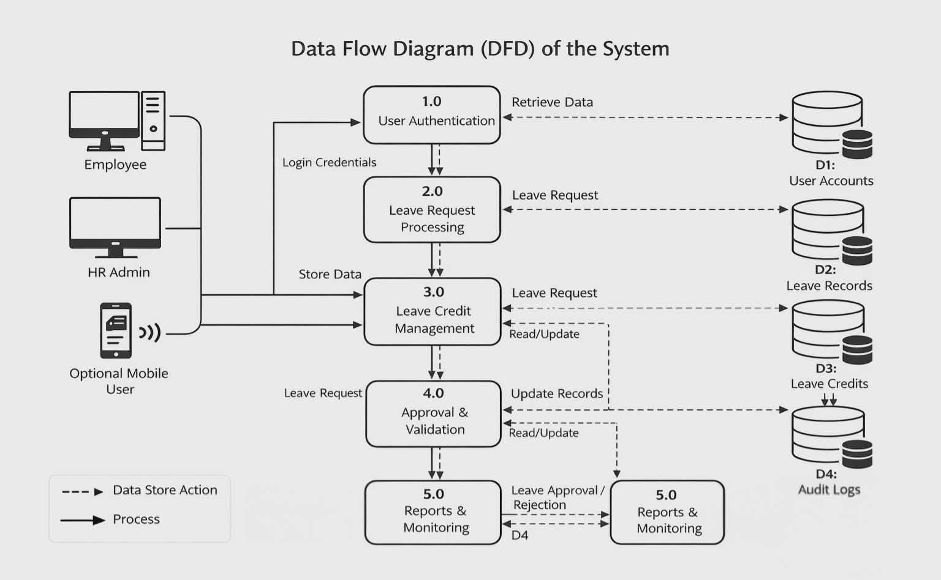
Note: Figure 6 illustrates the flow of data in the Cybersecurity Integrated Digital Leave Management System With Real-Time Intrusion Alerts For Local Government Unit Of Alicia, showing how user inputs are processed, stored, and managed through interconnected system components. The process starts with User Authentication (1.0), where login credentials are verified using the User Accounts (D1) database. Once validated, users proceed to Leave Request Processing (2.0), where leave applications are submitted and stored in Leave Records (D2). The system then performs Leave Credit Management (3.0) by reading and updating balances from Leave Credits (D3). Requests are handled in Approval and Validation (4.0), where decisions are made and recorded. All activities are logged in Audit Logs (D4) for traceability, while Reports and Monitoring (5.0) will generate outputs for users and administrators.
Overall, the DFD demonstrates a centralized, data-driven workflow where each process is interconnected with specific data stores. This design ensures data accuracy, consistency, and traceability, while also supporting efficient processing and secure handling of leave transactions within the system.

4.9.3 Security Framework Diagram

Figure 7
Security Framework of the Proposed Cybersecurity Integrated Digital Leave Management System With Real-Time Intrusion Alerts For Local Government Unit Of Alicia 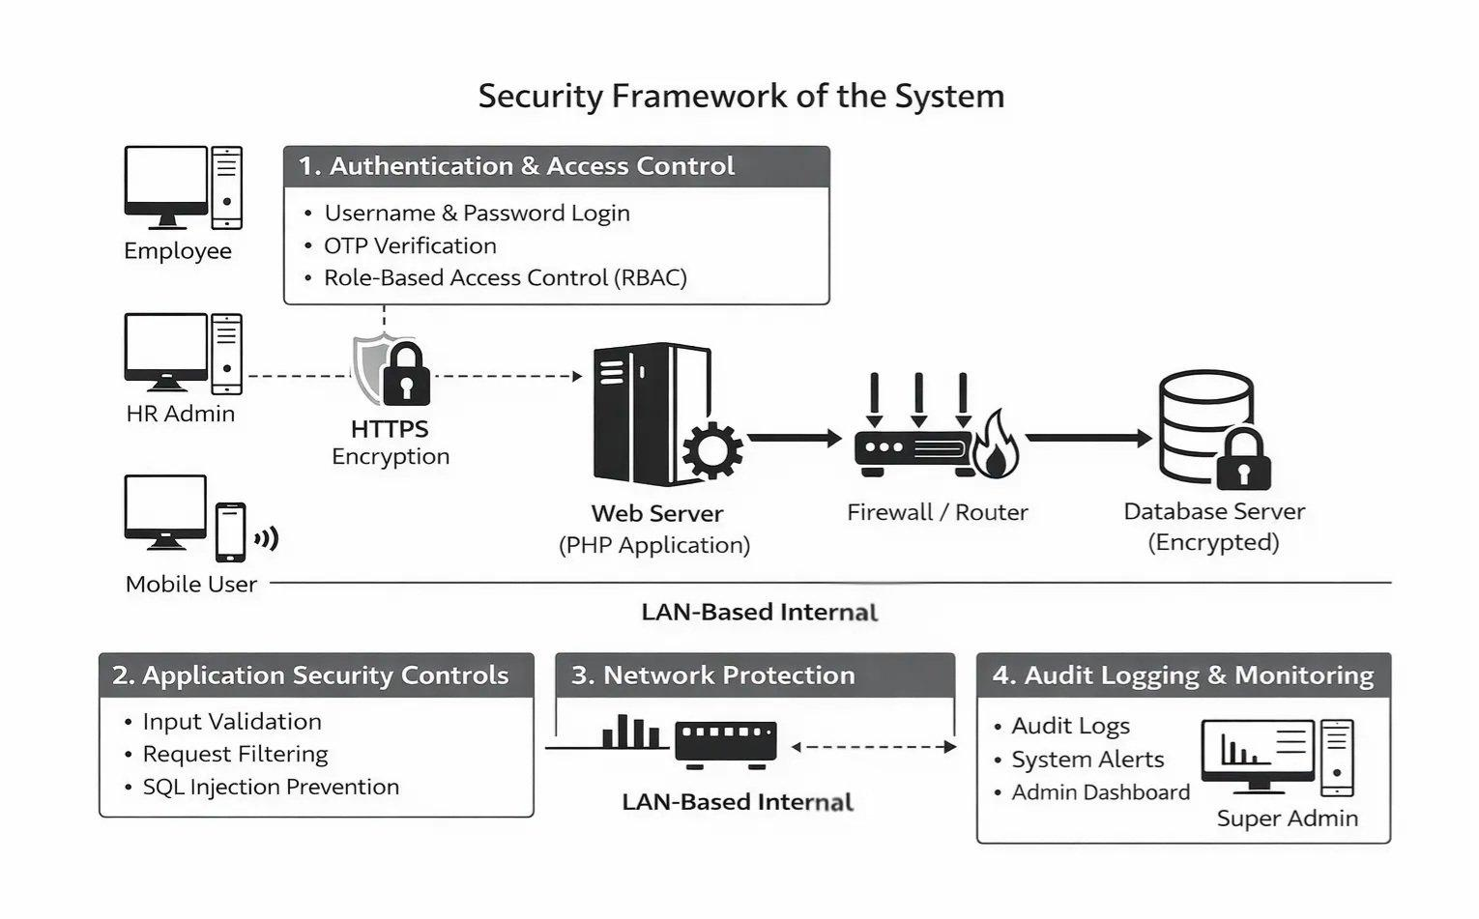
Note: Figure 7 presents the security framework of the Cybersecurity Integrated Digital Leave Management System With Real-Time Intrusion Alerts For Local Government Unit Of Alicia, illustrating a layered approach to system protection within a LAN-based environment. The diagram shows how authentication and access control mechanisms—including username-password login, OTP verification, and Role-Based Access Control (RBAC)—serve as the first line of defense to ensure only authorized users can access the system.
As data flows through the system, HTTPS encryption secures communication between users and the web server, while application-level controls such as input validation, request filtering, and SQL injection prevention protect against common web-based attacks. At the network level, the firewall/router enforces controlled access within the internal network, and the database server ensures secure storage of system data. Additionally, audit logging and monitoring mechanisms, managed through the Super Admin dashboard, provide visibility of system activities, enabling detection of suspicious behavior and ensuring accountability. Overall, the framework demonstrates a defense-in-depth strategy that enhances confidentiality, integrity, and system reliability.

4.9.4 Entity Relationship Diagram

Figure 8
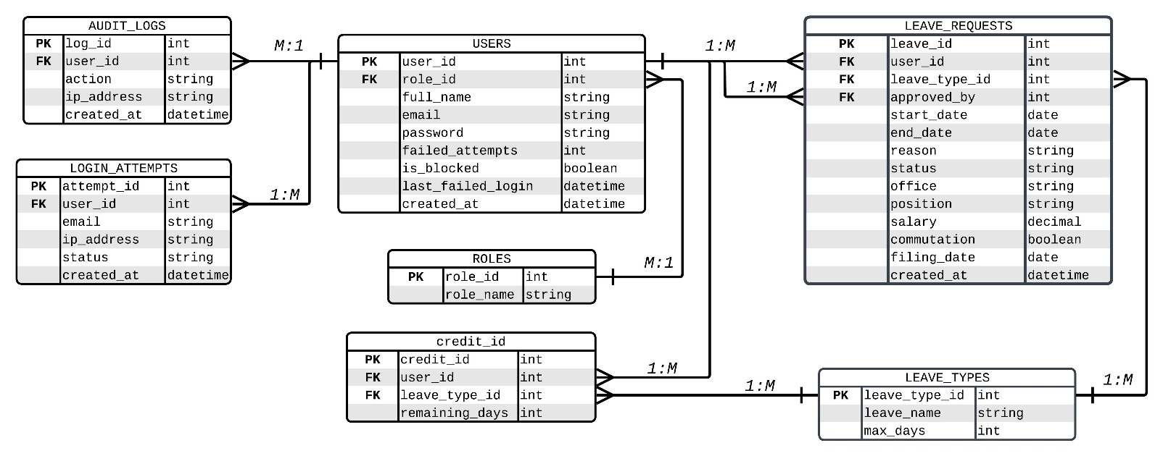
Entity Relationship Diagram of the Proposed Cybersecurity Integrated Digital Leave Management System With Real-Time Intrusion Alerts For Local Government Unit Of Alicia
Note: Figure 8 presents the Entity Relationship Diagram (ERD) of the proposed Cybersecurity Integrated Digital Leave Management System With Real-Time Intrusion Alerts for the Local Government Unit of Alicia. The diagram illustrates the logical structure of the database, including the entities, attributes, primary keys (PK), foreign keys (FK), and the relationships among system components using Crow’s Foot notation and cardinality indicators (1:M and M:1). These relationships define how data will be connected and managed within the system to support leave management operations, authentication, access control, and security monitoring.
At the center of the database design is the USERS entity, which is associated with the ROLES entity through a many-to-one (M:1) relationship to implement Role-Based Access Control (RBAC) and regulate user authorization levels throughout the application. Each user may file multiple LEAVE_REQUESTS, establishing a one-to-many (1:M) relationship between USERS and LEAVE_REQUESTS. Each leave request is linked to a specific LEAVE_TYPES record that defines the leave classification and maximum allowable leave duration. The system also maintains LEAVE_CREDITS records to monitor and update the remaining leave balances of employees according to approved leave transactions and assigned leave categories.
In addition, system activities and authentication attempts are monitored through the AUDIT_LOGS and LOGIN_ATTEMPTS entities. The AUDIT_LOGS entity maintains a one-to-many (1:M) relationship with USERS to record user actions, timestamps, and IP addresses for accountability and traceability. Similarly, the LOGIN_ATTEMPTS entity is connected to the USERS entity through a one-to-many (1:M) relationship using the user_id foreign key, allowing the system to associate multiple login attempt records with a specific user account. This entity stores authentication attempt details such as email addresses, IP addresses, login status, and timestamps to support intrusion detection, suspicious activity monitoring, and security auditing within the Local Area Network (LAN) environment.
Overall, the ERD reflects a relational and security-oriented database design that promotes data integrity, minimizes redundancy, and supports efficient storage and retrieval of organizational information. The inclusion of Crow’s Foot notation, PK and FK identifiers, and clearly defined cardinalities ensures accurate representation of entity relationships necessary for leave transaction processing, controlled user access, centralized monitoring, and reliable recording of security-related activities.

4.9.5 Technical Framework Diagram
Figure 9
Technical framework of the Proposed Cybersecurity Integrated Digital Leave Management System With Real-Time Intrusion Alerts For Local Government Unit Of Alicia
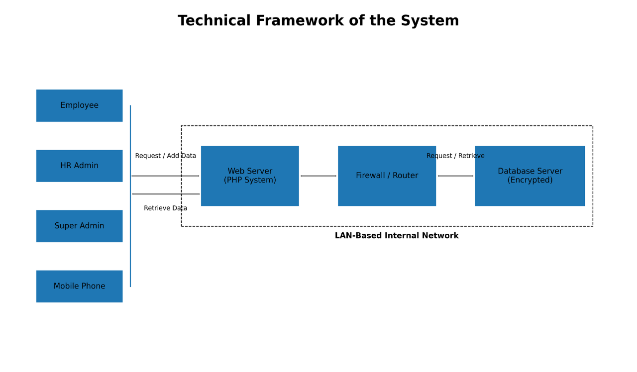

Note: Figure 9 illustrates the overall architecture and data flow of the system within a secure, LAN-based environment. It highlights how different user roles interact with the system and how data is processed, secured, and stored. At the user level, four primary actors are identified: Employee, HR Admin, Super Admin, and Mobile Phone users. These represent the different access points through which the system can be utilized. Employees typically initiate leave requests, while HR Admins and Super Admins manage, approve, and oversee system operations. The inclusion of mobile phone access indicates that the system is designed to be responsive and accessible across devices, enabling users to interact with it remotely within the network. All user interactions—such as requesting leave, adding data, or retrieving information—are directed to the Web Server (PHP System). This component acts as the core processing unit of the system. It handles user authentication, business logic, and request processing. For example, when an employee submits a leave request, the web server validates the input, applies relevant rules (such as leave balances or approval workflows), and prepares the data for storage.
The web server and the database run on a single centralized server within the internal network. The router and firewall shown in the diagram sit at the boundary of that network rather than between the web server and the database: they filter traffic entering and leaving the LAN segment and restrict which devices may reach the application, while the database itself accepts connections only from the local host and is not exposed to the network at all.
The database server stores all system data, including employee records, leave applications, approval histories, and system logs. Access to it is restricted to a dedicated database account holding only the privileges the application requires, and session data and cookies are encrypted by the application. Encryption of the database files at rest is not implemented in the present version of the system; protection of the stored data therefore rests on host access control, the restriction of database connections to the local host, and the physical security of the server, and at-rest encryption is identified in Section 4.8 as a limitation.
All core components—the web server, firewall/router, and database server—are enclosed within a LAN-Based Internal Network, as indicated by the dashed boundary in the diagram. This signifies that the system operates within a controlled internal infrastructure, enhancing security, reducing exposure to external threats, and improving performance through localized data exchange.

4.10 Development Status
This section reports the state of the artifact at the time of writing, so that the evaluation described in Chapter III is understood in relation to what has already been constructed.
All eleven development increments described in Section 3.2 have been completed. The system has been constructed and deployed to a test environment configured to mirror the intended LAN installation, and each increment satisfied the exit criteria defined for it before the succeeding increment was begun. Functional verification is in place through an automated test suite covering authentication and One-Time Password verification, Role-Based Access Control, the leave application workflow, leave credit computation including the prevention of negative balances under concurrent updates, working-day calculation, intrusion detection, reporting, and the application programming interface. Progress against the increments is recorded in the project phase plan and milestone log and is independently traceable through the version control history of the project repository, which is included as an appendix.

Table 8
Status of Development Increments
Increment | Delivered Functionality | Verification
1–3 Foundation and data layer | Project structure, offline assets, architecture documentation, database schema, models, and reference data | Schema migrates; reference data loads
4–5 Access control | Authentication with email OTP, lockout, password reset and change, session timeout, device restriction, and Role-Based Access Control | Authentication and access control tests pass
6 Leave management | CSC Form No. 6, fifteen CSC leave types, working-day and credit computation, Department Head to HR to Mayor workflow | Leave workflow and credit computation tests pass
7–8 Security layer | Audit and activity logging, intrusion detection, automatic address blocking, security dashboard, real-time alerts | Intrusion detection tests pass
9 Reporting and interface | Reports with PDF, Excel, and CSV export, role-scoped dashboards, versioned application programming interface | Report and interface tests pass
10–11 Validation and deployment | Full regression suite, penetration testing, ISO/IEC 25010 documentation, deployment and backup procedures | All accumulated tests pass; system installs on the target environment

Note: Table 8 presents the delivered functionality and the verification applied to each development increment. The table reports the construction of the artifact only; it does not report evaluation results.
What remains is the evaluation of the constructed artifact with human participants and with the reference data described in Chapter III, namely the baseline measurement of the manual process, the retrospective record audit, the gold-standard case validation, task-based testing, the role-differentiated ISO/IEC 25010 evaluation, and controlled penetration testing under written authorization. The results of these activities, and the conclusions drawn from them, will be presented in the succeeding chapters. Accordingly, the present manuscript describes a completed artifact and a specified evaluation that has not yet been carried out, and the future tense is retained throughout Chapter III for that reason.

REFERENCES
Adamu, A. (2020). Development of a web-based leave management system for organizational administration. FUDMA Journal of Sciences, 4(2), 86–91. https://doi.org/10.33003/fjs-2020-0402-162

Al Mehairi, A. (2022). Cyber security strategies while safeguarding information systems in public/private sectors. In F. Ortiz-Rodríguez, S. Tiwari, M.-A. Sicilia, & A. Nikiforova (Eds.), Electronic governance with emerging technologies (CCIS 1666, pp. 49–63). Springer. https://doi.org/10.1007/978-3-031-22950-3_5

Al-Husban, N., & Al-Husban, L. (2025). Analysis of authentication methods and secure web application readiness. Applied Mathematics and Information Sciences, 19(5), 1027–1038. https://doi.org/10.18576/amis/190505

Alade, T., Adewale, O., & Olatunji, O. (2022). Development of a web-based leave management system for organizational workforce administration. International Journal of Advanced Computer Science and Applications, 13(4), 120–128. https://doi.org/10.7753/IJCATR1104.1006

American National Standards Institute. (2004). Information technology — Role based access control (ANSI INCITS 359-2004). InterNational Committee for Information Technology Standards.

Anda, C. A., Alcala, J. M. J., Coper, J. D., Bayot, R. M., Rodriguez, R. L., & Serrano, E. A. (2022). A web-based application for employee's leave management system for the City Government of Tagaytay. In 2022 2nd International Conference in Information and Computing Research (iCORE) (pp. 275–278). IEEE. https://doi.org/10.1109/iCORE58172.2022.00066

Choudhari, S., & Yengantiwar, T. (2023). Review on leave management systems. International Journal of Advanced Research in Computer and Communication Engineering, 12(5), 1481–1485. https://doi.org/10.17148/IJARCCE.2023.125283

Civil Service Commission. (n.d.). Omnibus rules on leave (Rule XVI of the Omnibus Rules Implementing Book V of Executive Order No. 292, as amended by CSC Memorandum Circular No. 41, s. 1998 and subsequent issuances), and CSC Form No. 6 (Revised 2020), Application for Leave. Civil Service Commission, Republic of the Philippines.

Cofino, C., Cruz, M. M., Balogo, K., Alegria, J., Gutib, V., Escorial, R., & Wenceslao, F., Jr. (2023). New management standard for digital data protection using a PDCA model anchored to ISO/IEC 27001 and R.A. 10173. International Journal of Emerging Technology and Advanced Engineering, 13(5), 85–93. https://doi.org/10.46338/ijetae0523_08

Farayola, O. A., Olorunfemi, O. L., & Shoetan, P. O. (2024). Data privacy and security in IT: A review of techniques and challenges. Computer Science & IT Research Journal, 5(3), 606–615. https://doi.org/10.51594/csitrj.v5i3.909

International Organization for Standardization. (2011). ISO/IEC 25010:2011 — Systems and software engineering — Systems and software Quality Requirements and Evaluation (SQuaRE) — System and software quality models. ISO.

Jadhav, S. D., Ranaware, A. A., & More, P. D. (2023). Design steps of online leave management application system for academic institution. International Journal of Innovations in Engineering Research and Technology, 10(8), 1–4. ISSN 2394-3696. https://repo.ijiert.org/index.php/ijiert/article/view/3675

Khan, M., Ahmed, S., & Ali, R. (2023). Authentication mechanisms for securing web-based applications. IEEE Access, 9(2), 55–67. ISSN: 2169-3536 https://doi.org/10.1109/ACCESS.2021.3110310

Larman, C., & Basili, V. R. (2003). Iterative and incremental development: A brief history. Computer, 36(6), 47–56. https://doi.org/10.1109/MC.2003.1204375

Manoharan, P. (2024). Cybersecurity practices in human resource information systems: Protecting sensitive employee data. International Journal of Advanced Research in Science, Communication and Technology, 4(5), 102–110. https://doi.org/10.48175/IJARSCT-18492

Maulana, F., & Amelia, P. (2025). Development of integrated digital HR system using waterfall for leave and report management. Journal of Information Technology and Knowledge, 11(1), 192–200. ISSN: 2527-4864 https://doi.org/10.33480/jitk.v11i1.6215

Moreno, F., & Zabala, C. (2023). Digitalization of municipal governments in the Zamboanga Peninsula Region, Philippines: Problems, viability and way forward. SSRN Electronic Journal. https://doi.org/10.2139/ssrn.4519195

Munawir, A., Pratama, G. U., Auliana, S., Rohman, A., & Rizki, M. (2024). Enhancing leave management through an online employee leave application system. ARRUS Journal of Engineering and Technology, 4(1), 26–36. https://doi.org/10.35877/jetech2711

Pagayonan, S. M. S. (2022). Development of a leave management information system. International Journal of Research in Engineering and Science, 10(6), 511–516. https://www.ijres.org/papers/Volume-10/Issue-6/1006511516.pdf

Peffers, K., Tuunanen, T., Rothenberger, M. A., & Chatterjee, S. (2007). A design science research methodology for information systems research. Journal of Management Information Systems, 24(3), 45–77. https://doi.org/10.2753/MIS0742-1222240302

Republic of the Philippines. (2012). Republic Act No. 10173: An act protecting individual personal information in information and communications systems in the government and the private sector (Data Privacy Act of 2012).

Republic of the Philippines. (2012). Republic Act No. 10175: An act defining cybercrime, providing for the prevention, investigation, suppression and the imposition of penalties therefor (Cybercrime Prevention Act of 2012).

Salazar, G. P., Mutia, J. M., Providencia, J. J. U., & Neri, N. P. O. (2025). Kolumbano i-Leave: Online leave management system with trends using data visualization. International Journal of Science and Applied Information Technology, 14(2), 11–15. ISSN: 2278-3083. https://doi.org/10.30534/IJSAIT/2025/031422025

Sandhu, R. S., Coyne, E. J., Feinstein, H. L., & Youman, C. E. (1996). Role-based access control models. Computer, 29(2), 38–47. https://doi.org/10.1109/2.485845

Yona, F., & Meilani, Y. C. F. P. (2024). The impact of the HRIS usage in human resource management practice, employee innovation, and job satisfaction to increase employee performance. Quantitative Economics and Management Studies, 5(4), 815–831. https://doi.org/10.35877/454RI.qems2716

