## Project Overview

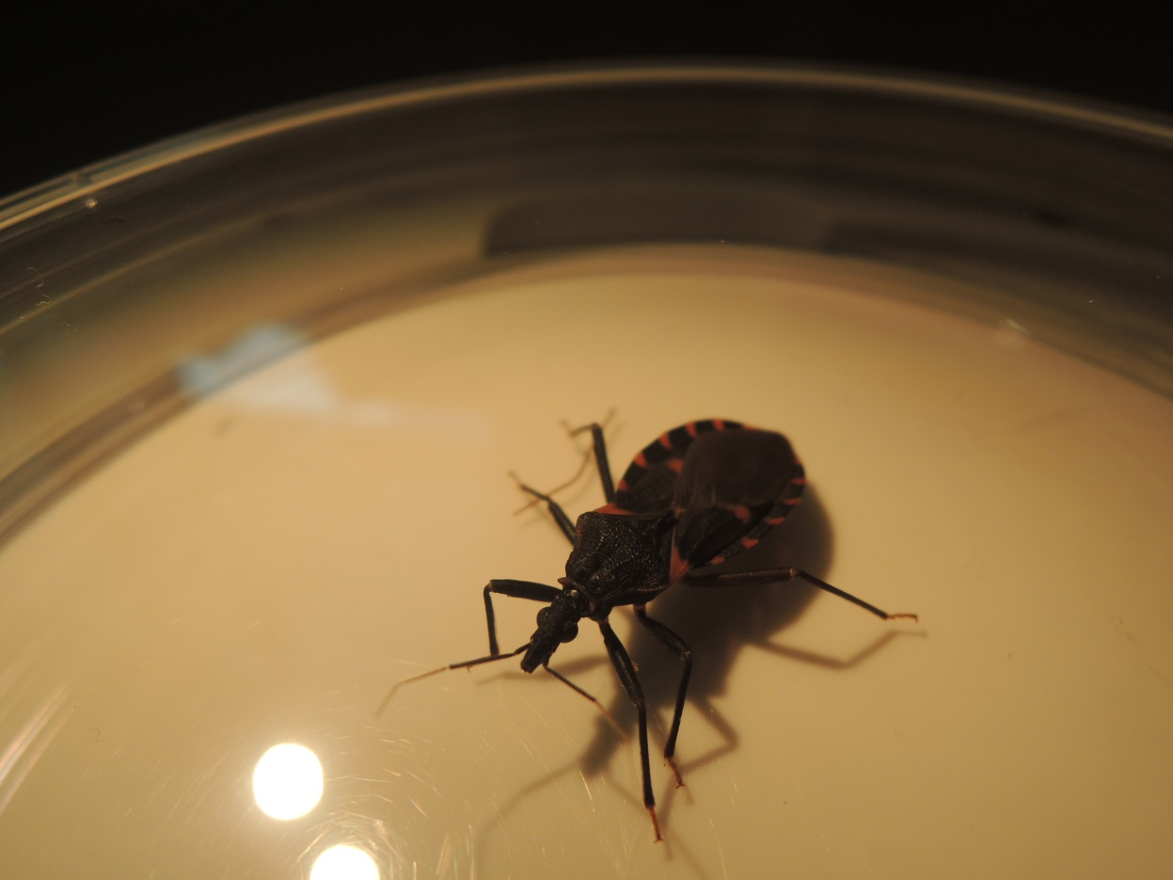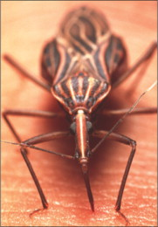

* Client Problem
* Design and Functionality Source
* Project Requirements:
  + Interactive Base Map
  + County Layers Map
  + Database Functionality
  + Drop Down Menu
  + Map for Each Species and All Species
    - Pop Ups and Show Data
    - Data Download Feature
    - Time Series Slider Display

# Kissingbug.tamu.edu

**Logistics:**

*Weekly Meetings*  
Day: Wednesday   
Time: 12:10 PM   
Location: Veterinary Medical Research Building

*Timeline*  
8 weeks starting February 17 – April 22, 2014 (includes one week off for spring break)

*Yolanda McDonald  
Rachel Curtis   
Jannel Gonzales*

**Client Problem:** Currently, the Chagas research group at TAMU does not have an interactive map that can be used by the public to access information about the presence of kissing bugs in Texas. Due to the large number of kissing bugs submitted to the lab by the general public, the lab would like to establish a site where submitters can see the role that their submissions play in Chagas research throughout Texas. The interactive map will be at the county-level, and it will have the number of kissing bugs found by type of bug, location (county), and the tested and infected status. It will be updated monthly, as well as contain user-defined time intervals to search kissing bugs status.

**Design and Functionality to be based up** [**http://soilmoisture.tamu.edu/Data/Map/**](http://soilmoisture.tamu.edu/Data/Map/)

**Project Requirements:**

**Step 1** - Set up interactive map, center point of the state is McCulloch County. The center point of this county is 31.221836, -99.374622.

Use google maps base map, keep sites that appear when centered on McCulloch County

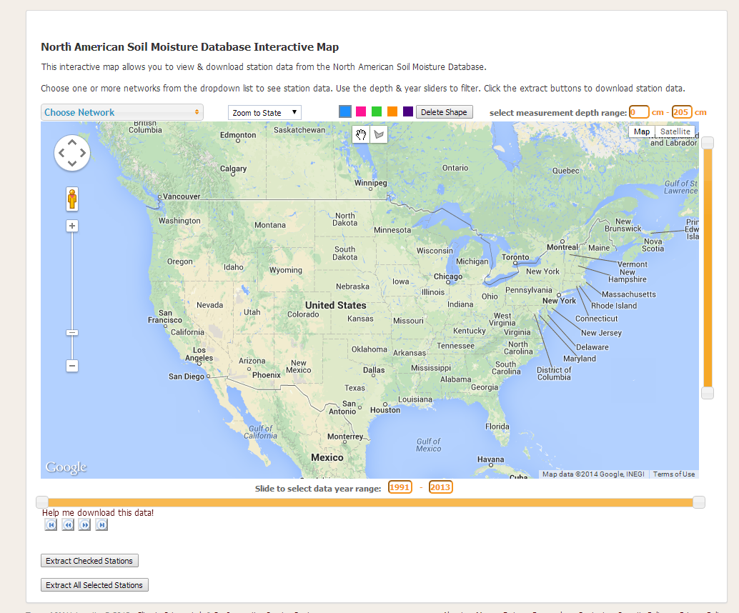

The “DEFAULT LOADED” MAP will display choropleth map of ALL species types by county, cumulative counts

**Step 2** - Add a counties polygon layer to the base map source: TIGER shapefile, will need to make projection match googlemaps, most likely Texas Centric

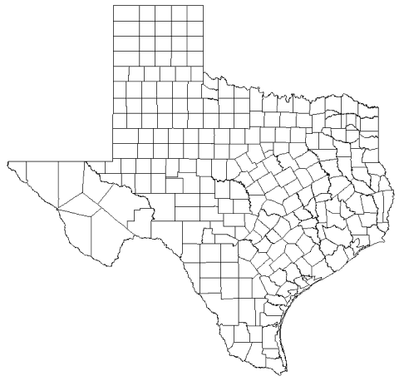

**Step 3** – Import monthly file of the following variables: bug id, unique id, species, month, year, county, and infected status



The database will be created and maintained by Rachel Curtis.

**Data upload requirements/Special Notes:**

The code will need to eliminate any rows that have missing data in any of the eight (8) columns. All species designated as ‘nymph’ will need to be deleted.

**Step 4** – Create drop down menu by type of species, and all species

Filter by species type

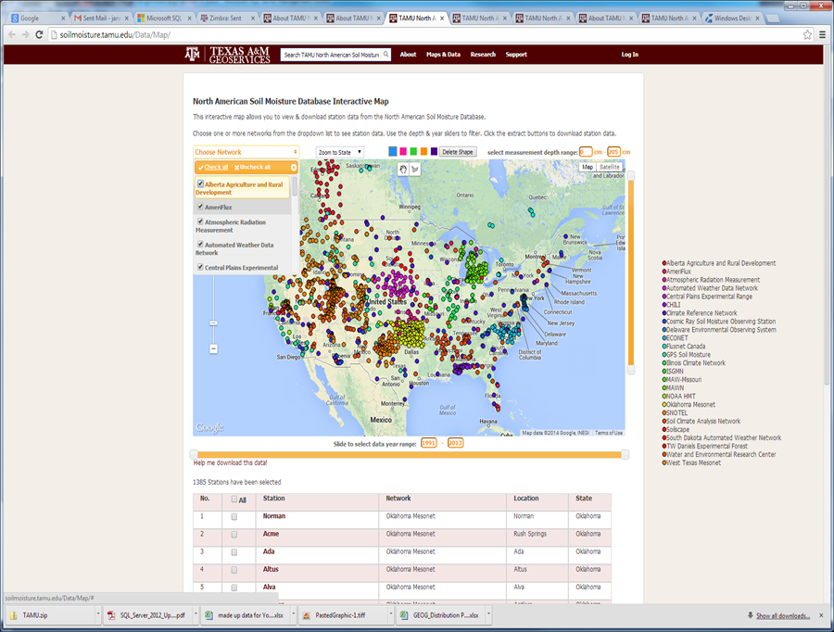

* T.gerstaeckeri
* T. sanguisuga
* T. lecticularia
* T. indictiva
* All (which is the default)

**Step 5** – Maps by species types, and all types **(5 maps)**

1) T. gerstaeckeri

2) T. sanguisuga

3) T. lecticularia

4) T. indictiva

5) All (which is the default)

**Step 6** – **Each map** will have pop-up, map info window and time series slider

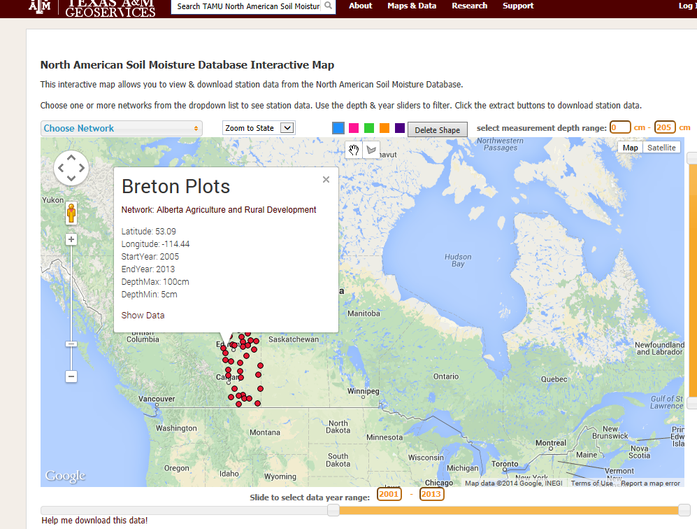

Pop Up Box

February 17, 2014 decision was made to not include the download data feature.

**Steps 7- 8** Pop Up & Show Data

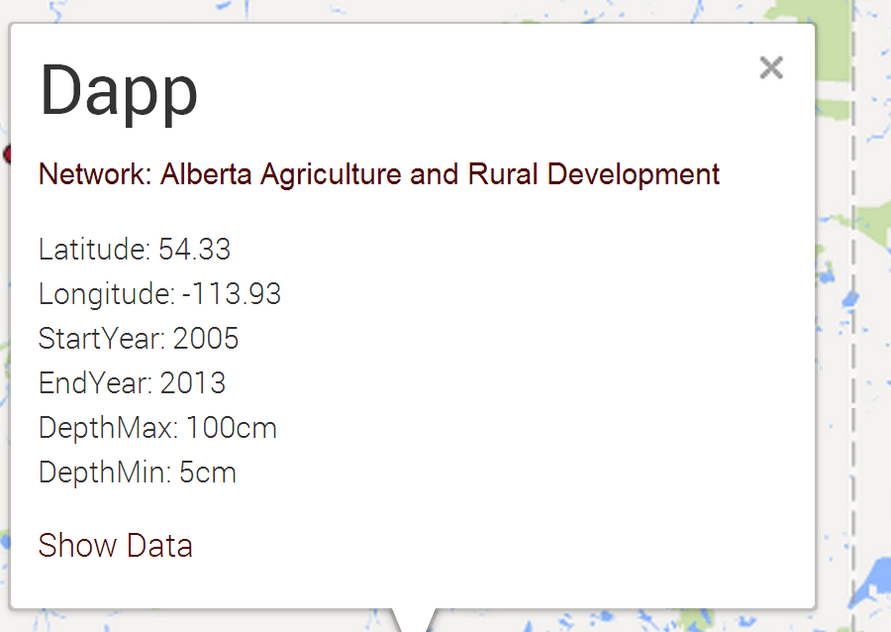

**Step 7 - Pop up content**

• County name

• Species name

• Picture of species (we need to give Rachel size specs, . i.e. pixels)

• Total number of species found for that month, number tested, & infected status, e.g. April 2014 - 10 found//9 tested/8 infected

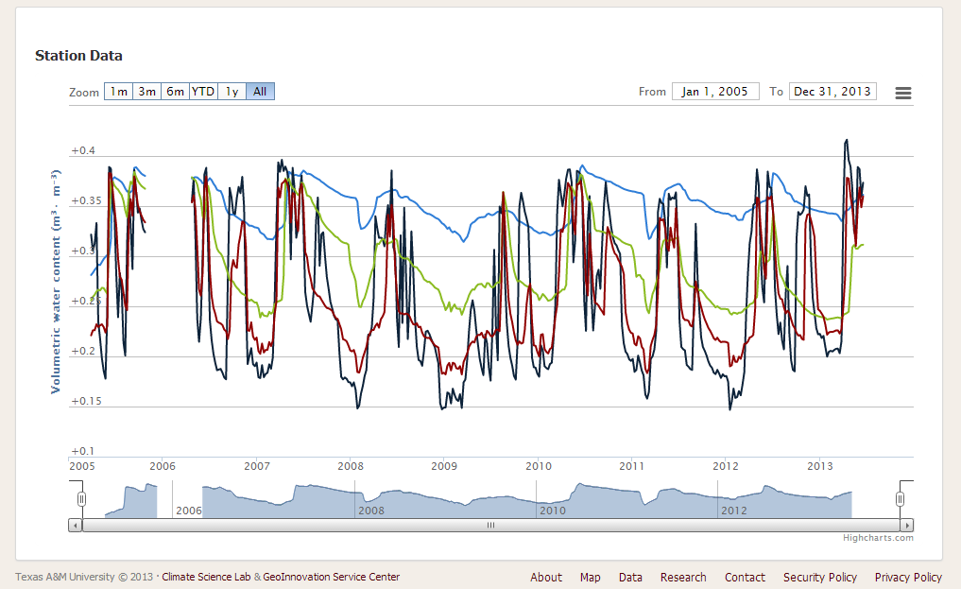

Date range

Sliding Scale

1 m, 3m, 6m, YTD, 1y, All

Timeline filtering functions

**Step 8 - Pop up ‘Show Data’ feature**

**•** County name

• Species name

• Time-series by species found & infected status (e.g. 1 m, 3m, 6m, YTD, 1y, All or date range, or sliding scale

<http://soilmoisture.tamu.edu/data/map/chart2.aspx?StationId=0270270513>

Note, each map will have its own set up pop-ups and data download section

The **Show Data** in the pop up window needs to be more prominent.

**Step 10** - Time series slider

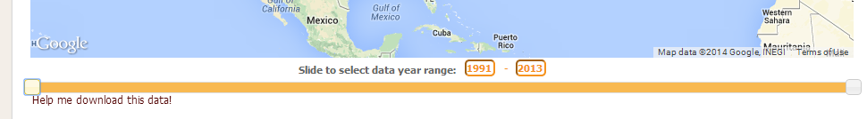

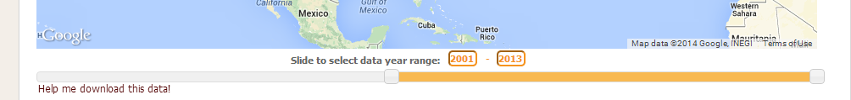

The time series slider will appear on each individual map. The map that is featured will be a choropleth map, using quintile breaks.

