## Project Overview

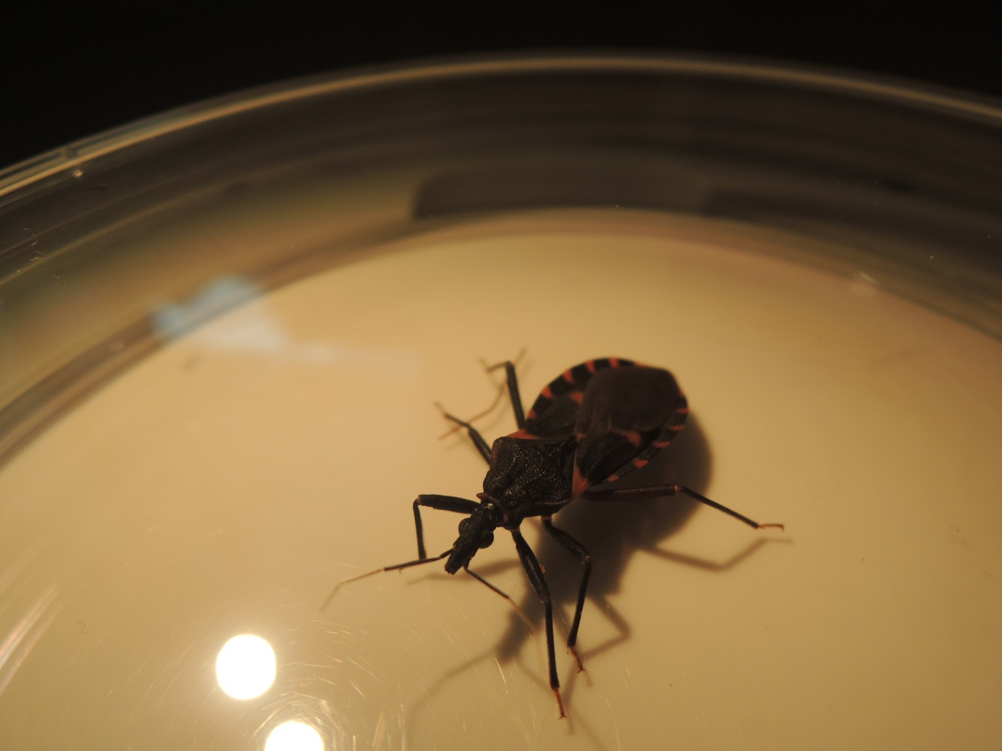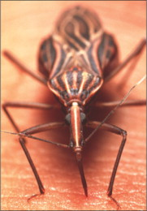

* Client Problem
* Design and Functionality Source
* Project Requirements:
  + Interactive Base Map
  + County Layers Map
  + Database Functionality
  + Drop Down Menu
  + Map for Each Species and All Species
    - Pop Ups and Show Data
    - Data Download Feature
    - Time Series Slider Display

# Kissingbug.tamu.edu

**Logistics:**

*Weekly Meetings*  
Day: Wednesday   
Time: 12:10 PM   
Location: Veterinary Medical Research Building

*Timeline*  
8 weeks starting February 17 – April 22, 2014 (includes one week off for spring break)

*Yolanda McDonald  
Rachel Curtis   
Jannel Gonzales*

**Client Problem:** Currently, the Chagas research group at TAMU does not have an interactive map that can be used by the public to access information about the presence of kissing bugs in Texas. Due to the large number of kissing bugs submitted to the lab by the general public, the lab would like to establish a site where submitters can see the role that their submissions play in Chagas research throughout Texas. The interactive map will be at the county-level, and it will have the number of kissing bugs found by type of bug, location (county), and infected status. It will updated monthly, as well as contain user-defined time intervals to search kissing bugs status.

**Design and Functionality to be based up** [**http://soilmoisture.tamu.edu/Data/Map/**](http://soilmoisture.tamu.edu/Data/Map/)

**Project Requirements:**

**Step 1** - Set up interactive map, center point of the state is McCulloch County. The center point of this county is 31.221836, -99.374622.

Use google maps base map, keep sites that appear when centered on McCulloch County

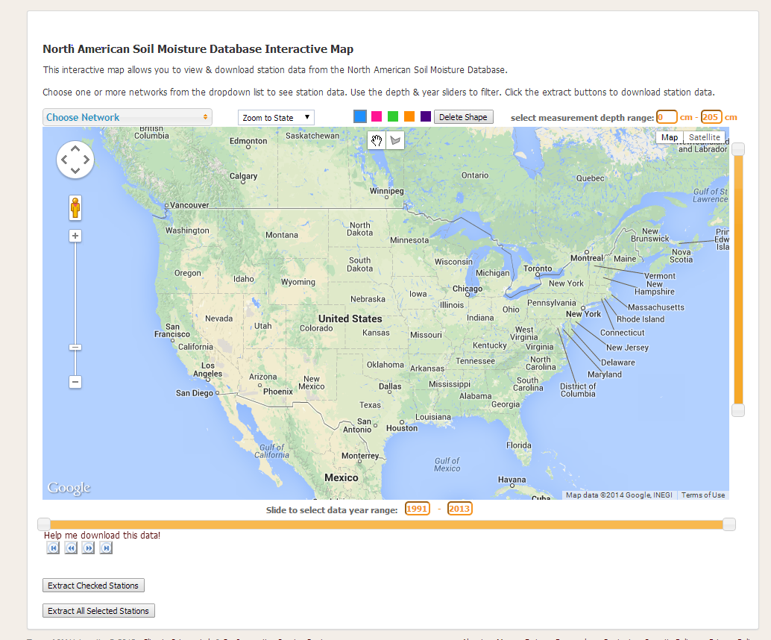

The “DEFAULT LOADED” MAP will display choropleth map of ALL species types by county, cumulative counts

**Step 2** - Add a counties polygon layer to the base map source: TIGER shapefile, will need to make projection match googlemaps, most likely Texas Centric

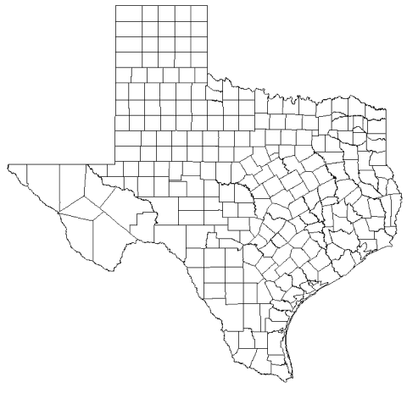

**Step 3** – Import bi-weekly file of the following variables: bug id, unique id, species, month, year, county, and infected status



The database will be created and maintained by Rachel Curtis.

**Step 4** – Create drop down menu by type of species, and all species

Filter by species type

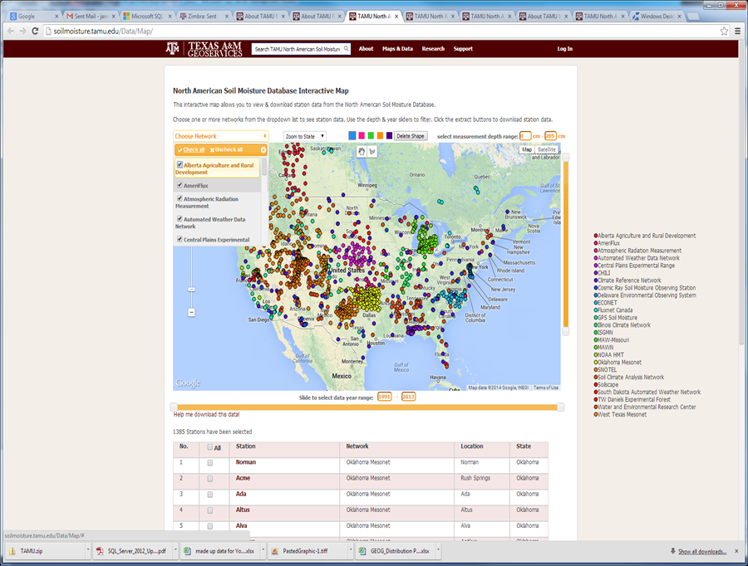

* T.gerstaeckeri
* T. sanguisuga
* T. lecticularia
* T. indictiva
* All (which is the default)

**Step 5** – Maps by species types, and all types **(5 maps)**

1) T. gerstaeckeri

2) T. sanguisuga

3) T. lecticularia

4) T. indictiva

5) All (which is the default)

**Step 6** – **Each map** will have pop-up windows, download data feature (by county and species), and time series slider

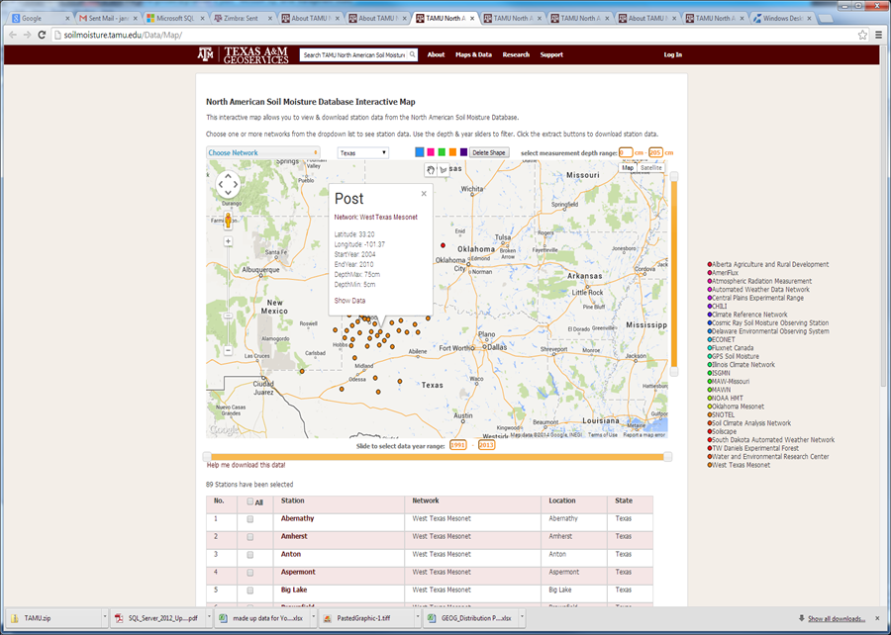

Data that can be downloaded by county

Pop Up Box

**Steps 7- 8** Pop Up & Show Data

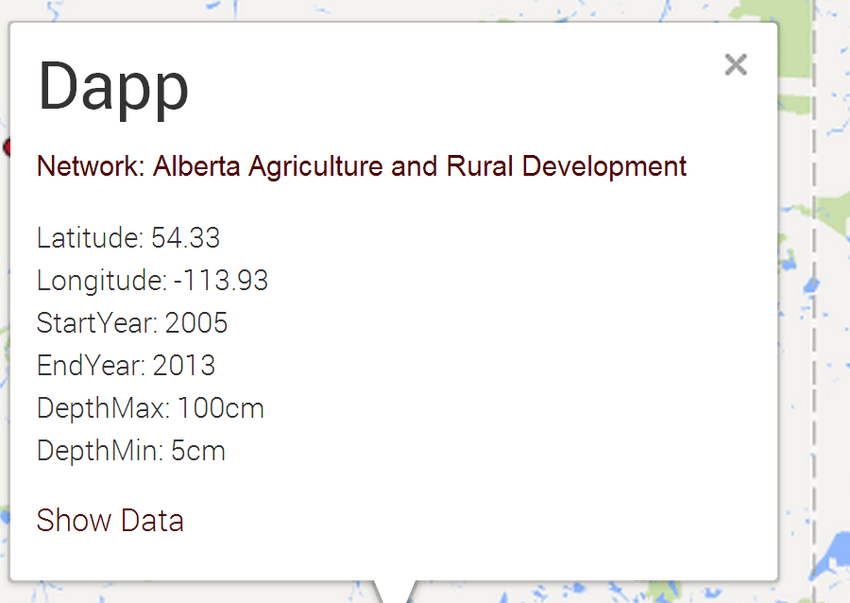

**Step 7 - Pop up content**

• County name

• Species name

• Picture of species (we need to give Rachel size specs, . i.e. pixels)

• Total number of species found for that month, number tested, & infected status, e.g. April 2014 - 10 found//9 tested/8 infected

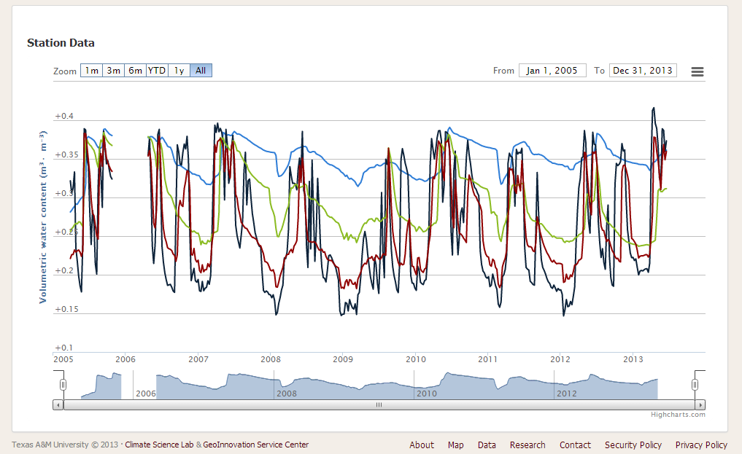

Date range

Sliding Scale

1 m, 3m, 6m, YTD, 1y, All

Timeline filtering functions

**Step 8 - Pop up ‘Show Data’ feature**

**•** County name

• Species name

• Time-series by species found & infected status (e.g. 1 m, 3m, 6m, YTD, 1y, All or date range, or sliding scale

<http://soilmoisture.tamu.edu/data/map/chart2.aspx?StationId=0270270513>

Note, each map will have its own set up pop-ups and data download section

**Step 9** –Data Download Feature (by species, county, and cumulative count)

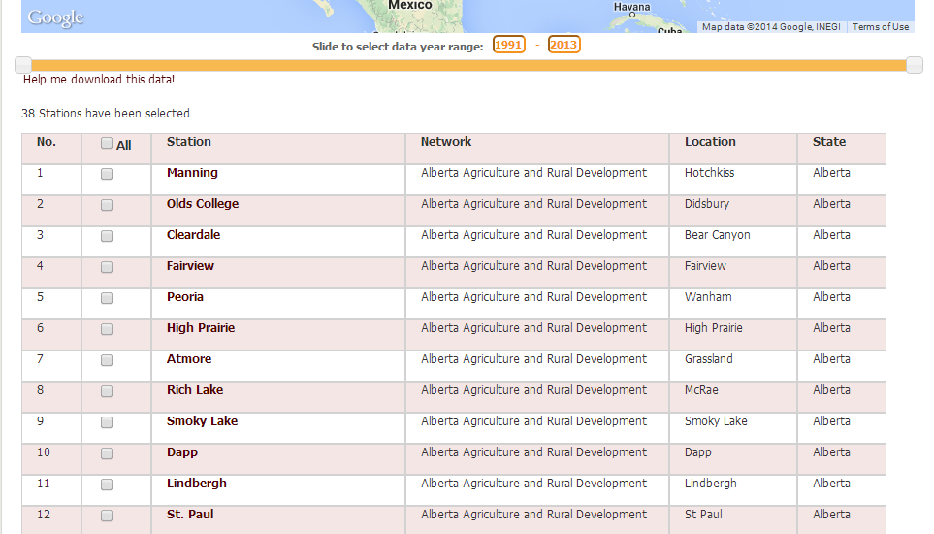

Fields to download: Species &County

A spreadsheet would be generated containing the following fields: species, county, and cumulative count.

**Step 10** - Time series slider

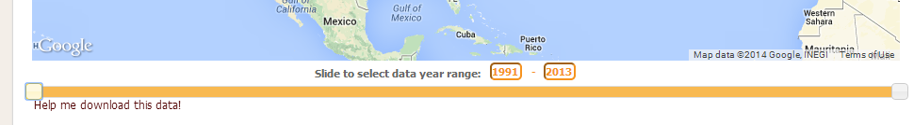

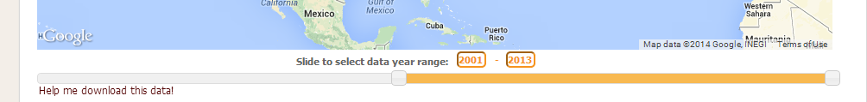

The time series slider will appear on each individual map. The map that is featured will be a choropleth map, using quintile breaks.