**Same but different: Rethinking the common understanding of ENSO and its impact on biodiversity**

# Introduction

Studying the relationship between environmental gradients and species turnover has become a cornerstone of biogeography and community ecology since Humbold’s and Bonpland’s travels to South America more than 200 years ago (Whittaker, 1967; MacArthur, 1984). Naturally, water availability drives floristic composition and biomass production in the (semi-)arid regions such as NW Peru (Muenchow et al., 2013d, 2013b). However, water availability does not only vary in space but also in time, especially in regions heavily affected by the El Niño Southern Oscillation (ENSO). A super-humid El Niño (EN) episode benefits other species than a super-dry and fire-bringing La Niña (LN) episode (Richter and Ise 2005).

ENSO is a recurrent climate phenomenon causing anomalies around the globe (Capotondi et al. 2015). EN represents the warm and LN the cold phase of this cycle. ENSO neutral refers to periods when neither EN nor LN are present. LN usually causes the reverse effects of EN. The effects depend on the region and include among others excessive rainfalls, droughts as well as temperature, wind and monsoon anomalies. The anomalies show recurrent patterns to a certain degree but are still highly variable especially on a local scale. For instance, in 2016 the predicted Super-Niño rainfalls largely failed to materialize along the coasts of Ecuador and Peru. Just a year later, unexpected, torrential rainfalls hit the same coasts during a supposedly ENSO neutral year with a magnitude comparable to that of the Super-Niño event in 1997/98. Originating from a so-called coastal EN, the 2017 rainfalls came as a complete surprise, and caused the unprepared population unbearable hardship (Fraser 2017, Ramírez and Briones 2017). Ecological research mostly focusses on the effects of EN, but tends to neglect the effects of LN. Nevertheless, the eco-climatic impact of LN is comparable in magnitude with that of EN. For instance, LN episodes were most likely the main driver for the hiatus in global warming at the beginning of the 21st century (Kosaka and Xie 2013).

Extreme climate events like EN and LN change and reshape ecosystems drastically (Kogan and Guo 2017). This effect is even pronounced in (semi)-arid ecosystems (Holmgren et al. 2006), and, for example, especially true for ENSO’s terrestrial core region in NW Peru and SW Ecuador (Muenchow et al. 2013a, Rollenbeck et al. 2015) – one of the most variable and vulnerable regions on Earth in terms of climate. This region is also home to the highly endemic tropical dry forest (TDF) ecosystems. Overall, TDFs feature an outstanding biodiversity which is almost as high as that of humid tropical forests (Espinosa et al. 2011). At the same time, they are the most threatened tropical ecosystem (Miles et al. 2006). In Peru, 95% of TDFs have already disappeared (Portillo-Quintero and Sánchez-Azofeifa 2010). Even so, tropical dry ecosystems are chronically understudied (Muenchow et al. 2018).

Naturally, water shortage is the main constraint to plant growth in arid environments, but edaphic and topographic properties are sometimes equally important in structuring vegetation of tropical ecosystems (Soethe et al. 2008, Laurance et al. 2010). Yet, the corresponding effects on the floristic composition of tropical (semi-)arid vegetation communities remain scarcely investigated (Peña-Claros et al. 2012, Muenchow et al. 2013c). This is especially true in terms of how soil properties influence vegetation communities as soon as water is no longer the limiting factor. For instance, nitrogen may increase primary production even in the presence of droughts and grazing pressure (Whitford and Steinberger 2011, Kinugasa et al. 2012).

To tackle the outlined issues at least in part, we examined how different ENSO episodes affect the floristic composition along a spatio-temporal gradient in NW Peru. For this, we surveyed the floristic composition on permanent plots in four years representing different ENSO episodes (dry (2011) and humid (2012) LN year; moderate EN year (2016); very humid coastal EN year (2017)). Specifically, we investigated the:

1. changes in alpha, beta, gamma and ecosystem diversity, and visualized corresponding changes by means of predictive mapping.
2. effects of soil characteristics and topography in shaping floristic composition and vegetation cover (biomass production) as soon as water is no longer the limiting factor.

We complemented the plot survey at the landscape scale with an irrigation-fertilization experiment, thereby considering the socio-economic perspective of the ENSO variability. Specifically, we quantified the effect of the water-nutrient interaction on biomass development under different rainfall scenarios.

# Methods

## Study area

The study area stretches for 120 km along a pronounced bioclimatic gradient in NW Peru and features a desert along the Pacific coast in the west and TDFs near the Andean foothills in the east (Fig. 1). The climatic gradient is at the same time a gradient of increasing human influence especially in terms of agricultural activity towards the Andean foothills (Muenchow et al. 2013b, a).

The study area is part of the core region where the ENSO phenomenon exerts its greatest terrestrial influence (Richter and Ise 2005). Generally, EN brings more rain than usual and LN enforces the already dry conditions in the study area. However, even this pattern is highly variable and can occasionally be reversed, see e.g., the years 2005, 2008 and 2012 in Fig. 1d. Additionally, so-called “local” or “coastal EN events” can take place as observed in 2017. Coastal EN events refer to the regional warming of coastal waters in the Gulf of Guayaquil in December as opposed to the Pacific basin-wide EN when warm North Australian waters reach the South American coast.

Therefore, to put the ecological results into context, it is important to keep in mind the varying rainfall patterns as produced by different ENSO episodes across the studied years. The observed years differed largely in terms of precipitation. 2011 corresponded to a dry LN year and the whole study area experienced drier conditions than normal. By contrast, 2012 was a humid LN year, and 1.5 times and 3 times more rain fell in Piura and Chulucanas, i.e., in the middle to eastern part of the study area (Fig. 1). 2016 was a moderate EN year and rainfall was double the median input in Paita and Piura, whereas in Chulucanas the median value was almost reached. 2017 coincided with a coastal EN event and is the only studied year during which the whole study area experienced exceptionally wet conditions: Paita received almost 15 times (379 mm), Piura almost 11 times (780 mm) and Chulucanas 6 times (1706 mm) more rain than on median (Fig. 1d). Moreover, it is noteworthy that vegetation development changes drastically in the study area during wet episodes but remains more or less uniform during normal years (Richter and Ise 2005, Holmgren et al. 2006, Muenchow et al. 2013b).

## Data compilation

### Vegetation sampling

We randomly sampled 50 vegetation plots of 30 × 30 m2 size stratified by distance to the Pacific Ocean in ten classes (Fig. 1). We excluded riparian, agricultural and urban areas. Each plot was located with a handheld Garmin GPS device in the field. Field sampling took place towards the end of the vegetation period (March-May) in 2011, 2012, 2016 and 2017. In each plot, we recorded all vascular plant species and determined their cover as portion of the plot area in percentage points. The nomenclature follows the conventions of the Tropicos online database (Missouri Botanical Garden 2018).

### Environmental variables

We randomly took and mixed three soil samples from 15 cm and 30 cm depth in each plot. Subsequently, we measured in the laboratory variables known to be important for vegetation development: pH, electrical conductivity (µS), carbon-to-nitrogen ratio, soil texture (%), the concentrations of the cations Ca, Mg, K and Na (cmol kg-1), and skeletal content (%; measured as gravimetric proportion of stones >2 mm; see Muenchow et al. (2013b) for a more detailed description).

We computed the topographic variables aspect, altitude, catchment slope, catchment area, soil wetness index, plan and vertical curvature from a digital elevation model with a 30 × 30 m2 resolution (Land Processes Distributed Active Archive Center 2018). For each year, we computed the mean of all normalized difference vegetation index (NDVI) images available for the vegetation period from the Moderate Resolution Imaging Spectrometer (MODIS) at a 250 × 250 m2 resolution.

The interpolated precipitation values from the WorldClim data provided a spatial distribution of the average annual rainfall (Hijmans et al. 2005). Local precipitation values were collected from automated climate stations (Fig. 1d) operated by the University of Piura near Paita (1997-2018), in Piura (1991-2018) and in Chulucanas (1997-2018).

### Irrigation-nutrient experiment

In addition to the plot survey at the landscape scale, we conducted a small-scale irrigation-nutrient experiment to quantify the beneficial effects of the water-nutrient interaction on vegetation development and biomass production. We established the experiment in the middle of the precipitation gradient, ranging from 26 mm (Paita; annual median precipitation) to 270 mm (Chulucanas; Fig. 1), on the campus of the University of Piura (5°10’S, 80°38’W, see Piura in Fig. 1). The environmental conditions are typical for the region in terms of climate, topography and soil properties (see Muenchow et al., 2013a, 2013c). Inside a sandy area devoid of woody vegetation, we placed 12 experimental plots of 3 × 3 m2, which were regularly spaced along a rectangular grid of 1 ha. Plots were assigned to one of three irrigation treatments: The first treatment represented a Super EN year (example of 1997/98: 1780 mm), the second represented a moderate EN event (example of 1991/1992: 258 mm). The last treatment represented the baseline with no additional water input and corresponded to the year in which the irrigation experiment was conducted (2013) which was a neutral year (54 mm; see also Fig. 1d). The irrigation water stemmed from rain-collecting tanks. In addition to the water treatment, two randomly chosen plots of each irrigation treatment received a fertilization treatment of 200kg/ha granular nitrogen fertilizer (NH4NO3). The experiment was carried out between December 2012 and May 2013. Plant development was monitored two times per month and included the determination of plant species (Missouri Botanical Garden 2018) and corresponding coverage (%). Please refer to Appendix 1 for a detailed description of the irrigation-nutrient experiment.

## Data analysis

### Biodiversity and plant cover analysis

We calculated four measures of biodiversity for each observed year, namely alpha, beta, gamma and ecosystem diversity (Whittaker 1967). Alpha diversity refers to the mean number of species per plot. Beta diversity is expressed as the range of the first Detrended Correspondence Analysis (DCA) axis (see below). This measure is given in units of standard deviation (SD) with four SDs corresponding to a complete species turnover. Gamma diversity is the total number of observed species across all plots. Ecosystem diversity was assessed with the help of a DCA (Hill & Gauch, 1980) to which the Londo-scale transformed cover values of the species-plot matrix was subjected. DCA tries to condense as much as possible the observed variance of the input matrix in a low-dimensional space (usually 2-3 axes), thereby extracting the main apparent gradients.

### Modeling and predictive mapping

To spatio-temporally visualize the change of the floristic composition along the climatic gradient, we modeled the scores of the first DCA axis representing the main observed floristic gradient in the study area with the help of a Generalized Additive Model (GAM) as a function of the interaction between NDVI and year:

(Formula 1)

where *i* refers to the *i*th observation, *α* is the intercept, *β*1 is the estimated coefficient for year and *f* is a spline smoother for the NDVI:year interaction.

The normalized root mean-square error (NRMSE) in percent was used to assess the model’s accuracy:

(Formula 2)

where *n* is the number of observations, *e* corresponds to the residuals, and *y* refers to the observed values.

Cross-validation accounts for over-optimistic predictions on the training set by randomly splitting a data set into partitions used for training and testing (Brenning 2012). Spatial cross-validation is an extension that measures a model’s ability to spatially predict the response variable in the presence of spatial autocorrelation (Schratz et al. 2018). Therefore, we subjected NRMSE to a 100-repeated 5-fold spatial cross-validation in which the partitioning is based on *k*-means clustering (*k* = 5; Ruß & Brenning, 2010). We also made sure that all annual observations of one plot were jointly placed in either the test or the training data set (Meyer et al. 2018).

### Impact of environmental variables

We used variation partitioning (Peres-Neto et al. 2006) to assess how edaphic and topographic variables influence vegetation composition under increasingly humid conditions. The first two DCA axes of each observed year served as response variables. Edaphic and topographic variables were the predictors. We log-transformed electrical conductivity, the CN ratio and the catchment area. Subsequently, we excluded all collinear variables which exceeded a variance inflation factor >3 leaving us with seven edaphic and eight topographic variables. We refrained from a forward selection of explanatory variables (Blanchet et al. 2008) because (i) we only used a reasonable number of meaningful, non-collinear variables that (ii) were available for all four years to guarantee inter-annual comparability.

All statistical analyses were conducted in the open source software R (R Core Team 2018) using its packages mgcv (Wood 2017), RQGIS (Muenchow et al. 2017), sperrorest (Brenning 2012) and vegan (Oksanen et al. 2018). To comply with the good practices of reproducibility we will make available the data and the code of this work on an open accessible github repository (https://github.com/) upon acceptance of the manuscript.

# Results

## Biodiversity and plant cover

Mean alpha diversity was lowest during the dry LN (2011) and highest during the moderate EN (2016; Table 1). Compared to the humid LN (2012) and the moderate EN (2016), species richness was lower in the east of the study area during the very humid neutral year(2017), however, higher within a distance of 20-25 km to the coast (left panel of Fig. 2). Species turnover (beta diversity) was also lowest during the dry LN (2011) and stayed almost the same in the remaining years. Gamma diversity increased from 2011 (dry LN) to 2012 (humid LN), remained almost the same in 2016 (moderate EN), and decreased in 2017 (very humid neutral year; Table 1). By contrast, the latter showed by far the highest plant coverage along the entire gradient (right panel of Fig. 2 & subsection 3.2).

The first two DCA axes explained 68% of the observed variance with the first axis contributing alone 48%. The first axis is mainly associated with precipitation while the second axis is related to topographic variables such as vertical curvature and catchment area. Overall, the DCA scatter cloud becomes more compressed over the years, and the plots become increasingly positioned along the first axis (Fig. 3). Put differently, the importance of the second axis steadily decreased from 3.22 during the dry LN (2011) to 1.35 units of standard deviation during the very humid neutral year (2017). By contrast, the first axis was more important in all phases which were wetter than the dry LN (Table 1).

## Spatio-temporal mapping

Our model explained 76% of the observed variance with a spline smoother absorbing 3 *df* (Formula 1 & section 2.3.2). The spatially cross-validated NRMSE also indicated a satisfying fit of 27% (SD 8.53% over 100 repetitions).

A clear trend towards more pronounced differences in vegetation formations became apparent between the studied years (Fig. 4). The dry LN (2011) showed a floristic composition that was almost uniform across great parts of the study area (Panel 2011 of Fig. 4). This changed during the wet LN (2012) where three distinct vegetation formations developed (Panel 2012 of Fig. 4). In the west, we observed a semi- to full desert with a sparse herb and grass cover, which at times was accompanied by isolated trees and bushes. This formation developed into an open xeric shrubland (green/yellow pixels in Fig. 4) where *Acacia macracantha* and *Encelia canescens* were the dominating species. Further east, the shrubland turned into a TDF formation (orange/red pixels in Fig. 4) with *Cordia lutea*, *Prosopis pallida*, *Cenchrus echinatus* and *Antephora hermaphrodita* being the most common species. The differentiation of these three vegetation formations was even more pronounced during the moderate EN (Panel 2016 of Fig. 4). This trend was both amplified and disrupted during the very humid neutral year (2017) during which a dominant grass-herb formation stretched from the coast until far behind the city of Piura (dark blue pixels in Panel 2017 of Fig. 4). TDF formations were also less dominant (orange to red pixels). Though species composition remained roughly the same during the very humid neutral year (2017) compared to previous years, plant cover has increased drastically, and particularly in the western part of the study area where where highest coverage values were observed for the grasses *Aristida adscensionis* and *Eragrostis cilianensis* and the seedlings of the shrub *Encelia canescens*. Among herbal species, *Crotalaria incana*, *Exodeconus maritimus* and *Tiquilia paronychioides* showed the highest cover values.

## Influence of environmental variables

The influence of edaphic and topographic variables on floristic composition was relatively small in the driest year (2011) with 25% and 28% of explained variance, respectively (Fig. 5). The explained variance roughly doubled in all other years, however, did not further increase with an excessive supply of water in the most humid year (2017; Fig. 5).

## Irrigation-fertilization experiment

The experiment revealed that edaphic variables are conducive to vegetation development. The fertilized plots representing moderate EN years exhibited a slightly greater plant coverage than in their unfertilized counterparts (middle panel of Fig. 6). Adding even more water revealed the true beneficial effects of fertilizing. The fertilized plots simulating Super EN conditions showed a threefold increase in plant cover compared to their unfertilized counterparts (right panel of Fig. 6). Nevertheless, there was an upper limit regarding the beneficial effects of nutrient addition. Biomass production stopped increasing or even decreased in the fertilized Super-EN plot after 8 March 2013, which corresponded to 1487 mm of irrigation and 200 kg ha-1 of NH4NO3.

# Discussion

## Biodiversity and biomass

Alpha, beta and gamma diversity increased with higher seasonal precipitation amounts. The relationship, however, is non-linear, i.e., the increase in diversity reached a plateau with the rainfall values recorded under humid LN (2012) and under moderate EN (2016) conditions. Then even more water input as observed during the very humid neutral year (2017) resulted in a slightly decreased diversity but also in a massive and sudden increase of overall plant cover due to higher biomass production. Interestingly, only a few grass and forb species were in large parts responsible for this increase. This is in contrast to other dryland studies which showed that dormant and annual species increased biodiversity under more humid conditions (Gutiérrez et al. 2000, Holmgren et al. 2006). On the other hand, this finding is in line with the theory that under favorable environmental conditions a limited amount of species become the dominant actors of an ecosystem, whereas under intermediate levels of stress and disturbance a higher species richness is supported (Brown 2014). Though obviously a few dominant species outcompeted other species in 2017, they still followed a ruderal strategy by growing as fast and producing as much offspring as possible in the short period of favorable conditions (Schmidtlein et al. 2012). Aside from the spectacular germination of annuals, perennial woody plants also largely benefit from wetter periods, e.g. through increased flower and fruit production (Holmgren et al. 2001). However, we only recorded plant cover, where the corresponding interannual difference is only marginal compared to previous years. Still, rainy periods are very conducive to the regeneration of woody vegetation in (semi-)arid areas (Brown et al. 1997, Bowers 1997, Sitters et al. 2012). For example, the growth and recruitment rate of *Prosopis pallida* is almost twice as high during wet EN years than in normal or dry years in northern Peru (Lopez et al. 2006).

Overall, water surplus converts the (semi-)arid landscape interspersed with shrubs and trees temporarily into a tree savannah. Shallow underground water near the Pacific coast is largely responsible for the occurrence of perennial species in the study area. In fact, dendrochronological studies have shown that the growth of the most frequent tree species in the study area, *Prosopis pallida*, is nearly independent of the interannual climatic variability because frequently the water input of the low annual precipitation and nearby rivers suffices to replenish the groundwater (Brown and Archer 1990, Throop et al. 2012, Salazar et al. 2018b).

## Floristic gradient mapping across ENSO episodes

The first ordination axis represents the main floristic gradient in the study area and is associated with the increasing amount of precipitation from east to west (see section 3.1). Its range, i.e. beta diversity, increased with wetter conditions up to a certain point but then remained almost the same under very wet conditions. The change of the shape of the point scatter between the relatively humid years (panels 2012 & 2016 of Fig. 3) and the very humid neutral year (panel 2017 of Fig. 3) can be most likely attributed to the increase of plant cover (see previous subsection). The second DCA axis is associated with topographic variables (section 3.1; see also Muenchow et al., 2013a, 2013c). Topographic heterogeneity was most important during the dry LN (panel 2011 of Fig. 3) and became less important in more humid years as evidenced by the concentration of the points along the first axis (panels 2012, 2016 & 2017 of Fig. 3).

The spatial prediction map highlights that specific vegetation formations become more pronounced with increasing water input. In the driest year (2011), a rather uniform distribution of the same floristic composition (green pixels in Fig. 4) developed along large parts of the study area. The corresponding DCA scores close to 0 indicates that plant community composition was primarily made up of species that are largely independent of the climatic gradient (Hill and Gauch 1980, von Wehrden et al. 2009). This is because in 2011 rainfall barely occurred along large parts of the study area, and therefore especially perennial species were recorded which can and must endure drought years (Salazar et al. 2018b). By contrast, during the humid LN (2012) and the moderate EN (2016) the same three distinct vegetation formations developed along the gradient. This can be explained by similar rainfall patterns though 2012 was a humid LN and 2016 a moderate EN year. Finally, a large water surplus during the very humid neutral year (2017) led to the disruption of the strictly ordered formations along the humidity gradient. On the one hand, dense grass and herb cover dominated large parts of the study area. The increased cover dominance of annual species is visible in larger negative DCA score values. On the other hand, vegetation patches (yellow, green, and orange pixels) can be found near the coast which are otherwise more typical of the eastern part of the gradient (section 3.2 & Fig. 4). TDF formations (orange and red pixels) are less visible in 2017 because the dense grass/herb cover temporarily converted the landscape into a savannah-like vegetation formation (Espinosa et al. 2011, Salazar et al. 2018b). Another interpretation could be also that the NDVI values, our main predictor for the floristic composition, is similar for the dense cover of annual plants and perennial woody plants in 2017 (Peña and Brenning 2015, Salazar et al. 2018a).

## Influence of environmental variables and nutrients

Variation partitioning clearly reveals that environmental predictors (topography, soil) gain in importance for explaining plant diversity and productivity dynamics as soon as water is no longer restricting plant growth (section 3.3 & Fig. 5). Interestingly, the shared explained variance in the floristic dataset is roughly the same for the years experiencing wetter conditions (humid LN (2012), moderate EN (2016) and the very humid neutral year (2017; coastal EN)) though 2017 was the most humid by far. This indicates that there is an upper limit to the beneficial effects of the water-soil and water-topography interaction. Topographic variables such as curvature and catchment area play some role in structuring the vegetation composition in the study area especially in dry years (Muenchow et al. 2013b, a). However, the most important topographic variable is altitude since it is highly correlated with mean annual precipitation in the study area. Of course, edaphic variables such as pH are also related to precipitation. The influence of edaphic variables on vegetation composition could even increase with more developed soils. However, large parts of the study area consist of sandy soils (arenosols). Only in the east of the study area, soils show more signs of humification and a brownish color due to iron oxide release from primary minerals.

Naturally, nutrients can play a major role in drylands (Ronnenberg and Wesche 2011, Whitford and Steinberger 2011) as confirmed by our irrigation-nutrient experiment. In fact, the water-nitrogen interaction can result in a biomass production three times as high as the production achieved when adding the same amount of water but without additional nutrients (Fig. 6). This is of utmost importance for sustainable yet productive agricultural management. In combination with a reliable climate prediction, it supports the decision on which crops (annual herbal and grass species) to grow and how much fertilizer to use.

## Lessons learned from highly variable ENSO episodes

The intensity of EN and LN is highly variable in the study area. EN is frequently associated with higher rainfall and LN with increased aridity in the study region, however, both can also cause the opposite effects. For instance, 2005 was a very dry EN year, 2012 was a humid LN year, and 2017 was first predicted to be a LN year and then turned out to be a very wet neutral year (coastal EN; see Fig. 1d for many more examples). Hence, deviations from the mean expectation were the norm in the last two decades. Still, this is only true if one relies only on the ONI index of the EN region 3.4 - an index, which measures sea surface temperature anomalies in the central Pacific. However, local anomalies possibly overlap, dilute and modify the ENSO signal stemming from the central Pacific. Studies have shown that indices computed from the EN region 1+2, which corresponds to an area in the tropical Pacific close to the South American coast, already provide better correlations with climate anomalies in northern Peru and southern Ecuador (Kao and Yu 2009). Typical local anomalies along the Ecuadorian and Peruvian coast include the EN & LN Modoki, the coastal EN and the veranillo del Niño (Ashok et al. 2007, Capotondi et al. 2015).

The local variability of ENSO leads to at least three climatological insights. First, the ONI index might be of limited use for local and regional climate predictions. When making climate predictions for a specific region, one should make sure to also account for local anomalies (see above). For instance, a likely candidate for diagnosing the state of the ENSO cycle is the close monitoring of outgoing long wave radiation anomalies by satellite (Capotondi et al. 2015). Second, if the impact of ENSO is already extremely variable in its terrestrial core region, it is very likely that its impact in regions further away (teleconnections) are even more variable. Again, even if simple patterns are alluring (such as EN corresponds to more/less rain in certain regions), oversimplifications might lead to wrong predictions and hence wrong recommendations with partly devastating effects especially for the affected population (Fraser 2017, Ramírez and Briones 2017). Third, climate change might have a big impact on ENSO patterns (IPCC 2014, Cai et al. 2014, Wang et al. 2017).

Hence, constant monitoring of ecosystem and ENSO dynamics is a prerequisite for a better understanding of ENSO-affected ecosystems. Since ENSO exerts its most direct influence on tropical regions, and all corresponding ecosystems are endangered without exception, the correct prediction of the expected ENSO effects are a cornerstone of informed conservation and reforestation management. A wet episode, regardless of its classification as EN or LN, always provides a window of opportunity for reforestation and renaturation in tropical drylands (Holmgren and Scheffer 2001). Conserving and reversing the state of degraded ecosystems also helps to mitigate the effects of floodings and landslides due to excessive rainfalls, and thereby contributes to protect the population and infrastructure from unnecessary harm.

# Conclusions - Rethinking the common understanding of ENSO

EN and LN episodes are highly variable in terms of frequency, intensity and impact in ENSO’s terrestrial core region. Climate change is believed to even increase the frequency of extreme EN and LN events (IPCC 2014, Cai et al. 2014, Wang et al. 2017). Failing to predict the occurrence of such extreme events causes the local population unbearable hardship as was the case along the Ecuadorian and Peruvian coast in 2017 (Fraser 2017, Ramírez and Briones 2017). Reforestation and renaturation are among the most effective countermeasures to prevent and mitigate hardship caused by flooding and catastrophic mass movements since intact ecosystems can store larger quantities of water and additionally contribute to increased slope stability. Moreover, our study has shown that the nitrogen-water interaction has increased biomass production manifold, a result which is highly valuable for sustainable agrarian management. However, both agrarian and effective conservation management depend on reliable climatic predictions, especially regarding the effect and intensity of the ENSO episode. For these predictions, authorities, stakeholders and conservationists should not solely rely on the ONI index but also consider local indices. Overall, it is time to overthink our sometimes overly simplistic understanding of ENSO (Richter et al. 2018).

# Tables

Table 1 : Temporal variation in the three biodiversity indices alpha-, beta- and gamma-diversity for a dry (2011) and humid (2012) La Niña year, a moderate El Niño year (2016), and a very wet neutral year (2017).

|  |  |  |  |
| --- | --- | --- | --- |
| **year** | **alpha** | **beta** | **gamma** |
| 2011 | 6.04 | 4.88 | 48 |
| 2012 | 14.92 | 5.44 | 79 |
| 2016 | 16.26 | 5.59 | 78 |
| 2017 | 15.12 | 5.56 | 73 |

# Figures

|  |
| --- |
| (a)  (b) |
| (c) |

d)

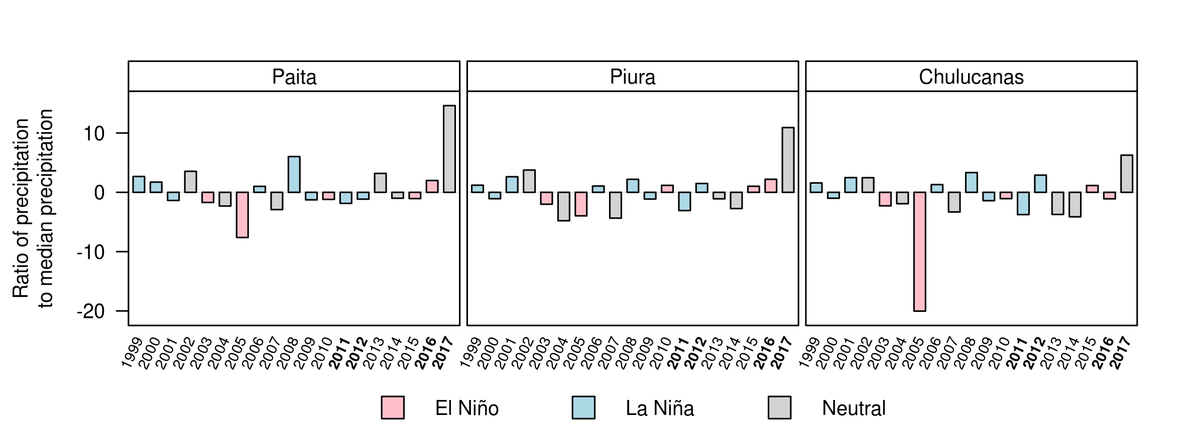

Fig. 1: The study area (Panels a and c) given as a false-color composite representing the change in NDVI across the observed years. The 2011 NDVI serves as the basis for the interannual change (Panel b). Green pixels occur where the interannual difference in NDVI was greatest between 2017 and 2011. Blue color tones indicate that NDVI differences were greatest between 2012 and 2011 (red: between 2016 and 2011). Panel d: Ratio between annual precipitation and median precipitation (median Paita: 25.9mm, median Piura: 71.4mm, median Chulucanas: 272.4mm) measured at the three automated climatic stations (see section 2.2.2). In case the precipitation was smaller than the median, we computed the ratio as: 1 / (precipitation / median(precipitation)) * -1. The years in which vegetation sampling took place are printed in bold (x-axis). The ENSO phases are in correspondence with the ONI index of the NOAA Climatic Prediction Center (http://origin.cpc.ncep.noaa.gov/products/analysis_monitoring/ensostuff/ONI_v5.php). Please note also that we have intentionally left out the 1997/1998 Super-Niño event since this would have dominated the y-axis.

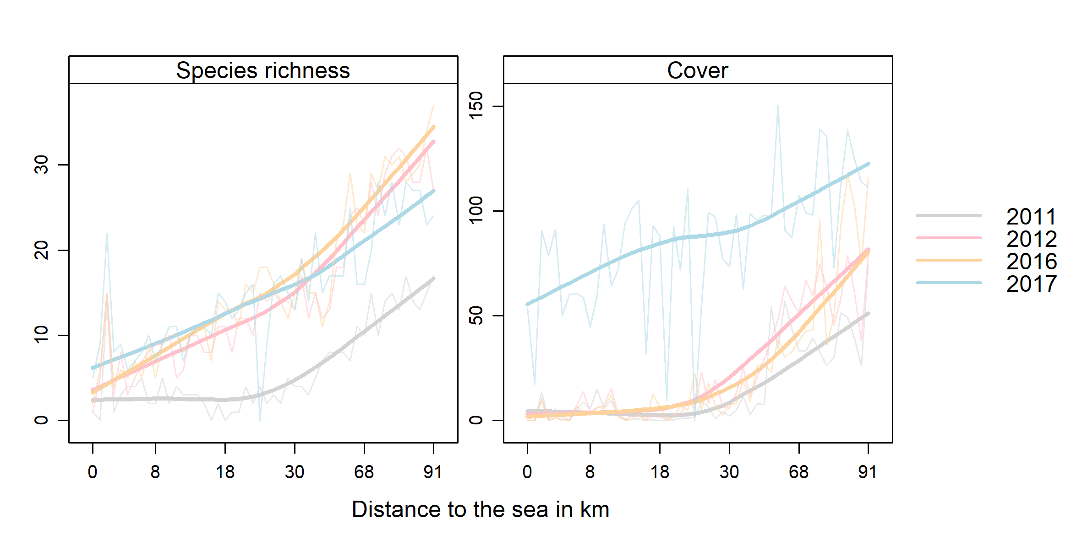

Fig. 2: Species richness (left panel) and plant cover (right panel, in %) along the spatio-temporal gradient. To aid visual interpretation, loess smoothers were added.

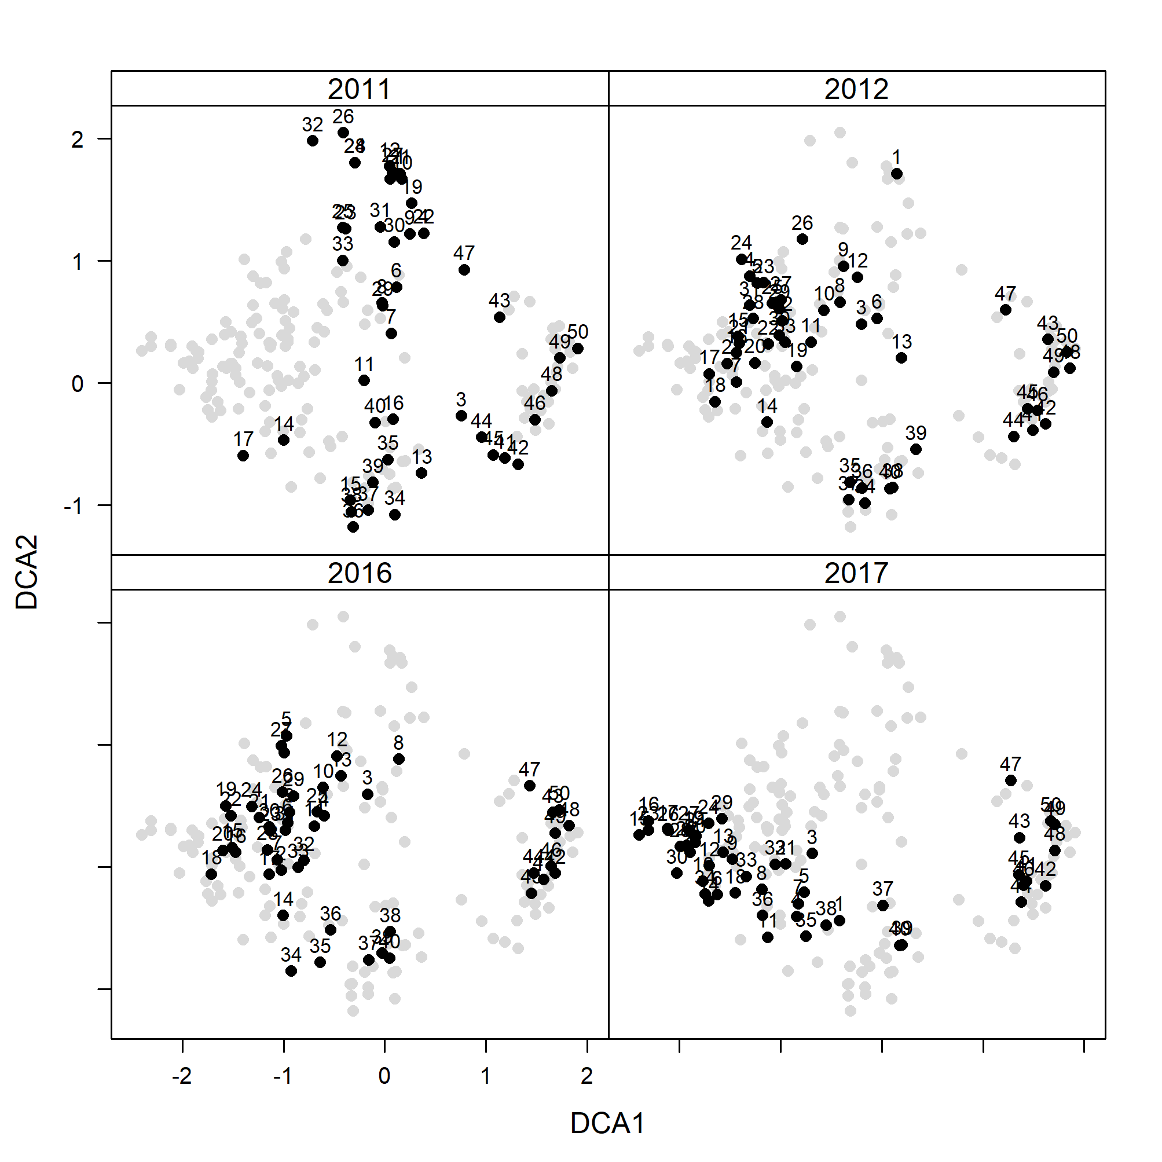

Fig. 3: Plotting the scores of the second DCA axis against the scores of the first DCA axis. To better visualize the cross-annual changes, the scores of all years were added in light gray to the background of each panel. The black dots refer to the scores of the year given in the strip of each panel. Numbers above the dots are the plot IDs which were ordered in accordance with the distance to the sea, i.e. plot number 1 is closest and plot number 50 farthest away from the sea.

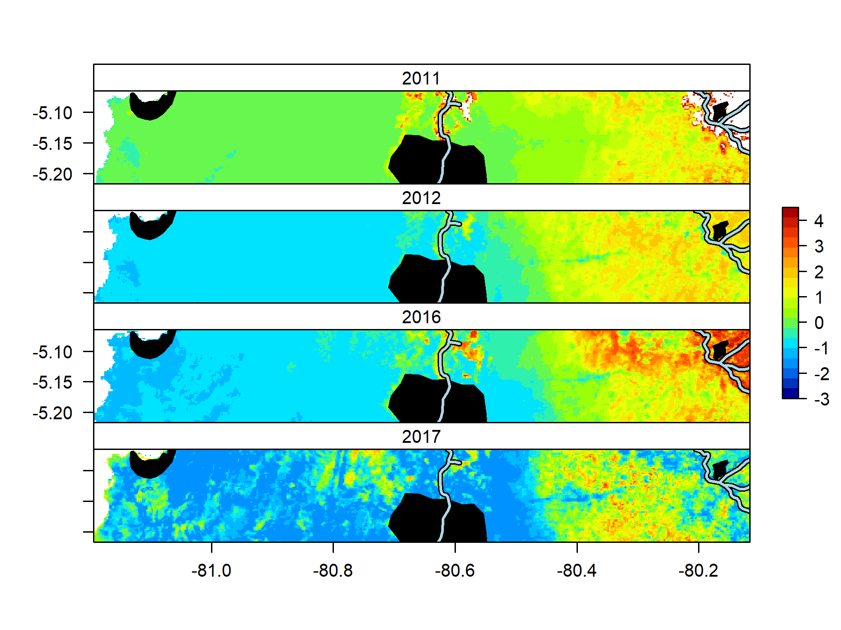

Fig. 4: Spatial prediction of the floristic composition along the cross-section for different ENSO episodes The urban boundaries of the cities Paita, Piura and Chulucanas are displayed in black. The Piura River and its tributaries are represented by light blue lines with a black contour.

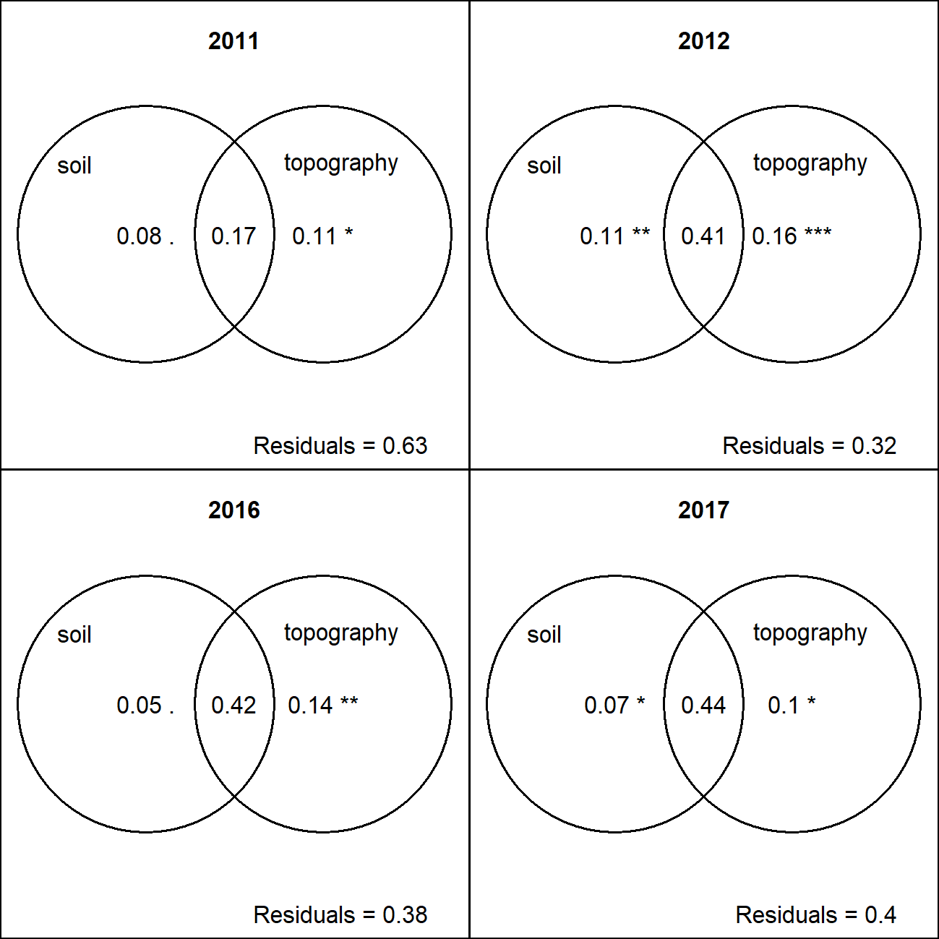

Fig. 5: Fractions explaining the floristic composition represented by the first two DCA axes in accordance with a RDA variation partitioning. Numbers within the circles represent the adjusted R2. Significance levels of the pure fractions are given in the soil and topography circles as . (<0.1), * (<0.05), ** (<0.01), and *** (<0.001).



Fig. 6. Results of the irrigation-nutrient experiment. The dashed line refers to the water input, note that the left y-axis was log-transformed. The solid lines represent the observed plant coverage in % (right y-axis).

# References

Ashok, K. et al. 2007. El Niño Modoki and its possible teleconnection. - J. Geophys. Res. 112: C11007.

Blanchet, F. G. et al. 2008. Forward selection of explanatory variables. - Ecology 89: 2623–2632.

Bowers, J. E. 1997. Demographic patterns of Ferocactus cylindraceus in relation to substrate age and grazing history. - Plant Ecol. 133: 37–48.

Brenning, A. 2012. Spatial cross-validation and bootstrap for the assessment of prediction rules in remote sensing: The R package sperrorest. - IEEE Int. Symp. Geosci. Remote Sens. IGARSS: 5372–5375.

Brown, J. H. 2014. Why are there so many species in the tropics? - J. Biogeogr. 41: 8–22.

Brown, J. R. and Archer, S. 1990. Water relations of a perennial grass and seedling vs adult woody plants in a subtropical savanna, Texas.: 11.

Brown, J. H. et al. 1997. Reorganization of an arid ecosystem in response to recent climate change. - Proc. Natl. Acad. Sci. 94: 9729–9733.

Cai, W. et al. 2014. Increasing frequency of extreme El Niño events due to greenhouse warming. - Nat. Clim. Change 4: 111–116.

Capotondi, A. et al. 2015. Understanding ENSO Diversity. - Bull. Am. Meteorol. Soc. 96: 921–938.

Espinosa, C. I. et al. 2011. What factors affect diversity and species composition of endangered Tumbesian dry forests in Southern Ecuador? - Biotropica 43: 15–22.

Fraser, B. 2017. Peru’s floods teach tough lessons. - Nature 544: 2.

Gutiérrez, J. R. et al. 2000. Variation in vegetation and seed bank in a Chilean semi-arid community affected by ENSO 1997. - J. Veg. Sci. 11: 641–648.

Hijmans, R. J. et al. 2005. Very high resolution interpolated climate surfaces for global land areas. - Int. J. Climatol. 25: 1965–1978.

Hill, M. O. and Gauch, H. G. 1980. Detrended correspondence analysis: an improved ordination technique. - Vegetatio 42: 47–58.

Holmgren, M. and Scheffer, M. 2001. El Niño as a window of opportunity for the restoration of degraded arid ecosystems. - Ecosystems 4: 151–159.

Holmgren, M. et al. 2001. El Niño effects on the dynamics of terrestrial ecosystems. - Trends Ecol. Evol. 16: 89–94.

Holmgren, M. et al. 2006. Extreme climatic events shape arid and semiarid ecosystems. - Front. Ecol. Environ. 4: 87–95.

IPCC 2014. Climate Change 2014: Synthesis report. Contribution of working groups I, II and III to the fifth assessment report of the Intergovernmental Panel on Climate Change.

Kao, H.-Y. and Yu, J.-Y. 2009. Contrasting Eastern-Pacific and Central-Pacific Types of ENSO. - J. Clim. 22: 615–632.

Kinugasa, T. et al. 2012. Increasing nitrogen deposition enhances post-drought recovery of grassland productivity in the Mongolian steppe. - Oecologia 170: 857–865.

Kogan, F. and Guo, W. 2017. Strong 2015-2016 El Niño and implication to global ecosystems from space data. - Int. J. Remote Sens. 38: 161–178.

Kosaka, Y. and Xie, S.-P. 2013. Recent global-warming hiatus tied to equatorial Pacific surface cooling. - Nature 501: 403–407.

Land Processes Distributed Active Archive Center 2018. LP DAAC, located at the U.S. Geological Survey (USGS) Earth Ressources Observation and Science (EROS) Center.

Laurance, S. G. W. et al. 2010. Influence of soils and topography on Amazonian tree diversity: a landscape-scale study. - J. Veg. Sci. 21: 96–106.

Lopez, B. C. et al. 2006. Climatic signals in growth and its relation to ENSO events of two Prosopis species following a latitudinal gradient in South America. - Glob. Change Biol. 12: 897–906.

Meyer, H. et al. 2018. Improving performance of spatio-temporal machine learning models using forward feature selection and target-oriented validation. - Environ. Model. Softw. 101: 1–9.

Miles, L. et al. 2006. A global overview of the conservation status of tropical dry forests. - J. Biogeogr. 33: 491–505.

Missouri Botanical Garden 2018. Tropicos.

Muenchow, J. et al. 2013a. Woody vegetation of a Peruvian tropical dry forest along a climatic gradient depends more on soil than annual precipitation. - Erdkunde 67: 241–248.

Muenchow, J. et al. 2013b. Coupling ordination techniques and GAM to spatially predict vegetation assemblages along a climatic gradient in an ENSO-affected region of extremely high climate variability. - J. Veg. Sci. 24: 1154–1166.

Muenchow, J. et al. 2013c. Soil texture and altitude, respectively, largely determine the floristic gradient of the most diverse fog oasis in the Peruvian desert. - J. Trop. Ecol. 29: 427–438.

Muenchow, J. et al. 2017. RQGIS: Integrating R with QGIS for statistical geocomputing. - R J. 9: 409–428.

Muenchow, J. et al. 2018. A review of ecological gradient research in the Tropics: identifying research gaps, future directions, and conservation priorities. - Biodivers. Conserv. 27: 273–285.

Oksanen, J. et al. 2018. vegan: Community ecology package.

Peña, M. A. and Brenning, A. 2015. Assessing fruit-tree crop classification from Landsat-8 time series for the Maipo Valley, Chile. - Remote Sens. Environ. 171: 234–244.

Peña-Claros, M. et al. 2012. Soil Effects on Forest Structure and Diversity in a Moist and a Dry Tropical Forest: Tropical Forest Characteristics Influenced by Soil. - Biotropica 44: 276–283.

Peres-Neto, P. R. et al. 2006. Variation partitioning of species data: Estimation and comparison of fractions. - Ecology 87: 2614–2625.

Portillo-Quintero, C. A. and Sánchez-Azofeifa, G. A. 2010. Extent and conservation of tropical dry forests in the Americas. - Biol. Conserv. 143: 144–155.

R Core Team 2018. R: A Language and Environment for Statistical Computing. - R Foundation for Statistical Computing.

Ramírez, I. J. and Briones, F. 2017. Understanding the El Niño Costero of 2017: The Definition Problem and Challenges of Climate Forecasting and Disaster Responses. - Int. J. Disaster Risk Sci. 8: 489–492.

Richter, M. and Ise, M. 2005. Monitoring plant development after El Niño 1997/98 in northwestern Perú. - Erdkunde 59: 136–155.

Richter, M. et al. 2018. Jedes Kind ist anders. El Niño-Variabilität in Nordwest-Peru. - Geogr. Rundsch. 7–8: 46–51.

Rollenbeck, R. et al. 2015. Climatic cycles and gradients of the El Niño core region in North Peru. - Adv. Meteorol. 2015: 10.

Ronnenberg, K. and Wesche, K. 2011. Effects of fertilization and irrigation on productivity, plant nutrient contents and soil nutrients in southern Mongolia. - Plant Soil 340: 239–251.

Ruß, G. and Brenning, A. 2010. Data mining in precision agriculture: Management of spatial information. - Comput. Intell. Knowl.-Based Syst. Des.: 350–359.

Salazar, P. C. et al. 2018a. Intraspecific leaf functional trait variability of eight Prosopis pallida tree populations along a climatic gradient of the dry forests of northern Peru. - J. Arid Environ.: 0–1.

Salazar, P. C. et al. 2018b. Effect of climate and ENSO events on Prosopis pallida forests along a climatic gradient. - For. Int. J. For. Res. in press.

Schmidtlein, S. et al. 2012. Mapping plant strategy types using remote sensing (D Rocchini, Ed.). - J. Veg. Sci. 23: 395–405.

Schratz, P. et al. 2018. Performance evaluation and hyperparameter tuning of statistical and machine-learning models using spatial data. - ArXiv180311266 Cs Stat in press.

Sitters, J. et al. 2012. Rainfall-Tuned Management Facilitates Dry Forest Recovery. - Restor. Ecol. 20: 33–42.

Soethe, N. et al. 2008. Nutrient availability at different altitudes in a tropical montane forest in Ecuador. - J. Trop. Ecol. 24: 397–406.

Throop, H. L. et al. 2012. Response of dominant grass and shrub species to water manipulation: an ecophysiological basis for shrub invasion in a Chihuahuan Desert Grassland. - Oecologia 169: 373–383.

von Wehrden, H. et al. 2009. Pluralism and diversity: trends in the use and application of ordination methods 1990-2007. - J. Veg. Sci. 20: 695–705.

Wang, G. et al. 2017. Continued increase of extreme El Niño frequency long after 1.5 °C warming stabilization. - Nat. Clim. Change: 1–6.

Whitford, W. G. and Steinberger, Y. 2011. Effects of simulated storm sizes and nitrogen on three Chihuahuan Desert perennial herbs and a grass. - J. Arid Environ. 75: 861–864.

Whittaker, R. H. 1967. Gradient analysis of vegetation. - Biol. Rev. 42: 207–264.

Wood, S. N. 2017. Generalized Additive Models: An Introduction with R. - Chapman and Hall/CRC.