User guide – CryoGrid

GEO4432 – The Surface Energy Balance in Cold Environments

# General

This guide will help you run CryoGrid and evaluate the results, even if you don’t have any Matlab skills. This is not a workflow, but rather a document describing data structure and controls to CryoGrid.

# File and data structure

## Folder structure

All relevant files are stored in a folder called CryoGrid (e.g. ‘M:\Dokumenter\CryoGrid\’) which contains several subfolders and some .m (Matlab) files. CryoGrid is operated using the ‘main.m’, which interacts with the other files folder structure. In ‘CryoGrid\forcing’ example files of forcing data for some previous years are found. These files contain the meteorological input in the format required to force a realization (run) of CryoGrid. For each realization there is a folder in ‘\CryoGrid\results’, see e.g. the subfolder ‘\test_excel’. The folder contains two excel sheets with information about the physical constants required and a control sheet with the model setup for this specific realization. After a realization is run the result/output is stored as one .mat file for each year in this subfolder.

If you only want to run realizations wit CryoGrid, you will only need to use the files in ‘\CryoGrid’, and the subfolders ‘\forcing’ and ‘\results’.

## Forcing data

Forcing data is stored as .mat files in ‘\CryoGrid\forcing’. A forcing file contains a struct called “FORCING”, and the data is stored as vectors in “FORCING.data” (see Figure 1). To run CryoGrid the following variables have to be provided for each time step:

|  |  |  |
| --- | --- | --- |
| **Variable** | **Name** | **Unit** |
| Time | t_span | Matlab time |
| Incoming Longwave radiation | Lin | W/m^2 |
| Incoming Shortwave radiation | Sin | W/m^2 |
| Air temperature | Tair | °C |
| Windspeed | wind | m/s |
| Precipitation rate, snow | snowfall | mm/day |
| Precipitation rate, rain | rainfall | mm/day |
| Specific humidity | q | g/kg |

Example files of forcing data are provided in the correct folder, but updated forcing (or for other sites) can be obtained using the XXXXXXXX script in ‘\CryoGrid\forcing\tools’. This requires some knowledge of programming in Matlab, and is described later in this guide.

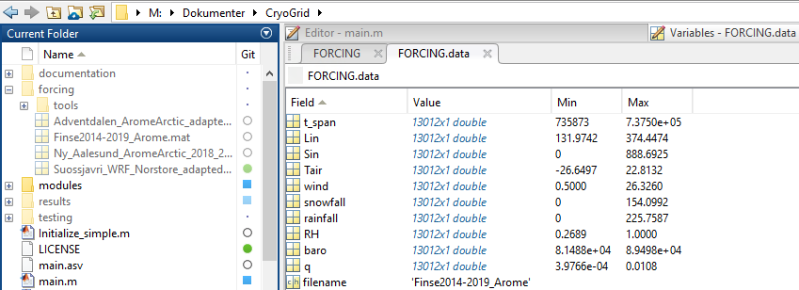

Figure 1

## Output data

CryoGrid stores output data as .mat files in the same folder as the control (excel) sheet (\CryoGrid\results\”run_number”. Where run_number is specified in main.m). The format of the output data is defined by which ‘OUT’ module is selected in the control sheet. Currently there are two options, ‘OUT_all’ and ‘OUT_GEO4432’, where the first one outputs all raw model data available. ‘OUT_GEO4432’ outputs data which is already structured and processed so it is ready for visualization. For this course we recommend that ‘OUT_GEO4432’ is used, and this data structure is described below.

The general output format is defined in the control sheet, where the timestep and save times is set, as well as the vertical grids extent and resolution. By default the results are then outputted into the run folder (where the control sheet is stored) for each hydrological year. Each output file (.mat) consists of a ‘1x1 OUT_GEO4432’ object called ‘out’ which contains all the output metadata and results. The vector ‘out.TIMESTAMP’ corresponds to the output times of the results, and the struct ‘out.RESULTS’ which contains the variables listed below. The temperature is given as a matrix with rows corresponding to the altitudes in ‘out.RESULTS.Grid’ and columns corresponding to the times in ‘out.TIMESTAMP’. The other vectors contain one value per timestamp.

|  |  |  |  |
| --- | --- | --- | --- |
| **Variable** | **Name** | **Unit** | **Type** |
| Grid | Vertical grid | m.a.s.l. | vector |
| Qh | Sensible heat flux | W/m^2 | vector |
| Qe | Latent heat flux | W/m^2 | vector |
| Lin | Incoming longwave radiation | W/m^2 | vector |
| Lout | Outgoing longwave radiation | W/m^2 | vector |
| Sin | Incoming longwave radiation | W/m^2 | vector |
| Sout | Outgoing longwave radiation | W/m^2 | vector |
| T_surf | Surface temperature | °C | vector |
| d_swe | Snow depth | m | vector |
| swe | Snow Water Equivalent | m | vector |
| T | Temperature | °C | matrix |

# How to run a realization of CryoGrid

Before a realization of CryoGrid can be run the control sheet with the initialization info must be created and stored in the results folder. For your own realization, you can use the function ‘write_controlsheet.m’ found in ‘\CryoGrid’. The control sheet needs to be stored in a folder in ‘\CryoGrid\results’, and the folder and the control sheet must have the same name. You also need to add the file called ‘CONSTANTS_excel.xlsx’ to this folder, See Figure 2. You need to fill out the following sections of the control sheet:

* OUT: Defines how results are outputted. By default results are stored on the 1. September every year, because this delimits the data into hydrological years and avoids splitting the snow season. Data is usually stored a few times a day (CryoGrid runs with variable time steps of max. 6 minutes, so storing all would be too much).
* FORCING: Contains information about the forcing data. NOTE: “filename” must be the whole name (with .mat extension) of the file containing the forcing data, which must be in the ‘\CryoGrid\forcing’ folder.
* STRATIGRAPHY: STRAT_layers defines the vertical soil structure, which by default is 10 m of soil underlain by bedrock. STRAT_classes defines which model modules which are used for the realization, needs to be filed in (e.g. as in Figure 3). SRAT_linear contains the initial ground temperatures, and can be edited according to location.

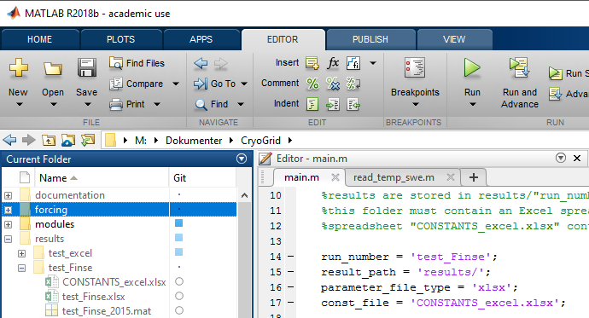 Figure 2: Example of the required folder location of the control sheet (left) and how main.m references to this file (right).

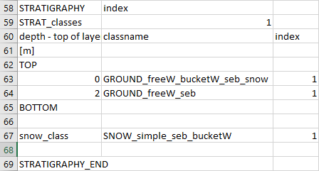A realization of CryoGrid is run via the main.m file. The only thing you need to change in this file is the “run_number” in line 14, so that it matches the folder and file name of the control sheet.

Figure 3: The recommended stratigraphy of classes.

Now a realization of CryoGrid can be initiated by running the main.m file (you must be in the same folder as the main.m file). While CryoGrid is running it lets you track the progress by writing the time and date of each time step which is outputted in the command window.

The output can be visualized by using the different sections in ‘visualize_output.m’. Feel free to use this code as a basis for further analysis of your data.

## Creating forcing data