Plasma Exploration Project
Julia Nordstrom
27 April 2026
Particle Trapping in a Dipole Magnetic Field
Relevant physics:
I aimed to explore the physics of particle trapping in this project.
As in a magnetic mirror machine, a dipole magnetic field should exhibit particle trapping behavior. Since the field lines of a dipole field should be mainly in the z-direction, I would expect the “mirror force” to be of the form $F_{m}=q(v_{x}B_{y}-v_{y}B_{x})$. Thus we should see particles moving along the field lines (essentially in the z-direction) of a dipole, oscillating between the poles.
Particle trapping of this sort is seen in Earth’s magnetosphere, where particles bounce between poles with a frequency of roughly 0.1 s.
Method:
I used PlasmaPy’s MagneticDipole function to create a dipole field that could be used to fill a grid that particles would then be allowed to move in. I then used PlasmaPy’s ParticleTracker module to do the particle tracing. ParticleTracker uses a Boris push algorithm to track charged particles moving in electric and magnetic fields. The ParticleTracker package allowed for several termination conditions, including a termination condition based on whether the particles had left the grid or a termination condition based on the time elapsed. Since ideally, my particles would never leave the grid because of trapping, I chose to use an elapsed time termination condition, although this had the downside that some runs would continue past when some of the particles had left the grid of magnetic field.
The first sanity check that I did was to verify that the MagneticDipole function produced something that looked like a dipole field. Fig 1 shows a contour plot of the z-component of the magnetic field over a slice of the xz plane.
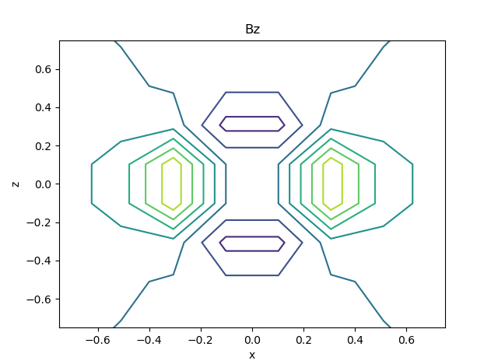
Fig 1: contour plot of the z-component of the dipole magnetic field in the xz-plane with y=0.
Then, I wanted to make sure that I could see gyromotion. I set the time step to be very small and ran the simulation for a short amount of time and was able to see the particle gyrating around the field line. This created a plot with far higher resolution than I would need for the trapping runs, but I was encouraged to see that the simulation had the physical effects on a particle that I would expect.
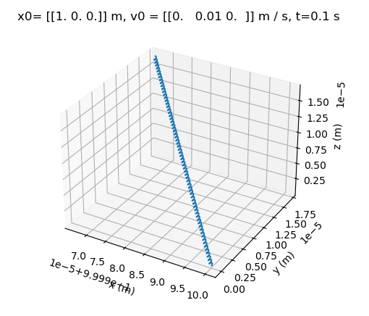
Fig 2: extreme time resolution creates a plot that displays particle gyromotion around a magnetic field line
Results and interpretation:
To do the actual simulation, I initialized a number of particles into the magnetic field grid with random positions and velocities. Because of the randomness of initial conditions, some particles would quickly escape the grid and some particles would exhibit trapped behavior. A run like this is shown on the left side of Fig 3. The particle from this run that seems to exhibit trapped behavior is plotted in orange on the left. The right plot of Fig 3 shows that particle’s position in x, y, and z vs time index, and it clearly displays bouncing between set points in x, y, and z.
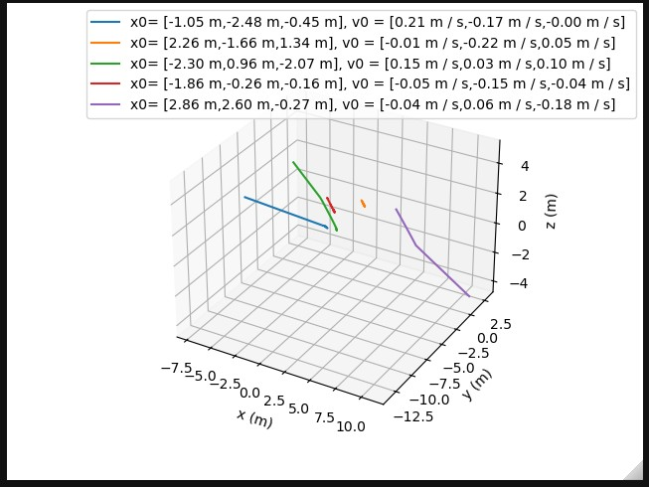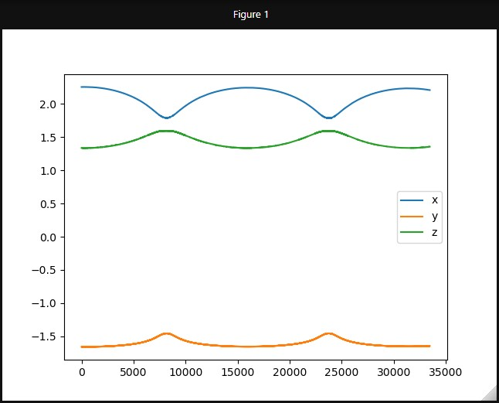
Fig 3: (left) a 3D plot of the trajectory of 5 particles with initial positions randomly chosen between -3 and 3 m and initial velocities randomly chosen between -0.25 and 0.25 m/s. (right) the trajectory of the orange particle from the left plot (x0=(2.26,-1.66,1.34) m; v0=-0.01,-0.22,0.05) m/s) vs time index.
Plots of a run that included only one particle are shown in Fig 4. As above, this particle clearly exhibits some bouncing behavior. I would have expected the particle’s bouncing behavior to be symmetric around z=0, though, and I haven’t been able to find any runs that exhibit the symmetric bouncing behavior I would expect. The rightmost panel of this figure shows a plot of $v_{x}B_{y}-v_{y}B_{x}$, which is proportional to the mirror force, along the trajectory of the particle. This plot shows extremely quick oscillatory motion between positive and negative values, and while there does seem to be correlation between the peaks on the mirror force plot and the bounce points on the trajectory plot, it appears that the particle is experiencing the mirror force in a very rapid oscillation, which would not allow for the particle to move significantly, perhaps leading to the trapping behavior displayed in a small region of space, rather than the expected larger scale trapping. Unfortunately, I have no physical explanation for why this is happening in my simulation.
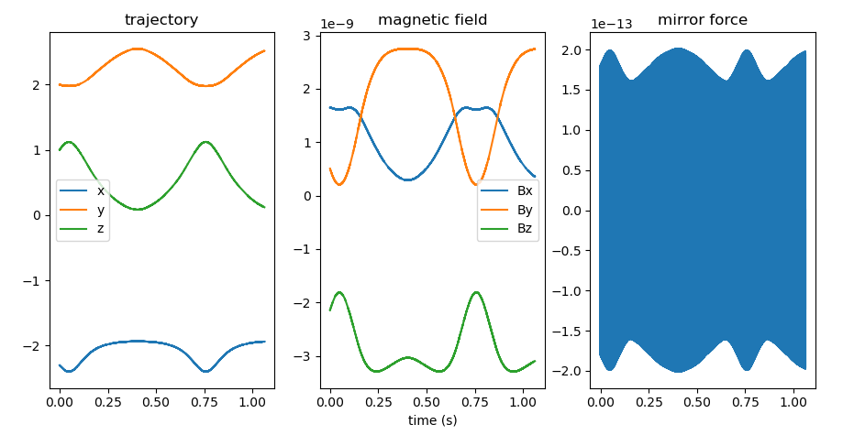
Fig 4: a particle with initial position (-2.3, 2, 1) m and initial velocity (-0.01,-0.2,0.01) m/s. (left) the particle’s trajectory vs time. (center) the magnetic field the particle experiences along its trajectory vs time. (right) the mirror force v_{x} B_{y}-v_{y}B_{x} the particle experiences. This plot shows extremely fast oscillatory behavior.

Stern, David P. Trapped Radiation. https://pwg.gsfc.nasa.gov/Education/wtrap1.html. 25 November 2001.

