Problem set 4
Put your name here
Table of contents

# load packages
library(tidyverse)
── Attaching core tidyverse packages ──────────────────────── tidyverse 2.0.0 ──
✔ dplyr 1.1.4 ✔ readr 2.1.5
✔ forcats 1.0.0 ✔ stringr 1.5.1
✔ ggplot2 3.5.1 ✔ tibble 3.2.1
✔ lubridate 1.9.3 ✔ tidyr 1.3.1
✔ purrr 1.0.2
── Conflicts ────────────────────────────────────────── tidyverse_conflicts() ──
✖ dplyr::filter() masks stats::filter()
✖ dplyr::lag() masks stats::lag()
ℹ Use the conflicted package (<http://conflicted.r-lib.org/>) to force all conflicts to become errors
set.seed(1234) # For reproducibility
Read the survey data.
# Load the survey data from class
survey <- read_csv("../data/distance-to-school_pet-preferences.csv")
In this solution, we’ll use simulated data.
# simulate survey data
sample_size <- 30
survey <- tibble(
name = 1:sample_size,
distance = round(runif(sample_size, min = 0.3, max = 20), 1),
pet_preference = sample(c("dogs", "cats"), size = sample_size, replace = TRUE)
)
Step 1: Calculate an estimate based on your sample
# compute rating difference in the sample
survey_estimate <- survey |>
group_by(pet_preference) |>
summarize(avg_distance = mean(distance)) |>
summarise(diff = avg_distance[pet_preference == "dogs"] - avg_distance[pet_preference == "cats"]) %>%
pull(diff)
survey_estimate
[1] -0.6533333
In our sample, cat people live further away, on average.
Step 2: Use simulation to invent a world where the true effect is null.
Simulate a population, say all students in Paris, i.e. 700’000 students.
# simulate survey data
population_size <- 700000
population <- tibble(
name = 1:population_size,
distance = round(runif(population_size, min = 0.3, max = 20), 1),
pet_preference = sample(c("dogs", "cats"), size = population_size, replace = TRUE)
)
Simulate 1000 samples with the same sample size that your estimate is based on. Store the estimates of this simulation in a vector called sampling_distribution.
n_simulations <- 1000
sample_size <- 30
differences <- c() # make an empty vector
for (i in 1:n_simulations) {
# draw a sample of 20'000 films
sample <- population |>
sample_n(sample_size)
# compute rating difference in the sample
estimate <- sample |>
group_by(pet_preference) |>
summarize(avg_distance = mean(distance)) |>
summarise(diff = avg_distance[pet_preference == "dogs"] - avg_distance[pet_preference == "cats"]) %>%
pull(diff)
differences[i] <- estimate
}
Step 3: Plot how well this estimate fits into your null world.
ggplot(data.frame(differences), aes(x = differences)) +
geom_histogram() +
geom_vline(xintercept = survey_estimate, color = "red", size = 1, linetype = "dashed") +
labs(title = "Sampling distribution based on simulated data",
x = "Distance to school",
y = "Frequency") +
theme_minimal()
Warning: Using `size` aesthetic for lines was deprecated in ggplot2 3.4.0.
ℹ Please use `linewidth` instead.
`stat_bin()` using `bins = 30`. Pick better value with `binwidth`.
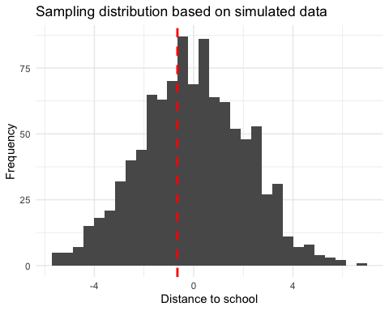
Step 4: Calculate the probability that your estimate could exist in the null world.
Use the standard deviation of your sampling_distribution to transform your initial estimate in a z-value.
sd_sampling_distribution <- sd(differences)
z_scaled_estimate = survey_estimate / sd_sampling_distribution
z_scaled_estimate
[1] -0.3074499
Based on this, calculate the p-value.
# the pnorm() function gives the cumulative probability from the standard normal distribution
# Two-tailed (i.e. a value "at least as extreme as", in both directions)
probability <- 2 * (1 - pnorm(z_scaled_estimate))
# in our case, the probability is reeaally low (practically 0)
probability
[1] 1.241499
Step 5: Decide if your estimate is statistically significant.
Use a significance threshold (the value at which you consider your estimate sufficiently unlikely to have occurred in the Null World) of 0.05
# significance levels are often called "alpha"
alpha <- 0.05
probability < alpha
[1] FALSE
No, our estimate is not statistically significant: We cannot cannot reject the Null hypothesis that in fact, in the population, there is no true effect. In other words, in a world where there is no effect, it does not appear sufficiently unlikely to randomly sample an estimate at least as big as the one we found.
- Is this result surprising to you or not? Explain.
This result is probably not surprising, since we would hardly expect a relationship between pet preferences and distance to school a priori.

