Volunteer Report Cité-Unis

Abstract
This report analyzes survey data for four different cohorts of Cité-Unis volunteers who did their service civique (2020-2024).

Volunteer Report Cité-Unis

Introduction
This report analyzes survey data for four different cohorts of Cité Unis volunteers who did their service civique in France between 2020 and 2024.
Section 2 provides information on who the volunteers are, in terms of age, sex, level of education and geographical location. Section 3 provides an overview on how many volunteers answered to questionnaires at different stages of their service civique (every volunteer is asked to fill out three questionnaires in total).
In Section 4, we look at how volunteers have changed certain attitudes and views during their service civique, and which demographic and other factors are associated with changes.
We then look at several outcomes of interest in detail, namely whether volunteers end their contract early (Section 5), how satisfied they are (Section 6), and how confident they are about their future (Section 7.2). For these outcomes, we analyze whether there are trends across the different cohorts, and whether the outcomes are associated with demographic and other factors.
In Section 8 we investigate demographic differences between different key programs offered by Cité Unis for their volunteers.
The report ends with a brief conclusion on methodological notes for future questionnaires.
For these analyses, we rely on questionnaires collected by Cité Unis for four different cohorts of volunteers who did their service civique for a year (2020-2021; 2021-2022; 2022-2023; 2023-2024). These questionnaires are very extensive. For the present analyses, we selected a subset of key questions (a full list can be found in the codebook).
Before diving into the results, a note on caution in interpreting the results presented in is report: Whenever we speak of “predictions” that simply means statistical associations—mere observations of differences between groups. This report does not provide any evidence that would warrant causal conclusions—answers as to why we observe these differences.
Because the data underlying this report is observational and—for most of it—does not allow to track opinion change (because most questions have only been asked once per cohort), the main objective of this report is not to provide specific and definitive answers. Instead, the aim of this report is to help Cité Unis in identifying patterns and sparking question that may inform new evaluation procedures. The quantitative results presented here can act as pointers, but they are not problem diagnoses. They always need to be accompanied by qualitative assessments of why we observe certain differences, and what could or could not be done about them.

Who are the volunteers ?
In this section, we review some demographic variables in detail. An extensive summary table with sample demographics across the different cohorts can be found in Tables.

Geographic location
Volunteers came from 80 different departments (see Figure 1). On average, across the different cohorts, most volunteers came from Bouches-du-Rhône (n = 404), followed by Nord (n = 350) and Seine-Saint-Denis (n = 316).
Overall, there has been a steady increase in volunteers, from 6386 in 20-21 to 7848 in 23-24, and an average increase of 490.4 per year. Since the 20-21 cohort, each departement has on average increased by 26.7. There were 51 departements who saw an increase, and 14 who saw a decrease (see Figure 2). For details on the trend of each departement, see Tables.

Age
As shown in Figure 3, across all promos, the majority of volunteers is between 18 and 20 years old. The share of the age group of 16-17 has been increasing rapidly, roughly doubling from 13% in 2020 to 24% in 2024.

Education
Figure 4 shows that volunteers with a “Bac + 3 et plus” are relatively rare, compared to the other education levels. The share of volunteers with a “Bac à Bac + 2” has been constantly decreasing, from 48% in 2020-21 to 40% in 2023-24. By contrast, volunteers “Infra-bac”, have been increasing from 32% in 2020-21 to 43% in 2023-24.

Sex
On average, more women (~60%) are being volunteers than men. This difference is relatively stable across cohorts—if anything, the data suggests a slight trend towards an increasing share of women over time (Figure 5).

Attrition
As part of their service civique, each volunteer is asked to fill out three different questionnaires: the first one at the onset of their service civique (later on referred to as “q1”), the second one at the end (“q2”), and the third one six months after their service civique (“q1”). Answering these questionnaires is voluntary, and response rates typically decline considerably from the first to the third questionnaire. These declining response rates are referred to as “attrition”. Some volunteers do not even respond to any one questionnaire.
Attrition can can have many causes. Here we distinguish between two explanations: ruptures, i.e. volunteers ending their service civique early (Section 5) and survey fatigue, i.e. volunteers who continue their service civique but do not fill out the questionnaires (Figure 7).
Figure 6 shows attrition generally, while Figure 7 excludes ruptures, thereby giving an estimate of survey fatigue. This latter figure shows that survey fatigue is an issue, but also suggests that there is a slightly positive trend towards reduced survey fatigue: more and more volunteers seem to answering the questionnaires at least for the first two questionnaires (q1 and q2), but less so for the third questionnaire (q3).

How have volunteers changed their attitudes?
In the selection of variables made for this report, there are only two questions that volunteers have been asked at several time points during their service civique:
- “Avez-vous voté lors des dernières élections (locales ou nationales) ?” (Section 4.1)
- “En général, pensez-vous que votre action individuelle peut contribuer à changer la société ?” (Section 4.2).

Voting
In this section, we look at how volunteers have changed regarding their voting behavior. Voting behavior was measured with the question: “Avez-vous voté lors des dernières élections (locales ou nationales) ?”, which has been asked at time points q1 and q2. Figure 8 shows that, averaged across all cohorts and time points, the majority of volunteers reports having voted.
In the following sections, we investigate how volunteers have changed in answering this question, throughout their service civique. For these analyses, we only consider those volunteers who have answered the question at both time points, q1 and q2. Changes towards “Yes” or “No” can have happened either from the respective other option, or from the third answer option: “Vous n’aviez pas l’âge de voter ou vous n’étiez pas inscrit.e sur les listes électorales”, which is abbreviated in the plots below as “Pas sur les listes”. We look at the different cohorts separately (promo 2020-21, Figure 9; promo 2021-22, Figure 10; 2022-23, Figure 11; 2023-24, Figure 12).
The following sections reveal considerable differences between the cohorts. For example, in 2020-21 and 2021-22, many volunteers reported changes in voting behavior, but in opposite directions: In 2020-21, 24% of volunteers changed towards “No”, outweighing those who changed to “Yes” (6%) by far. Inversely, in 2021-22, 35% of volunteers changed towards “Yes”, while only 8% changed towards “No”.
It is not clear why we observe these differences. One explanation might be that volunteers care more about national elections than local ones (or vice verse). If that is the case, we would expect changes in voting behavior to be dependent on whether there were national or local elections happening during the year of a cohort’s service civique.

Promo 2020-21
Figure 9 shows change in volunteers’ reported voting behavior for the promo “2020-21”.

Promo 2021-22
Figure 10 shows change in volunteers’ reported voting behavior for the promo “2021-22”.

Promo 2022-23
Figure 11 shows change in volunteers’ reported voting behavior for the promo “2022-23”.

Promo 2023-24
Figure 12 shows change in volunteers’ reported voting behavior for the promo “2023-24”.

Which demographic factors are associated with change of voting intentions?
To determine which demographic variables are associated with change of voting intentions, we ran statistical models. These models are explained in the Appendix (Section 12.1). Here, we only report the variables that were statistically significant in these models.

Sex.
As shown in Figure 13, more female volunteers changed towards “Yes” than towards “No”. Among male volunteers, the opposite was true.

Age.
Figure 14 compares changes in voting behaviour between age groups. Among the 18 to 20 year-olds, the share of volunteers who have changed towards “Yes” was highest. One interpretation could be, that the service civique might encourage this age group in particular to vote. However, an alternative explanation could be that this group could vote for the first time during their service civique, as the legal voting age in France is 18.
On a side note, looking at the 16 to 17 age groups shows that some answers were erroneous. In France, the legal voting age is 18. Therefore, the 16 to 17 year-olds, at least at the beginning of their service civique (q0/q1), have never been on a voting list before. However, as shown in Figure 15 there are 443 volunteers who answered “No” at q0/q1 (which technically is true, but not the most specific answer option), and 20 who answered “Yes” (probably not reading the question carefully or accidentally clicking on the wrong response).

Zone of Residence.
Figure 16 shows that volunteers from “QPV” and ZRR” residential areas had a greater tendency to change towards “No”, compared to “Yes”. By contrast, in particular in rural areas, but also slightly in urban ones, more volunteers changed towards “Yes”.

Education.
As shown in Figure 17, the share of volunteers who changed towards “Yes” was particularly high among those with a level of education corresponding to “Bac+2”. In all other education segments, the share of those changing towards “No” was higher.

Individual action for society
In this section, we look at how volunteers have changed regarding their perception on whether their individual action can contribute to changing society. This was measured with the question: “En général, pensez-vous que votre action individuelle peut contribuer à changer la société ?”, which has been asked at time points q1 and q3. We look at the different cohorts separately (promo 2020-21, Figure 18; promo 2021-22, Figure 10; 2022-23, Figure 11; 2023-24, Figure 12).
Descriptively, there is no clear positive or negative trend. On average, across all cohorts, slightly more people are changing towards “No” or “Not really”, compared to “Yes”.

Promo 2020-21
Figure 18 shows change in volunteers’ perceptions of whether their individual action contributes to changing society, for the promo “2020-21”.

Promo 2021-22
Figure 19 shows change in volunteers’ perceptions of whether their individual action contributes to changing society, for the promo “2021-22”.

Promo 2022-23
Figure 20 shows change in volunteers’ perceptions of whether their individual action contributes to changing society, for the promo “2022-23”.

Promo 2023-24
Figure 21 shows change in volunteers’ perceptions of whether their individual action contributes to changing society, for the promo “2023-24”.

Which demographic factors are associated with change in perceptions of one’s individual contribution to society?
Whether volunteers perceived their individual action can contribute to changing society varies along different demographic variables. These models are explained in the Appendix (Section 12.2). Here, we only report the variables that were statistically significant in these models.

Zone of Residence.
Figure 22 shows that in particular volunteers from rural areas had a greater tendency to change towards “Yes”, compared to changes towards “No” or “Not really”.

Education.
Figure 23 shows that volunteers with a “Bac+3” had a greater tendency to change towards “Yes”, compared to changing towards “No” or “Not really”, than the other groups.

Handicap (administrative).
Figure 24 shows that volunteers with a handicap (administrative) had a greater tendency to change towards “No” or “Not really”, compared to changing towards “Yes”.

Rupture
Not all volunteers work until the end of their contract. In fact, 22.9% of volunteers have a “rupture”, i.e. terminate the contract early (Figure 25). There are various motives for ending one’s contract early (Figure 26). Not all of them are necessarily bad, e.g. “Embauche en CDD d’au moins 6 mois ou CDI”, and some are outside of the influence of the volunteers, e.g. “Fin de validité du Titre de Séjour”.

Change in rupture
Figure 27 illustrates change regarding how many volunteers have ended their contract early (rupture) by comparing the different promos. There are no clear trends with slightly more than 20% of volunteers having a rupture.

What predicts whether volunteers end their contract early (rupture)?
Statistical models on rupture can be found in the Appendix (Section 12.3). Here, we only report the variables that were statistically significant in these models. Not all ruptures happen for negative reasons (Figure 26). For analyses in this section, we focus on negative reasons: We distinguish between volunteers who ended their contract early for apparently negative reasons, and all other volunteers.

Demographic factors
As shown in Figure 28, older volunteers tend to have less ruptures than younger ones; less educated volunteers (in particular “infra bac”) tend to have more ruptures than those with higher education; refugees tend to have less ruptures than non-refugees; male volunteers tend to have slightly more ruptures than female ones; volunteers in the “Relai” program tend to have slightly less ruptures than volunteers in the “Coeur” program; volunteers from “QPV” residential areas tend to have considerably higher rupture rates than volunteers from other residential areas.

Other factors
For non-demographic variables, investigating their relationship with rupture is not possible–simply because, by definition, for questions that have been only asked at “q2” and “q3”, volunteers who had ended their contract early were not available anymore (see Table A1). Only for the two variables that have been asked at “q1”:
- perception_avenir (Concernant votre avenir, êtes-vous…? Très confiant(e); Assez confiant(e); Peu confiant(e); Pas du tout confiant(e))
- action_individuelle_societe (En général, pensez-vous que votre action individuelle peut contribuer à changer la société ? Oui; Pas vraiment; Non)
As shown in Figure 29, perhaps unsurprisingly, those volunteers who tend to think that their individual action can contribute to changing society tend to disrupt their contract less. Interestingly, volunteers who are very confident regarding their future tend to distrupt their contract more.

Satisfaction
In this section, we look at satisfaction (“D’une manière générale, diriez-vous que votre Service Civique s’est déroulé de façon…” with levels 1, “pas du tout satisfaisainte”, to 4, “très satisfaisante”). As shown in Figure 30, taking all cohorts together, the majority of volunteers thinks their experience is “très satisfaisant”.

Change in Satisfaction
Figure 31 shows how satisfaction with the service civique has changed over time, between the different cohorts. The share of volunteers who are “very satisfied” has decreased over time, but the shares of those who are “not” or “little” satisfied have remained broadly stable.

What predicts whether volunteers are more satisfied ?
Statistical models on satisfaction can be found in the Appendix (Section 12.4). Here, we only report the variables that were statistically significant in these models.

Demographic factors
As shown in Figure 32, older volunteers tend to be more satisfied than younger ones; more educated volunteers tend to be more satisfied than less educated; refugees tend to have less ruptures than non-refugees; volunteers in the “Relai” program tend to be more satisfied than volunteers in the “Coeur” program; probably unsurprisingly, volunteers who have a rupture tend to be less satisfied than volunteers who don’t.

Other factors
The following variables are statistically associated with satisfaction (Figure 33):
- comparaison_utilite_autres [“Diriez-vous que votre Service Civique a été…? Plus utile à vous qu’aux autres; Autant utile à vous qu’aux autres; Moins utile à vous qu’aux autres”]. Probably unsurprisingly, volunteers who believe the service civique was less useful for them than for others tend to be less satisfied than those who think it was more usefult to them
- fierte [“Vous sentez-vous fier de ce que vous avez accompli pendant votre Service Civique ? Oui, tout à fait; Oui, un peu; Non, pas vraiment; Non, pas du tout”]. Volunteers who are more proud with what they have achieved during their service civique also tend to be more satisfied.
- confiance_en_soi [“Pensez-vous avoir gagné en confiance en vous durant votre Service Civique ? Oui, beaucoup; Oui, assez; Non, pas vraiment; Non, pas du tout; Je ne sais pas”] Volunteers who have gained confidence also tend to be more satisfied.
- confiance_avenir_personnel [“Concernant votre avenir personnel, êtes-vous…? Très confiant.e; Assez confiant.e; Peu confiant.e; Pas du tout confiant.e”] Volunteers who are more confident about their future also tend to be more satisfied.

Differences between key programs
Figure 34 shows descriptive differences in satisfaction between different key programs.

Confidence in one’s future
In this section, we look at confidence in one’s future (perception_avenir: “Concernant votre avenir, êtes-vous…?” with levels 1, “Pas du tout confiant.e”, to 4, “Très confiant.e”). As shown in Figure 35, taking all cohorts together, the majority of volunteers are “assez confiant.e”.

Change in confidence in one’s future
Figure 36 shows how confidence in one’s future has changed over time, between the different cohorts. The results are very stable, with a majority of volunteers being “assez confiant.e” in all cohorts.

What predicts whether volunteers are more confident in their future ?
Statistical models on volunteers’ confidence in their future can be found in the Appendix (Section 12.5). Here, we only report the variables that were statistically significant in these models.

Demographic factors
As shown in Figure 37, volunteers in the “Relai” program tend to be more confident about their future than volunteers in the “Coeur” program; male volunteers tend to be more confident than female ones; refugees tend to be more confident than non-refugees; compared to volunteers from urban residential zones, volunteers from “QPV” zones tend to be slightly more confident, while volunteers from “ZRR” zones tend to be slightly less confident; the more educated volunteers, the less confident they tend to be. For age, the pattern appears non-linear: volunteers from the age group “16-17” tend to be more confident than volunteers from the age groups “18-20” and “21-23”, but the most confident on average tend to be volunteers from the age group “24-30”.

Other factors
The only factor which we could statistically relate to confidence in one’s future is action_individuelle_societe (“En général, pensez-vous que votre action individuelle peut contribuer à changer la société ?” Oui; Pas vraiment; Non). As shown in Figure 38, volunteers who think they can contribute to society tend to have more confidence in their future than volunteers who don’t.

Differences between key programs
Figure 39 shows descriptive differences in volunteers’ confidence in their future between different key programs.

Differences between programs
There are 14 different programs, which can be sorted into 6 different categories (see Tables). Here, we only distinguish between 7 key program categories, namely: Solidarité Séniors; Médiaterre; Cinéma & Citoyenneté; Solidarité Aidants; Booster; Ecovolonterre; ASM. Figure 40 provides an overview of the number of volunteers in the different key programs, across promotions.
In the following sections, we look at how volunteers differ demographically between the different key programs. Statistical models on program differences can be found in the Appendix (Section 12.6). Here, we only descriptively show the differences between programs for those variables that were statistically significant in these models. Each of the following sections focuses on one key program. For relevant variables, we show how the average in the respective key program differs compared to the average of all other key programs combined.

Solidarité Aidants
Compared to all other programs combined, among the volunteers in the “Solidarité Aidants” program, there tend to be: more female volunteers; less refugees; fewer volunteers in the “16-17” and “24-30” age groups, but more refugees in the age groups “18-20” and “21-23”; more volunteers in rural, “QPV” and “ZRR” residential zones compared to urban ones; more educated volunteers, in particular in the “bac2” category; slightly more volunteers with a declared handicap.

Cinéma & Citoyenneté
Compared to all other programs combined, among the volunteers in the “Cinéma & Citoyenneté” program, there tend to be: more male volunteers; more older volunteers; more volunteers in urbain and “ZRR” residential zones; more educated volunteers; slighly fewer handicaped volunteers; fewer volunteers who have a rupture.

Booster
Compared to all other programs combined, among the volunteers in the “Booster” program, there tend to be: more male volunteers; considerably more younger volunteers; more volunteers in “QPV” residential zones; less educated volunteers; fewer volunteers with a declared and an adimistrative handicap; more volunteers who have a rupture.

Ecovolonterre
Compared to all other programs combined, among the volunteers in the “Ecovolonterre” program, there tend to be: more male volunteers; considerably more refugees; more volunteers in the “21-23” age category; more volunteers in urbain and fewer in “QPV” residential zones; more educated volunteers, in particular far more volunteers in the “bac+3” category; fewer handicapped volunteers; less volunteers who have a rupture.

Médiaterre
Compared to all other programs combined, among the volunteers in the “Médiaterre” program, there tend to be: more male volunteers; more older volunteers; considerably more volunteers in “ZRR” residential zones; more educated volunteers.

ASM
Compared to all other programs combined, among the volunteers in the “ASM” program, there tend to be: more female volunteers; more older volunteers, particular in the “21-23” age category; more volunteers in urbain and rural, considerably fewer in “QPV”, and none in “ZRR” residential zones; more educated volunteers, in particular far more volunteers in the “bac+3” category; less volunteers who have a rupture.

Solidarité Séniors
Compared to all other programs combined, among the volunteers in the “Solidarité Séniors” program, there tend to be: more female volunteers; more younger volunteers, in particular in the “18-20” age category; more volunteers in rural and in “QPV”, but fewer in “ZRR” residential zones; less educated volunteers, in particular fewer volunteers in the “bac+3” category; more volunteers with a declared and with a administrative handicap; more volunteers who have a rupture.

Conclusion: Some methodological notes
This report can only provide snapshots of the extensive questionnaire data collected by Cités Unies. We aimed to cover a broad range of topics and variables in order to reveal potentially informative patterns and trends. Rather than summarizing these patterns once more, we conclude with several methodological notes that highlight opportunities to improve future impact evaluations based on the questionnaires.
First, the questionnaires could likely be shorter. Reducing the number of questions would probably decrease attrition: volunteers who respond to a very long questionnaire at q1 may be less motivated to complete another long questionnaire at q2, let alone q3. Shorter questionnaires could also improve response quality. When questionnaires are lengthy, respondents may become tired or bored and begin answering quickly and without much attention. Another option to improve response quality would be to include attention checks. That said, because volunteers are not required to take the survey, it is reasonable to assume that those who do participate are generally motivated to complete it in good faith.
Another potential improvement would be to make the questionnaires at different time points more similar. Asking the same questions across multiple waves makes it possible to track how individual volunteers change over the course of their service civique (as done in Section 4).
On a minor note, it may be more informative to ask volunteers about their voting intentions rather than their past voting behavior. There are indications that some volunteers may not interpret the current question about past voting behavior as intended (Figure 15). In addition, changes in past voting behavior are inherently dependent on whether elections happen to occur for a particular cohort during their year of service civique.
Finally, I would like to reiterate a point already raised in the introduction: the questionnaire data are purely observational, and none of the associations presented in this report support specific causal interpretations. For example, in the section on demographic differences between programs (Section 8), programs with older volunteers also tend to have more highly educated volunteers. These observations are likely related, since older participants have simply had more time to pursue education. As another example, Figure 34 suggests that fewer volunteers report being “very satisfied” in key programs compared to other programs (listed in the figure under “NA”). However, key programs have attracted an increasing number of volunteers over time (Figure 40), and some of them are relatively recent. At the same time, the share of volunteers who report being “very satisfied” has declined slightly across cohorts (Figure 31). It is therefore unclear whether the observed differences are driven by the programs themselves, broader cohort trends in satisfaction, or other unobserved factors.

Figure 1
Répartition des volontaires en France à travers le temps.
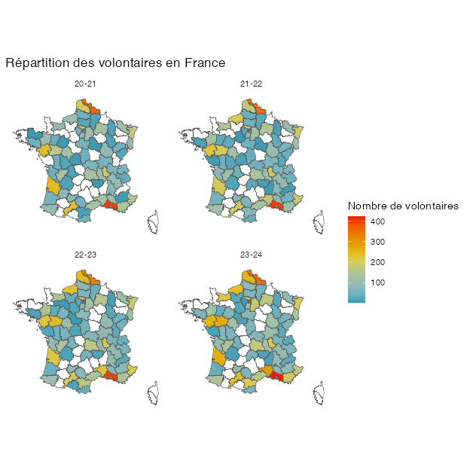

Figure 2
Evolution de recrutement pour la promo de 2023-24 par rapport à 2020-21.
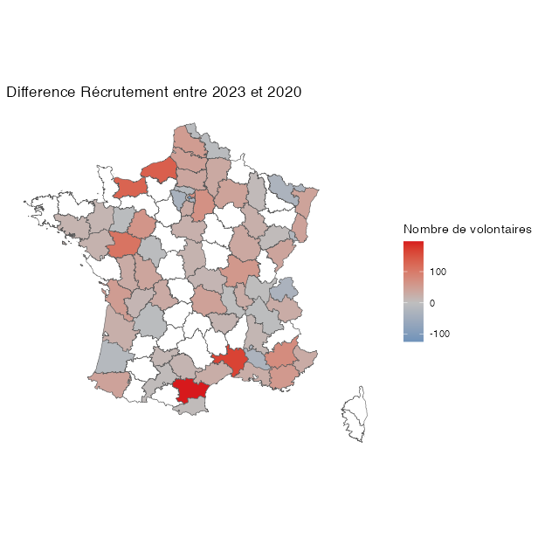

(A) (absolute numbers)
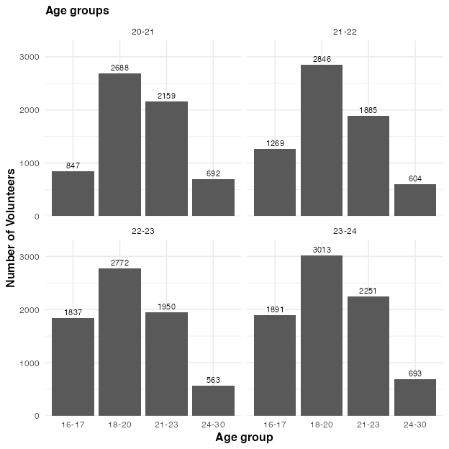
(B) (percentages)
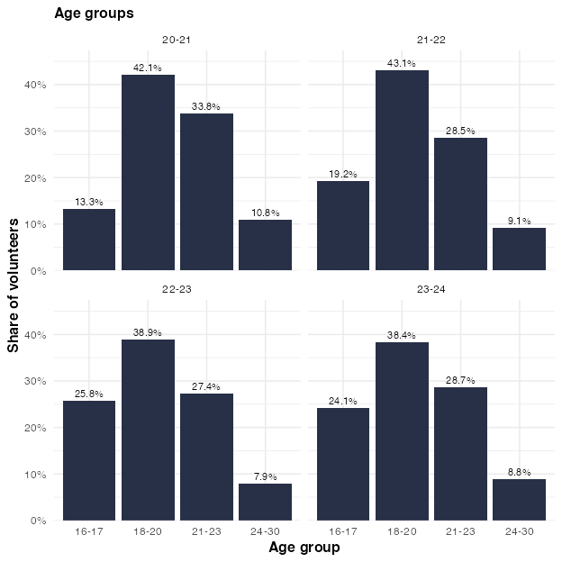

Figure 3
Number of volunteers per age group, within the different promos. Note that, in the percentage plot, the percentages are relative to all volunteers from the respective promo.

(A) (absolute numbers)
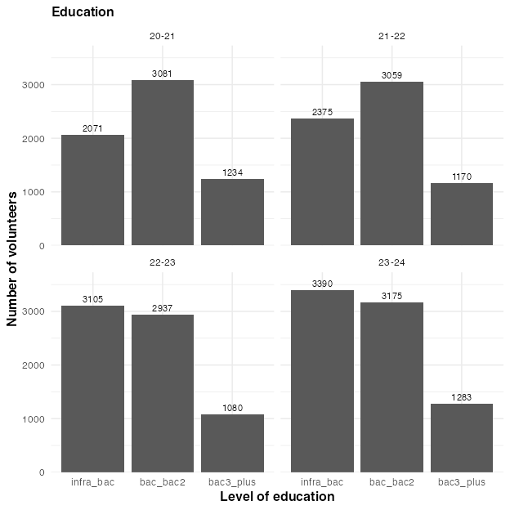
(B) (percentages)
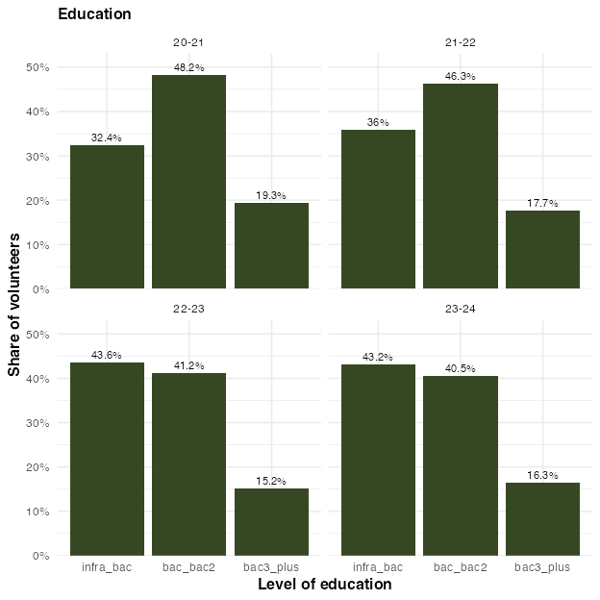

Figure 4
Number of volunteers per education level, within the different promos. Note that in the percentage plot, the percentages are relative to all volunteers from the respective promo.

(A) (absolute numbers)
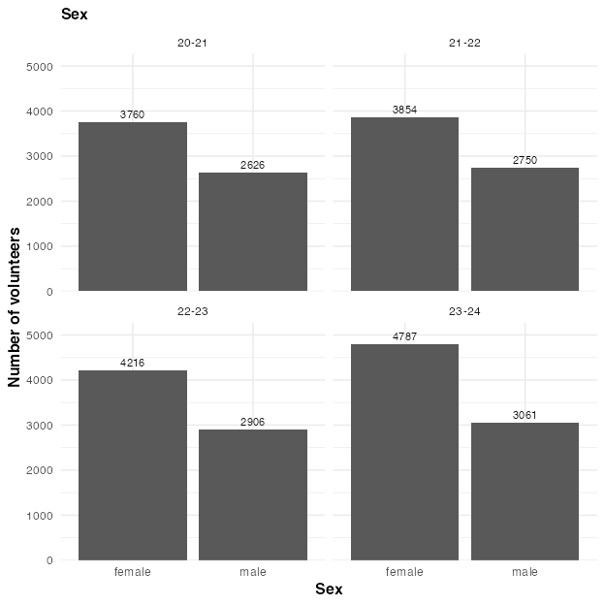
(B) (percentages)
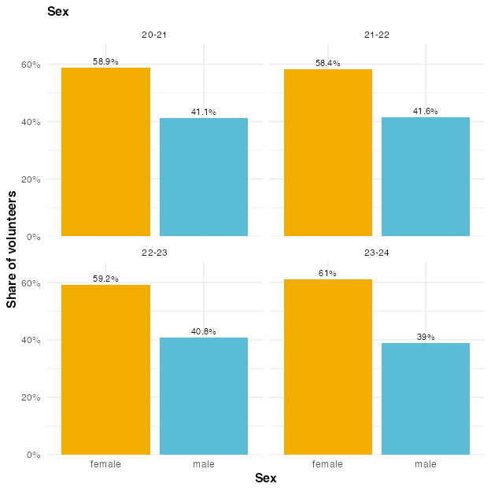

Figure 5
Number of male and female volunteers, within the different promos. Note that in the percentage plot, the percentages are relative to all volunteers from the respective promo.

(A) (absolute numbers)
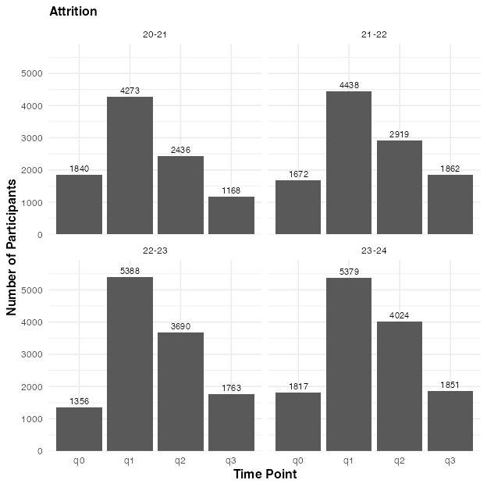
(B) (percentages)
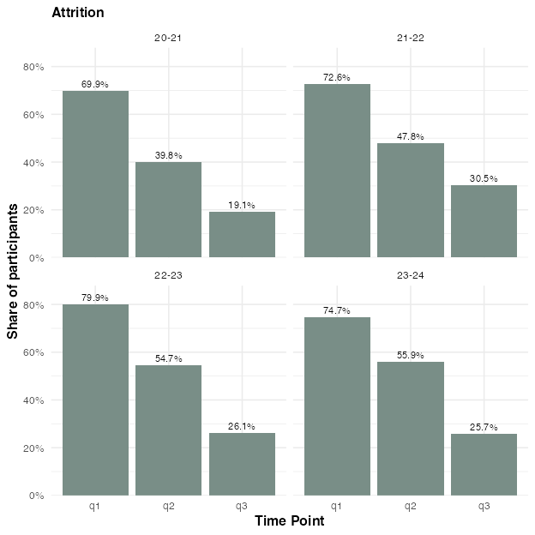

Figure 6
Number of volunteers per survey time point. Volunteers who appear under ‘q0’ have participated in the program but have not even filled out the first questionnaire (q1). Note that in the percentage plot, the percentages are relative to all volunteers from the respective promo. This plot includes ruptures.

(A) (absolute numbers)
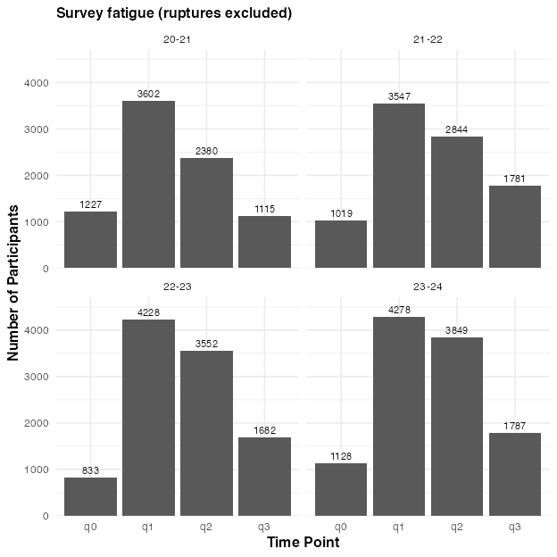
(B) (percentages)
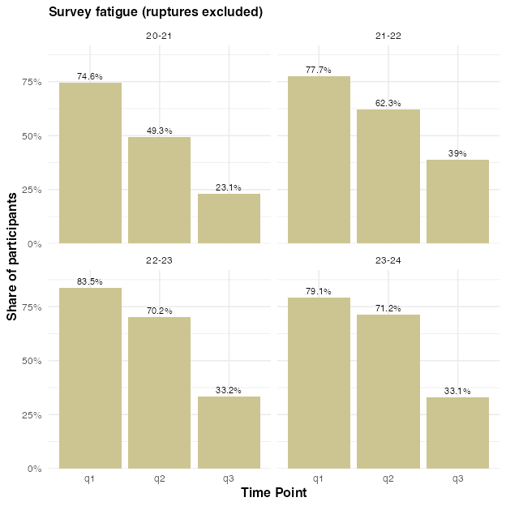

Figure 7
Number of volunteers per survey time point, excluding ruptures. Volunteers who appear under ‘q0’ have participated in the program but have not even filled out the first questionnaire (q1). Note that in the percentage plot, the percentages are relative to all volunteers from the respective promo.

(A) (absolute numbers)
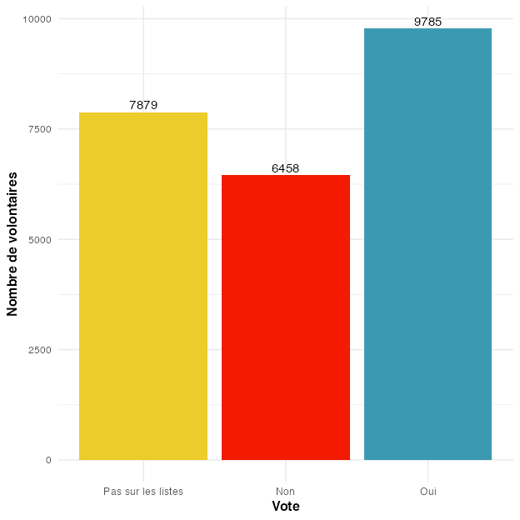
(B) (percentages)
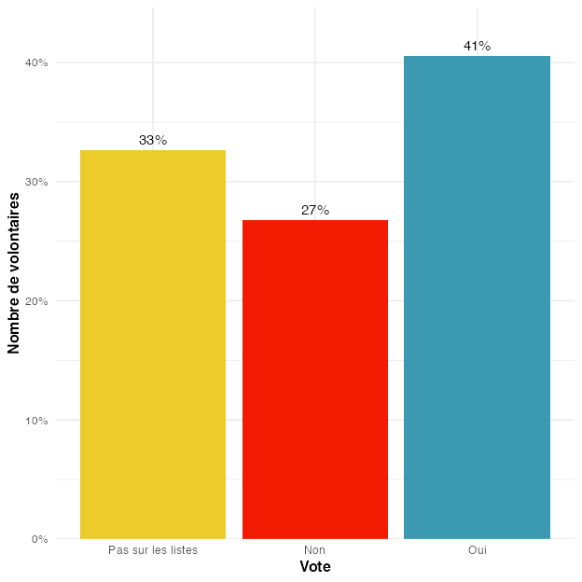

Figure 8
Distribution of whether volunteers reported having voted or not during the last elections, averaged across time points and cohorts.

(A) Alluvial plot
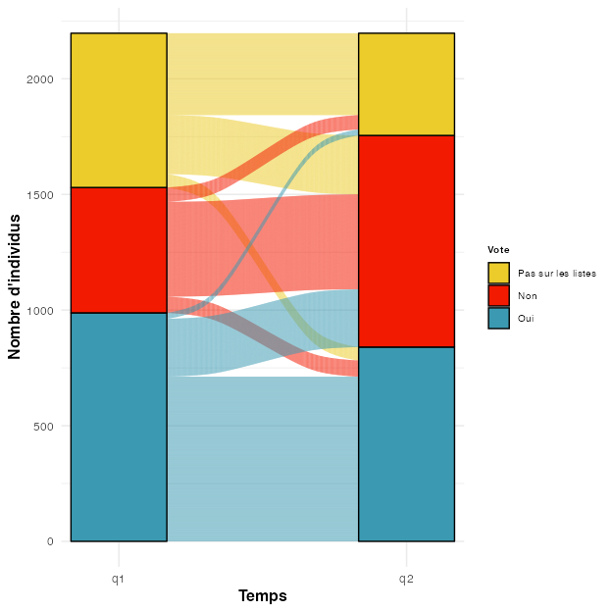
(B) Percentages
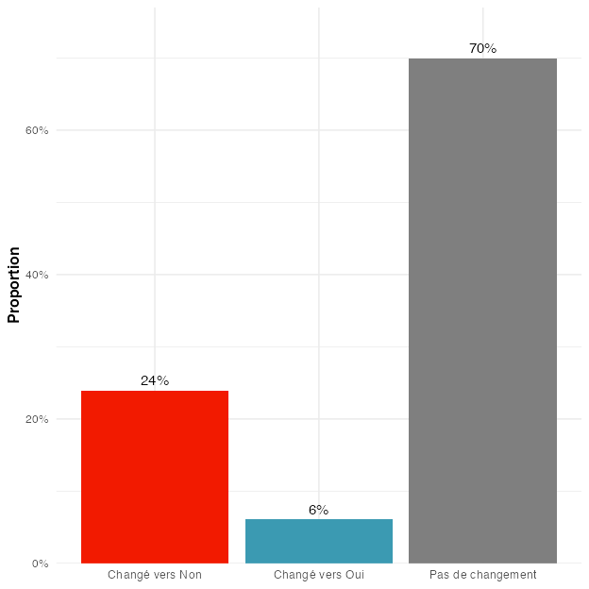

Figure 9
Promo 2020-21. Change in volunteers reporting whether they voted or not during the last elections, between Q1 and Q2. Note that this analysis considers only answers of volunteers who answered either yes or no at both time points.

(A) Alluvial plot
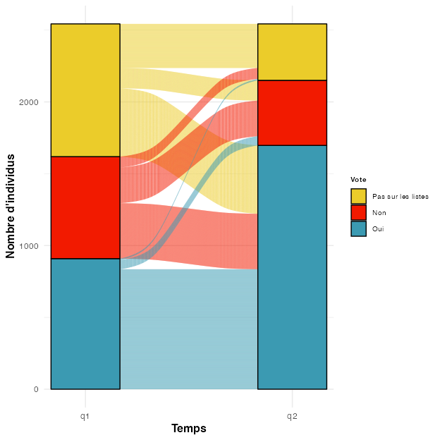
(B) Percentages
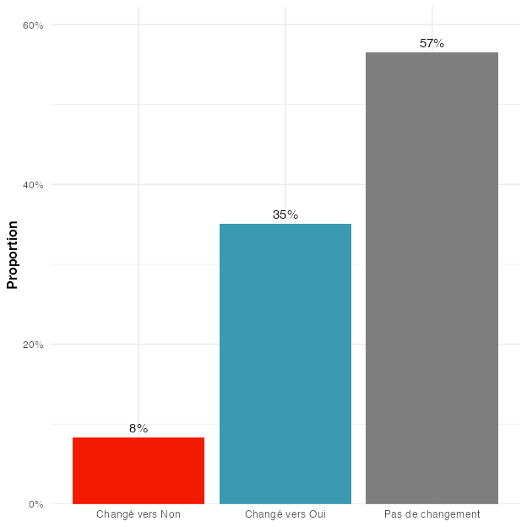

Figure 10
Promo 2021-22. Change in volunteers reporting whether they voted or not during the last elections, between Q1 and Q2. Note that this analysis considers only answers of volunteers who answered either yes or no at both time points.

(A) Alluvial plot
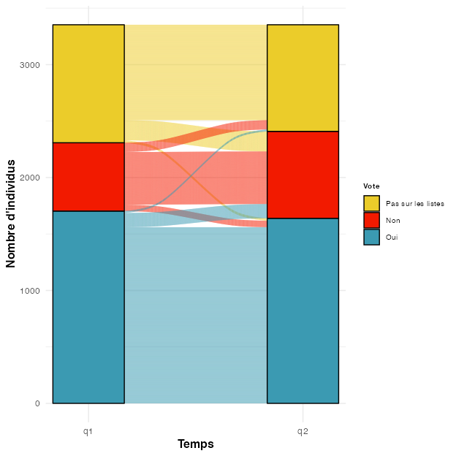
(B) Percentages
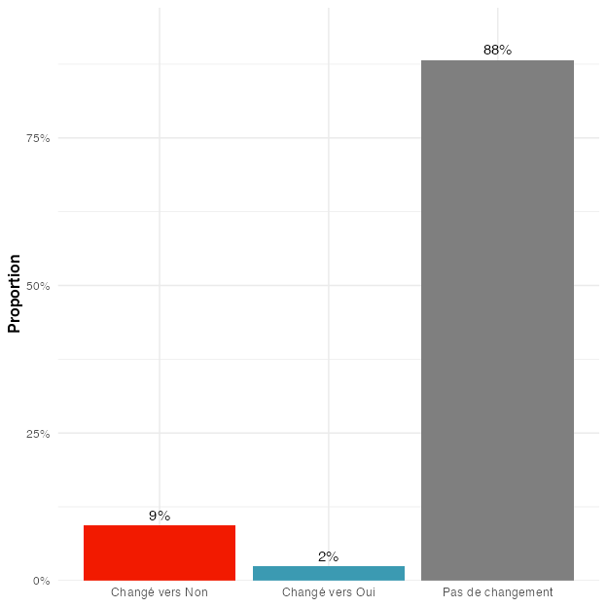

Figure 11
Promo 2022-23. Change in volunteers reporting whether they voted or not during the last elections, between Q1 and Q2. Note that this analysis considers only answers of volunteers who answered either yes or no at both time points.

(A) Alluvial plot
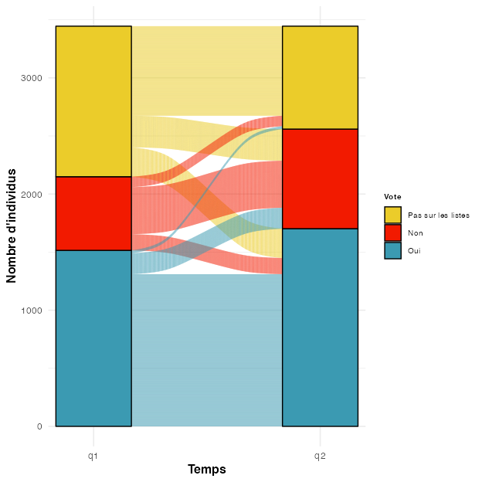
(B) Percentages
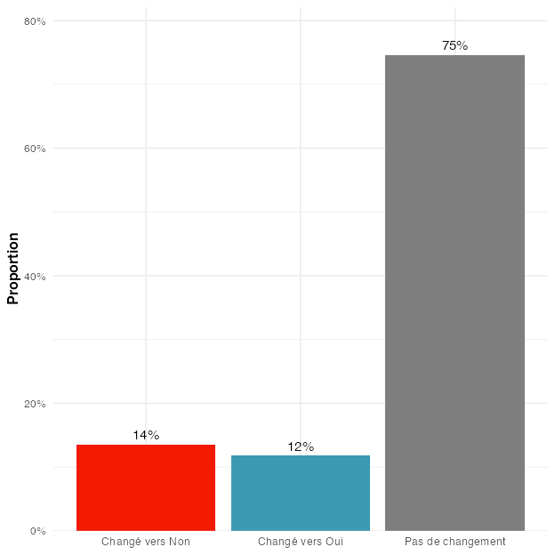

Figure 12
Promo 2023-24. Change in volunteers reporting whether they voted or not during the last elections, between Q1 and Q2. Note that this analysis considers only answers of volunteers who answered either yes or no at both time points.

(A) (absolute numbers)
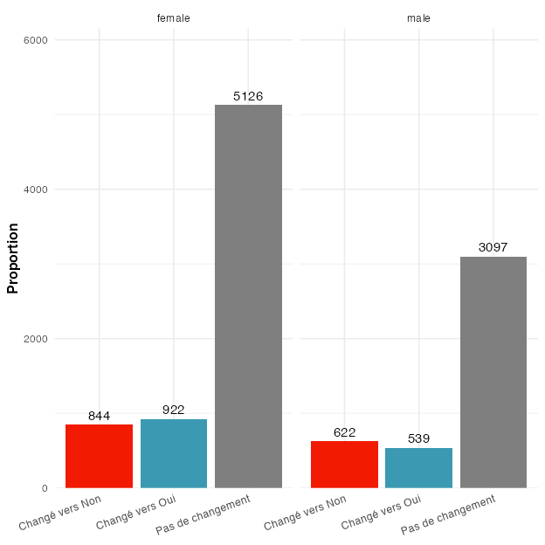
(B) (percentages)
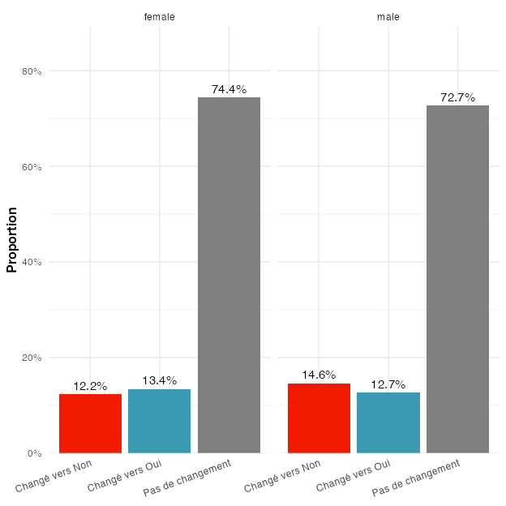

Figure 13
Change in volunteers reporting whether they voted or not during the last elections, between Q1 and Q2, according to their sex. Note that this analysis considers only answers of volunteers who answered either yes or no at both time points.

(A) (absolute numbers)
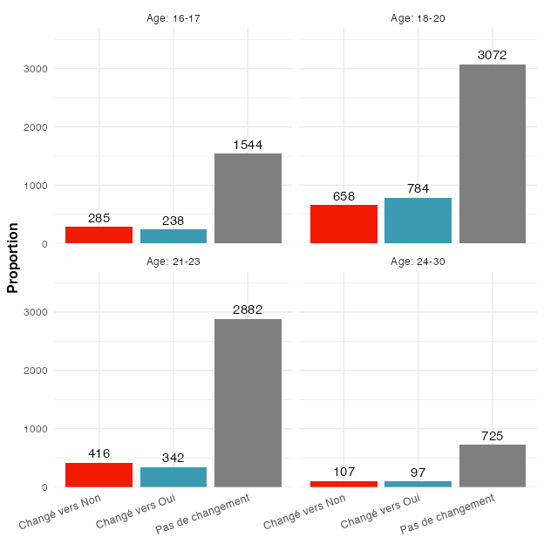
(B) (percentages)
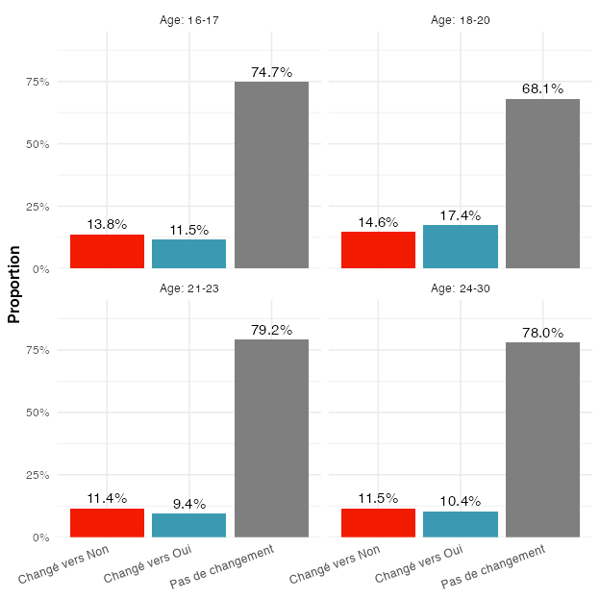

Figure 14
Change in volunteers reporting whether they voted or not during the last elections, between Q1 and Q2, for the different age groups. Note that this analysis considers only answers of volunteers who answered either yes or no at both time points.

Figure 15
Distribution of whether volunteers reported having voted or not during the last elections, at different time points, for the youngest age group (16–17 years old). All answers at q0/q1 that are not “Pas sur les listes” are not exactly correct.
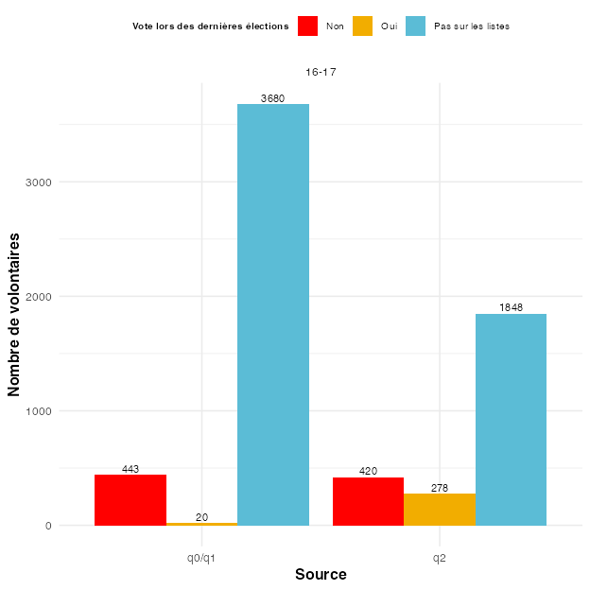

(A) (absolute numbers)
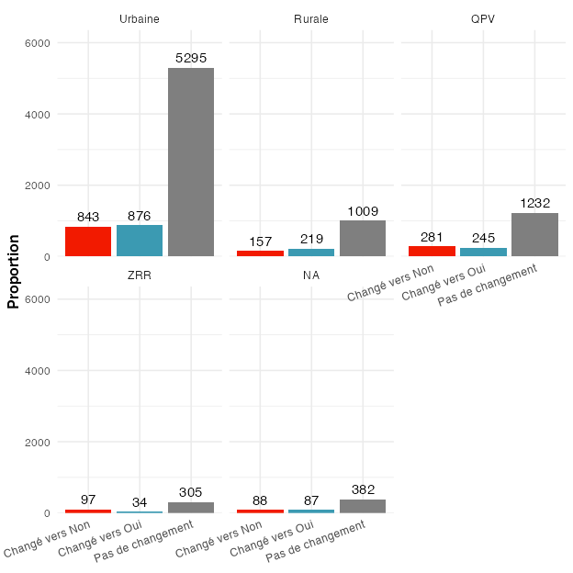
(B) (percentages)
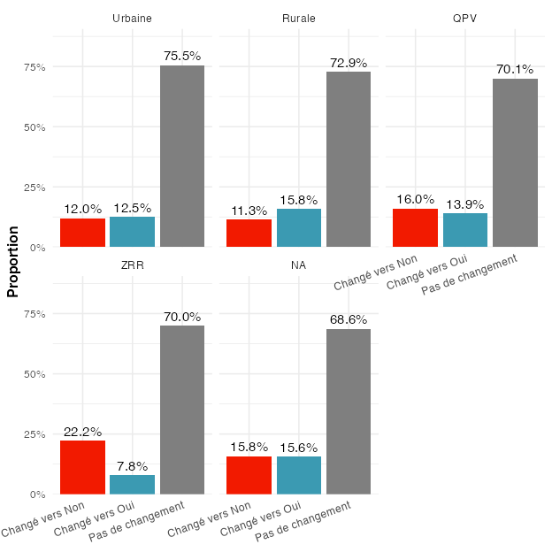

Figure 16
Change in volunteers reporting whether they voted or not during the last elections, between Q1 and Q2, according to their zone of residence. Note that this analysis considers only answers of volunteers who answered either yes or no at both time points.

(A) (absolute numbers)
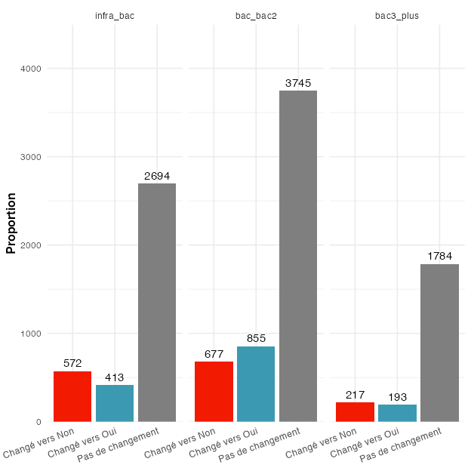
(B) (percentages)
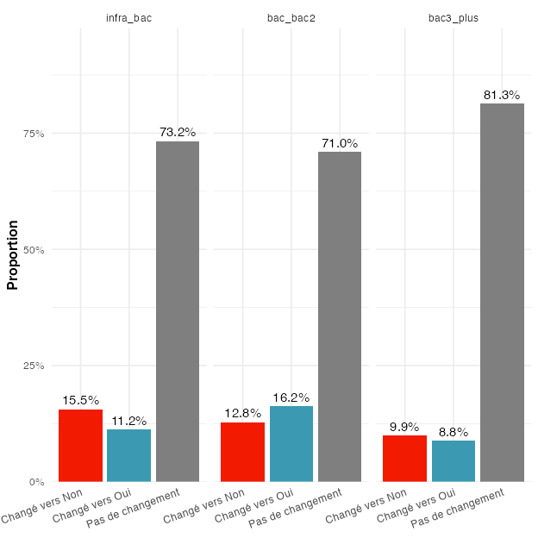

Figure 17
Change in volunteers reporting whether they voted or not during the last elections, between Q1 and Q2, according to their level of education. Note that this analysis considers only answers of volunteers who answered either yes or no at both time points.

(A) Alluvial plot
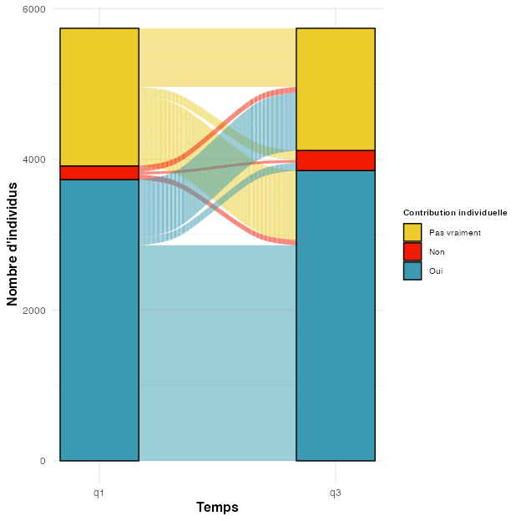
(B) Percentages
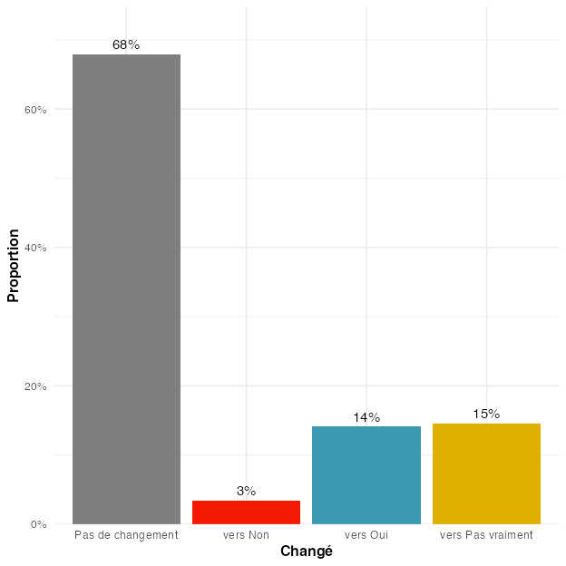

Figure 18
Promo 2020-21. Change in volunteers reporting whether they think their individual action can contribute to changing society, between Q1 and Q3. Note that this analysis considers only answers of volunteers who answered at both time points.

(A) Alluvial plot
(B) Percentages
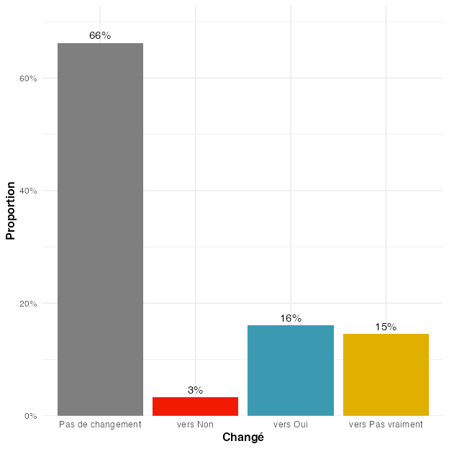

Figure 19
Promo 2021-22. Change in volunteers reporting whether they think their individual action can contribute to changing society, between Q1 and Q3. Note that this analysis considers only answers of volunteers who answered at both time points.

(A) Alluvial plot
(B) Percentages
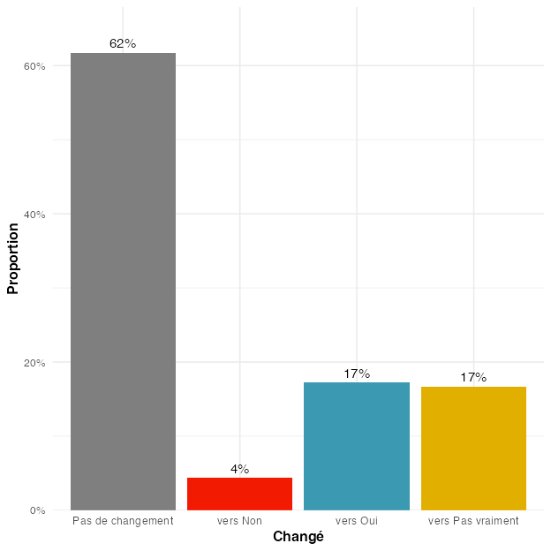

Figure 20
Promo 2022-23. Change in volunteers reporting whether they think their individual action can contribute to changing society, between Q1 and Q3. Note that this analysis considers only answers of volunteers who answered at both time points.

(A) Alluvial plot
(B) Percentages
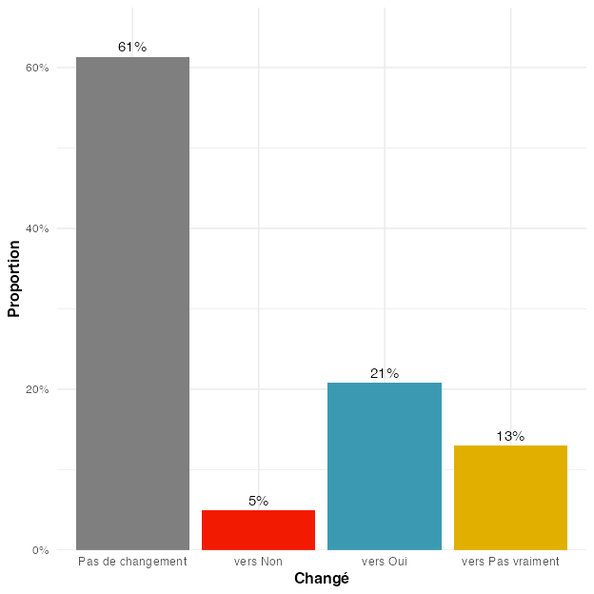

Figure 21
Promo 2023-24. Change in volunteers reporting whether they think their individual action can contribute to changing society, between Q1 and Q3. Note that this analysis considers only answers of volunteers who answered at both time points.

(A) (absolute numbers)
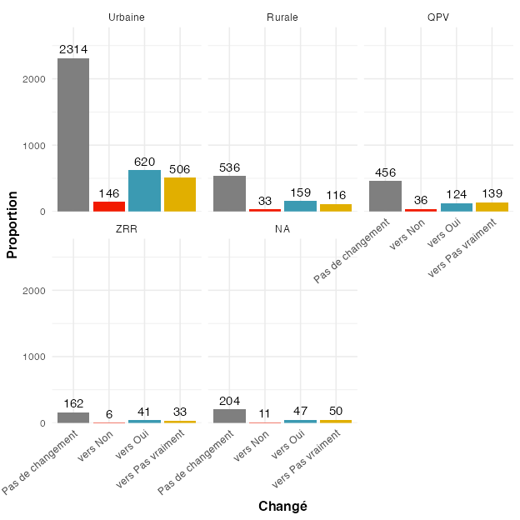
(B) (percentages)
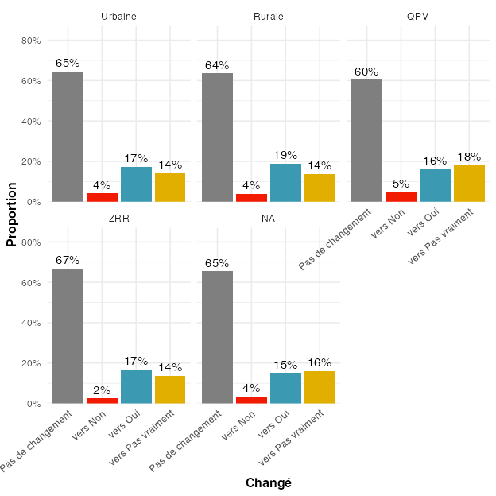

Figure 22
Change in volunteers reporting whether they think their individual action can contribute to changing society, between Q1 and Q3, according to their zone of residence. Note that this analysis considers only answers of volunteers who provided an answer at both time points.

(A) (absolute numbers)
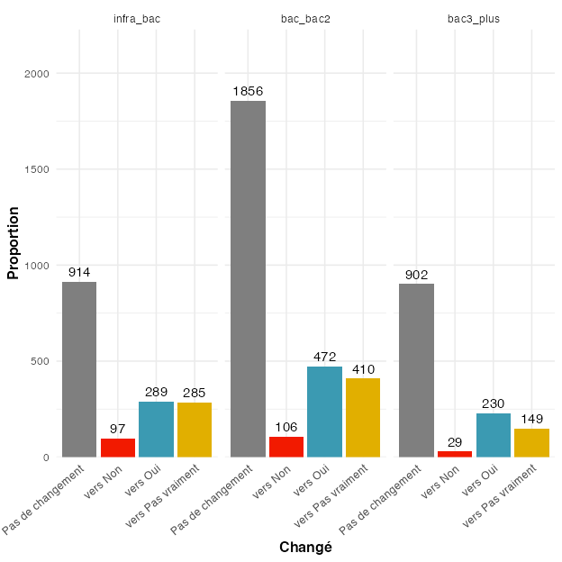
(B) (percentages)
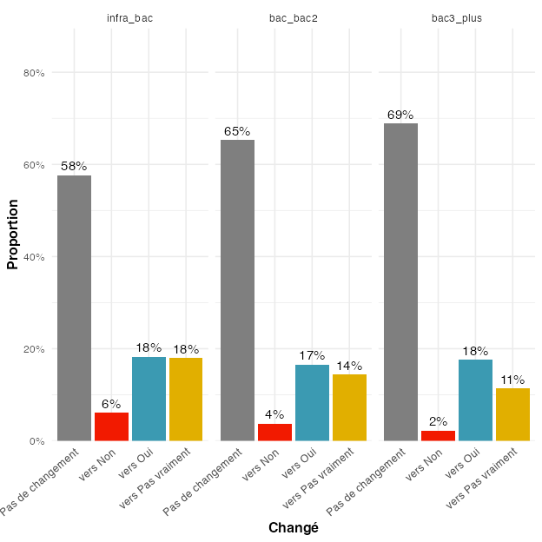

Figure 23
Change in volunteers reporting whether they think their individual action can contribute to changing society, between Q1 and Q3, according to their level of education. Note that this analysis considers only answers of volunteers who provided an answer at both time points.

(A) (absolute numbers)
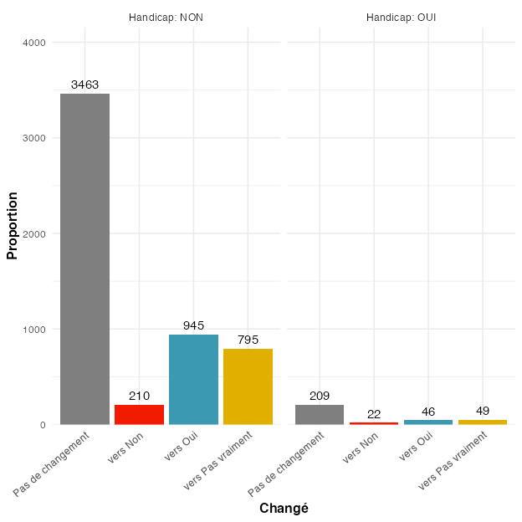
(B) (percentages)
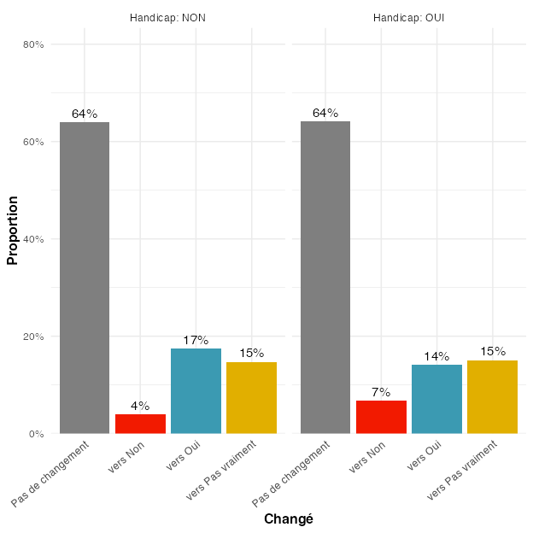

Figure 24
Change in volunteers reporting whether they think their individual action can contribute to changing society, between Q1 and Q3, according to whether they had a handicap (administrative) or not. Note that this analysis considers only answers of volunteers who provided an answer at both time points.

(A) (absolute numbers)
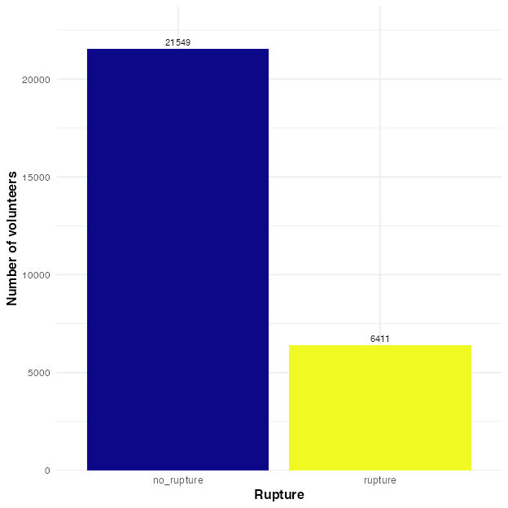
(B) (percentages)
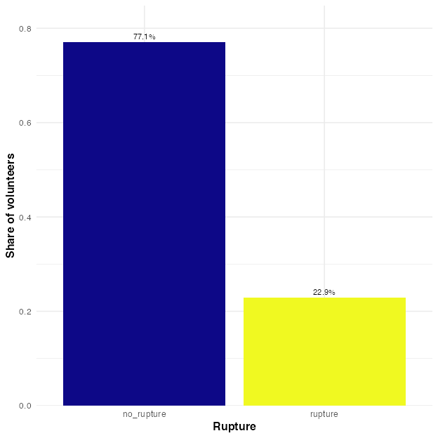

Figure 25
Number of volunteers with a rupture (for various possible reasons, including positive ones, such as obtaining a work contract), pooled across all cohorts.

Figure 26
Prevalence of different rupture motives, pooled across all cohorts.
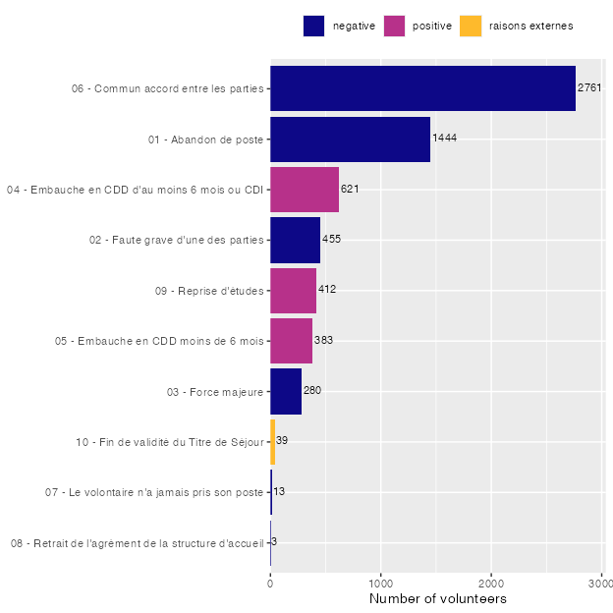

(A) (absolute numbers)
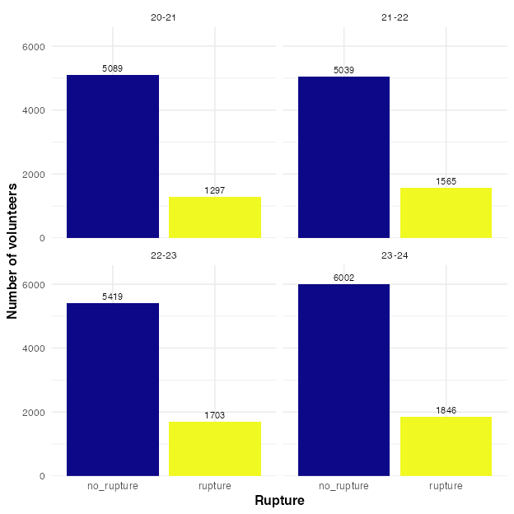
(B) (percentages)
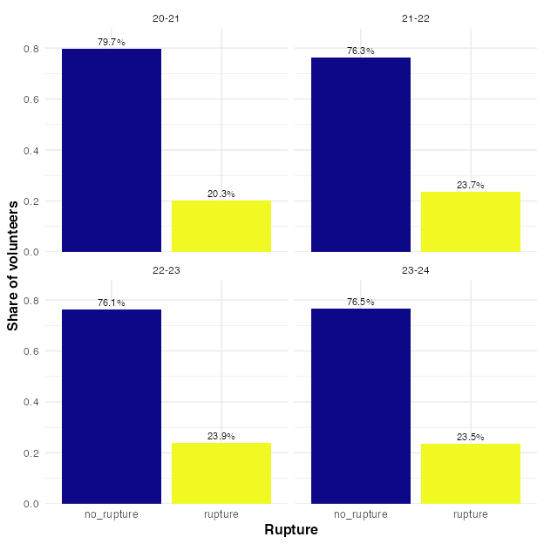

Figure 27
Number of volunteers with a rupture (for various possible reasons, including positive ones, such as obtaining a work contract).

Figure 28
Percentages of rupture for (allegedly) negative reasons for different groups, for different variables.
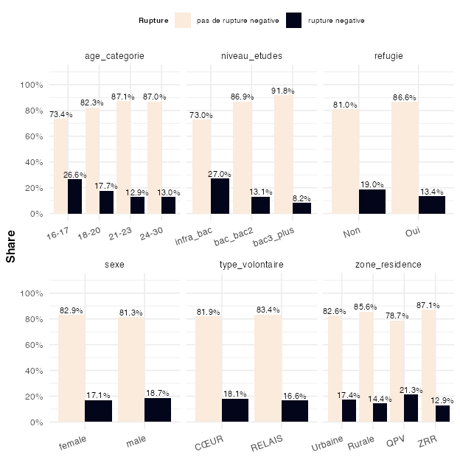

Figure 29
Percentages of rupture for (allegedly) negative reasons, as a function of (i) the volunteers’ confidence in their future and (ii) their perception that their individual action can contribute to changing society.
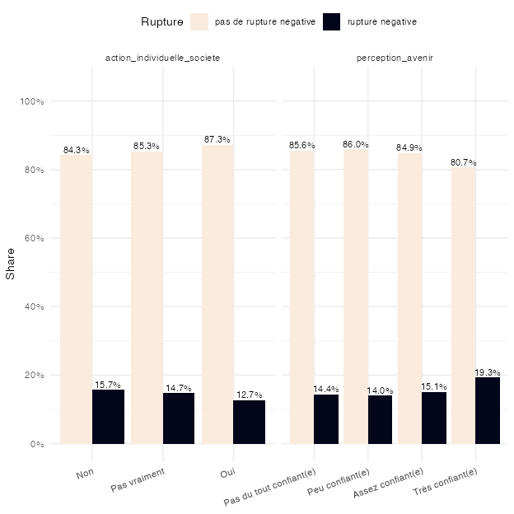

(A) (absolute numbers)
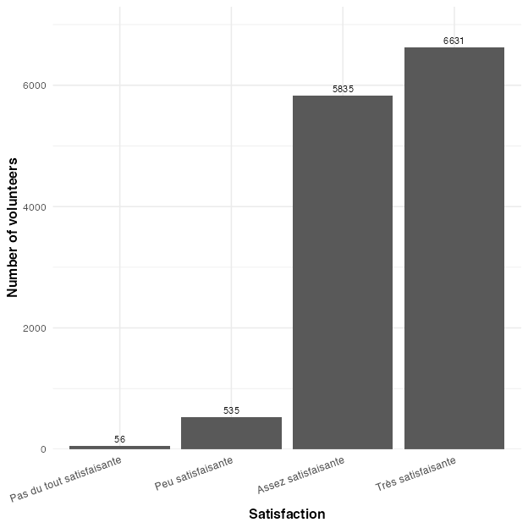
(B) (percentages)
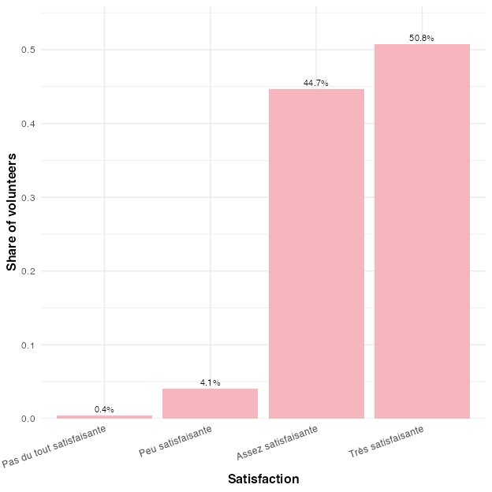

Figure 30
Répartition des niveaux de satisfaction

Figure 31
Satisfaction between cohorts.
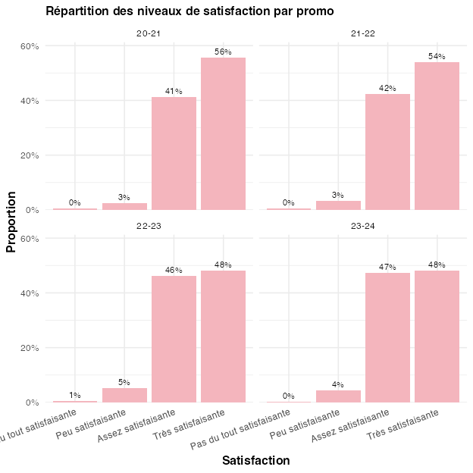

Figure 32
Share of volunteers responding to the different satisfaction levels, grouped by different variables.
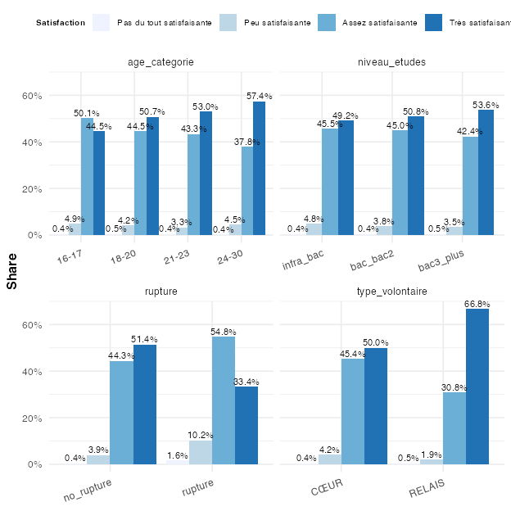

Figure 33
Share of volunteers responding to the different satisfaction levels, grouped by different variables.
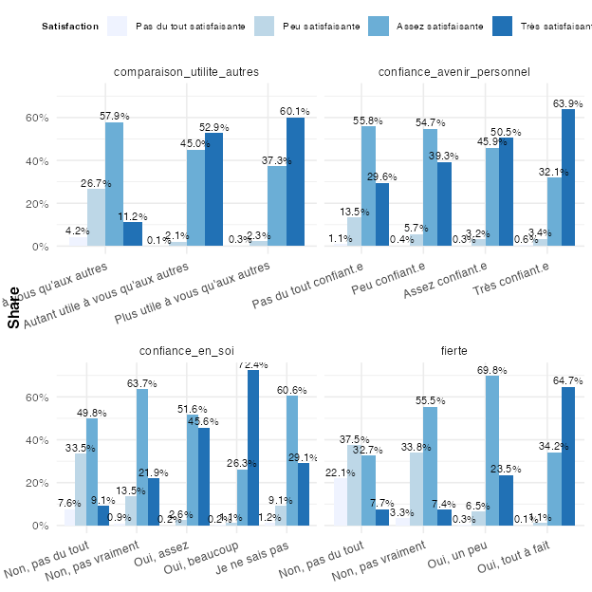

(A) (absolute numbers)
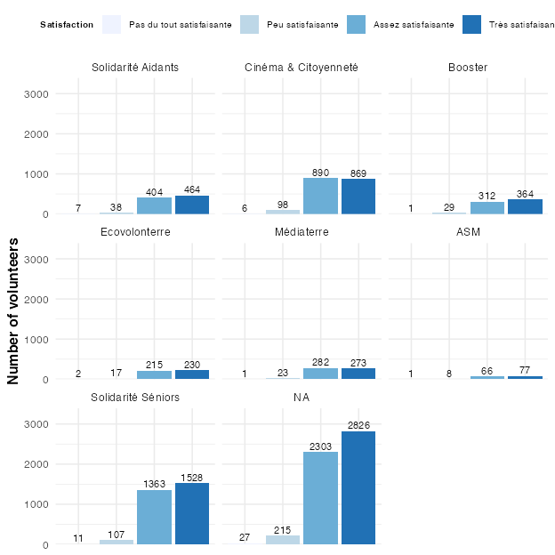
(B) (percentages)
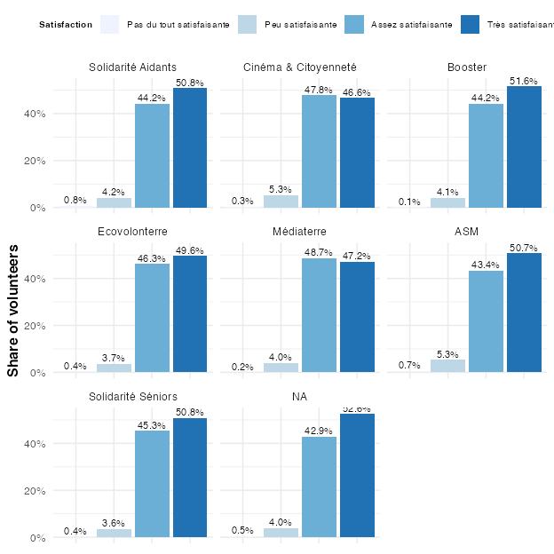

Figure 34
Share of volunteers responding to the different satisfaction levels, grouped by which program they were in. Note that we focus only on key programs here. All other programs appear under ‘NA’ in the plot.

(A) (absolute numbers)
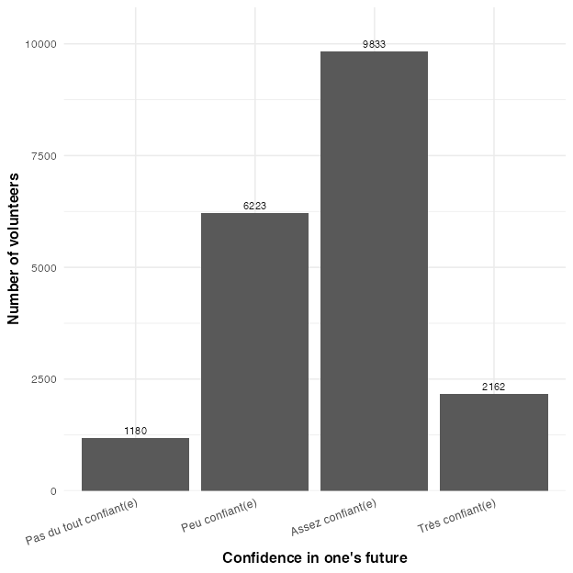
(B) (percentages)
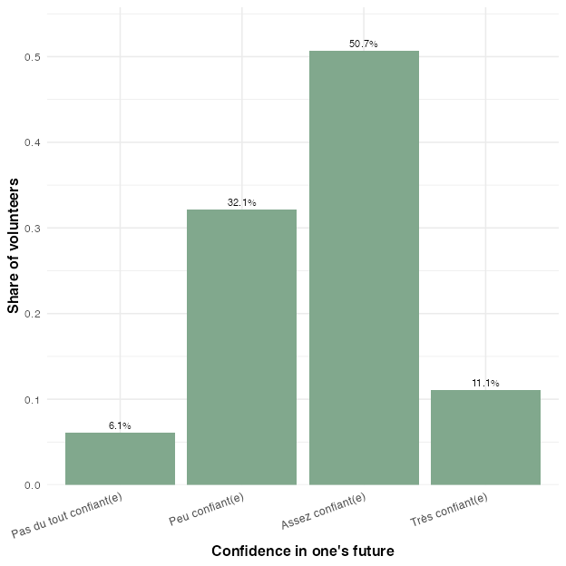

Figure 35
Confidence in one’s future, pooled across all cohorts.

Figure 36
Confidence in one’s future, between cohorts.
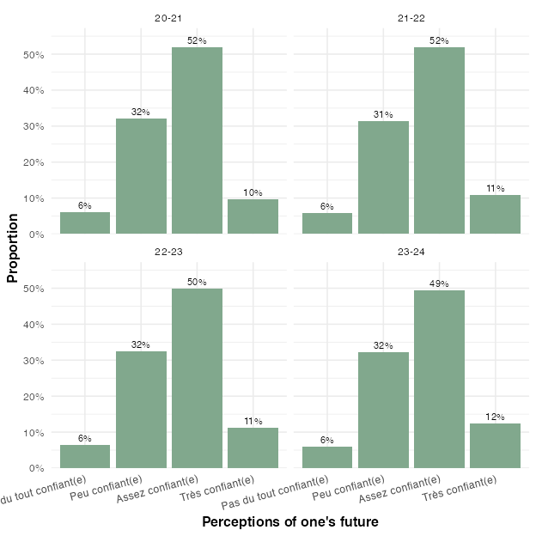

Figure 37
Share of volunteers according to their confidence in their future, grouped by different variables.
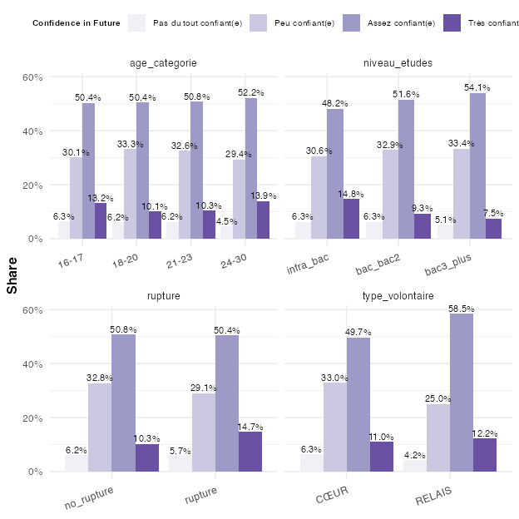

Figure 38
Share of volunteers according to their confidence in their future, as a function of whether they think their individual action can contribute to society.
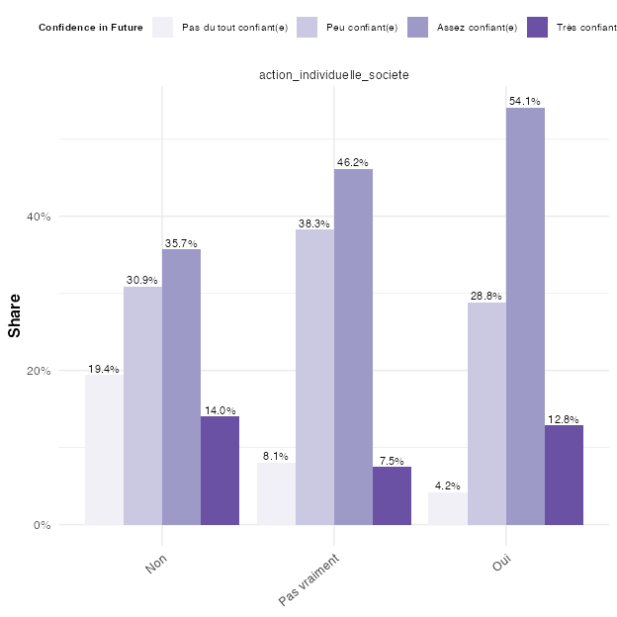

(A) (absolute numbers)
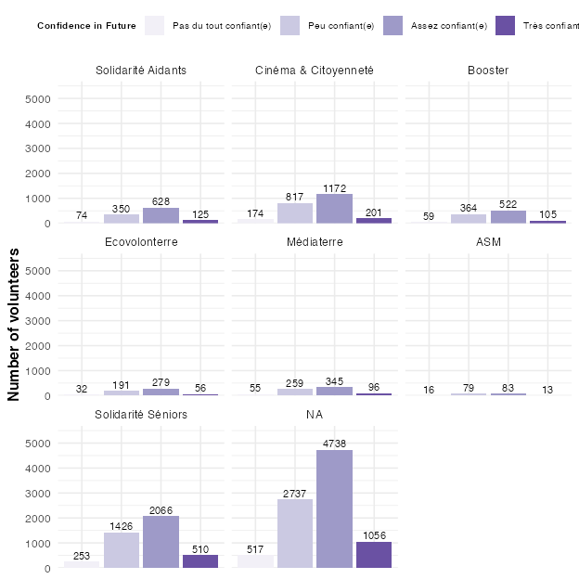
(B) (percentages)
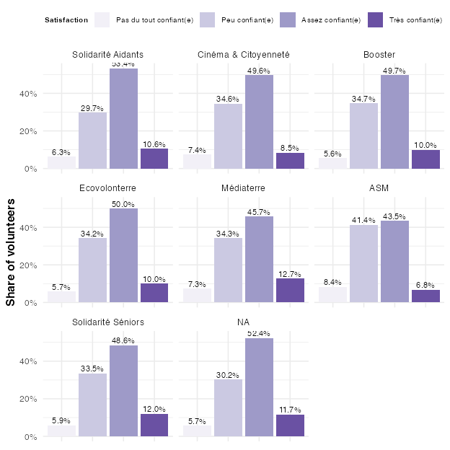

Figure 39
Number of volunteers responding with different levels of confidence in their future, grouped by which program they were in. Note that we focus only on key programs here. All other programs appear under ‘NA’ in the plot.

(A) (absolute numbers)
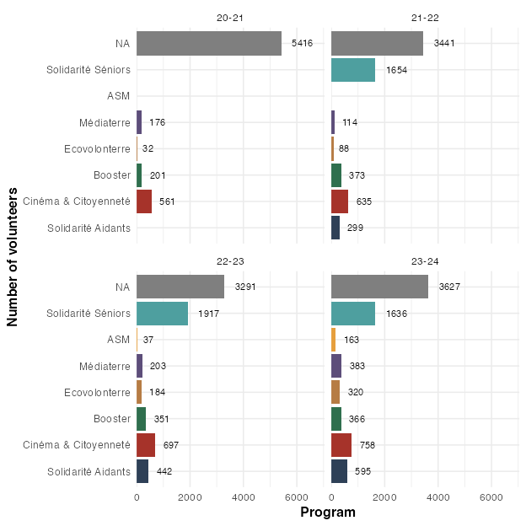
(B) (percentages)
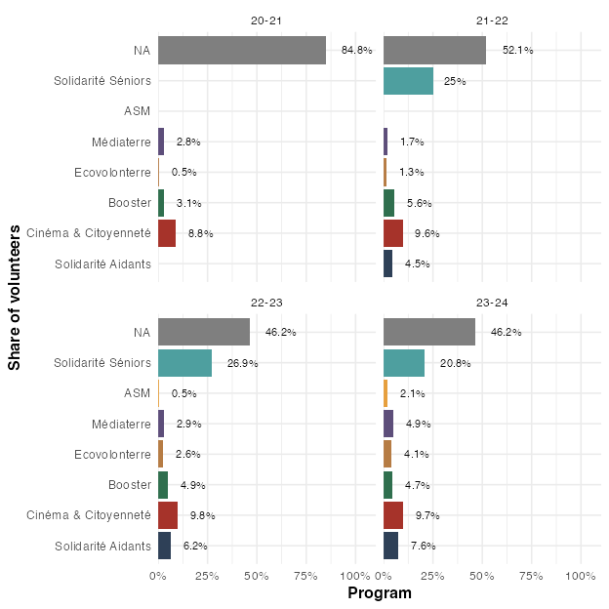

Figure 40
Number of volunteers per key program, within the different promos. Note that, in the percentage plot, the percentages are relative to all volunteers from the respective promo. All volunteers who were not included in any of the key programs appear in the plot under ‘NA’.

Figure 41
Differences in Solidarité Aidants vs. other programs along demographic factors.
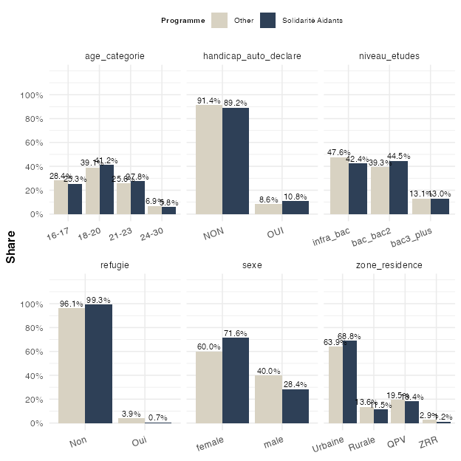

Figure 42
Differences in Cinéma & Citoyennetévs vs. other programs along demographic factors.
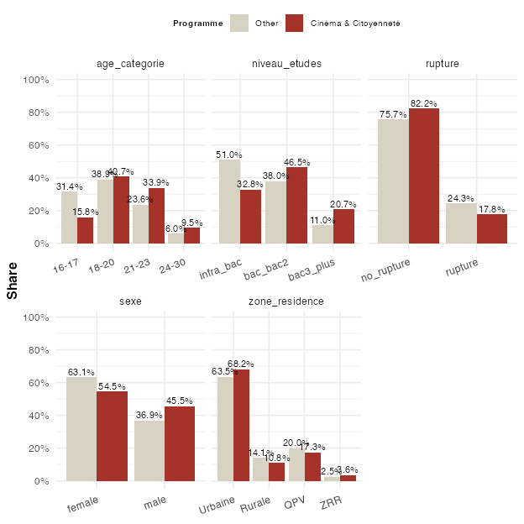

Figure 43
Differences in Booster vs. other programs along demographic factors.
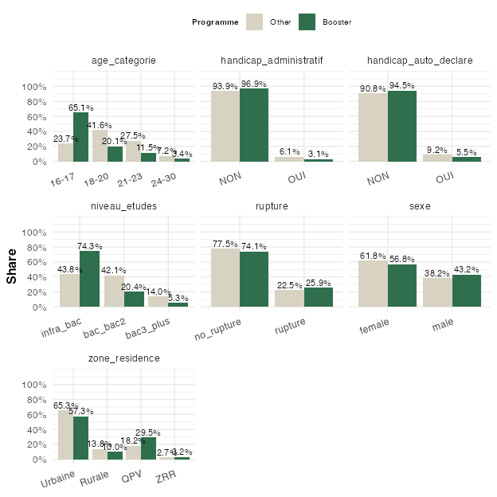

Figure 44
Differences in Ecovolonterre vs. other programs along demographic factors.
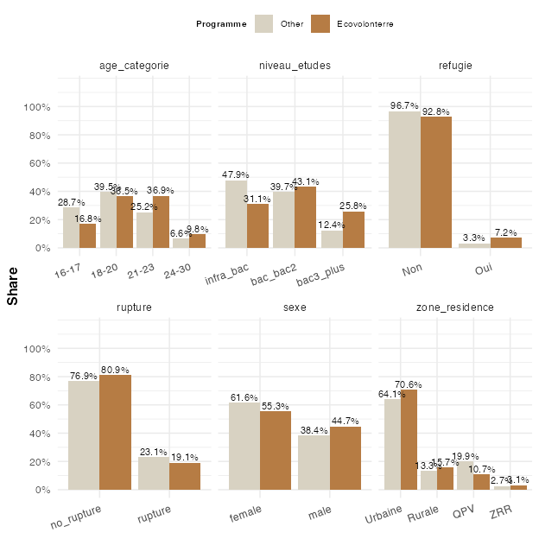

Figure 45
Differences in Ecovolonterre vs. other programs along demographic factors.
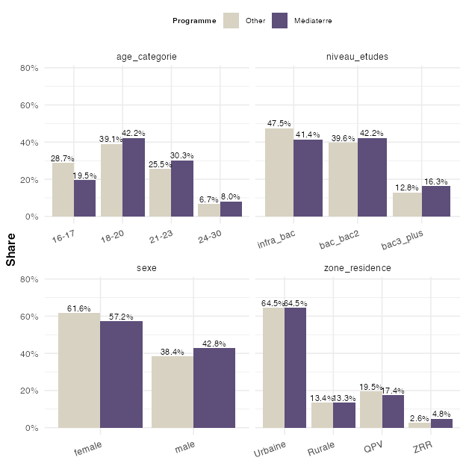

Figure 46
Differences in ASM vs. other programs along demographic factors.
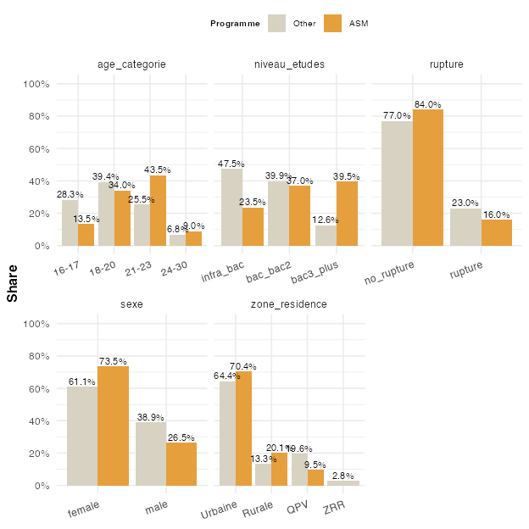

Figure 47
Differences in Solidarité Séniors vs. other programs along demographic factors.
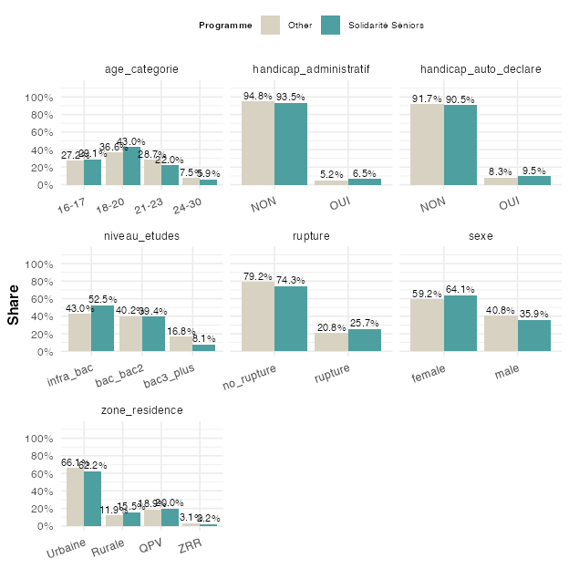

Appendix

Appendix

Voting
Figure A1 shows how different demographic variables predict changes in voting behavior. For this analysis, we look at all cohorts together. The outcome, changes in voting behavior, is binary (changed to no vs. changed to yes).
Plotted on the y-axis are the demographic variables, taken to predict change in voting behavior. For each categorical demographic variable, different levels are shown. For example, for the variable age_category, the plot shows three levels: age_categorie18-20, age_categorie21-23, age_categorie24-30. Each of these categories has an estimate (x-axis). These estimates are the results logistic regressions. They indicate how being part of a certain category (e.g. being between 18 and 20 years old) predicts the chances of changing one’s voting behavior. The estimates are “odds ratios”, which can be conceived of as probabilities: An odds ratio of 1 means that this group has the same chance changing to “no” as changing to “yes”. More than 1 means that this group is more likely to change to “yes”. For example, an odds ratio of 2.0 means twice as likely. Less than 1 means that this group is more likely to change to “no”. An odds ratio of 0.5 means half as likely.
For each categorical variable, one category is chosen as the baseline (or reference) category. The odds ratios of all other categories are relative to that baseline. For example, for the variable age_category, the category “16-17” is not appearing in the graph, because it is the (invisible) baseline category. If the odds ratio for age_category18–20 is 1.43, this means that 18 to 20 year-olds are more likely to change their vote towards “Yes”, compared to 16 to 17 year-olds. More specifically, the odds of changing towards “Yes” among 18–20-year-olds are about 43% higher than among 16–17-year-olds.

Figure A1
Effects of demographic factors on change in voting behavior. The outcome is binary (changed to no vs. changed to yes). The dots and their labels are the estimates of separate logistic regressions for each variable. The lines around the dots represent uncertainty in the estimates (95% confidence intervals). If these confidence intervals cross 1 (the dotted vertical line), the differences are not statistically significant, meaning we might observe them just by chance. The logarithmic scale (on the x-axis) is used so that in the visualization for the positive and negative odds ratio’s to be symmetric (i.e. that 2 is as far away from 1 as is 0.5).
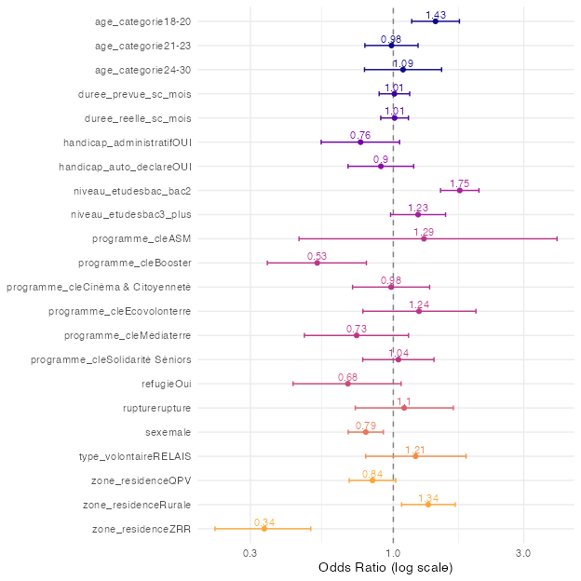
To understand this odds ratio, take Figure 14: it shows that among the 16 to 17 year-olds, 285 have changed towards “No”, while only 238 have changed towards “Yes”. That makes the odds of changing towards yes for the youngest age group, chosen as the baseline category in the model, 238:285 = ~0.84. By contrast, among the 18 to 20 year-olds, the odds were 784:658 = ~1.19. The odds ratio for the 18 to 20 year-olds compares their odds to those of the 16 to 17 year-olds odds ratio = 1.19:0.84 = 1.4. Figure 14 also allows to compare the odds ratios to the percentages for the different age groups. Just like for absolute numbers, the odds ratios can be calculated from the percentages. For example, among the 16 to 17 year-olds, 13.8% have changed towards “No”, while 11.5% have changed towards “Yes”, making the odds of changing to “Yes”, as above, 0.115:0.138 = ~0.83. Among the 18 to 20 year-olds, accordingly, the odds were, as above, 0.174:0.146 = ~1.19, resulting in the same odds ratio of ~1.4.

Individual action for society
Figure A2 shows how different demographic variables predict changes in perceptions of one’s individual contribution to society. For this analysis, we look at all cohorts together. The outcome, changes in perceptions of one’s individual contribution to society, collapsed into a binary measure (“vers Non/Pas vraiment” vs. “vers Oui”). The plots can be interpreted as described above in the section on voting behavior (Section 12.1). An odds ratio of 1 means that a certain group has the same chance of changing to “Non/Pas vraiment” as changing to “Oui”, compared to the baseline group. More than 1 means that this group is more likely to change to “Oui”. Less than 1 means that this group is more likely to change to “Non/Pas vraiment”.

Figure A2
Effects of demographic factors on change in perceptions of how one’s individual actions can contribute to society. The outcome is binary (“vers Non/Pas vraiment” vs. “vers Oui”). The dots and their labels are the estimates of separate logistic regressions for each variable. The lines around the dots represent uncertainty in the estimates (95% confidence intervals). If these confidence intervals cross 1 (the dotted vertical line), the differences are not statistically significant, meaning we might observe them just by chance. The logarithmic scale (on the x-axis) is used so that in the visualization for the positive and negative odds ratio’s to be symmetric (i.e. that 2 is as far away from 1 as is 0.5).
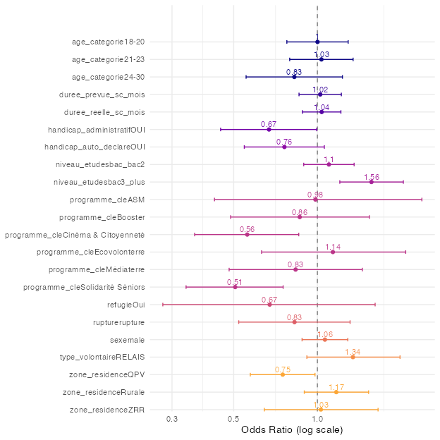

Rupture
For analyses on what predicts ruptures, we focus only on volunteers who ended their contract early for apparently negative reasons. We used a binary outcome measure (no negative rupture vs. negative rupture) and ran separate logistic regressions with demographic variables (Figure A3) a selection of other variables (Figure A4).
An odds ratio of 1 means that a certain group has the same chance of having a rupture, compared to the baseline group. More than 1 means that this group is more likely to have a rupture. Less than 1 means that this group is less likely to have a rupture.

Demographics

Figure A3
Effects of demographic factors on negative ruptures. The outcome is binary (no negative rupture vs. negative rupture). The dots and their labels are the estimates of separate logistic regressions for each variable. The lines around the dots represent uncertainty in the estimates (95% confidence intervals). If these confidence intervals cross 1 (the dotted vertical line), the differences are not statistically significant, meaning we might observe them just by chance. The logarithmic scale (on the x-axis) is used so that in the visualization for the positive and negative odds ratio’s to be symmetric (i.e. that 2 is as far away from 1 as is 0.5).
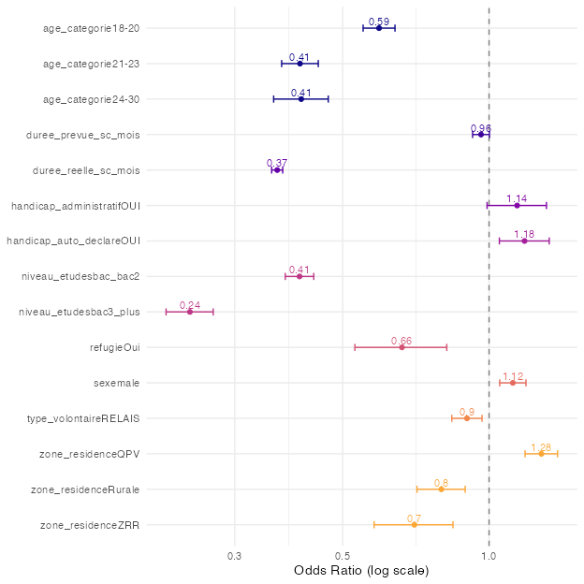

Other factors
Figure A4 shows how the two relevant variables predict rupture. The variable action_individuelle_societe is categorical and can be interpreted like the demographic variables in the previous results: one category serves as the reference (omitted) category, and the reported odds ratios represent how the odds of rupture differ relative to that reference. The variable perception_avenir_num is numeric (on a scale from 1 to 4). For numeric predictors, the estimated odds ratio indicates how much the odds of rupture change, on average, for each one-unit increase on the scale. For example, the resulting estimate of 1.14 in Figure A4 for perception_avenir_num means that, on average, a one point increase in confidence about one’s future corresponds to 14% higher odds of rupture. In other words, the results suggest that, the more confident volunteers are about their future, the more likely they are to have a rupture, on average. Figure 37 suggests that this average effect is mostly driven by those volunteers who are “very confident”.

Table A1
Candidate variables to evaluating their association with rupture.
variable | source
perception_avenir | q1
action_individuelle_societe | q1
projet_avenir_concret | q2
comparaison_utilite_autres | q2
fierte | q2
confiance_en_soi | q2
confiance_avenir_personnel | q2
action_individuelle_societe | q3
impact_situation_actuelle | q3
integration | q2

Figure A4
Effects of demographic factors on negative ruptures. The outcome is binary (no negative rupture vs. negative rupture). The dots and their labels are the estimates of separate logistic regressions for each variable. The lines around the dots represent uncertainty in the estimates (95% confidence intervals). If these confidence intervals cross 1 (the dotted vertical line), the differences are not statistically significant, meaning we might observe them just by chance. The logarithmic scale (on the x-axis) is used so that in the visualization for the positive and negative odds ratio’s to be symmetric (i.e. that 2 is as far away from 1 as is 0.5).
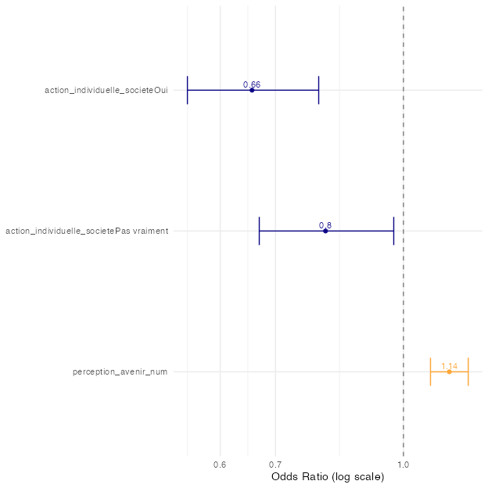

Satisfaction
For analyses on what predicts satisfaction, we treat satisfaction as a continuous variable (from 1, “Pas du tout satisfaisante”, to 4, “Très satisfaisante”). Because this outcome is continuous, we run linear regressions (and not logistic regressions, as before) on it. The results for demographic variables are displayed in Figure A3, for other variables in Figure A4.

Demographic factors
The results of the linear regressions are more straightforward to interpret. For categorical predictors (i.e., all demographic variables), the estimate is simply the average difference between the shown category and the (again, omitted) baseline category. For example, as shown with the variable refugie, refugees tend to be, on average, more satisfied by 0.2 points (on the 4-point satisfaction scale) than non-refugees.

Figure A5
Effects of demographic factors on satisfaction.
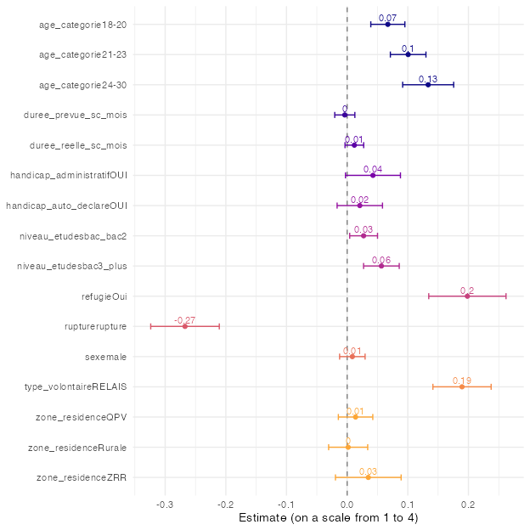

Other factors
Some of the non-demographic variables are numeric, for example, confiance_en_soi_num (Pensez-vous avoir gagné en confiance en vous durant votre Service Civique ? 1 - Non, pas du tout; 2 - Non, pas vraiment; 3 - Oui, assez; 4 - Oui, beaucoup).
For numeric variables, the estimates represent how much satisfaction increases or decreases with a one-unit increase in the predictor variable. For example, for confiance_en_soi_num, the estimate is 0.33. confiance_en_soi_num takes values on a 4-point scale (from 1, “Non, pas du tout”, to 4, “Oui, beaucoup”). This means that, on average, a one unit increase in confiance_en_soi_num is associated with a 0.33 point in crease in satisfaction (4-point scale).

Figure A6
Effects of other, non-demographic factors on satisfaction.
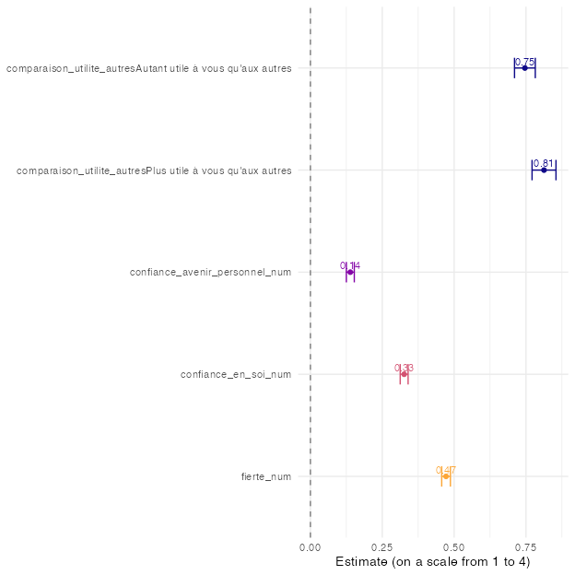

Confidence in one’s future
As for satisfaction above, for analyses on what predicts confident in their future, we treat it as a continuous variable (1, “Pas du tout confiant.e”, to 4, “Très confiant.e”). As for satisfaction, because this outcome is continuous, we run linear regressions on it. The results for demographic variables are displayed in Figure A7, for other variables in Figure A8.

Demographic factors

Figure A7
Effects of demographic factors on confidence in one’s future.
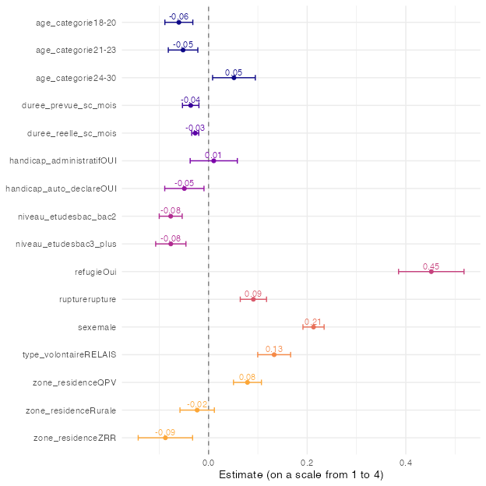

Other factors
The only other variable we consider here is action_individuelle_societe (“En général, pensez-vous que votre action individuelle peut contribuer à changer la société ?” Oui; Pas vraiment; Non). Figure A8 shows that volunteers who do not think that they can individually contribute to changing society (the omitted baseline category) are the least confident about their future: both volunteers who are slightly less pessimistic (having answered “Not really”) and volunteers think they can contribute (having answered “Yes) are more likely to be confident, with those having answered”Yes” being most likely.

Figure A8
Effects of other, non-demographic factors on confidence in one’s future.
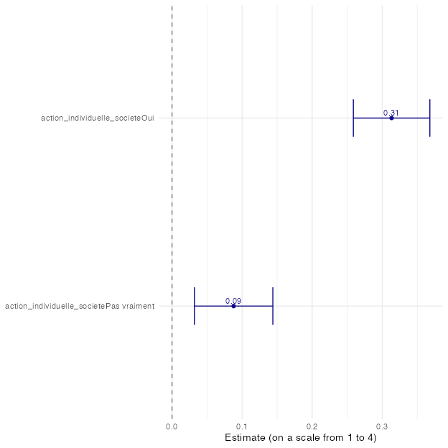

Differences between programs
The following sections show, for each key program category, how the volunteers of that program differ compared to all the other key program categories combined, in terms of demographic variables. The results are expressed in odds ratios, which can be interpreted as above: If the odds ratio is larger than 1, then a certain group is more likely to be represented in the target key program category, compared to all other programs. For example, in Figure A9, there are more 18 to 20 year-olds (odds ratio = 1.18, compared to the omitted baseline, 16 to 17 year-olds) in the “Solidarité Aidants” program, than in the other programs, on average. If the odds ratio is below 1, this means that a certain group is less likely to be represented in the target key program category. For example, refugees are considerably less likely (odds ratio = 0.17, compared to the omitted baseline, non-refugees) to be in the “Solidarité Aidants” program, compared to all other programs, on average.

Solidarité Aidants

Figure A9
Differences in Solidarité Aidants vs. other programs along demographic factors.
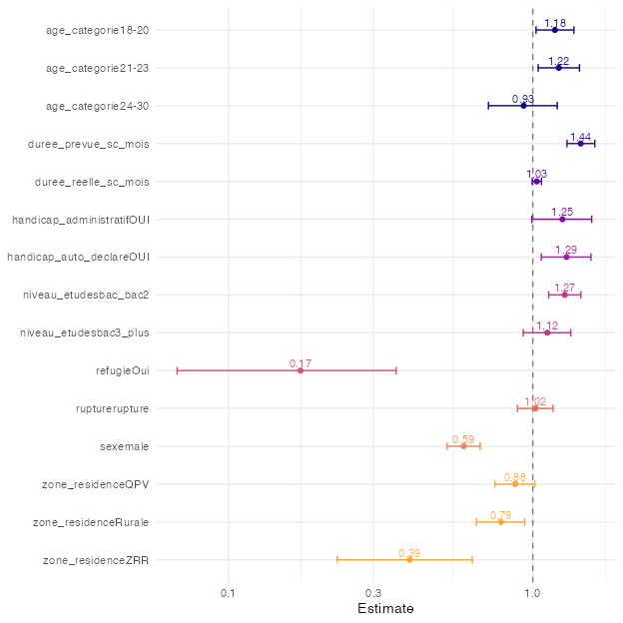

Cinéma & Citoyenneté

Figure A10
Differences in Cinéma & Citoyennetévs vs. other programs along demographic factors
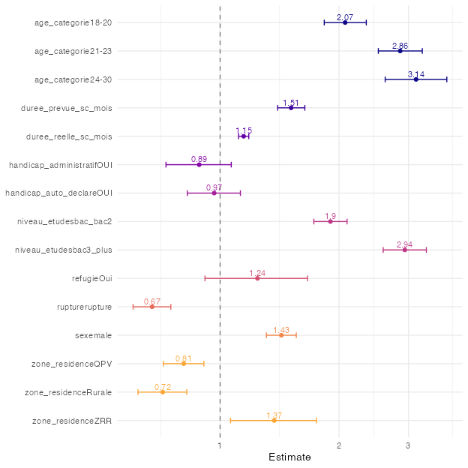

Booster

Figure A11
Differences in Booster vs. other programs along demographic factors.
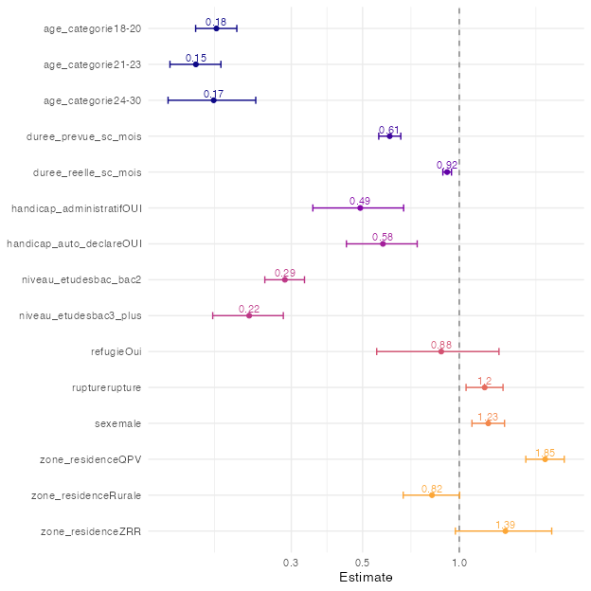

Ecovolonterre

Figure A12
Differences in Ecovolonterre vs. other programs along demographic factors.
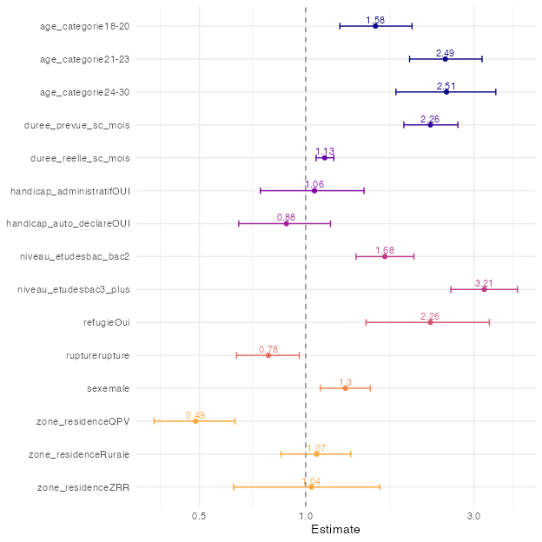

Médiaterre

Figure A13
Differences in Médiaterre vs. other programs along demographic factors.
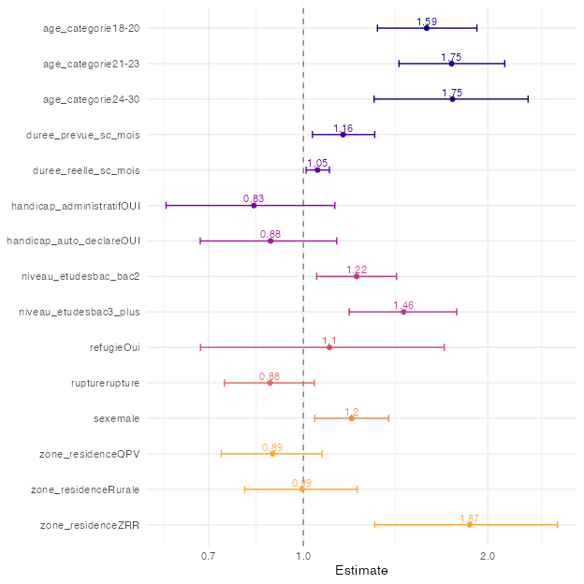

ASM

Figure A14
Differences in ASM vs. other programs along demographic factors.
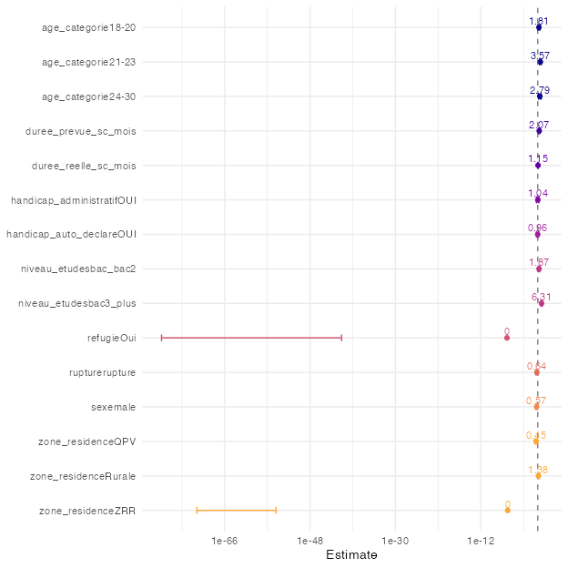

Solidarité Séniors

Figure A15
Differences in Solidarité Séniors vs. other programs along demographic factors.
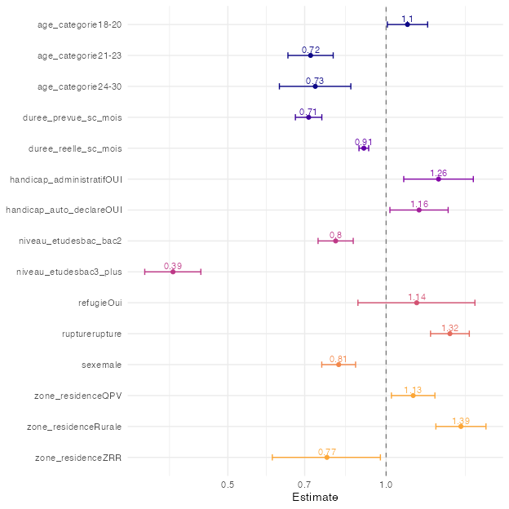

Note that the questions have been selected based on the questionnaire of the first cohort (2020/21). As a result, potentially interesting variables that only appear in later questionnaires will not appear here.
Cité Unis nevertheless has some administrative data on volunteers who did not respond to a single questionnaire, for example which program they have been in. In some of the plots in this report, notably in Section 3, these volunteers appear under the label “q0”.
In all analyses we treat this as a continuous variable
In all analyses we treat this as a continuous variable
I.e. ignoring all volunteers who did not change
For each variable, a separate logistic regression has been run. The estimates from the logistic regression are exponantiated, so that the reported estimates can be interpreted as odds ratios (ORs).
Note that in this illustration, we obtain a slightly different value compared to 0.84 above due to rounding imprecision.
Note _num in the variable name stands for ‘numeric’: we use a numeric version, from “Pas du tout confiant(e)” = 1, to “Très confiant(e)” = 4.
All variable names that end with _num have been treated as numeric for the present analyses

