Volunteer Report Unis-Cité

Abstract
This report analyzes survey data for four different cohorts of Unis-Cité volunteers who did their service civique (2020-2024).

Volunteer Report Unis-Cité

Introduction
This report analyzes survey data for four different cohorts of Unis-Cité volunteers who did their service civique in France between 2020 and 2024.
Section 2 provides information on who the volunteers are, in terms of age, sex, level of education and geographical location. Section 3 provides an overview on how many volunteers answered to questionnaires at different stages of their service civique (every volunteer is asked to fill out three questionnaires in total).
In Section 4, we look at how volunteers have changed certain attitudes and views during their service civique, and which demographic and other factors are associated with changes.
We then look at several outcomes of interest in detail, namely whether volunteers end their contract early (Section 5), how satisfied they are (Section 6), and how confident they are about their future (Section 7.2). For these outcomes, we analyze whether there are trends across the different cohorts, and whether the outcomes are associated with demographic and other factors.
In Section 8 we investigate demographic differences between different key programs offered by Unis-Cité for their volunteers.
The report ends with a brief conclusion on methodological notes for future questionnaires.
For these analyses, we rely on questionnaires collected by Unis-Cité for four different cohorts of volunteers who did their service civique for a year (2020-2021; 2021-2022; 2022-2023; 2023-2024). These questionnaires are very extensive. For the present analyses, we selected a subset of key questions (a full list can be found in the codebook).
Before diving into the results, a note on caution in interpreting the results presented in this report: Whenever we speak of “predictions” that simply means statistical associations—mere observations of differences between groups. This report does not provide any evidence that would warrant causal conclusions—answers as to why we observe these differences.
Because the data underlying this report is observational and—for most of it—does not allow to track opinion change (because most questions have only been asked once per cohort), the main objective of this report is not to provide specific and definitive answers. Instead, the aim of this report is to help Unis-Cité in identifying patterns and sparking questions that may inform new evaluation procedures. The quantitative results presented here can act as pointers, but they are not problem diagnoses. They always need to be accompanied by qualitative assessments of why we observe certain differences, and what could or could not be done about them.

Who are the volunteers ?
In this section, we review some demographic variables in detail. An extensive summary table with sample demographics across the different cohorts can be found in Tables.

Geographic location
Volunteers came from 73 different departments (see Figure 1). Note that the maps in this section only cover metropolitan France: the 541 volunteers from sites in La Réunion, as well as 19 volunteers from a site that could not be located (“Manche Nord”), are not shown. On average, across the different cohorts, most volunteers came from Bouches-du-Rhône (n = 404), followed by Nord (n = 350) and Seine-Saint-Denis (n = 316).
Overall, there has been a steady increase in volunteers, from 6386 in 20-21 to 7848 in 23-24, and an average increase of 490.4 per year. Since the 20-21 cohort, each departement has on average increased by 19.3. There were 47 departements who saw an increase, and 15 who saw a decrease (see Figure 2). For details on the trend of each departement, see Tables.

Age
As shown in Figure 3, across all promos, the majority of volunteers is between 18 and 20 years old. The share of the age group of 16-17 has been increasing rapidly, roughly doubling from 13% in 2020 to 24% in 2024.

Education
Figure 4 shows that volunteers with a “Bac + 3 et plus” are relatively rare, compared to the other education levels. The share of volunteers with a “Bac à Bac + 2” has been constantly decreasing, from 48% in 2020-21 to 40% in 2023-24. By contrast, volunteers “Infra-bac”, have been increasing from 32% in 2020-21 to 43% in 2023-24.

Sex
On average, more women (~60%) are being volunteers than men. This difference is relatively stable across cohorts—if anything, the data suggests a slight trend towards an increasing share of women over time (Figure 5).

Attrition
As part of their service civique, each volunteer is asked to fill out three different questionnaires: the first one at the onset of their service civique (later on referred to as “q1”), the second one at the end (“q2”), and the third one six months after their service civique (“q3”). Answering these questionnaires is voluntary, and response rates typically decline considerably from the first to the third questionnaire. These declining response rates are referred to as “attrition”. Some volunteers do not even respond to any one questionnaire.
Attrition can have many causes. Here we distinguish between two explanations: ruptures, i.e. volunteers ending their service civique early (Section 5) and survey fatigue, i.e. volunteers who continue their service civique but do not fill out the questionnaires (Figure 7).
Figure 6 shows attrition generally, while Figure 7 excludes ruptures, thereby giving an estimate of survey fatigue. This latter figure shows that survey fatigue is an issue, but also suggests that there is a slightly positive trend towards reduced survey fatigue: more and more volunteers seem to be answering the questionnaires at least for the first two questionnaires (q1 and q2), but less so for the third questionnaire (q3).

Which volunteers answer the questionnaires? A word of caution
Attrition is not only unfortunate because it means less data—it can also distort results. The volunteers who keep answering the questionnaires are not necessarily the same kind of people as those who stop answering. Imagine, as an extreme example, that only the happiest volunteers fill out the last questionnaire: results based on that questionnaire would paint a much rosier picture than reality, simply because the unhappy volunteers are missing from the data.
We can check whether something like this is going on, because we know how volunteers answered earlier questionnaires. The check works like this: take all volunteers who reported their satisfaction in the second questionnaire (q2), and split them into two groups—those who later answered the third questionnaire (q3), and those who did not. If the two groups gave very different answers back at q2, then the volunteers who answer q3 are not representative of everyone.
Figure 8 shows the result of this check: volunteers who later answered q3 were indeed somewhat more satisfied at q2 (55% answered “Très satisfaisante”) than volunteers who did not answer q3 (48%). The difference is real, but moderate. In practical terms: results based on the third questionnaire—for example, the changes in perceptions in Section 4.2—probably paint a slightly too positive picture, but they are unlikely to be fundamentally misleading. We ran the same check one questionnaire earlier (comparing the q1 answers of volunteers who did and did not answer q2) and also found only small differences there.

How have volunteers changed their attitudes?
In the selection of variables made for this report, there are only two questions that volunteers have been asked at several time points during their service civique:
- “Avez-vous voté lors des dernières élections (locales ou nationales) ?” (Section 4.1)
- “En général, pensez-vous que votre action individuelle peut contribuer à changer la société ?” (Section 4.2).
For all analyses in this section, keep in mind that they rely only on the minority of volunteers who answered at both relevant time points (see Section 3.1 for what this implies).

Voting
In this section, we look at how volunteers have changed regarding their voting behavior. Voting behavior was measured with the question: “Avez-vous voté lors des dernières élections (locales ou nationales) ?”, which has been asked at time points q1 (at the beginning of the service civique) and q2 (at its end). Figure 9 shows that, averaged across all cohorts and time points, the majority of volunteers reports having voted.
In the following sections, we investigate how volunteers have changed in answering this question, throughout their service civique. For these analyses, we only consider those volunteers who have answered the question at both time points, q1 and q2. Changes towards “Yes” or “No” can have happened either from the respective other option, or from the third answer option: “Vous n’aviez pas l’âge de voter ou vous n’étiez pas inscrit.e sur les listes électorales”, which is abbreviated in the plots below as “Pas sur les listes”. We look at the different cohorts separately (promo 2020-21, Figure 10; promo 2021-22, Figure 11; 2022-23, Figure 12; 2023-24, Figure 13).
Before turning to the differences between cohorts, note that in every cohort, most volunteers reported the same voting behavior at both time points. How many varies considerably between cohorts, however: from 57% in 2021-22 to 88% in 2022-23. The changes discussed in the following concern the remaining minority.
That said, the following sections reveal considerable differences between the cohorts. For example, in 2020-21 and 2021-22, many volunteers reported changes in voting behavior, but in opposite directions: In 2020-21, 24% of volunteers changed towards “No”, outweighing those who changed to “Yes” (6%) by far. Inversely, in 2021-22, 35% of volunteers changed towards “Yes”, while only 8% changed towards “No”. A plausible explanation for the shift towards “Yes” in 2021-22 is that 2022—the year in which this cohort filled out their second questionnaire—was the year of a presidential election.
More generally, one explanation for the differences between cohorts might be that volunteers care more about national elections than local ones (or vice versa). If that is the case, we would expect changes in voting behavior to depend on whether there were national or local elections happening during the year of a cohort’s service civique. For reference, France’s election calendar during the period covered by this report was as follows: municipal elections in spring 2020, regional elections in June 2021, presidential elections in April 2022 followed by legislative elections in June 2022, no nationwide elections in 2023, and European elections followed by snap legislative elections in June–July 2024. In the sections below, we indicate for each cohort which elections had taken place before each questionnaire. The 2022-23 cohort illustrates the point well: no nationwide elections took place during their service year, and this cohort was by far the most stable in its answers (88% reported the same voting behavior at both time points).

Promo 2020-21
Figure 10 shows change in volunteers’ reported voting behavior for the promo “2020-21”. For this cohort, the last elections before Q1 were the municipal elections of spring 2020; the regional elections of June 2021 took place around the time volunteers filled out Q2.

Promo 2021-22
Figure 11 shows change in volunteers’ reported voting behavior for the promo “2021-22”. For this cohort, the last elections before Q1 were the regional elections of June 2021; by the time of Q2, the presidential elections of April 2022 (followed by the legislative elections in June 2022) had taken place.

Promo 2022-23
Figure 12 shows change in volunteers’ reported voting behavior for the promo “2022-23”. For this cohort, the last elections before Q1 were the presidential and legislative elections of spring 2022; since no nationwide elections took place in 2023, these were still the last elections at the time of Q2.

Promo 2023-24
Figure 13 shows change in volunteers’ reported voting behavior for the promo “2023-24”. For this cohort, the last elections before Q1 were the presidential and legislative elections of 2022; depending on when volunteers filled out Q2, the European elections of June 2024 (followed by the snap legislative elections of June–July 2024) may have taken place shortly before.

Which demographic factors are associated with change of voting intentions?
To determine which demographic variables are associated with change of voting intentions, we ran statistical models. These models are explained in the Appendix (Section 10.1). Here, we only report the variables that were statistically significant in these models.
Note that these analyses pool all cohorts. As shown above, changes in voting behavior differed considerably between cohorts (likely depending on the election calendar), so the pooled associations reported here do not tell us which volunteers changed in a particular year. Running these analyses separately by cohort would be possible, but would considerably lengthen the report.

Sex.
As shown in Figure 14, more female volunteers changed towards “Yes” than towards “No”. Among male volunteers, the opposite was true.

Age.
Figure 15 compares changes in voting behaviour between age groups. Among the 18 to 20 year-olds, the share of volunteers who have changed towards “Yes” was highest. One interpretation could be, that the service civique might encourage this age group in particular to vote. However, an alternative explanation could be that this group could vote for the first time during their service civique, as the legal voting age in France is 18.
On a side note, looking at the 16 to 17 age groups shows that some answers were erroneous. In France, the legal voting age is 18. Therefore, the 16 to 17 year-olds, at least at the beginning of their service civique (q0/q1), have never been on a voting list before. However, as shown in Figure 16 there are 443 volunteers who answered “No” at q0/q1 (which technically is true, but not the most specific answer option), and 20 who answered “Yes” (probably not reading the question carefully or accidentally clicking on the wrong response).

Zone of Residence.
Figure 17 shows that volunteers from “QPV” and “ZRR” residential areas had a greater tendency to change towards “No”, compared to “Yes”. By contrast, in particular in rural areas, but also slightly in urban ones, more volunteers changed towards “Yes”. Note that, as for all demographic factors in this report, these are bivariate associations, and the groups overlap: for example, volunteers from “QPV” zones are also less educated on average (50% “infra bac”, compared to 36% among volunteers from urban zones). The patterns for individual variables should therefore not be interpreted in isolation.

Education.
As shown in Figure 18, the share of volunteers who changed towards “Yes” was particularly high among those with a level of education between “Bac” and “Bac+2”. In the other education segments, the share of those changing towards “No” was higher. Note that the most educated volunteers (“Bac+3” and above) were also the least likely to change their answer at all: roughly 80% of them reported the same voting behavior at both time points, compared to roughly 70% in the other education groups.

Individual action for society
In this section, we look at how volunteers have changed regarding their perception on whether their individual action can contribute to changing society. This was measured with the question: “En général, pensez-vous que votre action individuelle peut contribuer à changer la société ?”, which has been asked at time points q1 (at the beginning of the service civique) and q3 (six months after its end). We look at the different cohorts separately (promo 2020-21, Figure 19; promo 2021-22, Figure 20; 2022-23, Figure 21; 2023-24, Figure 22).
Descriptively, there is no clear positive or negative trend. The main takeaway is rather one of stability: a majority of volunteers (65% of those who answered at both time points) already think at the beginning of their service civique that their individual action can contribute to changing society, and most of them (77%) still think so six months after its end. This is perhaps not surprising: young people who choose to do a service civique probably tend to believe from the outset that their action can be useful. Among the minority who do change their answer, on average, across all cohorts, slightly more people change towards “No” or “Not really”, compared to “Yes”.

Promo 2020-21
Figure 19 shows change in volunteers’ perceptions of whether their individual action contributes to changing society, for the promo “2020-21”.

Promo 2021-22
Figure 20 shows change in volunteers’ perceptions of whether their individual action contributes to changing society, for the promo “2021-22”.

Promo 2022-23
Figure 21 shows change in volunteers’ perceptions of whether their individual action contributes to changing society, for the promo “2022-23”.

Promo 2023-24
Figure 22 shows change in volunteers’ perceptions of whether their individual action contributes to changing society, for the promo “2023-24”.

Which demographic factors are associated with change in perceptions of one’s individual contribution to society?
To determine which demographic variables are associated with change in volunteers’ perception that their individual action can contribute to changing society, we ran statistical models. These models are explained in the Appendix (Section 10.2). Here, we only report the variables that were statistically significant in these models.

Zone of Residence.
Figure 23 shows that in particular volunteers from rural areas had a greater tendency to change towards “Yes”, compared to changes towards “No” or “Not really”.

Education.
Figure 24 shows that volunteers with a “Bac+3” had a greater tendency to change towards “Yes”, compared to changing towards “No” or “Not really”, than the other groups.

Handicap (administrative).
Figure 25 shows that volunteers with a handicap (administrative) had a greater tendency to change towards “No” or “Not really”, compared to changing towards “Yes”.

Rupture
Not all volunteers work until the end of their contract. In fact, 22.9% of volunteers have a “rupture”, i.e. terminate the contract early (Figure 26). There are various motives for ending one’s contract early (Figure 27). Not all of them are necessarily bad, e.g. “Embauche en CDD d’au moins 6 mois ou CDI”, and some are outside of the influence of the volunteers, e.g. “Fin de validité du Titre de Séjour”.

When do ruptures happen?
Ruptures do not all happen at the same moment. Figure 28 shows, for all volunteers who ended their contract early, how many months of service they had completed at that point. Ruptures happen throughout the whole year, but disproportionately early on: about a third of the volunteers who have a rupture leave within their first three months, and half leave within their first five months (while most volunteers sign up for eight months). For Unis-Cité, this suggests that support aimed at preventing (negative) ruptures matters most in the first months of the service civique.

Change in rupture
Figure 29 illustrates change regarding how many volunteers have ended their contract early (rupture) by comparing the different promos. There are no clear trends with slightly more than 20% of volunteers having a rupture.

What predicts whether volunteers end their contract early (rupture)?
Statistical models on rupture can be found in the Appendix (Section 10.3). Here, we only report the variables that were statistically significant in these models. Not all ruptures happen for negative reasons (Figure 27). For analyses in this section, we focus on negative reasons: We distinguish between volunteers who ended their contract early for apparently negative reasons, and all other volunteers.

Demographic factors
As shown in Figure 30, older volunteers tend to have less ruptures than younger ones; less educated volunteers (in particular “infra bac”) tend to have more ruptures than those with higher education; refugees tend to have less ruptures than non-refugees; male volunteers tend to have slightly more ruptures than female ones; “RELAIS”-type volunteers tend to have slightly fewer ruptures than “CŒUR”-type volunteers (these are the two forms of volunteer status at Unis-Cité, coded in the variable type_volontaire); volunteers from “QPV” residential areas tend to have considerably higher rupture rates than volunteers from other residential areas.
Note, however, that these groups overlap: for example, volunteers from “QPV” areas are also less educated on average. When all demographic factors are taken into account at the same time (Section 10.6), the higher rupture rate of volunteers from “QPV” areas disappears almost entirely—it is largely explained by differences in education. Education itself remains the strongest predictor of ruptures.

Other factors
For non-demographic variables, investigating their relationship with rupture is not possible–simply because, by definition, for questions that have been only asked at “q2” and “q3”, volunteers who had ended their contract early were not available anymore (see Table 1). Only for the two variables that have been asked at “q1”:
- perception_avenir (Concernant votre avenir, êtes-vous…? Très confiant(e); Assez confiant(e); Peu confiant(e); Pas du tout confiant(e))
- action_individuelle_societe (En général, pensez-vous que votre action individuelle peut contribuer à changer la société ? Oui; Pas vraiment; Non)
As shown in Figure 31, perhaps unsurprisingly, those volunteers who tend to think that their individual action can contribute to changing society tend to end their contract early less often. Interestingly, volunteers who are very confident regarding their future tend to end their contract early more often. Note that this analysis only concerns ruptures for apparently negative reasons—so this pattern is not simply explained by confident volunteers leaving for positive reasons, such as finding a job.

Satisfaction
In this section, we look at satisfaction (“D’une manière générale, diriez-vous que votre Service Civique s’est déroulé de façon…” with levels 1, “pas du tout satisfaisante”, to 4, “très satisfaisante”). As shown in Figure 32, taking all cohorts together, the majority of volunteers thinks their experience is “très satisfaisant”.

Change in Satisfaction
Figure 33 shows how satisfaction with the service civique has changed over time, between the different cohorts. The share of volunteers who are “very satisfied” has decreased over time, but the shares of those who are “not” or “little” satisfied have remained broadly stable.

Is the decline in satisfaction driven by changing demographics?
The composition of volunteers has changed considerably across cohorts: among volunteers who answered the satisfaction question, the share of minors (16-17) has almost doubled (from roughly 12% in 2020-21 to roughly 22% in 2023-24), and the share of volunteers without a bac has increased (from roughly 27% to 38%). Since younger and less educated volunteers tend to report lower satisfaction, one might suspect that the declining share of “very satisfied” volunteers simply reflects this changing composition, rather than a change in the experience of the service civique itself.
The data suggest that this is not the case: as shown in Figure 34, the share of very satisfied volunteers has declined within practically all age groups and all education levels. In line with this, in a linear regression of satisfaction on cohort (coded 1 to 4), the estimated trend is essentially unchanged when adjusting for age and education (-0.033 points per cohort unadjusted, vs. -0.03 adjusted). The decline in satisfaction therefore does not appear to be explained by the changing demographic composition of volunteers.

What predicts whether volunteers are more satisfied ?
Statistical models on satisfaction can be found in the Appendix (Section 10.4). Here, we only report the variables that were statistically significant in these models.

Demographic factors
As shown in Figure 35, older volunteers tend to be more satisfied than younger ones; more educated volunteers tend to be more satisfied than less educated; “RELAIS”-type volunteers tend to be more satisfied than “CŒUR”-type volunteers; probably unsurprisingly, volunteers who have a rupture tend to be less satisfied than volunteers who don’t. When all demographic factors are considered at once (Section 10.6), the differences by education disappear (they mostly reflect age differences), while the differences by age and by volunteer type remain.

Other factors
The following variables are statistically associated with satisfaction (Figure 36):
- comparaison_utilite_autres [“Diriez-vous que votre Service Civique a été…? Plus utile à vous qu’aux autres; Autant utile à vous qu’aux autres; Moins utile à vous qu’aux autres”]. Probably unsurprisingly, volunteers who believe the service civique was less useful for them than for others tend to be less satisfied than those who think it was more useful to them
- fierte [“Vous sentez-vous fier de ce que vous avez accompli pendant votre Service Civique ? Oui, tout à fait; Oui, un peu; Non, pas vraiment; Non, pas du tout”]. Volunteers who are more proud with what they have achieved during their service civique also tend to be more satisfied.
- confiance_en_soi [“Pensez-vous avoir gagné en confiance en vous durant votre Service Civique ? Oui, beaucoup; Oui, assez; Non, pas vraiment; Non, pas du tout; Je ne sais pas”] Volunteers who have gained confidence also tend to be more satisfied.
- confiance_avenir_personnel [“Concernant votre avenir personnel, êtes-vous…? Très confiant.e; Assez confiant.e; Peu confiant.e; Pas du tout confiant.e”] Volunteers who are more confident about their future also tend to be more satisfied.

Differences between key programs
Figure 37 shows descriptive differences in satisfaction between different key programs.

Confidence in one’s future
In this section, we look at confidence in one’s future (perception_avenir: “Concernant votre avenir, êtes-vous…?” with levels 1, “Pas du tout confiant.e”, to 4, “Très confiant.e”). As shown in Figure 38, taking all cohorts together, the majority of volunteers are “assez confiant.e”.

Change in confidence in one’s future
Figure 39 shows how confidence in one’s future has changed over time, between the different cohorts. The results are very stable, with a majority of volunteers being “assez confiant.e” in all cohorts.

What predicts whether volunteers are more confident in their future ?
Statistical models on volunteers’ confidence in their future can be found in the Appendix (Section 10.5). Here, we only report the variables that were statistically significant in these models.

Demographic factors
As shown in Figure 40, “RELAIS”-type volunteers tend to be more confident about their future than “CŒUR”-type volunteers; male volunteers tend to be more confident than female ones; refugees tend to be more confident than non-refugees; compared to volunteers from urban residential zones, volunteers from “QPV” zones tend to be slightly more confident, while volunteers from “ZRR” zones tend to be slightly less confident; the more educated volunteers, the less confident they tend to be. For age, the pattern appears non-linear: volunteers from the age group “16-17” tend to be more confident than volunteers from the age groups “18-20” and “21-23”, but the most confident on average tend to be volunteers from the age group “24-30”. When all demographic factors are considered at once (Section 10.6), the differences by sex, refugee status and volunteer type remain clearly visible, while the differences by education and age are no longer statistically significant.

Other factors
The only factor which we could statistically relate to confidence in one’s future is action_individuelle_societe (“En général, pensez-vous que votre action individuelle peut contribuer à changer la société ?” Oui; Pas vraiment; Non). As shown in Figure 41, volunteers who think they can contribute to society tend to have more confidence in their future than volunteers who don’t.

Differences between key programs
Figure 42 shows descriptive differences in volunteers’ confidence in their future between different key programs.

Differences between programs
There are 14 different programs, which can be sorted into 6 different categories (see Tables). Here, we only distinguish between 7 key program categories, namely: Solidarité Séniors; Médiaterre; Cinéma & Citoyenneté; Solidarité Aidants; Booster; Ecovolonterre; ASM. Figure 43 provides an overview of the number of volunteers in the different key programs, across promotions. Note that not all key programs appear in all cohorts in the data: “Solidarité Séniors” and “Solidarité Aidants” only appear from the 2021-22 cohort onwards, and “ASM” only from the 2022-23 cohort onwards.
In the following sections, we look at how volunteers differ demographically between the different key programs. Note that these comparisons pool all cohorts; they describe average differences and do not capture how programs may have changed over time. Statistical models on program differences can be found in the Appendix (Section 10.7). Here, we only descriptively show the differences between programs for those variables that were statistically significant in these models. Each of the following sections focuses on one key program. For relevant variables, we show how the average in the respective key program differs compared to the average of all other key programs combined.

Solidarité Aidants
Compared to all other programs combined, among the volunteers in the “Solidarité Aidants” program, there tend to be: more female volunteers; less refugees; fewer volunteers in the “16-17” and “24-30” age groups, but more volunteers in the age groups “18-20” and “21-23”; more volunteers in rural, “QPV” and “ZRR” residential zones compared to urban ones; more educated volunteers, in particular in the “bac2” category; slightly more volunteers with a declared handicap.

Cinéma & Citoyenneté
Compared to all other programs combined, among the volunteers in the “Cinéma & Citoyenneté” program, there tend to be: more male volunteers; more older volunteers; more volunteers in urban and “ZRR” residential zones; more educated volunteers; slightly fewer handicapped volunteers; fewer volunteers who have a rupture.

Booster
Compared to all other programs combined, among the volunteers in the “Booster” program, there tend to be: more male volunteers; considerably more younger volunteers; more volunteers in “QPV” residential zones; less educated volunteers; fewer volunteers with a declared and an administrative handicap; more volunteers who have a rupture.

Ecovolonterre
Compared to all other programs combined, among the volunteers in the “Ecovolonterre” program, there tend to be: more male volunteers; considerably more refugees; more volunteers in the “21-23” age category; more volunteers in urban and fewer in “QPV” residential zones; more educated volunteers, in particular far more volunteers in the “bac+3” category; fewer handicapped volunteers; less volunteers who have a rupture.

Médiaterre
Compared to all other programs combined, among the volunteers in the “Médiaterre” program, there tend to be: more male volunteers; more older volunteers; considerably more volunteers in “ZRR” residential zones; more educated volunteers.

ASM
Note that ASM is by far the smallest of the key programs in our data (37 volunteers in 2022-23 and 163 in 2023-24, see Figure 43). The comparisons in this section therefore rest on few volunteers and should be read with extra caution.
Compared to all other programs combined, among the volunteers in the “ASM” program, there tend to be: more female volunteers; more older volunteers, particular in the “21-23” age category; more volunteers in urban and rural, considerably fewer in “QPV”, and none in “ZRR” residential zones; more educated volunteers, in particular far more volunteers in the “bac+3” category; less volunteers who have a rupture.

Solidarité Séniors
Compared to all other programs combined, among the volunteers in the “Solidarité Séniors” program, there tend to be: more female volunteers; more younger volunteers, in particular in the “18-20” age category; more volunteers in rural and in “QPV”, but fewer in “ZRR” residential zones; less educated volunteers, in particular fewer volunteers in the “bac+3” category; more volunteers with a declared and with a administrative handicap; more volunteers who have a rupture.

Conclusion: Some methodological notes
This report can only provide snapshots of the extensive questionnaire data collected by Unis-Cité. We aimed to cover a broad range of topics and variables in order to reveal potentially informative patterns and trends. Rather than summarizing these patterns once more, we conclude with several methodological notes that highlight opportunities to improve future impact evaluations based on the questionnaires.
First, the questionnaires could likely be shorter. Reducing the number of questions would probably decrease attrition (and, with it, the risk of distorted results discussed in Section 3.1): volunteers who respond to a very long questionnaire at q1 may be less motivated to complete another long questionnaire at q2, let alone q3. Shorter questionnaires could also improve response quality. When questionnaires are lengthy, respondents may become tired or bored and begin answering quickly and without much attention. Another option to improve response quality would be to include attention checks: questions with one obviously correct answer (for example, “To show that you are reading carefully, please select ‘Yes’ here”), which make it possible to identify respondents who answer without reading the questions. That said, because volunteers are not required to take the survey, it is reasonable to assume that those who do participate are generally motivated to complete it in good faith.
Another potential improvement would be to make the questionnaires at different time points more similar. Asking the same questions across multiple waves makes it possible to track how individual volunteers change over the course of their service civique (as done in Section 4).
On a minor note, it may be more informative to ask volunteers about their voting intentions rather than their past voting behavior. There are indications that some volunteers may not interpret the current question about past voting behavior as intended (Figure 16). In addition, changes in past voting behavior are inherently dependent on whether elections happen to occur for a particular cohort during their year of service civique. Note, however, that changing the wording of the question would break comparability with previous cohorts; one option would be to ask both questions in parallel during a transition year.
Finally, I would like to reiterate a point already raised in the introduction: the questionnaire data are purely observational, and none of the associations presented in this report support specific causal interpretations. For example, in the section on demographic differences between programs (Section 8), programs with older volunteers also tend to have more highly educated volunteers. These observations are likely related, since older participants have simply had more time to pursue education. As another example, Figure 37 suggests that fewer volunteers report being “very satisfied” in key programs compared to other programs (listed in the figure under “NA”). However, key programs have attracted an increasing number of volunteers over time (Figure 43), and some of them are relatively recent. At the same time, the share of volunteers who report being “very satisfied” has declined slightly across cohorts (Figure 33). It is therefore unclear whether the observed differences are driven by the programs themselves, broader cohort trends in satisfaction, or other unobserved factors. The multivariable models in the appendix (Section 10.6) are a first step towards disentangling such overlapping factors, but they, too, remain descriptive.

Supplemental materials: Appendix

Voting
Figure 51 shows how different demographic variables predict changes in voting behavior. For this analysis, we look at all cohorts together. The outcome, changes in voting behavior, is binary (changed to no vs. changed to yes).
Plotted on the y-axis are the demographic variables, taken to predict change in voting behavior. For each categorical demographic variable, different levels are shown. For example, for the variable age_categorie, the plot shows three levels: age_categorie18-20, age_categorie21-23, age_categorie24-30. Each of these categories has an estimate (x-axis). These estimates are the results of logistic regressions. They indicate how being part of a certain category (e.g. being between 18 and 20 years old) predicts the chances of changing one’s voting behavior. The estimates are “odds ratios”, which can be thought of in terms of relative chances: An odds ratio of 1 means that this group is as likely to change to “no” as to “yes”. More than 1 means that this group is more likely to change to “yes”. For example, an odds ratio of 2.0 means twice as likely. Less than 1 means that this group is more likely to change to “no”. An odds ratio of 0.5 means half as likely.
For each categorical variable, one category is chosen as the baseline (or reference) category. The odds ratios of all other categories are relative to that baseline. For example, for the variable age_categorie, the category “16-17” is not appearing in the graph, because it is the (invisible) baseline category. If the odds ratio for age_categorie18-20 is 1.43, this means that 18 to 20 year-olds are more likely to change their vote towards “Yes”, compared to 16 to 17 year-olds. More specifically, the odds of changing towards “Yes” among 18–20-year-olds are about 43% higher than among 16–17-year-olds.
To understand this odds ratio, take Figure 15: it shows that among the 16 to 17 year-olds, 285 have changed towards “No”, while only 238 have changed towards “Yes”. That makes the odds of changing towards yes for the youngest age group, chosen as the baseline category in the model, 238:285 = ~0.84. By contrast, among the 18 to 20 year-olds, the odds were 784:658 = ~1.19. The odds ratio for the 18 to 20 year-olds compares their odds to those of the 16 to 17 year-olds odds ratio = 1.19:0.84 = 1.4. Figure 15 also allows to compare the odds ratios to the percentages for the different age groups. Just like for absolute numbers, the odds ratios can be calculated from the percentages. For example, among the 16 to 17 year-olds, 13.8% have changed towards “No”, while 11.5% have changed towards “Yes”, making the odds of changing to “Yes”, as above, 0.115:0.138 = ~0.83. Among the 18 to 20 year-olds, accordingly, the odds were, as above, 0.174:0.146 = ~1.19, resulting in the same odds ratio of ~1.4.

Individual action for society
Figure 52 shows how different demographic variables predict changes in perceptions of one’s individual contribution to society. For this analysis, we look at all cohorts together. The outcome, changes in perceptions of one’s individual contribution to society, collapsed into a binary measure (“vers Non/Pas vraiment” vs. “vers Oui”). The plots can be interpreted as described above in the section on voting behavior (Section 10.1). An odds ratio of 1 means that a certain group has the same chance of changing to “Non/Pas vraiment” as changing to “Oui”, compared to the baseline group. More than 1 means that this group is more likely to change to “Oui”. Less than 1 means that this group is more likely to change to “Non/Pas vraiment”.

Rupture
For analyses on what predicts ruptures, we focus only on volunteers who ended their contract early for apparently negative reasons. We used a binary outcome measure (no negative rupture vs. negative rupture) and ran separate logistic regressions with demographic variables (Figure 53) a selection of other variables (Figure 54).
An odds ratio of 1 means that a certain group has the same chance of having a rupture, compared to the baseline group. More than 1 means that this group is more likely to have a rupture. Less than 1 means that this group is less likely to have a rupture.

Demographics

Other factors
Figure 54 shows how the two relevant variables predict rupture. The variable action_individuelle_societe is categorical and can be interpreted like the demographic variables in the previous results: one category serves as the reference (omitted) category, and the reported odds ratios represent how the odds of rupture differ relative to that reference. The variable perception_avenir_num is numeric (on a scale from 1 to 4). For numeric predictors, the estimated odds ratio indicates how much the odds of rupture change, on average, for each one-unit increase on the scale. For example, the resulting estimate of 1.14 in Figure 54 for perception_avenir_num means that, on average, a one point increase in confidence about one’s future corresponds to 14% higher odds of rupture. In other words, the results suggest that, the more confident volunteers are about their future, the more likely they are to have a rupture, on average. Figure 40 suggests that this average effect is mostly driven by those volunteers who are “very confident”.

Satisfaction
For analyses on what predicts satisfaction, we treat satisfaction as a continuous variable (from 1, “Pas du tout satisfaisante”, to 4, “Très satisfaisante”). Because this outcome is continuous, we run linear regressions (and not logistic regressions, as before) on it. The results for demographic variables are displayed in Figure 55, for other variables in Figure 56.

Demographic factors
The results of the linear regressions are more straightforward to interpret. For categorical predictors (i.e., all demographic variables), the estimate is simply the average difference between the shown category and the (again, omitted) baseline category. For example, as shown with the variable refugie, refugees tend to be, on average, more satisfied by 0.2 points (on the 4-point satisfaction scale) than non-refugees.

Other factors
Some of the non-demographic variables are numeric, for example, confiance_en_soi_num (Pensez-vous avoir gagné en confiance en vous durant votre Service Civique ? 1 - Non, pas du tout; 2 - Non, pas vraiment; 3 - Oui, assez; 4 - Oui, beaucoup).
For numeric variables, the estimates represent how much satisfaction increases or decreases with a one-unit increase in the predictor variable. For example, for confiance_en_soi_num, the estimate is 0.33. confiance_en_soi_num takes values on a 4-point scale (from 1, “Non, pas du tout”, to 4, “Oui, beaucoup”). This means that, on average, a one unit increase in confiance_en_soi_num is associated with a 0.33 point increase in satisfaction (4-point scale).

Confidence in one’s future
As for satisfaction above, for analyses on what predicts volunteers’ confidence in their future, we treat it as a continuous variable (1, “Pas du tout confiant.e”, to 4, “Très confiant.e”). As for satisfaction, because this outcome is continuous, we run linear regressions on it. The results for demographic variables are displayed in Figure 57, for other variables in Figure 58.

Demographic factors
As explained for satisfaction above, for categorical predictors, the estimate is the average difference between the shown category and the (omitted) baseline category. For example, as shown with the variable refugie in Figure 57, refugees tend to be, on average, more confident about their future by 0.45 points (on the 4-point confidence scale) than non-refugees.

Other factors
The only other variable we consider here is action_individuelle_societe (“En général, pensez-vous que votre action individuelle peut contribuer à changer la société ?” Oui; Pas vraiment; Non). Figure 58 shows that volunteers who do not think that they can individually contribute to changing society (the omitted baseline category) are the least confident about their future: both volunteers who are slightly less pessimistic (having answered “Not really”) and volunteers think they can contribute (having answered “Yes) are more likely to be confident, with those having answered”Yes” being most likely.

Looking at all factors at once
All models so far look at one factor at a time. This is easy to interpret, but it has a limit: the groups overlap. For example, volunteers from “QPV” areas are also less educated on average, and older volunteers tend to be more educated. So when we observe that volunteers from “QPV” areas have more ruptures, we cannot tell whether this is about where they live or about their level of education.
To help disentangle this, we can put all demographic factors into a single model (a “multivariable” model). The estimates then answer a slightly different question: “Comparing volunteers who are similar on all the other factors, does this factor still make a difference?” We ran such a model for three outcomes: negative ruptures (Figure 59), satisfaction (Figure 60) and confidence in one’s future (Figure 61). The plots read exactly like the corresponding one-factor-at-a-time plots above.
Three results stand out:
- For ruptures (Figure 59), the “QPV” difference disappears: comparing volunteers with the same level of education, age, sex, and so on, living in a “QPV” area makes almost no difference anymore (the odds ratio is very close to 1). The higher rupture rate of “QPV” volunteers seen in Figure 30 is thus largely explained by differences in education. Education itself remains the strongest predictor: all else equal, volunteers with a bac or more have considerably fewer negative ruptures. The age differences also shrink considerably—older volunteers have fewer ruptures mostly because they are more educated.
- For satisfaction (Figure 60), the opposite happens: the differences by education disappear, while the differences by age remain. Older volunteers are more satisfied, at every level of education.
- For confidence in one’s future (Figure 61), the differences by sex, by refugee status and by volunteer type remain clearly visible, while education and age make little difference once the other factors are taken into account.
Two notes of caution. First, these models can only include volunteers for whom all factors are known (for example, N = 14,927 volunteers for the rupture model)—volunteers with missing information on any factor are left out. Second, as everywhere in this report, these are associations: “all else equal” refers only to the factors in the model, not to everything that could possibly matter.

Differences between programs
The following sections show, for each key program category, how the volunteers of that program differ compared to all the other key program categories combined, in terms of demographic variables. The results are expressed in odds ratios, which can be interpreted as above: If the odds ratio is larger than 1, then a certain group is more likely to be represented in the target key program category, compared to all other programs. For example, in Figure 62, there are more 18 to 20 year-olds (odds ratio = 1.18, compared to the omitted baseline, 16 to 17 year-olds) in the “Solidarité Aidants” program, than in the other programs, on average. If the odds ratio is below 1, this means that a certain group is less likely to be represented in the target key program category. For example, refugees are considerably less likely (odds ratio = 0.17, compared to the omitted baseline, non-refugees) to be in the “Solidarité Aidants” program, compared to all other programs, on average.

Solidarité Aidants

Cinéma & Citoyenneté

Booster

Ecovolonterre

Médiaterre

ASM

Solidarité Séniors

Table 1
Candidate variables to evaluating their association with rupture.
variable | source
perception_avenir | q1
action_individuelle_societe | q1
projet_avenir_concret | q2
comparaison_utilite_autres | q2
fierte | q2
confiance_en_soi | q2
confiance_avenir_personnel | q2
action_individuelle_societe | q3
impact_situation_actuelle | q3
integration | q2

Figure 1
Distribution of volunteers across France, for each cohort. The maps only cover metropolitan France; volunteers from La Réunion are not shown.
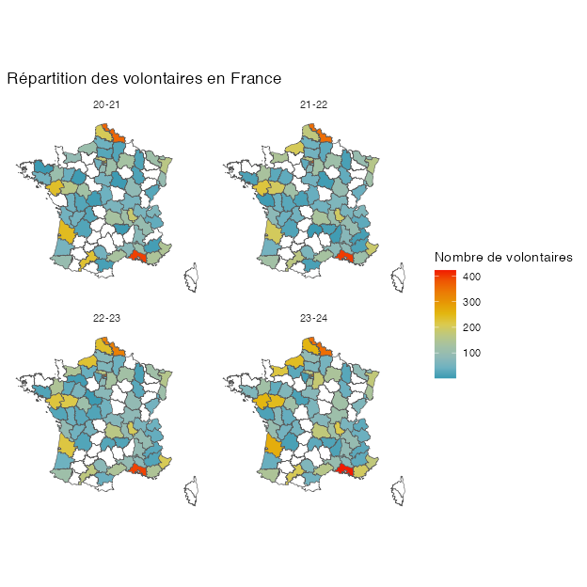

Figure 2
Change in the number of volunteers per département, promo 2023-24 compared to 2020-21. The map only covers metropolitan France.
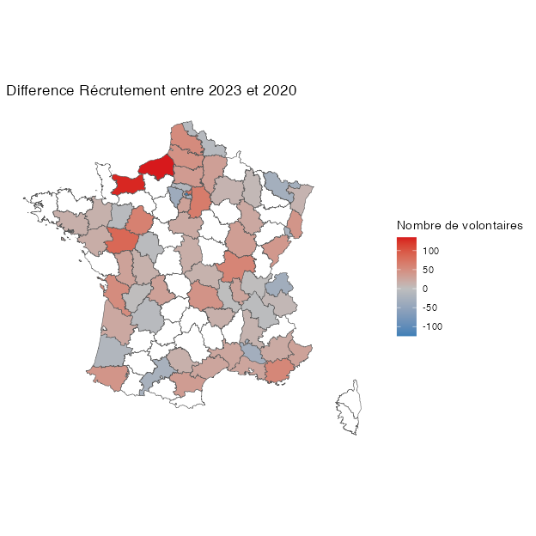

(A) (absolute numbers)
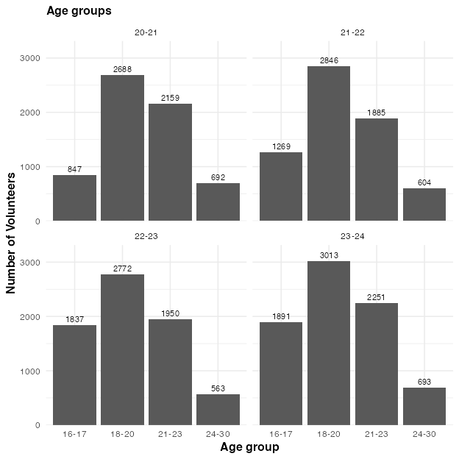
(B) (percentages)
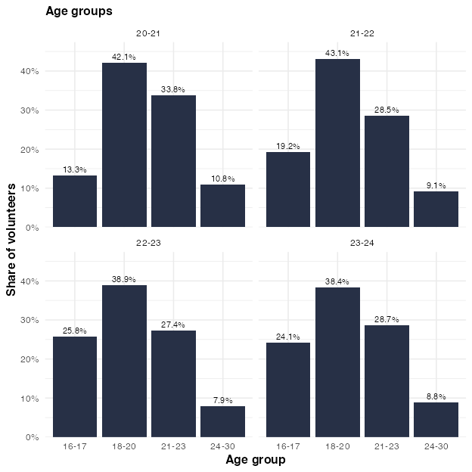

Figure 3
Number of volunteers per age group, within the different promos. Note that, in the percentage plot, the percentages are relative to all volunteers from the respective promo.

(A) (absolute numbers)
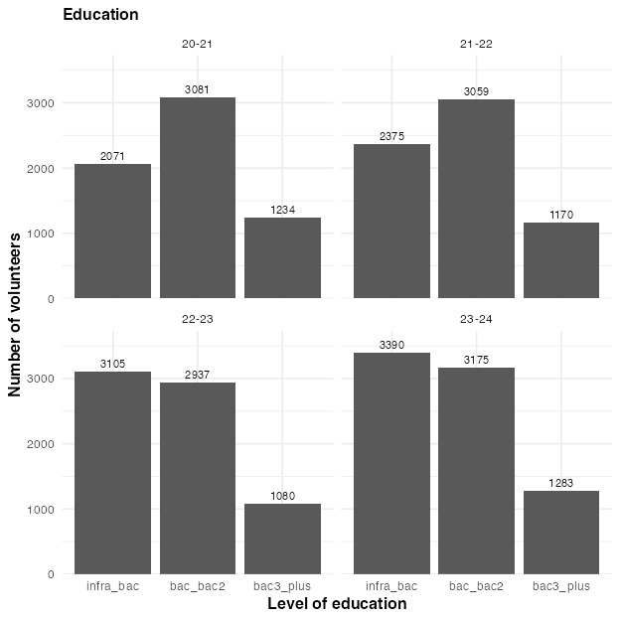
(B) (percentages)
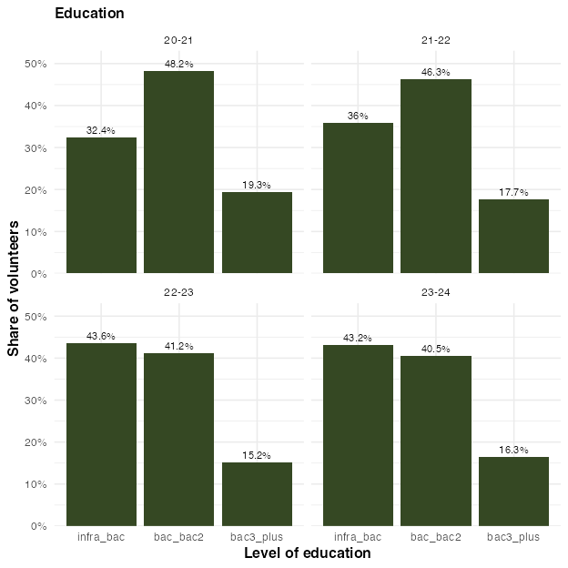

Figure 4
Number of volunteers per education level, within the different promos. Note that in the percentage plot, the percentages are relative to all volunteers from the respective promo.

(A) (absolute numbers)
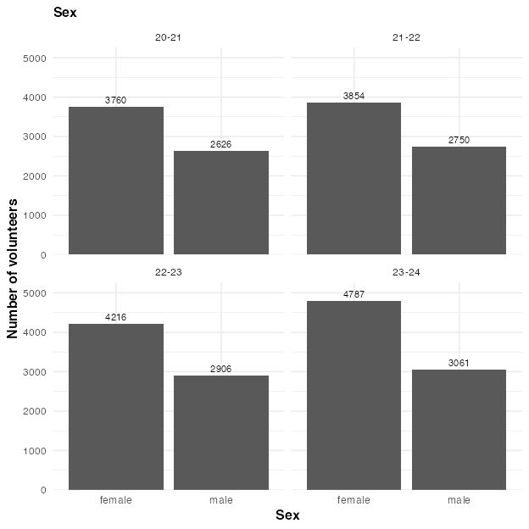
(B) (percentages)
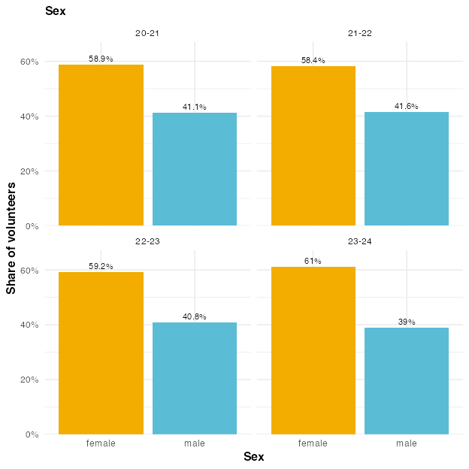

Figure 5
Number of male and female volunteers, within the different promos. Note that in the percentage plot, the percentages are relative to all volunteers from the respective promo.

(A) (absolute numbers)
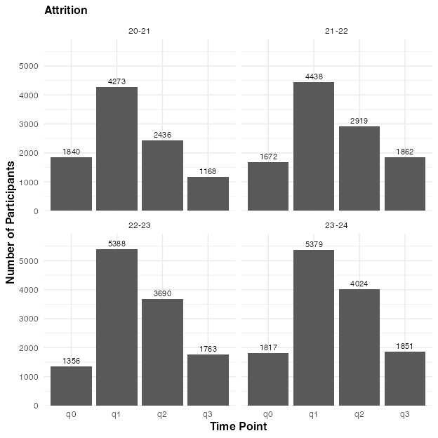
(B) (percentages)
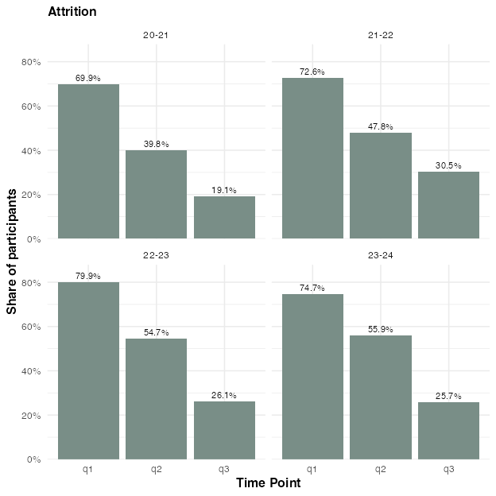

Figure 6
Number of volunteers per survey time point. Volunteers who appear under ‘q0’ have participated in the program but have not even filled out the first questionnaire (q1). Note that in the percentage plot, the percentages are relative to all volunteers from the respective promo. This plot includes ruptures.

(A) (absolute numbers)
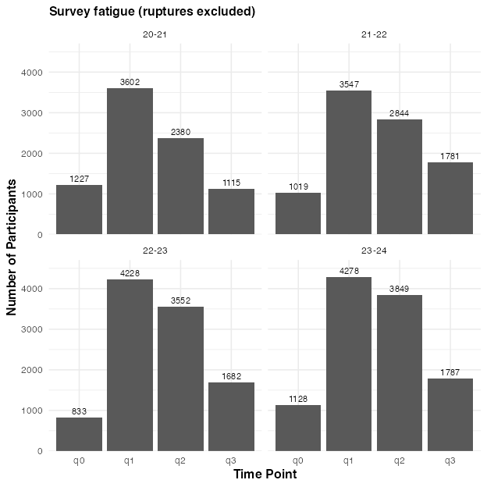
(B) (percentages)
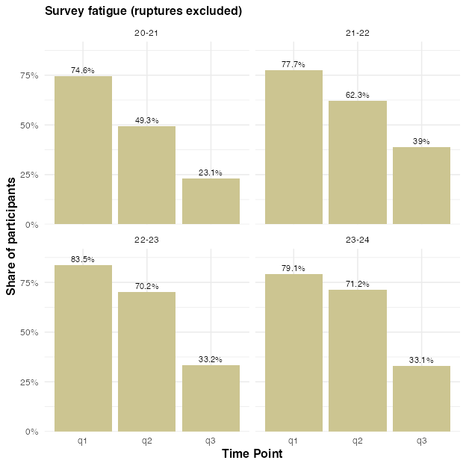

Figure 7
Number of volunteers per survey time point, excluding ruptures. Volunteers who appear under ‘q0’ have participated in the program but have not even filled out the first questionnaire (q1). Note that in the percentage plot, the percentages are relative to all volunteers from the respective promo.

Figure 8
Share of volunteers who reported being very satisfied (‘Très satisfaisante’) in the second questionnaire (q2), split by whether they later answered the third questionnaire (q3) or not. If the two bars were equal, the volunteers who answer q3 would be perfectly representative—at least in terms of satisfaction—of all volunteers who answered q2.
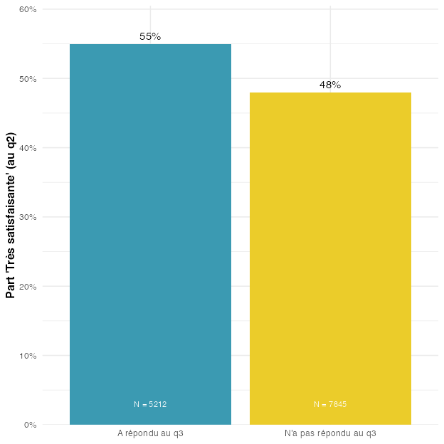

(A) (absolute numbers)
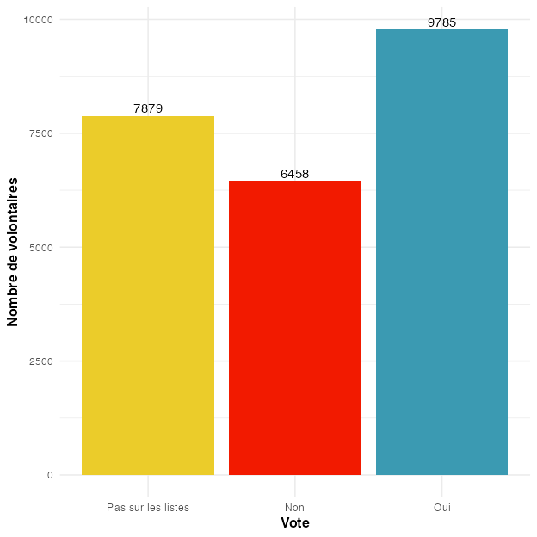
(B) (percentages)
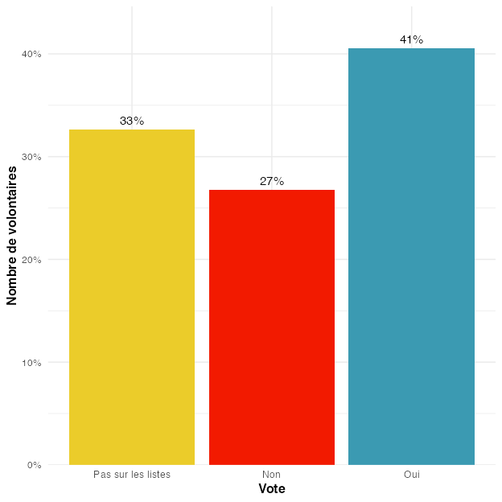

Figure 9
Distribution of whether volunteers reported having voted or not during the last elections, averaged across time points and cohorts.

(A) Alluvial plot
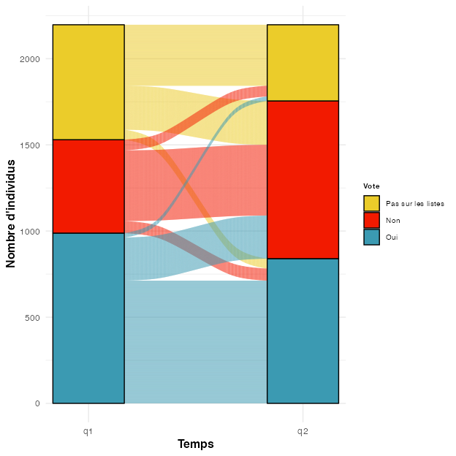
(B) Percentages
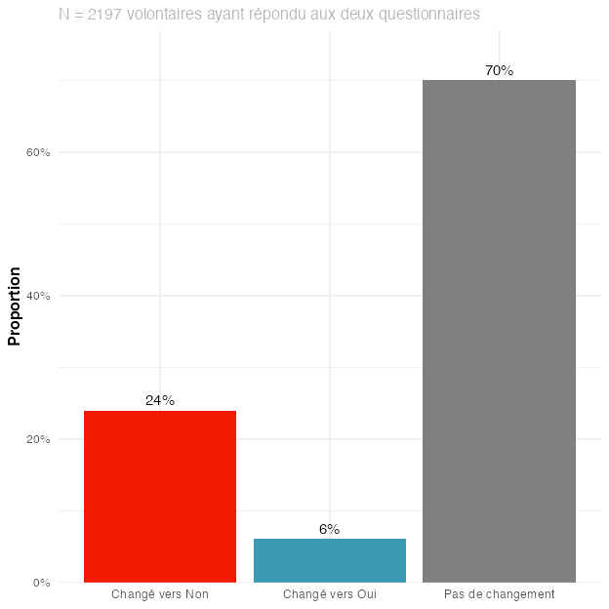

Figure 10
Promo 2020-21. Change in volunteers reporting whether they voted or not during the last elections, between Q1 (beginning of the service civique) and Q2 (end of the service civique). Note that this analysis considers only volunteers who answered the question at both time points. Changes towards ‘Pas sur les listes’ are rare and are not shown in the change plots.

(A) Alluvial plot
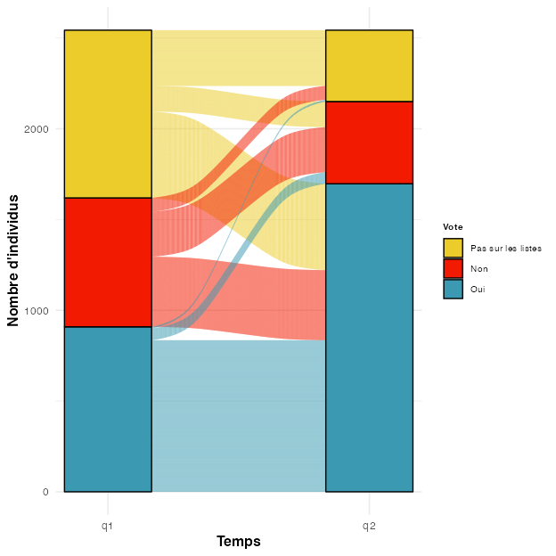
(B) Percentages
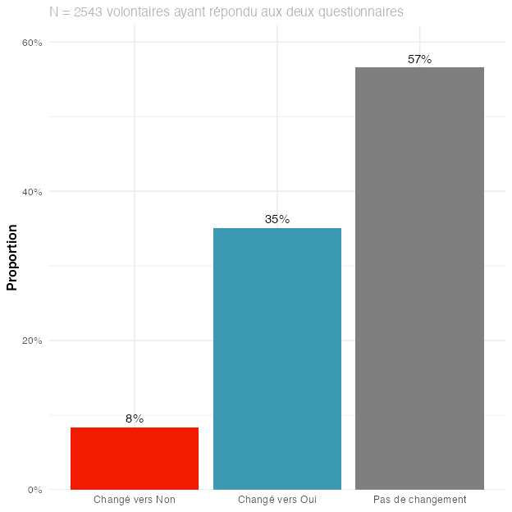

Figure 11
Promo 2021-22. Change in volunteers reporting whether they voted or not during the last elections, between Q1 (beginning of the service civique) and Q2 (end of the service civique). Note that this analysis considers only volunteers who answered the question at both time points. Changes towards ‘Pas sur les listes’ are rare and are not shown in the change plots.

(A) Alluvial plot
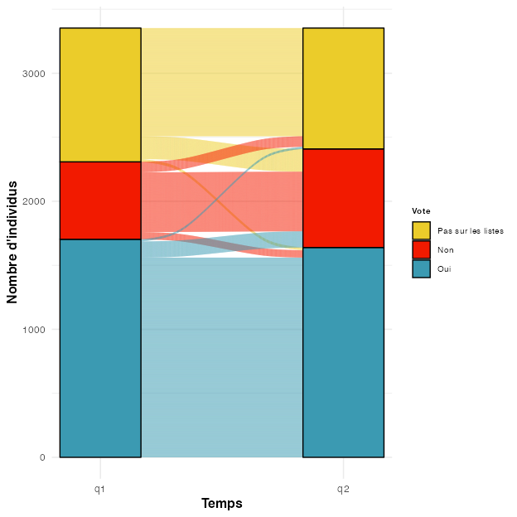
(B) Percentages
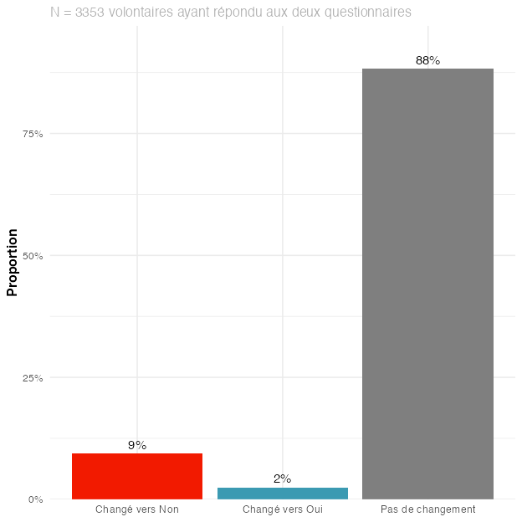

Figure 12
Promo 2022-23. Change in volunteers reporting whether they voted or not during the last elections, between Q1 (beginning of the service civique) and Q2 (end of the service civique). Note that this analysis considers only volunteers who answered the question at both time points. Changes towards ‘Pas sur les listes’ are rare and are not shown in the change plots.

(A) Alluvial plot
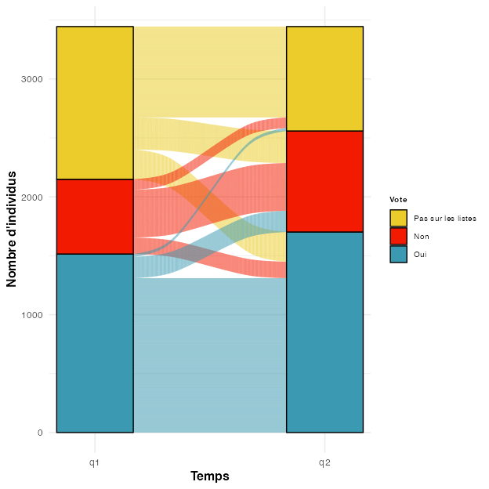
(B) Percentages
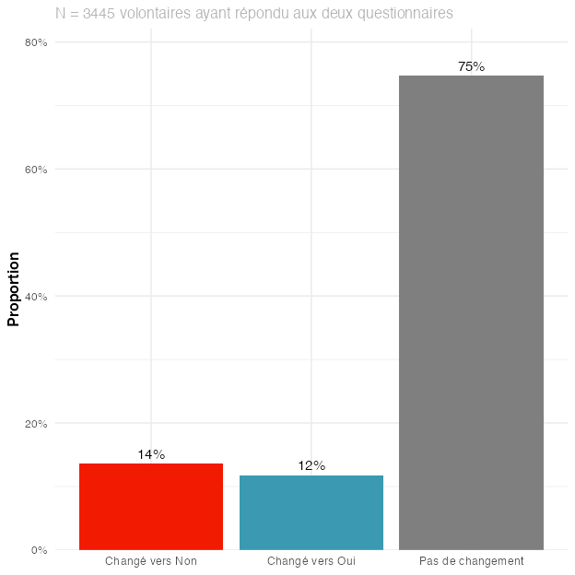

Figure 13
Promo 2023-24. Change in volunteers reporting whether they voted or not during the last elections, between Q1 (beginning of the service civique) and Q2 (end of the service civique). Note that this analysis considers only volunteers who answered the question at both time points. Changes towards ‘Pas sur les listes’ are rare and are not shown in the change plots.

(A) (absolute numbers)
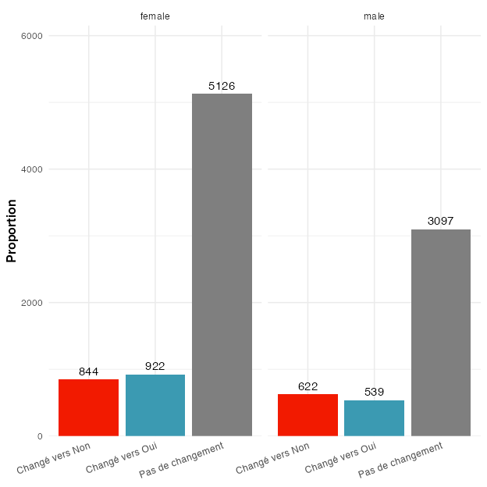
(B) (percentages)
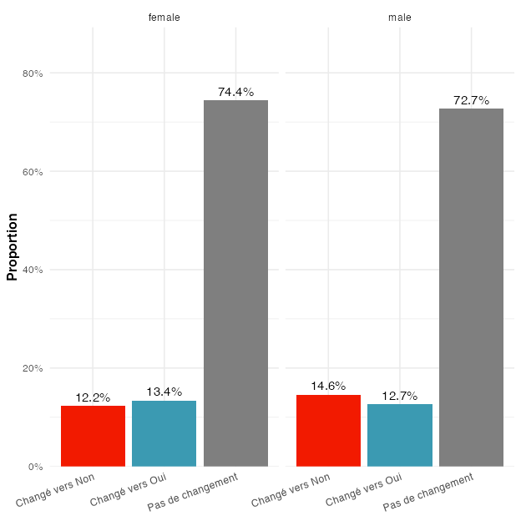

Figure 14
Change in volunteers reporting whether they voted or not during the last elections, between Q1 and Q2, according to their sex. Note that this analysis considers only volunteers who answered the question at both time points. Changes towards ‘Pas sur les listes’ are rare and are not shown in the change plots.

(A) (absolute numbers)
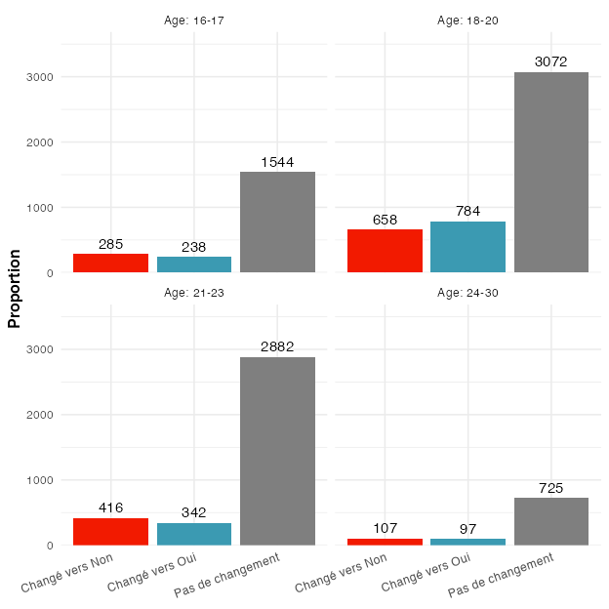
(B) (percentages)
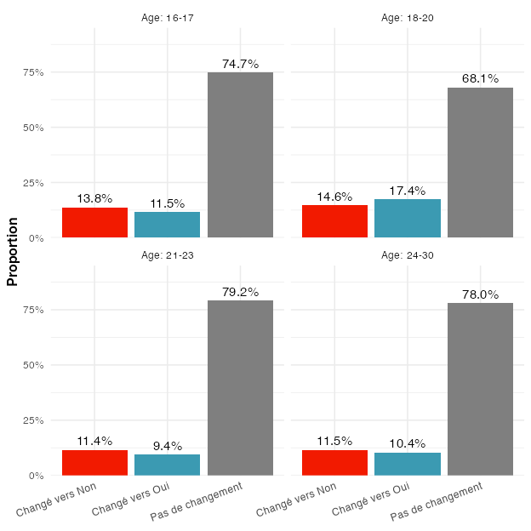

Figure 15
Change in volunteers reporting whether they voted or not during the last elections, between Q1 and Q2, for the different age groups. Note that this analysis considers only volunteers who answered the question at both time points. Changes towards ‘Pas sur les listes’ are rare and are not shown in the change plots.

Figure 16
Distribution of whether volunteers reported having voted or not during the last elections, at different time points, for the youngest age group (16–17 years old). All answers at q0/q1 that are not “Pas sur les listes” are not exactly correct.
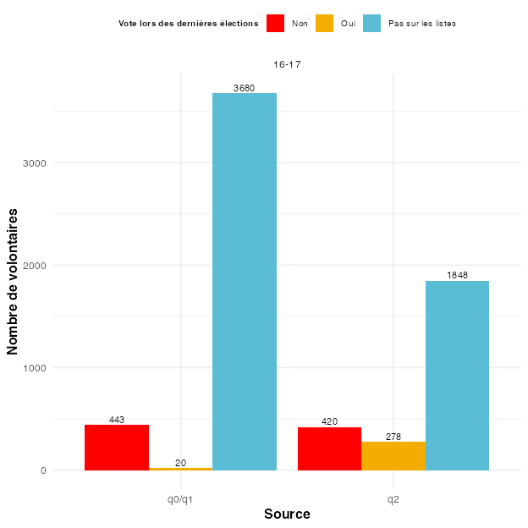

(A) (absolute numbers)
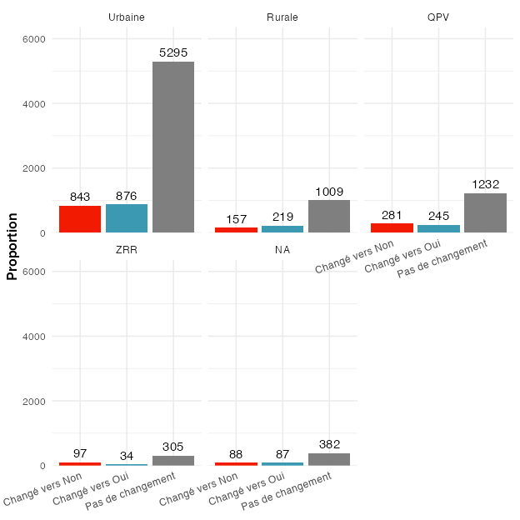
(B) (percentages)
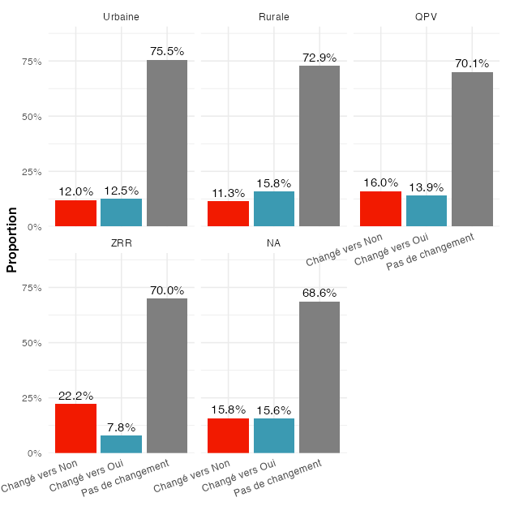

Figure 17
Change in volunteers reporting whether they voted or not during the last elections, between Q1 and Q2, according to their zone of residence. Note that this analysis considers only volunteers who answered the question at both time points. Changes towards ‘Pas sur les listes’ are rare and are not shown in the change plots.

(A) (absolute numbers)
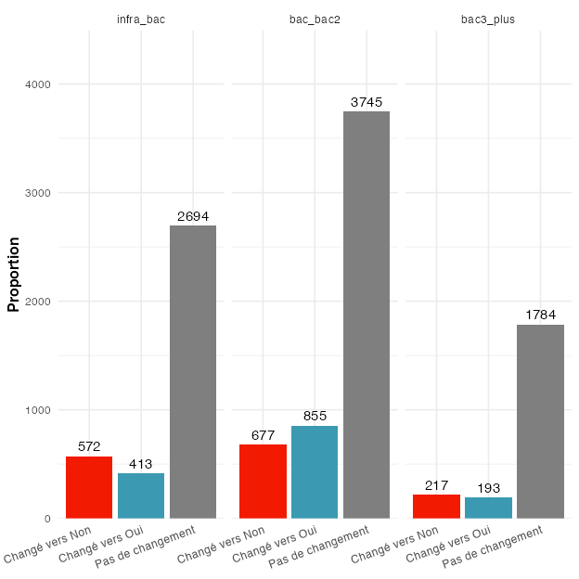
(B) (percentages)
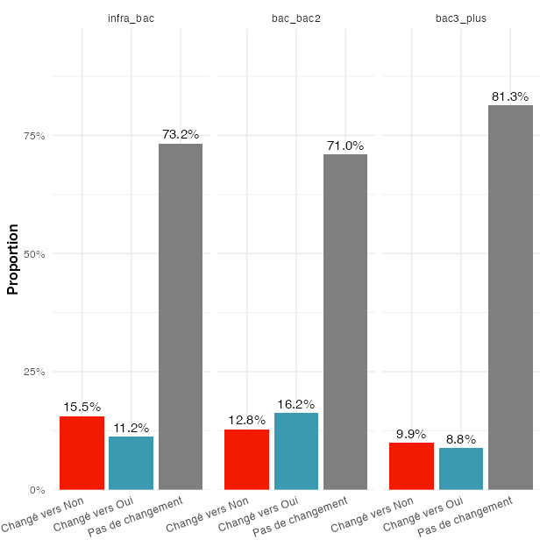

Figure 18
Change in volunteers reporting whether they voted or not during the last elections, between Q1 and Q2, according to their level of education. Note that this analysis considers only volunteers who answered the question at both time points. Changes towards ‘Pas sur les listes’ are rare and are not shown in the change plots.

(A) Alluvial plot
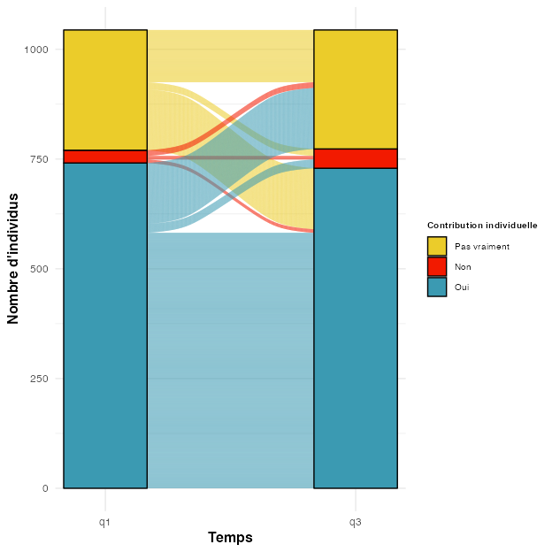
(B) Percentages
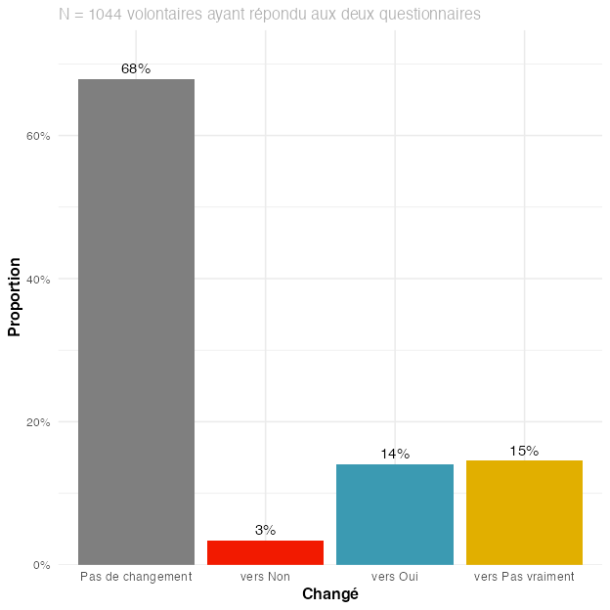

Figure 19
Promo 2020-21. Change in volunteers reporting whether they think their individual action can contribute to changing society, between Q1 (beginning of the service civique) and Q3 (six months after its end). Note that this analysis considers only answers of volunteers who answered at both time points.

(A) Alluvial plot
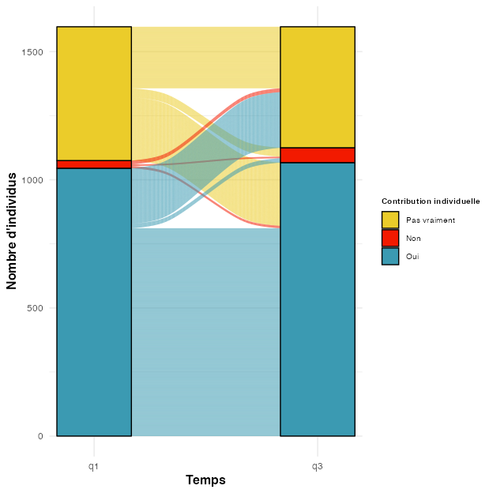
(B) Percentages
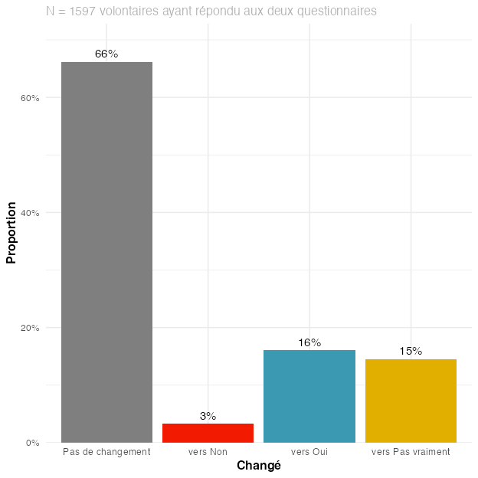

Figure 20
Promo 2021-22. Change in volunteers reporting whether they think their individual action can contribute to changing society, between Q1 (beginning of the service civique) and Q3 (six months after its end). Note that this analysis considers only answers of volunteers who answered at both time points.

(A) Alluvial plot
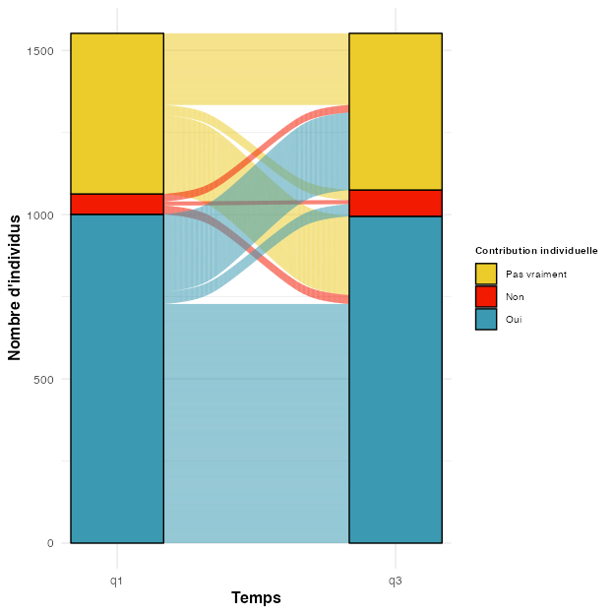
(B) Percentages
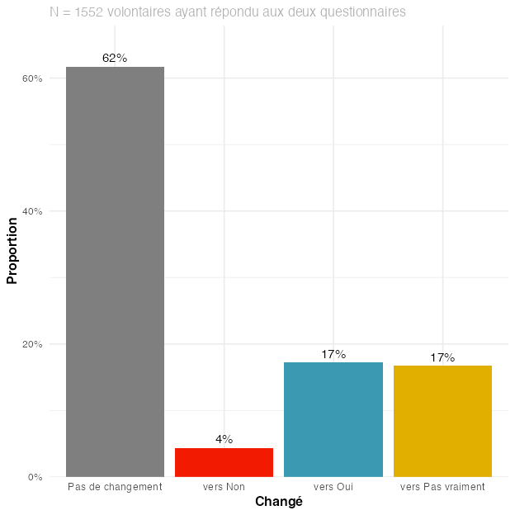

Figure 21
Promo 2022-23. Change in volunteers reporting whether they think their individual action can contribute to changing society, between Q1 (beginning of the service civique) and Q3 (six months after its end). Note that this analysis considers only answers of volunteers who answered at both time points.

(A) Alluvial plot
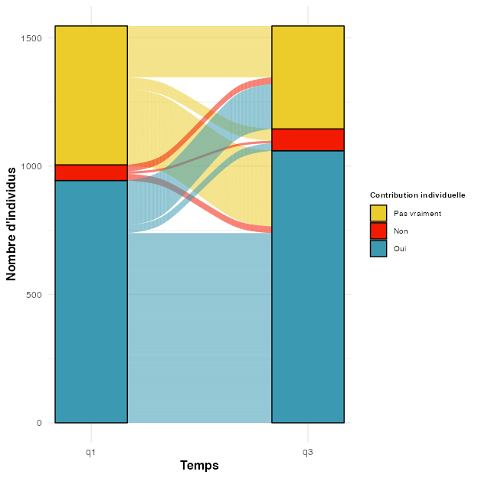
(B) Percentages
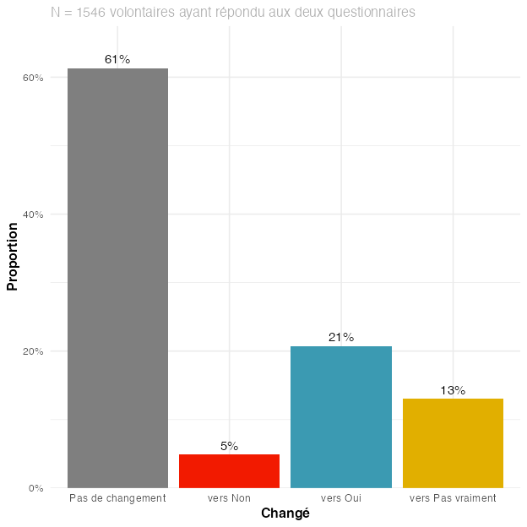

Figure 22
Promo 2023-24. Change in volunteers reporting whether they think their individual action can contribute to changing society, between Q1 (beginning of the service civique) and Q3 (six months after its end). Note that this analysis considers only answers of volunteers who answered at both time points.

(A) (absolute numbers)
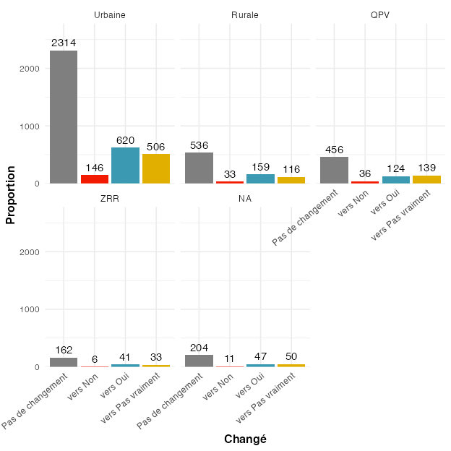
(B) (percentages)
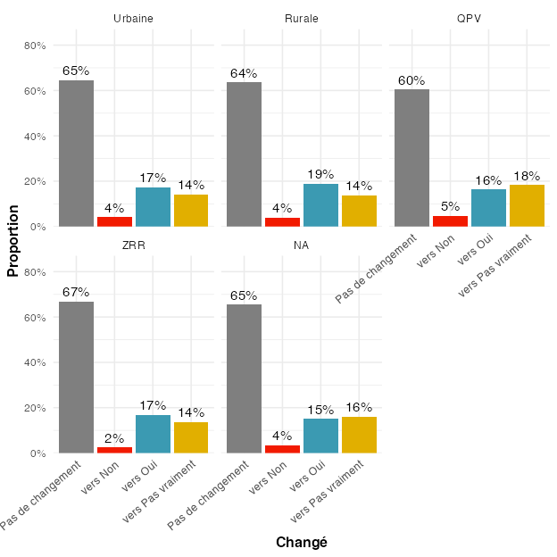

Figure 23
Change in volunteers reporting whether they think their individual action can contribute to changing society, between Q1 and Q3, according to their zone of residence. Note that this analysis considers only answers of volunteers who provided an answer at both time points.

(A) (absolute numbers)
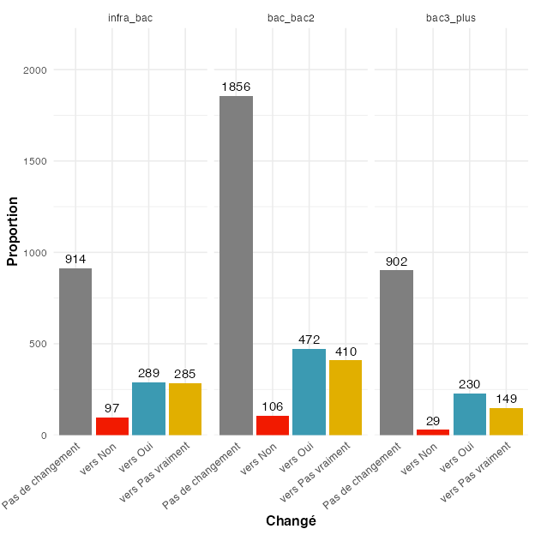
(B) (percentages)
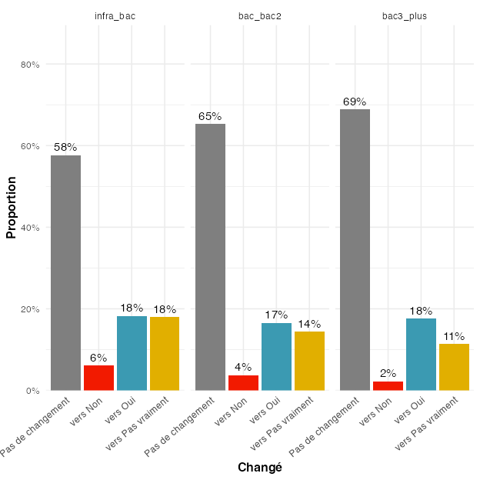

Figure 24
Change in volunteers reporting whether they think their individual action can contribute to changing society, between Q1 and Q3, according to their level of education. Note that this analysis considers only answers of volunteers who provided an answer at both time points.

(A) (absolute numbers)
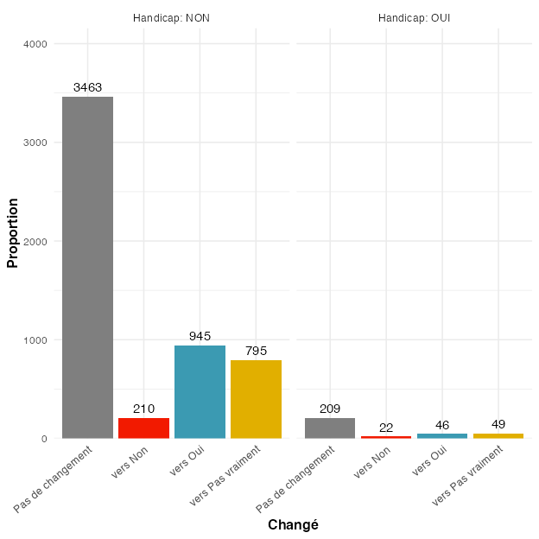
(B) (percentages)
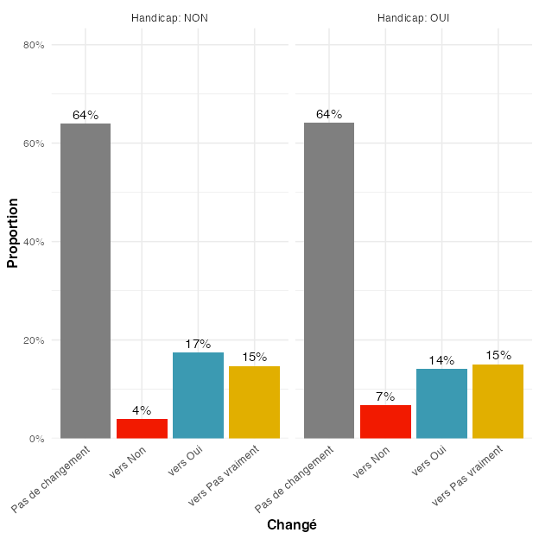

Figure 25
Change in volunteers reporting whether they think their individual action can contribute to changing society, between Q1 and Q3, according to whether they had a handicap (administrative) or not. Note that this analysis considers only answers of volunteers who provided an answer at both time points.

(A) (absolute numbers)
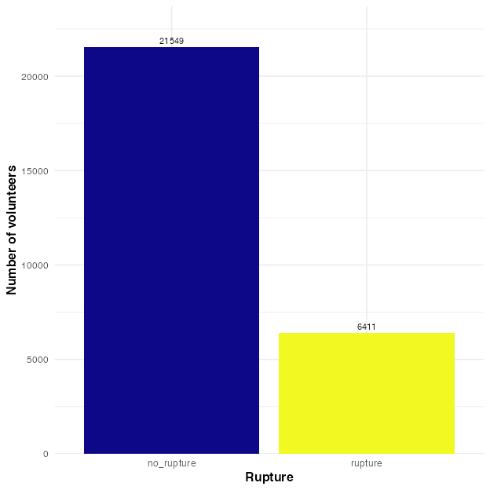
(B) (percentages)
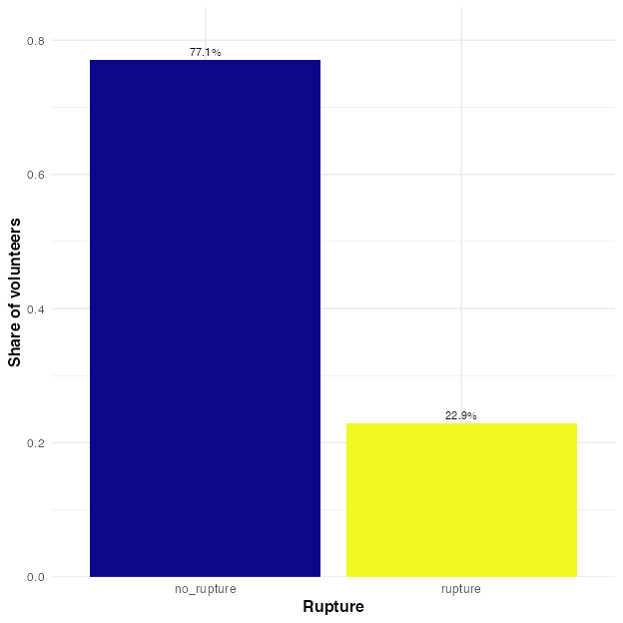

Figure 26
Number of volunteers with a rupture (for various possible reasons, including positive ones, such as obtaining a work contract), pooled across all cohorts.

Figure 27
Prevalence of different rupture motives, pooled across all cohorts.
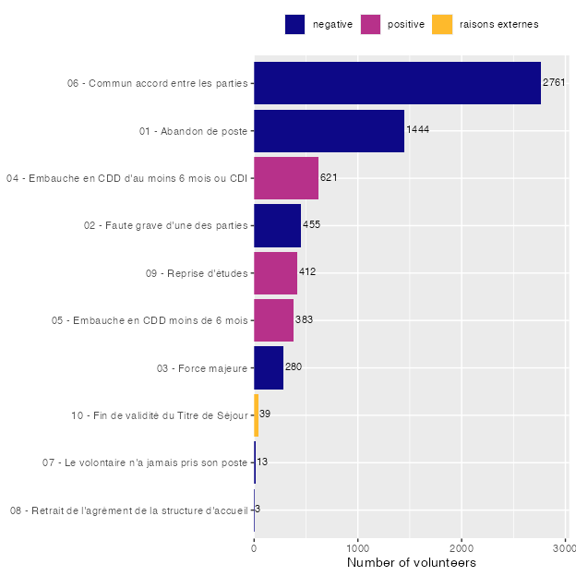

Figure 28
Number of months of service civique completed before the rupture, among all volunteers with a rupture (pooled across all cohorts, all rupture motives combined).
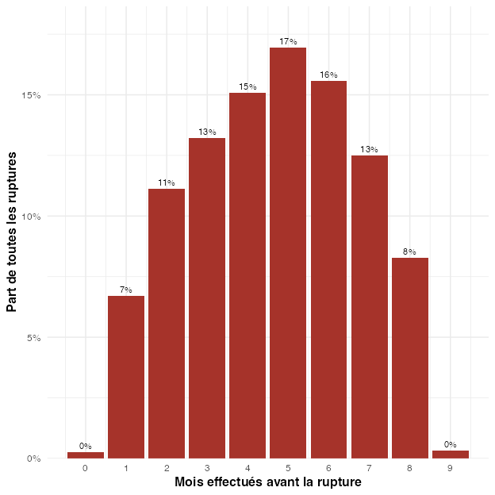

(A) (absolute numbers)
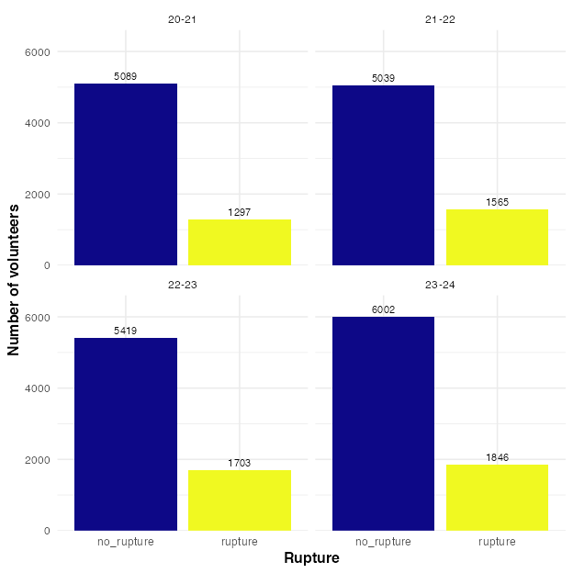
(B) (percentages)
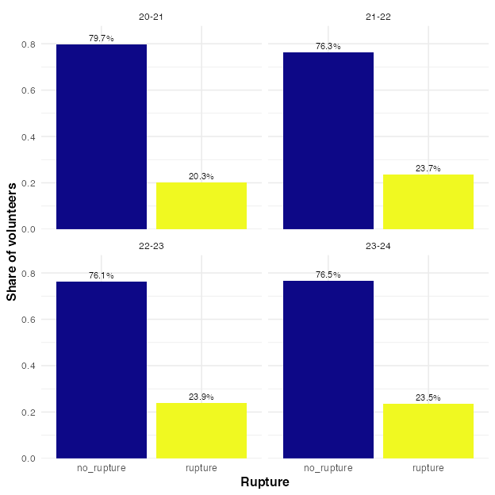

Figure 29
Number of volunteers with a rupture (for various possible reasons, including positive ones, such as obtaining a work contract).

Figure 30
Percentages of rupture for (allegedly) negative reasons for different groups, for different variables.
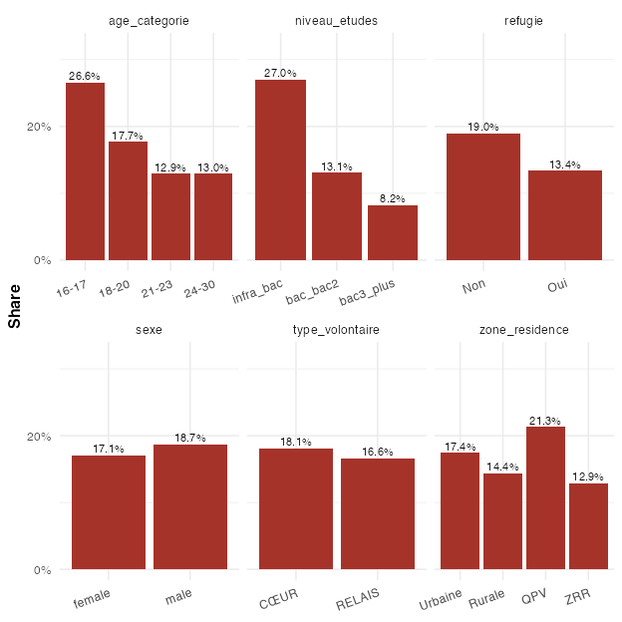

Figure 31
Percentages of rupture for (allegedly) negative reasons, as a function of (i) the volunteers’ confidence in their future and (ii) their perception that their individual action can contribute to changing society.
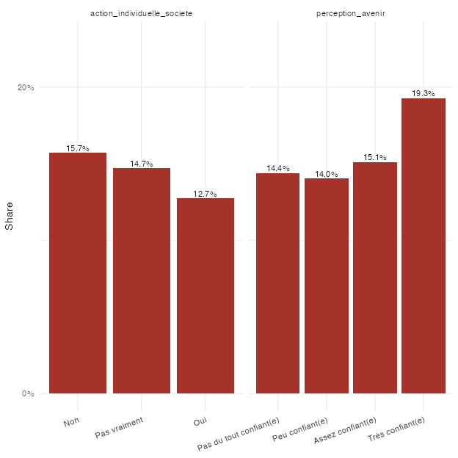

(A) (absolute numbers)
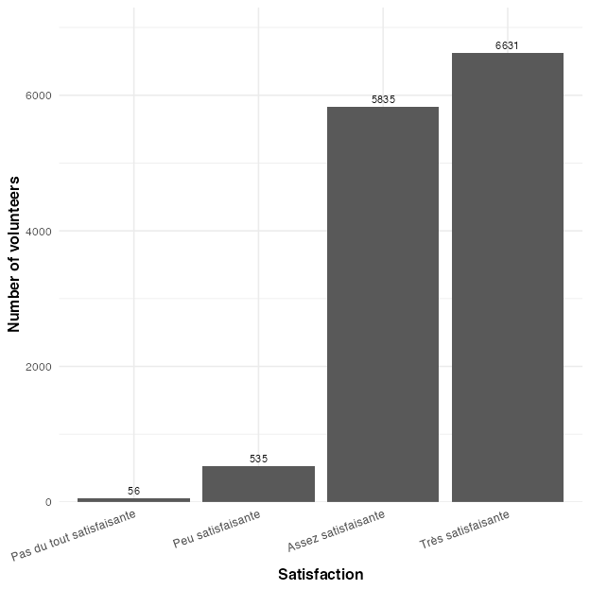
(B) (percentages)
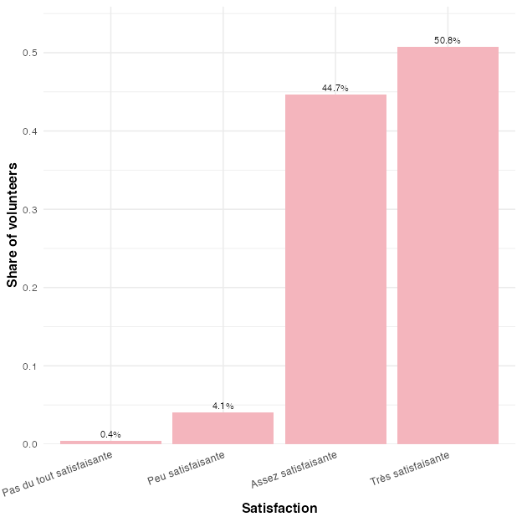

Figure 32
Distribution of satisfaction levels, pooled across all cohorts.

Figure 33
Satisfaction between cohorts.
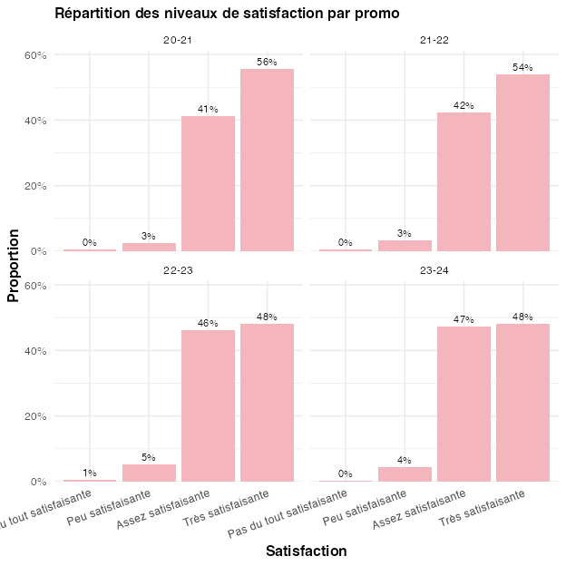

(A) (age groups)
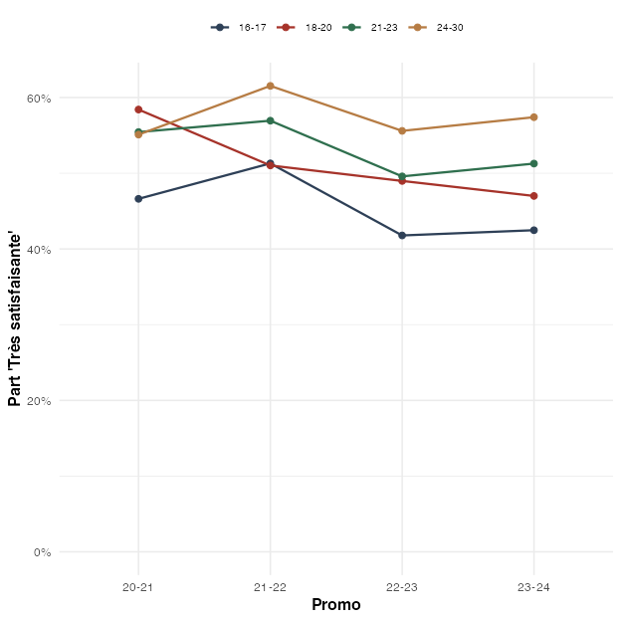
(B) (education levels)
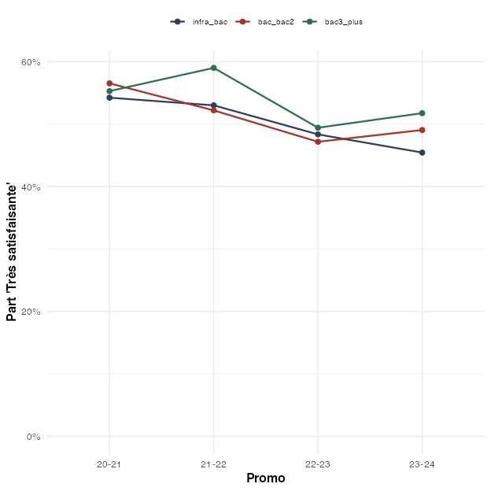

Figure 34
Share of volunteers who report being ‘very satisfied’ (‘Très satisfaisante’), by cohort, separately for age groups and education levels. If the overall decline were only driven by the changing composition of volunteers, the trends within groups would be flat.

Figure 35
Share of volunteers responding to the different satisfaction levels, grouped by different variables.
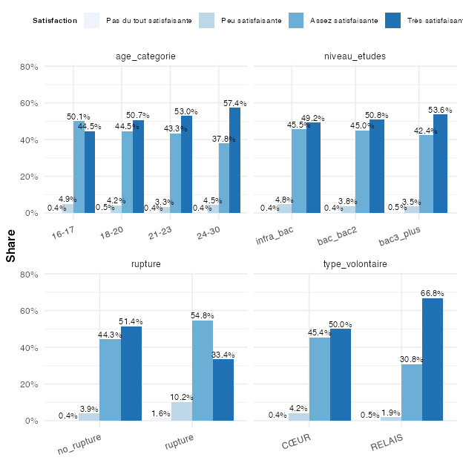

Figure 36
Share of volunteers responding to the different satisfaction levels, grouped by different variables.
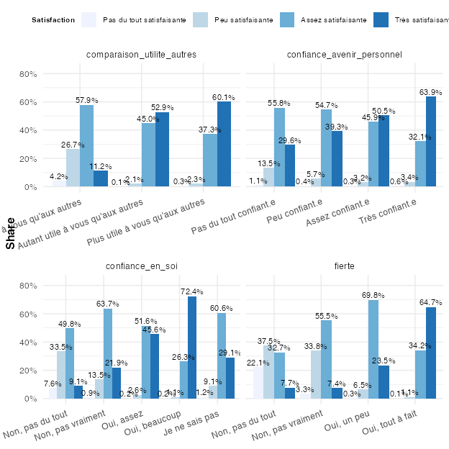

(A) (absolute numbers)
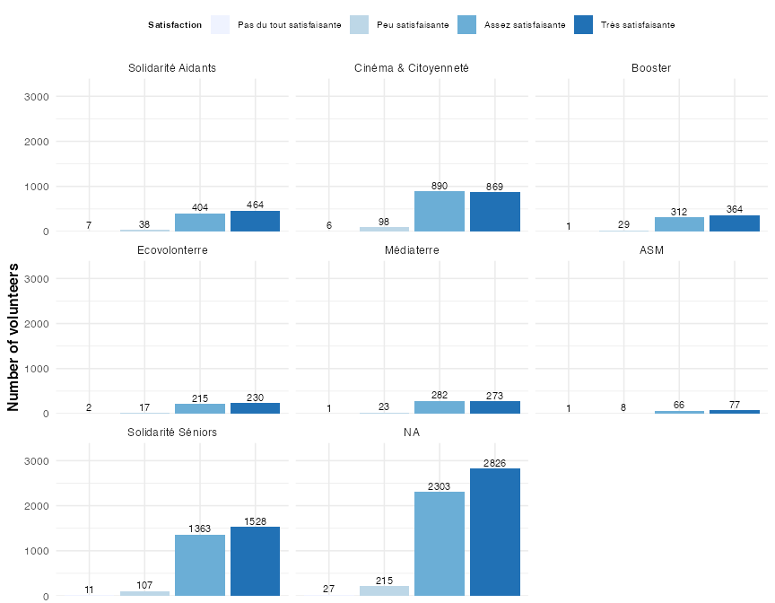
(B) (percentages)
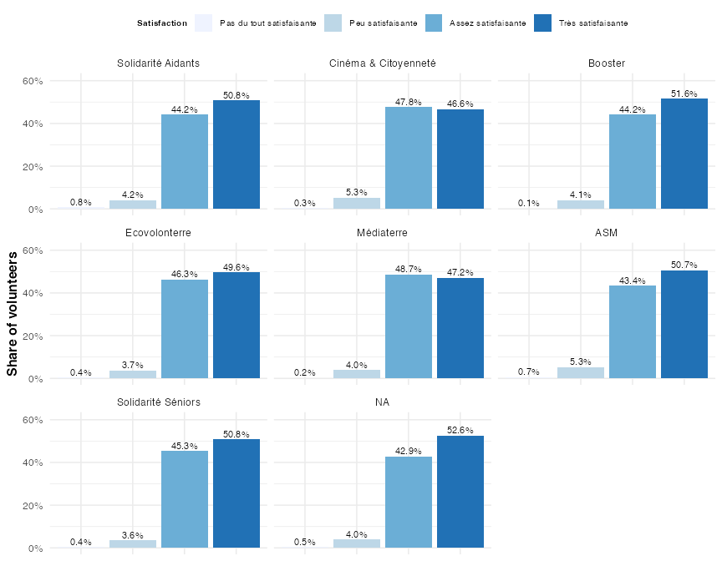

Figure 37
Share of volunteers responding to the different satisfaction levels, grouped by which program they were in. Note that we focus only on key programs here. All other programs appear under ‘NA’ in the plot.

(A) (absolute numbers)
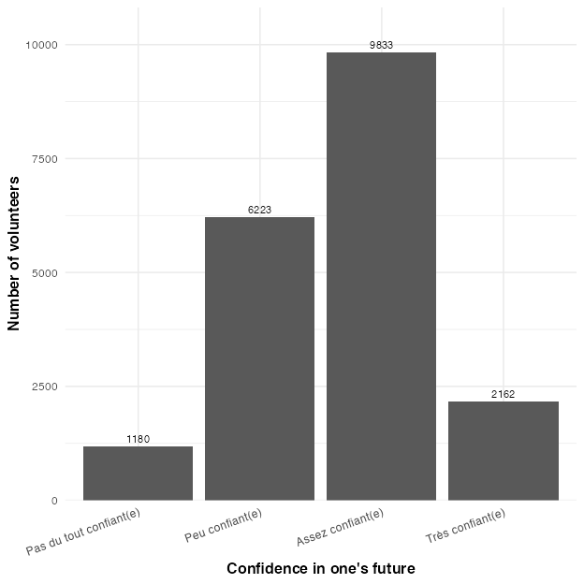
(B) (percentages)
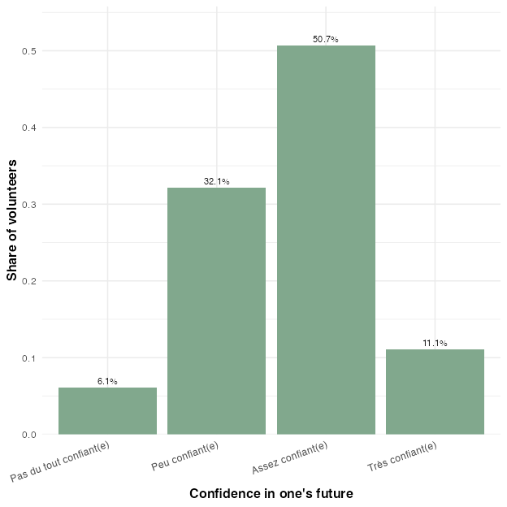

Figure 38
Confidence in one’s future, pooled across all cohorts.

Figure 39
Confidence in one’s future, between cohorts.
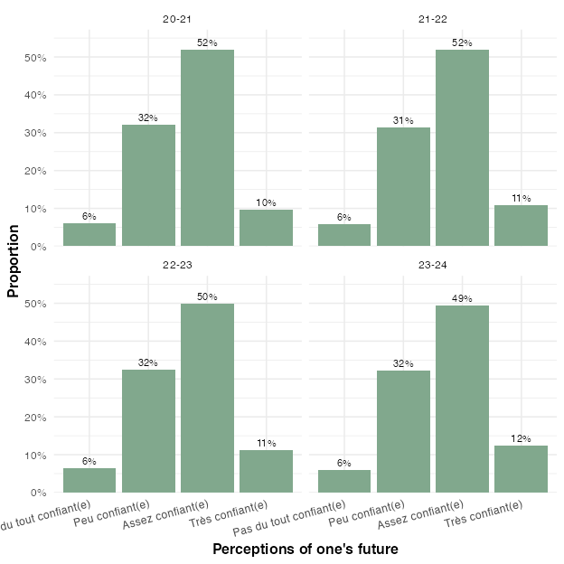

Figure 40
Share of volunteers according to their confidence in their future, grouped by different variables.
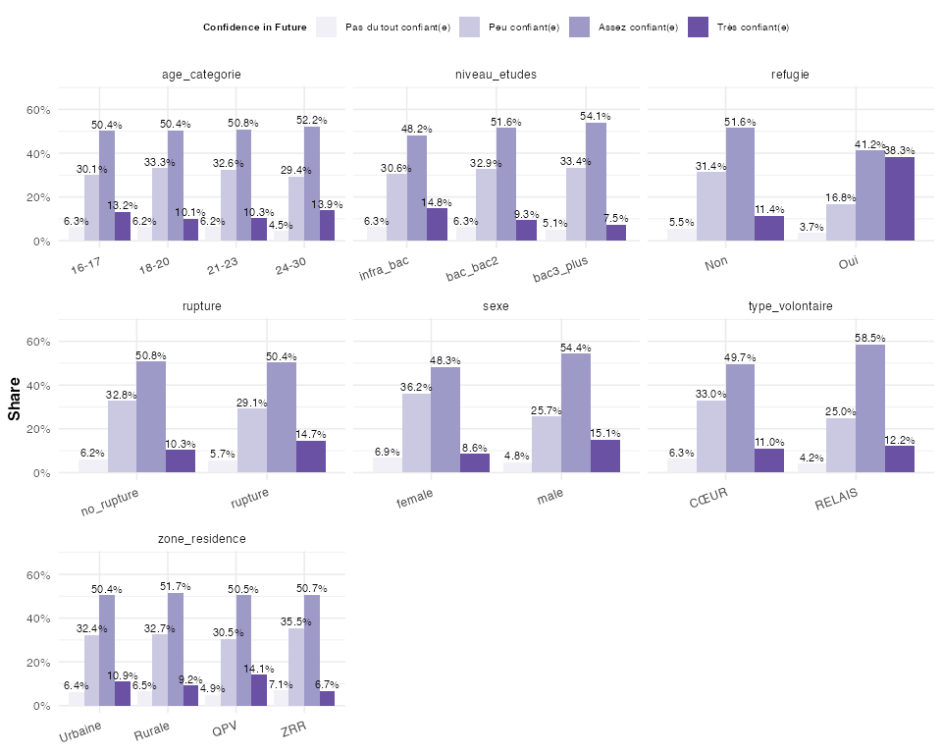

Figure 41
Share of volunteers according to their confidence in their future, as a function of whether they think their individual action can contribute to society.
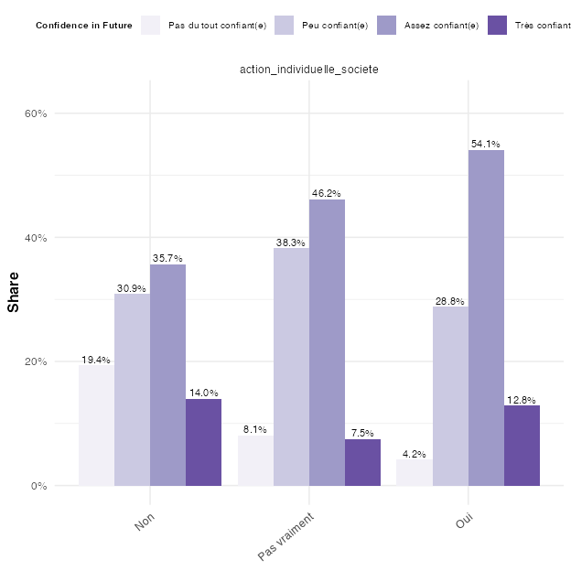

(A) (absolute numbers)
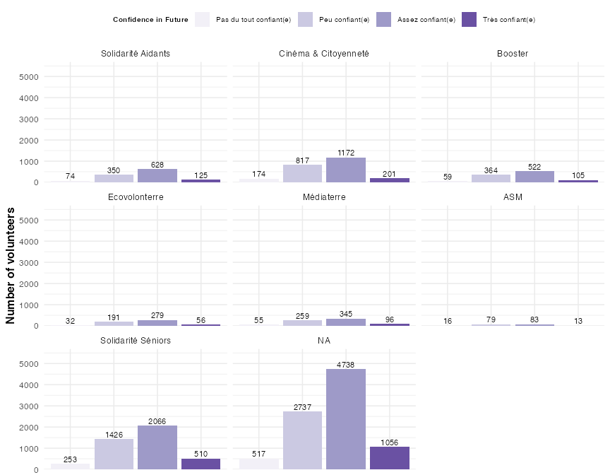
(B) (percentages)
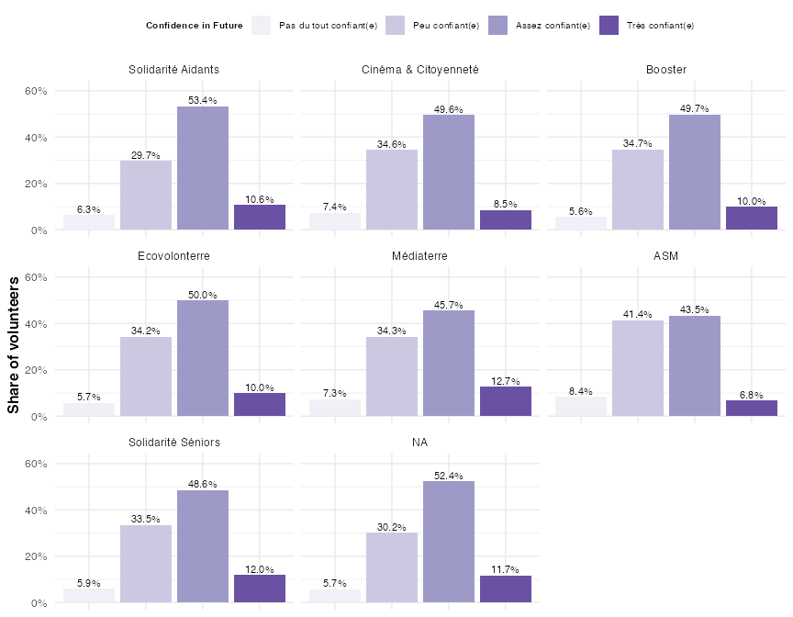

Figure 42
Number of volunteers responding with different levels of confidence in their future, grouped by which program they were in. Note that we focus only on key programs here. All other programs appear under ‘NA’ in the plot.

(A) (absolute numbers)
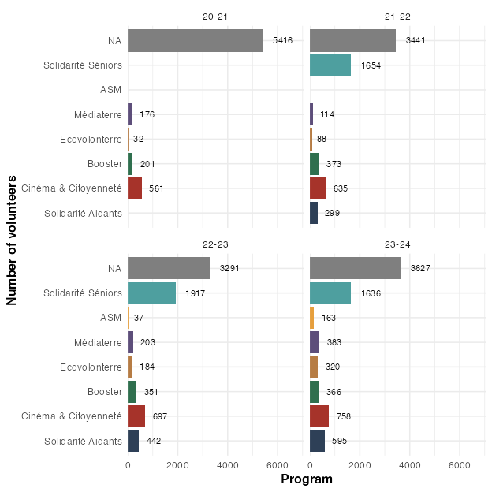
(B) (percentages)
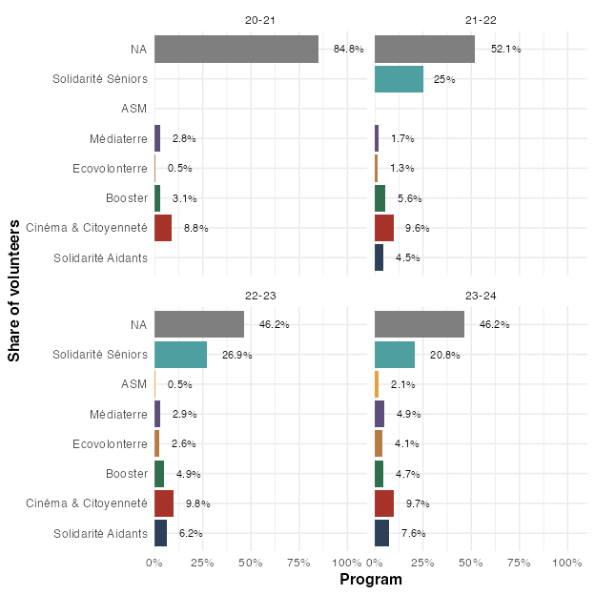

Figure 43
Number of volunteers per key program, within the different promos. Note that, in the percentage plot, the percentages are relative to all volunteers from the respective promo. All volunteers who were not included in any of the key programs appear in the plot under ‘NA’.

Figure 44
Differences in Solidarité Aidants vs. other programs along demographic factors.
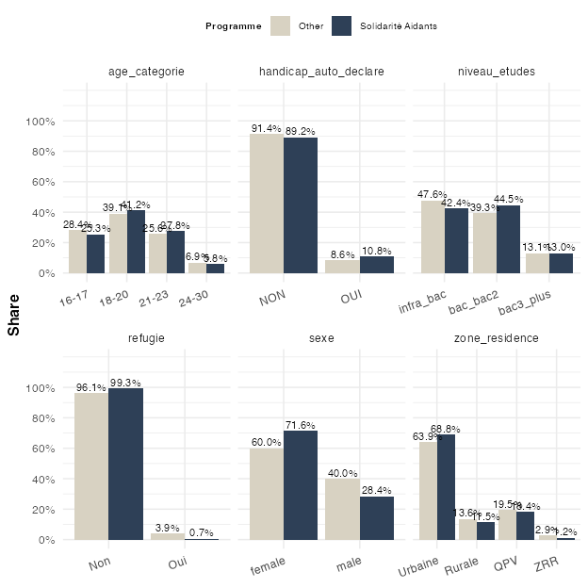

Figure 45
Differences in Cinéma & Citoyenneté vs. other programs along demographic factors.
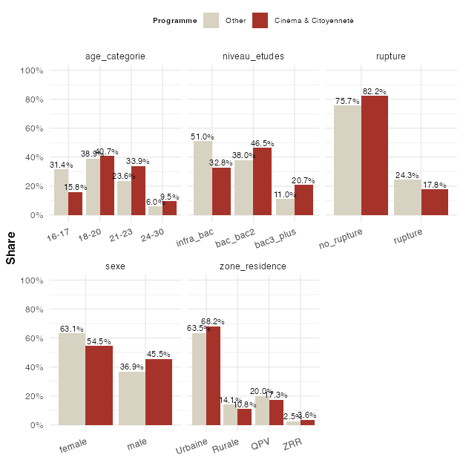

Figure 46
Differences in Booster vs. other programs along demographic factors.
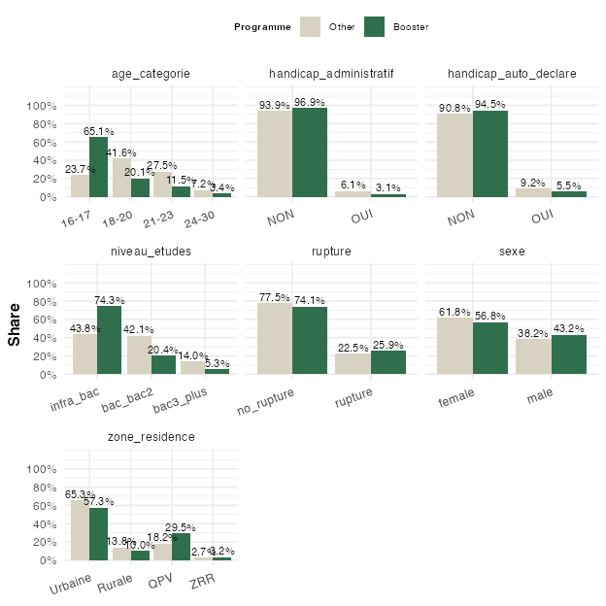

Figure 47
Differences in Ecovolonterre vs. other programs along demographic factors.
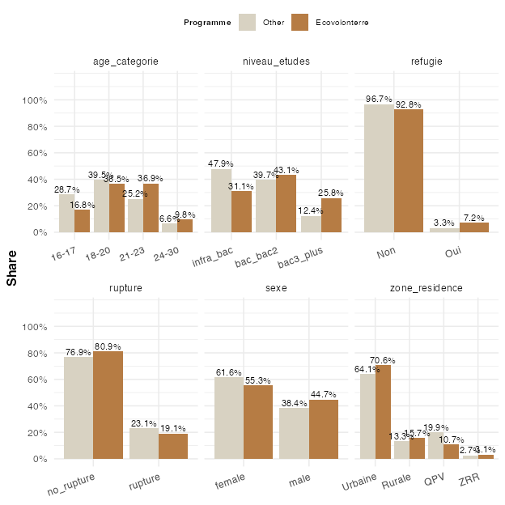

Figure 48
Differences in Médiaterre vs. other programs along demographic factors.
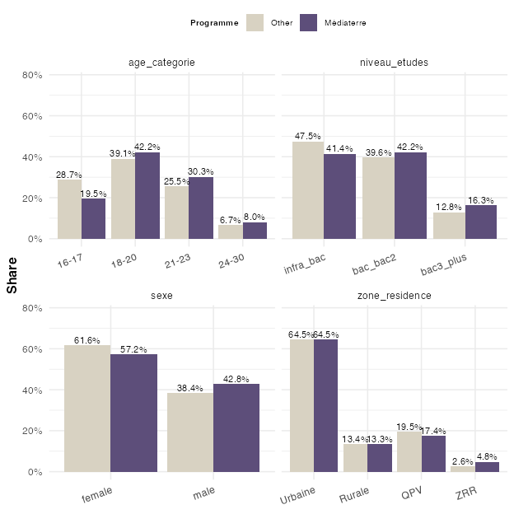

Figure 49
Differences in ASM vs. other programs along demographic factors.
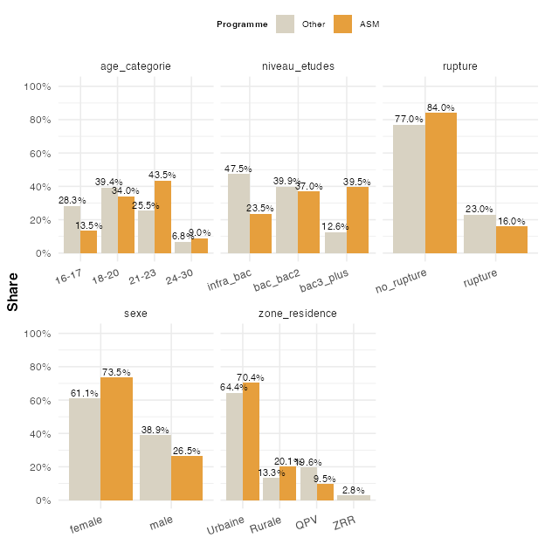

Figure 50
Differences in Solidarité Séniors vs. other programs along demographic factors.
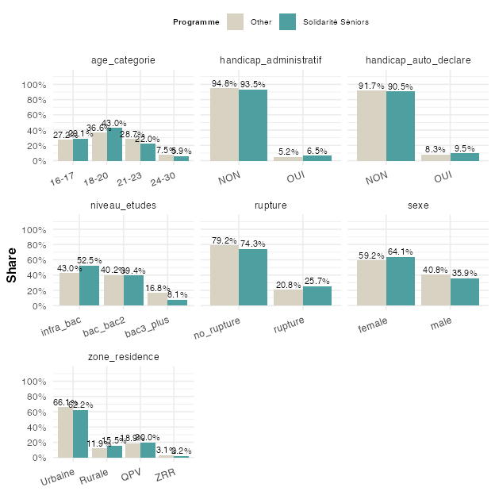

Figure 51
Effects of demographic factors on change in voting behavior. The outcome is binary (changed to no vs. changed to yes). The dots and their labels are the estimates of separate logistic regressions for each variable. The lines around the dots represent uncertainty in the estimates (95% confidence intervals). If these confidence intervals cross 1 (the dotted vertical line), the differences are not statistically significant, meaning we might observe them just by chance. The logarithmic scale (on the x-axis) is used so that in the visualization for the positive and negative odds ratio’s to be symmetric (i.e. that 2 is as far away from 1 as is 0.5).
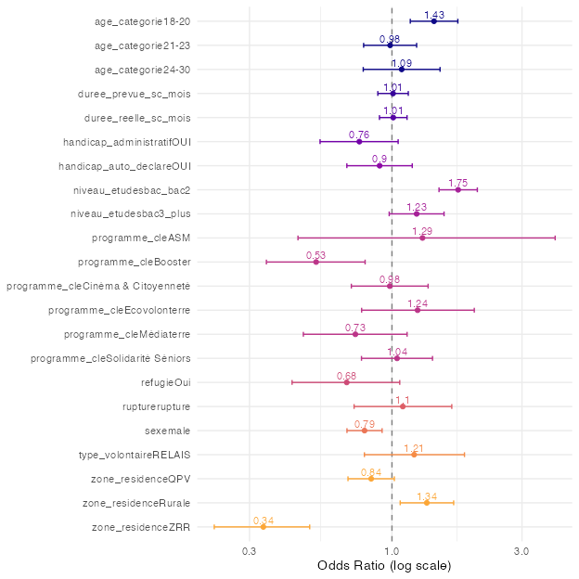

Figure 52
Effects of demographic factors on change in perceptions of how one’s individual actions can contribute to society. The outcome is binary (“vers Non/Pas vraiment” vs. “vers Oui”). The dots and their labels are the estimates of separate logistic regressions for each variable. The lines around the dots represent uncertainty in the estimates (95% confidence intervals). If these confidence intervals cross 1 (the dotted vertical line), the differences are not statistically significant, meaning we might observe them just by chance. The logarithmic scale (on the x-axis) is used so that in the visualization for the positive and negative odds ratio’s to be symmetric (i.e. that 2 is as far away from 1 as is 0.5).
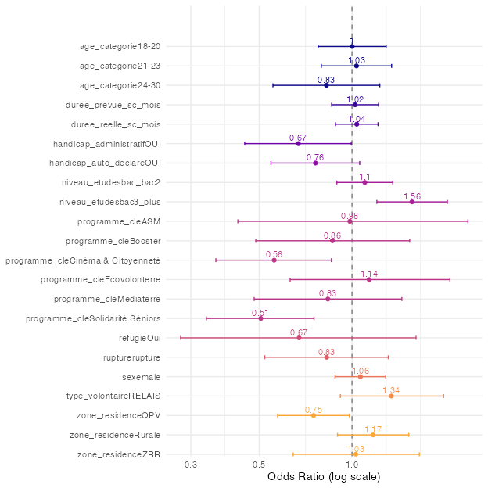

Figure 53
Effects of demographic factors on negative ruptures. The outcome is binary (no negative rupture vs. negative rupture). The dots and their labels are the estimates of separate logistic regressions for each variable. The lines around the dots represent uncertainty in the estimates (95% confidence intervals). If these confidence intervals cross 1 (the dotted vertical line), the differences are not statistically significant, meaning we might observe them just by chance. The logarithmic scale (on the x-axis) is used so that in the visualization for the positive and negative odds ratio’s to be symmetric (i.e. that 2 is as far away from 1 as is 0.5).
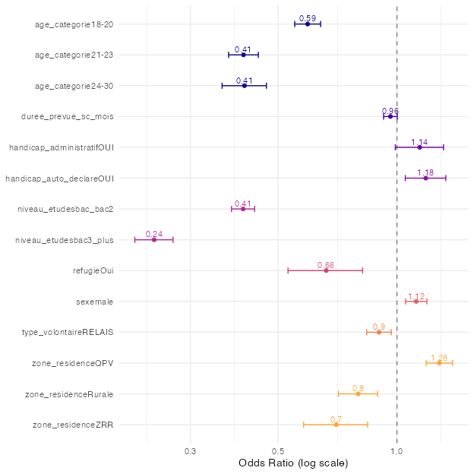

Figure 54
Effects of demographic factors on negative ruptures. The outcome is binary (no negative rupture vs. negative rupture). The dots and their labels are the estimates of separate logistic regressions for each variable. The lines around the dots represent uncertainty in the estimates (95% confidence intervals). If these confidence intervals cross 1 (the dotted vertical line), the differences are not statistically significant, meaning we might observe them just by chance. The logarithmic scale (on the x-axis) is used so that in the visualization for the positive and negative odds ratio’s to be symmetric (i.e. that 2 is as far away from 1 as is 0.5).
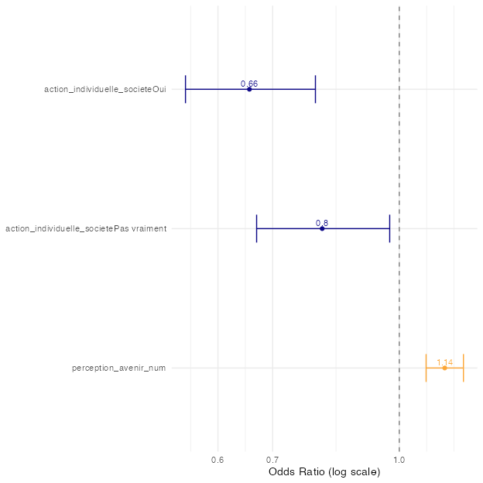

Figure 55
Effects of demographic factors on satisfaction.
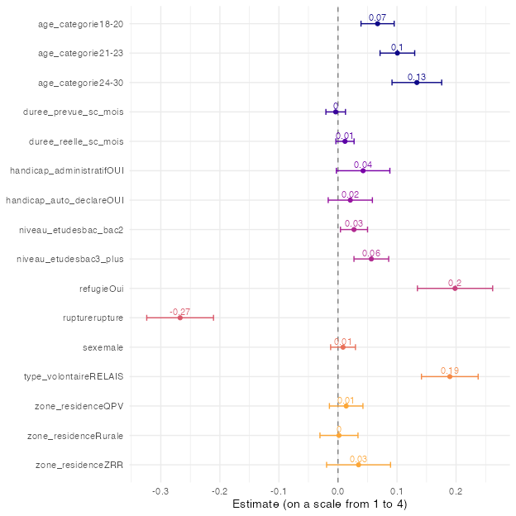

Figure 56
Effects of other, non-demographic factors on satisfaction.
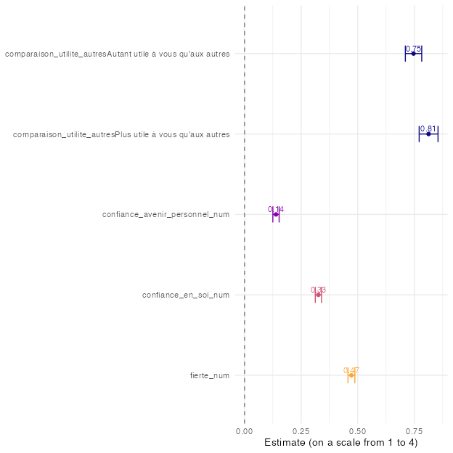

Figure 57
Effects of demographic factors on confidence in one’s future.
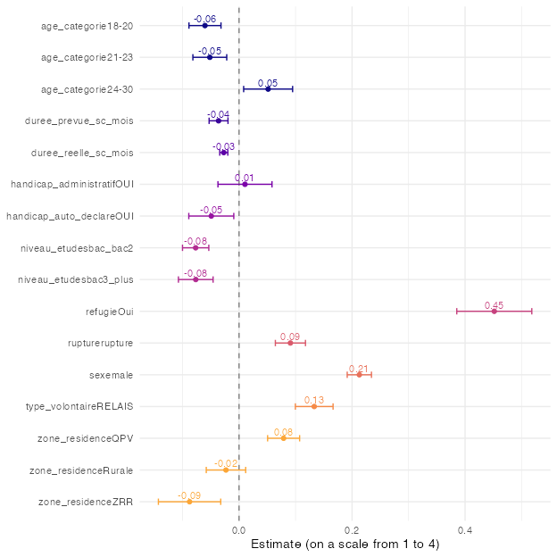

Figure 58
Effects of other, non-demographic factors on confidence in one’s future.
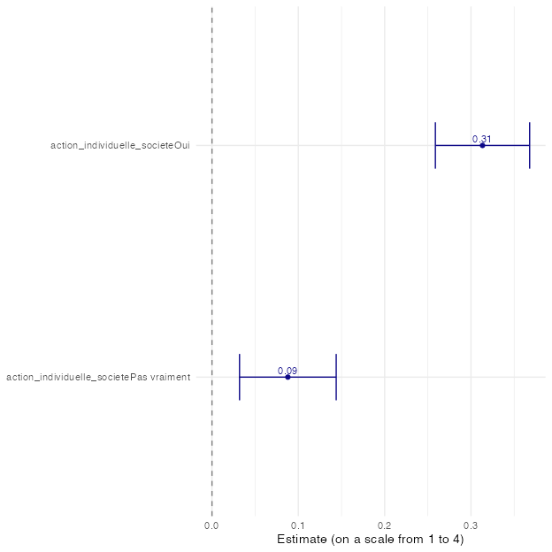

Figure 59
Effects of demographic factors on negative ruptures, when all factors are included in a single model. The outcome is binary (no negative rupture vs. negative rupture). Estimates are odds ratios and read as in the previous figures; the difference is that each estimate now compares volunteers who are similar on all the other factors shown.
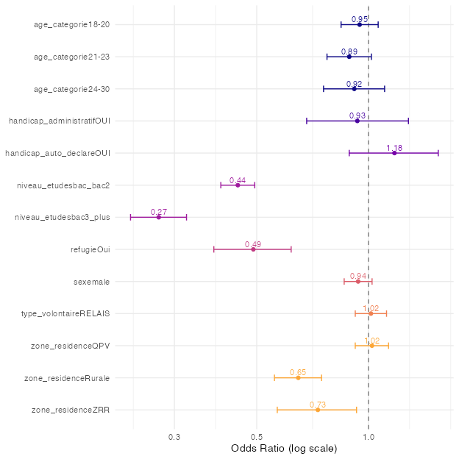

Figure 60
Effects of demographic factors on satisfaction, when all factors are included in a single model. Estimates are average differences on the 4-point satisfaction scale, compared to the (omitted) baseline category, for volunteers who are similar on all the other factors shown.
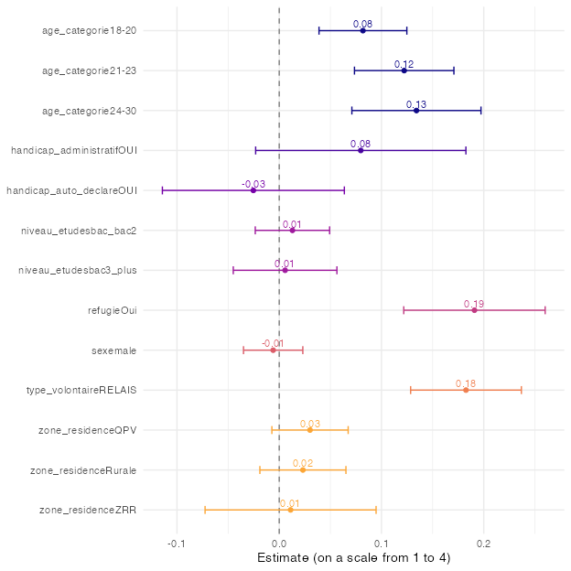

Figure 61
Effects of demographic factors on confidence in one’s future, when all factors are included in a single model. Estimates are average differences on the 4-point confidence scale, compared to the (omitted) baseline category, for volunteers who are similar on all the other factors shown.
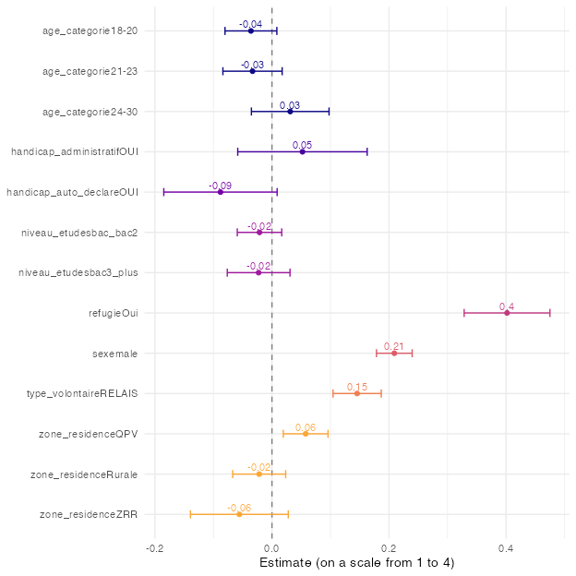

Figure 62
Differences in Solidarité Aidants vs. other programs along demographic factors.
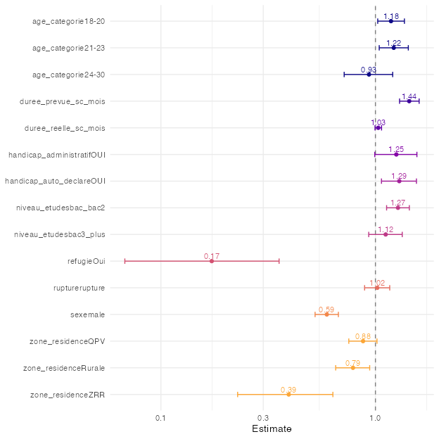

Figure 63
Differences in Cinéma & Citoyenneté vs. other programs along demographic factors
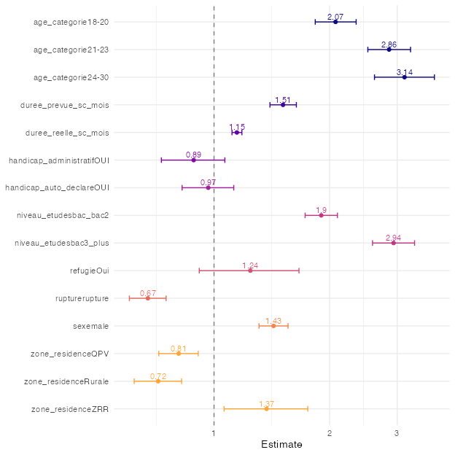

Figure 64
Differences in Booster vs. other programs along demographic factors.
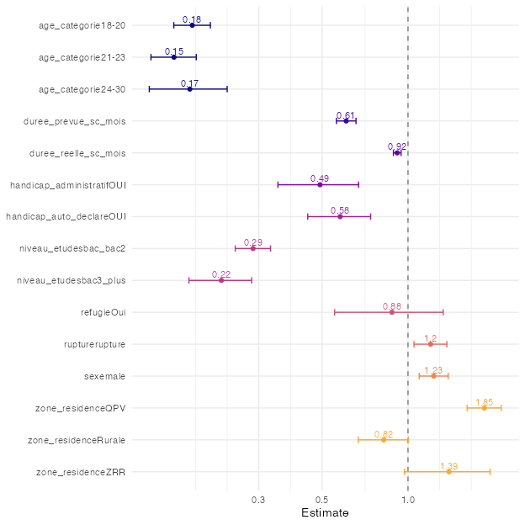

Figure 65
Differences in Ecovolonterre vs. other programs along demographic factors.
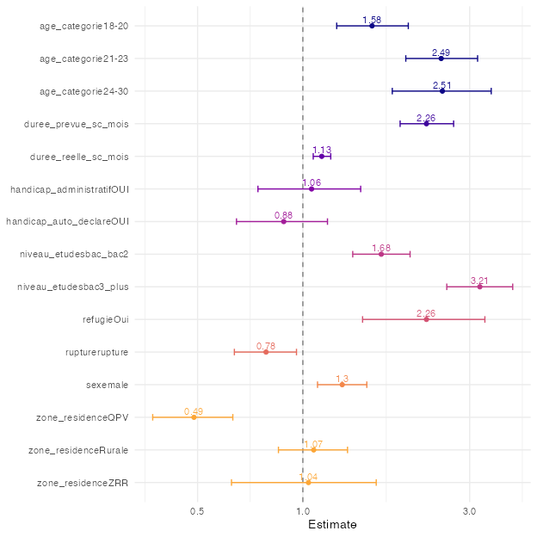

Figure 66
Differences in Médiaterre vs. other programs along demographic factors.
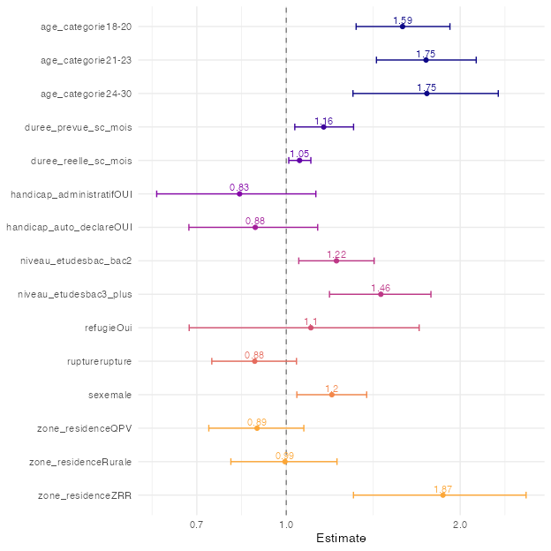

Figure 67
Differences in ASM vs. other programs along demographic factors.
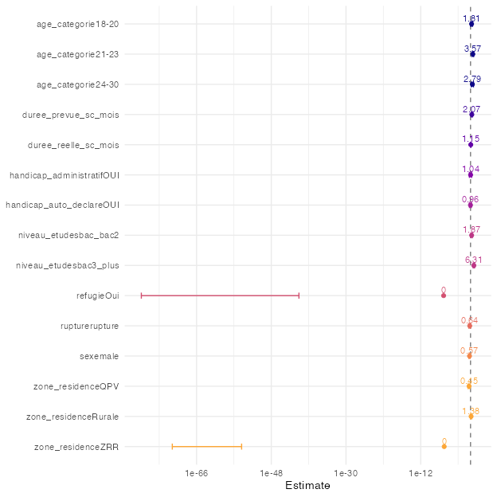

Figure 68
Differences in Solidarité Séniors vs. other programs along demographic factors.
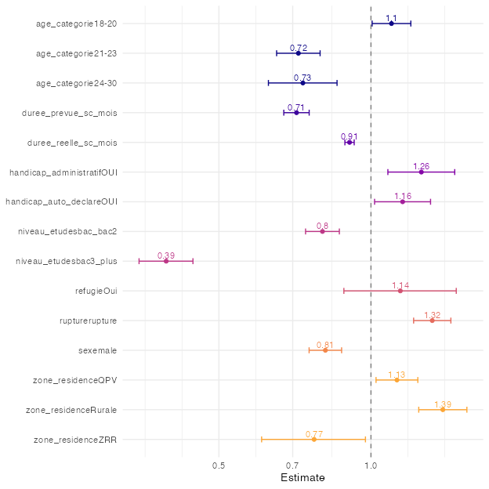

Note that the questions have been selected based on the questionnaire of the first cohort (2020/21). As a result, potentially interesting variables that only appear in later questionnaires will not appear here. In addition, a few questions whose wording changed in later cohorts could not be matched across all cohorts; the corresponding variables are missing for those cohorts.
Unis-Cité nevertheless has some administrative data on volunteers who did not respond to a single questionnaire, for example which program they have been in. In some of the plots in this report, notably in Section 3, these volunteers appear under the label “q0”.
In all analyses we treat this as a continuous variable
In all analyses we treat this as a continuous variable
I.e. ignoring all volunteers who did not change
For each variable, a separate logistic regression has been run. The estimates from the logistic regression are exponentiated, so that the reported estimates can be interpreted as odds ratios (ORs).
Note that in this illustration, we obtain a slightly different value compared to 0.84 above due to rounding imprecision.
Note _num in the variable name stands for ‘numeric’: we use a numeric version, from “Pas du tout confiant(e)” = 1, to “Très confiant(e)” = 4.
All variable names that end with _num have been treated as numeric for the present analyses

