Epidemiologic data analysis using R
Practicals 8
Faculty of Social Sciences, University of Tampere
–
Janne Pitkäniemi / Karri Seppä
17.03.2026

Topics of practical 8
Learning objectives of this practical
- Compare estimates and interpretations of different survival measures (overall, cause-specific and relative survival, and 1-cumulative incidence)
- Age standardisation of relative survival
- Piecewise constant excess hazard model for relative survival

Survival analysis: Rectal cancer patients

Description of the data
Data frame sire includes observations of a simulated cohort of 8243 female Finnish rectal cancer patients diagnosed between 1993-2012. The dataset contains the following variables:
variable | description
sex | 0 = Male, 1 = Female
bi_date | date of birth
dg_date | date of cancer diagnosis
ex_date | date of exit from follow-up (death or censoring)
status | status at the end of follow-up (numeric): = alive, 1 = death from rectal cancer, 2 = death from other causes.
dg_age | age at diagnosis (in fractional years)

Loading the packages and the data
Load the R packages Epi and popEpi needed in this exercise.
library(Epi)
library(popEpi)
#mortality rates of the population of Finland (included in popEpi package)
pm <- popEpi::popmort
First, let’s estimate the different measures of survival by using survtab function in popEpi package.

Lexis object with multi-state set-up
sire$agegr <- cut(sire$dg_age,c(0,45,55,65,75,Inf),right=F)
Lex <- Lexis(entry = list(FUT = 0, AGE = dg_age,
CAL = cal.yr(dg_date)),
exit = list(CAL = cal.yr(ex_date)),
data = sire,
exit.status = factor(status, levels = 0:2,
labels = c("alive", "canD", "othD")),
merge = TRUE)
NOTE: entry.status has been set to "alive" for all.
NOTE: Dropping 16 rows with duration of follow up < tol

Overall survival
In overall survival, outcome event is death from any cause.
#piecewise constant hazard using monthly intervals
BL <- list(FUT=seq(0, 15, by = 1/12))
#overall survival
st.obs <- survtab(
Surv(time=FUT, event=lex.Xst%in%c("canD", "othD")) ~ 1,
data = Lex,surv.type = "surv.obs",breaks = BL)
#summary(st.obs,t=c(1,5,10,15))

1 - Cumulative incidence of rectal cancer death
One minus cumulative incidence = Proportion of patients who avoid death from rectal cancer in the presence of other causes of death. Rectal cancer death is avoided if a patient died from other causes than cancer.
st.cif <- survtab(Surv(time = FUT, event = lex.Xst) ~ 1,
data = Lex,
surv.type = "cif.obs",breaks = BL)
#summary(st.cif,t=c(1,5,10,15))

Relative survival
Relative survival gives an estimate of net survival = the proportion of patients alive in the absence of other causes of death than cancer
names(pm) <- c("sex","CAL","AGE","haz")
w <- table(Lex$agegr)
w <- list(agegr = as.numeric(w))
st.rel <- survtab(
Surv(time = FUT, event = lex.Xst%in%c("canD", "othD"))
~ adjust(agegr), data = Lex, pophaz = pm,
surv.type = "surv.rel",breaks = BL, weights=w)
#summary(st.rel,t=c(1,5,10,15))
By default, survtab function uses the Ederer II estimator for relative survival.

Cause-specific survival (event = death from rectal cancer)
In cause-specific survival (normal Kaplan-Meier), outcome event is death from rectal cancer. It gives an estimate of net survival = the proportion of patients alive in the absence of other causes of death than cancer
st.cause<- survtab(
Surv(time = FUT, event = lex.Xst) ~ adjust(agegr),
data = Lex, pophaz = pm,
surv.type = "surv.cause",breaks = BL, weights=w)
#summary(st.cause,t=c(1,5,10,15))
plot(st.obs,conf.int=F,ylim=c(0,1),ylab="")
lines(st.cif$Tstop,1-st.cif$CIF_canD,col="magenta")
lines(st.rel,y="r.e2.as",conf.int=F,col="dodgerblue")
lines(st.cause,y="surv.obs.canD.as",conf.int=F,col="green")
legend("bottomleft",c("Overall survival",
"Proportion of patients who avoid rectal cancer death",
"Relative survival (proportion who avoid rectal cancer death\n in the absence of other causes of death)",
"Cause-specific survival (proportion who avoid rectal cancer death\n in the absence of other causes of death)"),
col=c("black","magenta","blue","green"),lty=1)
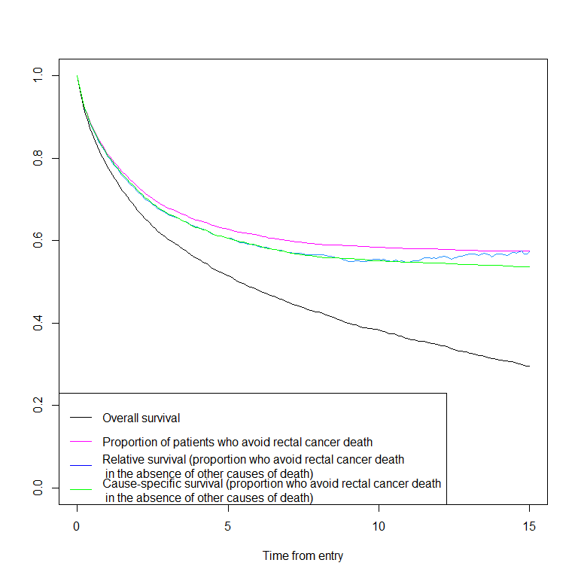
Compare the estimates and their interpretation. Remember that the probability interpretation of relative survival and cause-specific survival relies on the assumption that competing risks are independent, and you never know whether it is true or not.
Relative and cause-specific survival are, however, useful summary measures of excess mortality and cause-specific mortality, respectively, when the aim is to compare cancer survival between calendar periods (or e.g. countries) between which mortality due to other causes of death may also differ.

Age-standardised relative survival
Has rectal cancer survival in improved from 1993-2002 to 2003-2012. Estimate the age-standardised relative survival using ICSS weights and the Pohar Perme estimator.
Lex$period <- cut( cal.yr(Lex$dg_date), c(1993,2003,2013), right=F,dig.lab = 4)
ICSS1 <- aggregate(ICSS1~cut(ICSS$age,
c(0,45,55,65,75,Inf), right = FALSE),
data = ICSS, FUN = sum)
w <- list(agegr = ICSS1$ICSS1)
st.rel <- survtab(
Surv(time = FUT, event = lex.Xst%in%c("canD", "othD"))
~ sex + period + adjust(agegr),
data = Lex,pophaz = pm,surv.type = "surv.rel",
relsurv.method = "pp",breaks = BL, weights=w)
summary(st.rel,t=c(1,5,10,15))
Key: <sex, period>
sex period surv.int Tstart Tstop delta d pyrs
<int> <fctr> <int> <num> <num> <num> <num> <num>
1: 1 [1993,2003) 12 0.9166667 1 0.08333333 60 248.824778
2: 1 [1993,2003) 60 4.9166667 5 0.08333333 13 154.472450
3: 1 [1993,2003) 120 9.9166667 10 0.08333333 5 112.798768
4: 1 [1993,2003) 180 14.9166667 15 0.08333333 1 40.066222
5: 1 [2003,2013) 12 0.9166667 1 0.08333333 47 260.312286
6: 1 [2003,2013) 60 4.9166667 5 0.08333333 4 98.659993
7: 1 [2003,2013) 120 9.9166667 10 0.08333333 0 0.365332
8: 1 [2003,2013) NA NA NA NA NA NA
d.pp d.exp.pp d.pp.2 pyrs.pp surv.obs.as.lo surv.obs.as
<num> <num> <num> <num> <num> <num>
1: 63.650766 9.95612421 67.830645 256.7741010 0.7721363 0.7849992
2: 22.833276 10.44526079 67.354206 185.2233079 0.5018975 0.5177134
3: 10.656958 15.08950748 27.344593 168.0066044 0.3856067 0.4010478
4: 2.495137 12.89305701 6.225711 82.2248335 0.3077360 0.3235001
5: 49.862711 7.90154463 53.215723 266.6109419 0.8165912 0.8277087
6: 5.202564 4.98799512 6.953770 113.2821802 0.5879067 0.6043383
7: 0.000000 0.01376493 0.000000 0.4333571 0.4804040 0.5017128
8: NA NA NA NA NA NA
surv.obs.as.hi SE.surv.obs.as r.pp.as.lo r.pp.as r.pp.as.hi SE.r.pp.as
<num> <num> <num> <num> <num> <num>
1: 0.7972344 0.006401154 0.7930900 0.8064752 0.8190961 0.006631840
2: 0.5332825 0.008008062 0.5741027 0.5930722 0.6115029 0.009542744
3: 0.4164331 0.007866129 0.5127324 0.5394885 0.5654465 0.013454343
4: 0.3393524 0.008068372 0.4653960 0.5360451 0.6015042 0.034839317
5: 0.8382208 0.005515817 0.8342032 0.8457952 0.8566479 0.005722654
6: 0.6203412 0.008275263 0.6549621 0.6749420 0.6940489 0.009971536
7: 0.5226223 0.010774136 0.6069758 0.6725246 0.7296206 0.031297710
8: NA NA NA NA NA NA
summary prints estimates at given time points: at 1, 5, 10 and 15 years after diagnosis (column Tstop). Column surv.int shows the follow-up time interval (monthly intervals were defined in breaks): at the end of 12th follow-up time interval Tstop=1 (1-year survival). The length of the intervals is delta in years. Notice that d, pyrs and d.exp are the number of deaths, person-years and the expected number of deaths within a monthly interval only, e.g. from 11 to <12 months (surv.int=12). The Pohar Perme estimator is based on the weighted observations d.pp, pyrs.pp and d.exp.pp.
The age-standardised survival estimates (both overall survival surv.obs.as and relative survival r.pp.as (based on the Pohar Perme estimator) with 95% confidence intervals and standard errors were calculated for the two periods.
Plot the age-standardised relative survival curves in patients diagnosed in 1993-2002 and in 2003-2012:
plot(st.rel[st.rel$period=="[1993,2003)",])
lines(st.rel[st.rel$period=="[2003,2013)",],col="red")
legend("topright",c("1993-2002","2003-2012"),col=c("black","red"),lty=1)
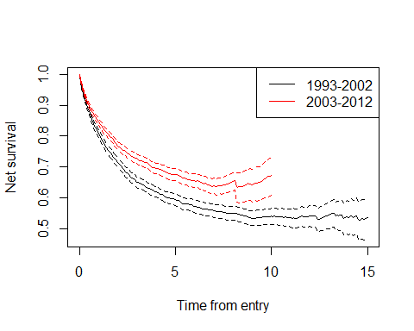

Regression model for relative survival
Estimate the relative excess risk (ratio of excess hazards) for the difference in rectal cancer survival between 1993-2002 and 2003-2012. First, tabulate the observations by follow-up time interval, age group, sex and period.
BL <- list(fot=c(0,3/12,1:5))
names(pm) <- c("sex","year","agegroup","haz")
sire$period <- cut( cal.yr(sire$dg_date), c(1993,2003,2013), right=F,dig.lab = 4)
Lex <- lexpand(sire, birth = bi_date,
entry = dg_date, exit = ex_date,
status = status%in%1:2,
breaks = BL, pophaz = pm,pp=F,
aggre = list(fot,agegr,sex,period)
)
The piecewise constant excess hazard model can be fitted using relpois_ag function in popEpi package:
m1 <- relpois_ag(formula = from0to1 ~ period+fot*agegr,
data = Lex, d.exp = d.exp, offset = log(pyrs))
ci.exp(m1)
exp(Est.) 2.5% 97.5%
(Intercept) 0.04737401 0.01488776 0.1507478
period[2003,2013) 0.77927020 0.71773516 0.8460810
fot[0.25, 1) 2.71244453 0.79186945 9.2911216
fot[1, 2) 2.21222063 0.64337392 7.6066498
fot[2, 3) 1.17643066 0.31455346 4.3998534
fot[3, 4) 0.23069625 0.03301250 1.6121394
fot[4, 5) 0.25656241 0.03714556 1.7720630
agegr[45,55) 1.61632499 0.45018845 5.8031398
agegr[55,65) 3.38092135 1.02971915 11.1007251
agegr[65,75) 4.01745353 1.23918760 13.0246081
agegr[75,Inf) 15.27985442 4.78676930 48.7748492
fot[0.25, 1):agegr[45,55) 0.65757436 0.16742843 2.5826201
fot[1, 2):agegr[45,55) 0.47746790 0.11999239 1.8999172
fot[2, 3):agegr[45,55) 0.70913424 0.16303899 3.0843627
fot[3, 4):agegr[45,55) 3.70825310 0.47610636 28.8824982
fot[4, 5):agegr[45,55) 2.53271577 0.32296122 19.8619799
fot[0.25, 1):agegr[55,65) 0.25892520 0.07220726 0.9284698
fot[1, 2):agegr[55,65) 0.28557714 0.07938867 1.0272788
fot[2, 3):agegr[55,65) 0.43614525 0.11105614 1.7128515
fot[3, 4):agegr[55,65) 1.34896798 0.18410639 9.8840383
fot[4, 5):agegr[55,65) 0.47238841 0.06087296 3.6658446
fot[0.25, 1):agegr[65,75) 0.34662599 0.09864939 1.2179455
fot[1, 2):agegr[65,75) 0.31294291 0.08856101 1.1058282
fot[2, 3):agegr[65,75) 0.39687364 0.10265032 1.5344198
fot[3, 4):agegr[65,75) 1.48450863 0.20602409 10.6966417
fot[4, 5):agegr[65,75) 1.34872879 0.18871692 9.6391428
fot[0.25, 1):agegr[75,Inf) 0.15399934 0.04460816 0.5316471
fot[1, 2):agegr[75,Inf) 0.09915330 0.02846077 0.3454361
fot[2, 3):agegr[75,Inf) 0.11761547 0.03064471 0.4514123
fot[3, 4):agegr[75,Inf) 0.32724123 0.04441284 2.4111680
fot[4, 5):agegr[75,Inf) 0.27202182 0.03644168 2.0305287
Age-adjusted excess mortality among patients diagnosed in 2003-2012 is 0.78-fold compared to patients diagnosed in 1993-2002.
In cancer survival, it is almost always necessary to include interactions between follow-up time and age into the model (i.e. excess hazards are not proportional between age groups):
m0 <- relpois_ag(formula = from0to1 ~ period+fot + agegr,
data = Lex, d.exp = d.exp, offset = log(pyrs))
anova(m0,m1,test="LRT")
Analysis of Deviance Table
Model 1: from0to1 ~ period + fot + agegr
Model 2: from0to1 ~ period + fot * agegr
Resid. Df Resid. Dev Df Deviance Pr(>Chi)
1 49 217.260
2 29 44.758 20 172.5 < 2.2e-16 ***
---
Signif. codes: 0 '***' 0.001 '**' 0.01 '*' 0.05 '.' 0.1 ' ' 1
EXTRA: The same model can be fitted using glm function. The link function of relative survival Poisson regression can be specified as follows:
Lex$FUT <- cut( Lex$fot, c(0,3/12,1:5), right=F)
d_star <- Lex$d.exp
#define link function for relative survival regression
rspois <- poisson()
rspois$link <- "glm relative survival model with Poisson error"
rspois$linkfun <- function(mu) log(mu - d_star)
rspois$linkinv <- function(eta) d_star + exp(eta)
assign(".d_star", Lex$d.exp, env = .GlobalEnv)
rspois$initialize <- expression({
if (any(y < 0)) stop(paste("Negative values not allowed for",
"the Poisson family"))
n <- rep.int(1, nobs)
mustart <- pmax(y, .d_star) + 0.1
})
#glm model
m2 <- glm(formula = from0to1 ~ period+FUT*agegr,
data = Lex, family=rspois, offset = log(pyrs))
ci.exp(m2)
exp(Est.) 2.5% 97.5%
(Intercept) 0.04737401 0.01488776 0.1507478
period[2003,2013) 0.77927020 0.71773516 0.8460810
FUT[0.25,1) 2.71244453 0.79186945 9.2911216
FUT[1,2) 2.21222063 0.64337392 7.6066498
FUT[2,3) 1.17643066 0.31455346 4.3998534
FUT[3,4) 0.23069625 0.03301250 1.6121394
FUT[4,5) 0.25656241 0.03714556 1.7720630
agegr[45,55) 1.61632499 0.45018845 5.8031398
agegr[55,65) 3.38092135 1.02971915 11.1007251
agegr[65,75) 4.01745353 1.23918760 13.0246081
agegr[75,Inf) 15.27985442 4.78676930 48.7748492
FUT[0.25,1):agegr[45,55) 0.65757436 0.16742843 2.5826201
FUT[1,2):agegr[45,55) 0.47746790 0.11999239 1.8999172
FUT[2,3):agegr[45,55) 0.70913424 0.16303899 3.0843627
FUT[3,4):agegr[45,55) 3.70825310 0.47610636 28.8824982
FUT[4,5):agegr[45,55) 2.53271577 0.32296122 19.8619799
FUT[0.25,1):agegr[55,65) 0.25892520 0.07220726 0.9284698
FUT[1,2):agegr[55,65) 0.28557714 0.07938867 1.0272788
FUT[2,3):agegr[55,65) 0.43614525 0.11105614 1.7128515
FUT[3,4):agegr[55,65) 1.34896798 0.18410639 9.8840383
FUT[4,5):agegr[55,65) 0.47238841 0.06087296 3.6658446
FUT[0.25,1):agegr[65,75) 0.34662599 0.09864939 1.2179455
FUT[1,2):agegr[65,75) 0.31294291 0.08856101 1.1058282
FUT[2,3):agegr[65,75) 0.39687364 0.10265032 1.5344198
FUT[3,4):agegr[65,75) 1.48450863 0.20602409 10.6966417
FUT[4,5):agegr[65,75) 1.34872879 0.18871692 9.6391428
FUT[0.25,1):agegr[75,Inf) 0.15399934 0.04460816 0.5316471
FUT[1,2):agegr[75,Inf) 0.09915330 0.02846077 0.3454361
FUT[2,3):agegr[75,Inf) 0.11761547 0.03064471 0.4514123
FUT[3,4):agegr[75,Inf) 0.32724123 0.04441284 2.4111680
FUT[4,5):agegr[75,Inf) 0.27202182 0.03644168 2.0305287

