Epidemiologic data analysis using R

Practicals 9

Faculty of Social Sciences, University of Tampere

–

Janne Pitkaniemi / Karri Seppä

23.3.2020

# Topics of practical 9

Learning objectives of this practical

* Compare estimates and interpretations of different survival measures (overall, cause-specific and relative survival, and 1-cumulative incidence)
* Age standardisation of relative survival
* Piecewise constant excess hazard model for relative survival

# Survival analysis: Rectal cancer patients

## Description of the data

Data frame sire includes observations of a simulated cohort of 8243 female Finnish rectal cancer patients diagnosed between 1993-2012. The dataset contains the following variables:

|  |  |
| --- | --- |
| variable | description |
| sex | 0 = Male, 1 = Female |
| bi_date | date of birth |
| dg_date | date of cancer diagnosis |
| ex_date | date of exit from follow-up (death or censoring) |
| status | status at the end of follow-up (numeric): 0 = alive, 1 = death from rectal cancer, 2 = death from other causes. |
| dg_age | age at diagnosis (in fractional years) |

## Loading the packages and the data

Load the R packages Epi and popEpi needed in this exercise.

library(Epi)  
library(popEpi)  
#mortality rates of the population of Finland (included in popEpi package)  
pm <- popmort

First, let’s estimate the different measures of survival by using survtab function in popEpi package.

## Lexis object with multi-state set-up

sire$agegr <- cut(sire$dg_age,c(0,45,55,65,75,Inf),right=F)  
  
Lex <- Lexis(entry = list(FUT = 0, AGE = dg_age,   
 CAL = cal.yr(dg_date)),  
 exit = list(CAL = cal.yr(ex_date)),  
 data = sire,  
 exit.status = factor(status, levels = 0:2,  
 labels = c("alive", "canD", "othD")),  
 merge = TRUE)

NOTE: entry.status has been set to "alive" for all.  
NOTE: Dropping 16 rows with duration of follow up < tol

## Overall survival

In overall survival, outcome event is death from any cause.

#piecewise constant hazard using monthly intervals  
BL <- list(FUT=seq(0, 15, by = 1/12))  
#overall survival  
st.obs <- survtab(  
 Surv(time=FUT, event=lex.Xst%in%c("canD", "othD")) ~ 1,   
 data = Lex,surv.type = "surv.obs",breaks = BL)  
#summary(st.obs,t=c(1,5,10,15))

## 1 - Cumulative incidence of rectal cancer death

One minus cumulative incidence = Proportion of patients who avoid death from rectal cancer in the presence of other causes of death. Rectal cancer death is avoided if a patient died from other causes than cancer.

st.cif <- survtab(Surv(time = FUT, event = lex.Xst) ~ 1,   
 data = Lex,   
 surv.type = "cif.obs",breaks = BL)  
#summary(st.cif,t=c(1,5,10,15))

## Relative survival

Relative survival gives an estimate of net survival = the proportion of patients alive in the absence of other causes of death than cancer

names(pm) <- c("sex","CAL","AGE","haz")  
w <- table(Lex$agegr)  
w <- list(agegr = as.numeric(w))  
st.rel <- survtab(  
 Surv(time = FUT, event = lex.Xst%in%c("canD", "othD"))   
 ~ adjust(agegr), data = Lex, pophaz = pm,  
 surv.type = "surv.rel",breaks = BL, weights=w)  
#summary(st.rel,t=c(1,5,10,15))

## Cause-specific survival (event = death from rectal cancer)

In cause-specific survival (normal Kaplan-Meier), outcome event is death from rectal cancer. It gives an estimate of net survival = the proportion of patients alive in the absence of other causes of death than cancer

st.cause<- survtab(  
 Surv(time = FUT, event = lex.Xst) ~ adjust(agegr),   
 data = Lex, pophaz = pm,  
 surv.type = "surv.cause",breaks = BL, weights=w)  
#summary(st.cause,t=c(1,5,10,15))

plot(st.obs,conf.int=F,ylim=c(0,1),ylab="")  
lines(st.cif$Tstop,1-st.cif$CIF_canD,col="magenta")  
lines(st.rel,y="r.e2.as",conf.int=F,col="dodgerblue")  
lines(st.cause,y="surv.obs.canD.as",conf.int=F,col="green")  
legend("bottomleft",c("Overall survival",  
 "Proportion of patients who avoid rectal cancer death",  
 "Relative survival (proportion who avoid rectal cancer death\n in the absence of other causes of death)",  
 "Cause-specific survival (proportion who avoid rectal cancer death\n in the absence of other causes of death)"),  
 col=c("black","magenta","blue","green"),lty=1)

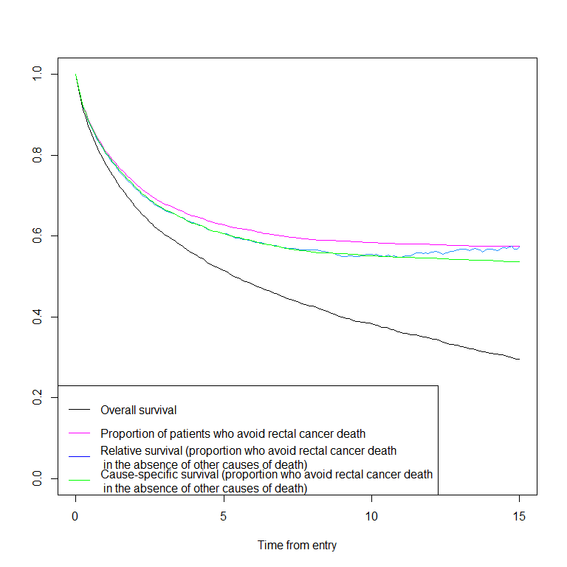

Compare the estimates and their interpretation. Remember that the probability interpretation of relative survival and cause-specific survival relies on the assumption that competing risks are independent, and you never know whether it is true or not.

Relative and cause-specific survival are, however, useful summary measures of excess mortality and cause-specific mortality, respectively, when the aim is to compare cancer survival between calendar periods (or e.g. countries) between which mortality due to other causes of death may also differ.

# Age-standardised relative survival

Has rectal cancer survival in improved from 1993-2002 to 2003-2012. Estimate the age-standardised relative survival using ICSS weights and the Pohar Perme estimator.

Lex$period <- cut( cal.yr(Lex$dg_date), c(1993,2003,2013), right=F,dig.lab = 4)  
ICSS1 <- aggregate(ICSS1~cut(ICSS$age,   
 c(0,45,55,65,75,Inf), right = FALSE),   
 data = ICSS, FUN = sum)  
w <- list(agegr = ICSS1$ICSS1)  
st.rel <- survtab(  
 Surv(time = FUT, event = lex.Xst%in%c("canD", "othD"))   
 ~ sex + period + adjust(agegr),   
 data = Lex,pophaz = pm,  
 surv.type = "surv.rel",breaks = BL, weights=w)  
summary(st.rel,t=c(1,5,10,15))

sex period surv.int Tstart Tstop delta d pyrs  
1: 1 [1993,2003) 12 0.9166667 1 0.08333333 60 248.824778  
2: 1 [1993,2003) 60 4.9166667 5 0.08333333 13 154.472450  
3: 1 [1993,2003) 120 9.9166667 10 0.08333333 5 112.798768  
4: 1 [1993,2003) 180 14.9166667 15 0.08333333 1 40.066222  
5: 1 [2003,2013) 12 0.9166667 1 0.08333333 47 260.312286  
6: 1 [2003,2013) 60 4.9166667 5 0.08333333 4 98.659993  
7: 1 [2003,2013) 120 9.9166667 10 0.08333333 0 0.365332  
8: 1 [2003,2013) NA NA NA NA NA NA  
 d.exp surv.obs.as.lo surv.obs.as surv.obs.as.hi SE.surv.obs.as  
1: 9.09563484 0.7721363 0.7849992 0.7972344 0.006401154  
2: 6.11622165 0.5018975 0.5177134 0.5332825 0.008008062  
3: 5.15019634 0.3856067 0.4010478 0.4164331 0.007866129  
4: 2.11596923 0.3077360 0.3235001 0.3393524 0.008068372  
5: 7.29231605 0.8165912 0.8277087 0.8382208 0.005515817  
6: 3.10701614 0.5879067 0.6043383 0.6203412 0.008275263  
7: 0.00968556 0.4804040 0.5017128 0.5226223 0.010774136  
8: NA NA NA NA NA  
 r.e2.as.lo r.e2.as r.e2.as.hi SE.r.e2.as  
1: 0.7936840 0.8070312 0.8196157 0.006612849  
2: 0.5734342 0.5919015 0.6098606 0.009294218  
3: 0.5147726 0.5375984 0.5598470 0.011502965  
4: 0.5037066 0.5431610 0.5808687 0.019705047  
5: 0.8348022 0.8463516 0.8571640 0.005701507  
6: 0.6564928 0.6757391 0.6941712 0.009612207  
7: 0.6044351 0.6430301 0.6789034 0.019004517  
8: NA NA NA NA

plot(st.rel[st.rel$period=="[1993,2003)",])  
lines(st.rel[st.rel$period=="[2003,2013)",],col="red")  
legend("topright",c("1993-2002","2003-2012"),col=c("black","red"),lty=1)

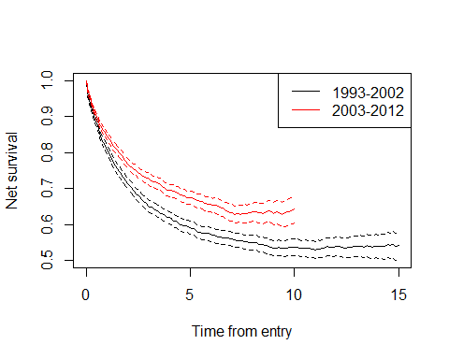

# Regression model for relative survival

Estimate the relative excess risk (ratio of excess hazards) for the difference in rectal cancer survival between 1993-2002 and 2003-2012. First, tabulate the observations by follow-up time interval, age group, sex and period.

BL <- list(fot=c(0,3/12,1:5))  
names(pm) <- c("sex","year","agegroup","haz")  
sire$period <- cut( cal.yr(sire$dg_date), c(1993,2003,2013), right=F,dig.lab = 4)  
Lex <- lexpand(sire, birth = bi_date,  
 entry = dg_date, exit = ex_date,  
 status = status%in%1:2,  
 breaks = BL, pophaz = pm,pp=F,  
 aggre = list(fot,agegr,sex,period)  
)

The piecewise constant excess hazard model can be fitted using relpois_ag function in popEpi package:

m1 <- relpois_ag(formula = from0to1 ~ period+fot*agegr,   
 data = Lex, d.exp = d.exp, offset = log(pyrs))  
ci.exp(m1)

exp(Est.) 2.5% 97.5%  
(Intercept) 0.04737401 0.01488776 0.1507478  
period[2003,2013) 0.77927020 0.71773516 0.8460810  
fot[0.25, 1) 2.71244453 0.79186945 9.2911216  
fot[1, 2) 2.21222063 0.64337392 7.6066498  
fot[2, 3) 1.17643066 0.31455346 4.3998534  
fot[3, 4) 0.23069625 0.03301250 1.6121394  
fot[4, 5) 0.25656241 0.03714556 1.7720630  
agegr[45,55) 1.61632499 0.45018845 5.8031398  
agegr[55,65) 3.38092135 1.02971915 11.1007251  
agegr[65,75) 4.01745353 1.23918760 13.0246081  
agegr[75,Inf) 15.27985442 4.78676930 48.7748492  
fot[0.25, 1):agegr[45,55) 0.65757436 0.16742843 2.5826201  
fot[1, 2):agegr[45,55) 0.47746790 0.11999239 1.8999172  
fot[2, 3):agegr[45,55) 0.70913424 0.16303899 3.0843627  
fot[3, 4):agegr[45,55) 3.70825310 0.47610636 28.8824982  
fot[4, 5):agegr[45,55) 2.53271577 0.32296122 19.8619799  
fot[0.25, 1):agegr[55,65) 0.25892520 0.07220726 0.9284698  
fot[1, 2):agegr[55,65) 0.28557714 0.07938867 1.0272788  
fot[2, 3):agegr[55,65) 0.43614525 0.11105614 1.7128515  
fot[3, 4):agegr[55,65) 1.34896798 0.18410639 9.8840383  
fot[4, 5):agegr[55,65) 0.47238841 0.06087296 3.6658446  
fot[0.25, 1):agegr[65,75) 0.34662599 0.09864939 1.2179455  
fot[1, 2):agegr[65,75) 0.31294291 0.08856101 1.1058282  
fot[2, 3):agegr[65,75) 0.39687364 0.10265032 1.5344198  
fot[3, 4):agegr[65,75) 1.48450863 0.20602409 10.6966417  
fot[4, 5):agegr[65,75) 1.34872879 0.18871692 9.6391428  
fot[0.25, 1):agegr[75,Inf) 0.15399934 0.04460816 0.5316471  
fot[1, 2):agegr[75,Inf) 0.09915330 0.02846077 0.3454361  
fot[2, 3):agegr[75,Inf) 0.11761547 0.03064471 0.4514123  
fot[3, 4):agegr[75,Inf) 0.32724123 0.04441284 2.4111680  
fot[4, 5):agegr[75,Inf) 0.27202182 0.03644168 2.0305287

Age-adjusted excess mortality among patients diagnosed in 2003-2012 is 0.78-fold compared to patients diagnosed in 1993-2002.

In cancer survival, it is almost always necessary to include interactions between follow-up time and age into the model (i.e. excess hazards are not proportional between age groups):

m0 <- relpois_ag(formula = from0to1 ~ period+fot + agegr,   
 data = Lex, d.exp = d.exp, offset = log(pyrs))  
anova(m0,m1,test="LRT")

Analysis of Deviance Table  
  
Model 1: from0to1 ~ period + fot + agegr  
Model 2: from0to1 ~ period + fot * agegr  
 Resid. Df Resid. Dev Df Deviance Pr(>Chi)   
1 49 217.260   
2 29 44.758 20 172.5 < 2.2e-16 ***  
---  
Signif. codes: 0 '***' 0.001 '**' 0.01 '*' 0.05 '.' 0.1 ' ' 1

The same model can be fitted using glm function. The link function of relative survival Poisson regression can be specified as follows:

Lex$FUT <- cut( Lex$fot, c(0,3/12,1:5), right=F)  
d_star <- Lex$d.exp  
  
#define link function for relative survival regression  
rspois <- poisson()  
rspois$link <- "glm relative survival model with Poisson error"  
rspois$linkfun <- function(mu) log(mu - d_star)  
rspois$linkinv <- function(eta) d_star + exp(eta)  
assign(".d_star", Lex$d.exp, env = .GlobalEnv)  
rspois$initialize <- expression({  
 if (any(y < 0)) stop(paste("Negative values not allowed for",   
 "the Poisson family"))  
 n <- rep.int(1, nobs)  
 mustart <- pmax(y, .d_star) + 0.1  
})  
  
#glm model  
m2 <- glm(formula = from0to1 ~ period+FUT*agegr,   
 data = Lex, family=rspois, offset = log(pyrs))  
ci.exp(m2)

exp(Est.) 2.5% 97.5%  
(Intercept) 0.04737401 0.01488776 0.1507478  
period[2003,2013) 0.77927020 0.71773516 0.8460810  
FUT[0.25,1) 2.71244453 0.79186945 9.2911216  
FUT[1,2) 2.21222063 0.64337392 7.6066498  
FUT[2,3) 1.17643066 0.31455346 4.3998534  
FUT[3,4) 0.23069625 0.03301250 1.6121394  
FUT[4,5) 0.25656241 0.03714556 1.7720630  
agegr[45,55) 1.61632499 0.45018845 5.8031398  
agegr[55,65) 3.38092135 1.02971915 11.1007251  
agegr[65,75) 4.01745353 1.23918760 13.0246081  
agegr[75,Inf) 15.27985442 4.78676930 48.7748492  
FUT[0.25,1):agegr[45,55) 0.65757436 0.16742843 2.5826201  
FUT[1,2):agegr[45,55) 0.47746790 0.11999239 1.8999172  
FUT[2,3):agegr[45,55) 0.70913424 0.16303899 3.0843627  
FUT[3,4):agegr[45,55) 3.70825310 0.47610636 28.8824982  
FUT[4,5):agegr[45,55) 2.53271577 0.32296122 19.8619799  
FUT[0.25,1):agegr[55,65) 0.25892520 0.07220726 0.9284698  
FUT[1,2):agegr[55,65) 0.28557714 0.07938867 1.0272788  
FUT[2,3):agegr[55,65) 0.43614525 0.11105614 1.7128515  
FUT[3,4):agegr[55,65) 1.34896798 0.18410639 9.8840383  
FUT[4,5):agegr[55,65) 0.47238841 0.06087296 3.6658446  
FUT[0.25,1):agegr[65,75) 0.34662599 0.09864939 1.2179455  
FUT[1,2):agegr[65,75) 0.31294291 0.08856101 1.1058282  
FUT[2,3):agegr[65,75) 0.39687364 0.10265032 1.5344198  
FUT[3,4):agegr[65,75) 1.48450863 0.20602409 10.6966417  
FUT[4,5):agegr[65,75) 1.34872879 0.18871692 9.6391428  
FUT[0.25,1):agegr[75,Inf) 0.15399934 0.04460816 0.5316471  
FUT[1,2):agegr[75,Inf) 0.09915330 0.02846077 0.3454361  
FUT[2,3):agegr[75,Inf) 0.11761547 0.03064471 0.4514123  
FUT[3,4):agegr[75,Inf) 0.32724123 0.04441284 2.4111680  
FUT[4,5):agegr[75,Inf) 0.27202182 0.03644168 2.0305287