Challenge Dashboard Page



<https://drive.google.com/file/d/1g7izxjlIMIZ9tMYgCq0gbHcM8KdBC3zT/view?usp=sharing>

New link here:

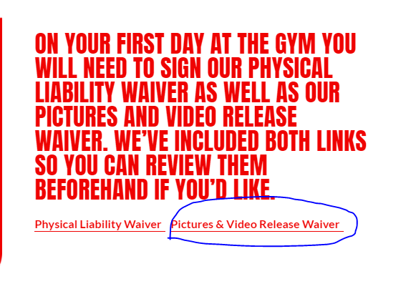

<https://docs.google.com/document/d/1gJgdJ4JDw7dErS_WLRHOa2G1KqC3usDCLnW_l6wfYjI/edit?usp=sharing>

New link here:

Accountability App Page

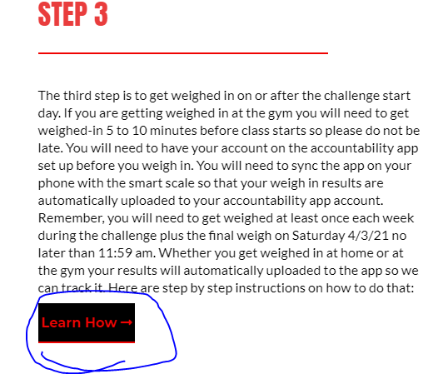

<https://drive.google.com/file/d/1g7izxjlIMIZ9tMYgCq0gbHcM8KdBC3zT/view?usp=drive_web>

New link here:

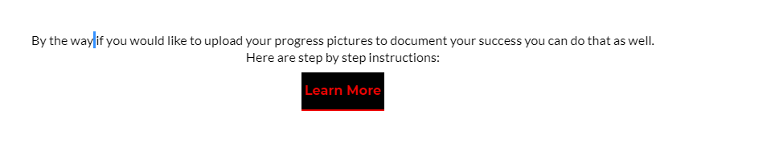

https://drive.google.com/file/d/1XHM9ITeoR-gx8iEcBT_kw0aNr2wM6mhN/view?ts=60255297

New link here:



<https://drive.google.com/file/d/19BIbji6KJJcrZaA4DxQsUKi29U1EeYcc/view?usp=sharing>

New link here:

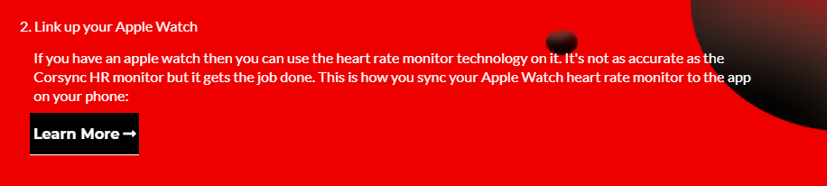

<https://drive.google.com/file/d/1Z7dUJQ3UHeZteR7i8Cmz4K8qWY_YlJPT/view?usp=sharing>

New link here:

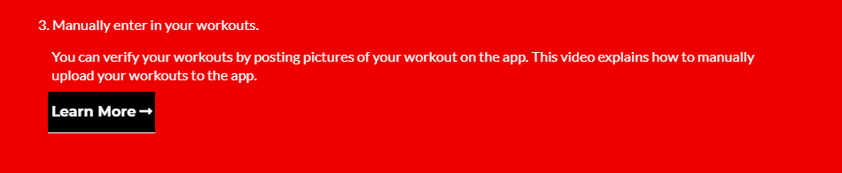

<https://drive.google.com/file/d/1-2Uj_5_txmBuOQrsThngCaOv9nRsvex6/view?usp=sharing>

New link here:

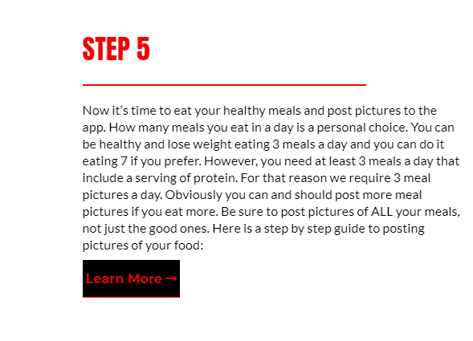

<https://drive.google.com/file/d/12Mq8beLniHev5nJXheP7NJjiuKg-oLlq/view?usp=drive_web>

New link here:

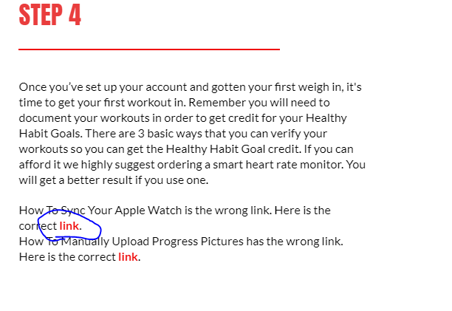

<https://drive.google.com/file/d/1Z7dUJQ3UHeZteR7i8Cmz4K8qWY_YlJPT/view>

New link here:

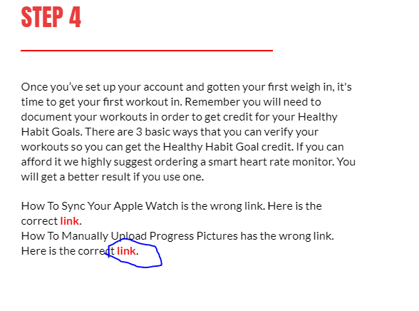

<https://drive.google.com/file/d/1-2Uj_5_txmBuOQrsThngCaOv9nRsvex6/view>

New link here:

Game Plan Page



<https://drive.google.com/file/d/1g7izxjlIMIZ9tMYgCq0gbHcM8KdBC3zT/view?usp=sharing>

New link here:

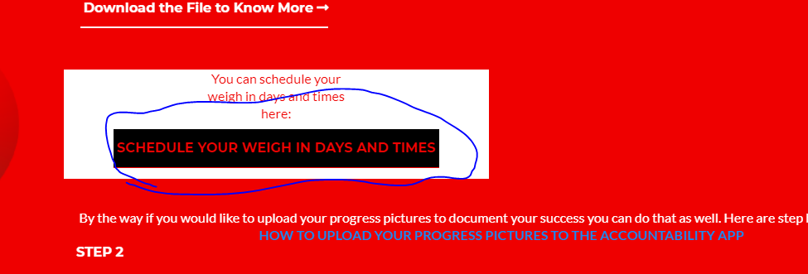

<https://drive.google.com/file/d/1XHM9ITeoR-gx8iEcBT_kw0aNr2wM6mhN/view?usp=drive_web>

New link here:

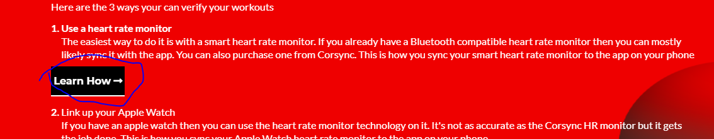

<https://drive.google.com/file/d/19BIbji6KJJcrZaA4DxQsUKi29U1EeYcc/view?usp=drive_web>

New link here:

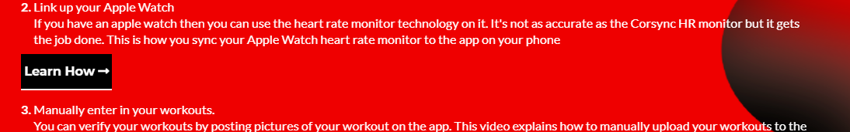

https://drive.google.com/file/d/19BIbji6KJJcrZaA4DxQsUKi29U1EeYcc/view?usp=drive_web

New link here:



<https://drive.google.com/file/d/1XHM9ITeoR-gx8iEcBT_kw0aNr2wM6mhN/view?usp=drive_web>

New link here:

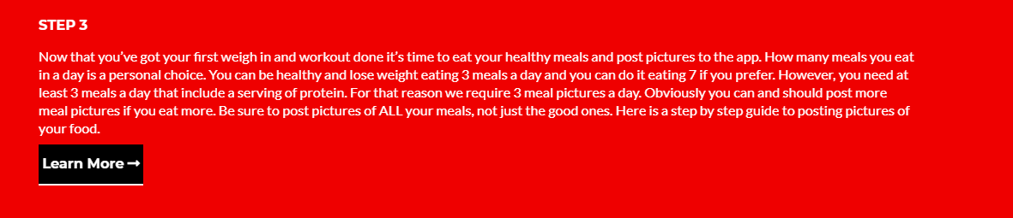

<https://drive.google.com/file/d/12Mq8beLniHev5nJXheP7NJjiuKg-oLlq/view?usp=drive_web>

New link here:

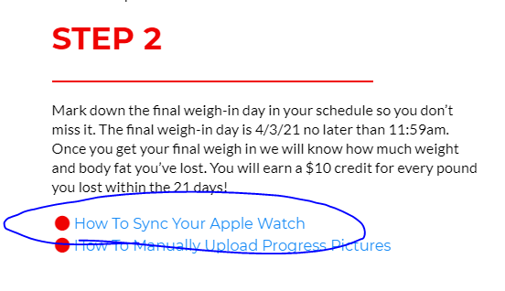

<https://drive.google.com/file/d/1Z7dUJQ3UHeZteR7i8Cmz4K8qWY_YlJPT/view>

New link here:

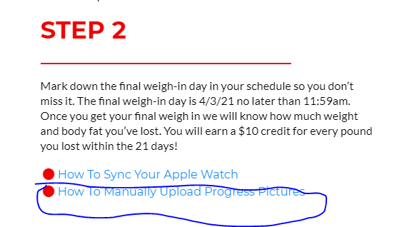

<https://drive.google.com/file/d/1-2Uj_5_txmBuOQrsThngCaOv9nRsvex6/view>

New link here: