1. 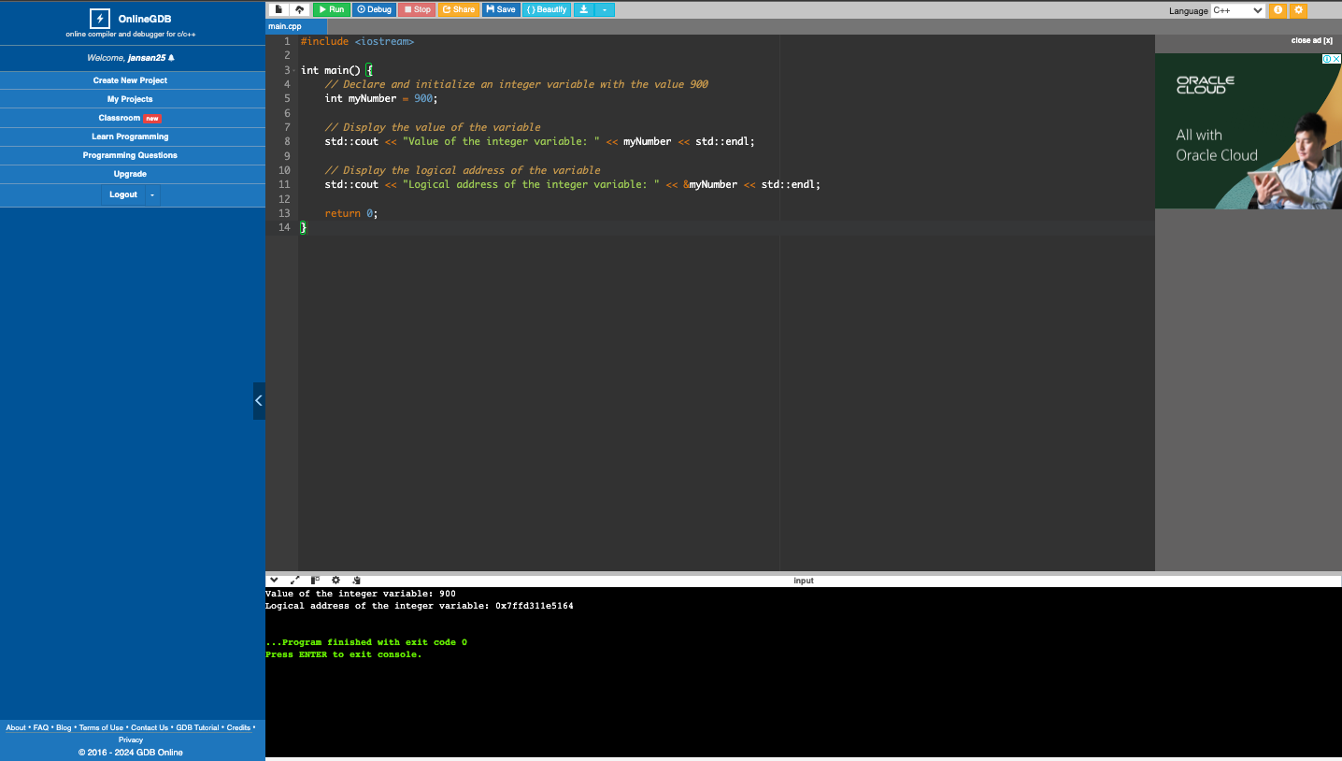Write a program that will display the value and logical address of an integer variable with an initial value of 900.
2. Write a program that will display the value and logical address of an uninitialized character array with size ten (10) and a pointer pointing to the array. (Hint: you may need to perform some casting.)

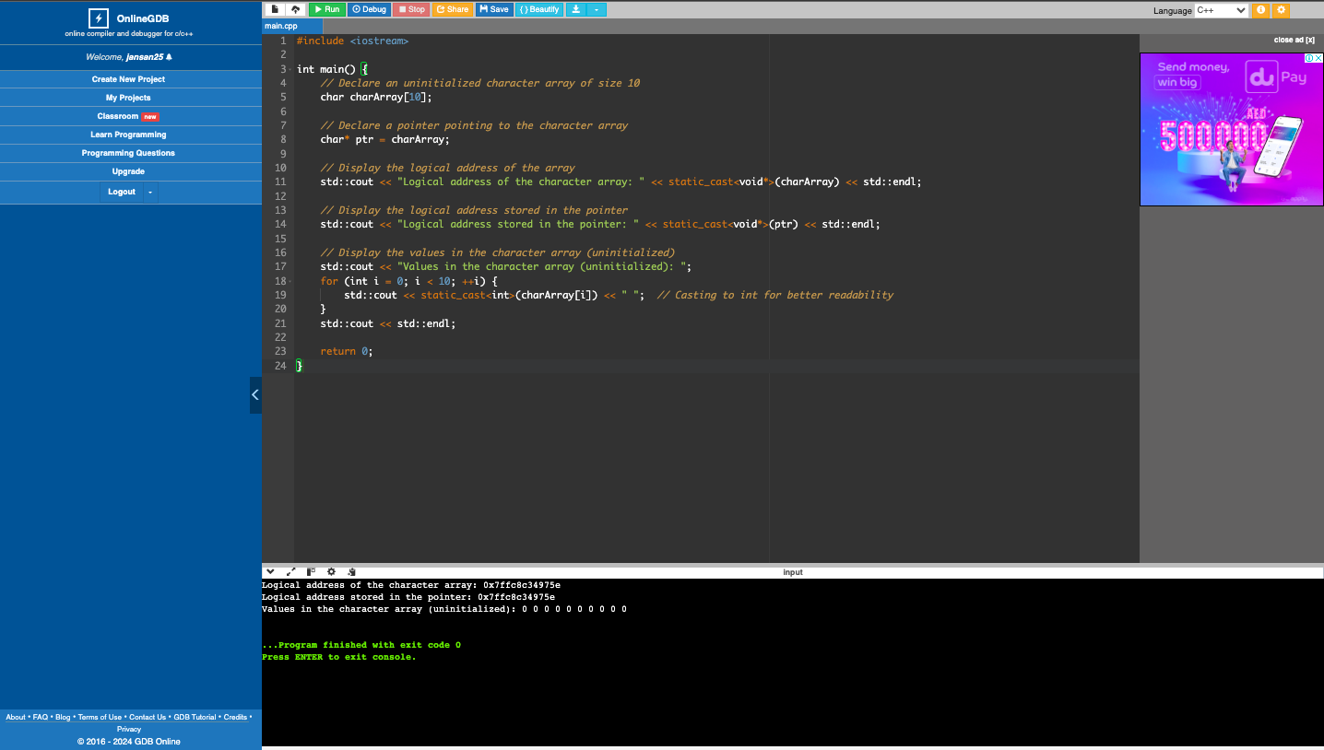

1. Write a program that will display the value and logical address of an uninitialized float array with size twenty (20) and a reference pointing to the array.

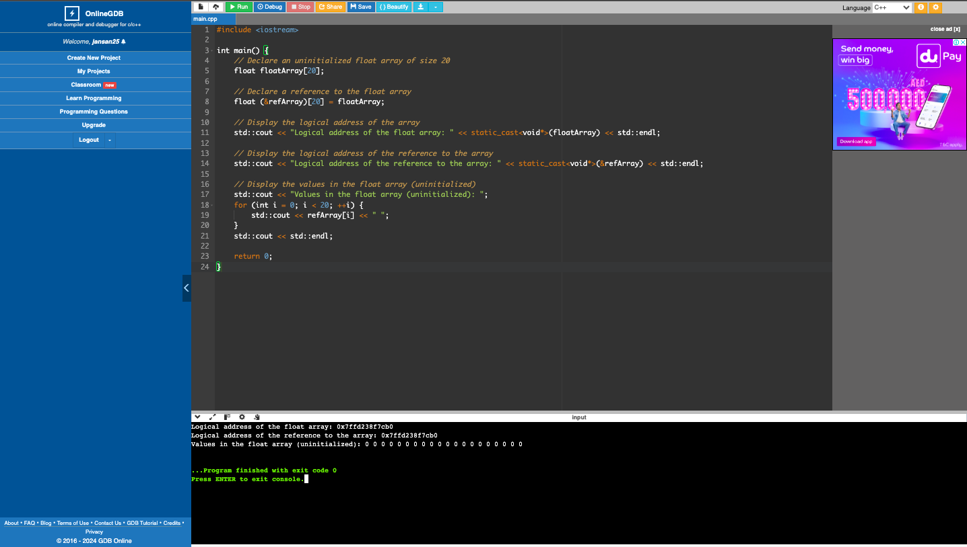

1. What can you conclude from this activity?

In this activity, I learned how to use pointers and reference variables to temporarily store data in memory.