1. Write a program that will change the value of an integer variable with initial value of 654,321 to 27,946 without directly assigning a value to the variable. You cannot create any pointersor references in the main function.

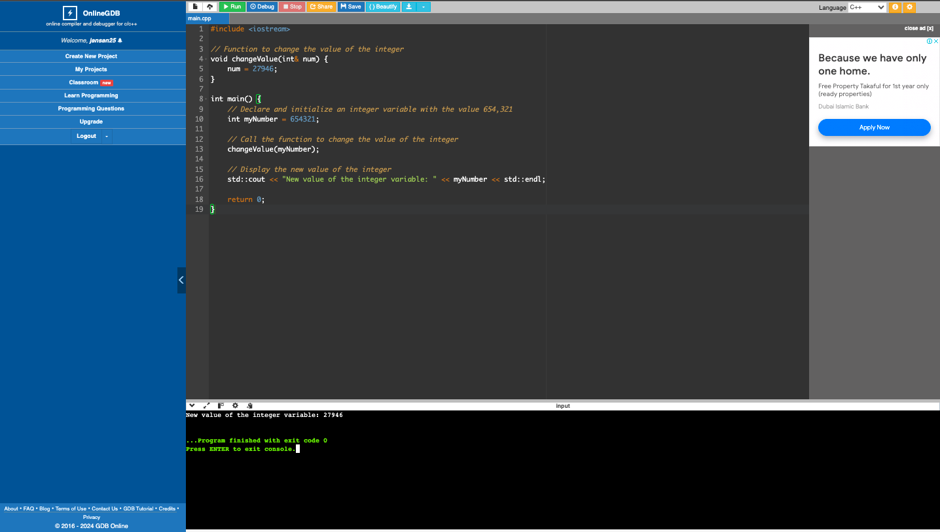

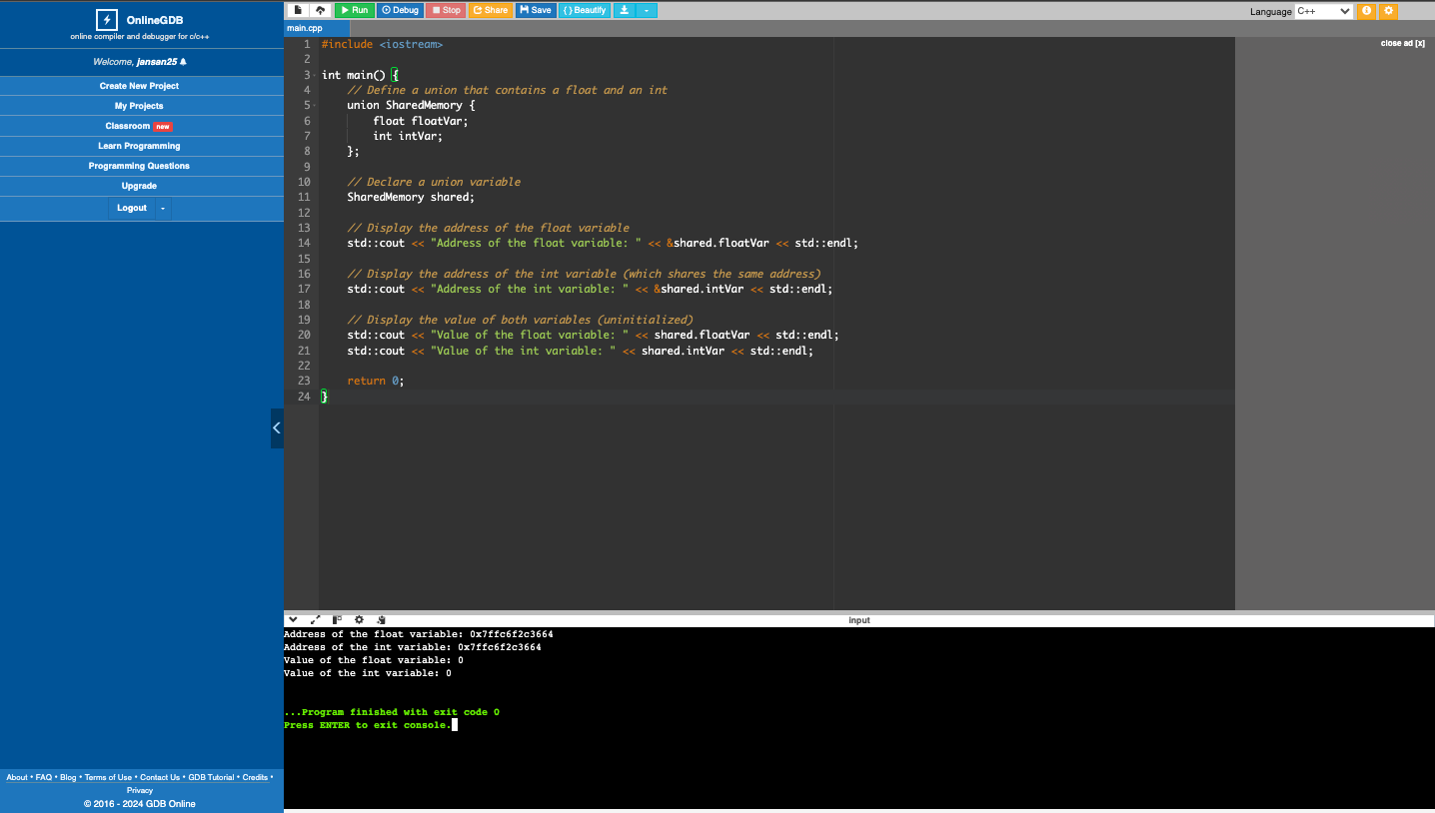2, Write a program that will display the address of a float variable and another variable that shares the same address and value as the first variable. Do not initialize the first variable.

1. Write a program that will display the words “This is it!” from a variablewithout assigning any characters to the variable. You cannot use cout << “This is it!” << endl; or any variants of it.

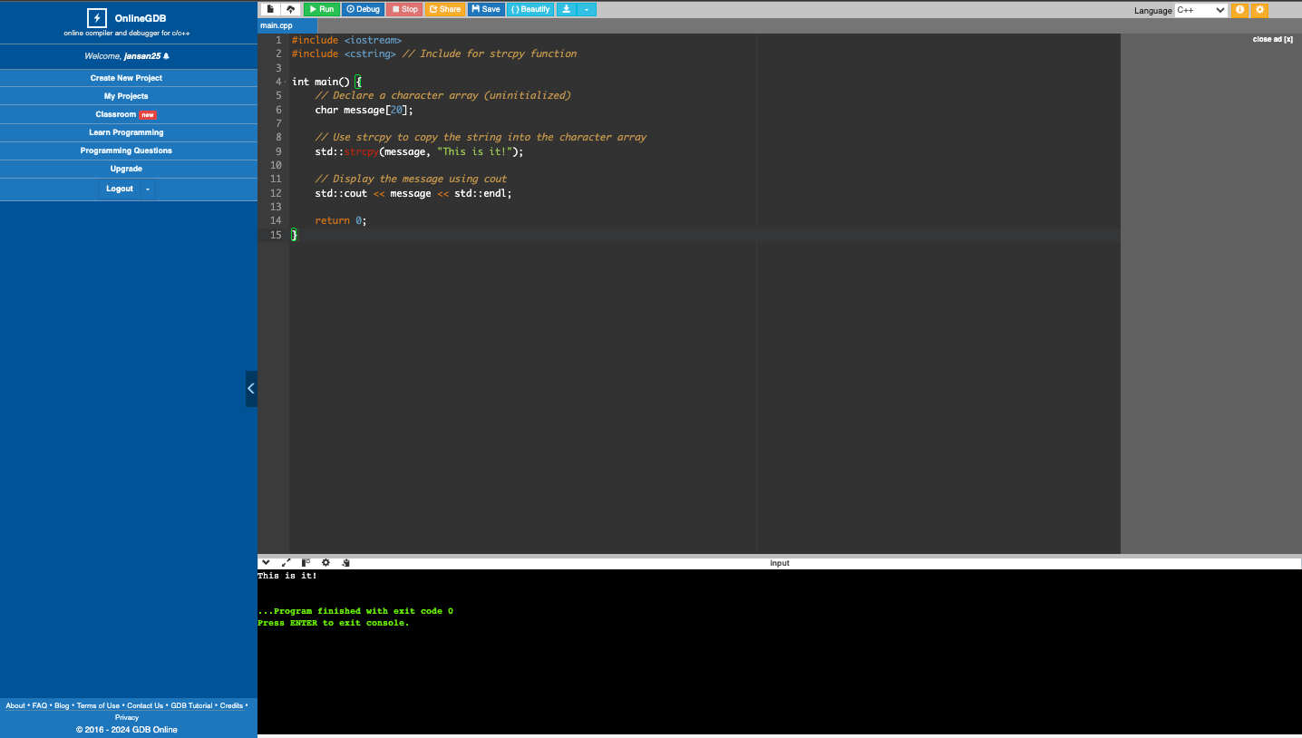

1. What can you conclude from this activity?

I learned that the Pointers and references are helpful for storing and directing to other elements.