

Team Commitment Planning and Tracking

© Jan Schrage 2008

Table of Contents
1Introduction 4
2Getting and installing the software 5
2.1Prerequisites 5
2.2Getting the software 5
2.3Setting up the software 5
2.4Receiving updates 7
3Use 7
3.1Logging in 7
3.2Periodicity 8
3.3The planning dashboard 8
3.4My team 10
3.5Review 11
3.6Reports 11
3.7The cumulative reporting dashboard 14
4Audit trails 15
5Maintenance 16
5.1The Maintenance Screen 16
5.2Import of time data 16
5.3User Administration, Roles and Rights 20
5.4Users vs. employees, how teams and countries work 22
5.5Projects and work types 22
6Reporting a problem 23
7License 23
83rd Party Components 24

Symbols and Notation

This documentation uses the following notation:

Code and commands you should execute are in red sans monotype: rake test:units
Files and folders are in blue sans monotype: config/database.yml
Internet links are in blue sans serif: http://www.ruby-lang.org

The following symbols are used:
Caution. Ignore at your peril.
Example

Additional information

Introduction

GSPlan is a team commitment planning and tracking tool. Its main purpose is to enable teams that have their own projects and collaborative projects to plan this, make commitments, and track them.

It is not a project planning tool: It does not and will not support planning of tasks, resources etc. at a level that is suitable for project planning.

GSPlan can
- Aid your teams in planning and committing to what they will do next month.
- Track the execution of those commitments.
- Aid in quality control through a review tracking system that is coupled to the project status workflow.
- Serve as an aid in team and cross-team discussions on the project portfolio.
- Promote transparency and efficiency.
- Help you to keep an overview of the status of your project portfolio.

The goal on creation was simplicity in use and data quality: There are no hidden menus or submenus, there is no distracting eye candy just for the sake of it, actions can mostly be taken on the elements on the screen and only those parts you can or are allowed to use are visible at any time. Database updates have a series of checks that enforce consistency and will alert you if things do not go as planned, are missing, or simply wrong.

GSPlan is licensed under the GPL v3. Please make sure to review and understand this license before you use GSPlan. A copy of the license is included in doc/License.txt. By using GSPlan you agree to this license.

Getting and installing the software

Prerequisites
In order to use this software you will need:
- git - http://git.or.cz/
- Ruby - http://www.ruby-lang.org
- Ruby on Rails - http://www.rubyonrails.org/
- ImageMagick - http://www.imagemagick.org/
- Rmagick - http://rmagick.rubyforge.org/
- A database. Rails supports a number of databases including Oracle, DB2 and MySQL. For the full list see http://wiki.rubyonrails.org/rails/pages/DatabaseDrivers
Optional but recommended:
- SQLite DB (for playing around before production and for testing) – http://www.sqlite.org
- Apache as production web server – http://www.apache.org
- A Unix-based server OS, such as Linux or Solaris.

The use of a standards-compatible browser, such as Firefox, Opera or Safari is highly recommended. While you should be able to use Internet Explorer I do not guarantee that anything looks good or even works on IE and there are some known visual quirks. See also Reporting a problem

If you are using Linux you can install all or most of these packages via your package administration without any need for manual installation. (Ubuntu, on which GSPlan was developed, comes with all of them so you only have to make sure they are actually installed.)

Getting the software
GSPlan is hosted on GitHub at https://github.com/janschrage/gsplan/

You can clone the repository with

git clone git://github.com/janschrage/gsplan.git

Alternatively, you can download a tar or a zip file from the hosting site. If you want to receive upgrades cloning with git is the suggested method, as it allows for easy integration of changes made to the central repository.

Setting up the software

All examples are on Linux and can be executed from a shell there. All commands must be executed from the installation directory unless noted otherwise.

In order to make sure the software is in a workable condition after download (including DB setup etc) you should first run the unit test suite:

rake test:units

You should not receive any errors.

Please note that by default the test suite uses sqlite. If you have not installed it you will get errors now. I would recommend installation. Alternatively you can change the test environment by editing

config/database.yml

If you wish to get a feel of GSPlan right now you can use the development database which is already populated (with nonsense, but nevertheless). Run
mongrel_rails start
Then point your browser at http://localhost:3000
The administrative login is User Jan / Password test

The next step is to set up the database.
You will have to
- Create a database
- Configure GSPlan to access it
- Load the DB schema
- Populate the database

The following paragraph describes how to do that with MySQL.

Create a database:

mysqladmin -u root create GSPlan

Configure GSPlan for access:

Edit config/database.yml
Assuming this is your production database you need to edit the production section:

production:
adapter: mysql
encoding: utf8
database: GSPlan
username: root
password:
socket: /var/run/mysqld/mysqld.sock

If you did not set a user and a password for the GSPlan database this is sufficient.
You should set a user and a password for the database and update the configuration file accordingly. Do not run a productive system without a database password. A step-by-step description can be found in the MySQL manual.

Load the DB schema:
RAILS_ENV=production rake db:schema:load

Populate the database. This will set up the default roles and associated rights. It will not set up users.
RAILS_ENV=production rake db:populate_roles

Start the application:
mongrel_rails start -e production -d
You should now be able to point your browser at http://localhost:3000 and get started. As no users are in the database there will be no login screen.

You should, at this point, make sure you have a solid and reliable backup for your database in place.

Receiving updates
GSPlan is in ongoing development and you may want to receive updates or bugfixes.
In your installation directory execute
git pull
This will pull all updates from the project. You may have to migrate the database after an update with
rake db:migrate
Do not try this on a productive system. You should first review and test all upgrades to make sure you know what you are doing. You should also verify the commit logs on the project's site at github to see what updates you will receive. Please note: What happens on your systems is entirely your responsibility, including loss of data, nerves, limb and life, and the destruction of the neighbourhood. You have been warned.

Use

Logging in
The login is case sensitive. After installation, with no users, you will not need to login. As soon as you create the first user a login and all authority checks are enforced. Please make sure to review chapter 5.3 (User Administration, Roles and Rights) before you create users. The first user should have the admin role assigned; otherwise you will lock yourself out of the system.

Periodicity
GSPlan operates on periods of one month.

The planning dashboard
The planning dashboard has four parts:
- The team capacity graph (top left)
- The team capacity list (top tight)
- Current team commitments (bottom left)
- Current projects (bottom right)
In general status and information fields are in shades of blue. Action fields have a pale yellow background. Action fields will only be visible if you are authorized for this action.

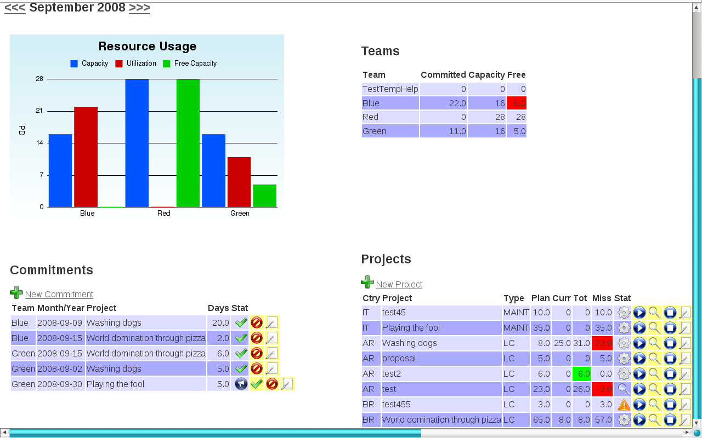
Navigation between months is done with the arrows to the left and the right of the current month at the top of the screen.

The capacity graph and the capacity list
Both graph and list show the same data: For each team the capacity is calculated based on the persons assigned to the team. The usage is based on the commitments the team has for this month. Only accepted commitments are counted.
Capacity is calculated as 16 days per person and month at 100%. This accounts for vacation, illness, trainings etc. If you want to change that you will need to edit
app/helpers/statistics.rb
Change the line
DaysPerPerson = 16;
to something that is more suitable for you.

The commitment list

The commitment list shows all commitments of all teams for the selected month. Each team can commit any number of days to any project. Commitments must be unique, i.e. you cannot have two entries for the same team and the same project. The column „Stat“ shows the status of the commitment. By default any new commitment has the status „proposed“. It is only counted when „accepted“.

Symbol | Meaning
Status: accepted (days count)
Action: accept
 | Status: proposed (days don't count)
 | Action: delete
 | Action: edit

With the default role setup team leads can propose commitments and administrators can accept them, e.g. in a common planning session.

The project list
The project list shows all projects that:
- fall into the selected month or
- end before the selected month but are not closed (will be marked with status „overdue“)

The columns show:

Pre? | Ctry | Project | Type | Plan | Curr | Tot | Miss | Stat
Work type is part of preload (red up arrow) / no preload (blue down arrow) | Country (or functionality), e.g. UK or UK-XYZ | Project name | Type of project (e.g. maintenance, documentation) | Total planned time (person days) | Committed this month (only accepted commitments) | Total committed time (only accepted commitments) (green if fully committed) | Missing time (Total planned – total committed) (red if overcommitted) | Project status (see below for symbols)

Symbols used:
Symbol | Meaning
 | Status: proposed
 | Status: not started
 | Status: in process
Status: testing/piloting
Action: set to „testing“
Status: closed
Action: accept
Status: rejected
Action: reject
 | Action: set to „in process“
 | Action: set to „closed“
 | Action: edit
 | Status: overdue (planned end reached but project not closed)
 | Status: Parked. This project is on hold and not being worked on or considered in planning. Parked projects will not appear in monthly planning and reporting. There is a dashboard report „Parked projects.“

Project workflow:
- When created, a project has the status „proposed“. It can then be accepted or rejected. By default team leads can create projects, but not accept or reject. This can be done by admins, e.g. in a common planning session.
- Rejected projects cannot be changed from this screen.
- If accepted, the status is set to „not started“.
- The „play“ button will set the status to „in process“. This is not possible if a project is in testing or closed.
- The „test“ and „stop“ button will set the status to testing and closed, respectively. If the project type needs reviews this is only possible if all reviews have been passed. Please see section Review for further explanation.

Successful execution of an action will highlight the row with a pale yellow flash. An error will highlight the row with a red flash. An error is normally due to missing reviews. Please note the comments on the workflow above.

My team
The „My team“ page combines elements of
- the planning dashboard
- project reporting
- review reporting
for the user's assigned team. Refer to those sections for details.

Review

The review workflow
The review section is intended to help you keep an overview of your review process. Through a link to the project workflow reviews can be enforced.
The review screen displays all current projects (i.e. overlapping with the selected month) and their review status. Currently specification, design and code reviews are handled.
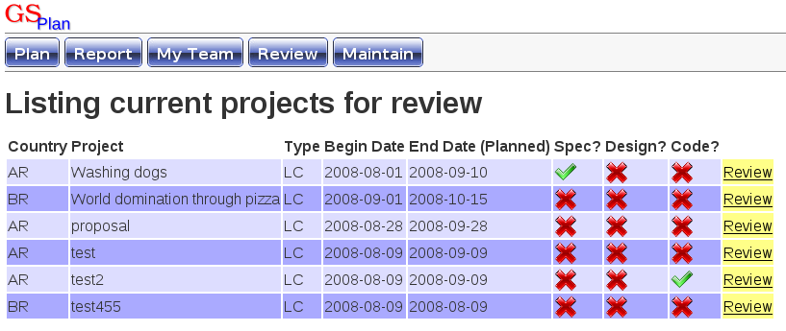
The „review“ link allows a reviewer to add a review with comments. The reviewer is stored automatically. A project can have multiple reviews of any type.
The status of each review can be
- „OK“
- „OK with comments“
- „Fail“
Only failed reviews will prevent testing and closing projects.
The current default setup for the database does not include a specific reviewer role. Refer to section User Administration, Roles and Rights for an explanation on how to do this.

How to add new review types
The database model is flexible enough to handle this, but you will need small code modifications in a few places:
- model Review (app/model/review.rb): Add the new review type to the constants
- helper ReviewsHelper::review_type_list (app/helpers/reviews_helper.rb): Add the review type text to the list
- view app/views/reviews/current_projects.html.erb: Add a field for the new review type to the table
- model Project::reviews_ok_before_pilot_or_close (app/model/project.rb): If you want a check on the new review type for the project workflow it has to be added in this method, similar to the existing ones.

Reports
The report page displays a list of all projects that
- overlap with the current month or
- are overdue
It also shows a graph on the distribution of project types and another on the quality of project planning/execution.
Currently all reports are only for the current month. Cumulative reports are planned for the near future.

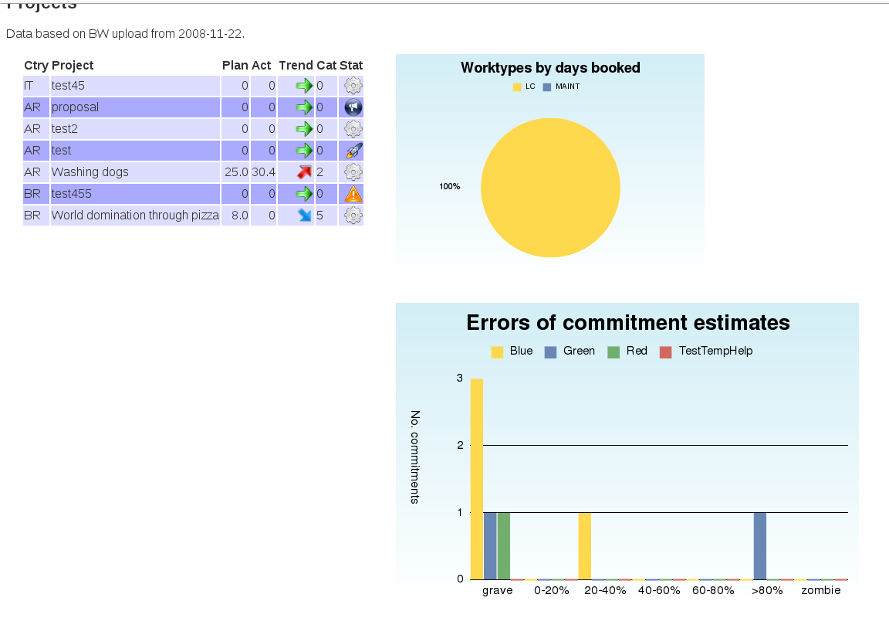
The first information on the screen is the date when the time data was uploaded (refer to section Import of time data).

The project list
The project list shows the following information:
Ctry | Project | Plan | Act | Trend | Cat | Stat
Country | Project name | Committed days (selected month) | Booked days (selected month) | Trend committed vs. Booked (see below) | Quality of execution/planning (see below) | Project status (as described in the planning dashboard)

Project trend
This indicates the trend of actually spent time compared to the commitment:
Project on commitment +- 10%
Project under commitment, delta > 10%. This is expected for most projects before a month is closed.
Project over commitment, delta > 10%.

Quality of execution/planning
This category describes, depending on how you look at it, how good your planning was or how well it was executed. The values mean:
0 | 1 | 2 | 3 | 4 | 5 | 6
No time committed, none spent | Estimation error 0-20% | Estimation error 20-40% | Estimation error 40-60% | Estimation error 60-80% | Estimation error > 80% | No time committed, time spent

Apart from the obvious categories 1-5 category 0 are projects that are just lying around (and should possibly be closed) and category 6 is the intransparent part of ad-hoc work, where one thing was planned and something completely different done. While this is always likely to be present it should be kept low.

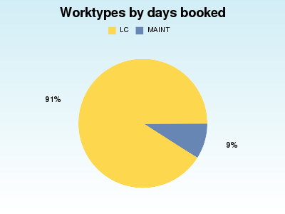
The graphs
The worktype distribution graphs show you how time was distributed between different types of work.

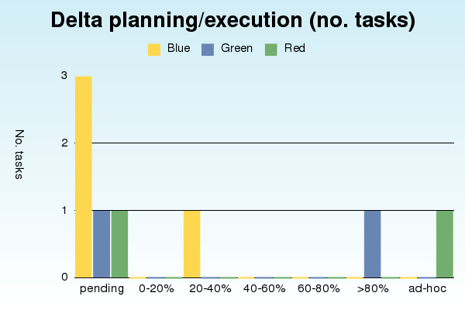
The graph „Delta planning/execution“ shows you the planning quality categories discussed above per team (not per country, as the project list does). The y-axis shows the number of commitments in a certain category. „pending“ is category 0 from above, and „ad-hoc“ is category 6. Note that before a month is closed the estimation errors for that month will be quite high as not all times have been booked.

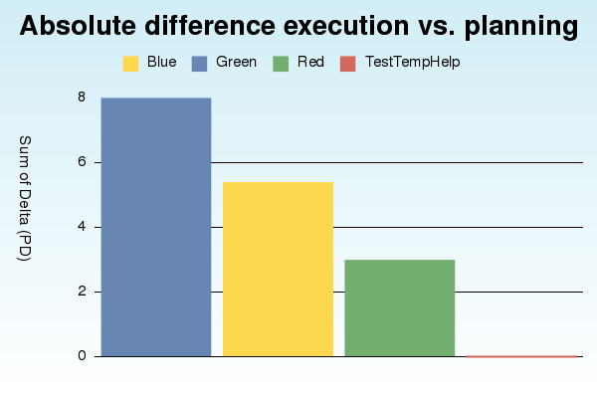
The graph „Absolute difference of execution vs. Planning“ gives a different view of the same data: While the previous graphs counts the number of projects this graph shows the sum of absolute differences of planning vs. execution per team in days. (Absolute means it does not matter if the estimate was above or below the time spent, it adds to the sum.)

The cumulative reporting dashboard
In addition to the monthly overview report there is a dashboard for cumulative and tracking reports over a period of time. It can be reached via the button „Dashboard“ in the menu.
All reports display their data in a normalized table that makes further analysis in a spreadsheet or other tool easy. If you are using Firefox the add-on Table2clipboard (https://addons.mozilla.org/de/firefox/addon/1852) will allow you to copy&paste the data into a spreadsheet or a csv.

The default time range is 3 months from now into the past, including the current month. In effect this will give you a rolling 3 months report.

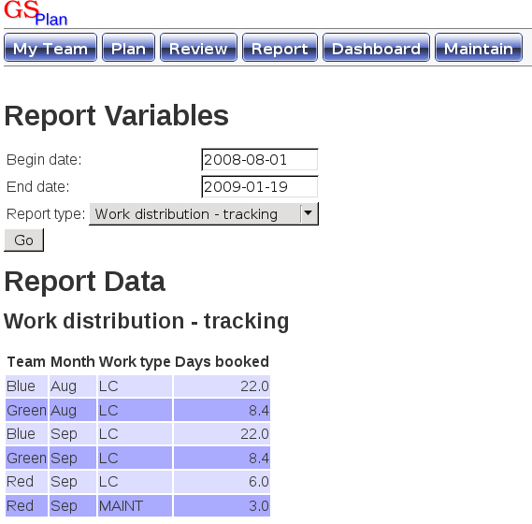
Work type distribution – tracking
This report displays the work types per team, work type and month between begin and end date, to the extent to which data is available. Like in the monthly report the last upload will be used for each month. In the example on the right you can see that while the end date is January 09 data is only available till September 08.

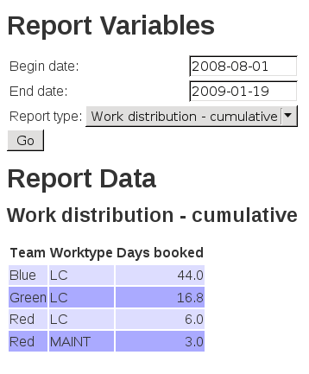
Work type distribution – cumulative
This report works exactly like the tracking report, but cumulates over the months between begin and end date. Please note that missing months are not easy to see here. You should make sure that data is actually available over the perios chosen.

Project age for current projects
The purpose of this report is to identify projects that are just lying around without being touched (and possibly should be closed). It displays data on currently open projects, including the number of weeks since they were created, their status and the number of weeks since they were last updated. Please note that „updated“ refers to an update in the system, e.g. a change in status from in process to testing. This report uses the time stamps on database changes. The graph counts the number of projects per bin. In the example graph and report you can easily see two outliers with very low efforts.
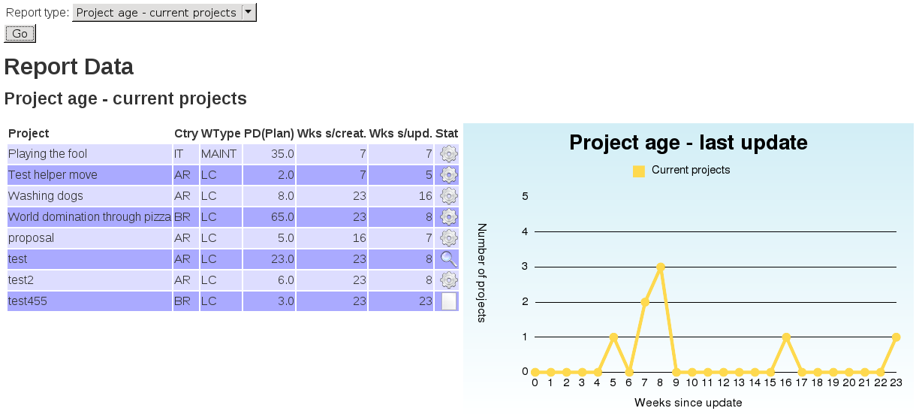
The project age report does not use begin and end date from the selection screen. It evaluates all projects that are currently not closed or rejected. It does not evaluate projects with a begin date in the future.

Process cycle time (PCT)
This report evaluates the process cycle time for all projects finished between the selected begin and end date. It also shows work in progress, i.e the number of projects that are currently open, in process, or in testing. The date used for selecting closed projects for the evaluation is the planned end date, the date used for calculating the actual PCT is the date the project was last updated. A closed project should not be updated any more from a process point of view. (A project that gets updated is not closed.)
The detailed project list also shows the PCT as a percentage of the planned effort.

Audit trails
All relevant database changes are automatically logged in a table called audit_trails. There is currently no interface to view them. If needed the audit trail can be accessed from a suitable db administration tool.

Maintenance

The Maintenance Screen
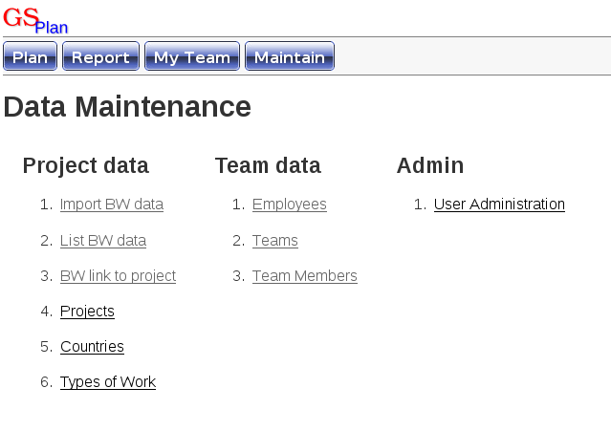
The maintenance screen allows for maintenance of project data, team data, and user administration. Currently not implemented are roles and rights administration, as they are hardly ever needed.

Import of time data
Time data is imported from a CSV file (comma separated values) that has bookings per employee and task. During import that data is mapped to the teams in-memory, personal data is at no point retained or stored on disk.
Several tasks can be mapped to one project (e.g. specification, design, development, test) allowing for a granularity in your time data that differs from your commitment planning. (Project planning, and planning time per tasks, is not the purpose of GSPlan in any way whatsoever.)
GSPlan operates on a monthly basis, but you can import several sets of time data per month. For all calculations the most current set will be used.
We will now
- Look at the format of the import file
- Discuss the steps of the import
- See how to link a task from the import file to a project
- Briefly discuss how to adapt the software to a different input format

The format of the input file
- The import file must be a .csv, fields are separated by a semicolon.
- The decimal separator can be a comma or a decimal point. There must no be a thousands separator.
- Numbers are assumed to be days, not hours.
- During import non-project time is read from a different column than project time. The mapping for both, however, is identical. That means if you wish to book this time you should have a project that takes the task type „Not assigned“.

Column | A | B | C | D | E | F
Content | Personnel number | Employee name | Task name | Time (unproductive) | Time (productive) | unused
Use | Identifies a person. If empty, time data is assumed to belong to the last person seen.  Used to identify the team to book time for. | Not used during import. | Used to identify the project to book the time on. The task „Result“ is ignored (compare screenshot below). | Times such as absences, training etc might go here. When the task name „Not assigned“ is found this column is used. | Project time should go here. This column is used by default for reading time.

An example screenshot can be seen below.
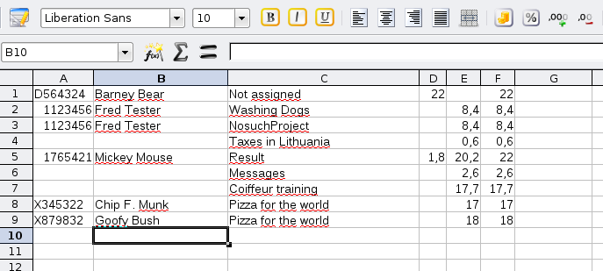

Import steps

Step 1 – Select file and booking period
The import starts with point (1) on the maintenance screen: Import BW data.
The first step is a file and date selection dialog. The date should be in the month you want to book the time for, in the format yyyy-mm-dd. The day does not matter. All data will be tagged with the current date, too, in order to identify the most current set of data for this month. The file should have the format described above.

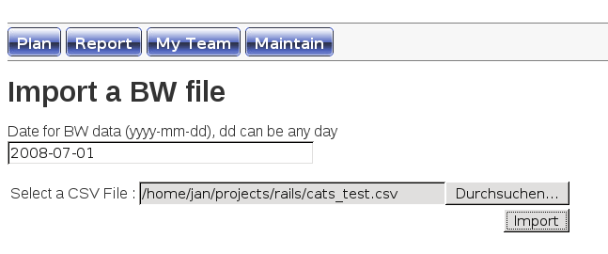

Step 2 – Verification of employee and project data
In the second import step employee and project data are verified:
- Does the employee exist in the database?
- Is the task linked to a project in the database?
All imported lines will be listed, with a column for employee and task that shows either a green check for „OK“ or an alert sign if there is a problem.
- If all data is OK there will be a button on the screen that allows you to proceed.
- If you see no data or get a rails error screen the file format is very likely wrong. In this case you should check the file or the server log.

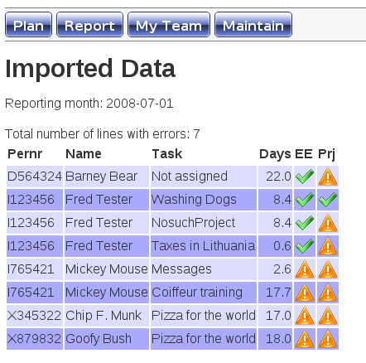
Below, you can see two screenshots with and without errors.
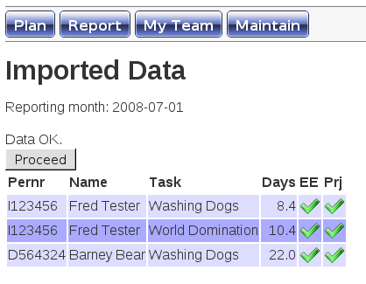
An error on the project that results from a missing link can be resolved by creating this link via item (3) on the maintenance screen: BW link to project. This will list all currently open projects and offer the option to create or edit links. The task name to be entered is the one from the CSV that you see on the import screen in the „Task“ column.
Note: You can have several tasks linked to the same project.

Step 3 – Book days for teams and projects
The proceed button will bring you to the next verification step for team and project time booking. This verifies that:
- The employee is assigned to a team in the booking month.
- The booking date is in the timeframe of the project.
You will see a list with the converted data and a list of errors if there are any. Again, you will only be allowed to proceed if all data is correct.

Below you can see screenshots with and without errors.
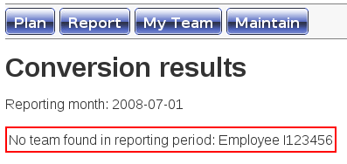
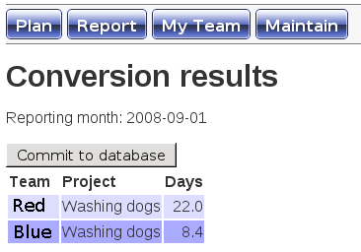

If everything is OK you can commit the imported data to the database. All statistics and report for the booking month will now use that data set.

Changing the file format
The file format is defined in ProjecttracksController::do_import, in file
app/controllers/projecttracks_controller.rb

Changing it is straightforward: This method only deals with reading the data from the columns, so you can easily change it without affecting the other import steps.

User Administration, Roles and Rights

Roles and Rights
The authorization concept of GSPlan is based on:
- Role(s) assigned to a user
- Right(s) assigned to a role, linking a right to a controller and action

A set of rights define a whitelist for a role: Any action not explicitly allowed is forbidden.
Each right gives you access to one action in a controller. For ease of use we will note this as controller/action in the following paragraphs.

The predefined right right_create_project gives you access to projects/create, i.e. the create action in the project controller. In effect, everybody who has that right can now create a project. This right is part of the predefined role „Teamlead“.
All users with the role „Teamlead“ will be able to create projects.

The special controller/action placeholder „*“ gives you right to any controller or action.

The right projects/* will allow access to all actions of the projects controller. Likewise the right */edit will allow access to the edit action of all controllers. This is not normally a good idea.

The predefined role „Admin“ has the single right */*, allowing access to everything.

Adding your own roles and rights
Adding your own roles and rights (and assigning them to users) is straightforward, although there is no UI at this point.
First, start the ruby console (assuming your production environment):
RAILS_ENV=production ruby script/console
Execute all following commands in the console you just started.
Example 1 – Create a reviewer role, allow it to see the review list and create a review
role_reviewer = Role.create :name => "Reviewer"
right_list_rev = Right.create :name => "list_current_projects", :controller => "reviews", :action => "current_projects"
right_create_rev = Right.create :name => "create_review", :controller => "reviews", :action => "create"
role_reviewer.rights << right_list_rev
role_reviewer.rights << right_create_rev
role_reviewer.save!

Example 2 – Add the right to see current project reviews to the teamlead role (assuming the right exists as defined above)
role_tl = Role.find_by_name(„Teamlead“)
right_list_rev = Right.find_by_name(„list_current_projects“)
role_tl << right_list_rev
role_tl.save!
For more examples on adding a role and assigning rights to it you can follow lib/tasks/db_populate_roles.rake
In order to be useful a role will need some more rights than defined in the examples above. Typical rights to consider on all controllers are „show“, „create“, „new“, „delete“, „edit“, „update“. After assigning rights to a role you should always test the intended workflow. Please compare to the predefined teamlead role in lib/tasks/db_populate_roles.rake

Assigning a role to a user
While users can be defined and assigned to a team via the maintenance screen roles currently have to be assigned via the console. There are two rake tasks to help:
- Assign the team member role to all existing users: rake db:make_all_teammembers
- Assign a role to a user: rake db:assign_role user=<user> role=<role>
In order to make user Fred an administrator in the production system, you would either:

RAILS_ENV=production rake db:assign_role user=Fred role=Admin

Or

RAILS_ENV=production ruby script/console
fred = User.find_by_name(„Fred“)
role_admin = Role.find_by_name(„Admin“)
fred.roles << role_admin
fred.save!
Note: Users can have more than one role. The rake tasks do not check if a role is assigned twice but assume you know what you are doing.
As long as no users are defined in the system at all, all authority checks are switched off. When you define your first user the next step should be to assign it the administrator role.

Users vs. employees, how teams and countries work
Users are users of the application. This is a purely administrative concept.
Employees participate in projects. They are part of the planning and booking.
There will most likely be some overlap, depending on which rights you decide to give whom.

Each user should be assigned to a team: This makes the „My Team“ page work.
Each employee should be assigned to a team: This is used for the calculation of the team's capacity and booking time. Team members can be assigned on a temporary basis and with a certain percentage (relevant for capacity calculations).

Each team owns one or more countries (or functionalities, it really doesn't have to be a country).

Projects and work types
Each project is assigned to a country and has a type of work. You are free in the work types you define. The review workflow is defined per work type.
Each work type has two relevant flags:
- Preload: If this type of work is part of your preload (i.e. must do, not negotiable) you should flag this. Currently the preload flag is visible in planning and reporting.
- Needs review: If a work type needs to be controlled through the review workflow, this flag must be set. E.g. development projects typically will be, whereas training probably won't.

Reporting a problem
Problems can be reported via http://janschrage.lighthouseapp.com/projects/15941

Do not report any issues with the Internet Explorer. If you cannot reproduce an issue you have in IE on a browser that follows W3C standards such as Firefox, Opera, Konqueror or Safari report the problem to Microsoft, not to me. If you can reproduce a problem on a compliant browser, by all means report it. Overall GSPlan works on the Internet Explorer, but you may encounter quirks in the visualization. These problems are entirely due to the Internet Explorer not following W3C standards, in particular, CSS specifications.

License
Copyright (C) 2008 Jan Schrage <jan@jschrage.de>
This program is free software: you can redistribute it and/or modify it under the terms of the GNU General Public License as published by the Free Software Foundation, either version 3 of the License, or (at your option) any later version.
This program is distributed in the hope that it will be useful, but WITHOUT ANY WARRANTY; without even the implied warranty of MERCHANTABILITY or FITNESS FOR A PARTICULAR PURPOSE. See the GNU General Public License for more details.
You should have received a copy of the GNU General Public License along with this program. If not, see <http://www.gnu.org/licenses/>.

3rd Party Components
This software uses the 3rd party components listed below.
- Icons from the Crystal icon set: http://www.everaldo.com/crystal/
- Icons from the Spheres icon set: http://www.mouserunner.com/Spheres_Icons_Index.html
- Gruff chart plugin: http://nubyonrails.com/pages/gruff
- Aero Button Menu from the Dynamic Drive CSS library: http://www.dynamicdrive.com/style/csslibrary/item/vista_aero_buttons_menu/
- Active Scaffold for some of the table maintenance: http://activescaffold.com/

