

**Documentation**

Version: 1.0.0

Draft/Final as of:

Owner: DataBridge Asia Inc.

Home Page ……………………………………………………………………………………………………………………………. 3

Login Page …………………………………………………………………………………………………………………………….. 5

Dealer Account ……………………………………………………………………………………………………………………… 6

**Homepage DataBridge Asia Inc.**

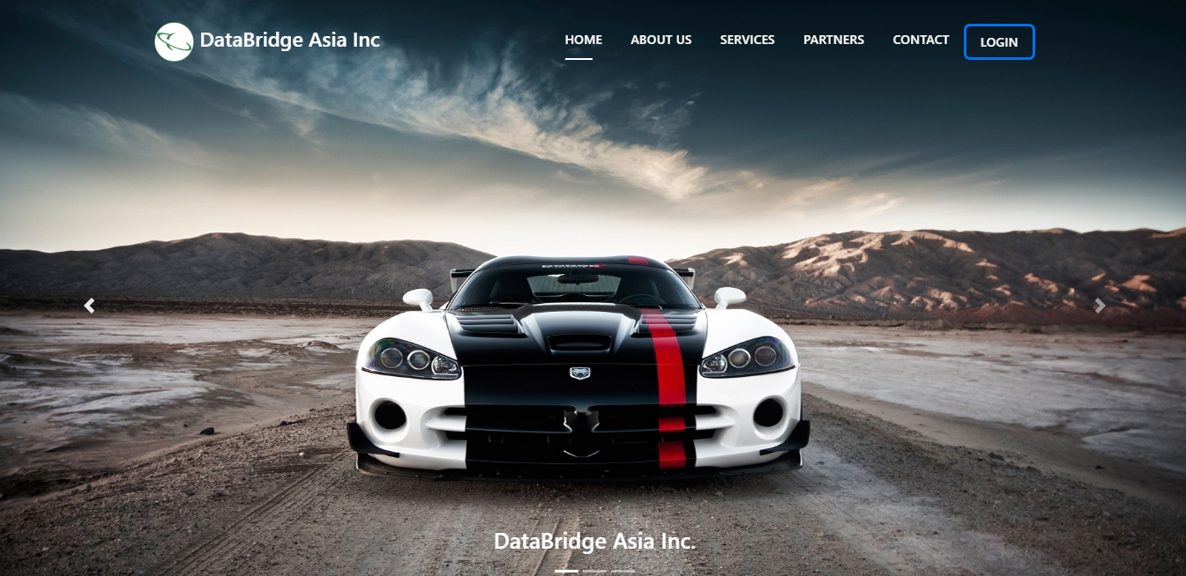

### About uS

**DATABRIDGE ASIA INC**. was incorporated in the

Philippines on February 2008. It is an IT company

based in Makati which offers a full range of

hardware and software development, quality

assurance and IT consulting services for the

domestic and international market.

Over the past years, the company has provided

services and solutions to customers like

PHILAMLIFE, WORKFORCE SOLUTIONS, KFORCE

GLOBAL SOLUTIONS, MISYS, and AMMEX.

A Member of Team FirstAsia.

### Service

## IT PROCESS OUTSOURCING | IT RESOURCE DEVELOPMENT | IT RESOURCE MANAGEMENT

### PARTNERS

###### **THE FIRST ASIA | BRAINSPARKS** | **BITSPACE**

Get in Touch

###### Contact Details:

* Bitspace, 6th floor, PDCP Bank Centre, Rufino corner Leviste Street, Salcedo Village, Makati City, Metro Manila, Philippines 1227
* (632) 8892-5462
* -none-

###### Affiliate Websites:

* First Asia Venture Capital Inc. - <http://www.firstasia.com.ph/>
* Brainsparks - <https://www.brainsparks.ph/>

**Login**

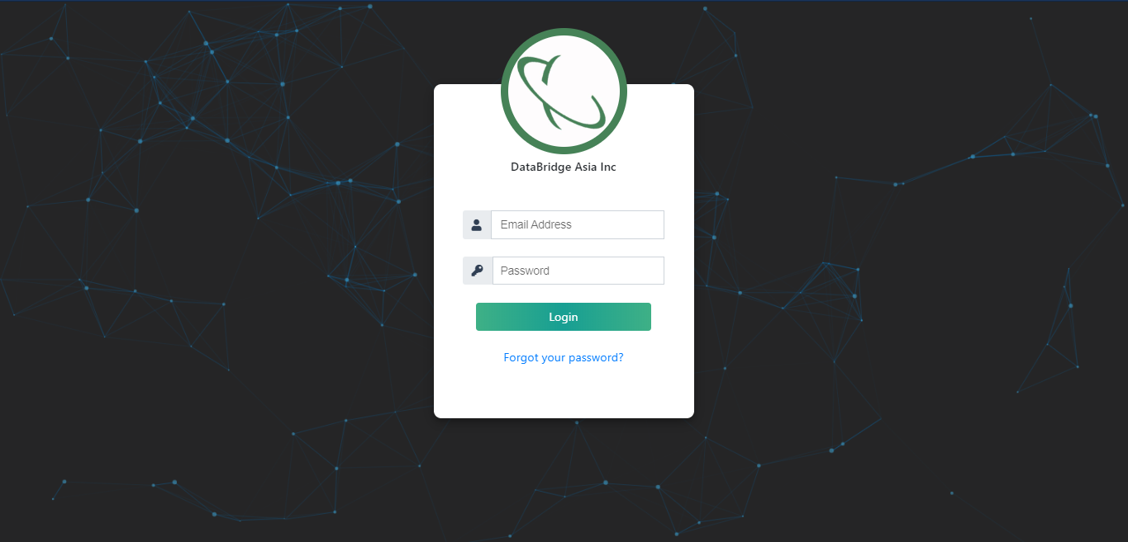

**Dealer Dashboard**

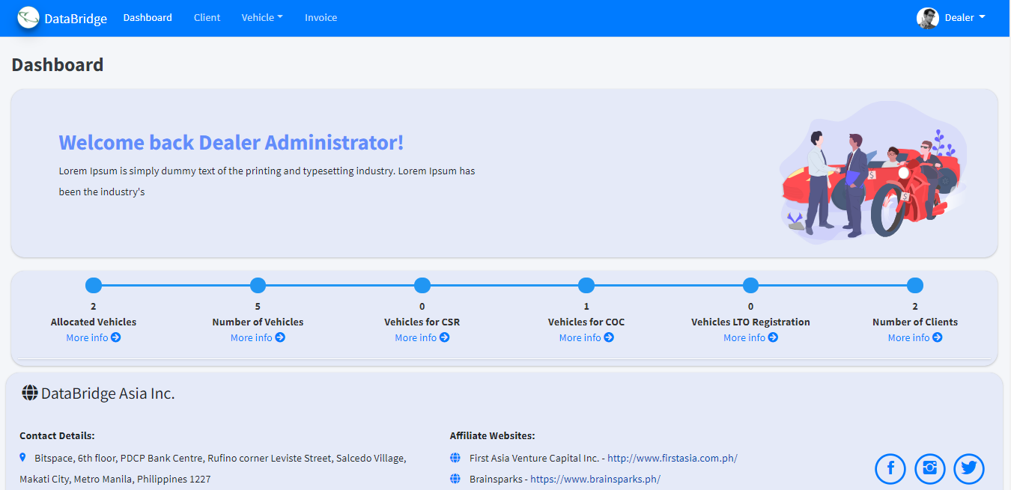

**Client List**

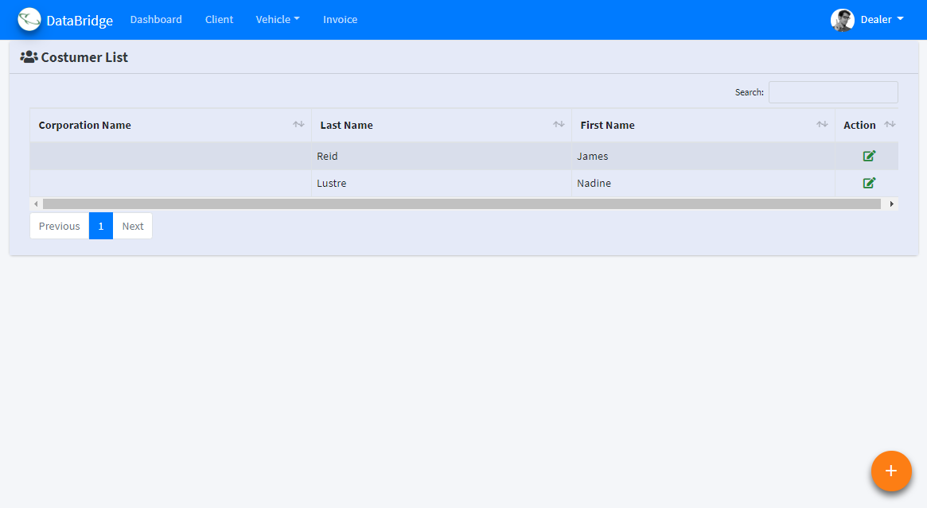

**Create new Costumer**

Click **+** sign button to create new Costumer

**Costumer Registration form**

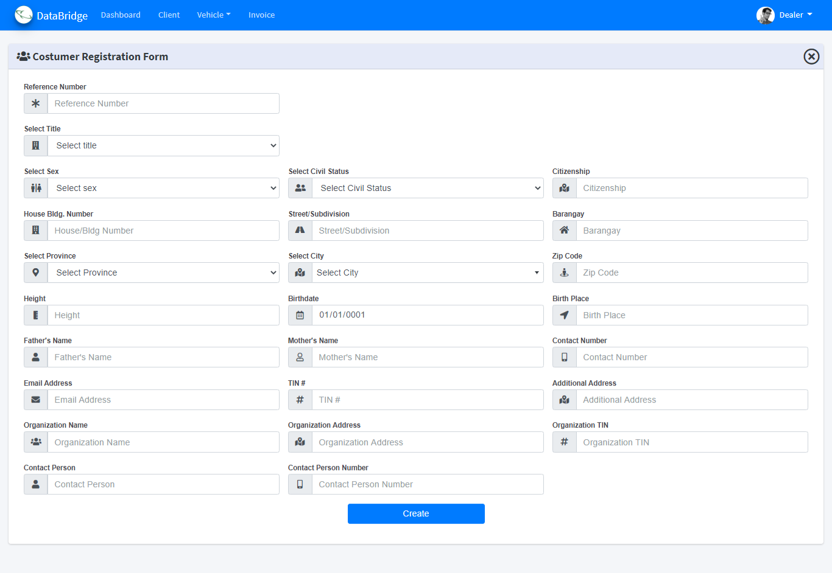

Fill-up the form for the New Register Costumer and click the button to Create

**Vehicle**

Vehicle => Vehicle Info

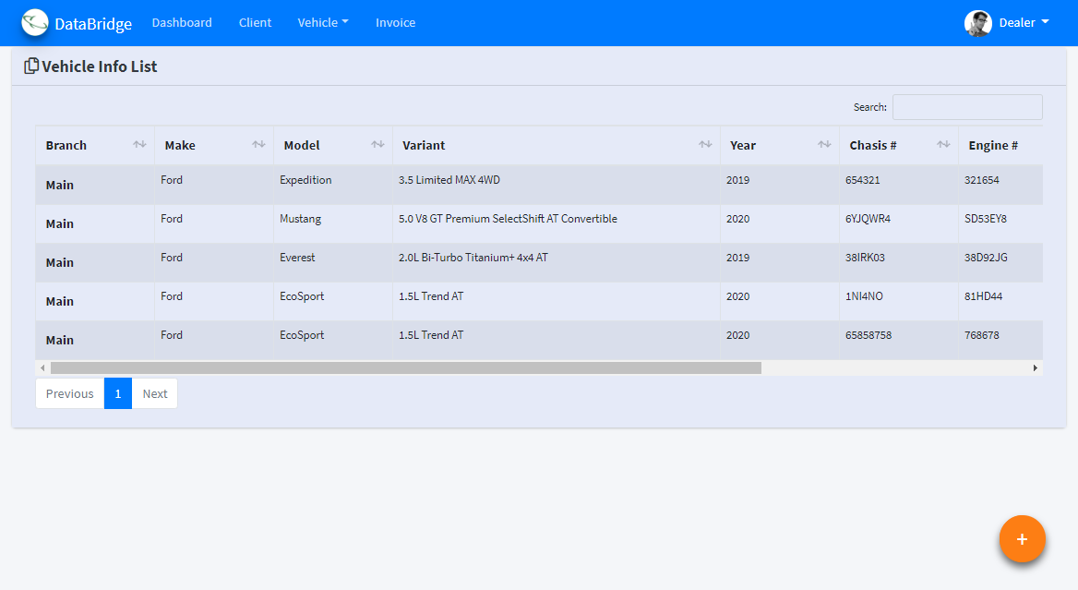

**Create new Vehicle**

Click **+** sign button and Select **+** sign to create new Vehicle

**Vehicle Info Registration From**

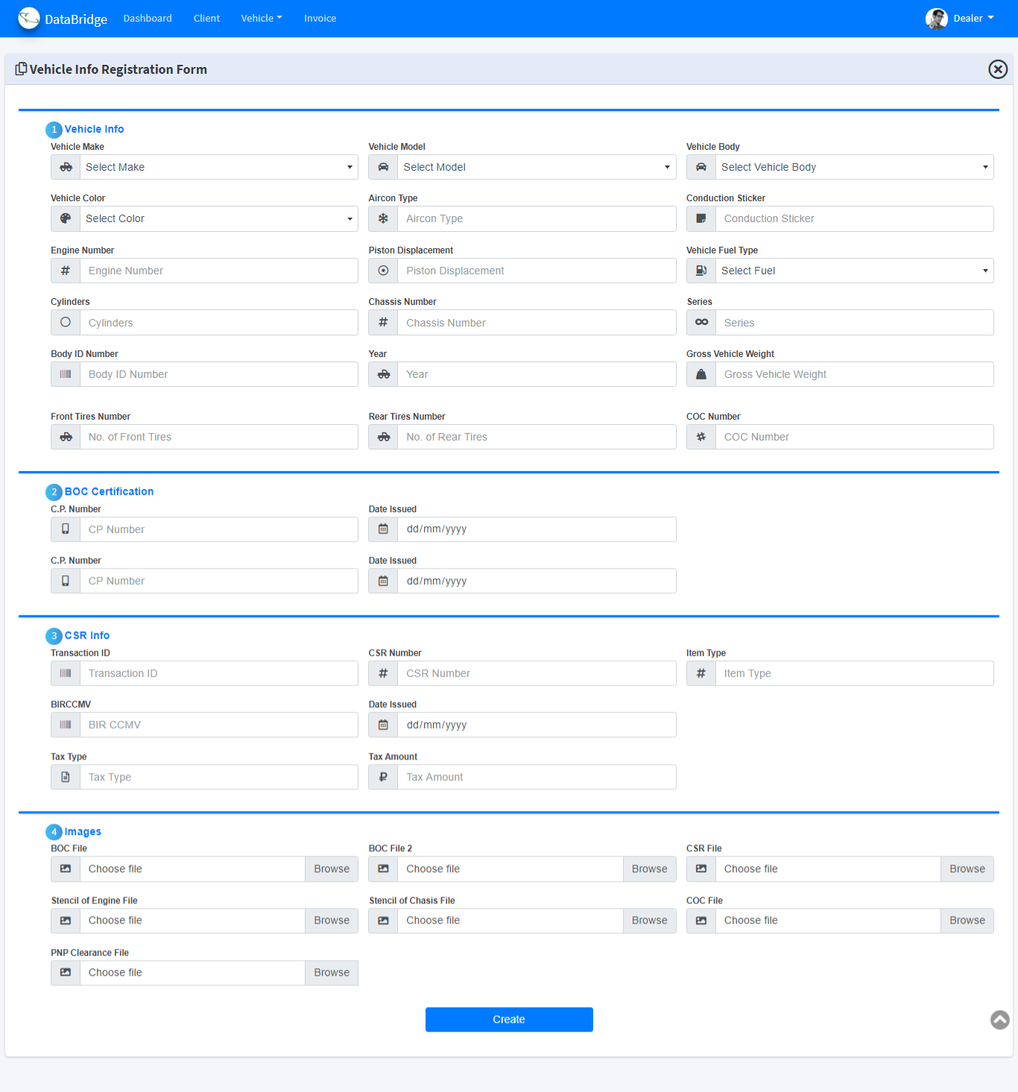

Fill-up the form for the New Register Vehicle Info and click the button to Create

**Upload Multi Vehicle Info Registration From**

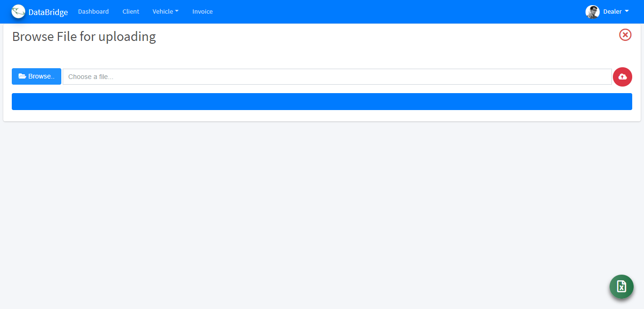

**Download Excel Template**

Click circle green button

**Upload Multi Vehicle info via Excel Template**

Click browse button and browse your excel template files and click the cloud button circle to upload your multi vehicle info