Script Controlled ACL - Restrict Record Access Based on Field Values
A Project Report Submitted in Partial Fulfillment of the Requirement for the Award of the Degree in
BACHELOR OF COMPUTER APPLICATIONS
Submitted by
S.Jansi 24081040500112106
M.Muthulakshmi 24081040500112107
M.Sowmiya 24081040500112113
R. Pensiya 24081040500112109


CSI Jayaraj Annapackiam College – Nallur 627853
(Affiliated to Manonmaniam Sundaranar University, Tirunelveli)

DECLARATION

I hereby declare that the project titled “Script Controlled ACL - Restrict Record Access Based on Field Values” is an academic project carried out to understand and implement record-level access control using ServiceNow Access Control Lists (ACLs) and scripting.
The project focuses on restricting access to records based on field values. The implementation demonstrates how a scripted ACL can evaluate record data and allow or deny access according to the configured business rule.

ABSTRACT

The project “Script Controlled ACL - Restrict Record Access Based on Field Values” focuses on implementing field-value-based record security in ServiceNow. Access Control Lists (ACLs) are used to control whether users can read or modify records. In this project, a scripted ACL checks a selected field value in a record and decides whether access should be granted.
The main purpose of the project is to demonstrate how scripting can make access control more flexible than a simple role-based condition. The ACL evaluates the record at runtime and permits or restricts access according to the configured field value. The final output demonstrates controlled record access using a Scripted ACL.

Table Of Contents

S. No. | Phase | Page No.
1 | Brainstorming & Ideation Phase | 1
2 | Requirement Analysis Phase | 3
3 | Project Design Phase | 4
4 | Project Planning Phase | 6
5 | Project Development Phase | 8
6 | Project Testing Phase | 10
7 | Project Documentation Phase | 11
8 | Project Demonstration Phase | 13
9 | Conclusion | 14

1. Brainstorming & Ideation Phase
Objective
To identify a practical ServiceNow security requirement and propose a scripted ACL solution for restricting record access based on field values.
Activities Performed
- The project idea was developed around controlling access to records according to the value stored in a selected field.
- The need for field-level or record-level restrictions was considered in addition to normal role-based access.
- A Scripted ACL was identified as a suitable approach because it can evaluate record data before granting access.
- The proposed solution focuses on a clear and testable field-value condition.
Expected / Produced Output
The project concept: when a user attempts to access a protected record, the ACL evaluates the configured field value and allows or denies access accordingly.
Screenshots:
____________________________________________________________
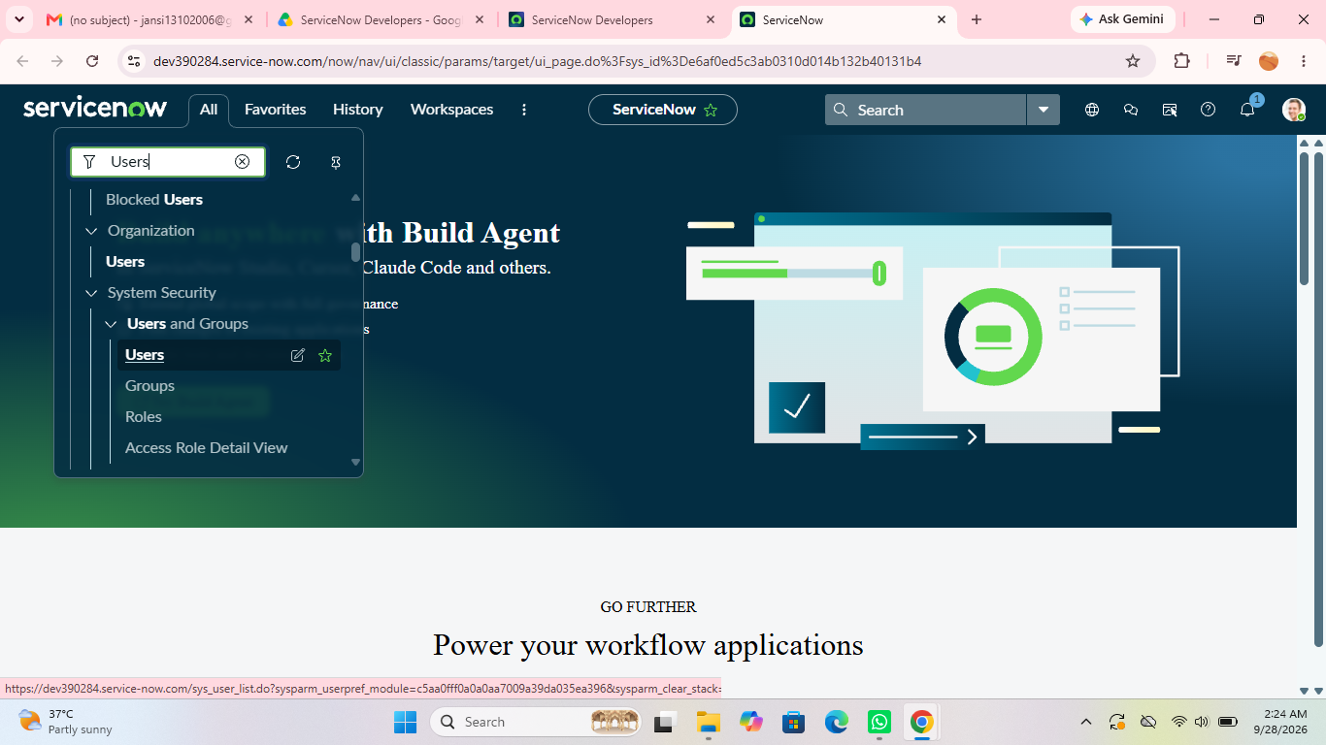

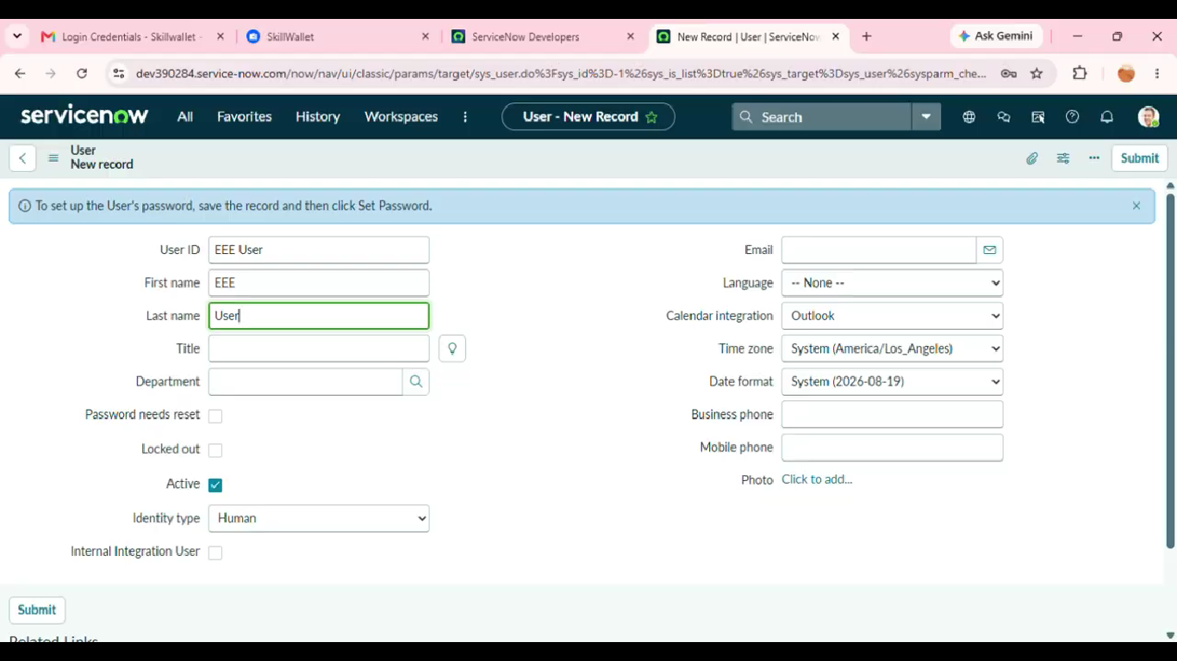
2. Requirement Analysis Phase
Objective
To understand the users, protected records, field values, ACL type, access operation, and expected security behaviour.
Activities Performed
- Identify the table and records that require protection.
- Identify the field whose value will control access.
- Define the field values that should permit or restrict access.
- Determine the ACL operation, such as read, write, create, or delete.
- Identify the roles or users involved in testing access.
- Define positive and negative access scenarios.
Expected / Produced Output
The requirement analysis results in a clear security rule: User Request → ACL Evaluation → Field-Value Check → Allow Access / Deny Access.
Screenshots:

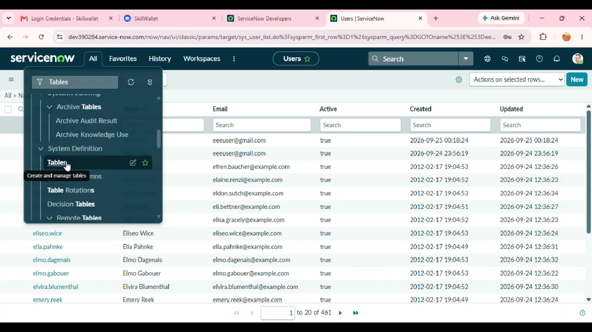_____________________________
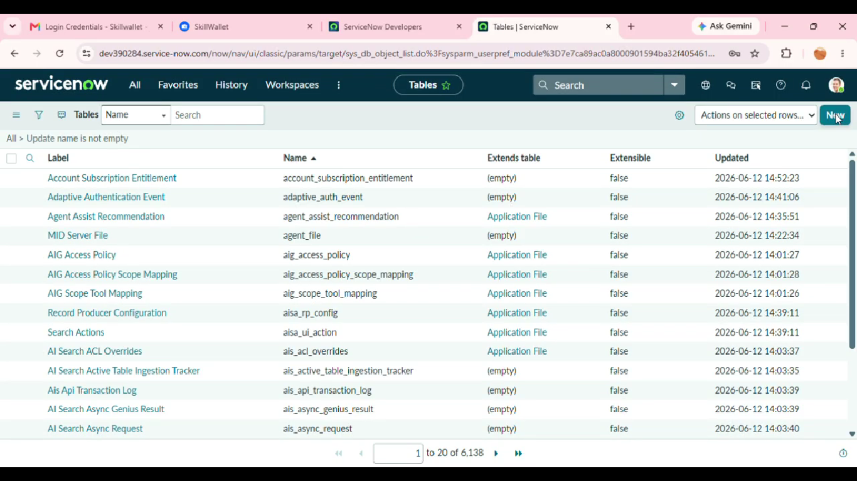
3. Project Design Phase
Objective
To design the logical security rule before implementing the Scripted ACL in ServiceNow.
Activities Performed
- Select the target table and ACL operation.
- Define the field used for the access decision.
- Design the condition that compares the record field value with the permitted value.
- Plan the scripted logic using the current record.
- Define the expected result for matching and non-matching field values.
- Plan test users and sample records for validation.
Expected / Produced Output
High-level security design: User Access Request → ACL Trigger → Script Checks Field Value → Access Granted or Access Denied.
Screenshots:
____________________________________________________________
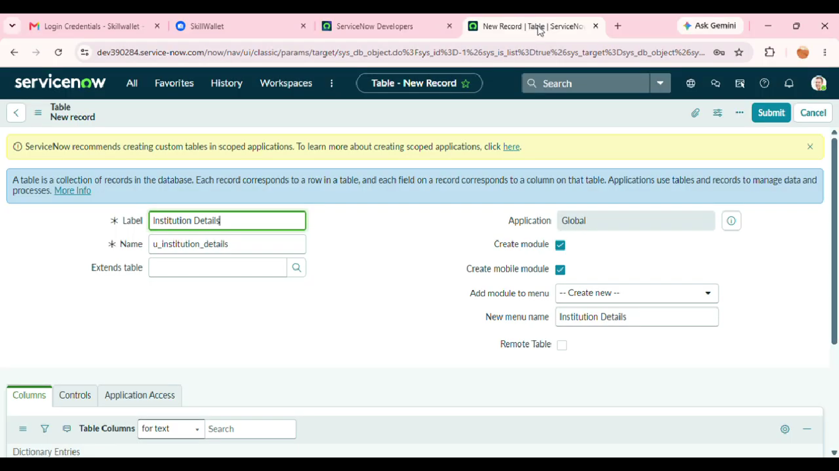

4. Project Planning Phase
Objective
To organize the ACL implementation into manageable activities and define the sequence of work.
Activities Performed
- Review the project objective and finalize the access-control scope.
- Prepare the required ServiceNow table, records, users, and roles.
- Select the field that controls record access.
- Create the ACL with the required operation.
- Configure the scripted condition and prepare test data.
- Prepare positive and negative test scenarios.
- Capture screenshots and prepare the final documentation.
Expected / Produced Output
The planned implementation follows a structured sequence from environment preparation to ACL development, testing, documentation, and demonstration.
Screenshots:
____________________________________________________________
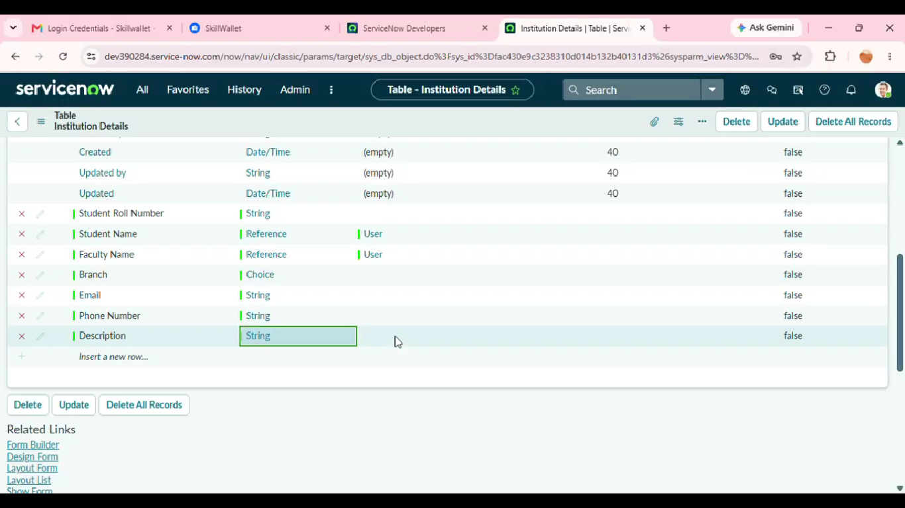

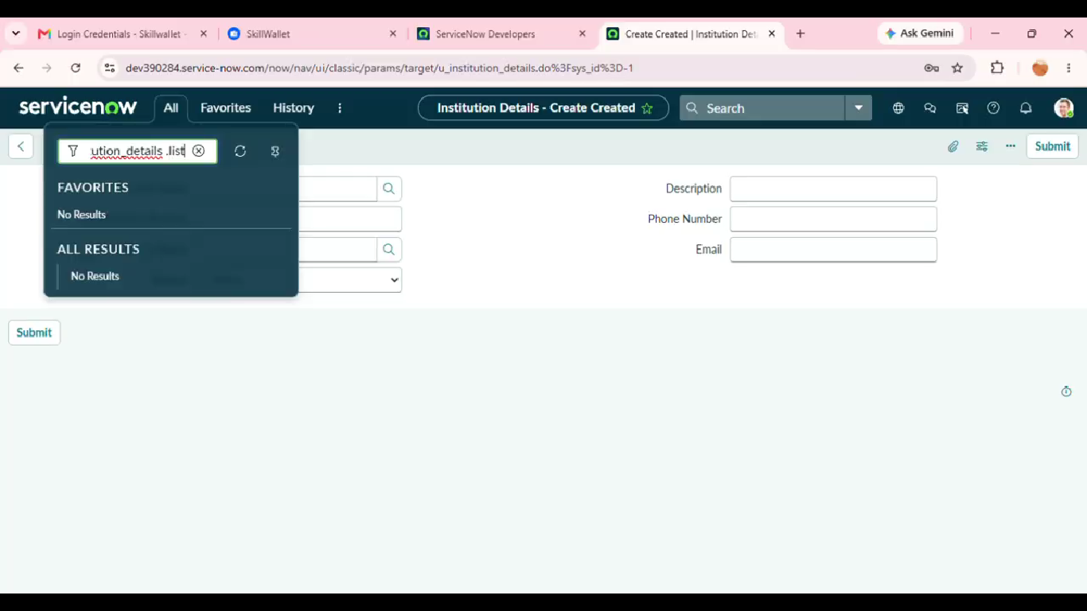
5. Project Development Phase
Objective
To implement the Scripted ACL in ServiceNow and enforce record access based on a field value.
Activities Performed
- Open the required table and identify the record field used for access control.
- Create the appropriate Access Control rule for the required operation.
- Configure the required table, field, operation, and roles if applicable.
- Add the script that checks the value of the selected field.
- Configure the script to return true when the access condition is satisfied.
- Configure the script to return false when the access condition is not satisfied.
- Save and validate the ACL configuration.
- Test the ACL with records having different field values.
Expected / Produced Output
A working Scripted ACL that grants access for the configured field value and restricts access when the condition is not satisfied.
Screenshots:
____________________________________________________________
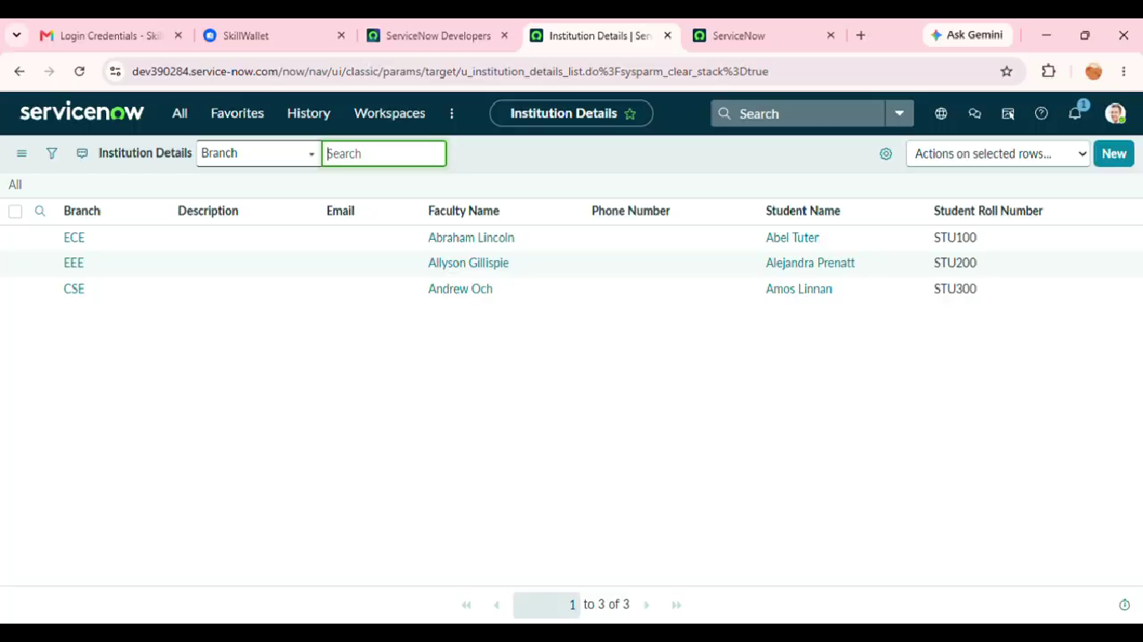
6. Project Testing Phase
Objective
To verify that the Scripted ACL correctly allows and restricts access for different record conditions.
Activities Performed
- Test a record with the permitted field value.
- Verify that the user can access the record when the condition is satisfied.
- Test a record with a restricted or different field value.
- Verify that access is denied when the condition is not satisfied.
- Test the ACL with the selected operation such as Read or Write.
- Verify that unrelated records are not incorrectly blocked.
- Record issues and correct the ACL script or configuration before the final demonstration.
Expected / Produced Output
The ACL should grant access for valid test cases and restrict access for records that do not satisfy the configured field-value condition.
Screenshots:
____________________________________________________________
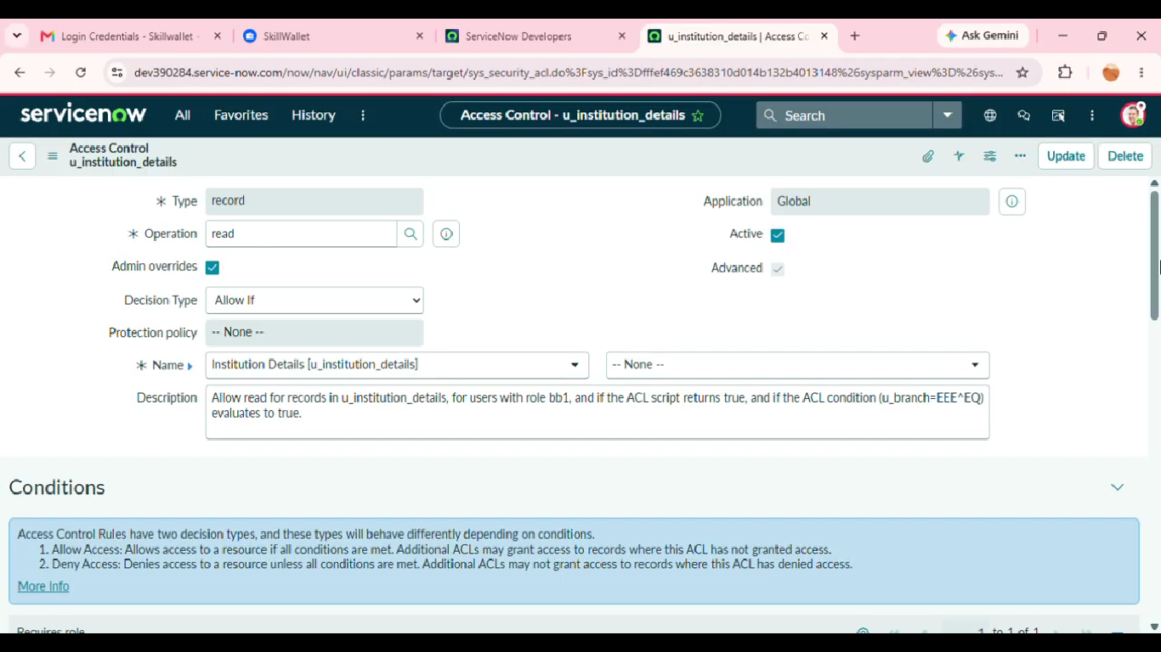
7. Project Documentation Phase
Objective
To record the complete ACL configuration, testing evidence, and final outcome in a clear and reusable format.
Activities Performed
- Document the project title, objective, scope, and problem statement.
- Document the requirements and field-value access rule.
- Describe the ACL design and scripted logic.
- Document the ServiceNow configuration and important security steps.
- Include screenshots as evidence for configuration and execution.
- Document positive and negative test scenarios and observed results.
- Record the final outcome, limitations, and possible future enhancements.
Expected / Produced Output
This document provides the phase-wise record of the Scripted ACL project and can be used as the final project documentation.
Screenshots:
____________________________________________________________
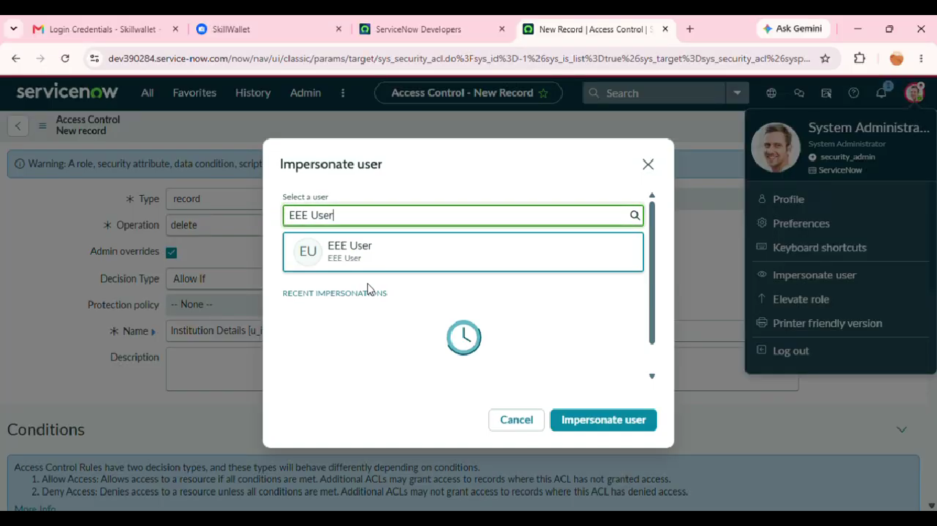
8. Project Demonstration Phase
Objective
To demonstrate the completed Scripted ACL and explain how field-value-based access control works.
Activities Performed
- Introduce the security problem and project objective.
- Show the target table and the field used for access control.
- Show the configured ACL and its operation.
- Explain the script condition in simple terms.
- Demonstrate access to a record whose field value satisfies the condition.
- Demonstrate restricted access to a record whose field value does not satisfy the condition.
- Show the test results and explain the difference between allowed and denied access.
Expected / Produced Output
The demonstration should show a complete access-control lifecycle from user request to ACL evaluation and final access decision.
Screenshots:

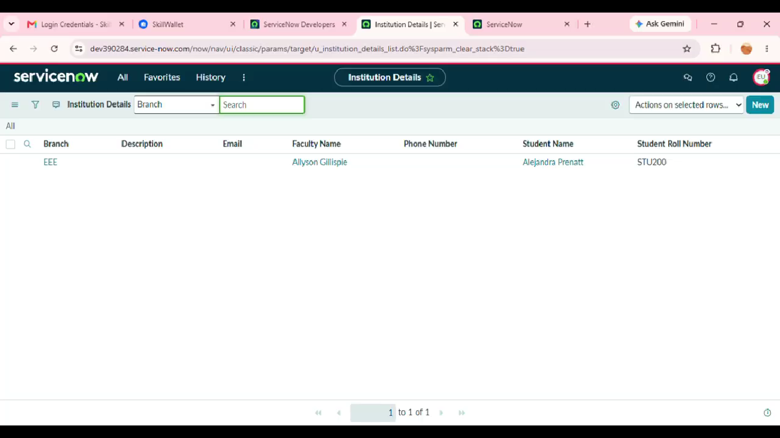
__________________________

9. Conclusion
The project demonstrates how ServiceNow Scripted ACLs can be used to restrict record access based on field values. By evaluating a record field during access control processing, the system can provide more specific security behaviour for different records.
The phase-wise approach covers idea generation, requirement analysis, design, planning, development, testing, documentation, and demonstration. The same approach can be extended to other tables, fields, and access operations where record-level security is required.
Future Enhancements
- Extend the ACL logic to support multiple field-value conditions.
- Combine field-value checks with user roles or groups for more detailed access control.
- Create separate ACLs for Read, Write, Create, and Delete operations where required.
- Add more test users and test records to validate different security scenarios.
- Improve the script logic with reusable security rules for larger applications.
- Maintain clear documentation of ACL conditions and security requirements.

