DAY – 21
GAMING
K means algorithm clustering
Unsupervised learning is a unlabeled data
K – number of clustering
Means – average we can choose them
For K = 3/
Euclidean distance-
d=(x2−x1)2+(y2−y1) the whole square root.
From sklearn.cluster import KMeans
DAY – 22
KNN
KNN stands for k nearest neighbors, comes under the supervised learning. They are classification and regression.
They are called as lazy algorithm. It does not build any training model and make only prediction. If any query appears on the output, then they will start to analyze.
When they enter new, calculated as neighbors. K nearest point will calculate the nearest value.
Once you choose the k value you can calculate the value.
The basic formula is (y2-y1)^2.
Manhattan Distance is defined as d=|x1-x2||y1-y2|.
High is underfitting and low is overfitting.

ASSIGNMENT – 5
K MEANS CLUSTERING
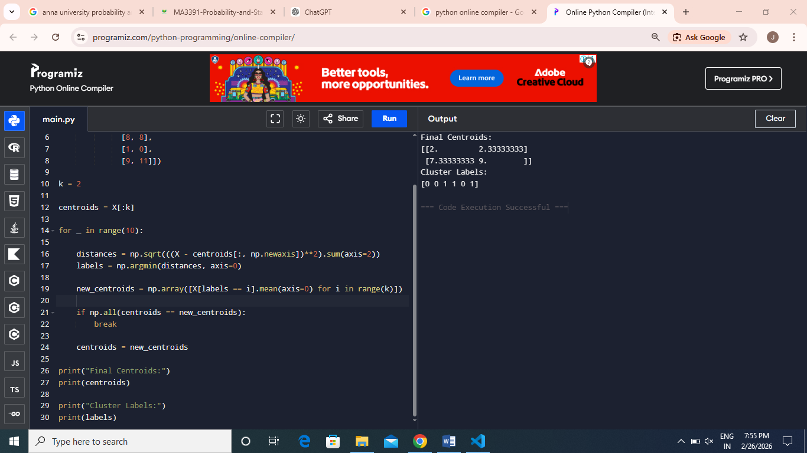

KNN
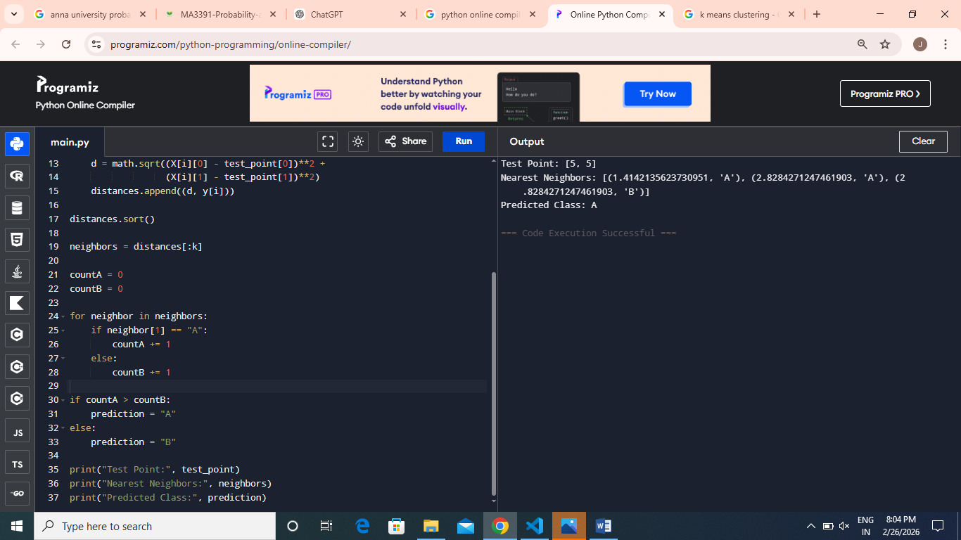
DAY – 23
Backpropagation
Deals with neural network.
By adjusting the models weights and bases to minimizer prediction error.
- Forward pass
- Backward pass
Predicted output, ground output
Difference between them called loss.
Example
Apple – 2 KG but 1 and ½ remaining is the error.
Target output is the predicted output.
Activation function.
DAY – 24
Working on project and documentation.
DAY – 25
Working on project.

