Report for Problem Set 4:

Climate Change and Impacts

Report Author: [insert kerb]

Instructions
- Please use a size 12pt font with 1-inch margins for your written answers.
- All graphs should be clearly labeled with appropriate titles, axis labels, and legends where necessary. Note that the example graphs we provide are just meant to give you confidence in your graph shapes and do not satisfy this requirement.
- Please clearly label the parts you're answering for each plot and explanation.
- For each of the analysis questions, make sure to base your answers only on the data we have provided.
- We don't need a full essay; just a sentence or two for each question is fine. Responses longer than a paragraph will not be graded.

Part 1a: Understanding the data

Answer the following questions:

How many unique countries are there in each dataset?

For each of the three datasets, are there missing values? If so, which columns have them?

Part 2: Global mean temperature over time

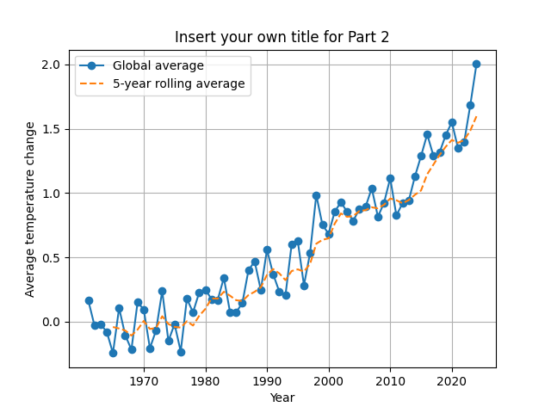

[Replace with your own figure here]

Answer the following questions:

What does the rolling average do to our data?

Which decade (70s, 80s, 90s, 2000s, 2010s) saw the largest jump in average temperature, when compared to the average temperature of the previous decade?

What other trends do you observe?

Part 3: Temperatures and disasters
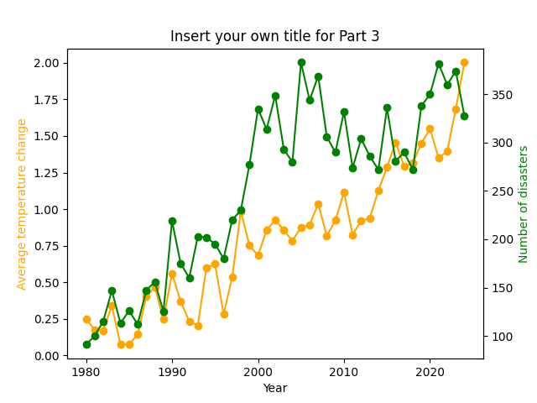

[Replace with your own figure here]

Answer the following questions:

Do periods of higher temperature coincide with an increase in disaster frequency?

What alternative measures (instead of the number of disasters) could provide more insight?

How might these other measures change your interpretation?

Part 4b: Continent comparison
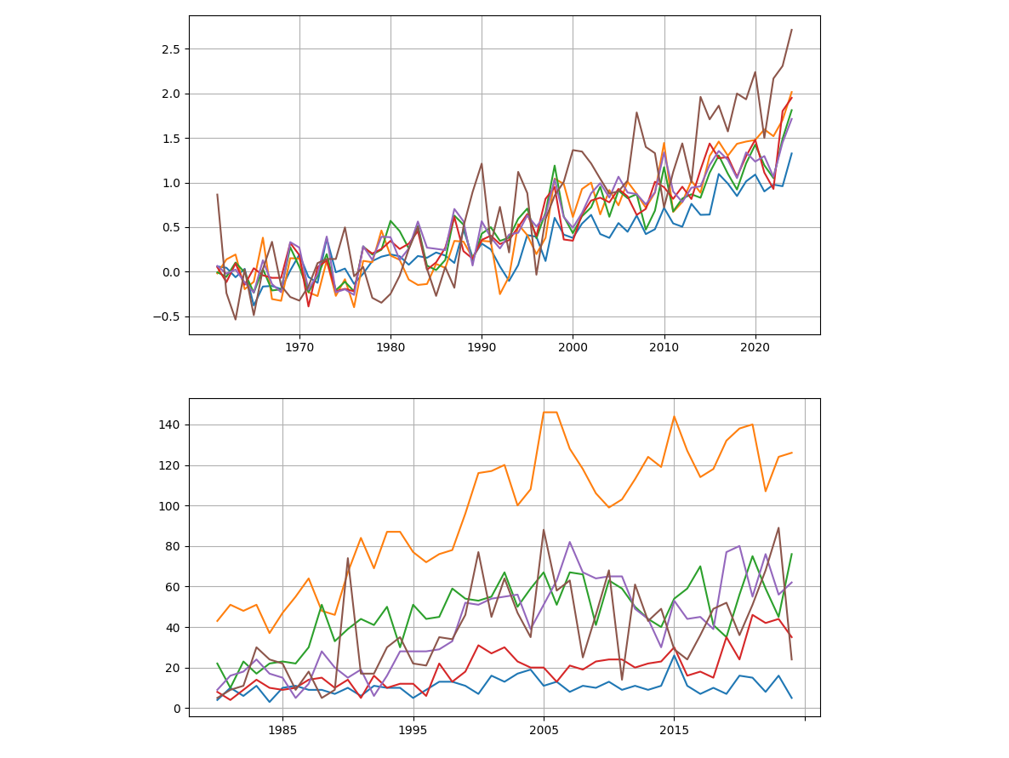

[Replace with your own figure here]

Answer the following questions:

Which continent(s) show the strongest warming trend?

Do those same continent(s) experience more disasters?

Part 5: Correlation by chance?

Interpret the results of the Mann-Kendall test and answer the following questions:

What does the trend test say for each of the two series above (increasing, decreasing, or no trend)?

What does this tell you about which variable fluctuates more relative to its average?

Part 6: Polynomial regression

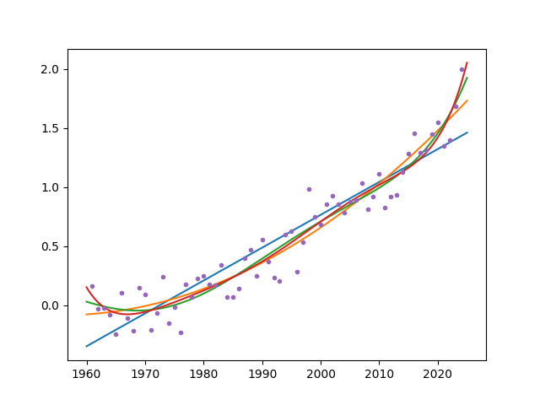

[Replace with your own figure here]

Answer the following questions:

Which degree best captures the overall disaster occurrence trend?

What happens to the curve shape as the degree increases?

Why might higher-degree models give misleading confidence about future predictions?

Use the regression model that best fits your data (based on R² and visual inspection) to predict the average number of disasters expected for the year 2030.

Part 7: More cheese, more people

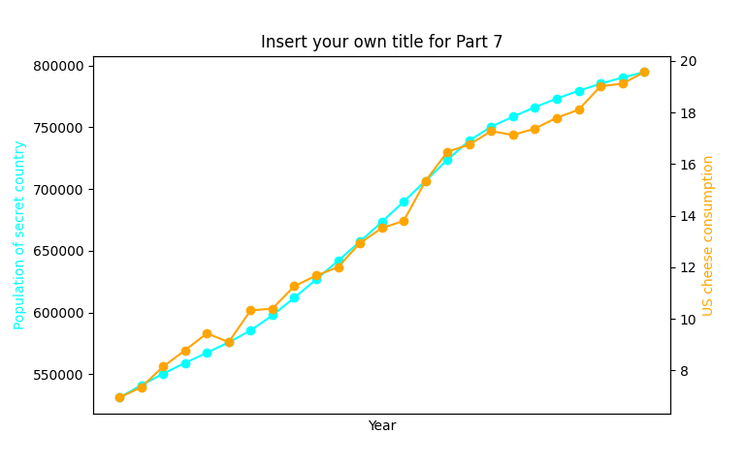

[Replace with your own figure here]

Answer the following questions:

Which country showed the strongest correlation, and what was the coefficient?

Does this imply that U.S. cheese consumption caused population change in that country? Why or why not?

What might explain why some random time series appear correlated even when unrelated?

