MAIO Project 7: K-transect data (West Greenland ice sheet)

Contact: Peter Kuipers Munneke (VMA 3.14), Paul Smeets (VMA 3.56)

For the data, contact: Peter Kuipers Munneke after the project start date (p.kuipersmunneke@uu.nl)

In general, all these projects deal with recent summertime data sets from standard IMAU automatic weather stations and turbulence mast data enabling the study of the different energy balance components that contribute to surface melt in summertime.

Turbulence data, radiation data, various sensors to measure surface height changes or melt (also using the KAN_L station nearby) – study various the surface energy balance components and the agreement between the calculated and measured melt.

Some ideas for projects:
- Compare IMAU and PROMICE weather station data from 7 different locations: S5, S6, S9, S10 (IMAU) and KAN_L, KAN_M, KAN_U (PROMICE)
- Compare flux observations from nearby stations S5 and SHR (close to KAN_L)
- Calculate empirical regressions of atmospheric parameters (air temperature, wind speed, radiation) versus elevation, and analyze longer term trends.

Link to datasets:
- IMAU weather station data from the K-transect: https://doi.org/10.1594/PANGAEA.947483
- PROMICE weather station data: https://doi.org/10.22008/FK2/IW73UU
- Recent flux measurements at S5, SHR, and older flux data from S5, S6 and S10: https://doi.org/10.1594/PANGAEA.945307
- More recent eddy covariance data from S5 is available from Maurice van Tiggelen
- Draw wire measurements from PROMICE network at locations S4, S5, S6, S7: contact Maurice van Tiggelen
- Long-term mass balance observations at all IMAU stations: contact Maurice van Tiggelen

Important references:
Kuipers Munneke P, Smeets CJPP, Reijmer CH, et al (2018) The K-transect on the western Greenland Ice Sheet: Surface energy balance (2003–2016). Arctic, Antarct Alp Res 50:S100003. https://doi.org/10.1080/15230430.2017.1420952
Bøggild CE, Olesen OB, Ahlstrøm AP, Jørgensen P (2004) Automatic glacier ablation measurements using pressure transducers. J Glaciol 50:303–304. https://doi.org/10.3189/172756504781830097
Hulth J (2010) Instruments and Methods Using a draw-wire sensor to continuously monitor glacier melt. J Glaciol 56:922–924
Tiggelen M Van, Smeets PCJP, Reijmer CH, Broeke MR Van Den (2023) Observed and Parameterized Roughness Lengths for Momentum and Heat Over Rough Ice Surfaces Journal of Geophysical Research : Atmospheres. https://doi.org/10.1029/2022JD036970
Fausto RS, Van As D, Mankoff KD, et al (2021) Programme for Monitoring of the Greenland Ice Sheet (PROMICE) automatic weather station data. Earth Syst Sci Data 13:3819–3845. https://doi.org/10.5194/essd-13-3819-2021
Smeets PCJP, Kuipers Munneke P, van As D, et al (2018) The K-transect in west Greenland: Automatic weather station data (1993–2016). Arctic, Antarct Alp Res 50:S100002. https://doi.org/10.1080/15230430.2017.1420954
Lenaerts JTM, Smeets CJPP, Nishimura K, et al (2014) Drifting snow measurements on the Greenland Ice Sheet and their application for model evaluation. Cryosph 8:801–814. https://doi.org/10.5194/tc-8-801-2014
Van den Broeke MR, Smeets CJPP, van de Wal RSW (2011) The seasonal cycle and interannual variability of surface energy balance and melt in the ablation zone of the west Greenland ice sheet. Cryosph 5:377–390. https://doi.org/10.5194/tc-5-377-2011

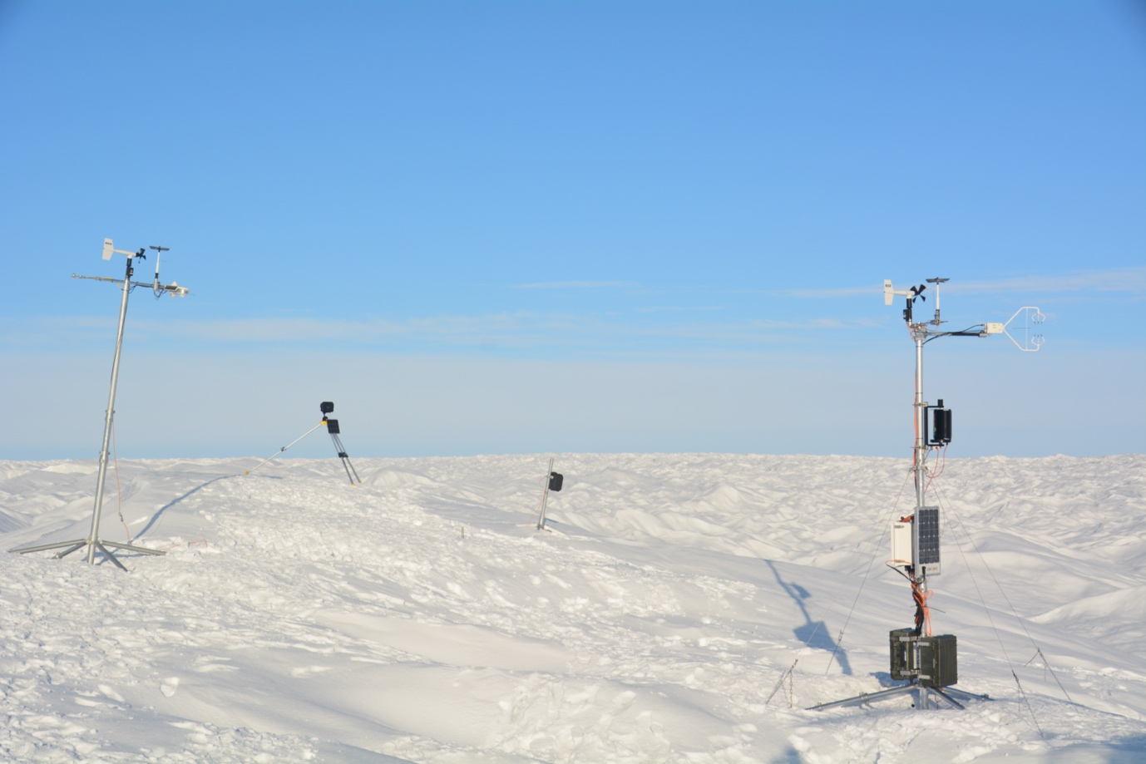
Picture: S5 on 9 Sep 2020 (Photo Maurice van Tiggelen)

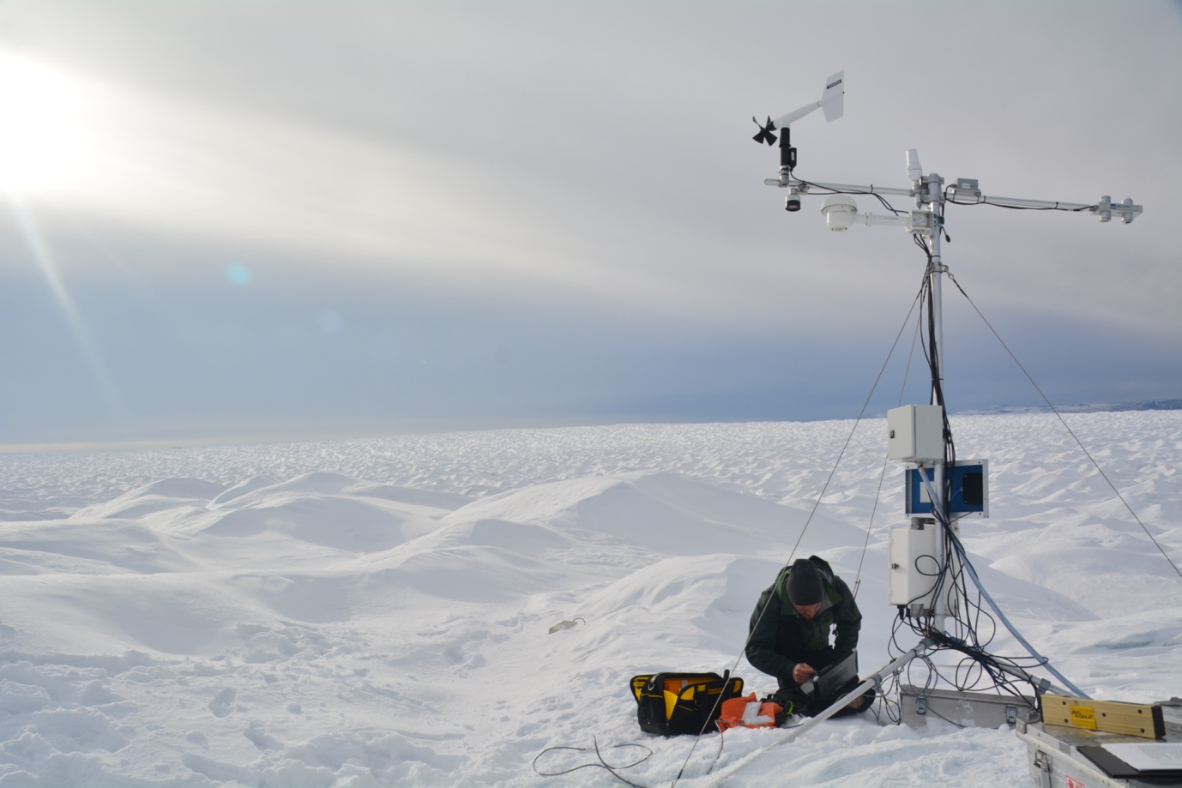
Picture: KAN_L on 9 Sep 2020 (photo Maurice van Tiggelen)

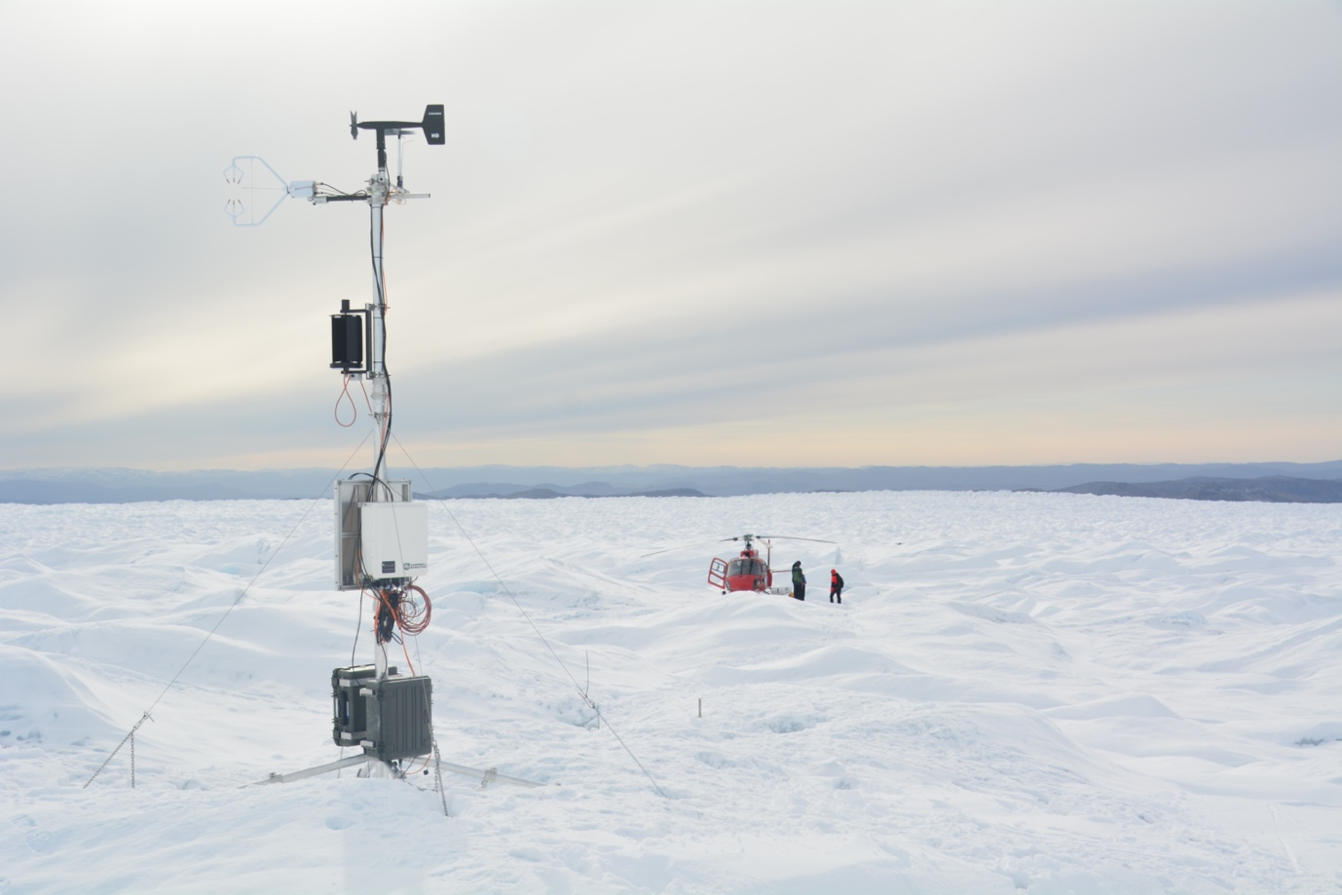
Photo: site SHR (not far from KAN_L) on 9 Sep 2020 (photo Maurice van Tiggelen)

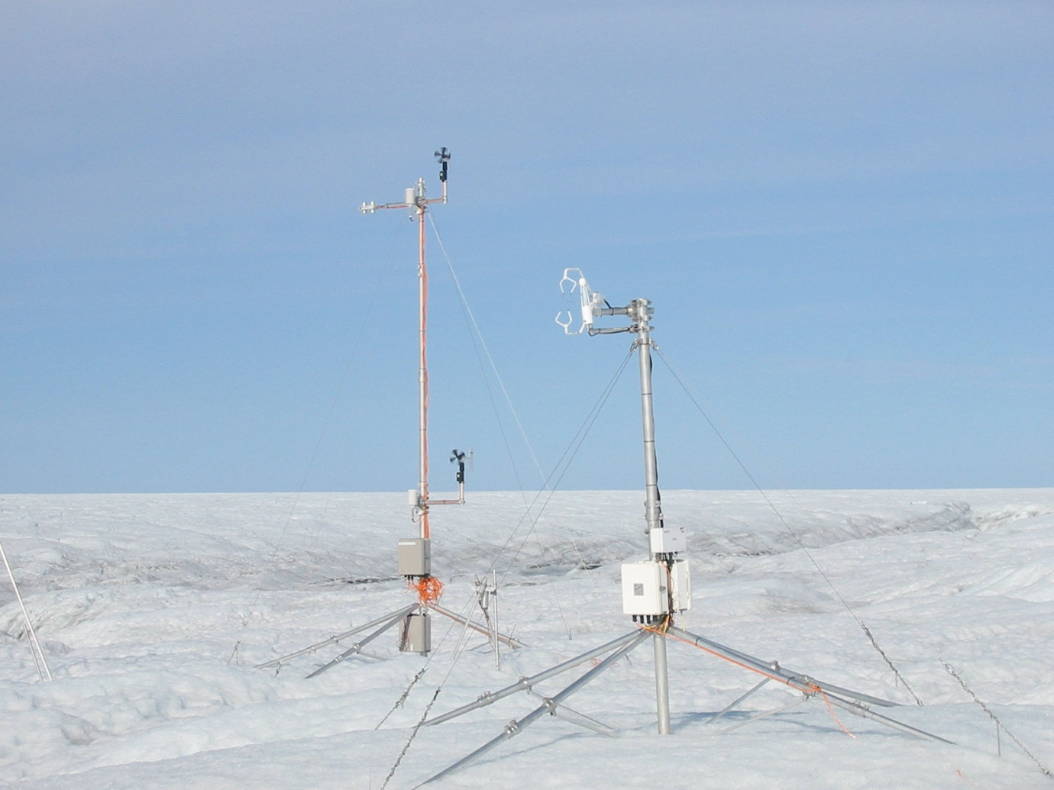
Photo: S6 on 29 aug 2003 (Photo Paul Smeets)

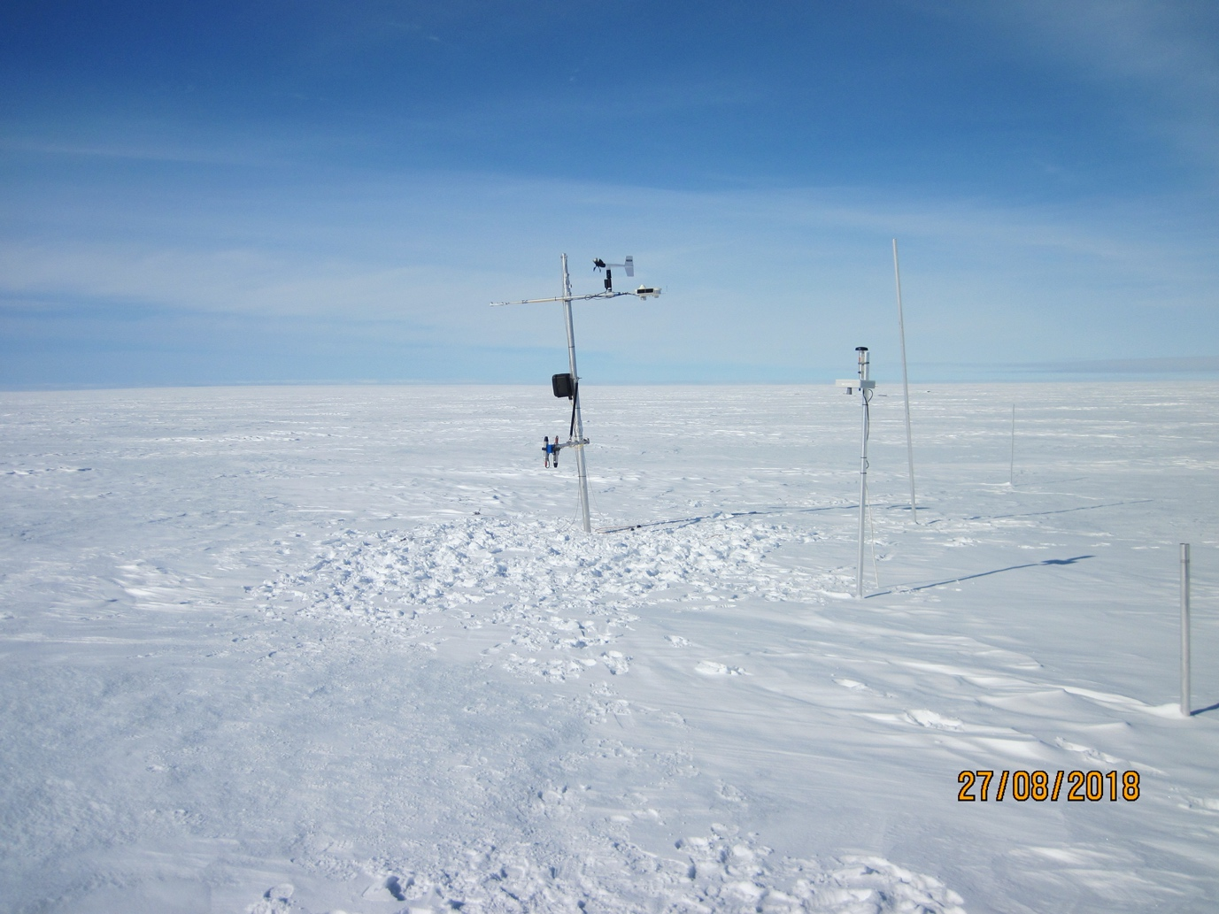
Photo: S9 on 27 Aug 2018 (photo Paul Smeets)

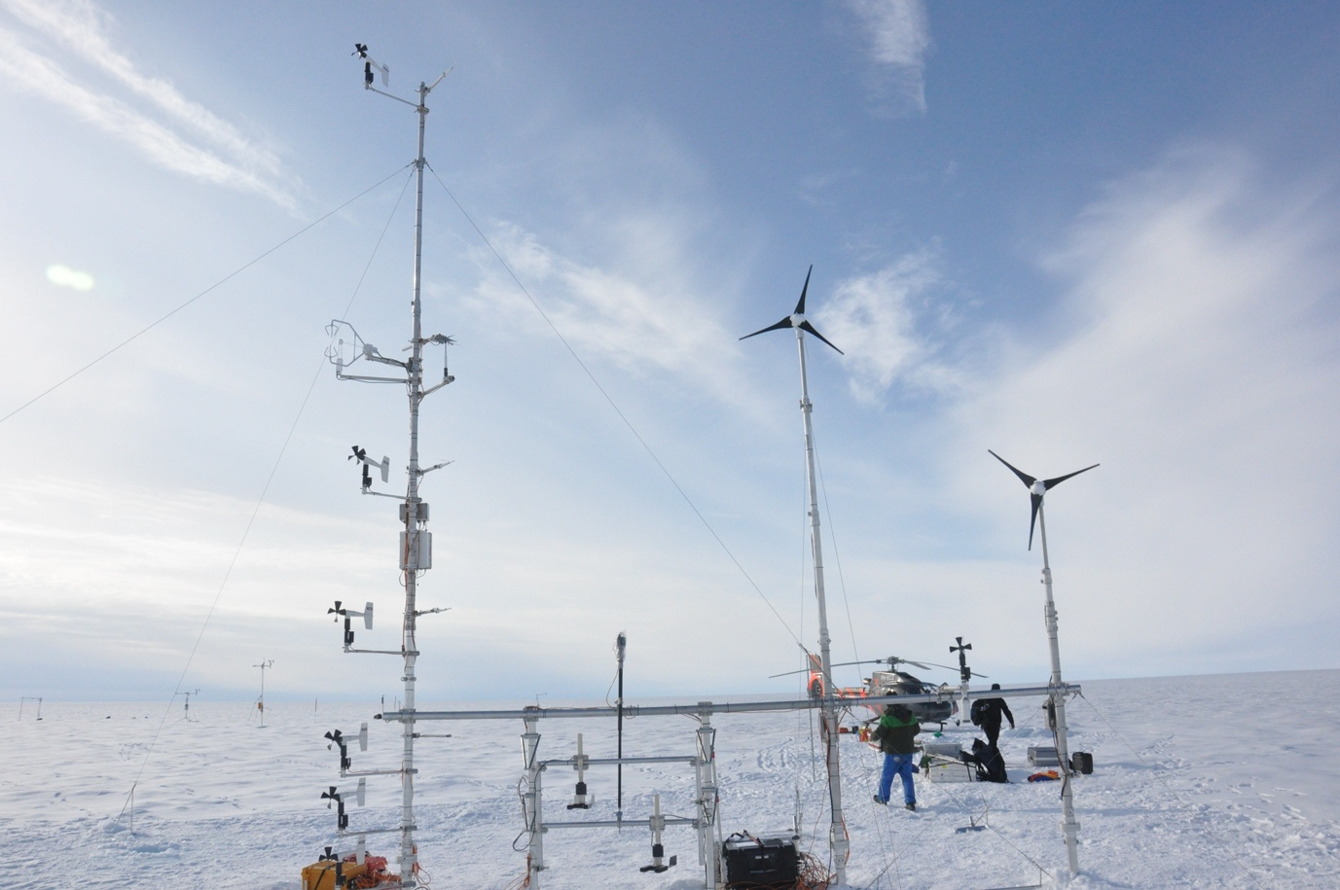
Photo: S10/KAN_U on 13 Aug 2012 (Photo Paul Smeets)

Background info (maybe not all useful):

Sonic anemometer physics in detail in Schotanus1983:
http://www.climatexchange.nl/projects/alteddy/papers/Schotanus-1983.pdf
of https://link.springer.com/article/10.1007/BF00164332
compare the thermocouple data to the humidity corrected sonic temperature and mechanically ventilated Vaisala sensor

https://journals.ametsoc.org/view/journals/atot/22/7/jtech1762_1.xml
paper on excess temperatures for shielded naturally ventilated T sensors

https://www.wmocimo.net/wp-content/uploads/P1_26_Sotelino_teco_2018_lgs.pdf
study concerning radiation shelters including the Barani Helix

Thermocouple physics and their excess temperatures are described in detail in vanAsselt1991 https://dare.uva.nl/search?identifier=8bca63be-8bcc-408a-b4e0-bcf33d568170

General references and background on energy balance and Bowen ratio: …..https://elibrary.asabe.org/abstract.asp?aid=45291 OR https://acsess.onlinelibrary.wiley.com/doi/abs/10.2134/agronmonogr47.c17

sonic anemometer temperature physics and also Bowen ratio intro:
http://www.climatexchange.nl/projects/alteddy/papers/Schotanus-1983.pdf

Bowen ratio from gradient and turb data – an energy balance study
https://journals.ametsoc.org/view/journals/hydr/4/2/1525-7541_2003_4_160_eotseb_2_0_co_2.xml

A method that allows direct calculation of the turbulence fluxes via an analytic method provide in a PDF from WUR University (Dutch text I’m afraid).

Thermocouple physics and their excess temperatures are described in detail in vanAsselt1991 https://dare.uva.nl/search?identifier=8bca63be-8bcc-408a-b4e0-bcf33d568170

Sonic anemometer physics in detail in Schotanus1983:
http://www.climatexchange.nl/projects/alteddy/papers/Schotanus-1983.pdf
of https://link.springer.com/article/10.1007/BF00164332
compare the thermocouple data to the humidity corrected sonic temperature and mechanically ventilated Vaisala sensor

Description of sensors used in weather stations (slow) or at turbulence masts (fast)

Fast sensors on the turbulence mast
Sonic anemometer
The instrument is designed to measure wind velocity components
by transmitting and receiving sonic signals along fixed non-orthogonal directions. Pairs of
transducers act alternately as transmitters and receivers, sending pulses of high frequency
ultrasound between themselves. The times of flight in each direction are measured from
which also a temperature is derived according to Ts = C2/403 with Ts the sonic temperature,
C the speed of sound and 403 a constant (Schotanus et al, 1983). Note that Ts is almost
equal to the virtual temperature. The microcomputer electronics inside the sonic control
box then processes this information and calculates the wind speed in three axes (i.e. u, v,
w). Since there are no moving parts to come into dynamic equilibrium with the air flow, the
Sonic Anemometer/Thermometer responds rapidly to wind velocity fluctuations (the CSAT3
can even be operated in a 60 Hz sampling mode). It responds linearly to wind velocity and
is free from contamination from other velocity components as well as pressure, temperature,
and relative humidity. Any calibration of the sensor in the field is not necessary and can be
used as an absolute instrument.
http://www.climatexchange.nl/projects/alteddy/papers/Schotanus-1983.pdf

Thermocouple
The fine wire thermocouple comprises of a chromel and constantan wire joined at a measurement junction by welding. A voltage potential is
generated when the measurement end of the thermocouple (our sensor in the EC system) is
at a different temperature than the reference end of the thermocouple (inside the datalogger).
The magnitude of the voltage potential is related to the temperature difference. Therefore,
temperature can be determined by measuring the differences in potential created at the
junction of the two wires and a reference temperature measurement at the reference end of
the thermocouple (inside the datalogger using a different slow sensor). At the MAIO mast we have two thermocouples with different diameters - 0.0762, 0.0254 and 0.0127mm.

Important for this type of sensor is the dynamic frequency response of sensors: this describes how well a sensor can monitor the high frequency fluctuations. As an example we could choose the thermocouple, a thin
(<0.1mm) wire thermometer. Due to its size a fine wire can react relatively fast to temperature
fluctuations, i.e. the thinner the wire the faster it gets. Nevertheless, the instrument
will be limited in response related to its physical dimensions: the more mass the larger the
portion of lost high frequency signal

Characteristics of thermocouples are well described/studied in:
WATER RESOURCES RESEARCH, VOL. 45, W08431, doi:10.1029/2008WR007600, 2009

Slow sensors at the MAIO mast

Air temperature Vaisala HMP110 -40 to + 80C 0.3!C
Relative humidity Vaisala HMP110 0 to 100% 2% (RH<90% 1.5%)
Air pressure Vaisala PTB101B 600 to 1060 hPa 4 hPa
Wind speed Young 05103 0 to 100 ms−1 0.1 ms−1 threshold 1 m/s
Wind direction Young 05103 0 to 360 2 threshold 1.1 m/s
Pyranometer Kipp en Zonen CNR1 305 to 2800 nm 2%
Pyrradiometer Kipp en Zonen CNR1 5000 to 50000 nm 15 Wm−2
Radiation shelter with artificial ventilation (unknown manufacturer)
Barani Helix radiation shelter (https://www.baranidesign.com/meteoshield-professional)

