|  |
| --- |
| **Anritsu MasterClaw README**  VMWare Marketplace |

|  |  |  |  |  |  |
| --- | --- | --- | --- | --- | --- |
| Date: | 2020-07-06 |  |  |  |  |

Dear Customer,

Thank you for your interest in the Anritsu MasterClaw Service Assurance solution for VMware.

Anritsu has developed a set of integrated OSS Service Assurance solutions allowing network operators and service providers to become uniquely competitive in the marketplace. Each of the solutions has been designed to maximize the profitability of the existing telecommunications services and infrastructure, while reducing the cost of operation. The core solution areas are based on a set of products that are combined, tailored and customized based on the unique needs of network operators within mobile, fixed or converged service domains.

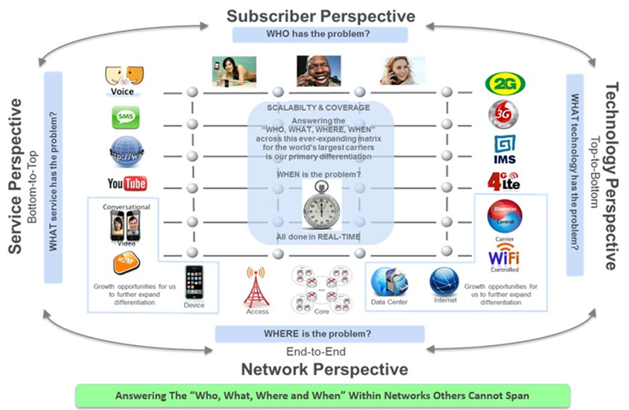

Anritsu’s network monitoring platform, MasterClaw™, was originally launched for SS7 and ISDN but has established itself as a system that has pioneered the support of new protocols and physical interfaces. From its first launch, new technologies have been added and integrated into the core product without development of separate product lines for GSM, UMTS, LTE, VoIP and lately by adding support for 5G and IoT. This has resulted in a product that supports the latest technologies and is ideally positioned for end-to-end monitoring across current and future networks.

The MasterClaw™ system enables network operators to manage all their Voice/Data/SMS services from Radio to Core, including IMS for fixed/mobile convergence and management of Roaming Partners and Interconnect routes.

The Anritsu MasterClaw™ solution integrates performance monitoring, troubleshooting as well as service and customer experience monitoring, offering a complete and complex solution for Mobile Network Operators.

Due to its complexity, the Anritsu MasterClaw™ cannot be easily packaged as a single VM appliance and if you or your company is interested in seeing our solution in action, you are more than welcome to contact us using the following web-page: <https://customer.eu.anritsu.com/form/default?f=ServiceAssuranceRequest>

Best regards,

Anritsu A/S

|  |
| --- |
| Anritsu MasterClaw README |

|  |  |  |  |
| --- | --- | --- | --- |
|  | \\intranet2.eu.anritsu.com\DavWWWRoot\SBU6\Product Marketing\Logos\Logos\BrandLogo_RGB.jpg | **Anritsu A/S**  Regus Winghouse  Ørestads Boulevard 73, 4th floor 2300 Copenhagen, Denmark  Tel: +45 72 11 22 00  Fax: +45 72 11 22 10  E-mail: info@anritsu.com  Web: www.anritsu.com | Japan +81-46-223-1111  USA +1-972-644-1777 |
| ISO 9001:2015 certified. ©2019 Anritsu. All Rights Reserved.  Specifications subject to change without notice. |