Linear Programming Formulation of Portfolio Management
created by: pgeorge@mesoncapital.com
Edited by: Janu314@gmail.com
last edited: 2017-10-18

Overview
This document presents portfolio management, as used by the Gravity simulation engine, as a linear programming problem in standard form. It also discusses implementation details using the scipy.optimize.linprog Python module.

Data
- Ideal_portfolio.2010-01-01.csv

CSV headers:

name | type | description
tradingitemid | integer | Internal equity ID.
ind_long | boolean | Indicates long position (proba_long > 0.5).
ind_short | boolean | Indicates short position (proba_short > 0.5).
proba_long | float | Probability long equity (i.e. value will increase).
proba_short | float | Probability short equity (i.e. value will decrease).
marketcap | float | Marketcap (MM).
volume | integer | Weekly trade volume.
beta | float | 12 month average volatility relative to S&P 500.
borrowcost | float | Actual annualized cost to borrow.
borrowavailability | integer | Outstanding volume available for borrow.

Mathematical Formulation

Ideal Portfolio
Consider probability vectors  and  generated by a binary classification model, defined such that the elements

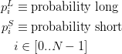

For both longs and shorts, we neglect any position with a probability < 0.5.

We apply an exponential weighting function to and to generate a set of position weight vectors  and , respectively. These vectors should be normalized such that

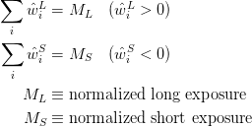

For example, an unlevered dollar-neutral portfolio would have .

Objective Function
Given an ideal portfolio, 

we seek to minimize the error between it and our optimal portfolio, 

objective function:
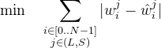

Optimization Constraint Bounds (Optimization Hyperparameters)
This table contains constraints definitions and default values for portfolio optimization. The goal is make these constraint bounds parameterizable inputs to our portfolio management algorithm.

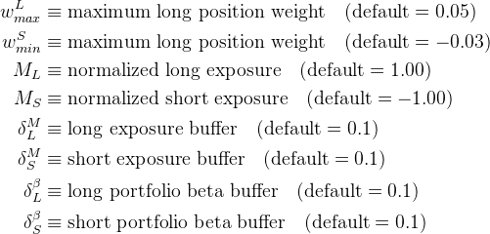

Constraints
Here, we itemize the list of constraints.

- Bounds on individual weightings
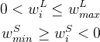
- Bounds on exposure
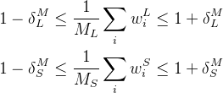
- Bounds on relative volatility (“beta”). We will eventually revisit this constraint to enforce near-beta-neutrality.
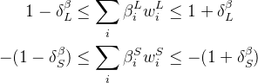
- Constraints on liquidity (to be completed)
We should have something here to that say 50% of entire portfolio can be liquidated completely in 2 weeks at 20% of volume cap. Potential hyperparams:
- percent of portfolio required to be liquid (default = 50%)
- time period of liquidity (default = 2 weeks)
- max volume percent (default = 20%)
- Constraints on short availability (to be completed)
This is a tricky one because you need to define this constraint as the new position (e.g. PositionSizeIdeal - PositionSizeToday = order size <= short avail quantity). I think this is ok to use though since position size today is known.

Linearizing the Above Problem (Long Only)

- new variables to linearize the problems

New Objective function: 

New Constraints added:



Scipy Implementation
To be completed.

