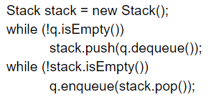

First dequeue the q and add to the stack using push

For example q = [1,2,3,4,5,6]

Then stack =[1,2,3,4,5,6]

|  |  |  |  |  |  |  |  |
| --- | --- | --- | --- | --- | --- | --- | --- |
| q | Stack | q.isEmpty | q.dequeue  FIFO | Stack.push(  q.dequeue) | Stack.pop  LIFO | Stack.  isEmpty | q.enqueue(  stack.pop) |
| [1,2,3,4,5] | [] | False | 1 | 1 |  |  |  |
| [2,3,4,5] | [1] | False | 2 | 2 |  |  |  |
| [3,4,5] | [1,2] | False | 3 | 3 |  |  |  |
| [4,5] | [1,2,3] | False | 4 | 4 |  |  |  |
| [5] | [1,2,3,4] | False | 5 | 5 |  |  |  |
| [] | [1,2,3,4,5] | True |  |  | 5 | False | 5 |
| [5] | [1,2,3,4] |  |  |  | 4 | False | 4 |
| [5,4] | [1,2,3] |  |  |  | 3 | False | 3 |
| [5,4,3] | [1,2] |  |  |  | 2 | False | 2 |
| [5,4,3,2] | [1] |  |  |  | 1 | False | 1 |
| [5,4,3,2,1] | [] |  |  |  |  | True |  |