Name : SASI KUMAR .T

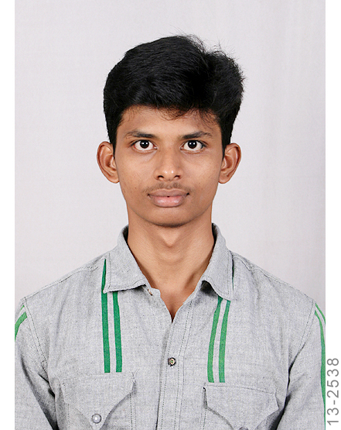
Address:
S/O Thangavel .L,
Venkatasamy Road,
New Sithaputhur,
Coimbatore District,
Tamil Nadu .
Pin Code : 641 044
Email id: sasikumarmts017@gmail.com
Mobile no: +91- 8883510997

CAREER OBJECTIVE:

To build a successful career, I aspire to apply my knowledge and skills in an organization that allows for personal and professional growth, which will enhance my skills and increase my credibility to the Organization. I am a fast learner and eager to learn, My confidence and my goal oriented path shall allow me to carry out in duties put before me, My career goals are to be the best employee that I can be. To do better is to by all rules and don’t take short cuts.

PERSONAL PROFILE:

Father’s name : Thangavel .L
Mother’s name : Tamil selvi .T
Gender : Male
Marital status : Single
D.O.B : 01.07.1994
Blood Group : B + ve
Nationality : Indian
Religion : Hindu

EDUCATION QUALIFICATION:

COURCE | INSTITUTION | BOARD/CURRICULLUM | YEAR OF PASSING | % OF MARKS
Degree BE Mechatronics | SNS college of Technology | Tamilnadu Anna University | 2012- 2015 | 6.49
Diploma in Automobile Engineering | CIT Sandwich polytechnic college | State board | 2009-2012 | 76
SSLC | Sri Rahavendra Higher Secondary School | State Board | 2009 | 83

Skills: Computer Related:
- AUTO CAD
- PRO Engineering
- C&C++ basic
- Core Java

Languages Known:
To Read : English, Tamil
To Speak : English, Tamil
To Write : English, Tamil

Industrial Experience
- Ten days in-plant training in MM gears and motors.
- Done my final year project in ROOTS india pvt.
- Three days industrial visit in TVS company hosur.
- Ten days training in Nastic Automation in chennai.

Interest & Hobbies :
- Table Tennis.
- Music – Electric Guitar tuning.
- Cricket.

Strength :

- Work dedicated Team Player.
- Positive thinker.
- Smart worker.

Projects Done on:

- Hydraulic lift controller and reservoir.
- Load sensor in two wheeler.
- Water level controller.
- Integration of diaphragm assembly and height measuring fixture
(Roots india PVT)

Tasks Done On Cloud Crisp Solution :

- Module - Grid Table, Forum page.

- Environment - Angular js, bootstrap 3, node js.

- Description - Forum page(if students have any doubt regarding their projects they can ask questions and post a comment).

- Design detail - The front end of this module is designed by HTML 5 and Angular
And backend using Node js and Mysql.

- Unit Test - Node js - Mocha and Chai .
Angular js - Karma and Jasmine .
- Learning Material - W3schools.com, Youtube.com

DECLARATION:
I, here by declere that the particular of information and facts stated here in above are true, correct and complete to the best of my knowledge and belief.

Place: COIMBATORE Yours sincerely ,
Date: (SASI KUMAR. T)

