Part C: Prior Art Matrix & System Deliverables
A-LAW-min Legal Informatics Engine • Figma Prototype & Visual System Specification
C. Prior Art Matrix
C1. System Architecture
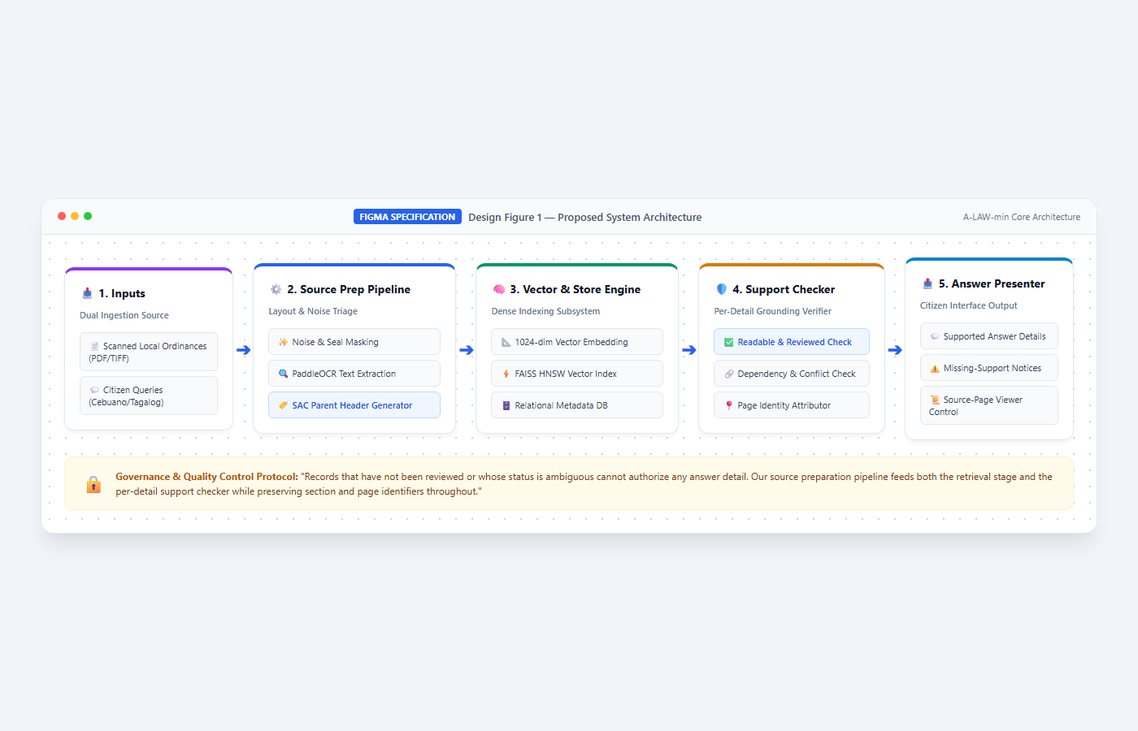
Design Figure 1 — Proposed System Architecture (Figma Visual Specification)
Our source preparation pipeline feeds both the retrieval stage and the per-detail support checker. The answer presenter retains the supporting section and page identifiers throughout. The system takes scanned PDFs and citizen questions as input and produces supported answer details, missing-support notices, and source-page controls as output. Records that have not been reviewed or whose status is ambiguous cannot authorize any answer detail.
C2. Primary User Interface
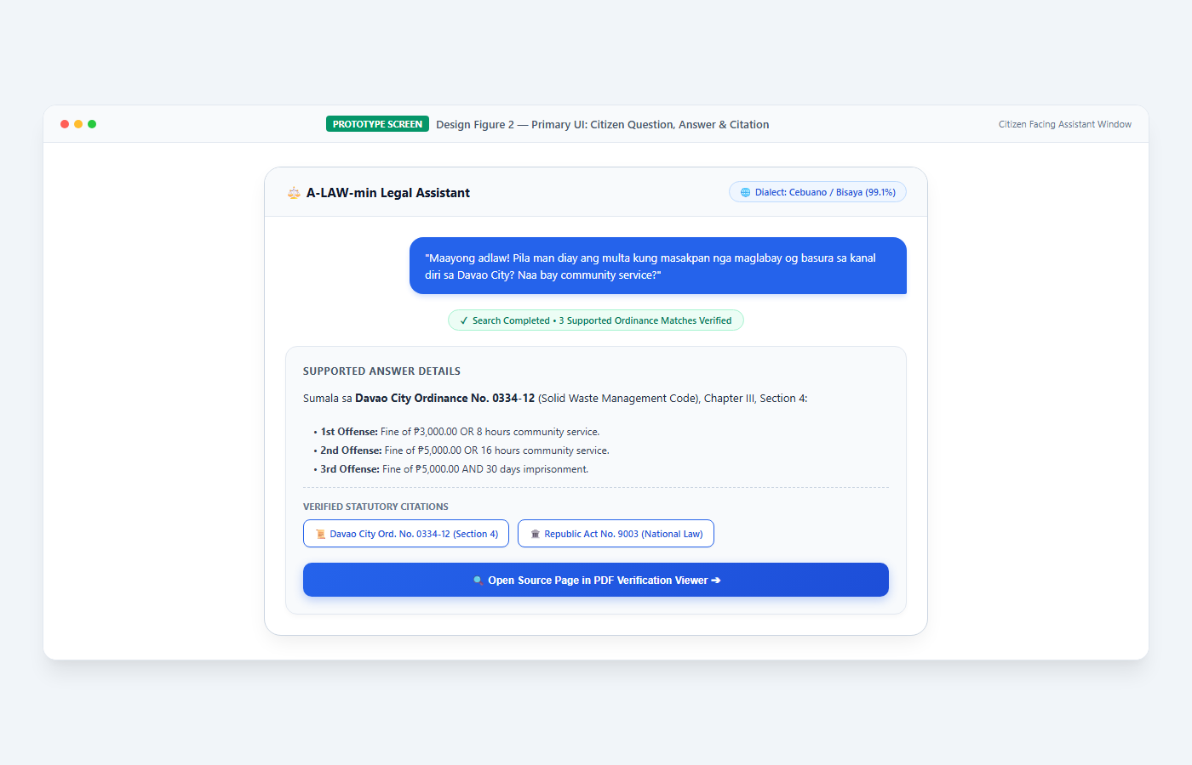
Design Figure 2 — Primary UI: Citizen Question, Answer, Citation, and Source-Opening Screen (Figma Visual Specification)
Our proposed primary screen presents the citizen's question field, the supported answer, citation links, and a control to open the source page. Before a search is submitted, the screen prompts for a question; during retrieval it shows progress; when no supported match is found, it requests clarification or reports that no answer could be verified.
C3. Secondary User Interface
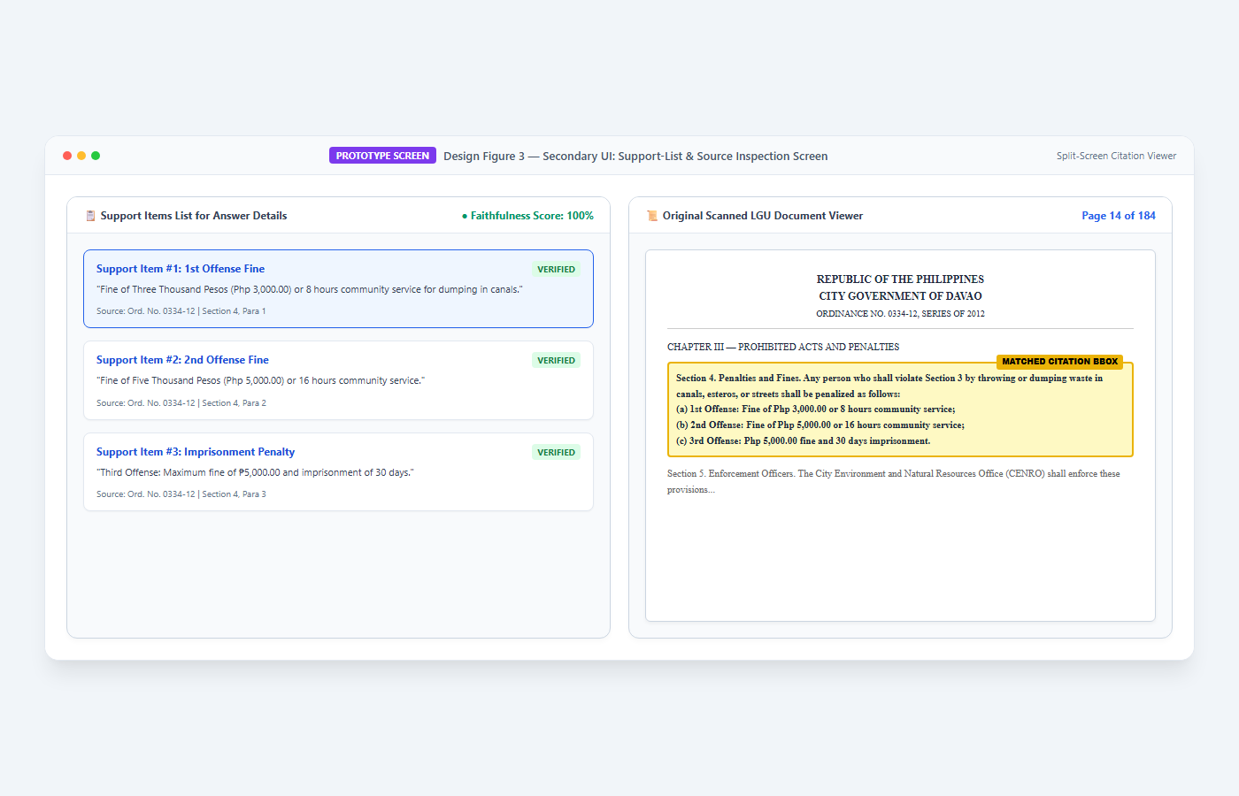
Design Figure 3 — Secondary UI: Support-List and Source-Inspection Screen (Figma Visual Specification)
Our proposed secondary screen displays the list of support items for each answer detail and allows the citizen to inspect the linked source page. The viewer resolves the selected citation to its stored PDF page. When a source file is unavailable, the screen shows a source-access error. The system does not silently substitute a different page or mark unreviewed text as verified.
C4. Detailed Flowchart -- Primary Feature
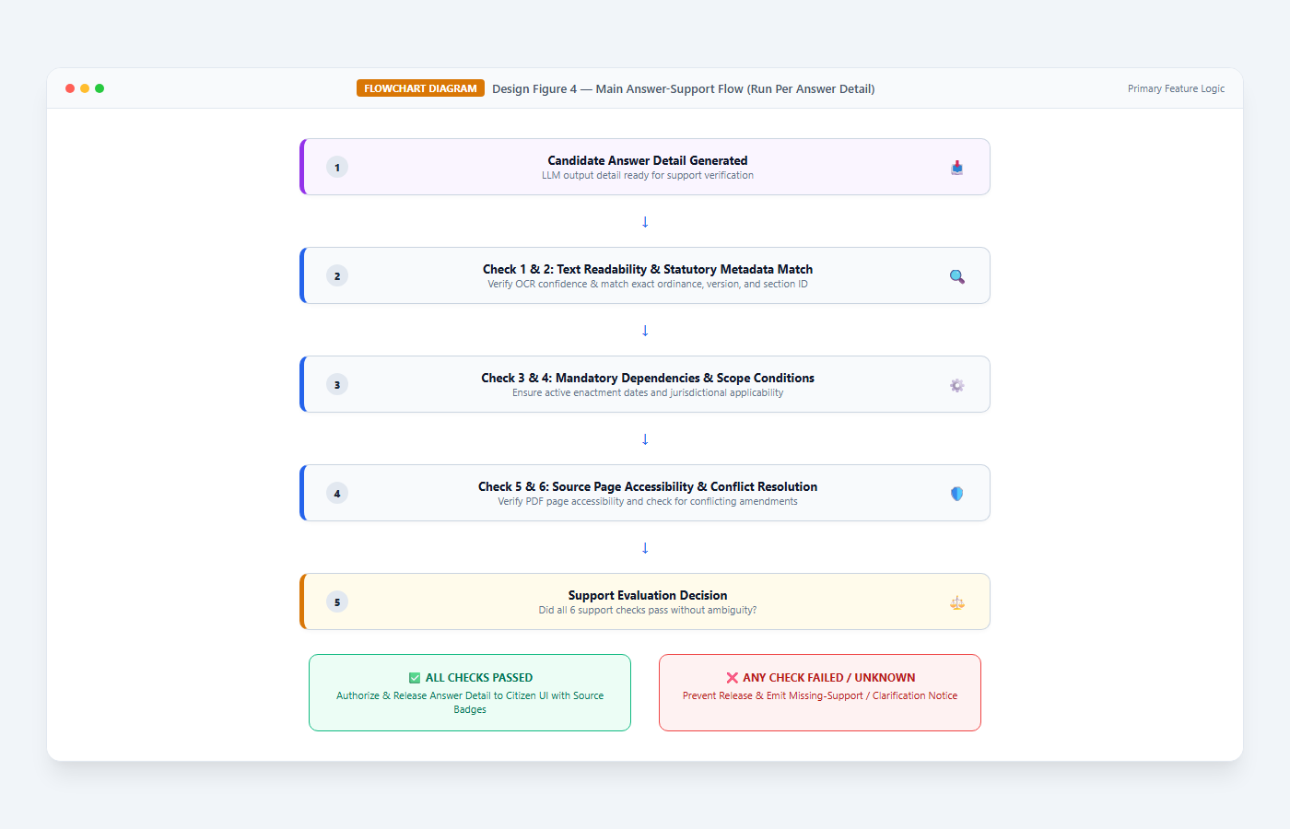
Design Figure 4 — Main Answer-Support Flow (run per answer detail) (Figma Visual Specification)
We run the support decision independently for each answer detail. The required checks are: readable and reviewed section text; correct ordinance, version, and section identifier; all mandatory dependencies resolved; recorded scope conditions met; source pages accessible; and no unresolved conflict. A failed or unknown result on any item prevents that detail from being released.
C5. Detailed Flowchart -- Secondary Feature
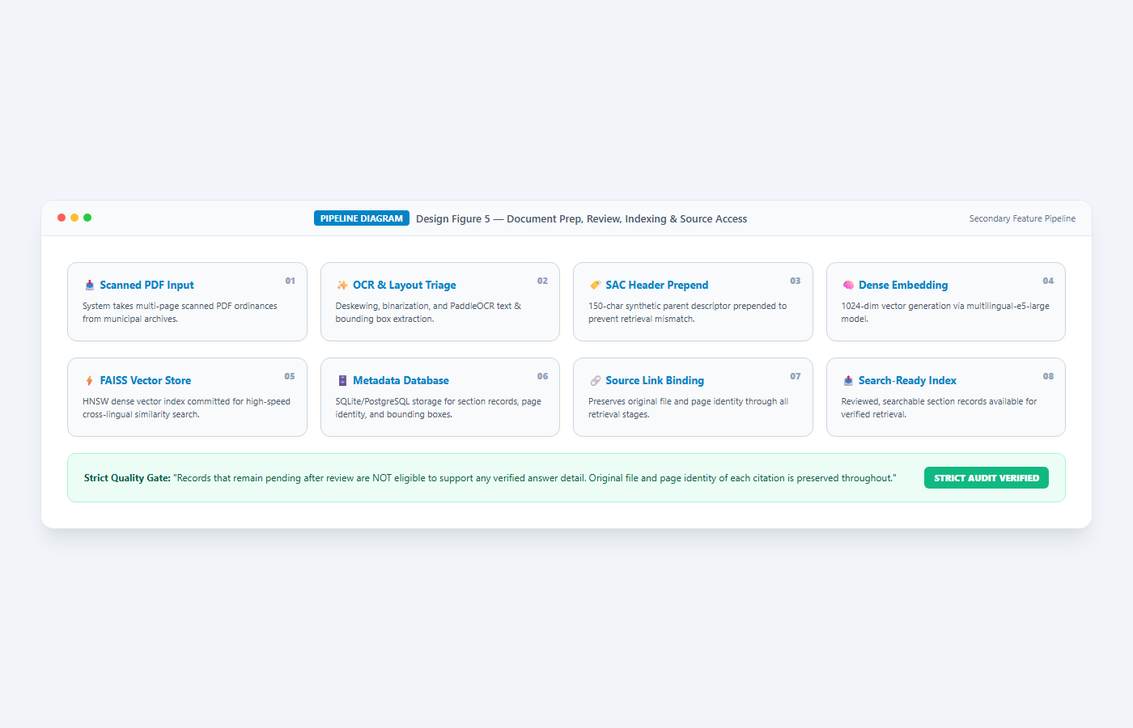
Design Figure 5 — Document Preparation, Review, Indexing, and Source-Access Pipeline (Figma Visual Specification)
The system takes PDF pages as input and produces reviewed, searchable section records with source links as output. Records that remain pending after review are not eligible to support any verified answer detail. We preserve the original file and page identity of each citation through all stages of retrieval.

