Practicals 04 part deux

JW

2024-05-31

# Iris data set analysis

## Summary of the data set

data(iris)  
summary(iris)

## Sepal.Length Sepal.Width Petal.Length Petal.Width Species   
## Min. :4.300 Min. :2.000 Min. :1.000 Min. :0.100 setosa :50   
## 1st Qu.:5.100 1st Qu.:2.800 1st Qu.:1.600 1st Qu.:0.300 versicolor:50   
## Median :5.800 Median :3.000 Median :4.350 Median :1.300 virginica :50   
## Mean :5.843 Mean :3.057 Mean :3.758 Mean :1.199   
## 3rd Qu.:6.400 3rd Qu.:3.300 3rd Qu.:5.100 3rd Qu.:1.800   
## Max. :7.900 Max. :4.400 Max. :6.900 Max. :2.500

## Boxplot of sepal widths depending on the species

boxplot(Sepal.Width ~ Species, data = iris)

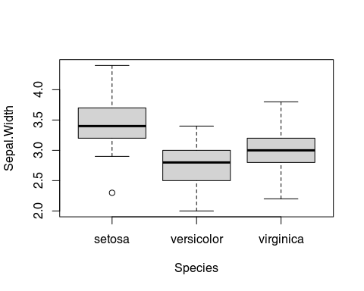

# Section

## R Markdown

### Subsubsection

#### etc

Text with a footnote[1].

This is an R Markdown document. Markdown is a simple formatting syntax for authoring HTML, PDF, and MS Word documents. For more details on using R Markdown see <http://rmarkdown.rstudio.com>.

This will be **bold**, and this will be *italics*.

And here comes a list:

* one
* two
* three

You can also use stars:

* one
* two
* three (and of course *italic* or **bold** work)

And a numbered list:

1. one
2. two
3. three

When you click the **Knit** button a document will be generated that includes both content as well as the output of any embedded R code chunks within the document. You can embed an R code chunk like this:

data(iris)  
summary(iris)

## Sepal.Length Sepal.Width Petal.Length Petal.Width Species   
## Min. :4.300 Min. :2.000 Min. :1.000 Min. :0.100 setosa :50   
## 1st Qu.:5.100 1st Qu.:2.800 1st Qu.:1.600 1st Qu.:0.300 versicolor:50   
## Median :5.800 Median :3.000 Median :4.350 Median :1.300 virginica :50   
## Mean :5.843 Mean :3.057 Mean :3.758 Mean :1.199   
## 3rd Qu.:6.400 3rd Qu.:3.300 3rd Qu.:5.100 3rd Qu.:1.800   
## Max. :7.900 Max. :4.400 Max. :6.900 Max. :2.500

| column1 | column2 | column3 |
| --- | --- | --- |
| test1 | test2 | test3 |

## Tables with R

iris_first_10 <- head(iris, n = 10)  
knitr::kable(iris_first_10)

| Sepal.Length | Sepal.Width | Petal.Length | Petal.Width | Species |
| --- | --- | --- | --- | --- |
| 5.1 | 3.5 | 1.4 | 0.2 | setosa |
| 4.9 | 3.0 | 1.4 | 0.2 | setosa |
| 4.7 | 3.2 | 1.3 | 0.2 | setosa |
| 4.6 | 3.1 | 1.5 | 0.2 | setosa |
| 5.0 | 3.6 | 1.4 | 0.2 | setosa |
| 5.4 | 3.9 | 1.7 | 0.4 | setosa |
| 4.6 | 3.4 | 1.4 | 0.3 | setosa |
| 5.0 | 3.4 | 1.5 | 0.2 | setosa |
| 4.4 | 2.9 | 1.4 | 0.2 | setosa |
| 4.9 | 3.1 | 1.5 | 0.1 | setosa |

## Including Plots

You can also embed plots, for example:

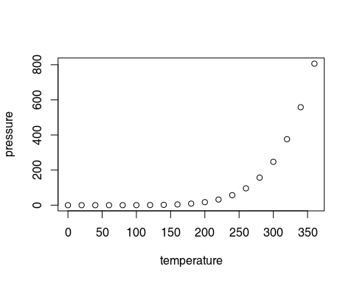

Note that the echo = FALSE parameter was added to the code chunk to prevent printing of the R code that generated the plot.

## Images

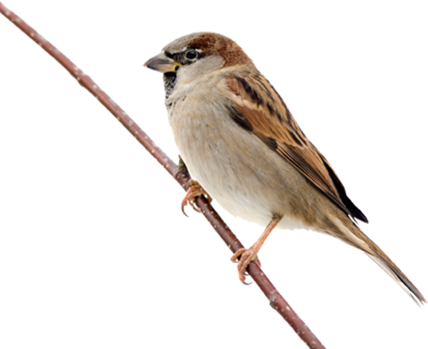

Image of a sparrow

1. This is the footnote.